Introduction to IBM System z Mini-Boot Camp
Hosting the Introduction to System z Mini-Boot Camp

IBM Contact:
Patricia McAteer
IBM CORP Learning Consultant
pmcateer@us.ibm.com
Table of Contents
Overview 3
Steps to Deliver the Program 3
1. Download the Program Files 3
2. Create a Web Page 4
3. Set Up the Exercise Environment 6
Appendix I: Sample Web Page 7
Visual Example of a Web Page 7
Web Page Text 9
Appendix II: IBM Academic Initiative Web Site 11
Appendix III: Browser Settings 12
I. How to set the Adobe Flash Player Security settings 12
II. How to Allow Browser Pop-ups for the Mini-Boot Camp Program 13

Overview

The Introduction to System z® Mini-Boot Camp is a comprehensive offering that includes lecture content in web-based modules, checkpoint questions, assessments, demonstrations, and hands-on exercises.

This document explains how to set up and host the Introduction to System z Mini-Boot Camp program from either a website (which is the recommended delivery method) or as stand-alone course materials.

Steps to Deliver the Program

To deliver the program, you need to:

- Download the program files.
- Create a Web page to make the program available to students.
- Set up the exercise environment.

1. Download the Program Files

Be sure to move all the files to the server that will either host your web page for this program (see Appendix 1) or that will be used as the location for the students to download the files onto their computers.

All the files, instructions, and tools, for hosting the IBM Introduction to System z Mini-Boot Camp program are located at the following IBM website:

- IBM Academic Initiative
(http://www-03.ibm.com/systems/z/advantages/charter/skills_coursematerials.html#BootCamp)

1. From the IBM Academic Initiative site, under the heading, Introduction to System z Mini-Boot Camp, download these two WORD documents:

- Hosting the Introduction to System z Mini Boot Camp – provides instructions on how to move the program materials from the IBM Academic Initiative website to your organization.

- IBM Design Document: Introduction to System z Mini-Boot Camp – this document explains step-by-step how to proceed through this program.

2. Modules

Note: The demonstrations and assessments are included in the modules.

Web-based (zipped) Modules – The 13 web-based modules are packaged as .zip files. The zip files should be unzipped after they have been downloaded.

As the files unzip, a separate folder for each module, containing the following files, is created automatically:
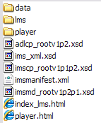
3. Exercises – the exercises, instructions, and tools (explained in the Exercise Setup document) are located in the Exercises section, which includes five individual files:
- Setup document – (Exercise Setup.doc)
- Setup tool (zOSLSA.zip) – unzip this file to create a folder
- Setup tool demonstration (zOSLSA_Demo.zip) – unzip this file to create a folder
- Exercise data sets (zprof.zip) – unzip this file to create a folder
- Exercise notebook (Exercises.doc)
4. Program Reference Material – The reference materials contain the student Redbook and the instructor Redbook and they are located in the Program Reference Material section.
- Student/mentee redbook (Student_redbook.zip)
- Technical Knowledge Partner/mentor redbook (TKP_redbook.zip)
Note: the student’s browsers will need to be set up for the Flash player and to allow pop-ups. Refer to Appendix III. Browser Settings for instructions.

2. Create a Web Page for this Program

The recommended way to deliver this program is via an internal Web site. However the individual modules can be downloaded to a pc and run from there by double-clicking on each module’s player.html file.

Creating the web page
Create a web page with links to each of the user program components (for example, to the exercise notebook, to the reference materials, and to each module).

To help you construct the web page, the following two items are located in Appendix I: Sample Web Page:
- A visual example of the IBM Prgram web page: this is a screen shot of the web page IBM created to host the program.

- Web page text: this text can be copied, pasted, and/or modified as desired, to create your web page.

Note: each module is presented to the student via a Flash player. Each module’s Flash player was automatically included within each module’s folder when the files were unzipped, which produced a set of folders similar to this:

To set it up so that each module’s Flash player opens correctly, when you create the link for each module, set the link to each module’s specific player.html file, as shown below:

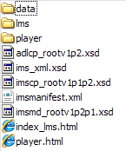

Do this for each of the 13 modules. When the module link on the web page is clicked, the Flash player launches the module.

Note: If the course will not be run from a web site, the individual modules can be downloaded to a person’s pc and ran from there by double-clicking on the player.html file.

3. Set up the Exercise Environment
Please refer to the Exercise Setup document (Exercise Setup.doc) for steps to set up the exercise environment. The document is included in the program package downloaded in step 1.

Appendix I: Sample Web Page

Visual Example of a Web Page
This is a screen shot of the IBM web page for the Introduction to System z Mini-boot camp. This screen shot illustrates one way the page can be laid out.
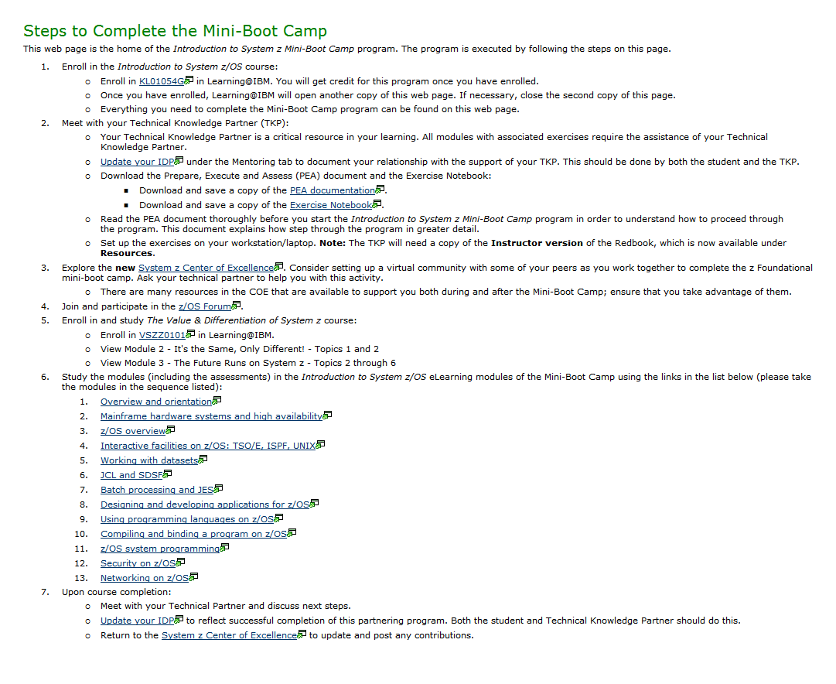

Web Page Text
This is a copy of the text from the IBM Introduction to System z Mini-boot Camp web page. The underlined blue text should be modified by you to correspond to your content and associated links for your offering.

NOTE: this text is provided for example purposes only.

Steps to Complete the Mini-Boot Camp

This Web page is the home of the IBM Introduction to System z Mini-Boot Camp program. This program is executed by completing the following steps:
- Enroll in the Introduction to System z/OS program:
  - Enroll in your program code here. You will get credit for this program once you have enrolled.
  - Once you have enrolled… provide any additional information here.
- Meet with your Technical Knowledge Partner/Mentor (TKP):
  - Your Technical Knowledge Partner/Mentor is a critical resource in your learning. All modules with associated exercises require the assistance of your Technical Knowledge Partner.
  - Update your Performance Objectives. This should be done by both the student and the TKP.
  - Download the Hosting the Introduction to System z Mini Boot Camp document and the Exercise Notebook:
    - Download and save the IBM Design Document: Introduction to System z Mini-Boot Camp and the Exercise Guide.
  - Read the IBM Design Document: Introduction to System z Mini-Boot Camp document thoroughly before you start the Introduction to System z Mini-Boot Camp program in order to understand how to proceed through the program. This document explains in greater detail how to step through the program.
  - Set up the exercises on your workstation/laptop.
Note: The TKP will need a copy of the Instructor version of the Redbook, which is now available under Resources.
- Explore the new System z Center of Excellence. Consider setting up a virtual community with some of your peers as you work together to complete the z Foundational Mini-Boot Camp. Ask your Technical Partner to help you with this activity.
  - There are many resources in the COE that are available to support you both during and after the Mini-Boot Camp; ensure that you take advantage of them.
- Join and participate in the z/OS Forum.
- Study the modules (including the assessments) in the Introduction to System z/OS eLearning modules of the Mini-Boot Camp using the links in the list below (please take the modules in the sequence listed):
  - Overview and orientation
  - Mainframe hardware systems and high availability
  - z/OS overview
  - Interactive facilities on z/OS: TSO/E, ISPF, UNIX
  - Working with datasets
  - JCL and SDSF
  - Batch processing and JES
  - Designing and developing applications for z/OS
  - Using programming languages on z/OS
  - Compiling and binding a program on z/OS
  - z/OS system programming
  - Security on z/OS
  - Networking on z/OS
- Upon course completion:
  - Meet with your Technical Knowledge Partner/Mentor and discuss next steps.
  - Return to the System z Center of Excellence to update and post any contributions.

Appendix II: IBM Academic Initiative Web Site
This is a screen capture of the IBM Academic Initiative website. This is where the program files will be downloaded from. The link to the site is included in Step 1 of this document.

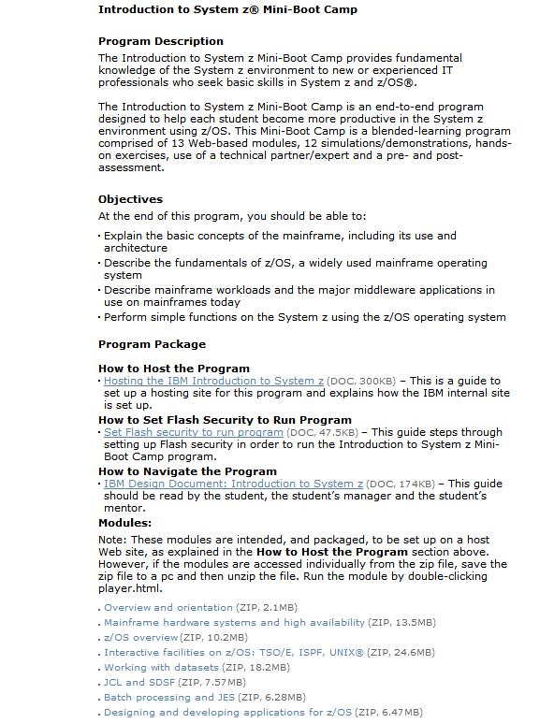

Appendix III: Browser Settings

I. How to set the Adobe Flash Player Security settings

If you receive the following message (shown in screen capture) when you try to open a module or while trying to open the demonstrations, you will need to add the location of the file in order to access the demos.

Please follow these steps to allow the Flash interaction:

- Click the Settings button in the Adobe Flash Player Security message box (as seen in this screen capture).
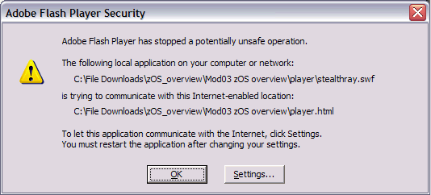
- The Adobe Flash Player Settings Manager page displays.
Click the arrow in the Edit locations drop-down box.
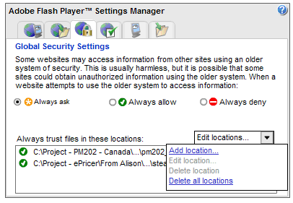
- Select Add location.
- The following box displays.
Click the Browse for folder button.
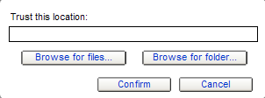
- Select the folder where you have saved the course.
- Re-launch the Introduction to System z Mini-Boot Camp program in a new browser session.

II. How to Allow Browser Pop-ups for the Mini-Boot Camp Program

A pop-up is a small web-browser window that opens up. In the Introduction to System z Mini-Boot Camp, pop-ups are intentionally used to present various types of information to the user. Be sure that the web browser allows pop-ups while using the course. Pop-up blocker can be reset when not taking the course.

To turn it off, or to turn it on again if you've already turned it off, use the following steps for your browser:

Internet Explorer
- From the Internet Explorer menu bar, select Tools > Pop-up Blocker.
- Click Turn Off Pop-up Blocker.

FireFox
- From the Internet Explorer menu bar, select Tools > Options.
- Click Content from the menu.
- Ensure the Block Pop-up windows checkbox is unchecked and click OK.
Note: If it is checked, click the Exceptions button and enter the URL of the Introduction to System z Mini-Boot Camp site.

