
Decision and Solutions Guide

November 2006

Smarter power delivery
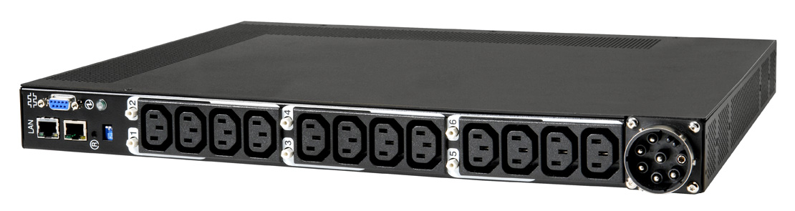  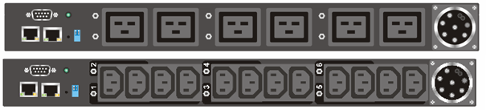 | IBM Distributed Power  Interconnect products
Featuring  the NEW  DPI PDU+  power distribution products with remote monitoring  NEW!  Contents  Products and solutions 2  Key features 2  IBM DPI product family 3  IEC vs NEMA standard 8  Benefits of the DPI PDUs 9  Customer requirements 9  Key messages 9  Selection questions 10  Product specifications 11  Product diagrams 19  Sizing and configuration 21  Installation and use 22  Installation options in  IBM rack models 23  Sample configurations  to help maximize uptime 25  System x rack configurator  software 27  Country-specific  considerations 28  Preparing for the future 34  Additional resources 35 | Help enhance system and data availability with modular, space-efficient power distribution solutions from IBM  With the changes brought on by the new generation of Intel®-based servers, power distribution and power delivery are becoming critical issues. Only a few years ago, the quest was on to find ways to easily place 42 outlets in a rack for what was then an amazingly dense configuration of 1U servers. Today, there are more factors to consider than counting the power line cords and matching them to the number of outlets. The quest for outlet count has now been joined by the quest for delivering current adequate to feed the substantial power draw of today's servers. This trend toward higher current (amperage) draw in servers is making it more difficult to design a fault-tolerant system.  IBM offers Distributed Power Interconnect (DPI) products, a family of modular "zero-U" power distribution units (PDUs) designed to be capable of supporting solutions from a handful of servers to an array of large enterprise servers—all without consuming valuable rack space. These units can be configured to provide redundant power distribution, thus helping to eliminate a point of failure and assure higher levels of data availability.  IBM® DP Interconnect (DPI) products were developed specifically for use with sensitive electronic equipment in the rack environment. Unlike many third-party products which were designed for the desktop or industrial environments, the DPI products are sized and protected with servers in mind.  There are compelling reasons why one should include IBM DPI PDUs in a rack-based IBM System x solution:  - Even in simple configurations, the combined power-line requirement of devices in the rack can easily exceed the capacity of existing wall outlets. A PDU can help customers efficiently use the available power and the available outlets  - A properly configured PDU solution may help customers increase availability and protect their system investments at a very affordable price. IBM PDUs can be used to help provide an advanced fault-tolerant power distribution system  - IBM's modular approach provides the flexibility to mix and match components as needed to configure a wide range of power distribution solutions. Universal voltage support, plus single- and three-phase models, provide solutions that can be used in virtually any facility or location to meet almost any rack power requirement  - These PDUs assume a three-year onsite limited warranty when they are in an IBM rack , which means they include award-winning IBM service and support. A fully configured IBM rack solution-including PDUs, uninterruptible power supply (UPS), console switches and cables-,may help customers speed implementation with one-stop shopping and simplify installation with the assurance that the pieces will work together out of the box.  About this Guide  Choosing a properly designed and properly protected PDU is more important than ever. This guide will provide an introduction to the IBM DPI family of PDUs and explain:  The design philosophy driving the development of these products  How to use, size and install PDUs  Trends in power requirements for Intel-based servers and data center power architecture  Factors to be considered when designing the layout of your power system.

 | Products and solutions
Key features | The IBM DPI family of PDUs can help satisfy customer business needs for reliable, redundant power at a competitive price point. Key features of these PDUs include:  Intelligent power management  The new IBM DPI PDU+ models provide advanced remote monitoring capabilities including monitored power draw at the breaker level, remote access to the monitoring data and temperature and humidity values from the Environmental Monitoring Probe.  Ease of use  DP Interconnect products are quick and easy to install. They come standard with the necessary brackets and hardware for your installation, plus the appropriate line cord for connecting to a wall power source and the appropriate jumper cord for connection to a front-end PDU. One reason to choose IBM DPI PDUs is that they are built using customer-attachable line cords and connectors. This design approach helps eliminate terminal blocks and the expensive electrician visits required for their installation. This means that virtually anywhere in the world you are located, IBM DPI PDUs come ready to deploy.  Zero-space design  DPI products are designed to mount in the sidewall compartment, preserving valuable "U" rack real estate for servers, storage devices and other rack options. Customers can mount several PDUs in an IBM rack's sidewall compartments.  High-availability solutions  Units can be configured to provide redundant power distribution for servers and other critical components.  Outstanding scalability and flexibility  Modular design allows you to mix and match components, adjusting configurations to accommodate growing power distribution needs, from total wattage to a sufficient number of outlets for rack-mounted equipment. Plus, by combining multiple units you can support rack-dense, power-hungry configurations such as:  Up to 42 1U servers in a single rack  High-density, power intensive blade servers  A large array of multiple rack-optimized servers  Clustered eight-way enterprise servers  Large-scale redundant storage systems  Cord consolidation and cable management  Using short, easy-to-manage jumper cables to connect multiple rack devices to a single PDU, you may significantly reduce the number of individual power cords going from the rack to the wall. Plus, you can mount PDUs in sidewall pockets close to the equipment they support, helping to further reduce cable clutter.  Protection  Internal fuses and/or breakers in DPI PDUs help protect equipment from catastrophic faults in connected devices.

Feature | DPI PDU+ | DPI Enterprise PDU | DPI High Density PDU | DPI Front-end PDU | DPI NEMA PDU | DPI Rack PDU
Qty 5-15 outlets | - | - | - | - | 6 | -
Qty C13 (10a) outlets | 12 | 12 | - | - | - | 7
Qty C19 (16/20a) outlets | 6 + 3 C13 | 6 | 12 | 3 | - | -
PDU Size (full or half width) | Full | Full | Full | Half | Half | Half
No. Sides with connections | 1/2 | 1 | 1 | 2 | 2 | 2
Overload protection | Breaker | Breaker | Fuse/Breaker combo | Fuse | Breaker | Breaker
Max. Operating Temp. | 60C | 40C | 40C | 40C | 40C | 40C
Monitoring | Ethernet remote | None | None | None | None | None

IBM DPI  product family | Design philosophy  The design philosophy of the entire DPI line is twofold. First, make it easy to install and access outlets within the rack. Second, minimize the number of line cords leaving the rack, thus helping to decrease power infrastructure requirements without sacrificing scalable growth. IBM System x offerings pioneered the scalable modular approach to power distribution, our NetBAY Modular and now DPI line of PDUs have been making it easy for customers to support rack-dense environments for years.  No matter the version that you choose, the IBM DPI PDU products can help you meet demanding power requirements in the rack environment while saving space, consolidating line cords and providing easy access to outlets for scaling up and for cable management.
DPI PDU+ | These new models are intelligent power management solution for IBM System x customers looking for a monitoring power distribution product for the rack environment. IBM DPI PDU+ products provide excellent power availability with advanced remote monitoring capabilities.  Features include:  - Monitored power draw at the breaker level  - Remote access to the monitoring data – no need to be right at the rack to view information  - With the included Environmental Monitoring Probe (EMP), you can get both temperature and humidity values  - Designed with input cable connection, receptacles, communication connections, and breakers on one face to improve usability and cable management  - Comprehensive power management and flexible configuration through a Web browser, NMS, Telnet, SNMP, or HyperTerminal (console)  - Detailed data-logging for statistical analysis and diagnostics  - Offers a higher level of flexibility to upgrade/change the application of the unit  - Easy installation into the rack  Test drive the DPI PDU+ at http://192.104.67.81 user name and password: ibm  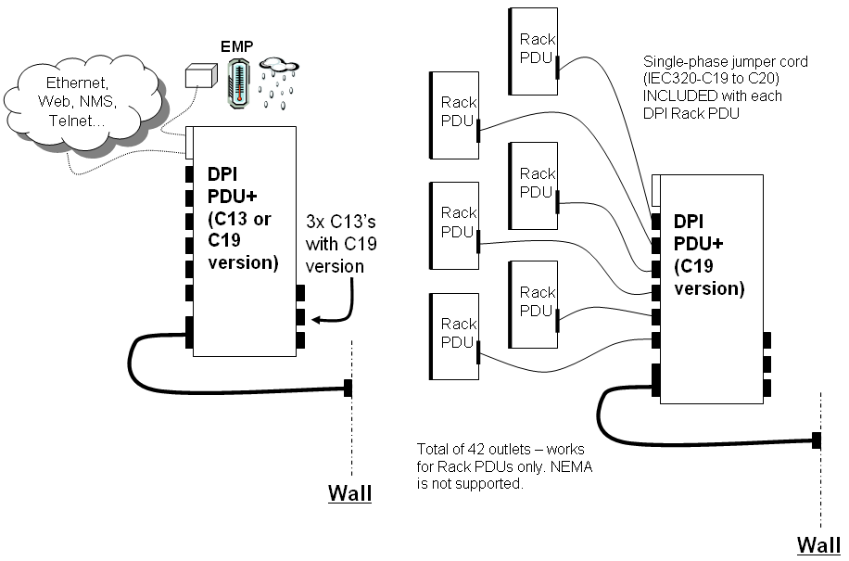

DPI Enterprise PDUs  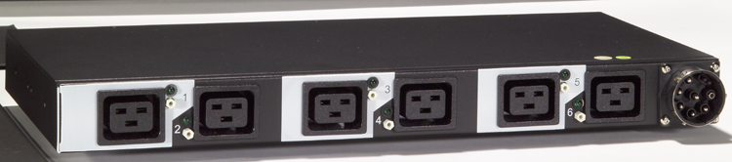  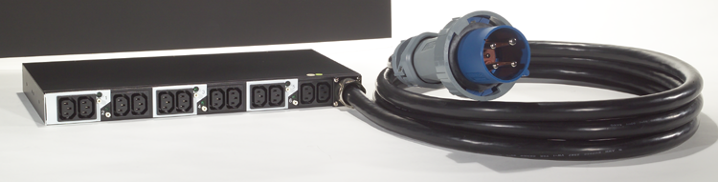 | DPI Enterprise PDU  Two Models Available: Twelve C13 or Six C19 Outlets  Features common to both models:  - Power cord connection, breakers and outlets all on the same side of PDU for easy access  - 1U full rack width  - Includes hardware to mount in either EIA space of side pocket of rack  - Available in single or three phase models  - Available in either 30/32A or 60/63A versions  Twelve C13 Models  - Built with twelve C13 outlets rated at 10A each  - Push button breaker for each pair of outlets  Six C19 Models  - Built with six C19 outlets rated at 16A each  - Push button breaker for each outlet  - Can be used as either a front End PDU or directly connected to servers  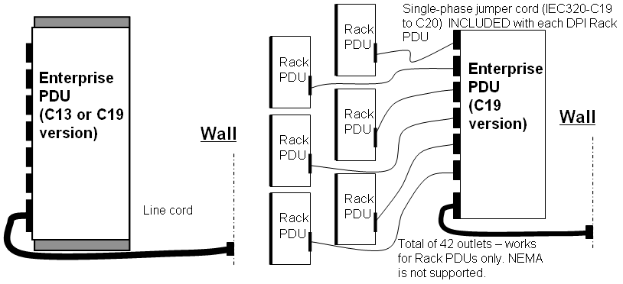

DPI High Density PDUs  Front view  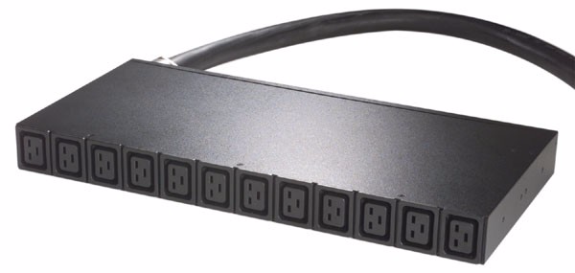 | DPI High Density PDU  Twelve C19 outlet PDU available in 32A/60A 3-phase or 60/63A 1-phase models  Built with twelve (12) IEC C19 outlets (same as the Front End PDUs)  Each outlet is rated to support up to 16A  Fixed 4.3M line cords  Hardware allows mounting in EIA space or in side pockets  Push button breaker on each outlet for protection  Brackets for vertical and sidewall rack mounting  Cable retention aids  1U full rack width  Three phase units  Available in North American version as a 60A unit with IEC309 3P+G style connector  North American version can deliver up to 27A per phase (derated)  Available in World Trade (International) as a 32A unit with IEC 3P+N+G style connector  World Trade version can deliver up to 32A per phase
Rear view  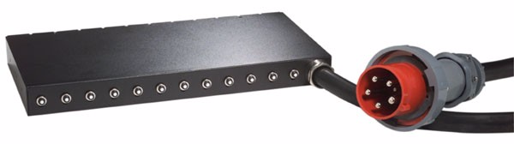 | Single phase units  Available in North American version as a 60A unit with IEC309 2P+G style connector  North American version can deliver up to 48A (derated)  Available in World Trade (International) as a 63A unit with IEC P+N+G style connector  World Trade version can deliver up to 63A  Note: This PDU can be used directly attached to servers or as a front end to the DPI Universal Rack PDUs. See diagram below.  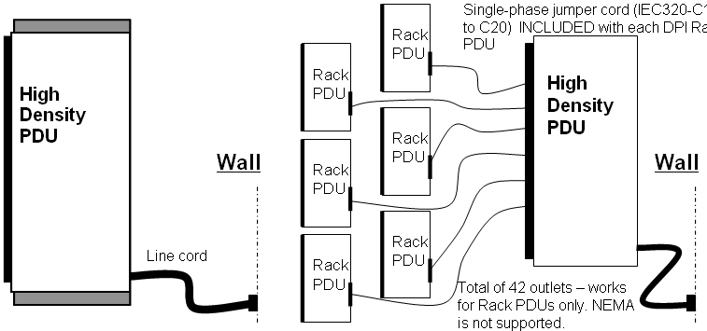
DPI Front-end PDU  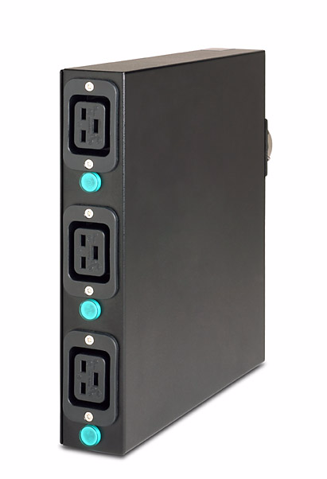  Front view of DPI Front-end PDU  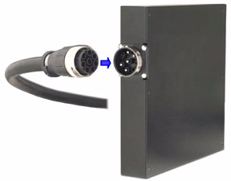  Rear view of DPI Front-end PDU, showing pin-out connector on the PDU and line cord. Customers can easily detach or attach the high amperage line cord. | DPI Single-phase Front-end PDU  One unit supports both 30/32amp and 60/63amp power supply  DPI Single-phase Front-end PDUs provide a front-end wiring box to allow connection of multiple DPI Universal Rack models to higher-current single-phase circuits. These modular, front-end PDUs provide three single-phase output circuits from one single-phase (100V-240V at 30amp or 200V-240V at 60amp) input circuit. Features include:  Adapts to high-current circuits (three-wire, single-phase)  100V-240V at 30/32amp, supports up to 3000W at 100V or up to 7200W at 240V  200V-240V at 60/63amp, supports up to 9000W at 200V or up to 10,800W at 240V  Three single-phase output circuits with three IEC 320-C19 receptacles (for connection to PDUs and blades)  Non-replaceable fuse for protection  Brackets for vertical (sidewall) rack mounting only  Power on LED indicator on each load segment  Mount in rack side walls, or on the EIA space. PDU is half-rack width, so you can mount two in a single 1U space  A DPI Front-end PDU with 60(63)amp line cord is an ideal choice for rack optimized servers and IBM eServer BladeCenter™. This high- amperage product offering is designed to make it easier for customers to support large installations of virtually any server, helping to reduce the number of line cords and helping reduce electrical power infrastructure needed to feed the rack.  One of the hot new features of the DPI family is the scalability of power support. The same DPI Front-end PDU unit can be used at 30amps to 63amps, depending on the line cord you choose. This provides an excellent way to grow your solution as needs change or to size the right solution for even the most power-hungry setups.  How do the line cords work?  The photograph (left) shows the rear of the PDU equipped with a special pin-out connector. This connector enables you to attach one of several different line cords to the unit. Depending on the line cord, the DPI Front-end PDU can be either 30(32)amp or 60(63)amp, which may offer enhanced investment protection to help prepare the way for future growth.  For example, a customer in the US can migrate from low voltage 30amp to high voltage 30amp to high voltage 60amp via only a line cord change. Or, a customer in the UK could migrate from 32amp 250V to a 63amp 250V. The intended result is great investment protection and solution flexibility.  DPI Front-end PDU configuration  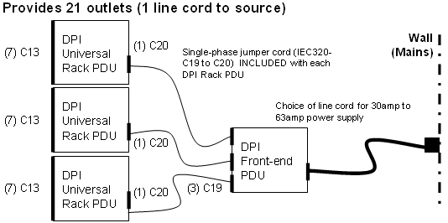

DPI NEMA  100-127V  Rack PDU  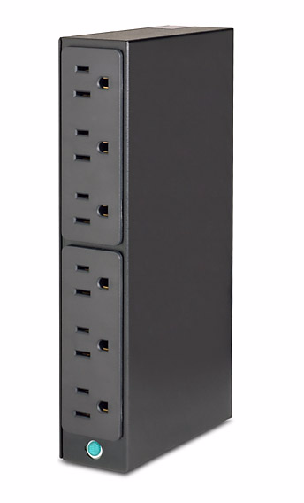 | This PDU provides an economical, basic power distribution capability for rack-based systems, helping to enable you to satisfy the power requirements of your devices. It has one low-voltage power input and supports up to six devices with a combined power requirement of up to 1200W at 100V through 1524W at 127V. This 1U PDU is half-rack width, so you can mount two in a single 1U space for a total of 12 outlets.  This PDU is primarily used in North America, Japan, Taiwan, the Philippines and various other nations that have power systems that work at 100V-127V. Features include:  Low voltage (100V-127V)  Brackets for vertical (sidewall) and horizontal (EIA space) rack mounting  Two-pole 15-amp circuit breaker with time-delay protection  Six NEMA 5-15 power outlets  Fixed L5-15 line cord  Cable retention aids  Although very similar to the IEC-based DPI Universal Rack PDU, this NEMA model does not provide the same flexibility and scalability of configurations. Unlike the rest of the IBM PDU product line, this unit is designed to be used on its own, not in combination with front-end PDU units. Simply plug it into the wall and power up as many as six devices. Because this PDU shares the same form factor as the DPI Universal Rack PDU, it can be mounted on the same hardware—a great benefit for customers who require both NEMA and IEC outlets in the same rack.
DPI Universal  Rack PDU  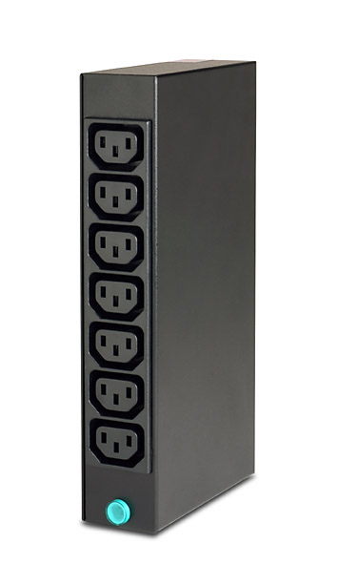 | This PDU provides an economical, basic power distribution capability for rack-based systems, helping to enable you to satisfy the power requirements of each device without overtaxing your power source. It has one universal-voltage power input and supports up to seven devices with a combined power requirement of 1500W at 100Vac to 3600W at 240Vac (based on AC input volts). Features include:  - Universal voltage (100-240Vac, 50-60Hz)  - Mount in rack side walls, or on the EIA space. PDU is half-rack width, so you can mount two in a single 1U space  - Two-pole 15-amp circuit breaker with time-delay protection  - Seven IEC 320-C13 power outlets (for connection to devices)  - One IEC 320-C20 power inlet (for connection to wall or to front-end PDU)  - Single LED power on indicator  - Cable management brackets included with PDU to help neatly and securely run cabling  This unit is designed to be used one of three ways: plugged into an appropriate wall outlet, used in conjunction with the innovative DPI Front-end PDU; or, used in conjunction with the new IBM UPS 3000 HV. Below is a graphical overview of the three ways to use the DPI Rack PDUs:  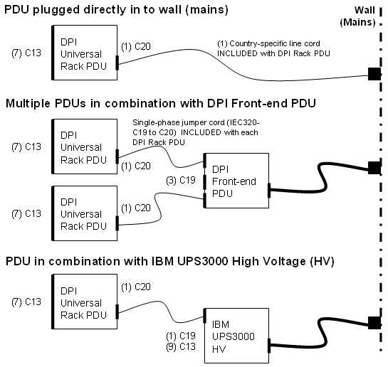

IEC versus NEMA standard | Why we believe IEC is the best outlet choice for your rack systems  For many customers, there is no choice: IEC 320 C13-based PDUs are the accepted standard for internal rack power outlets for the vast majority of the countries around the world. But for customers in North America, Japan, Taiwan, the Philippines, Saudi Arabia and various other nations, the NEMA standard is an available alternative.  The NEMA outlets on our DPI 100-127V Rack PDU are the same size and shape as many wall outlets where 100-127V power systems are used (NEMA 5-15R). The larger size of the NEMA outlet means that fewer outlets can be incorporated into the same "real estate" on a piece of electronic equipment. As a result, products with NEMA outlets typically are less dense and not as flexible as products designed with IEC outlets.  The C13 outlet has been adopted throughout the world as the choice for internal rack power. Unlike country-specific outlets, the IEC C13 outlet extends beyond country borders and across various types of power distribution, from 100V all the way to 240V. Many of the benefits engineered into the IBM line of modular PDU products originate from the higher-density, smaller-sized IEC outlets. These benefits, which we believe make IEC-based PDU products the best choice for internal-rack power distribution, include:  - Universal support for both low voltage (100V-127V) and high voltage (200V-240V) input in a single product, helping to provide enhanced flexibility and investment protection  - Optimizing device support in a small space, helping to conserve valuable rack real estate.  Going forward, IEC is the platform that IBM intends to support for innovation because it enables us to focus resources on a product line that can virtually be used worldwide.
   | Rack PDU (IEC) | 100-127V PDU (NEMA)
  Can be used with DPI Front-end PDUs to reduce cord clutter? | YES | NO
  Maximum number of outlets in full 1U rack width | 14 (2 PDUs) | 12 (2 PDUs)
  Able to adapt to high voltage inputs? | YES | NO
  Accepted virtually worldwide for internal rack distribution systems? | YES | NO
  Rating of the PDU | 15 amp | 12 amp

 | The benefits of IBM DPI PDUs
Customer requirements | Keeping today’s enterprise up and running is a top priority for IT managers. Server downtime originates from many sources but often it is due to unexpected power problems stemming from natural disasters, faulty electrical systems, poor quality power or an accidental cutting of electrical lines. At the same time, the power requirements of ever more powerful computing equipment continues to grow. With rack-dense solutions allowing companies to fit an old data center's worth of computing horsepower into the space of a small wiring closet IT managers can find it difficult to keep the electricity flowing.  To meet new high-availability requirements, a fault-tolerant system design must address power management. Desired solution components include:  - PDUs to help assure that the combined line-cord requirement of all rack-mounted equipment is met  - Redundant configurations that provide power from separate sources to enable fail over capability  - In unprotected data center environments, combining PDUs with uninterruptible power supply (UPS) products for even greater levels of reliability in the event of a power failure.  In addition, power fault tolerance solutions should address requirements for:  - Preserving valuable “U” space in a rack that quickly fills up with network-critical equipment  - Easy serviceability, high reliability, and high availability  - Scalable and flexible systems that can grow with changing network demands.  The use of IBM DP Interconnect PDUs alone may not solve all the issues with power that customers are facing today. Many problems such as power surges, brownouts, under-voltage and the like can only be protected against by the use of the right UPS products. IBM offers a complete suite of power-protecting UPS products. For detailed information on these products and how to choose the right one for your application, download the IBM Decision Maker's Guide to Selecting the Right UPS from: http://www-1.ibm.com/servers/eserver/xseries/storage/rack.html. This guide includes information on the IBM UPS solutions- an ideal addition to any midrange solution of System x servers and storage.
Key messages | - LINE CORD CONSOLIDATION: Innovative, modular design is designed to reduce the number of line cords leaving the rack, while increasing the possible total outlet count possible in the rack.  - CUSTOMER-FRIENDLY DESIGN: Equipped with customer-attachable rather than hardwired line cords, IBM DPI PDUs may help you save money. This design approach helps eliminate terminal blocks and the expensive electrician visits required for their installation. Instead, to power up these PDUs you just plug them into an appropriate outlet.  - SERVER-LEVEL PROTECTION: Designed for IBM servers. Unlike the PDUs one might find at local retailers or available from third parties, IBM PDUs are designed for protecting expensive and sensitive IT equipment. DPI PDUs help provide protection against overload and surge for the large loads required on today’s servers.  - DESIGNED FOR THE RACK ENVIRONMENT: These products are designed to be used in the space-constrained environment of a server rack. Unlike many other PDU products that support higher power levels, our 1U designs allow placement of multiple PDUs in the rack side panels, helping to preserve the maximum amount of “U” space.  - GREATER AVAILABILITY: DPI products can be configured to provide redundant power distribution, thus eliminating a single point of failure and helping to increase data availability.  - FASTER INSTALLATION: Now, you may significantly speed solution setup by deploying IBM PDUs in combination with IBM racks. We design our PDUs with IBM racks in mind. When you combine IBM racks and IBM power, you get simple, quick, stable and thoughtful solutions. Add these benefits to the ability to pre-wire a location for these "connectorized" PDUs and you can help eliminate the waiting period that is so common after your equipment arrives, but before the electricians finish their work.  - SUPERIOR SCALABILITY: The modularity of the IBM PDUs make it easy to support virtually any configuration, from a handful of servers to an entire rack. For example, you can place up to 84 outlets in a single IBM Enterprise Rack—without sacrificing a single “U” of space.  - CUSTOMER CHOICE: No matter the type of input power DPI PDUs have versions that are designed to accommodate 20A, 30A, 32A, 60A, or 63A single phase; or, 32A, 60A three phase.  - INTELLIGENT POWER MANAGEMENT: New IBM DPI PDU+ models feature advanced monitoring capabilities including monitored power draw at the breaker level, remote access to the monitoring data and temperature and humidity values from the bundled Environmental Monitoring Probe.  - SERVICE BENEFITS: Buying DPI products and placing them in an IBM rack may mean enhanced protection and service benefits to the customer. An IBM PDU placed in an IBM rack receives the same level of service as the rack itself. The standard protection for IBM racks is a three-year on-site limited warranty. Add a service pack or warranty uplift to the rack, and you gain the same extended coverage for your PDUs as well. This is a great way to consolidate services and help protect your investment.

Selection questions: Helping ensure that you get the right product
  Selection questions | Rationale for asking
  Do you currently have the infrastructure in place to run multiple line cords to the rack? | If not, the modular design of IBM DP Interconnect PDUs may help you avoid having to run new lines, which could be a huge cost savings for customers adding a new rack or adding to their existing solution.
  Are you paying an electrician to hardwire your current PDUs? | This can be one of the most substantial expenses involved with server set up. DPI products with customer- friendly line cords and connectors may help you do away with much of this cost.
  Do you anticipate adding new servers to your environment? | IBM DPI solutions scale easily to accommodate growing rack configurations. Customers can start with a single Universal Rack PDU, and add more Universal Rack PDUs, Front-end PDUs or Enterprise PDUs as needs grow.  The DPI family's scalability of power support also helps growing customers quickly modify their power systems to add newer, more powerful servers with very little effort.
  Is your business-critical data adequately protected in the event of a power outage? How much downtime can your business tolerate until systems can be brought back online? | DPI PDUs can be configured to provide redundant power distribution. Plus, these units can be used in combination with select rack-mountable UPS products from IBM to provide an advanced fault-tolerant power distribution system.
  If you are considering third-party PDUs, are you sure they will provide protection against catastrophic faults? | Many third-party PDUs were not designed for the IT environment. Rather, they are intended to protect motors or other industrial equipment, which may not be as sensitive as the electronics equipment that IBM PDUs are designed to safeguard.
  Is your solution likely to be shipped configured in the rack? | DP Interconnect PDUs have been designed and tested to withstand the rigors of configured shipment in the rack. Many alternative products have plastic components that may not survive transit outside their carefully packaged boxes.

Product specifications

This section details the PDU models used in the North Americas marketplace. Countries where this standard is common are: United States, Canada, Japan, Saudi Arabia, Taiwan, Philippines. It is common in these countries to see power rated at 100-127V or 200-208V.

Americas PDU+ Models
Model | DPI C13 PDU+ | DPI C19 PDU+ | DPI C19 three-phase PDU+
Part number | 39M2816 | 39M2818 | 39M2819
Form factor | Units are 1U high, full-rack width, and can be mounted in EIA space of side panel
Description | 200-240V output, with twelve (12) IEC320-C13 outlets | 200-240V output, with six (6) IEC320-C19 and three (3) C13 outlets | 200-208V output, with six (6) IEC320-C19 and three (3) IEC320-C13 outlets
Capacity | Line Cord Input VAC Capacity  40K9611 380V 21120W  40K9611 400V 22080W  40K9611 415V 23040W  40K9612 220V 7040W  40K9612 230V 7360W  40K9612 240V 7680W  40K9613 220V 13860W  40K9613 230V 14490W  40K9613 240V 15120W  40K9614 208V 4992W  40K9615 208V 9984W  40K9617 230V 7360W  40K9618 220V 6600W | Line Cord Input VAC Capacity  40K9611 380V 21120W  40K9611 400V 22080W  40K9611 415V 23040W  40K9612 220V 7040W  40K9612 230V 7360W  40K9612 240V 7680W  40K9613 220V 13860W  40K9613 230V 14490W  40K9613 240V 15120W  40K9614 208V 4992W  40K9615 208V 9984W  40K9617 230V 7360W  40K9618 220V 6600W | Up to 17313W @ 208V
Line cord | Detachable line cord 2.5m, varies:  Line Cord Description  40K9611 IEC309 (3P+N+G) 32A  40K9612 IEC309 (P+N+G) 32A  40K9613 IEC309 (P+N+G) 63A  40K9614 NEMEA L6-30P  40K9615 IEC309 (2P+G) 60A  40K9617 AS/NZS 3112 32A  40K9618 KSC 8305 30A | Detachable line cord 2.5m, varies:  Line Cord Description  40K9611 IEC309 (3P+N+G) 32A  40K9612 IEC309 (P+N+G) 32A  40K9613 IEC309 (P+N+G) 63A  40K9614 NEMEA L6-30P  40K9615 IEC309 (2P+G) 60A  40K9617 AS/NZS 3112 32A  40K9618 KSC 8305 30A | Fixed line cord, IEC 309 3P+G 60amp connector (4.3m)
Power source | Dependent on line cord used: 208 -240Vac, single-phase 50/60Hz or 380-415Vac three-phase wye 50Hz | Dependent on line cord used: 208 -240Vac, single-phase 50/60Hz or 380-415Vac three-phase wye 50Hz | 200-208Vac, three-phase delta, 50/60Hz
Mounting option | Hardware included for both EIA mounting and side pocket mounting; both installations are approved for reconfigured shipment in an IBM rack
Protection | 20 amp push button circuit breaker/pair outlets | 20 amp push button circuit breaker/outlet/pair (C19+C13) | 20 amp push button circuit breaker/outlet/pair (C19+C13)
Dimensions | 41.5x450x350mm  1.70x17.7x13.5” | 41.5x450x350mm  1.70x17.7x13.5” | 41.5x450x350mm  1.70x17.7x13.5”
Warranty | Three-year limited onsite warranty when installed in an IBM Rack

Americas Enterprise PDU Models
Model | DPI C13 Enterprise PDU | DPI C19 Enterprise PDU | DPI C19 three-phase Enterprise PDU
Part number | 39Y8941 | 39Y8948 | 39Y8923
Form factor | Units are 1U high, full-rack width, and can be mounted in EIA space of side panel
Description | 200-240V output, with twelve (12) IEC320-C13 outlets | 200-240V output, with six (6) IEC320-C19 outlets | 200-208V output, with six (6) IEC320-C19 outlets
Capacity | Line Cord Input VAC Capacity  40K9611 380V 21120W  40K9611 400V 22080W  40K9611 415V 23040W  40K9612 220V 7040W  40K9612 230V 7360W  40K9612 240V 7680W  40K9613 220V 13860W  40K9613 230V 14490W  40K9613 240V 15120W  40K9614 208V 4992W  40K9615 208V 9984W  40K9617 230V 7360W  40K9618 220V 6600W | Line Cord Input VAC Capacity  40K9611 380V 21120W  40K9611 400V 22080W  40K9611 415V 23040W  40K9612 220V 7040W  40K9612 230V 7360W  40K9612 240V 7680W  40K9613 220V 13860W  40K9613 230V 14490W  40K9613 240V 15120W  40K9614 208V 4992W  40K9615 208V 9984W  40K9617 230V 7360W  40K9618 220V 6600W | Up to 17313W @ 208V
Line cord | Detachable line cord 2.5m, varies:  Line Cord Description  40K9611 IEC309 (3P+N+G) 32A  40K9612 IEC309 (P+N+G) 32A  40K9613 IEC309 (P+N+G) 63A  40K9614 NEMEA L6-30P  40K9615 IEC309 (2P+G) 60A  40K9617 AS/NZS 3112 32A  40K9618 KSC 8305 30A | Detachable line cord 2.5m, varies:  Line Cord Description  40K9611 IEC309 (3P+N+G) 32A  40K9612 IEC309 (P+N+G) 32A  40K9613 IEC309 (P+N+G) 63A  40K9614 NEMEA L6-30P  40K9615 IEC309 (2P+G) 60A  40K9617 AS/NZS 3112 32A  40K9618 KSC 8305 30A | Fixed line cord, IEC 309 3P+G 60amp, connector (4.3m)
Power source | Dependant on line cord used: 208 -240Vac, single-phase 50/60Hz or 380-415Vac three-phase wye 50Hz |  | 200-208Vac, three-phase delta, 50/60Hz
Mounting option | Hardware included for both EIA mounting and side pocket mounting; both installations are approved for reconfigured shipment in an IBM rack
Protection | 20 amp push button circuit breaker/pair outlets | 20 amp push button circuit breaker/outlet | 20 amp push button circuit breaker/outlet
Dimensions | 41.5x450x213mm  1.70x17.7x8.4” | 41.5x450x213mm  1.70x17.7x8.4” | 41.5x450x213mm  1.70x17.7x8.4”
Warranty | Three-year limited onsite warranty when installed in an IBM Rack

Americas High-Density PDU Model
Model | DPI High-Density 60A Three Phase
Part number | 73P5847
Form factor | Units are 1U high, full-rack width, and can be mounted in EIA space of side panel
Description | 200-208V output, with twelve (12) IEC320-C19 outlets
Capacity | Up to 17097W @ 208V
Line cord | Fixed line cord, IEC 309 3P+G connector (4.3m)
Power source | 200-208Vac, three-phase delta 50/60Hz
Mounting option | Hardware included for both EIA mounting and side pocket mounting; both installations are approved for reconfigured shipment in an IBM rack
Protection | 15amp push button circuit breaker/outlet
Dimensions | 41.5x450x213mm  1.70x17.7x8.4”
Warranty | Three-year limited onsite warranty when installed in an IBM Rack

Americas Front-End PDU Models
Model | DPI 30amp/125V Front-end  PDU with NEMA L5-30 line cord | DPI 30amp/250V Front-End PDU with NEMA L6-30 line cord | DPI 60amp/250V Front-end PDU with IEC 309 2P+G line cord
Part number | 39Y8938 | 39Y8939 | 39Y8940
Form factor | Units are 1U high, half-rack width, and can be mounted alone or in combination
Description | 110-127V output, with three (3) IEC320-C19 outlets | 208V output, with three (3) IEC320-C19 outlets
Capacity  Low Voltage  High Voltage | Up to 3048W @ 127V  N/A | N/A  Up to 4992W @ 208V | N/A  Up to 9360W @ 208V
Line cord | NEMA L5-30 (2.5m) | NEMA L6-30 (2.5m) | IEC 309 60amp 2P+G (2.5m)
Power source | 30amp, 100-127Vac, single-phase 50/60 Hz | 30amp, 200-208Vac, single-phase 50/60 Hz | 60amp, 200-208Vac, single-phase 50/60 Hz
Mounting option | Units come with side wall mounting hardware only; however, FE PDUs can be mounted in the EIA space using the rack PDU hardware. Front-end PDUs only support reconfigured shipment in side panel.
Protection | Non-replaceable fuse included with each outlet circuit for protection
Dimensions | 41.5x225.5x222.5mm  1.63x8.76x8.76" | 41.5x225.5x222.5mm  1.63x8.76x8.76" | 41.5x225.5x222.5mm  1.63x8.76x8.76"
Warranty | Three-year limited onsite warranty when installed in an IBM Rack

Americas Rack PDU Models
Model | DPI 100-127V Rack PDU | DPI Universal Rack PDU
Part number | 39Y8905 with fixed NEMA L5-15 line cord | 39Y8951 - US line cords (NEMA L5-20 and L6-20)  39Y8960 - Brazil line cord (NBR 6147)  39Y8962 - Argentina line cord (IRAM 2073)
Form factor | Units are 1U high, half-rack width, and can be mounted alone or in combination.
Description | 100-127V output, with six (6) NEMA 5-15 outlets | 100-240V output, with seven (7) IEC320-C13 outlets
Capacity  Low Voltage  High Voltage | Up to 1524W @ 127V  N/A | Up to 1905W @ 127V  Up to 3120W @ 208V
Input | Fixed line cord, NEMA L5-15 connector  (2.5m) | IEC 320 C20 input connector with (1) IEC320-C19 to C20 rack line cord, along with 4.3m country-specific line cord (see above)
Power source | 100-127Vac, single-phase 50/60Hz | 100-240Vac, single-phase 50/60Hz depending on line cord selected
Mounting option | Hardware included for both EIA mounting and side pocket mounting; both installations are approved for reconfigured shipment in an IBM rack
Protection | 15amp dual pole circuit breaker | 15amp dual pole circuit breaker
Dimensions | 41.50x225.5x114.5mm  1.63x8.76x4.51" | 41.50x222.5x114.5mm  1.63x8.76x4.51"
Warranty | Three-year limited onsite warranty when installed in an IBM Rack

This section details the PDU models used in the World Trade marketplace. This standard covers most of the rest of the world. It is common in these environments to see power listed as 220-240V.

EMEA and Asia Pacific PDU+ Models
Model | DPI C13 PDU+ | DPI C19 PDU+
Part number | 39M2816 | 39M2818
Form factor | Units are 1U high, full-rack width, and can be mounted in EIA space of side panel
Description | 200-240V output, with twelve (12) IEC320-C13 outlets | 200-240V output, with six (6) IEC320-C19 and three (3) C13 outlets
Capacity | Line Cord Input VAC Capacity  40K9611 380V 21120W  40K9611 400V 22080W  40K9611 415V 23040W  40K9612 220V 7040W  40K9612 230V 7360W  40K9612 240V 7680W  40K9613 220V 13860W  40K9613 230V 14490W  40K9613 240V 15120W  40K9617 230V 7360W  40K9618 220V 6600W | Line Cord Input VAC Capacity  40K9611 380V 21120W  40K9611 400V 22080W  40K9611 415V 23040W  40K9612 220V 7040W  40K9612 230V 7360W  40K9612 240V 7680W  40K9613 220V 13860W  40K9613 230V 14490W  40K9613 240V 15120W  40K9617 230V 7360W  40K9618 220V 6600W
Line cord | Detachable line cord 2.5m, varies:  Line Cord Description  40K9611 IEC309 (3P+N+G) 32A  40K9612 IEC309 (P+N+G) 32A  40K9613 IEC309 (P+N+G) 63A  40K9617 AS/NZS 3112 32A  40K9618 KSC 8305 30A | Detachable line cord 2.5m, varies:  Line Cord Description  40K9611 IEC309 (3P+N+G) 32A  40K9612 IEC309 (P+N+G) 32A  40K9613 IEC309 (P+N+G) 63A  40K9617 AS/NZS 3112 32A  40K9618 KSC 8305 30A
Power source | Dependent on line cord used: 208 -240Vac, single-phase 50/60Hz or 380-415Vac three-phase wye 50Hz | Dependent on line cord used: 208 -240Vac, single-phase 50/60Hz or 380-415Vac three-phase wye 50Hz
Mounting option | Hardware included for both EIA mounting and side pocket mounting; both installations are approved for reconfigured shipment in an IBM rack
Protection | 20 amp push button circuit breaker/pair outlets | 20 amp push button circuit breaker/outlet/pair (C19+C13)
Dimensions | 41.5x450x350mm, 1.70x17.7x13.5”
Warranty | Three-year limited onsite warranty when installed in an IBM Rack

EMEA and Asia Pacific Enterprise PDU Models
Model | DPI C13 Enterprise PDU | DPI C19 Enterprise PDU
Part number | 39Y8941 | 39Y8948
Form factor | Units are 1U high, full-rack width, and can be mounted in EIA space of side panel
Description | 200-240V output, with twelve (12) IEC320-C13 outlets | 200-240V output, with six (6) IEC320-C19 outlets
Capacity | Line Cord Input VAC Capacity  40K9611 380V 21120W  40K9611 400V 22080W  40K9611 415V 23040W  40K9612 220V 7040W  40K9612 230V 7360W  40K9612 240V 7680W  40K9613 220V 13860W  40K9613 230V 14490W  40K9613 240V 15120W  40K9617 230V 7360W  40K9618 220V 6600W | Line Cord Input VAC Capacity  40K9611 380V 21120W  40K9611 400V 22080W  40K9611 415V 23040W  40K9612 220V 7040W  40K9612 230V 7360W  40K9612 240V 7680W  40K9613 220V 13860W  40K9613 230V 14490W  40K9613 240V 15120W  40K9617 230V 7360W  40K9618 220V 6600W
Line cord | Detachable line cord 2.5m, varies:  Line Cord Description  40K9611 IEC309 (3P+N+G) 32A  40K9612 IEC309 (P+N+G) 32A  40K9613 IEC309 (P+N+G) 63A  40K9617 AS/NZS 3112 32A  40K9618 KSC 8305 30A | Detachable line cord 2.5m, varies:  Line Cord Description  40K9611 IEC309 (3P+N+G) 32A  40K9612 IEC309 (P+N+G) 32A  40K9613 IEC309 (P+N+G) 63A  40K9617 AS/NZS 3112 32A  40K9618 KSC 8305 30A
Power source | Dependant on line cord used: 208 -240Vac, single-phase 50/60Hz or 380-415Vac three-phase wye 50Hz
Mounting option | Hardware included for both EIA mounting and side pocket mounting; both installations are approved for reconfigured shipment in an IBM rack
Protection | 20 amp push button circuit breaker/pair outlets | 20 amp push button circuit breaker/outlet
Dimensions | 41.5x450x213mm, 1.70x17.7x8.4”
Warranty | Three-year limited onsite warranty when installed in an IBM Rack

EMEA and Asia Pacific High-Density PDU Model
Model | DPI High-Density 32A Three Phase
Part number | 39Y8999
Form factor | Unit is 1U high, full-rack width, and can be mounted in EIA space of side panel
Description | 200-240V output with twelve (12) IEC320-C19 outlets
Capacity | Up to 22080W @ 230V
Line cord | Fixed line cord, IEC 309 3P+N+G connector (4.3m)
Power source | 380-415Vac, three-phase wye 50/60Hz input
Mounting option | Hardware included for both EIA mounting and side pocket mounting; both installations are approved for reconfigured shipment in an IBM rack
Protection | 15amp push button circuit breaker/outlet
Dimensions | 41.5x450x213mm  1.70x17.7x8.4”
Warranty | Three-year limited onsite warranty when installed in an IBM Rack

EMEA and Asia Pacific Front-End PDU Models
Model | DPI 32amp/250V  Front-end PDU with IEC  309 P+N+G | DPI 63amp/250V Front-end PDU with IEC 309  P+N+G | DPI 30amp/250V Front-end PDU with KSC 8305 | DPI 32amp/250V Front-end PDU with AS/NZS 3112
Part number | 39Y8934 | 39Y8935 | 39Y8936 | 39Y8937
Form factor | Units are 1U high, half-rack width, and can be mounted alone or in combination.
Description | 200-240V with three (3) IEC320-C19 outlets
Capacity  220V  240V | Up to 7,040W  Up to 7,680W | Up to 9,900W  Up to 10,800W | Up to 6,600W  N/A | N/A  Up to 7360W
Line cord | IEC 309 32amp P+N+G (2.5m) | IEC 309 63amp P+N+G (2.5m) | KSC 8305 30amp P+N+G  (2.5m) | AS/NZS 3112 32amp P+N+G (2.5m)
Power source | 32amp 220-240Vac, single-phase 50/60Hz | 63amp 220-240Vac, single-phase 50/60Hz | 30amp 220-240Vac, single-phase 50/60Hz | 32amp 220-240Vac, single-phase 50/60Hz
Mounting option | Included hardware supports side wall mounting. Units can also be mounted on EIA mounting bracket included with Rack PDU. Configured shipment supported in rack side panel only.
Protection | Non-replaceable fuse included with each outlet circuit for protection
Dimensions | 41.50x225.5x225mm  1.63x8.76x8.76"
Warranty | Three-year limited onsite warranty when installed in an IBM Rack

EMEA and Asia Pacific Rack PDU Models
Model | DPI Universal Rack PDU
Part number | 39Y8952 - Europe (CEE7-VII)  39Y8953 - Denmark (IEC309 P+N+Gnd) 16A  39Y8954 - Israel (SI 32)  39Y8955 - Italy (CEI 23-16)  39Y8956 - South Africa (SABS 164)  39Y8957 - United Kingdom (BS 1363/A)  39Y8958 - Australia/ New Zealand (AS/NZ 3112)  39Y8959 - China (BG 2099.1)  39Y8961 - India (IS6538)
Form factor | Units are 1U high, half-rack width, and can be mounted alone or in combination.
Description | 200-240V output, with seven (7) IEC320-C13 outlets
Capacity  220V  240V | Up to 3,300W  Up to 3,600W
Line cord | IEC 320 C20 input connector with (1) IEC320-C19 to C20 rack line cord, along with 4.3m country-specific line cord (see above)
Power source | 220-240Vac, single-phase 50/60Hz
Mounting option | Included hardware supports EIA and side pocket mounting. Supports configured shipment in an IBM Rack.
Protection | 15amp dual pole circuit breaker
Dimensions | 41.50x225.5x114.5mm  1.63x8.76x4.51"
Warranty | Three-year limited onsite warranty when installed in an IBM Rack

Line cord description reference

IBM DPI NEMA and Rack PDU Line Cord Description Reference
Part Number | Description | Line Cord | Availability by Country
39Y8905 | DPI NEMA 100-127V PDU with Fixed NEMA L5-15P line cord | Fixed-line NEMA L5-15P | US, Canada,  Mexico, Japan,  Taiwan, Philippines  in EMEA and most of AP
39Y8951 | DPI Universal Rack PDU with NEMA L5-20P & L6-20P US line cords | IEC C19 to NEMA L5-20 and IEC C19 to NEMA L6-20 | US, Canada,  Mexico, Japan, Taiwan, Philippines, Saudi
39Y8952 | DPI Universal Rack PDU with  CEE7-VII Europe line cord | IEC C19 to CEE7-VII | Europe
39Y8953 | DPI Universal Rack PDU with  IEC 309 16A P+N+G Denmark line cord | IEC C19 to IEC 309 16amp P+N+G | Denmark, Switzerland
39Y8954 | DPI Universal Rack PDU with  SI 32 Israel line cord | IEC C19 to SI 32 | Israel
39Y8955 | DPI Universal Rack PDU with  CEI 23-16 Italy line cord | IEC C19 to CEI 23-16 | Italy
39Y8956 | DPI Universal Rack PDU with  SABS 164 South Africa line cord | IEC C19 to SABS 164 | South Africa
39Y8957 | DPI Universal Rack PDU with  BS 1363/A UK line cord | IEC C19 to BS 1363/A | UK, Hong Kong
39Y8958 | DPI Universal Rack PDU with  AS/NZ 3112 Australia/NZ line cord | IEC C19 to AS/NZ 3112 | Australia, New Zealand
39Y8959 | DPI Universal Rack PDU with  GB 2099.1 China line cord | IEC C19 to GB 2099.1 | China
39Y8960 | DPI Universal Rack PDU with  NBR 6147 Brazil line cord | IEC C19 to NBR 6147 | Brazil
39Y8961 | DPI Universal Rack PDU with  IS6538 India line cord | IEC C19 to IS6538 | India
39Y8962 | DPI Universal Rack PDU with  IRAM 2073 Argentina line cord | IEC C19 to IRAM 2073 | Argentina, Uruguay, Paraguay

IBM DPI Front-End PDU Line Cord Description Reference
Part Number | Description | Line Cord | Availability by Country
39Y8938 | DPI 30amp Front-end PDU with  NEMA L5-30P (127V) Americas line cord | Burndy to NEMA 30A L5-30P (127V) | US, Canada, Mexico, Japan,  Taiwan, Philippines
39Y8934 | DPI 32amp Front-end PDU with  IEC 309 32A P+N+G (250V) EMEA line cord | Burndy to IEC 309 32A P+N+G (250V) | All of EMEA, all HV AP
39Y8935 | DPI 63amp Front-end PDU with  IEC 309 63A P+N+G (250V) EMEA line cord | Burndy to IEC 309 63A P+N+G (250V) | All of EMEA, all HV AP
39Y8939 | DPI 30amp Front-end PDU with  NEMA 30A L6-30P (208V) line cord | Burndy to NEMA 30A L6-30P (208V) | US, Canada, Mexico, Japan,  Taiwan, Philippines
39Y8940 | DPI 60amp Front-end PDU with  IEC 309 60A 2P+Gnd (250V) line cord | Burndy to IEC 309 60A 2P+Gnd (250V) | US, Canada, Mexico, Japan,  Taiwan, Philippines
39Y8936 | DPI 32amp Front-end PDU with  AS/NZS 3112 (250V) line cord | Burndy to AS/NZS 3112 32A | Australia, New Zealand
39Y8937 | DPI 30amp Front-end PDU with  KSC 8305 S. Korea line cord | Burndy to KSC 8305 30A | South Korea

IBM DPI High-Density PDU Line Cord Description Reference
Part Number | Description | Line Cord | Availability by Country
39Y8999 | DPI High-Density 32A three-phase wye PDU with IEC320 C19 outlets | Fixed line cord. IEC309 32A 3P+N+G | All of EMEA, all HV Asia Pacific
73P5847 | DPI High-Density 60A three phase delta PDU with IEC320 C19 outlets | Fixed line cord. IEC309 3P+G | US, Canada,  Mexico, Japan,  Taiwan, Philippines

Product diagrams

This section provides visual aids (product diagrams) for IBM DPI PDU models.

IBM DPI+ C13 PDU IBM DPI+ C19 PDUs
(39M2819 has attached line cord)
Front Side Rear
Front Side Rear

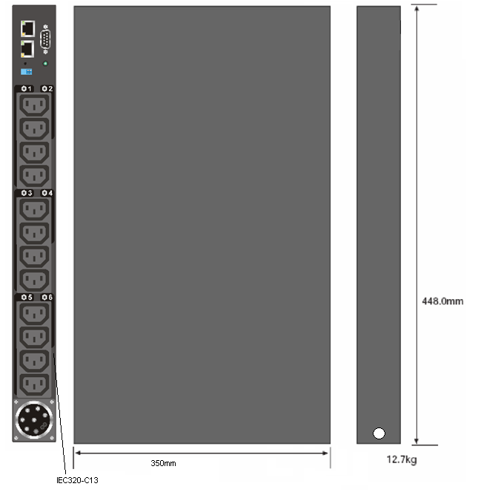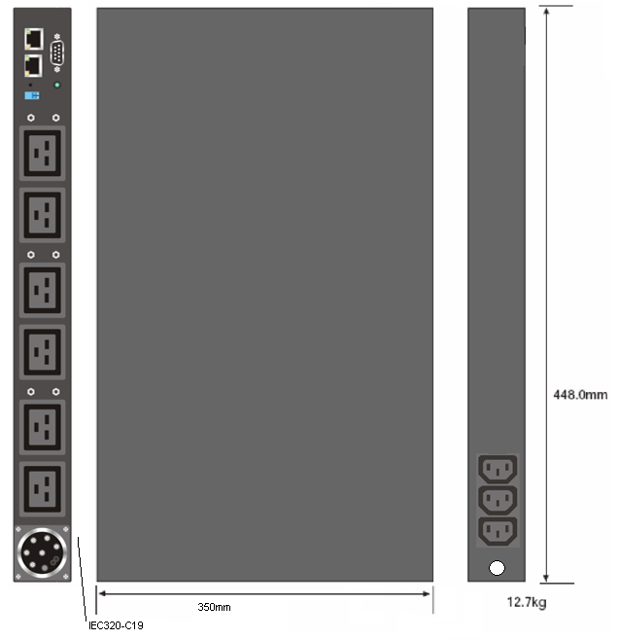
39M2816 |  |  | 39M2818 | 39M2819

IBM DPI Enterprise C13 PDU IBM DPI Enterprise C19 PDUs
(39Y8923 has attached line cord)
Front Side Rear
Front Side Rear

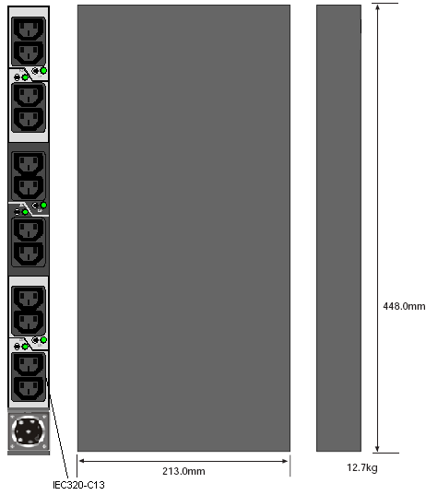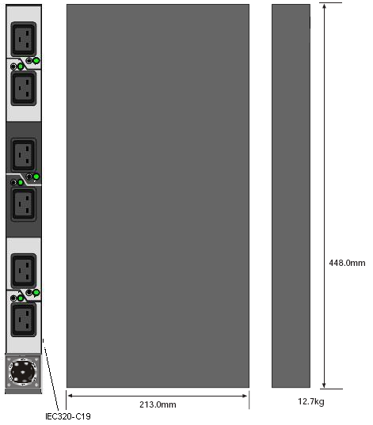
39Y8941 |  |  | 39Y8923 | 39Y8948

IBM DPI Front-end PDUs IBM DPI High Density PDUs
(All models have attached line cord)
Front Side Rear

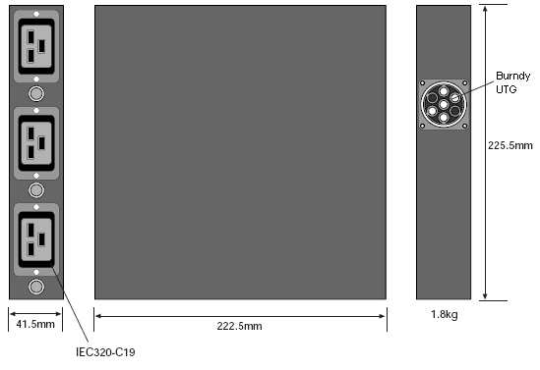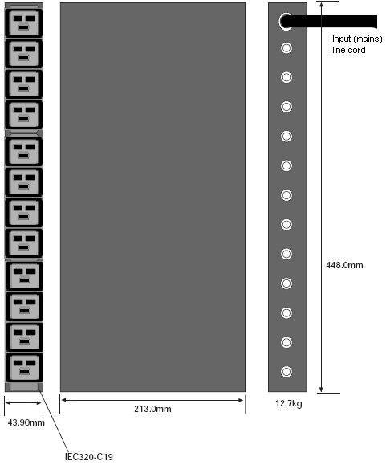
Front Side Rear
39Y8934 | 39Y8938 |  | 39Y8999 | 73P5847
39Y8935 | 39Y8939
39Y8936 | 39Y8940
39Y8937

IBM DPI NEMA PDU IBM DPI Rack PDUs
Front Side Rear
Front Side Rear

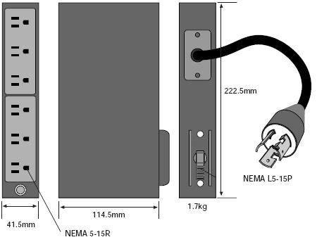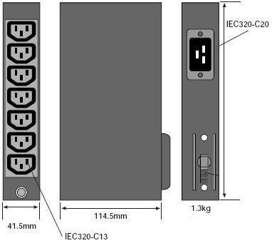

39Y8905 |  |  | 39Y8951 | 39Y8957
 |  |  | 39Y8952 | 39Y8958
 |  |  | 39Y8953 | 39Y8959
 |  |  | 39Y8954 | 39Y8960
 |  |  | 39Y8955 | 39Y8961
 |  |  | 39Y8956 | 39Y8962

 | Sizing and configuring PDU solutions
Step 1:  Identify the devices contained in the rack configuration  Step 2:  Sum the total load (watts) and total outlet requirements of all devices in the configuration.  Step 3:  Begin adding servers to the chosen PDU until you reach the total load of the PDU. It is critical that you not exceed the amperage of the breaker or fuse on the PDU or the outlet.
  Server | # Power Cords (Std/Max) | Watt Load (Typ/Max)
  System x 206m | 2/2 | 246/352
  System x 226 (single power supply) | 1/1 | 495/707
  System x 226 (redundant power supplies) | 2/2 | 480/685
  System x 236 | 1/2 | 625/893
  System x 260 (two power supplies) | 2/3 | 679/970
  System x 260 (three power supplies) | 2/3 | 1288/1840
  System x 306m | 1/1 | 350/500
  System x 336 | 1/2 | 385/550
  System x 346 | 1/2 | 581/830
  System x3850 and xSeries 366 | 1/2 | 1103/1575
  System x3950 and xSeries 460 | 2/2 | 1103/1575
  e326m | 1/1 | 280/400
  x3400 entry | 1/1 | 463/662
  x3550 | 1/2 | 490/700
  x3650 | 1/2 | 679/970
  x3800 (two power supplies) | 2/3 | 679/970
  x3800 (three power supplies) | 2/3 | 1288/1840
  x3850 | 2/2 | 1103/1575
  X3950 | 2/2 | 1103/1575
  BladeCenter™ (two 2000W power supplies) | 2/4 | 1855/2650
  BladeCenter (four 2000W power supplies) | 4/4 | 3710/5300
  BladeCenter H (two 2900W power supplies) | 2/2 | 3325/4750
  BladeCenter H (four 2900W power supplies) | 4/4 | 6650/9500
  Other Devices
  EXP400 Storage Expansion Unit (17331RU) | 2/2 | 310/440
  DS4100 Disk System (1724100) | 2/2 | 275/390
  DS4300 Disk System (172260U) | 2/2 | 390/557
  DS4400 Disk System (17421RU) | 2/2 | 275/390
  DS4500 Disk System (174290U) | 2/2 | 275/390
  DS4000 EXP100 Storage Expansion Unit (171010U) | 2/2 | 245/350
  SAN Fibre Channel Switch, 16-port (2005H16) | 2/2 | 140/200
  TotalStorage SAN Switch F08, 8-port (3534F08) | 1/1 | n/a /50
  SAN Data Gateway Router UltraSCSI LVD Port (2108R3L) | 1/1 | n/a /90
  DLT Tape Autoloader and Library (3502) | 1/1 | n/a /135
  Magstar® MP 3570 Tape Subsystem (C2x) | 1/1 | 140/200
  NetMEDIA Storage Expansion Unit EL (3551) | 2/2 | 130/185
  3600 Series Tape Autoloader and Library (3600xxx) | 1/1 | 500/700
  NetBAY Tape Enclosure (003B0X) | 1/1 | 320/457
  SDLT/LTO Modular Tape Library (4560SLX) | 1/1 | 300/430

 | Installation and use of IBM PDUs
 | Customers must connect the plug on the power cord that comes with the Front-end, High Density, Enterprise and PDU+ PDU to a properly wired and grounded outlet. Below is a quick guide to the plug types you might encounter while installing the IBM PDUs. The chart below details the plug style on each PDU along with it’s mating receptacle.
Electrical information: Guidelines for mating plugs and receptacles  More details are provided for the 30A single-phase to the 60A three-phase products to assist you in choosing the right connector type.
  Plug Type / Used With | Outlet | Plug
  30amp/125V single-phase with NEMA L5-30P connector  Used with: 39Y8938 Front-end PDU | 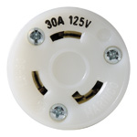 | 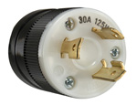
  30amp/250V single-phase with NEMA L6-30P connector  Used with: 39Y8939 Front-end PDU, 40K9614 line cord option for Enterprise and PDU+ PDUs | 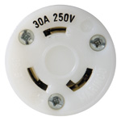 | 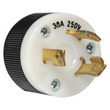
  32amp/250V single-phase with IEC 309 P+N+G connector  Used with: 39Y8934 Front-end PDU, 40K9612 line cord option for Enterprise and PDU+ PDUs | 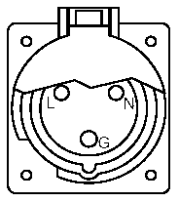 | 
  63amp/250V single-phase with IEC309 P+N+G connector. Receptacle listing 363R6W IP-67 Hubbell. Receptacle P/N HBL363R6W.  Used with: 39Y8935 Front-end PDU, 40K9613 line cord option for Enterprise and PDU+ PDUs |  | 
  60amp/250V single-phase with IEC309 2P+Gnd connector. Receptacle listing 360R6W IP-67 Hubbell. Receptacle P/N HBL360R6W.  Used with: 39Y8940 Front-end PDU, 40K9615 line cord option for Enterprise and PDU+ PDUs |  | 
  32amp/380-415V three-phase with IEC309 3P+N+G. Receptacle listing 532R6W IP-67. Receptacle listing HBL532R6W.  Used with: 39Y8999 High Density PDU, 40K9611 line cord option for Enterprise and PDU+ PDUs | 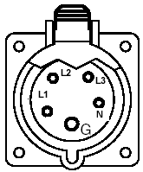 | 
  60amp/250V three-phase with IEC309 3P+G. Receptacle listing 460C9W IP-67 HUBBELL. Receptacle P/N HBL460C9W.  Used with: 73P5847 High Density PDU, 39Y8923 Enterprise PDU, 39M2819 PDU+ PDU | 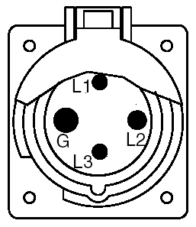 | 
  32A/250V single-phase with AS/NZS 3112 P+N+G.  Used with: 39Y8937 Front-end PDU, 40K9617 line cord option for Enterprise and PDU+ PDUs | 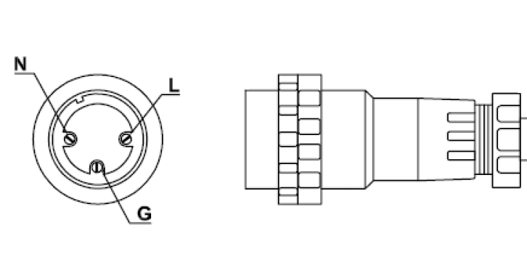  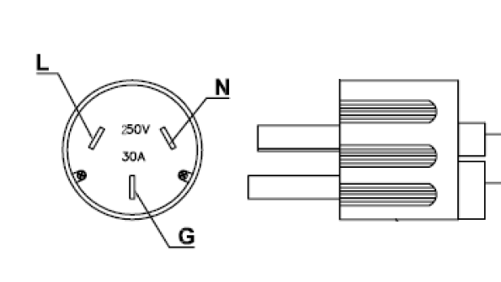
  30A/250V single-phase with KSC 8305
  Used with: 39Y8936 Front-end PDU, 40K9618 line cord option for Enterprise and PDU+ PDUs

Installation options in IBM rack models | IBM DPI PDUs are part of the IBM family of rack-based products. They are designed to easily install and work within IBM rack offerings. To gain a better understanding of the NetBAY rack family of products and the benefits they offer, please see the “Decision makers' guide to IBM Rack/Stack/Power Solutions” , available on the IBM System x and rack solutions Web page at ibm.com/servers/eserver/xseries/storage/rack.html  DPI PDUs are designed to be mounted in any EIA-standard rack offering, but given the diversity of rack designs, many of the benefits for flexible mounting do not apply to non-IBM racks. For even more detailed information on the installation and maintenance of the IBM family of PDUs, consult the Installation and Maintenance Guides for these products available on the ibm.com site.
Basic installation ideas | The DPI PDUs can be mounted in a variety of methods. The simplest is to mount these in the EIA space of the rack as shown here. Two Rack PDUs can be installed like this to make accessing the devices very easy. Many customers choose to mount PDUs this way for the serviceability benefits.  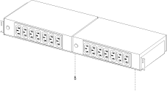
A more space-efficient method for mounting the PDUs is to install them in the side pockets of the rack. The following examples can be accomplished using the standard hardware provided with the PDUs. Each of these “nested” configurations can be placed in a variety of ways in the different NetBAY racks.

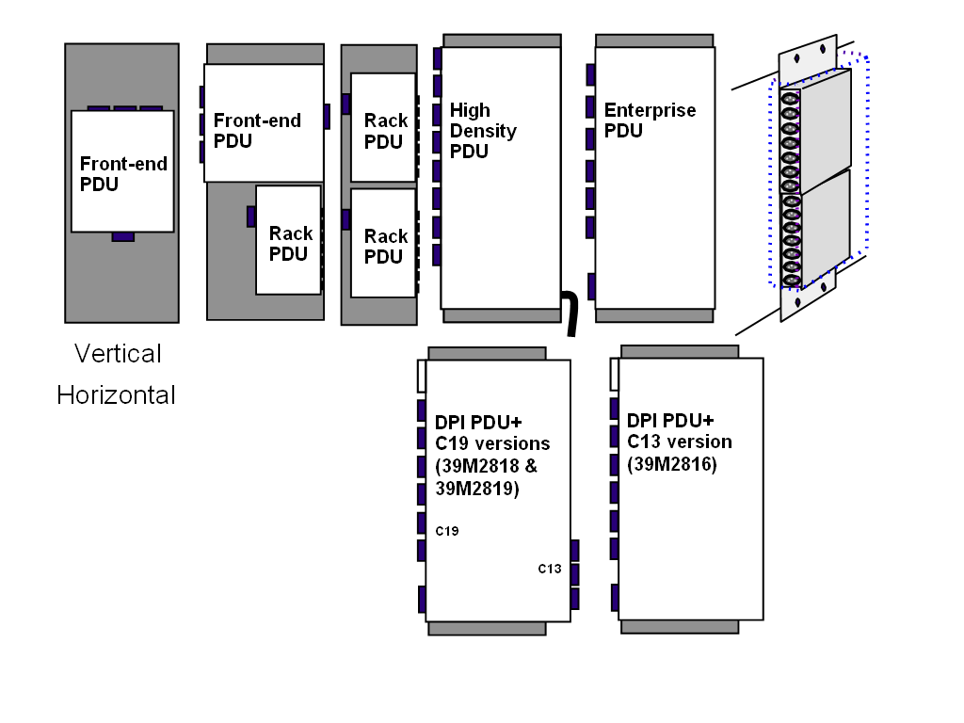

Enterprise Rack installation options | The IBM Enterprise Rack is the premier IBM rack, offering four deep side pockets that enable the greatest variety of side pocket mounting options. This flexibility is one of the major benefits of choosing this rack. Using all the available space in the side pockets of this rack enables customers to install up to 84 outlets in this rack without sacrificing any valuable “U” space. The picture below details these side pockets and provides a lettering guide to make explaining installation location easier.  The depth of these side pockets allows the PDUs to be nested side by side for support of large numbers of PDUs or KVM switches in the rack’s pockets. Here are a few examples of the supported installations for the Enterprise Rack.  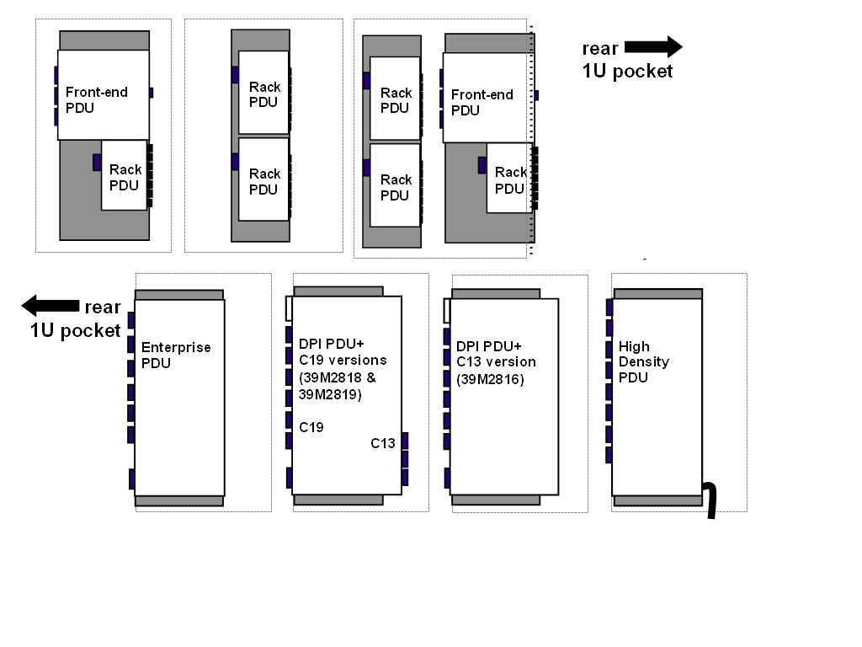  The illustration below further clarifies how the rack looks once these PDUs are installed. These examples show how the pockets can be utilized in the Enterprise Rack. Notice the vertical placement option is not supported in this rack. One very nice feature of the Enterprise Rack is the fact that it has four 1U pockets that are accessible and visible from the rear of the rack. It is possible with the Enterprise Rack to install a pair of PDUs in these 1U pockets using the EIA mounting hardware- this yields easy access to the PDUs.  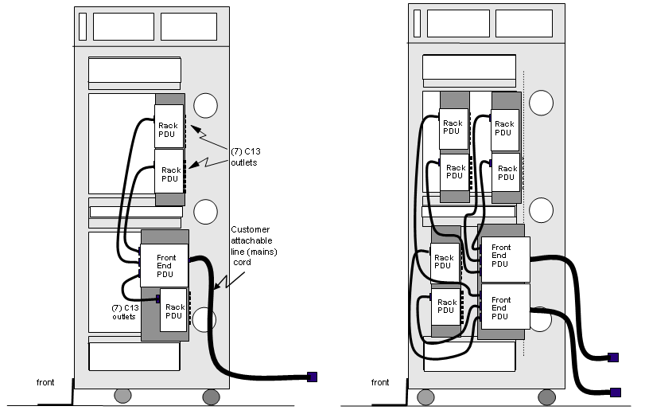

IBM S2 Rack installation options | This entry rack offers six side panel pockets mounting locations. While it has more side pockets than the Enterprise Rack, the Standard Rack's pockets are much less deep and do not allow the variety of mounting options of the Enterprise Rack. Even so, customers can install up to 56 outlets in the Standard Rack without sacrificing any "U" space. Here is graphical depiction of the side pockets of the Standard Rack along with a lettering guide.
Here are examples of accepted mounting configurations in a single IBM S2 Rack pocket. Up to four Front-end PDUs can be placed in the six pockets of the Standard rack.
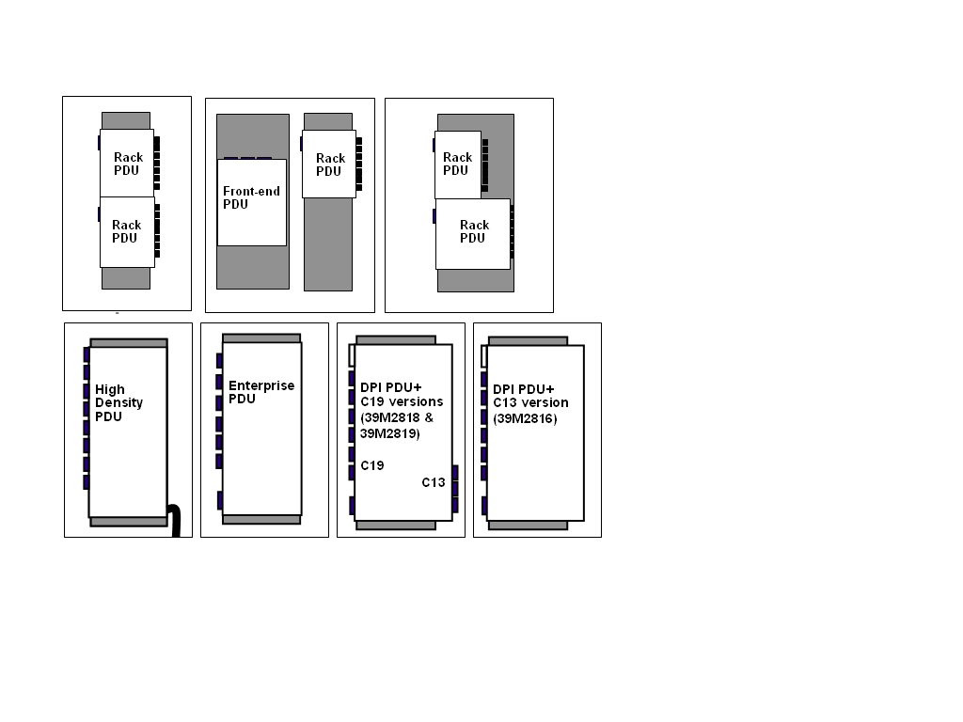

Sample configurations to help maximize uptime and availability | The pictures below detail ways to use PDUs to help maximize uptime and availability of your solution.  The first illustration shows the simplest configuration, with a Rack PDU plugged into a wall outlet or a Front-end PDU outlet. This simple topology provides non-protected, non-redundant power for up to seven devices.  Addition of a second PDU to this yields redundancy back to the power source. With this topology, even if one power source is lost, the second power source and PDU are designed to power the load without bringing the solution down.
 |  | The last three topologies below go a long way in preventing the many types of power problems that effect equipment today. All these topologies involve the use of a UPS product to add power conditioning and battery backup in case of an outage. Notice how much better the load on these PDUs is protected when used in combination with the proper UPS.

System x Rack Configurator software | While this Guide provides a basic understanding of the way in which IBM DPI PDUs are used and installed, the complexity of today’s power solutions and the variety of sizes, access options and cabling requirements of servers, accessories and storage components make configuring a complex networked system a challenge. A more detailed sizing tool is needed. The IBM System x Rack Configurator provides this functionality. It is an easy-to-use tool that helps you design the optimum layout. The configurator helps check, correct and report the following:  Components by product number and position  Infrastructure specifications, including weight, power, volt-amps (VA), heat (BTU/hr), bays, EIA, outlets and console ports  Width and depth; front, rear and side clearances; total weight and top clearance  Cables and connectors by component position  You can download the configurator software from ibm.com/servers/eserver/xseries/  storage/rack.html. The configurator is a good source of accurate information on designing a redundant, reliable power distribution topology. Individual User and Installation Guides also provide detailed information on the use and mounting of for DPI PDU products. These are available from the IBM Web site above.

Country-specific considerations | To accommodate a wide variety of country-specific power systems, line cords and wiring rules, IBM offers a large number of PDU options. This section will provide basic detail of what each of these country-specific PDU options are and how they would be used. For more details, contact your local IBM representative.

North America, Japan, Taiwan, Philippines, Saudi Arabia

DPI PDU+
Option Part Number (PDU) | Option Part Number (line cord) | Plug Type | Source Circuit  (phase 50/60Hz) | PDU Output  (single-phase 50/60Hz)
39M2816 | 40K9614 | NEMA L6-30P | 200-240Vac, 30A, single-phase | Twelve IEC320-C13, 200-240Vac, 10A each, shared 24A
39M2816 | 40K9615 | IEC309 2P+G, 60A | 200-240Vac, 60A, single phase | Twelve IEC320-C13, 200-240Vac, 10A each, shared 48A
39M2818 | 40K9614 | NEMA L6-30P | 200-240Vac, 30A, single-phase | Six IEC320-C19, and three IEC320-C13 200-240Vac, 10A each, shared 24A
39M2818 | 40K9615 | IEC309 2P+G, 60A | 200-240Vac, 60A, single-phase | Six IEC320-C19, and three IEC320-C13 200-240Vac, 16A each, shared 48A
39M2819 | - | IEC309 3P+G, 60A | 208Vac, 60A, three-phase delta | Six IEC320-C19, and three IEC320-C13 200-240Vac, 16A each, shared 27A per three outlet (2/C19 & 1/C13) phase group

High Density PDU
Part Number | Plug Type | Source Circuit  (three-phase 50/60Hz) | PDU Output  (single-phase 50/60Hz)
73P5847 | IEC309 3P+G | 208Vac, 60A, three-phase delta | Twelve IEC320-C19, 200-240Vac, 16A each, shared 27A per four outlet phase group

Enterprise PDU
Option Part Number (PDU) | Option Part Number (line cord) | Plug Type | Source Circuit  (phase 50/60Hz) | PDU Output  (single-phase 50/60Hz)
39Y8941 | 40K9614 | NEMA L6-30P | 200-240Vac, 30A, single-phase | Twelve IEC320-C13, 200-240Vac, 10A each, shared 24A
39Y8941 | 40K9615 | IEC309 2P+G, 60A | 200-240Vac, 60A, single phase | Twelve IEC320-C13, 200-240Vac, 10A each, shared 48A
39Y8948 | 40K9614 | NEMA L6-30P | 200-240Vac, 30A, single-phase | Six IEC320-C19, 200-240Vac, 16A each, shared 24A
39Y8948 | 40K9615 | IEC309 2P+G, 60A | 200-240Vac, 60A, single-phase | Six IEC320-C19, 200-240Vac, 16A each, shared 48A
39Y8923 | - | IEC309 3P+G | 208Vac, 60A, three-phase delta | Six IEC320-C19, 200-240Vac, 16A each, shared 27A per two outlet phase group

Front-end PDUs
Part Number | Plug Type | Source Circuit  (single-phase 50/60Hz) | PDU Output  (single-phase 50/60Hz)
39Y8938 | NEMA L5-30P | 100-127Vac, 30A | Three IEC320-C19, 100-127Vac, 20A each, shared 24A
39Y8939 | NEMA L6-30P | 200-240Vac, 30A | Three IEC320-C19, 200-240Vac, 20A each, shared 24A
39Y8940 | IEC309 2P+G | 200-240Vac, 60A | Three IEC320-C19, 200-240Vac, 20A each, shared 48A

Rack PDUs
Part Number | Plug Type | Source Circuit  (single-phase 50/60Hz) | PDU Output  (single-phase 50/60Hz)
39Y8905 | NEMA L5-15P | 100-127Vac, 15A | Six 100-127Vac, NEMA 5-15R receptacles, shared 12A
39Y8951 | NEMA L5-20P | 100-127Vac, 20A | Seven IEC320-C13 receptacles, 100-127Vac, shared 15A
39Y8951 | NEMA L6-20P | 200-240Vac, 20A | Seven IEC320-C13 receptacles, 200-240Vac, shared 15A

Asia Pacific, EMEA and parts of Latin America
DPI PDU+
Option Part Number (PDU) | Option Part Number (line cord) | Plug Type | Source Circuit  (phase 50/60Hz) | PDU Output  (single-phase 50/60Hz)
39M2816 | 40K9611 | IEC309 3P+N+G | 380-415Vac, 32A, three-phase wye | Twelve IEC320-C13, 200-240Vac, 10A each, shared 32A per four outlet phase group
39M2816 | 40K9612 | IEC309 P+N+G | 200-240Vac, 32A, single-phase | Twelve IEC320-C13, 200-240Vac, 10A each, shared 32A
39M2816 | 40K9613 | IEC309 P+N+G | 200-240Vac, 63A, single-phase | Twelve IEC320-C13, 200-240Vac, 10A each, shared 63A
39M2816 | 40K9614 | NEMA L6-30P | 200-240Vac, 30A, single-phase | Twelve IEC320-C13, 200-240Vac, 10A each, shared 24A
39M2816 | 40K9615 | IEC309 2P+G, 60A | 200-240Vac, 60A, single-phase | Twelve IEC320-C13, 200-240Vac, 10A each, shared 48A
39M2816 | 40K9617 | AS/NZS 3112 | 200-240Vac, 32A, single-phase | Twelve IEC320-C13, 200-240Vac, 10A each, shared 32A
39M2816 | 40K9618 | KSC 8305 | 200-240Vac, 30A, single-phase | Twelve IEC320-C13, 200-240Vac, 10A each, shared 30A
39M2818 | 40K9611 | IEC309 3P+N+G | 380-415Vac, 32A, three-phase wye | Six IEC320-C19, three IEC-320-C13, 200-240Vac, 16A each, shared 32A per three outlet (2/C19 & 1/C13) phase group
39M2818 | 40K9612 | IEC309 P+N+G | 200-240Vac, 32A, single-phase | Six IEC320-C19, three IEC-320-C13, 200-240Vac, 16A each, shared 32A
39M2818 | 40K9613 | IEC309 P+N+G | 200-240Vac, 63A, single-phase | Six IEC320-C19, three IEC-320-C13, 200-240Vac, 16A each, shared 63A
39M2818 | 40K9614 | NEMA L6-30P | 200-240Vac, 30A, single-phase | Six IEC320-C19, three IEC-320-C13, 200-240Vac, 16A each, shared 24A
39M2818 | 40K9615 | IEC309 2P+G, 60A | 200-240Vac, 60A, single-phase | Six IEC320-C19, three IEC-320-C13, 200-240Vac, 16A each, shared 48A
39M2818 | 40K9617 | AS/NZS 3112 | 200-240Vac, 32A, single-phase | Six IEC320-C19, three IEC-320-C13, 200-240Vac, 16A each, shared 32A
39M2818 | 40K9618 | KSC 8305 | 200-240Vac, 30A, single-phase | Six IEC320-C19, three IEC-320-C13, 200-240Vac, 16A each, shared 30A
39M2819 | - | IEC309 3P+G | 208Vac, 60A, three-phase delta | Six IEC320-C19, three IEC320-C13, 200-240Vac, 16A each, shared 27A per three outlet (2/C19 & 1/C13) phase group

High Density PDU
Part Number | Plug Type | Source Circuit  (three-phase 50/60Hz) | PDU Output  (single-phase 50/60Hz)
39Y8999 | IEC309 3P+N+G | 380-415Vac, 32A, three-phase wye | Twelve IEC320-C19, 200-240Vac, 16A each, shared 32A per four outlet phase group
73P5847 | IEC309 3P+G | 208Vac, 60A, three-phase delta | Twelve IEC320-C19, 200-240Vac, 16A each, shared 27A per four outlet phase group

Asia Pacific, EMEA and parts of Latin America (cont’d)

Enterprise PDU
Option Part Number (PDU) | Option Part Number (line cord) | Plug Type | Source Circuit  (phase 50/60Hz) | PDU Output  (single-phase 50/60Hz)
39Y8941 | 40K9611 | IEC309 3P+N+G | 380-415Vac, 32A, three-phase wye | Twelve IEC320-C13, 200-240Vac, 10A each, shared 32A per four outlet phase group
39Y8941 | 40K9612 | IEC309 P+N+G | 200-240Vac, 32A, single-phase | Twelve IEC320-C13, 200-240Vac, 10A each, shared 32A
39Y8941 | 40K9613 | IEC309 P+N+G | 200-240Vac, 63A, single-phase | Twelve IEC320-C13, 200-240Vac, 10A each, shared 63A
39Y8941 | 40K9614 | NEMA L6-30P | 200-240Vac, 30A, single-phase | Twelve IEC320-C13, 200-240Vac, 10A each, shared 24A
39Y8941 | 40K9615 | IEC309 2P+G, 60A | 200-240Vac, 60A, single-phase | Twelve IEC320-C13, 200-240Vac, 10A each, shared 48A
39Y8941 | 40K9617 | AS/NZS 3112 | 200-240Vac, 32A, single-phase | Twelve IEC320-C13, 200-240Vac, 10A each, shared 32A
39Y8941 | 40K9618 | KSC 8305 | 200-240Vac, 30A, single-phase | Twelve IEC320-C13, 200-240Vac, 10A each, shared 30A
39Y8948 | 40K9611 | IEC309 3P+N+G | 380-415Vac, 32A, three-phase wye | Six IEC320-C19, 200-240Vac, 16A each, shared 32A per two outlet phase group
39Y8948 | 40K9612 | IEC309 P+N+G | 200-240Vac, 32A, single-phase | Six IEC320-C19, 200-240Vac, 16A each, shared 32A
39Y8948 | 40K9613 | IEC309 P+N+G | 200-240Vac, 63A, single-phase | Six IEC320-C19, 200-240Vac, 16A each, shared 63A
39Y8948 | 40K9614 | NEMA L6-30P | 200-240Vac, 30A, single-phase | Six IEC320-C19, 200-240Vac, 16A each, shared 24A
39Y8948 | 40K9615 | IEC309 2P+G, 60A | 200-240Vac, 60A, single-phase | Six IEC320-C19, 200-240Vac, 16A each, shared 48A
39Y8948 | 40K9617 | AS/NZS 3112 | 200-240Vac, 32A, single-phase | Six IEC320-C19, 200-240Vac, 16A each, shared 32A
39Y8948 | 40K9618 | KSC 8305 | 200-240Vac, 30A, single-phase | Six IEC320-C19, 200-240Vac, 16A each, shared 30A
39Y8923 | - | IEC309 3P+G | 208Vac, 60A, three-phase delta | Six IEC320-C19, 200-240Vac, 16A each, shared 27A per two outlet phase group

Front-end PDUs
Part Number | Plug Type | Source Circuit  (single-phase 50/60Hz) | PDU Output  (single-phase 50/60Hz)
39Y8934 | IEC309 P+N+G | 200-240Vac, 32A | Three IEC320-C19, 200-240Vac, 16A each, shared 32A
39Y8935 | IEC309 P+N+G | 200-240Vac, 63A | Three IEC320-C19, 200-240Vac, 16A each, shared 48A
39Y8936 | KSC 8305 | 200-240Vac, 30A | Three IEC320-C19, 200-240Vac, 16A each, shared 32A
39Y8937 | AS/NZS 3112 | 200-240Vac, 32A | Three IEC320-C19, 200-240Vac, 16A each, shared 30A
39Y8938 | NEMA L5-30P | 100-127Vac, 30A | Three IEC320-C19, 100-127Vac, 20A each, shared 24A
39Y8939 | NEMA L6-30P | 200-240Vac, 30A | Three IEC320-C19, 200-240Vac, 20A each, shared 24A
39Y8940 | IEC309 2P+G | 200-240Vac, 60A | Three IEC320-C19, 200-240Vac, 20A each, shared 48A

Asia Pacific, EMEA and parts of Latin America (cont’d)

Rack PDUs
Part Number | Plug Type | Source Circuit  (single-phase 50/60Hz) | PDU Output  (single-phase 50/60Hz)
39Y8905 | NEMA L5-15P | 100-127Vac, 15A | Six 100-127Vac, NEMA 5-15R receptacles, shared 12A
39Y8951 | NEMA L5-20P | 100-127Vac, 20A | Seven IEC320-C13 receptacles, 100-127Vac, shared 15A
39Y8951 | NEMA L6-20P | 200-240Vac, 20A | Seven IEC320-C13 receptacles, 200-240Vac, shared 15A
39Y8952 | CEE7-VII | 200-240Vac, 16A | Seven IEC320-C13 receptacles, 200-240Vac, shared 15A
39Y8953 | IEC309 P+N+G | 200-240Vac, 16A | Seven IEC320-C13 receptacles, 200-240Vac, shared 15A
39Y8954 | SI 32 16A | 200-240Vac, 16A | Seven IEC320-C13 receptacles, 200-240Vac, shared 15A
39Y8955 | CEI 23-16 | 200-240Vac, 16A | Seven IEC320-C13 receptacles, 200-240Vac, shared 15A
39Y8956 | SABS 164 | 200-240Vac, 16A | Seven IEC320-C13 receptacles, 200-240Vac, shared 15A
39Y8957 | BS 1363/A | 200-240Vac, 13A | Seven IEC320-C13 receptacles, 200-240Vac, shared 13A
39Y8958 | AS/NZS 3112 | 200-240Vac, 15A | Seven IEC320-C13 receptacles, 200-240Vac, shared 15A
39Y8959 | GB 2099.1 | 200-240Vac, 15A | Seven IEC320-C13 receptacles, 200-240Vac, shared 15A
39Y8960 | NBR 6147 | 100-127Vac, 15A | Seven IEC320-C13 receptacles, 100-127Vac, shared 15A
39Y8961 | IS6538 | 200-240Vac, 16A | Seven IEC320-C13 receptacles, 200-240Vac, shared 15A
39Y8962 | IRAM 2073 | 200-240Vac, 15A | Seven IEC320-C13 receptacles, 200-240Vac, shared 15A

Japan

DPI PDU+
Option Part Number (PDU) | Option Part Number (line cord) | Plug Type | Source Circuit  (phase 50/60Hz) | PDU Output  (single-phase 50/60Hz)
39M2816 | 40K9614 | NEMA L6-30P | 200Vac, 30A, single-phase | Twelve IEC320-C13, 200Vac, 10A each, shared 24A
39M2816 | 40K9615 | IEC309 2P+G, 60A | 200Vac, 60A, single phase | Twelve IEC320-C13, 200Vac, 10A each, shared 48A
39M2818 | 40K9614 | NEMA L6-30P | 200Vac, 30A, single-phase | Six IEC320-C19, and three IEC320-C13 200Vac, 10A each, shared 24A
39M2818 | 40K9615 | IEC309 2P+G, 60A | 200Vac, 60A, single-phase | Six IEC320-C19, and three IEC320-C13 200Vac, 16A each, shared 48A
39M2819 | - | IEC309 3P+G, 60A | 200Vac, 60A, three-phase delta dedicated circuit | Six IEC320-C19, and three IEC320-C13 200Vac, 16A each, shared 27A per three outlet (2/C19 & 1/C13) phase group

High Density PDU
Part Number | Plug Type | Source Circuit  (three-phase 50/60Hz) | PDU Output  (single-phase 50/60Hz)
73P5847 | IEC309 3P+G | 200Vac, 60A, three-phase delta dedicated circuit | Twelve IEC320-C19, 200Vac, 16A each, shared 27A per four outlet phase group

Enterprise PDU
Option Part Number (PDU) | Option Part Number (line cord) | Plug Type | Source Circuit  (phase 50/60Hz) | PDU Output  (single-phase 50/60Hz)
39Y8941 | 40K9614 | NEMA L6-30P | 200Vac, 30A, single-phase | Twelve IEC320-C13, 200Vac, 10A each, shared 24A
39Y8941 | 40K9615 | IEC309 2P+G, 60A | 200Vac, 60A, single phase | Twelve IEC320-C13, 200Vac, 10A each, shared 48A
39Y8948 | 40K9614 | NEMA L6-30P | 200Vac, 30A, single-phase | Six IEC320-C19, 200Vac, 16A each, shared 24A
39Y8948 | 40K9615 | IEC309 2P+G, 60A | 200Vac, 60A, single-phase | Six IEC320-C19, 200Vac, 16A each, shared 48A
39Y8923 | - | IEC309 3P+G | 200Vac, 60A, three-phase delta dedicated circuit | Six IEC320-C19, 200Vac, 16A each, shared 27A per two outlet phase group

Front-end PDUs
Part Number | Plug Type | Source Circuit  (single-phase 50/60Hz) | PDU Output  (single-phase 50/60Hz)
39Y8938 | NEMA L5-30P | 100Vac, 30A | Three IEC320-C19, 100Vac, 20A each, shared 24A
39Y8939 | NEMA L6-30P | 200Vac, 30A | Three IEC320-C19, 200Vac, 20A each, shared 24A
39Y8940 | IEC309 2P+G | 200Vac, 60A | Three IEC320-C19, 200Vac, 20A each, shared 48A

Rack PDUs
Part Number | Plug Type | Source Circuit  (single-phase 50/60Hz) | PDU Output  (single-phase 50/60Hz)
39Y8905 | NEMA L5-15P | 100Vac, 15A | Six 100Vac, NEMA 5-15R receptacles, shared 12A
39Y8951 | NEMA L5-20P | 100Vac, 20A | Seven IEC320-C13 receptacles, 100Vac, shared 15A
39Y8951 | NEMA L6-20P | 200Vac, 20A | Seven IEC320-C13 receptacles, 200Vac, shared 15A

Preparing for the future

Road maps for Intel processors confirm that the trend of increasing power requirements and thermal output for servers is expected to continue in the short and long term. Therefore, it is critical that companies take this trend into consideration when making investments in data center infrastructure, including power service. Escalating power and thermal output requirements of Intel-based servers may soon approach levels traditionally seen in mainframes.

Here are a few points to consider moving forward:
When designing new data centers, consider the addition of 60amp and 125amp service feeds in your plans. With continued growth in server power requirements, 60amp and even 125amp service feeds may become standard for data centers in the coming years. If 60amp is not currently needed, consider installing wiring that can handle a future upgrade to 60amp service.
While not commonplace today, delta and wye power three-phase service may become much more widely used. A look into these power distribution systems now might be helpful. The IBM Three-phase Front-end PDU is a great way to help maximize power delivery to servers. IBM has plans for more three-phase products in the future to assist in this arena.
The power requirements and thermal output of individual racks are rising and may be bumping the limits of today’s cooling and power delivery. One must carefully consider how new equipment will be cooled and powered before introducing it into a data center.
In the near future, traditional guidelines that state data center design should accommodate 50-75W per square foot may be inadequate. The requirement for 100-150W and greater per square foot may be on the horizon. Anyone considering a data center redesign should take this trend into consideration. For more information on thermal trends, consult the Uptime Institute’s Web site at www.upsite.com/TUIpages/whitepapers/tuicooling.html.
Customers in countries that can choose to use either a NEMA-style PDU or an IEC C13-based PDU may gain an advantage by making the move now to the IEC standard. The IBM IEC-based PDUs allow migration from low voltage to high, or single-phase to three-phase, simply by changing the front-end PDU used. This means you may have an easy way to scale up your power topology without completely replacing your investment in power distribution equipment.
Customers who can choose between low voltage and high voltage should consider selecting high voltage whenever possible. Already, the amperage needed to run several of today’s servers cannot be easily met with 100-127V power feeds. Many new servers may be high -voltage only or redundantly powered only at high voltage.
When choosing PDUs, make sure you look to offerings that allow quick and easy scalability. The modular design of the IBM PDUs means that addition of outlets may be as simple as adding a single Rack PDU, eliminating the need for more wiring to the rack in many cases.
Buying an all-IBM solution that includes IBM racks, rack options and PDUs may help ensure that your server investment is both easy to install and safe from power or thermal problems. As server installations grow in complexity, the decision of which rack products to buy becomes critical. Will a non-IBM rack handle the thermal loads you will require in the future? IBM rack products are tested to work with IBM servers and the cooling methodologies that they employ. Non-IBM racks may not meet these requirements. Will a non-IBM PDU be capable of both protecting and powering the servers of tomorrow? A lot of thought goes into how our PDUs fit into our server road map.

Additional resources

IBM System x Racks and rack options
ibm.com/servers/eserver/xseries/storage/rack.html

IBM System x Options
ibm.com/servers/eserver/xseries/already.html

IBM System x Rack Configurator
ibm.com/servers/eserver/xseries/library/configtools.html

IBM System x Configuration and Options Guide
ibm.com/servers/eserver/xseries/library/configtools/cog.html

Important notes and trademarks

© IBM Corporation 2006

All Rights Reserved

Warranty Information: For a copy of applicable product warranties, write to: Warranty Information, P.O. Box 12195, RTP, NC 27709, Attn: Dept. JDJA/B203. IBM makes no representation or warranty regarding third-party products or services including those designated as ServerProven or ClusterProven.

Prices do not include tax or shipping and are subject to change without notice. Price may include applicable discounts. Reseller prices may vary. Unless otherwise specified, pricing information is current as of original publication of this document.

For a copy of the IBM Statement of Limited Warranty, call 1 800 426-7378. Telephone support may be subject to additional charges. For onsite labor, IBM will attempt to diagnose and resolve the problem remotely before sending a technician.

Outside the US, for a copy of applicable product warranties, contact your local IBM sales representative or visit: ibm.com/servers/support/machine_warranties

IBM System x servers are assembled in the U.S., Great Britain, Japan, Australia and Brazil and comprise U.S. and non-U.S. components.

IBM, the IBM logo, the e-business logo, System x, BladeCenter and Magstar are registered trademarks or trademarks of International Business Machines Corporation in the United States, other countries, or both. For a complete list of IBM Trademarks, see www.ibm.com/legal/copytrade.shtml.

Intel is a trademark of the Intel Corporation in the United States, other countries, or both.

Other company, product or service names may be trademarks or service marks of others.

All statements regarding IBM’s future direction and intent are subject to change or withdrawal without notice, and represent goals and objectives only.

Information about non-IBM products is obtained from the manufacturers of those products or their published announcements. IBM has not tested those products and cannot confirm the performance, compatibility, or any other claims related to non-IBM products. Questions on the capabilities of non-IBM products should be addressed to the suppliers of those products.

Any references in this information to non-IBM Web sites are provided for convenience only and do not in any manner serve as an endorsement of those Web sites. The materials at those Web sites are not part of the materials for these IBM products and use of those Web sites is at your own risk.

IBM reserves the right to change specifications or other product information without notice. This publication could include technical inaccuracies or typographical errors. References in this publication to IBM products or services do not imply that IBM intends to make them available in all countries in which IBM operates. IBM PROVIDES THIS PUBLICATION “AS IS” WITHOUT WARRANTY OF ANY KIND, EITHER EXPRESS OR IMPLIED, INCLUDING THE IMPLIED WARRANTIES OF MERCHANTABILITY AND FITNESS FOR A PARTICULAR PURPOSE. Some jurisdictions do not allow disclaimer of express or implied warranties in certain transactions; therefore, this statement may not apply to you.

