Analytics Appliance
Problem Determination and Service Guide

Version 1.0
EC L68572
August 27, 2014
Service information for: 4534 A07 / A14 / A21 / A28 / A35 / A42
If your IBM components were purchased as part of a Software Group Appliance, certain information contained in the product documentation may or may not apply to your particular product. Information that may differ is:
- The warranty period
- Parts replacement procedure
- Service support call flow
The information in this document supersedes the Problem Determination and Service Guide for the individual components. The table below maps the Software Group Appliance Part Numbers to the IBM Systems and Technology Group Part Numbers.
Appliance Name | Appliance Model Type | Component Names | Component Machine Types and Models
IBM Now Factory Analytics Appliance 101 | All Models | 42U Enterprise Rack | 9308-4PX
IBM Now Factory Analytics Appliance 101 | All Models | IBM Ultra Density Enterprise C19/C13 PDU Module | 7176-2NX
IBM Now Factory Analytics Appliance 101 | All Models | IBM Flex System Enterprise Chassis | 8721-HC1
IBM Now Factory Analytics Appliance 101 | All Models | IBM Flex System x240 Compute Node | 8737-AC1
IBM Now Factory Analytics Appliance 101 | All Models | IBM System Networking RackSwitch G8264 | 7309-G64
IBM Now Factory Analytics Appliance 101 | All Models | IBM Storwize V3700 | 2072-S2C
Table 1 – Models and Components

Table of Contents
Section 1. Appliance Configuration 2
Section 2. Cabling 4
Section 3. Relocating the Analytics Appliance 5
Section 4. Appliance Serial Number Location 6
Section 5. IP Addressing 7
Section 6. Parts listing 7
Section 7. Links to Service Documents 8
Appendix A. Component Configurations 9
Appendix B. Network Port Assignments 11
Appendix C. Flex Chassis Diagram – Rear View 15
Appendix D. Getting help and technical assistance 16

- Appliance Configuration
Each model of the Analytics Appliance contains one to three Flex chassis, a V3700, two G8264 switches, and 4 to 10 PDU modules. Their positioning, as well as in which models they are contained, is shown in table 1-1. Figure 1-1 shows visually how they are configured within the rack.

Component | Instance | Rack position | Models
IBM Flex System Enterprise Chassis | Chassis-1 | 1u to 10u | All
IBM Flex System Enterprise Chassis | Chassis-2 | 15u to 24u | A21, A28, A35, A42
IBM Flex System Enterprise Chassis | Chassis-3 | 27u to 36u | A35, A42
IBM Storwize V3700 | V3700-1 | 11u to 12u | All
IBM System Networking RackSwitch G8264 | G8264-1 | 41u | All
IBM System Networking RackSwitch G8264 | G8264-2 | 42u | All
IBM Ultra Density Enterprise C19/C13 PDU Module | PDU-1 | Side pocket | All
IBM Ultra Density Enterprise C19/C13 PDU Module | PDU-2 | Side pocket | All
IBM Ultra Density Enterprise C19/C13 PDU Module | PDU-3 | Side pocket | All
IBM Ultra Density Enterprise C19/C13 PDU Module | PDU-4 | Side pocket | All
IBM Ultra Density Enterprise C19/C13 PDU Module | PDU-5 | 13u | A21, A28, A35, A42
IBM Ultra Density Enterprise C19/C13 PDU Module | PDU-6 | 14u | A21, A28, A35, A42
IBM Ultra Density Enterprise C19/C13 PDU Module | PDU-7 | 25u | A21, A28, A35, A42
IBM Ultra Density Enterprise C19/C13 PDU Module | PDU-8 | 26u | A21, A28, A35, A42
IBM Ultra Density Enterprise C19/C13 PDU Module | PDU-9 | 37u | A35, A42
IBM Ultra Density Enterprise C19/C13 PDU Module | PDU-10 | 38u | A35, A42
Table 1-1 – Component Locations in 42u Enterprise Rack

Figure 1-1 – Component Locations in 42u Enterprise Rack
- Cabling
There are five types of cables in the Analytics Appliance:
- Power
- Direct-Attach Copper (DAC) SFP+ Ethernet cables. Used for 10 Gb Ethernet connections.
- Direct-Attach Copper (DAC) QSFP+ Ethernet cables. Used for 40 Gb Ethernet connections.
- Cat 5e Ethernet cables. Used for 1 Gb Ethernet connections, they plug into 8P8C modular connectors, often referred to as RJ-45 connectors.
- Fiber Channel cables. Used to connect the V3700 storage to the first Flex chassis.

Each Flex chassis has a total of 6 power supplies, and the V3700 and two G8264 switches have two each. Figure 2-1 shows how the power is configured across the PDUs.

Figure 2-1 – Rack Power Configuration
Each chassis contains two IBM Flex System Fabric SI4093 System Interconnect Modules that support 10 Gb Ethernet connections. Each switch has 8 total SFP+ DAC connections, 4 to G8264-1 and 4 to G8264-2. Refer to Appendix B for full port assignments.
Additionally, all models of the appliance come with four 7m DAC SFP+ cables for attachment to an IBM PureData System for Analytics.
There are four DAC QSFP+ cables that are used to provide high speed inter switch links between the two G8264 switches.
Cat 5e Ethernet cables are used to connect the management ports of all of the components. Each chassis and the V3700 has two management connections (one to each G8264), and the management ports of the two 8264 switches are connected.
There are two Fiber Channel cables that go from the V3700 to Chassis-1.
Refer to Appendix B for full port assignments.
- Relocating the Analytics Appliance
Moving the Analytics Appliance requires planning for safety of both the personnel and the equipment. When moving a full system (Model A42), the top two PDUs (PDU-9 and PDU-10 located at rack positions 37u and 38u) must be removed to improve overall stability. The external power cables will need to be removed, as well as 4 power supply cables that go to Chassis-3. Follow the instructions in the Ultra Density Enterprise C19/C13 PDU+ and PDU Modules: Installation and Maintenance Guide to remove the PDUs.
When the rack location is complete, reinstall the PDUs in the PDU-9 and PDU-10 locations, and reconnect the external power connections and Chassis-3 power supply cables. The two PDUs are identical, so can be installed in either rack location with no loss of capability.

DANGER
- Always lower the leveling pads on the rack cabinet.
- Always install stabilizer brackets on the rack cabinet.
- Always remove PDU 37U and 38U prior to moving MTM 4535-A42

- Appliance Serial Number Location
The serial number is located on a label on the upper right side of the appliance, inside the door. See figure 4-1 for the location on the rack, and figure 4-2 for the layout of the label.
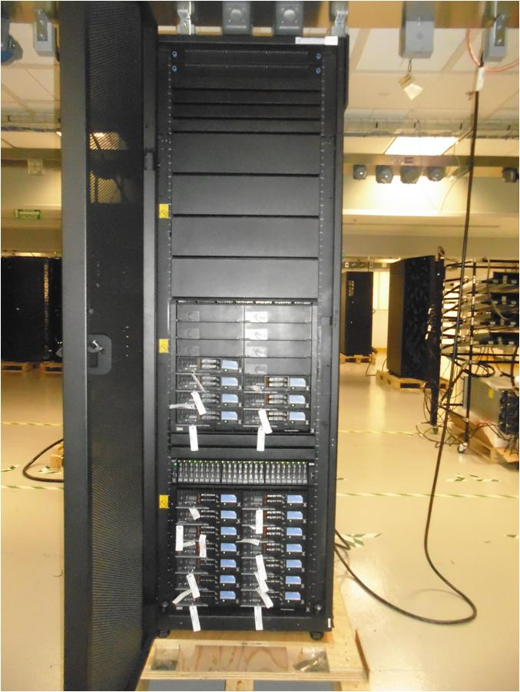
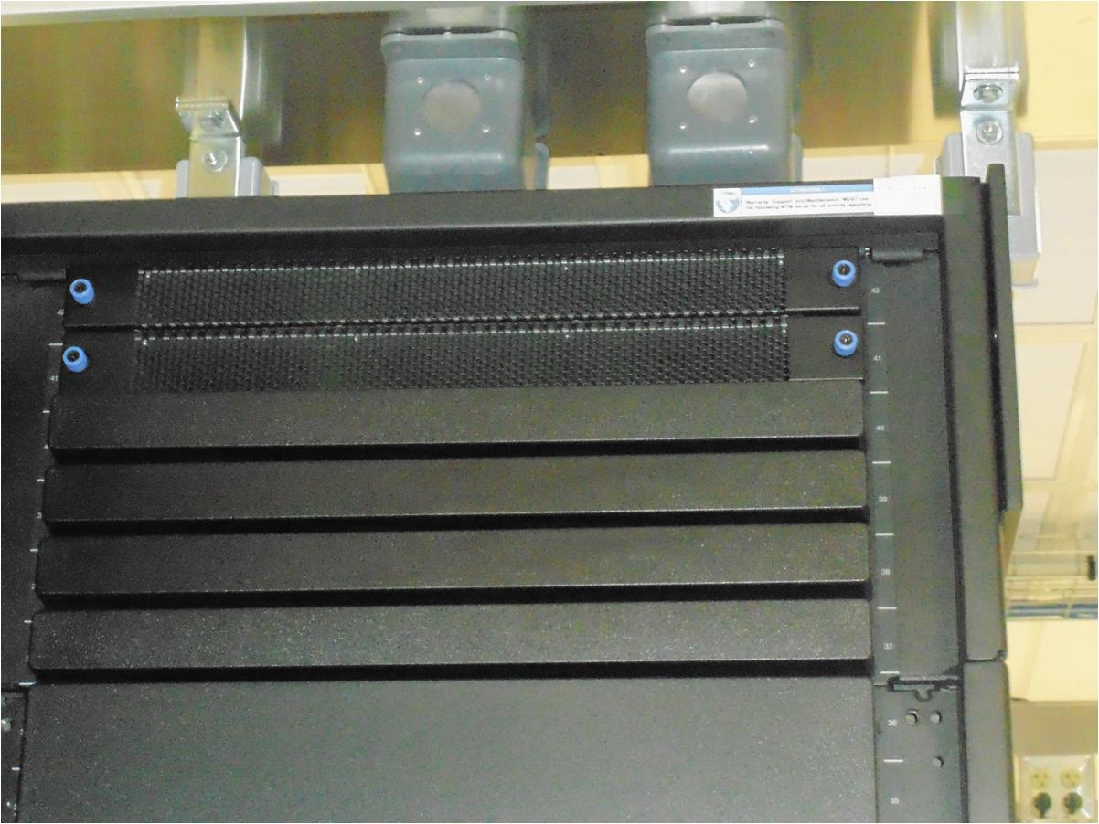

Figure 4-1 – Serial Number Label Location

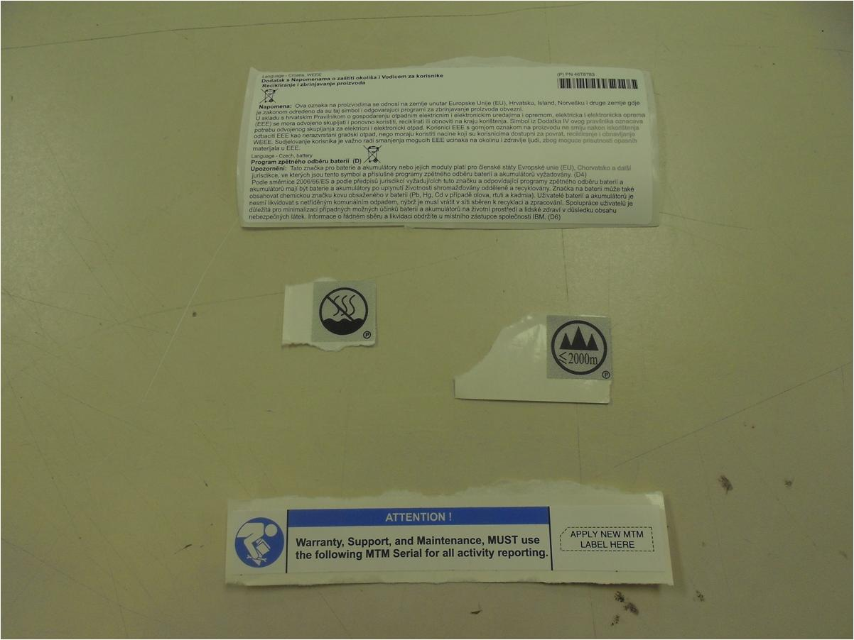
MT: 4534A21
SN: 7800001

Figure 4-2 – Serial Number Label

- IP Addressing
The Analytics Appliance has predefined IP addressing for the management network, which consists of the G8264 switches, the V3700 storage, the Flex Enterprise Chassis chassis management modules (CMM), and the Flex x240 node integrated management modules (IMM). There are two CMMs per Flex Enterprise Chassis, and one IMM per node. Table 4-1 lists the default IP addresses for the management network for rack components, and Table 4-2 shows the IP addresses of the IMM for each node.
 | IP Address |  | IP Address
G8264-1 Mgmt | 10.1.1.201 | Chassis-1 FC3171 2 | 10.1.1.105
G8264-2 Mgmt | 10.1.1.202 | Chassis-2 CMM 1 | 10.1.2.100
V3700 Mgmt, Host 1 | 10.1.1.50 | Chassis-2 CMM 2 | 10.1.2.101
V3700 Service Host 1 | 10.1.1.51 | Chassis-2 SI4093 1 | 10.1.2.102
V3700 Service Host 2 | 10.1.1.52 | Chassis-2 SI4093 2 | 10.1.2.103
Chassis-1 CMM 1 | 10.1.1.100 | Chassis-3 CMM 1 | 10.1.3.100
Chassis-1 CMM 2 | 10.1.1.101 | Chassis-3 CMM 2 | 10.1.3.101
Chassis-1 SI4093 1 | 10.1.1.102 | Chassis-3 SI4093 1 | 10.1.3.102
Chassis-1 SI4093 2 | 10.1.1.103 | Chassis-3 SI4093 2 | 10.1.3.103
Chassis-1 FC3171 1 | 10.1.1.104
Table 4-1 – Management Network IP Addresses

 | IP Address |  | IP Address |  | IP Address
Chassis-1 Node 1 | 10.1.1.151 | Chassis-2 Node 1 | 10.1.2.151 | Chassis-3 Node 1 | 10.1.3.151
Chassis-1 Node 2 | 10.1.1.152 | Chassis-2 Node 2 | 10.1.2.152 | Chassis-3 Node 2 | 10.1.3.152
Chassis-1 Node 3 | 10.1.1.153 | Chassis-2 Node 3 | 10.1.2.153 | Chassis-3 Node 3 | 10.1.3.153
Chassis-1 Node 4 | 10.1.1.154 | Chassis-2 Node 4 | 10.1.2.154 | Chassis-3 Node 4 | 10.1.3.154
Chassis-1 Node 5 | 10.1.1.155 | Chassis-2 Node 5 | 10.1.2.155 | Chassis-3 Node 5 | 10.1.3.155
Chassis-1 Node 6 | 10.1.1.156 | Chassis-2 Node 6 | 10.1.2.156 | Chassis-3 Node 6 | 10.1.3.156
Chassis-1 Node 7 | 10.1.1.157 | Chassis-2 Node 7 | 10.1.2.157 | Chassis-3 Node 7 | 10.1.3.157
Chassis-1 Node 8 | 10.1.1.158 | Chassis-2 Node 8 | 10.1.2.158 | Chassis-3 Node 8 | 10.1.3.158
Chassis-1 Node 9 | 10.1.1.159 | Chassis-2 Node 9 | 10.1.2.159 | Chassis-3 Node 9 | 10.1.3.159
Chassis-1 Node 10 | 10.1.1.160 | Chassis-2 Node 10 | 10.1.2.160 | Chassis-3 Node 10 | 10.1.3.160
Chassis-1 Node 11 | 10.1.1.161 | Chassis-2 Node 11 | 10.1.2.161 | Chassis-3 Node 11 | 10.1.3.161
Chassis-1 Node 12 | 10.1.1.162 | Chassis-2 Node 12 | 10.1.2.162 | Chassis-3 Node 12 | 10.1.3.162
Chassis-1 Node 13 | 10.1.1.163 | Chassis-2 Node 13 | 10.1.2.163 | Chassis-3 Node 13 | 10.1.3.163
Chassis-1 Node 14 | 10.1.1.164 | Chassis-2 Node 14 | 10.1.2.164 | Chassis-3 Node 14 | 10.1.3.164
Table 4-2 – Node IMM IP Addresses
- Parts listing
Field Replaceable Unit (FRU): FRUs must be installed only by trained service technicians. IBM will perform On-Site install for FRUs, at no additional charge. All consumables, structural parts, and Tier 1/Tier 2 parts listed in the Problem Determination and Service Guide for the IBM machine types listed in Table 1 are delegated as FRUs for the IBM Now Factory Analytics Appliance Type 4534.
The IBM Service Technician should follow the Problem Determination and Service Guide for the IBM machine types listed in Table 1 to remove, replace, and/or install all parts.
- Links to Service Documents
42U Enterprise Rack
https://www-947.ibm.com/support/entry/myportal/docdisplay?lndocid=MIGR-4VVGNT&brandind=5000019
IBM Ultra Density Enterprise C19/C13 PDU Module
https://www-947.ibm.com/support/entry/myportal/docdisplay?lndocid=MIGR-5076527&brandind=5000019
IBM Flex System Enterprise Chassis
http://pic.dhe.ibm.com/infocenter/flexsys/information/index.jsp?topic=%2Fcom.ibm.acc.8737.doc%2Fparts_listing.html
IBM Flex System x240 Compute Node
http://pic.dhe.ibm.com/infocenter/flexsys/information/index.jsp?topic=%2Fcom.ibm.acc.8737.doc%2Fparts_listing.html
IBM System Networking RackSwitch G8264
http://www-01.ibm.com/support/docview.wss?uid=isg3T7000294
IBM Storwize V3700
http://www-01.ibm.com/support/knowledgecenter/STLM5A/landing/V3700_welcome.html?lang=en
- Component Configurations
Configuration for Chassis-1:
Component | Quantity | FRU Part Number
IBM Flex System FC3171 8Gb SAN Switch | 2 | 69Y1933
IBM Flex System Fabric SI4093 System Interconnect Module | 2 | 95Y3314
IBM Flex System Enterprise Chassis 2500W Power Module | 4 | 94Y8251
IBM Flex System Enterprise Chassis 80mm Fan Module | 2 | 81Y2910
IBM Flex System Chassis Management Module | 2 | 68Y7032
Fiber Optic transceiver - 8Gb SFP+SW | 2 | 88Y6419
Configuration for Chassis-2 and Chassis-3:
Component | Quantity | FRU Part Number
IBM Flex System Fabric SI4093 System Interconnect Module | 2 | 95Y3314
IBM Flex System Enterprise Chassis 2500W Power Module | 4 | 94Y8251
IBM Flex System Enterprise Chassis 80mm Fan Module | 2 | 81Y2910
IBM Flex System Chassis Management Module | 2 | 68Y7032
Configuration for Flex x240 Node with Fiber Channel:
Description | Quantity | FRU Part Number
Intel Xeon Processor E5-2697 v2 12C 2.7GHz 30MB Cache 1866MHZ 130W | 1 | 00Y2777
16GB (1x16GB, 2Rx4, 1.5V) PC3-14900 CL13 ECC DDR3 1866MHz LP RDIMM | 16 | 00D4970
IBM Flex System FC3172 2-port 8Gb FC Adapter | 1 | 69Y1941
IBM 900GB 10K 6Gbps SAS 2.5" SFF HS HDD | 2 | 81Y9651
Configuration for Flex x240 Node without Fiber Channel:
Description | Quantity | FRU Part Number
Intel Xeon Processor E5-2697 v2 12C 2.7GHz 30MB Cache 1866MHZ 130W | 1 | 00Y2777
16GB (1x16GB, 2Rx4, 1.5V) PC3-14900 CL13 ECC DDR3 1866MHz LP RDIMM | 16 | 00D4970
IBM 900GB 10K 6Gbps SAS 2.5" SFF HS HDD | 2 | 81Y9651
Configuration of V3700:
Description | Quantity | FRU Part Number
IBM Storwize V3700 SFF DC Dual Control Enclosure | 1 | 00Y2613
900GB 2.5In 10K rpm 6Gb SAS HDD | 12 or 24 | 00Y2505
8Gb FC 4 Port Host Interface Card | 2 | 00Y2491
Cables and transceivers used in the Analytics Appliance:
Description | Qty (max) | FRU Part Number
1m Fiber Cable (LC) | 2 | 39M5699
0.6m IBM Cat5e Cable | 3 | 40K8966
3m IBM Cat5e Cable | 4 | 40K8968
1 m IBM QSFP+-to-QSFP+ Cable | 4 | 49Y7934
1m IBM Passive DAC SFP+ Cable | 1 | 90Y9426
3m IBM Passive DAC SFP+ Cable | 16 | 90Y9429
7.0M Passive DAC SFP+ Cable | 4 | 00D6150
IBM SFP 1000Base-T (RJ-45) Transceiver | 6 | 78P3824
DUAL SFP+ SX | 2 | 46N5338
Component Usage by Model:
 | A07 | A14 | A21 | A28 | A35 | A42
42u Enterprise Rack | 1 | 1 | 1 | 1 | 1 | 1
PDU Module | 4 | 4 | 8 | 8 | 10 | 10
Flex Enterprise Chassis | 1 | 1 | 2 | 2 | 3 | 3
x240 Node w/FC | 3 | 6 | 6 | 6 | 6 | 6
x240 Node w/o FC | 4 | 8 | 15 | 22 | 29 | 36
V3700 | 1 (12 HDD) | 1 | 1 | 1 | 1 | 1
G8264 RackSwitch | 2 | 2 | 2 | 2 | 2 | 2
1m Fiber Cable (LC) | 2 | 2 | 2 | 2 | 2 | 2
0.6m IBM Cat5e Cable | 1 | 1 | 1 | 1 | 3 | 3
3m IBM Cat5e Cable | 4 | 4 | 6 | 6 | 6 | 6
1 m IBM QSFP+ Cable | 4 | 4 | 4 | 4 | 4 | 4
1m IBM DAC SFP+ Cable | 0 | 0 | 0 | 0 | 16 | 16
3m IBM DAC SFP+ Cable | 16 | 16 | 32 | 32 | 32 | 32
7.0M DAC SFP+ Cable | 4 | 4 | 4 | 4 | 4 | 4
IBM SFP Transceiver | 6 | 6 | 8 | 8 | 10 | 10
Dual SFP+ SX Transceiver | 2 | 2 | 2 | 2 | 2 | 2

- Network Port Assignments
The RackSwitch G8264 has one management port, four 40 Gb/sec QSFP+ ports, and 48 10 Gb/sec SFP+ ports as shown in Figure B-1. The management port is labeled “Mgmt”, the QSFP+ ports are labeled “1”, “5”, “9”, and “13”, and the SFP+ ports are labeled “17” through “64”.

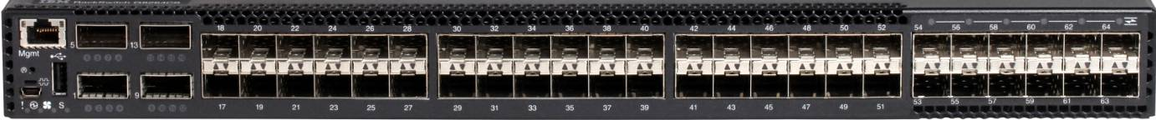
Mgmt Port
QSFP+ Ports
SFP+ Ports
Figure B-1 – RackSwitch G8264 Ports
There are four 40 Gb/sec ISL links between the two G8264 switches, and there is also a connection between the management ports on the two switches. The ports and cables for these connections are shown in Table B-1.
From | To | Cable Part Number | Cable Type | Cable Length
G8264-1, Port 1 | G8264-2, Port 1 | 49Y7890 | QSFP+ | 1m
G8264-1, Port 5 | G8264-2, Port 5 | 49Y7890 | QSFP+ | 1m
G8264-1, Port 9 | G8264-2, Port 9 | 49Y7890 | QSFP+ | 1m
G8264-1, Port 13 | G8264-2, Port 13 | 49Y7890 | QSFP+ | 1m
G8264-1, Mgmt Port | G8264-2, Mgmt Port | 40K5679 | Cat 5e | 0.6m
Table B-1 – Inter-switch connections
There are up to 24 10 Gb/sec Ethernet connections between each G8264 switch and the SI4093 switches in the Flex Enterprise Chassis. The port assignments on the G8264, the SI4093 switches, the cables used, and which models include the connections are shown in Table B-2 for G8264-1 and Table B-3 for G8264-2.
The Analytics Appliance uses two management and two Fiber Channel ports on the V3700, as shown in Figure B-2. The V3700 has redundant controllers, Host 1 and Host 2.
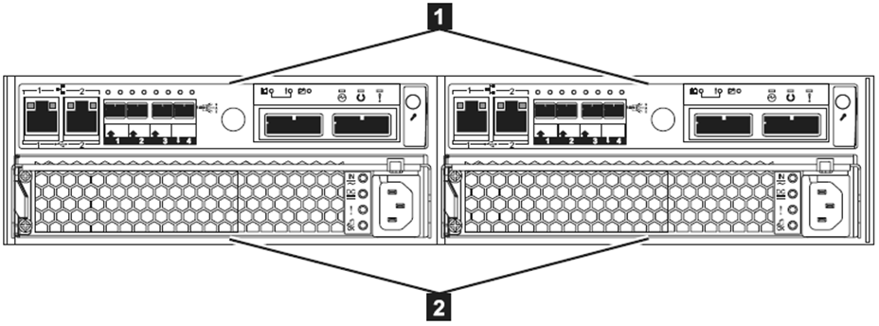
Mgmt Ports
FC Ports
Figure B-2 – V3700 Ports

Port | Description | Cable Part Number | Cable Type | Cable Length | Models
17 | Chassis-1, SI4093-1, Port 1 | 90Y9430 | SFP+ | 3m | All
18 | Chassis-1, SI4093-1, Port 2 | 90Y9430 | SFP+ | 3m | All
19 | Chassis-1, SI4093-1, Port 3 | 90Y9430 | SFP+ | 3m | All
20 | Chassis-1, SI4093-1, Port 4 | 90Y9430 | SFP+ | 3m | All
21 | Chassis-2, SI4093-1, Port 1 | 90Y9430 | SFP+ | 3m | A21, A28, A35, A42
22 | Chassis-2, SI4093-1, Port 2 | 90Y9430 | SFP+ | 3m | A21, A28, A35, A42
23 | Chassis-2, SI4093-1, Port 3 | 90Y9430 | SFP+ | 3m | A21, A28, A35, A42
24 | Chassis-2, SI4093-1, Port 4 | 90Y9430 | SFP+ | 3m | A21, A28, A35, A42
25 | Chassis-3, SI4093-1, Port 1 | 90Y9427 | SFP+ | 1m | A35, A42
26 | Chassis-3, SI4093-1, Port 2 | 90Y9427 | SFP+ | 1m | A35, A42
27 | Chassis-3, SI4093-1, Port 3 | 90Y9427 | SFP+ | 1m | A35, A42
28 | Chassis-3, SI4093-1, Port 4 | 90Y9427 | SFP+ | 1m | A35, A42
45 | Chassis-3, SI4093-2, Port 1 | 90Y9427 | SFP+ | 1m | A35, A42
46 | Chassis-3, SI4093-2, Port 2 | 90Y9427 | SFP+ | 1m | A35, A42
47 | Chassis-3, SI4093-2, Port 3 | 90Y9427 | SFP+ | 1m | A35, A42
48 | Chassis-3, SI4093-2, Port 4 | 90Y9427 | SFP+ | 1m | A35, A42
49 | Chassis-2, SI4093-2, Port 1 | 90Y9430 | SFP+ | 3m | A21, A28, A35, A42
50 | Chassis-2, SI4093-2, Port 2 | 90Y9430 | SFP+ | 3m | A21, A28, A35, A42
51 | Chassis-2, SI4093-2, Port 3 | 90Y9430 | SFP+ | 3m | A21, A28, A35, A42
52 | Chassis-2, SI4093-2, Port 4 | 90Y9430 | SFP+ | 3m | A21, A28, A35, A42
53 | Chassis-1, SI4093-2, Port 1 | 90Y9430 | SFP+ | 3m | All
54 | Chassis-1, SI4093-2, Port 2 | 90Y9430 | SFP+ | 3m | All
55 | Chassis-1, SI4093-2, Port 3 | 90Y9430 | SFP+ | 3m | All
56 | Chassis-1, SI4093-2, Port 4 | 90Y9430 | SFP+ | 3m | All
Table B-2 – G8264-1 Port Assignments

Port | Description | Cable Part Number | Cable Type | Cable Length | Models
17 | Chassis-1, SI4093-1, Port 5 | 90Y9430 | SFP+ | 3m | All
18 | Chassis-1, SI4093-1, Port 6 | 90Y9430 | SFP+ | 3m | All
19 | Chassis-1, SI4093-1, Port 7 | 90Y9430 | SFP+ | 3m | All
20 | Chassis-1, SI4093-1, Port 8 | 90Y9430 | SFP+ | 3m | All
53 | Chassis-1, SI4093-2, Port 5 | 90Y9430 | SFP+ | 3m | All
54 | Chassis-1, SI4093-2, Port 6 | 90Y9430 | SFP+ | 3m | All
55 | Chassis-1, SI4093-2, Port 7 | 90Y9430 | SFP+ | 3m | All
56 | Chassis-1, SI4093-2, Port 8 | 90Y9430 | SFP+ | 3m | All
21 | Chassis-2, SI4093-1, Port 5 | 90Y9430 | SFP+ | 3m | A21, A28, A35, A42
22 | Chassis-2, SI4093-1, Port 6 | 90Y9430 | SFP+ | 3m | A21, A28, A35, A42
23 | Chassis-2, SI4093-1, Port 7 | 90Y9430 | SFP+ | 3m | A21, A28, A35, A42
24 | Chassis-2, SI4093-1, Port 8 | 90Y9430 | SFP+ | 3m | A21, A28, A35, A42
49 | Chassis-2, SI4093-2, Port 5 | 90Y9430 | SFP+ | 3m | A21, A28, A35, A42
50 | Chassis-2, SI4093-2, Port 6 | 90Y9430 | SFP+ | 3m | A21, A28, A35, A42
51 | Chassis-2, SI4093-2, Port 7 | 90Y9430 | SFP+ | 3m | A21, A28, A35, A42
52 | Chassis-2, SI4093-2, Port 8 | 90Y9430 | SFP+ | 3m | A21, A28, A35, A42
25 | Chassis-3, SI4093-1, Port 5 | 90Y9427 | SFP+ | 1m | A35, A42
26 | Chassis-3, SI4093-1, Port 6 | 90Y9427 | SFP+ | 1m | A35, A42
27 | Chassis-3, SI4093-1, Port 7 | 90Y9427 | SFP+ | 1m | A35, A42
28 | Chassis-3, SI4093-1, Port 8 | 90Y9427 | SFP+ | 1m | A35, A42
45 | Chassis-3, SI4093-2, Port 5 | 90Y9427 | SFP+ | 1m | A35, A42
46 | Chassis-3, SI4093-2, Port 6 | 90Y9427 | SFP+ | 1m | A35, A42
47 | Chassis-3, SI4093-2, Port 7 | 90Y9427 | SFP+ | 1m | A35, A42
48 | Chassis-3, SI4093-2, Port 8 | 90Y9427 | SFP+ | 1m | A35, A42
Table B-3 – G8264-2 Port Assignments
The Analytics Appliance management network connects from the G8264 switches to the Chassis Management Module for all chassis in the appliance and to the management ports of the V3700. The V3700 and each chassis has one connection to each G8264 switch, with the port assignments shown in table B-4. Each G8264 also has a dedicated port for access to the appliance management network, located at port 64. Port 64 on each switch has a transceiver in that port that allows connection via a standard cat 5e Ethernet cable.
From | To | Cable Part Number | Cable Type | Cable Length | Models
G8264-1,Port 60 | Chassis-1 CMM 1, Port 1 | 40K5581 | Cat 5e | 3m | All
G8264-1,Port 61 | Chassis-2 CMM 1, Port 1 | 40K5581 | Cat 5e | 3m | A21, A28, A35, A42
G8264-1,Port 62 | Chassis-3 CMM 1, Port 1 | 40K5679 | Cat 5e | 0.6m | A35, A42
G8264-1,Port 63 | V3700 Mgmt Node 1, Port 1 | 40K5581 | Cat 5e | 3m | All
G8264-2,Port 60 | Chassis-1, CMM 2, Port 1 | 40K5581 | Cat 5e | 3m | All
G8264-2,Port 61 | Chassis-2, CMM 2, Port 1 | 40K5581 | Cat 5e | 3m | A21, A28, A35, A42
G8264-2,Port 62 | Chassis-3, CMM 2, Port 1 | 40K5679 | Cat 5e | 0.6m | A35, A42
G8264-2,Port 63 | V3700 Mgmt Node 2, Port 1 | 40K5581 | Cat 5e | 3m | All
Table B-4 – Management Network Connections
Additional ports on each switch have dedicated usage - customer network, PureData System for Analytics (PDA), and the management network noted previously. Cables are provided for connection to the PDA appliance, although the customer may choose to use different cables. For the customer network and the management ports, transceivers are provided. Table B-5 lists the dedicated ports, the cable or transceiver provided, and the part numbers.
Port | Use | Part Number | Cable/Transceiver
G8264-1 Port 29 | PDA Data Host 1 | 00D6151 | SFP+ Cable, 7m
G8264-1 Port 30 | PDA Management Host 1 | 00D6151 | SFP+ Cable, 7m
G8264-1 Port 33 | Customer Network | 46N5338 | SFP+ Transceiver
G8264-1 Port 34 | Customer Network | 46N5338 | SFP+ Transceiver
G8264-1 Port 40 | Big Insights
G8264-1 Port 41 | Big Insights
G8264-1 Port 43 | Remote Support VPN
G8264-1 Port 64 | Management port | 00FE333 | 8P8C/RJ-45 Transceiver
G8264-2 Port 29 | PDA Data Host 2 | 00D6151 | SFP+ Cable, 7m
G8264-2 Port 30 | PDA Management Host 2 | 00D6151 | SFP+ Cable, 7m
G8264-2 Port 33 | Customer Network | 46N5338 | SFP+ Transceiver
G8264-2 Port 34 | Customer Network | 46N5338 | SFP+ Transceiver
G8264-2 Port 40 | Big Insights
G8264-2 Port 41 | Big Insights
G8264-2 Port 43 | Remote Support VPN
G8264-2 Port 64 | Management port | 00FE333 | 8P8C/RJ-45 Transceiver
Table B-5 – G8264 Dedicated Ports

- Flex Chassis Diagram – Rear View
Figure C-1 shows the rear view of the Flex System Enterprise Chassis indicating the bay naming/numbering scheme. All chassis in the Analytics Appliance will have two SI4093 Ethernet switches in I/O module bays 1 and 2. Chassis-1 will also have two FC3171 8Gb SAN switches in I/O module bays 3 and 4. All chassis are fully configured with 6 power supplies in Power supply bays 1 through 6. All chassis will have either 7 or 14 nodes. 7 node chassis, found in models A07, A21, and A35, will have fans in Fan bays 1-3, 5-8, and 10. 14 node chassis will have fans in all Fan bays.
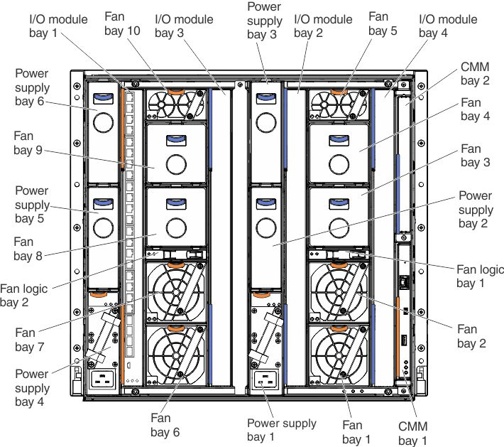

Figure C-1 - Rear view of the chassis.
- Getting help and technical assistance
Software and Hardware service and support
When calling IBM for hardware or software support, please select the 'Software Service Option' as the Product type for your IBM Now Factory Analytics Appliance. You are required to provide your IBM Customer Number (ICN) for Support and open a problem management record for 'Now Factory Analytics' (PID 5725-Q80) with a description of the problem.
All Service Support calls should be directed to the IBM Software Support Line. The Software support team owns the appliance engagement with the customer and will engage the hardware support team when necessary. Any calls that come directly to the hardware support team will automatically be rerouted to the software support team.

