1) Obtain IPMIUTIL from http://ipmiutil.sourceforge.net/FILES/archive/ipmiutil-2.9.1.msi and install it on a Windows workstation.
2) Go to the IMM web interface and go to IMM Management -> Users:
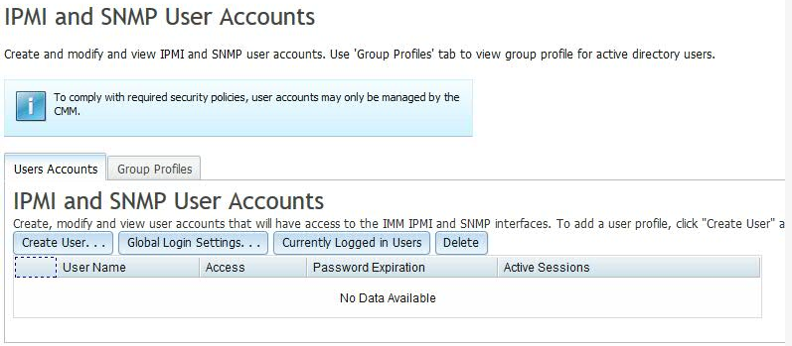
3) Create a user called ipmiuser and assign it a password.
4) Run C:\Program Files (x86)\sourceforge\ipmiutil>ipmiutil sel -d -N <IMM IP address> -U <USERID> -P <Password>
You should see something similar to the following:
C:\Program Files (x86)\sourceforge\ipmiutil>ipmiutil sel -d -N 9.5.66.41 -U ipmiuser -P Passw0rd
ipmiutil ver 2.91
isel: version 2.91
Opening lan connection to node 9.5.66.41 ...
Connecting to node 9.5.66.41
-- BMC version 2.00, IPMI version 2.0
SEL Ver 51 Support 0a, Size = 511 records (Used=3, Free=508)
ClearSEL: Log Cleared successfully
ipmiutil sel, completed successfully

