TS3310 Library Service Utility Tool and Fix README

- Download the TS3310LibraryServiceUtilityInstall.xxx file off the FTP site into a Temp directory on the Windows Server that is being used to connect to the TS3310 Library. Rename the extension from .xxx to .exe so that “TS3310LibraryServiceUtilityInstall.xxx” becomes “TS3310LibraryServiceUtilityInstall.exe”.

- Via a Windows Browser, make sure you can connect and login to the library and then logout prior to doing the next steps. Make sure the connection is in place to the library, so if having to login through a firewall, if installed, it does not stop the tool from connecting to the library.

Note: The Library should be offline to the Host Backup Application. The library will be rebooted after the fix is installed.

- Run the executable TS3310LibraryServiceUtilityInstall.exe from the Temp directory that the file was saved into in Step 1.

- Check mark the box for “Start Menu Shortcuts” and click Next.

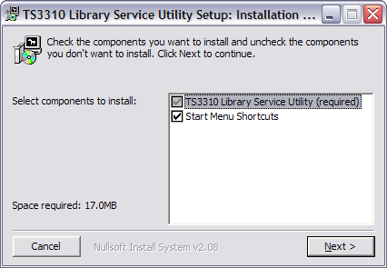

- Make note of the directory that the Utility installs in. Click Install on the Installation screen and then Close on the last screen

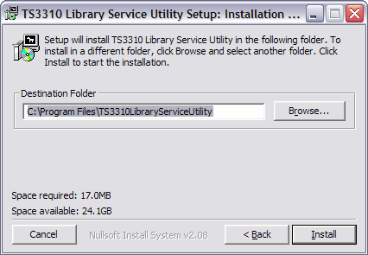

- From the Window Server Desktop. Click Start -> All Programs and there will be a new application option called TS3310 Library Service Utility which was created in Step 4 above. Click TS3310 Library Service Utility from the pull down to start the tool.

7. Click Wizards -> TS3310 Library Update Fix

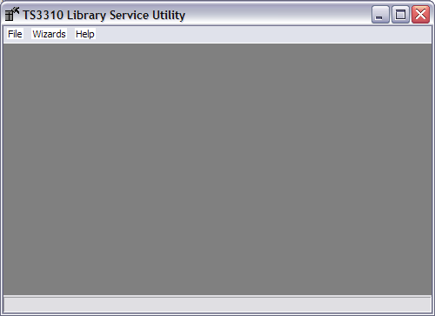

8. Click Next on the Introduction screen

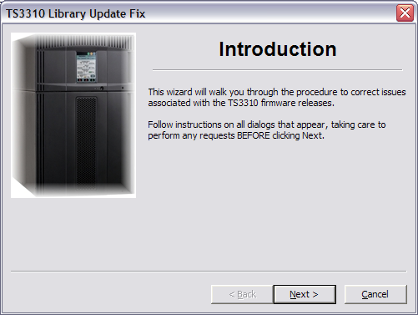

9. Click Next on the Connection screen

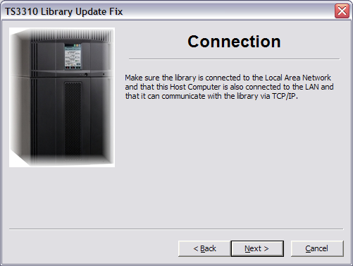
- Enter the Library's IP address and the admin's password (default is secure) and click Next. If you changed the admin’s password, type in the new password then click Next.

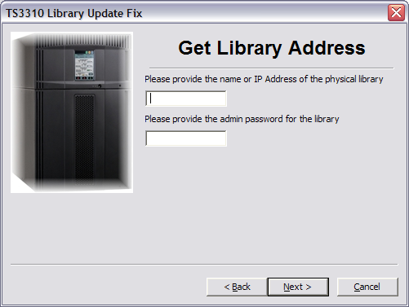

- Select the Perform TS3310 Library Update Fix button.
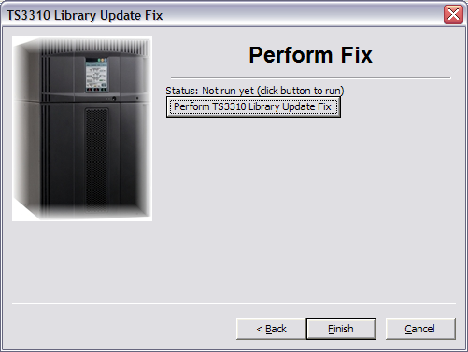
12. Click Continue.

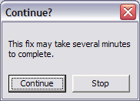

- The fix update will take about a minute to execute. Notice the Status line as it updates as the fix is being applied. Wait for the Complete screen to pop up and then click OK.

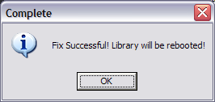

14. Click Finish and then the tool will take you back to the starting GUI screen as follows.

15. Close the screen
- After the Library reboots, log into the Library via the Windows Browser, and verify that you
can view the Library Code level (view via the Service Library -> View / Update Library
Firmware Level).

- To uninstall, go to the Window Server Desktop and click Start -> All Programs -> TS3310 Library Service Utility -> select Uninstall and then click Uninstall on the GUI screen.

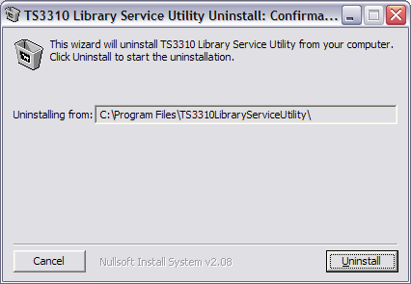

- Click Close.

- You will need to manually delete the TS3310LibraryServiceUtility subdirectory from
under the Program Files directory that was created in step 5 above.

