JK Enterprises HATS/Portal Demo



Background
This demonstration is intended to showcase the potential value of an integrated solution that includes IBM’s WebSphere Portal and Host Access Transformation Services (HATS). While this example uses a manufacturing sector scenario, most of the concepts and functions would be relevant to all industries.

This is the opening scenario for the script:
Here we have JK Enterprises, a manufacturer of toys and sporting goods for small children, working hard to sell their products to end customers through distributors. Like most firms, JK Enterprises operates with both a direct sales force (selling to large customer opportunities) and a distributor team (that in turn sells to consumers and small business). Over time they have implemented a national Inside Sales team to offload their highly paid direct sales reps (from both direct sales and distributor operations) of re-orders and other administrative concerns.
JK Enterprises has a member within the Inside Sales team for each of its geographic regions: Northeast; Southeast; Central; and West territories. Each region also has its own warehouse where inventory is kept to expedite orders to their distributors when necessary.
Distributors for JK Enterprises can submit their orders in a number of different ways: they can send an e-mail with the part numbers they are ordering; they can fax in their order; they can mail in their order; or they can call their inside sales representative for their region and place their order over the telephone.
JK Enterprises has implemented a phased approach to their Enterprise Portal framework, using IBM WebSphere Portal and Host Access Transformation Services. JK Enterprises is currently in its first phase of their portal implementation. The current phase now allows their sales team to access and interact with legacy inventory tracking applications, product information, and customer data all within a personalized, single point-of-entry. The second phase will include an extranet portal environment that will allow their distributors to place orders directly to JK Enterprises.

Here we find Peter Miller, an inside sales representative for the Northeast logging into his portal.
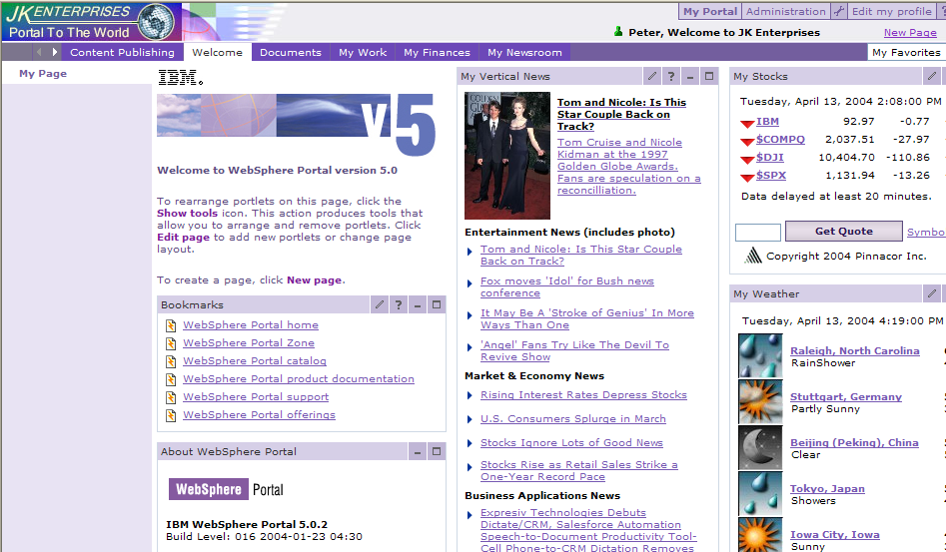

Peter navigates to his “My Office” tab to view his e-mail. Some distributors in his Northeast region prefer to place their orders in this manner.
There is an e-mail sent by Lisa Blalock at NC Toys.
Peter opens up Lisa’s e-mail (left mouse click on the upside down triangle next to e-mail and choose “Open”).
Lisa wants to place an order for 3 different products: stuffed koala, stuffed dachshund and toy panda. Peter closes the e-mail popup window and begins to process Lisa’s order.

Peter first wants to confirm that the items and quantities requested are in stock at their regional warehouse. In the past, Peter would need to access several 5250 screens and input the same data on many of those screens to confirm those items are available. Today, with WebSphere Portal, Peter can access all their iSeries applications directly from JK Enterprises’ portal.

Peter first needs to specify a part category. Within the “Parts Category” portlet, Peter left mouse clicks on the drop down menu box.

From the choices available within the drop-down menu, he chooses “Animals”, then “Get Products”.

(For the purposes of the demonstration, make the assumption that Peter has already checked that the first two items are in stock and is now about to check on the third item, the toy panda)
To obtain details about the panda, Peter can either manually enter the part number in the “PartsDetail” portlet or he can take advantage of the portal’s inter-portlet communication and “click-to-action” capabilities.
The portal server provides a mechanism for portlets to communicate with one another, exchanging data or other messages. Portlet communication can be used to copy common data between portlets. This saves redundant typing by the user and makes the portal easier to use. The term "Click-to-Action" is used for the pop-up menu that allows the user to direct the information to a target portlet or set of portlets. The objective of the click-to-action portlets is to increase the productivity of portal users working with multiple portlets by easily enabling them to send information from one portlet to another.

Peter clicks on the icon, to the left of part number 11 with the left mouse button. This activates the “click-to-action” popup menu. His choices allow him to transfer the data to the “Parts Detail” portlet, the “PartsPicture” portlet or to all portlets on the page. He chooses the latter by clicking that choice with the left mouse button. That action automatically sends the part information to the other two portlets. The “Parts Detail” portlet is a 5250 application and the “Parts Picture” portlet is a picture database.

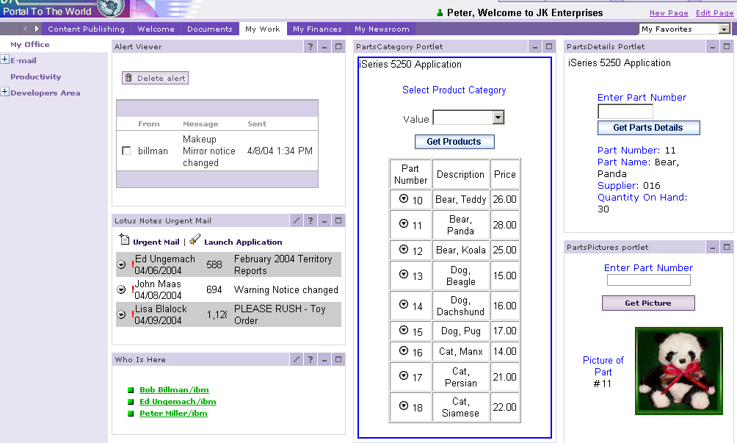

Peter sees from the “PartsDetail” portlet that their regional warehouse does not have enough quantity on hand to fulfill Lisa’s order. “That’s too bad”, Peter thinks for he knows Lisa needs these items as soon as possible.

Peter is about to place this item on backorder, when he notices that Bob Billman, Warehouse manager, has an online status next to his name in the “Who is Here” portlet.
Many functions for dynamic communication are embedded within the fabric of the portal, such as online awareness. Awareness is the ability to tell who a person is and whether they are online, offline, or not available. Awareness can be added anyplace there is a name. This contextual collaboration provides “supercharged” instant messaging and dynamic information capability.
Peter sends Bob an instant message to inquire whether or not a shipment has arrived from the factory that may contain enough toy pandas to complete Lisa’s order. Fortunately, as we see from the instant message, there are indeed enough pandas in this morning’s shipment to fulfill the order.

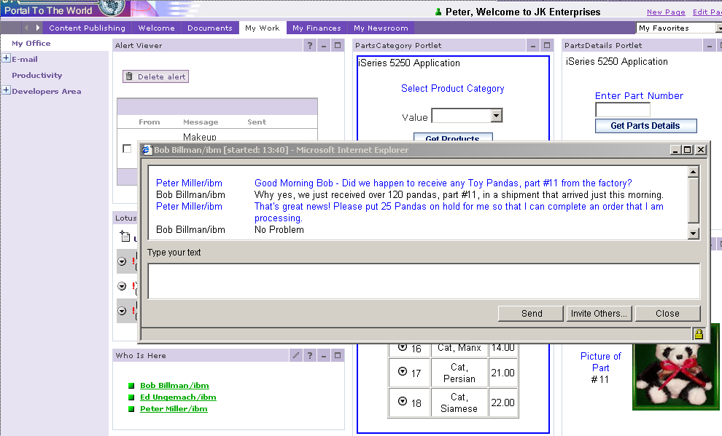

Because of this real-time collaboration, Peter can now process the order, instead of placing Lisa’s request on backorder.
Now that Peter has processed customer orders that were generated overnight, he is ready to continue his daily activities.
Peter observes that his alert viewer contains a notice pertaining to one of their children’s toys that they distribute. He will review the notice in a moment.
Meanwhile, when Peter was reviewing the contents of his e-mail earlier, Peter noticed an item sent by his regional manager Ed Ungemach. Ed has requested that Peter review the monthly sales report for his territory.

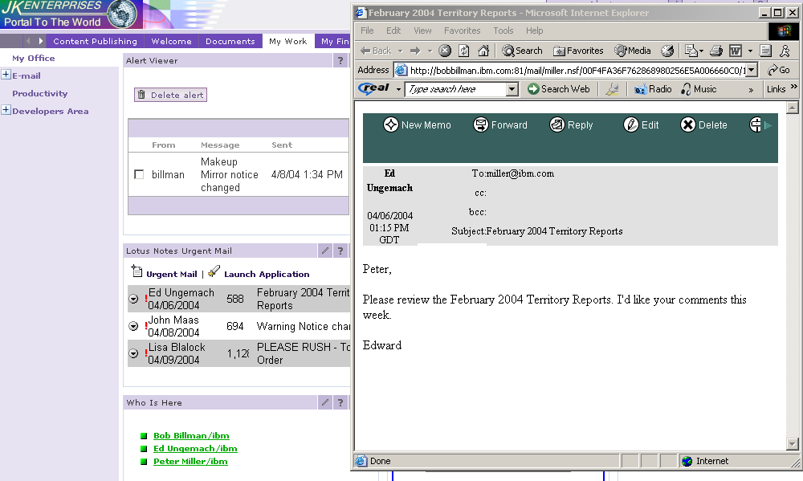

Each month, the regional manager sends the previous month’s sales figures to each of the territory reps for their perusal and commentaries.
Ed did not send an e-mail with an attachment, but instead refers Peter to their company’s centralized document repository, the Portal Document Manager. PDM empowers the territory reps with the capability of viewing, modifying, and managing their documents and information. This is a far more efficient and scalable means of sharing documents than by continually attaching a team document to an e-mail.
Peter clicks on the “Documents” tab and notices several categories within the Portal Document Manager. Since he is a territory sales rep, he then clicks on his department’s (“Sales Dept”) tab to review the monthly sales report.
Peter clicks on “Territory Reports”. He now has several choices: he can view the “Dec 2004 Territory Report” spreadsheet or he can edit that same document. Peter chooses to edit the December 2004 sales spreadsheet because he needs to add both his comments and his initials to it.
Peter clicks on the edit button ( ) to open up the December 2004 Territory spreadsheet in edit mode.

This spreadsheet was originally created by Ed using Microsoft® Excel. Ed then stored the spreadsheet within the Document Manager for all territory reps to access. Text editing and spreadsheet functions are critical to many business processes. However, these functions are not integrated with other systems and are expensive to maintain with existing solutions.
Although Peter doesn’t have the Microsoft® Excel application on his desktop, he may still work with the spreadsheet using the WebSphere Portal Productivity Components. Provided with WebSphere Portal, WebSphere Portal Productivity Components allow users to view, create, convert and edit basic documents, spreadsheets and presentation files from the same portal interface.
The December 2004 Territory spreadsheet contains both the forecasted and the actual sales figures per territory for the month of December. Ed requires all his territory reps to initial the spreadsheet to confirm their perusal. In addition, he asks them to make pertinent comments, such as reasons why actual sales exceeded or didn’t achieve their projected monthly sales figures.
For demonstration sake, we have already appended Peter’s comments to the spreadsheet. Notice that we are adding Peter’s initials using a spreadsheet macro.
Now that Peter has completed his review of the previous month’s sales, he recalls a product notice is listed in his alert viewer. He is now ready to navigate through the folder hierarchy to “Product Notices”. Because a “bread crumb trail” is always visible, Peter always knows where he is in the document management structure and can quickly reach the documents he needs.

Peter clicks on “Sales Dept” within the “navigation” or “bread crumb” trail. This trail is a way for the user to know where he or she is within the hierarchical folder structure and can easily retrace his or her steps.

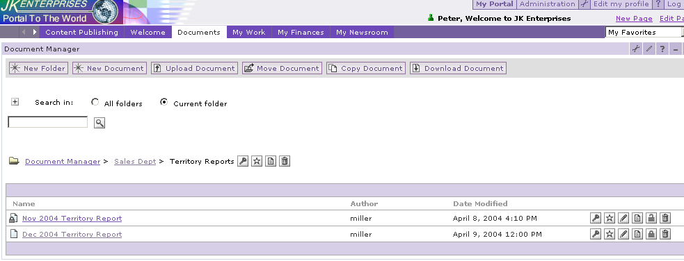
“Navigation” or “Bread Crumb” Trail

Since Peter only needs to view the document, he clicks on “Make-Up Mirror Notice”. You will see a pop-up window that contains the notice. Increase the window size to better read the document.
(Increase the size of the pop-up window by moving the mouse to the bottom right hand side of the window. When you see the double arrows appear, click on the left mouse button and while the left mouse button is still depressed, move mouse to the right until the window is large enough)
This document was created using the productivity components integrated within the portal. Peter notes that the warning notice has changed to now safely recommend this product to 3 and 4 year old children, which increases their market segment for the Make-Up Mirror set.

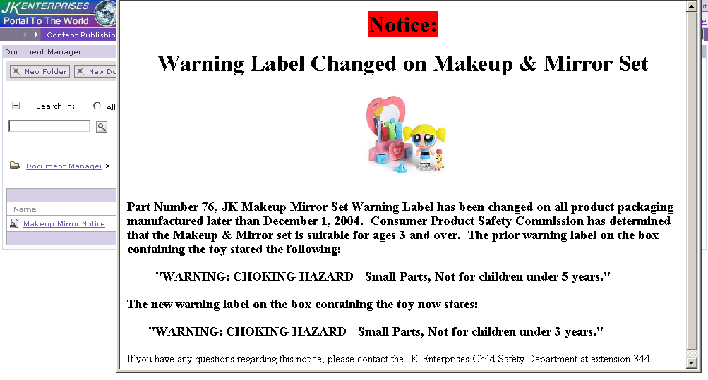

Because WebSphere Portal has helped Peter to prioritize and execute on his tasks in an efficient manner, he handled his most urgent tasks quickly and completely. Now Peter can move on to his regular e-mail for lower priority tasks or for other longer running projects he’s working on.

This concludes the WebSphere Portal HATS/Click-to-Action demo.

See the next few pages for a summary of the key WebSphere Portal benefits shown in this demo.

JK Enterprises HATS/Portal Demo

IBM WebSphere® Portal Benefits

- Application Integration
  - Connect to virtually any application in your enterprise.

- Integration at the glass
  - Combine disparate applications into meaningful work functions.

- Collaboration
  - Permit real-time, person-to-person communications for more efficient work environments.
  - Share documents across the enterprise with security and access control.

IBM WebSphere® Portal
– A single workplace for everything you do.

JK Enterprises HATS/Portal Demo

Host Access Transformation Services Benefits

- Transforms 3270 and 5250 screens into HTML dynamically
- Migrates host applications in a very short timeframe (in hours) without recoding applications
- Integrates with IBM WebSphere® Portal, IBM WebSphere® Application Server and IBM WebSphere® Studio.

IBM WebSphere® Host Access Transformation Services (HATS)

- Quickly and easily extend your legacy applications

JK Enterprises HATS/Portal Demo

Behind the Scenes
(What’s in the Demo?)

WebSphere Portal
People Awareness
Portal Document manager
Click-to-Action
Productivity Components

Host Access Transformation Services (HATS)
Click-to-Action
Rules-based data stream transformation engine

