Problem:
Unable to use the embedded function selector with the delimited data handler because the embedded function selector needs the data handler to read the business object name from the stream and that is how the embedded function selector determines the function name.

Solution:
A couple of new properties are added on the delimited data handler called
- Business object name in stream (check box)
This property indicates if the business object name is in the incoming stream and if it is then it has to be the first field of the stream.

- Business object namespace
If the business object name is in the stream, then the business object namespace has to be specified in this property.

Note: If customer is using WID 6.1.2.IFix002 or higher version, do not need to make WID changes as WID changes will be included in these releases.

Specify properties in WID:
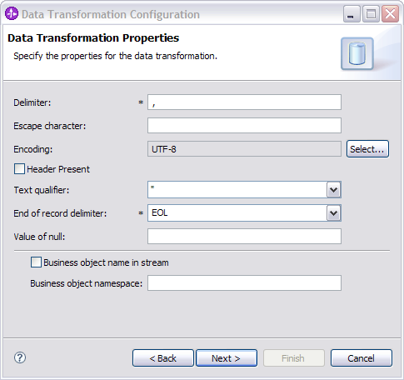

In absence of WID Ifix:
Since the WID ifix for this PMR is not available, the above properties have to be added in the binding resource configuration file by hand until the WID ifix is available.
To add the above properties to the binding resource configuration file, follow these steps
- Create a configuration (.bcfg file) for delimited data handler as before.
- Open the above file in notepad or some text editor.
- Add the following lines to the file (.bcfg)
<isBONameInStream type="boolean">true</isBONameInStream>
<targetNamespace>http://www.ibm.com/crm</targetNamespace>
4. Below is an example a .bcfg file that has the properties added to it in blue.
<?xml version="1.0" encoding="UTF-8"?>
<cfg:bindingConfiguration xmlns:cfg="http://www.ibm.com/xmlns/prod/websphere/bindingconfiguration/6.1.0" name="DataTransformationConfiguration1" targetNamespace="http://LI712I4WIDDemo">
<cfg:typeName>com.ibm.wbiserver.datahandler.delimited.DelimitedDataHandler</cfg:typeName>
<cfg:propertyBean type="com.ibm.wbiserver.datahandler.delimited.DelimitedDataHandlerProperties">
<isBONameInStream type="boolean">true</isBONameInStream>
<targetNamespace>http://www.ibm.com/crm</targetNamespace>
</cfg:propertyBean>
<cfg:tag>BindingKind_DataHandler</cfg:tag>
<cfg:tag>BindingType_JMS</cfg:tag>
<cfg:tag>BindingType_MQ</cfg:tag>
<cfg:tag>BindingType_EIS/Email Server</cfg:tag>
<cfg:tag>BindingType_HTTP</cfg:tag>
<cfg:tag>BindingType_EIS/Remote File System</cfg:tag>
<cfg:tag>BindingType_EIS/Local File System</cfg:tag>
</cfg:bindingConfiguration>

