Problem:
Customer is unable to determine the number of child objects dynamically.

Solution:
Consider the following scenario. There is a customer business object that contains a list of address business objects. The number of address business objects that are received at runtime is determined by the value of the property called “count” in the Customer business object. This is indicated by an annotation on the address property in the Customer schema.

Customer.xsd
<?xml version="1.0" encoding="UTF-8"?>
<xsd:schema xmlns:xsd="http://www.w3.org/2001/XMLSchema" xmlns:bons0="http://www.ibm.com/crm1" targetNamespace="http://www.ibm.com/crm1">
<xsd:include schemaLocation="AnnotatedAddress.xsd"/>
<xsd:annotation>
<xsd:appinfo source="commonj.connector.asi">
<asi:annotationSet xmlns:asi="commonj.connector.asi" asiNSURI="http://www.ibm.com/wbiserver/datahandlers/metadata">
</asi:annotationSet>
</xsd:appinfo>
</xsd:annotation>

<xsd:complexType name="AnnotatedCustomer">
<xsd:sequence>
<xsd:element minOccurs="0" name="id" type="xsd:string"/>
<xsd:element minOccurs="0" name="count" type="xsd:int"/>
<xsd:element maxOccurs="unbounded" minOccurs="0" name="address" type="bons0:AnnotatedAddress">
<xsd:annotation>
<xsd:appinfo source="http://www.ibm.com/wbiserver/datahandlers/metadata">
<metadata:BOPropertyNameASI xmlns:metadata="http://www.ibm.com/wbiserver/datahandlers/metadata">
<metadata:propertyNameForCount>count</metadata:propertyNameForCount>
</metadata:BOPropertyNameASI>
</xsd:appinfo>
</xsd:annotation>
</xsd:element>
</xsd:sequence>
</xsd:complexType>
</xsd:schema>

Please note that the count field has to appear before the list field in the schema.
When specifying the field width in the properties for this case, the width for every field of address is listed only once.
The first annotation is for the business object to be anchored with the application specific editor in WID.

Note: If customer is using WID 6.1.2.IFix002 or higher version, do not need to make WID changes as WID changes will be included in these releases.

Specifying the annotation using WID:
The steps below describe how the property name for count annotation can be added to the business object schema.
- Open the business object in the business object editor.
- Select the property that is of type list or array and select Application Info on the properties view.
- Click on Add…
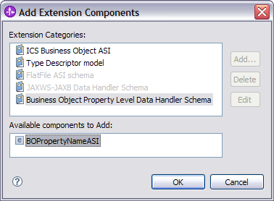

- Select Business Object Property Level Data Handler Schema and then select BOPropertyNameASI and click Ok
- Select BOPropertyNameASI from the Extensions properties view and right click, New ->propertyNameForCount
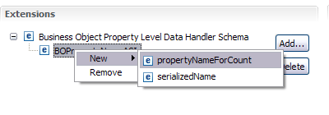
- Add text value in the Extension details section. This value is the name of the property that corresponds to the count of the elements in the array/list property. In our example, this property is called count.
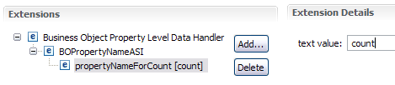
7. Save and this will add the annotation in the schema file.

Note: If WID ifix with the change is not available, then the schema file has to be modified by hand as shown in the example in the solution section.

