Building a SOA Solution with WebSphere Process Integration. A Proof of Technology - Implement Process

Introduction
You will recall that in previous labs, a Business Analyst created the process and exported it from WebSphere Business Modeler v6.0 to WebSphere Integration Developer v6.0. Then the Architect realized one architecture element (Determine Applicant Eligibility activity) from the business model in WebSphere Business Modeler v6.0 and implemented it as a Web Service and an EJB.
In this lab, using WebSphere Integration Developer, the Integration Specialist will implement and test the Account Verification process and use the Determine Applicant Edibility EJB as an implementation of the Determine Applicant Edibility component.

Important: If you encounter problems during the course of this lab, refer to the last section for troubleshooting tips. If you still require assistance, please call the attention of the class instructor or any of the lab assistants.

Lab Module Overview
- 30 min. - Part 1: Examine the Components Exported to WebSphere Integration Developer from WebSphere Business Modeler
- 10 min. - Part 2: Create Originating Human Task for Process Launching
- 20 min. - Part 3: Configure the Human Tasks to Use Custom JSPs
- 15 min. - Part 4: Implement the Java Components
- 45 min. - Part 5: Implement the “Credit Risk Assessment” Business Rules Group Component
- 30 min. - Part 6: Implement the “Request Credit Report” Interface as a Web Service
  - 15 min. – OPTIONAL: Change the Transform from Move Type to Custom Type
- 50 min. - Part 7: Test the Process

Check Point Workspaces
On the C:\Workspaces directory you will find several workspaces.
AccountVerifcation – This is the current workspace.
AccountVerifcation_START – This is the staring workspace for this lab.
AccountVerifcation_COMPLETED_PART6 – This workspace was captured after completing part 6 lab.

- Examine the Components Exported to WebSphere Integration Developer from WebSphere Business Modeler
- Start WebSphere Integration Developer and Refresh the AccountVerification Workspace
- Double click on the WebSphere Integration Developer shortcut on the desktop.
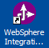
The WebSphere Integration Developer 6.0 shortcut will open the workspace C:\Workspaces\AccountVerification in the Business Integration perspective.
Notice the files in the Business Integration view.
These files have been created for you. They were not generated when the process was exported from WebSphere Business Modeler as BPEL. They represent implementation of the activities invoked from the Account Verification Process.
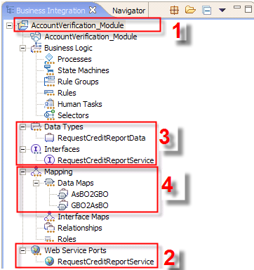
- Notice the AccountVerification_Module. This is the top folder for the Account Verification project.
- Notice the RequestCreditReportService is a Web Service that we will use to implement the “Request Credit Report” task.
Note: The Web Service has been already imported into the workspace. Typically we would use the Web Service Import wizard which allows you to use a selection of UDDI Registries to locate a Web Service 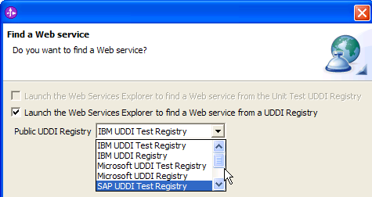
- Notice the Data Types and Interfaces. They define the Web Service and were created when we imported the Web Service.
- Notice the data maps represent the data transformations between the Web Service and the “Request Credit Report” task.
Finally notice that there are some warnings in the Problems view.
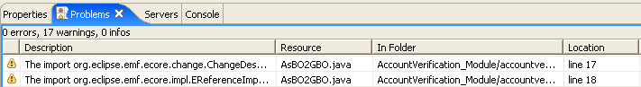
These are expected and can be ignored.
- From the navigation tree in the Business Integration view select AccountVerification_Module.

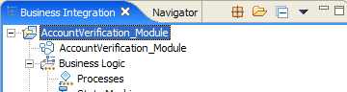
In the next step you will “refresh” the workspace so that it becomes aware of the files generated by WebSphere Business Modeler when you exported Account Verification process to WebSphere Process Server.
- On the AccountVerification_Module click the right mouse button and from the pop-up menu, select Refresh.
The progress indicator in the lower right corner becomes active.

Wait until the progress indicator disappears.
The Business Integration view should now look similar to this:
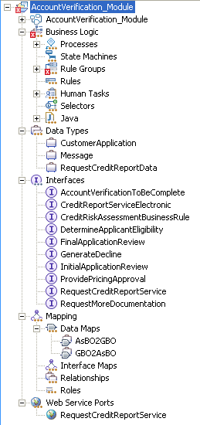
You should now see some warning messages in the Problems view (the error will only appear if specific filter settings are selected).
The warning messages may be ignored.
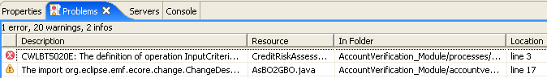
- In the AccountVerification_Module navigation tree expand all + buttons ( )
The Business Integration view should look similar to this:

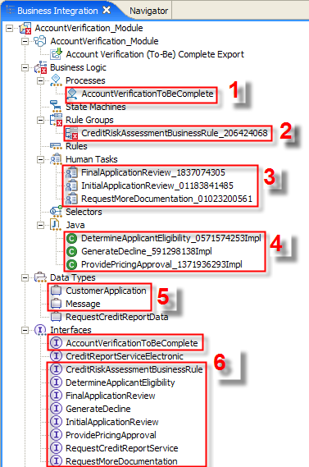 | Note, the artifacts that are not highlighted were pre-built for you.  The highlighted artifacts were generated by the WebSphere Business Modeler export:  - Account Verification Component implemented as a BPEL Process.  - Credit Risk Component implemented as a Business Rule Group Component.  - Final Application Review, Initial Application Review and Request More Documentation components implemented as Human Tasks Components.  - The Java skeletons for the Java components (Determine Applicant Eligibility, Generate Decline and Provide Pricing Approval).  - The Business Objects that represent the input and the output message for the Account Verification process.  - The Interfaces which represent the interface for the BPEL Component (AccountVerifcationToBeCompleted), and below it, the interfaces for the Components that the Account Verification process invokes.

- Examine the CustomerApplication Business Object
Note: This section is optional. It does not contain any steps required to implement the Account Verification Process.
You will now use the Business Object Editor to examine the Business Object representing the input data to the process.
- From the navigation tree in the Business Integration view, double-click AccountVerification_Module > Data Types > CustomerApplication.

The Business Object Editor opens with the CustomerApplication object.
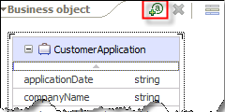

Note that it a top-down design the BO Editor may be used to define a Business Object. You can use the Add Attribute button () to add attributes to the Business Object.

In our case the CustomerApplication Business Object was created during the export from WebSphere Business Modeler. In WebSphere Business Modeler it was originally defined as the CustomerApplication Business Item.

Business Item in WebSphere Business Modeler | Business Object in WebSphere Integration Developer
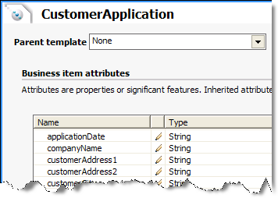

- Click the X button to close the BO Editor.

If you have made any changes do not save them. Press the NO button on the Save Resource window to dismiss changes and close the BO Editor.

- Examine the AccountVerificationToBeComplete Interface
Note: This section is optional. It does not contain any steps required to implement the Account Verification Process.
You will now use the Interface Editor to examine the AccountVerificationToBeComplete interface.
- From the navigation tree in the Business Integration view, double-click AccountVerification_Module > Interfaces > AccountVerificationToBeComplete.

The Interface Editor opens with the AccountVerificationToBeComplete interface.
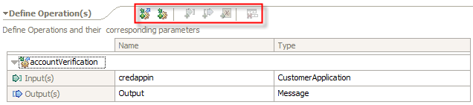

This is the Interface of the Account Verification process and is used by the BPEL Component.

Note the operation name of accountVerification and the two messages: the CustomerApplication input message and the Message output message.

Note that in a top-down design the Interface Editor may be used to define new Interfaces. You can use the various buttons in the Interface Editor palette (highlighted in the screen-shot) to add new operations and messages to an operation.

- Click the X button to close the Interface Editor.

If you have made any changes do not save them. Press the NO button on the Save Resource window to dismiss changes and close the BO Editor.

- Become Familiar with the Process Editor
Note: This section is optional. It does not contain any steps required to implement the Account Verification Process.
The process editor is a graphical programming environment that you use to visually create and manipulate business processes.
The process editor has been designed to make you, the user feel comfortable and to facilitate your creativity. While you are designing your process, think of it as an exercise in how to paint. The white space is called the canvas and it's where you create your process from the objects that you pull from the palette on the left. Below that is an interactive properties area that changes to display pertinent details about whatever object you currently have selected on the canvas.
The process editor is divided into several distinct areas, each with its own individual use.
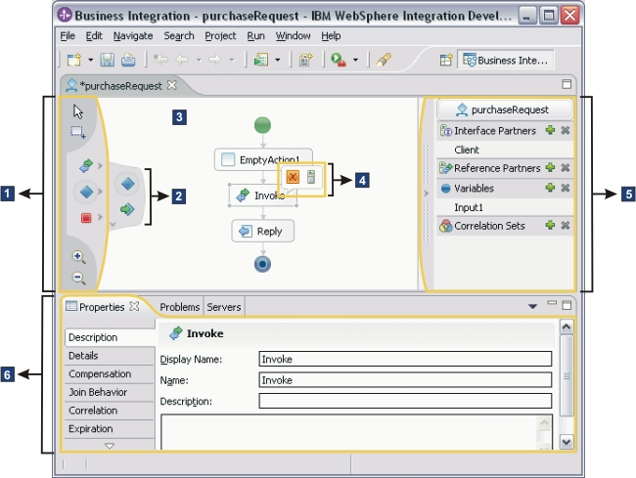
The areas are as follows:
- The palette
  - The palette is the shaded area to the left of the canvas that houses the objects that you click and drag onto the canvas to build your process.
  - Those icons with dark grey arrows contain a submenu with more choices. Click the arrow to expose the submenu. When you chose an activity from submenu, it then becomes active on the main palette

- The submenu
  - Those icons with dark grey arrows contain a submenu with a wider selection of activities.
  - Click the horizontal arrow to expose the submenu, and click the vertical arrows to scroll through the choices.
  - When you choose an activity from submenu, it then becomes active on the main palette.

- The canvas
  - The canvas is the white empty area in the middle of the editor that you use it to assemble the activities to compose your business process.
  - When you click and drag an activity from the palette onto the canvas, the icon beside your cursor has a plus symbol and you can decide where you want to drop the activity. When the cursor becomes a crossed out circle, continue moving the cursor until it becomes a plus sign again.
  - Structured activities (that contain other activities) can be expanded or collapsed by clicking either the miniature plus () or minus () icon.

- The action bar
  - The action bar is a miniature dialogue that pops up beside the activity that you've selected and contains a series of one or more icons that are relevant to that activity.

- The tray
  - The tray displays the Partners, Variables and Correlation sets that are associated with your process.
  - To create a new partner, variable, or correlation set, click the corresponding icon, or to remove one, highlight it and click the icon.
  - Click the gray horizontal arrow to collapse or expand the tray.

- The properties area
  - This area displays properties that are relevant to the object that is currently selected on the canvas. Click on the tabs to the left of this view to toggle through the pages. Some pages display properties in tabular format. You can add or modify these properties by clicking the appropriate cell and then interacting with the graphical interface that appears.
  - The contents of the page will differ on the activity or object chosen. In all cases, you can type F1 to launch a help window and click the link to be taken directly to the product documentation for more details.
  - If you see the File selection ( ) icon you will be able to browse the file system. If you see the Drop Down ( ) icon, you will be presented with a choice of one or more options on-screen.
- Examine the AccountVerificationToBeComplete BPEL Process Component
You will now use the BPEL Editor to examine one of the interfaces files.
- From the navigation tree in the Business Integration view, double-click AccountVerification_Module > Business Logic > Processes > AccountVerificationToBeComplete.

The BPEL Editor opens with the AccountVerificationToBeComplete process.

- Similarly, as required, drag other activities within the Parallel activity so that the process looks similar to this:

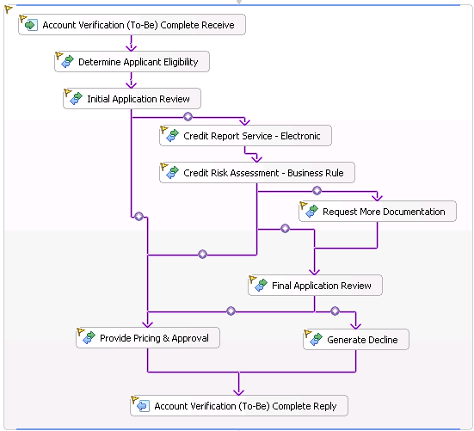

- Compare the Account Verification process defined in WebSphere Business Modeler (shown below) with the BPEL process in WebSphere Integration Developer.
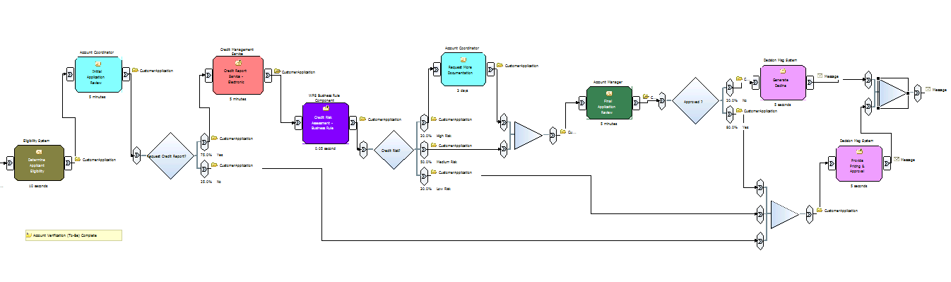
- Examine the BPEL process artifacts.

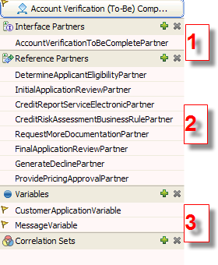 | 1. Interface Partners  This section defines how the process is invoked. Specifically it references the AccountVerificationToBeComplete interface.  2. Referenced Partners  This section defines the interfaces that may be used to invoke the activities defined in the process. For example, in the BPEL process, the Generate Decline activity uses the GenerateDeclinePartner partner reference This partner reference is defined in using the GenerateDecline interface.  3. Variables  The Account Verification process uses two BPEL variables: CustomerApplicationVariable for input and MessageVariable for output. These BPEL variables are defined in terms of the Business Objects shown in the Business Integration view.

Let’s examine how one of the BPEL activities was configured.

- Select the Generate Decline activity.

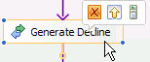

- In the view below the Process Editor, click the Properties tab to switch to the Properties view.

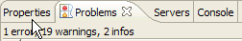

- In the Properties view (below the BPEL editor window) click the Details tab.

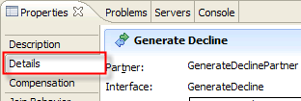

- Examine the details for the Generate Decline activity.

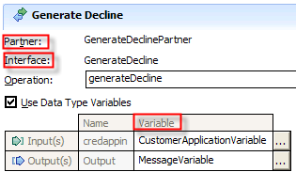 | Partner  Note the Partner GenerateDeclinePartner Recall that it is defined in the Referenced Partners section.  Interface  This is the GenerateDecline interface. It is defined in the Business Integration view.  Variable  Note the names of the BPEL input and output variables. The Generate Decline activity uses CustomerAccplicationVariable for input and MessageVariable for output.

- Examine the Assembly Diagram
When you opened the Account Verification process with the Process editor you saw the activities that the process invokes arranged in an acyclic directed graph. The process editor allows us to configure and connect the activities but it does not allow us to specify the component types or bindings. In short the process editor creates abstract processes. To make a process concrete that is invokable we need to specify the component types and bindings. This is the role of the Assembly Diagram Editor.
- From the navigation tree in the Business Integration view, double-click AccountVerification_Module > AccountVerification_Module.

The Assembly Diagram Editor opens with the AccountVerification_Module module.

- Examine the contents of the Assembly Diagram Editor.

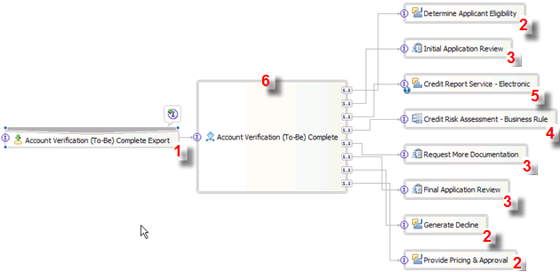
- SCA Export allows the Account Verification process to be ‘visible’. As a result it may be invoked from other modules or from J2EE applications  - Three Components are implemented as Java Components. Recall that their implementations can be seen in the Business Integration view. 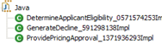  - Three Components are implemented as Human Tasks. Recall that their implementations can be seen in the Business Integration view. 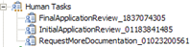 | - One Component is implemented as a Business Rule Group. Recall that its implementation can be seen in the Business Integration view.  - One Service invoked from the Process Component is an existing Web Service and therefore does not need to be implemented. In the Assembly Diagram it appears as unimplemented (). In the Business Integration view there is a Web Service that we imported into the workbench. We will be wiring that Web Service to the Process Component  - The Account Verification process was rendered as a Process Component. Note that the Process component references all the other components.

- Create Originating Human Task for Process Launching
In this part you will create an Originating Human Task for starting the Account Verification process. This type of human task allows to control who may start a process or communicate with a running process by specifying who is authorized to start the process. An Originating Task also allows us to specify the user interface to provide input to the process (either a JSP or a Portlet). Rather than creating a new Human Task Component, you will create an Inline Human Task. An Inline Human Task is only visible to the process in which it is included.
- Create Inline Human Task
- Switch to the Process Editor for AccountVerificationToBeComplete process.
- In the process editor select the Account Verification (To-Be) Complete Receive activity.
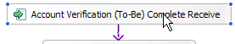
- In the Properties view (below the BPEL editor window) click the Human Task tab.

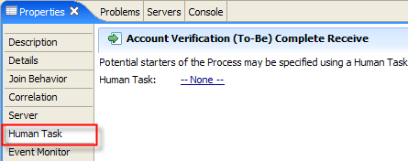

Notice that no Human Task for starting the process has been defined.

- On the Properties page, click the New… button to create a new Originating Task.
The Interface Selection window opens.
- In the Interface Selection window, select the AccountVerifcationToBeComplete interface.
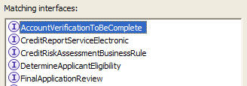
Recall that this is the interface that defines the AccountVerifcation process.
Click the OK button.
The Human Task editor opens for AccountVerificationToBeCompleteTask1 Human Task.
- Configure the Human Task

- Move the cursor over the buttons in the Originator settings section.
Note that you can define Administrator, Potential Starter and Reader roles.
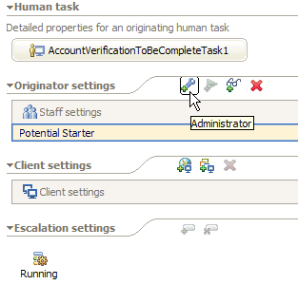
Also note that the Potential Starter role has been already defined.
- Click the Potential Starter role.
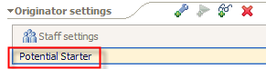
- Examine the contents of the Properties window below the Human Task editor.
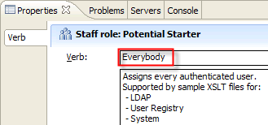
Note that by default, the “Verb” is set to “Everybody”. The verb defines the query against a Staff Repository. A Staff Repository holds the information about the organization structure of an enterprise. Out of the box, WebSphere Process Server can plug into three types of Staff Repositories: (i) Lightweight Directory Access Protocol (LDAP), (ii) Local operating system user registry, and (iii) WebSphere Application Server user registry.
You will now configure the user interface settings for this Originating Task.
- Move the cursor over the buttons in the Client settings section.
Note that you can define BPC Explore and Portal Client for user interface targets.
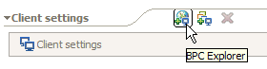
- Click the BPC Explorer button.

- In the Properties window below the Human Task editor, click the Add button.

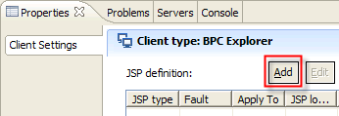

The JSP Definition window appears.

- In the JSP Definition window select the following:

ATTRIBUTE | SETTING
JSP type | Input message JSP
Apply to | All

You will now specify the JSP that defines the user interface for starting the process.

Note: Typically you would need to develop this JSP using the JSP editor. In this lab all of the JSPs have been developed for you. The JSPs are packaged in a separate WAR file called UI_Web.

- To select the JSP location, click the Browse… button.

The Select a JSP window appears.

- In the Select a JSP window, navigate to UI_Web > WebContent and select StartProcess.jsp.

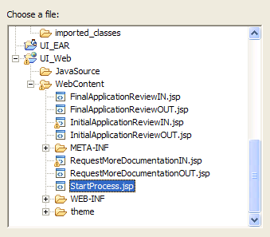

- Click the OK button.

- On the JSP Definition window click the OK button.

The Properties page for the BPC Explorer should look similar to this. Note, you may need to resize the columns to see the full contents.

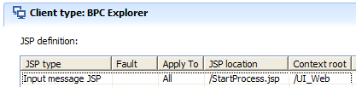

- Press Ctrl-s to save.
Note: In this workspace the automatic incremental workspace re-built is turn on. Whenever you change and then save a file WebSphere Integration Developer will rebuild you project.
- Click the X button to close the Human Task Editor.
- On the Process Editor, Press Ctrl-s to save.
- Click the X button to close the Process Editor.
- Configure the Human Tasks to Use Custom JSPs
Recall that in WebSphere Business Modeler you defined three tasks to have a Human Task implementation. As part of the export to WebSphere Process Server, WebSphere Business Modeler created three Human Task components.
In this part we will configure the three Human Tasks defined in the Account Verification process to use custom JSPs for input and output.
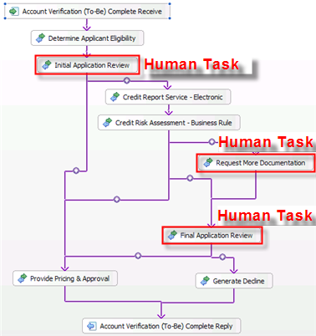
- Configure Final Application Review Human Task
- From the navigation tree in the Business Integration view, double-click AccountVerification_Module > Business Logic > Human Tasks > FinalApplicationReview_1837074305.
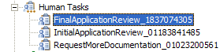
The Business Object Editor opens with the Human Task.
- Move the cursor over the buttons in the Client settings section and click the BPC Explorer button.
- In the Properties window below the Human Task editor, click the Add button.

The JSP Definition window appears.

- In the JSP Definition window select the following:

ATTRIBUTE | SETTING
JSP type | Input message JSP
Apply to | All

You will now specify the JSP that defines the user interface for this Human Task.

- To select the JSP location, click the Browse… button.

The Select a JSP window appears.

- In the Select a JSP window, navigate to UI_Web > WebContent and select FinalApplicationReviewIN.jsp.
- Click the OK button.
- On the JSP Definition window click the OK button.

- In the Properties window below the Human Task editor, click the Add button.

The JSP Definition window appears.

- In the JSP Definition window select the following:

ATTRIBUTE | SETTING
JSP type | Output message JSP
Apply to | All

You will now specify the JSP that defines the user interface for this Human Task.

- To select the JSP location, click the Browse… button.

The Select a JSP window appears.

- In the Select a JSP window, navigate to UI_Web > WebContent and select FinalApplicationReviewOUT.jsp.
- Click the OK button.
- On the JSP Definition window click the OK button.

The Properties window for the BPC Explorer should now look similar to this:

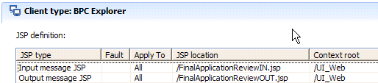

- Press Ctrl-s to save.
Hint: If you see a window that is reporting an error, simply dismiss it and continue.
- Click the X button to close the Human Task Editor.
- Configure Initial Application Review Human Task
- From the navigation tree in the Business Integration view, double-click AccountVerification_Module > Business Logic > Human Tasks > InitialApplicationReview_01183841485.
The Business Object Editor opens with the Human Task.
- Repeat the steps b-j from Section 1. Configure Final Application Review Human Task
Use the following settings for the Input JSP:
ATTRIBUTE | SETTING
JSP type | Input message JSP
Apply to | All
JSP location | UI_Web > WebContent > InitialApplicationReviewIN.jsp.
Use the following settings for the Output JSP:
ATTRIBUTE | SETTING
JSP type | Output message JSP
Apply to | All
JSP location | UI_Web > WebContent > InitialApplicationReviewOUT.jsp.

The Properties window for the BPC Explorer should now look similar to this:

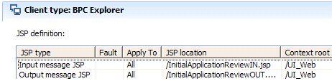

- Configure Request More Documentation Human Task
- From the navigation tree in the Business Integration view, double-click AccountVerification_Module > Business Logic > Human Tasks > RequestMoreDocumentation_01023200561.
The Business Object Editor opens with the Human Task.
- Repeat the steps b-j from Section 1. Configure Final Application Review Human Task
Use the following settings for the Input JSP:
ATTRIBUTE | SETTING
JSP type | Input message JSP
Apply to | All
JSP location | UI_Web > WebContent > RequestMoreDocumentationIN.jsp.
Use the following settings for the Output JSP:
ATTRIBUTE | SETTING
JSP type | Output message JSP
Apply to | All
JSP location | UI_Web > WebContent > RequestMoreDocumentationOUT.jsp.

The Properties window for the BPC Explorer should now look similar to this:

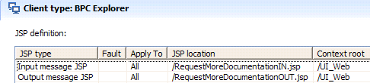

- Implement the Java Components
Recall that in WebSphere Business Modeler you defined three tasks to have a Java implementation. As part of the export to WebSphere Process Server, WebSphere Business Modeler created three Java components.
In this section, acting as a J2EE Developer, you will write some Java code to implement the Java components.
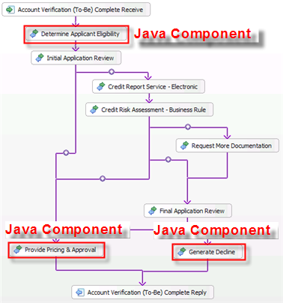
- Implement Determine Applicant Eligibility Component
- From the navigation tree in the Business Integration view, double-click AccountVerification_Module > Business Logic > Java > DetermineApplicantEligibility_0571574253Impl.
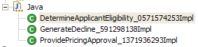
The Java Editor opens with the Java source code. Recall that you are now acting as a J2EE Developer, you will write some Java code to implement the Java components.
- In the Java editor, use the cursor and the left mouse button to highlight the following code:

- Click the Delete button to delete it.
The Java editor should now show an empty Java method similar to this:
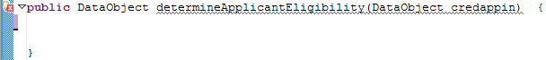
- Position the cursor inside the empty Java method.
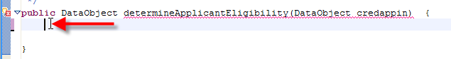
- Type a code template dae (determine applicant eligibility) and click the Ctrl-space Bar
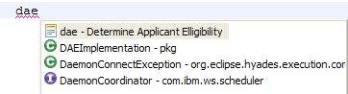
Note: Typically you would need to type this code just like a Java developer would. In this lab the code was stored in a Eclipse editor template called “dea”.
- Press the Enter key.
The Java method with the code implementing it show now look similar to this:
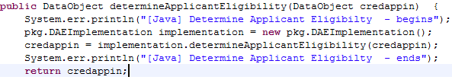
This code snippet invokes the EligibilityService EJB. Recall that you created the EJB using Rational Application Developer from the model of this activity that you imported from WebSphere Business Modeler.
- Press Ctrl-s to save.
Click the X button to close the Java Editor.
- Implement Generate Decline Component
- From the navigation tree in the Business Integration view, double-click AccountVerification_Module > Business Logic > Java > GenerateDecline_591298138Impl.
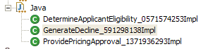
The Java Editor opens with the Java source code.
- Repeat the steps b-g from section 1. Implement Determine Applicant Eligibility Component.
Use the template name of: gd (generate decline).

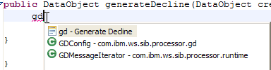

The Java method with the code implementing it show now look similar to this:

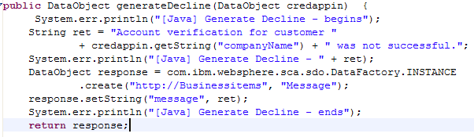
- Implement Provide Pricing Approval Component
- From the navigation tree in the Business Integration view, double-click AccountVerification_Module > Business Logic > Java > ProvidePricingApproval_1371936293.
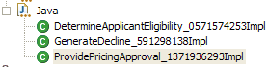
The Java Editor opens with the Java source code.
- Repeat the steps b-g from section 1. Implement Determine Applicant Eligibility Component.
Use the template name of: ppa (provide pricing & approval).
Hint: After typing the template name of ppa you will not have to hit the Enter key to select the macro. It will be automatically selected because it is the only thing resolved during the Ctrl-Space.

The Java method with the code implementing it show now look similar to this:

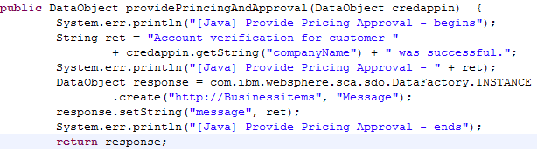

- Implement “Credit Risk Assessment” Business Rules Group Component
Recall that in WebSphere Business Modeler you defined one task to have a Business Rule Group implementation. As part of the export to WebSphere Process Server, WebSphere Business Modeler created a Business Rule Group component.
In this section we will use a visual editor to implement the Business Rule Group component.
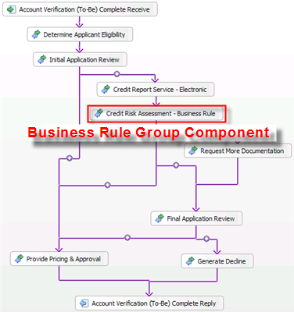
- Configure the Business Rule Group Component
- From the navigation tree in the Business Integration view, double-click AccountVerification_Module > Business Logic > Rule Groups > CreditRiskAssessmentBusinessRule_206424068.
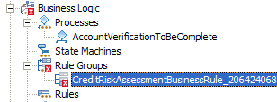
The Rule Group editor opens with the Credit Risk Assessment Rule Group component.
- In the Interfaces section click the InputCriterion operation.
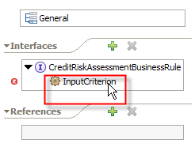
- In the right pane, click Enter Destination.
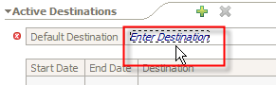
- From the pull down menu click New Ruleset…
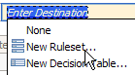
The New Rule set window appears.
- In the New Rule set window click the Finish button.
The Rule Set Editor opens for the InputCriterion Rule Set.
- Create Rule Set – Create Rule Template
- In the Templates section, click the Add if Then Template button.
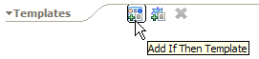
- Within Template 1, click the Add Template Parameter button three (3) times.
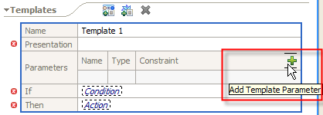
- Click Select Type of param1 and select int.
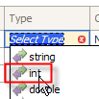
- Click Select Type of param2 and select int.
- Click Select Type of param3 and select string.
The Parameters should now look similar to this:
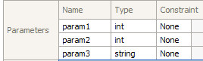
- Click Condition and select All of the following are true.
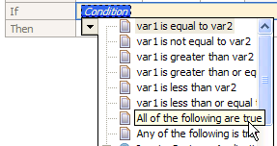
- Click the first Condition and enter Input.creditScore > param1
Note: The editor will allow you to select these values from existing choices. Foe example, if you type in “I”, the expand the input value, scroll down until you see creditScore and click it. 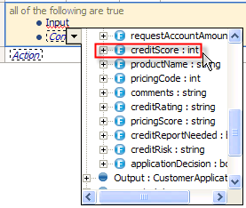 However you can also type the condition values as well.
- Click the second Condition and enter Input.creditScore < param2
The If clause should now look similar to this:
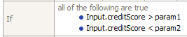
- Click Action and enter Output.creditRisk = param3
The Then clause should now look similar to this:
- Position the cursor on the Presentation entry area.
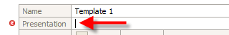
- Type “If customer credit score is greater than “.
- Click the down arrow button and select param1.
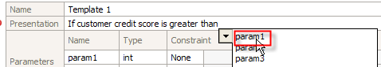
- Type “ and less than “.
- Click the down arrow button and select param2
- Type “ then credit risk is “.
- Click the down arrow button and select param3
The Presentation should now look similar to this:
Note: Using a special web application (Business Rules Manager) the thresholds (param1, param2 and param3) may be changed dynamically without redeploying the Business Rule Group component.
- Create Rule Set – Create Default Rule
Before we add our rules we need to add some action rules for the default behavior.
- In the Rules section, click the Add Action Rule button.
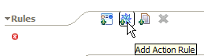
- In Rule 1 select Action and enter Output = Input.
- Press Enter key to add a new Action.
- In Rule 1 select the second Action and enter Output.creditRisk = “HIGH”
Rule 1 should now look similar to this:
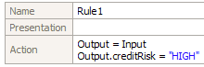
- Create Rule Set – Create Template Rules
We will now add three action rules that map the credit score obtained from the “Request Credit Report” Web Service to the a credit score value of “LOW”, “MED” and “HIGH”.
- In the Rules section, click the Add Template Rule button and select Template1
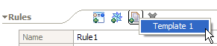
- In the Presentation section entry area for Rule2 enter:
ATTRIBUTE | SETTING
1st Enter Value | 330
2nd Enter Value | 589
3rd^{t} Enter Value | HIGH
- In the Rules section, click the Add Template Rule and select Template1
- In the Presentation section entry area for Rule3 enter:
ATTRIBUTE | SETTING
1st Enter Value | 590
2nd Enter Value | 749
3rd^{t} Enter Value | MED
- In the Rules section, click the Add Template Rule and select Template1
- In the Presentation section entry area for Rule4 enter:
ATTRIBUTE | SETTING
1st Enter Value | 750
2nd Enter Value | 830
3rd^{t} Enter Value | LOW
The rules Rule2, Rule3 and Rule4 should now look similar to this:
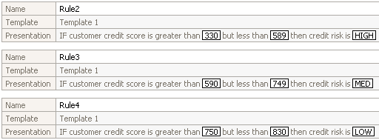
- Press Ctrl-s to save.
- Click the X button to close the Rule Set Editor.
- Press Ctrl-s to save.
- Click the X button to close the Rule Group Editor.
At this point the Problems window should show no errors; it should look similar to this:
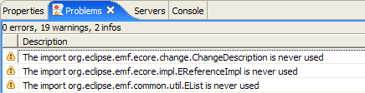
- Implement the “Request Credit Report” Interface as a Web Service
Recall that in WebSphere Business Modeler you defined one task to have no implementation. As a result, when the process was exported to WebSphere Process Server, a component with no component type was created.
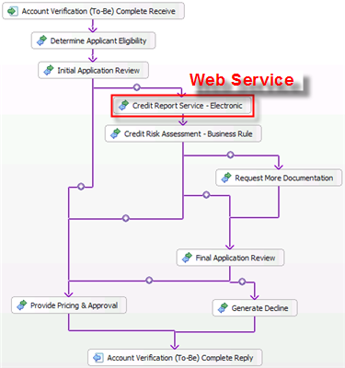
In this section we will use SCA Import to make an exiting Credit Report Web Service available to the Account Verification process.
Our design point is to maintain the contract between the Account process and the Request Credit Report service. In concrete terms this means that we cannot change the interface or the data types used in the process to invoke the Credit Report service. This poses a problem. The Web Service we have selected does not support the interface that the process uses. In order to solve this problem we will use an interface map component and data maps. The interface map component will map the interface required by the process to the interface offered by the Web Service, and the data maps will map the input/output data between the process and the Web Services.
This is a good example of bottom up development. So far we have been using the bottom-up approach: we have been generating implementation rather than reusing it.
- Wire the Web Service to the Process via the Interface Map Component
- In the main view, click the Assembly Diagram Editor tab to switch to the Assembly Diagram Editor.
- Select the Interface Map component () from the palette.
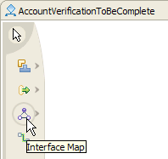
- Click the cursor on the Assembly Diagram.
The interface Map component appears.
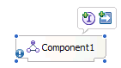
- From the navigation tree in the Business Integration view, select Web Service Ports > RequestCreditReportService.
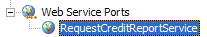
Drag it and drop it on the Assembly Diagram Editor.
The Component Creation window appears.
- In the Component Creation window select Import with Web Services Binding and click the OK button.
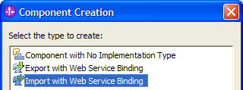
The Web Service SCA Import appears.
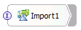
- Select the Credit Report Service – Electronic component.
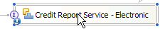
- Click the Delete key to delete it.
- On the Account Verification (To-Be) Complete component, click the un-wired reference.
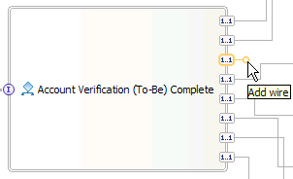
- Select the yellow circle and hold the left mouse button.
- While holding the left mouse button, move the cursor to the Interface Map component (Component1) and release.
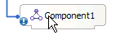
The Add Wire window appears.
- On the Add Wire window click the OK button.
The Interface Map component is now connected to the Process component.
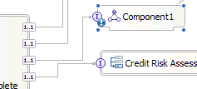
- Select the Interface Map component (Component1), and select the yellow circle.
- Select the yellow circle and hold the left mouse button.
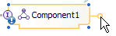
- While holding the left mouse button, move the cursor to the Web Service Import component (Import1) and release.
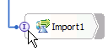
The Add Wire window appears.
- On the Add Wire window click the OK button.
The Interface Map component is now connected to the Web Service Import component.
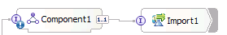
- Click on the Assembly Diagram Editor, click the right mouse button and from the pop-up menu select Arrange Contents Automatically.
The Assembly Diagram should now look similar to this:
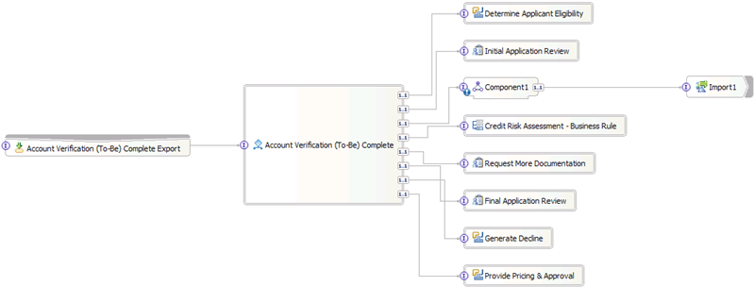
- Implement the Interface Map Component
- In the Assembly Diagram Editor, select the Interface Map component (Component1), click the right mouse button and from the pop-up menu select Generate Implementation.
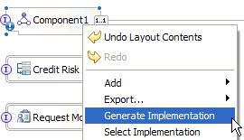
The Generate Implementation window appears.
- On the Generate Implementation window click the OK button.
The Interface Map Editor opens for Component1.
- Select the operation on the left (InputCriterion), press the left mouse button and start dragging the cursor towards the operation on the right (getCustomerCreditScore).
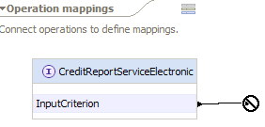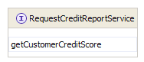
- Connect the InputCriterion operation with the getCustomerCreditScore operation by releasing the cursor on getCustomerCreditScore.
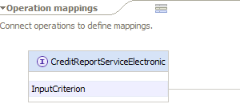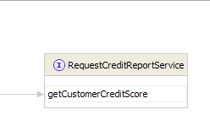
- Click the connection between the operations.
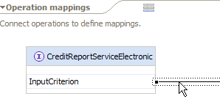
The Parameter mappings pane appears below.
- In the Parameter mappings pane, connect Input CustomerApplication message to Input RequestCreditReportData (left to right).
Hint: Use the same steps (drag and drop method) as when connecting operations in steps c-d.
- From the Properties window below select map for the Parameter Mapping Type.
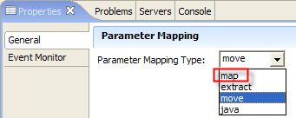
We will now use a pre-built Business Map to map the Business Object used in our process to the Business object used in the Web Service. In Section 3 and 4 you will learn how to build Business Object Maps.
- In the Properties window select the Advanced tab.
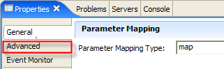
- For the Business Object Map select GBO2AsBO (General Business Object to Application Specific Business Object)
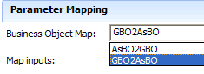
Note: Two Business Object Maps have been provided for you. You can find them in the Business Integration view:
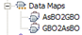
After you complete this section we will examine the how the data maps were constructed.
At this point the parameter mapping page should look similar to this:
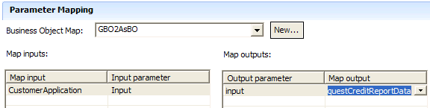
- Inside the Interface Map Editor, connect getCustomerCreditScoreReturn RequestCreditReportData message to Output CustomerAplicationData (right to left).
Hint: Use the same steps (drag and drop method) as when connecting operations in steps c-d.
- From the Properties window below select map for the Parameter Mapping Type.
- In the Properties window select the Advanced tab.
- For Business Object Map select AsBO2GBO (General Business Object to Application Specific Business Object)
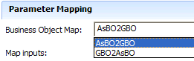
At this point the parameter mapping page should look similar to this:
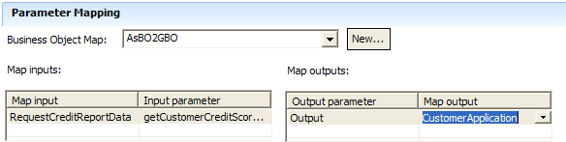
- Press Ctrl-s to save.
- Click the X button to close the Interface Map Editor.
- With the focus on the Assembly Diagram Editor, press Ctrl-s to save.
- Click the X button to close the Assembly Diagram Editor.
The progress indicator in the lower right corner becomes active
Wait until the progress indicator disappears.
- Examine How the Business Object Maps Were Constructed
Recall that in the previous steps we needed an interface map component to resolve the impedance mismatch between an interface originally designed in WebSphere Business Modeler and the Web Service interface we decided to use. The interfaces we needed to transform used different data types. The Interface Map component uses Business Object Maps to map the attributes of these different data types.
The Business Object Maps were pre-built for you. Let’s examine how they were constructed.
- From the navigation tree in the Business Integration view, double-click AccountVerification_Module > Mapping > Data Maps > GBO2AsBO.

The Business Object (BO) Map Editor opens with the Customer Application object.

- Examine the contents of the BO Map Editor.

Notice that it maps the CustomerApplication BO (used by the Account Verification process) to the RequestCreditReportData BO (used by the Web Service).

Typically the objects would contain different data that would require more complex mappings. For the purpose of this lab we used simple “Move” mapping strategy.

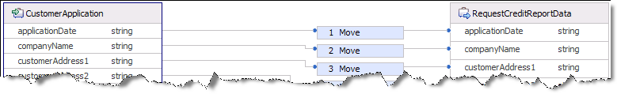

- Select the first 1 Move box, click the right mouse button and from the pop-up menu select Change Transform Type. Do not select anything, just examine the available transform types.

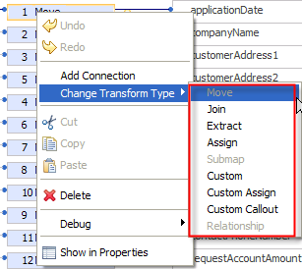

There are nine transform types to choose from:
- Move - This type of transform assigns the value in the source attribute to the target attribute.
- Extract - In this type of transform, the source attribute value must be a String. This extracts a portion of the String and assigns it to the target attribute. This is similar to the String.substring() method in Java™.
- Join - This type of transform combines the values of two or more source attributes into one, and assigns that to the target attribute. The target of a Join transform must be a String.
- Submap - In this type of transform, the source and target must be business object themselves (that is, they must be complex types). The input and output of the specified business object map must be of the same type as the sources and targets of the transform.
- Custom - This type of transform specifies the logic for mapping the inputs and output by using Java code.
- Assign - This type of transform sets the constant value to the output.
- Relationship - This type of transform performs relationship management. The source and target of a Relationship transform must also be complex types.
- Custom Assign - This type of transform is similar to Custom, except that it does not take any input. It is also similar to Assign, except that you can use more in assigning the values using Java (via text or visual editor).
- Custom Callout - This type of transform is similar to Custom, except that it does not take any output. It may be useful for initialization before executing any transforms.
- Click the X button to close the BO Map editor.

If you have made any changes do not save them. Press the NO button on the Save Resource window to dismiss changes and close the BO Map Editor.

- OPTIONAL: Change the Transform Type from Move to Custom
This is an optional exercise.
We will change the transform type for the companyName attribute from Move to Custom. In the Custom transform we will convert the string that represents the company name to lower case. We will use the Visual Snippet Editor rather than code in Java.

- From the navigation tree in the Business Integration view, double-click AccountVerification_Module > Mapping > Data Maps > GBO2AsBO.

The Business Object Map Editor opens with the Customer Application object.

- Select the second Move box- the one that maps the companyName attribute.

- Click the right mouse button and from the pop-up menu select Change Transform Type > Custom.

- In the Properties view (below the BO Map editor window) click the Details tab.

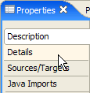

The Visual Snippet Editor opens in the Properties view.

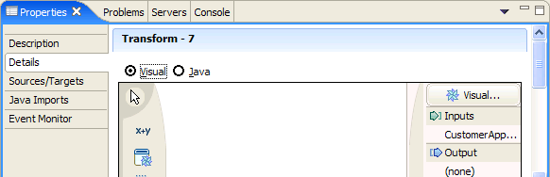

- Double-click on to maximize the Visual Snippet Editor.

- On the editor surface click the right mouse button and from the pop-up menu select Add Existing > CustomerApplication_companyName.

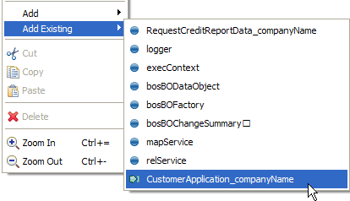
The cursor changes to 

- Click the left mouse button.

The input variable was added. This variable is the companyName attribute from the CustomerApplication BO.

- On the editor surface click the right mouse button and from the pop-up menu select Add Existing > RequestCreditReportData_companyName.
The cursor changes to

- Click the left mouse button.

The output variable was added. This variable is the companyName attribute from the RequestCreditReportData BO.

- On the editor surface click the right mouse button and from the pop-up menu select Add > Standard….

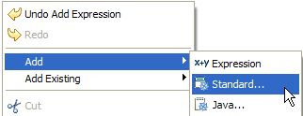

The Add a Standard Visual Snippet window appears.

- In the Add a Standard Visual Snippet window select text > convert to lower case and then click the OK button.

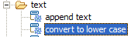

The cursor changes to

- Click the left mouse button with cursor pointing between the other two variables as shown below:

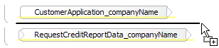
The convert to lower case Visual Snippet appears.

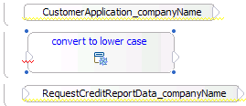

- Click the output terminal of the customerApplication_companyName variable and then click the yellow circle on the customerApplication_companyName variable.

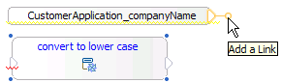
- With the left mouse button pressed, drag the cursor to the input terminal of the convert to lower case Visual Snippet then and release the cursor.

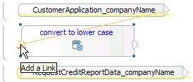

This connects the variable to the Visual Snippet.
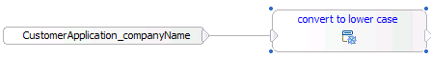

- Click the output terminal of the convent to lower Visual Snippet and then click the yellow circle on the convert to lower Visual Snippet.

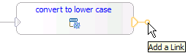
- With the left mouse button pressed, drag the cursor to the input terminal of the RequestCreditReportData_companyName variable.

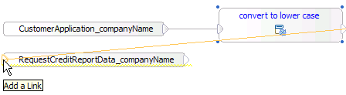

This connects the variable to the Visual Snippet.

- Double-click on to restore the size of the Visual Snippet Editor.

- Press Ctrl-s to save.
- Click the X button to close the BO Map Editor.

- Test the Process
IMPORTANT ➔ Make sure you SHUTDOWN WID and Open It Up again pointing at a NEW workspace named:
“c:\Workspaces\AccountVerification_COMPLETED_PART6”
As we were working on the implementation detail of the Account Verification process, WebSphere Integration Developer incrementally kept building the J2EE artifacts. We are now ready to test the process. For this purpose WebSphere Integration Developer was configured out of the box with a fully functioning WebSphere Process Server. Before we can start testing all we need to do is to point WebSphere Process Server to the J2EE artifacts that WebSphere Integration Developer has generated for us. Once we do that we will be ready to test.
In this section we will test two paths through the process: the simple one and the most complex one.
To test the process you will be using Business Process Choreography (BPC) Explorer. BPC is a web client that communicates with a user in a runtime environment. It allows the user to launch a process and interact with the Human Task components that are defined in the process.
Note: BPC Explorer is intended as a testing/problem determination and administrative tool for managing your WebSphere Process Server solutions.
- Deploy the Process on WebSphere Process Server
- In the view located in the lower right corner click the Servers tab to switch to the Servers view.

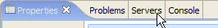

- Select the WebSphere Process Server v6.0 instance and click the Start the server button.

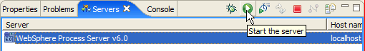

Wait for the server to start.

Before you proceed to the next step wait until all activity in the Console view ceases.

The Console view at that point should look similar to this:

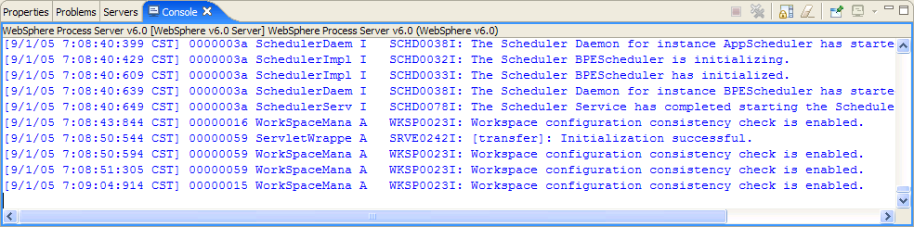

- In the view located in the lower right corner click the Servers tab to switch to the Servers view.

- Select the WebSphere Process Server v6.0 instance, click the right mouse button and from the pop-up menu select Add and remove projects…

The Add and Remove Projects window appears.

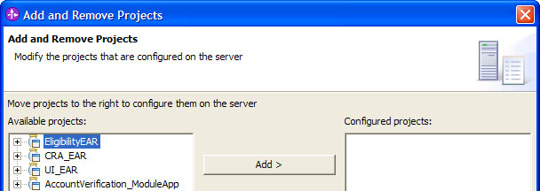

There are four projects (EARs) ready to be deployed to the server:

EligibilityEAR | This project contains the Determine Applicant Eligibility EJB which we used to implement the Determine Applicant Eligibility component.
CRA_EAR | This project contains the Credit Risk Assessment Web Service. This project was pre-built for you.
UI_EAR | This project contains the JSPs used for displaying input and output data for the Human Task components. This project was pre-built for you.
AccountVerification_ModuleApp | This project was generated by WebSphere Integration Developer from the process component and the components that the process components references.

- In the Add and Remove Projects window click the Add All >> button and then click the Finish button.

The view changes from Server to Console.

Wait for the server to finish publishing.

Before you proceed to the next step wait until all activity in the Console view ceases. If the projects published successfully the Console view should contain messages similar to these:

- Run the “Simple Path” Test Case

- In the view located in the lower right corner click the Servers tab to switch to the Servers view.
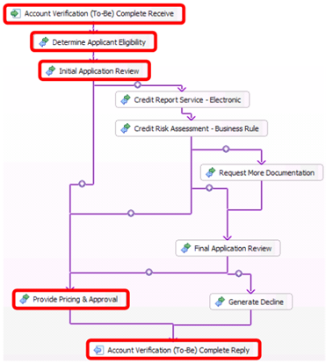 | “Simple Path” Test Case  In the “simple” path the application is approved outright.  There are three processing steps in the “Simple” path:  1. Determine Application Eligibility – determines if the customer is eligible and supplies customer details data.  2. Initial Application Review (Human) – based on the data supplied, determines if the customer’s application should be approved outright or requires more approval steps.  3. Provide Pricing & Approval – processes customer application approval.

- Select the WebSphere Process Server v6.0 instance, click the right mouse button and from the pop-up menu select Launch > BPC Explorer

The BPC Explorer (a Web application) is launched and appears in the main view.

- In the BPC Explorer click the My Process Templates link.

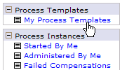

In the right pane a list of Process Templates appears.

- Select the AccountVerifcationToBeComplete_01619437232 check box and then click the Start Instance… button.

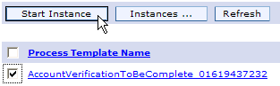
The JSP for starting the process appears.

- In the JSP, make sure that the Company Name is set to ACME and then click the Submit button.

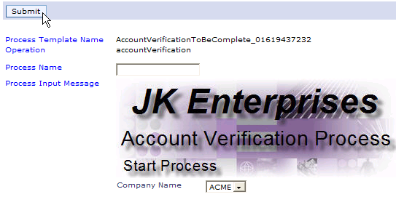

Wait for a few moments and then examine the Console view below the BPC Explorer window. You should see in it a message from the Determine Applicant Eligibility component:

- In the BPC Explorer, click the My Tasks link.

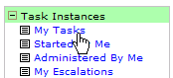

In the right pane, you should now see an instance of the Initial Application Review Human Task.

- Select the InitialApplicationReview_01183841485 check box and then click the Work on button.

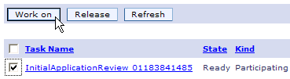

The JSP for providing the input and output for the Human Task appears.

- In the JSP make sure not to select the Credit Report Needed checkbox

- Click the Complete button.

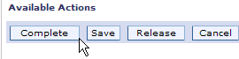

Wait for a few moments and then examine the Console view below the BPC Explorer window. You should see in it a message from the Provide Pricing & Approval component:

This message indicates that the process successfully completed the “Simple Path” test.

- Run the “Complete Path” Path Test Case

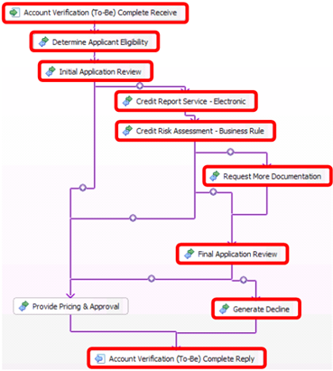
“Complete Path” Test Case
A “Complete Path” is where an application goes through several approval steps and then it is rejected.
There are six processing steps in the “complete path” test case:
1. Determine Application Eligibility – determines if the customer is eligible and supplies the customer details data.
2. Initial Application Review (Human) – based on the data supplied, determines if the customer’s application should be approved outright or requires more approval steps.
3. Retrieve Credit Report – a Web Service that provides a credit rating. In the case of the customer “ACME” the credit rating returned is 800.
4. Credit Risk Assessment – a Business Rule Group that given the credit rating returns a credit risk value. In the case of the customer ‘ACME the credit risk returned is “HIGH”.
5. Request More Documentation (Human) – provides more or changes some of the customer information. It is only executed if the customer credit risk is “HIGH”.
5. Final Application Review (Human) – based on the data supplied, determines if the customer’s application should be approved or declined.
6. Generate Decline – processes customer verification refusal.
- In the BPC Explorer click the My Process Templates link.

In the right pane a list of Process Templates appears.

- Select the AccountVerifcationToBeComplete_01619437232 check box and then click the Start Instance… button.

The JSP for starting the process appears.

- In the JSP, make sure that the Company Name is set to ACME and then click the Submit button.

Wait for a few moments and then examine the Console view below the BPC Explorer window. You should see in it a message from the Determine Applicant Eligibility component:

- In the BPC Explorer, click the My Tasks link.

In the right pane, you should now see an instance of the Initial Application Review Human Task.

- Select the check box of the last instance (the one in a “Ready” state) of InitialApplicationReview_01183841485 Human Task instance and then click the Work on button.

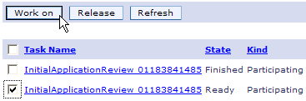

The JSP for providing the input and output for the Human Task appears.

- In the JSP make sure to check the Credit Report Needed checkbox.

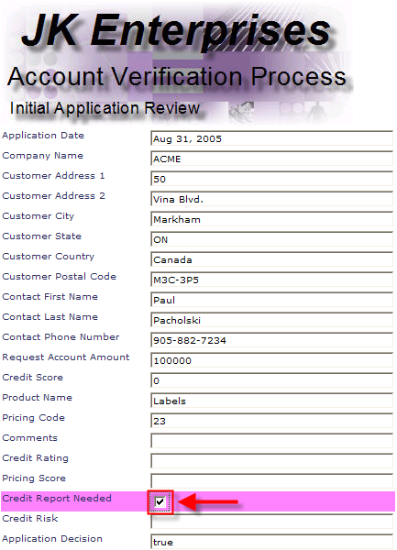

- Click the Complete button.

Wait for a few moments and then examine the Console view below the BPC Explorer window. You should see in it a message from the Request Credit Report Web Service:

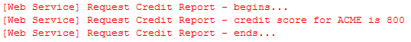

If you have completed the option exercise in Part 6, Step 4 OPTIONAL: Change Transform Type from Move to Custom, you should see the company name in lower case.

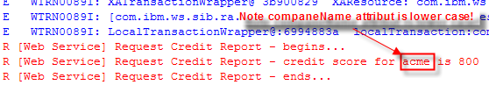

- In the BPC Explorer, click the My Tasks link.

In the right pane, you should now see an instance of the Request More Documentation Human Task.

- Select check box of the RequestMoreDocumentation_01023200561 Human Task instance and then click the Work on button.

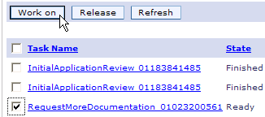

The JSP for providing the input and output for the Human Task appears.

- Enter Reject in the Comments field.
Note: The Request More Documentation Human Task enables you to make changes to the customer application information. Note that most of the entry fields are enabled.
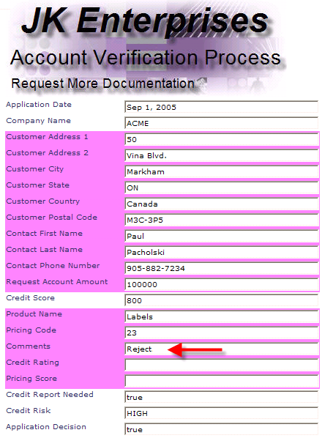

- Click the Complete button.

- In the BPC Explorer, click the Refresh button.

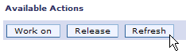

In the right pane, you should now see an instance of the Final Application Review Human Task.

- Select check box of the FinalApplicationApproval_1837074305 Human Task instance and then click the Work on button.

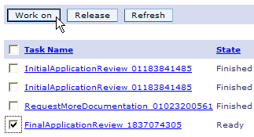

The JSP for providing the input and output for the Human Task appears.

- In the Final Application Review JSP note that the Comments field contains “Reject”.

In the JSP make sure not to select the Application Decision checkbox.

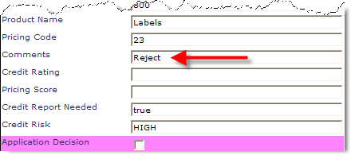

- Click the Complete button.

Wait for a few moments and then examine the Console view below the BPC Explorer window. You should see in it a message from the Provide Pricing & Approval component:

This message indicates that the process successfully completed the “Complete Path” test.

- Cleanup
We need to remove the J2EE artifacts generated in this lab from the WebSphere Process Server 6.0 Test Server.
- Click Server tab in the bottom view.
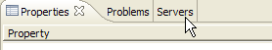
- Select the WebSphere Process Server v6.0.
- Click the right mouse button and from the pop-up menu select Add and remove projects…
Add and Remove Projects wizard appears.
- In the Add and Remove Projects click the << Remove All push button and click the Finish button.

Congratulations!
You have successfully completed your first WebSphere Integration Developer v6.0 lab. ☺

