Building a SOA Solution with WebSphere Process Integration
Develop and Deploy: Rational Application Developer

Lab Introduction
In this lab the student plays the role of the Developer.
Starting with the skeleton implementation produced by the Architect, the Developer uses Rational Application Developer to refine the implementation and to add the required business logic. The Developer then generates a Web service from the implementation, deploys and unit tests the service, passing parameters and verifying that everything works as expected. The Developer then makes the implementation available to the Integration Developer.

Lab Overview
The lab is divided into four parts. These parts correspond to a set of activities that the J2EE Developer performs in a typical Model Driven Development approach.
- Part 1: Refine the Implementation
- Part 2: Deploy the Application
- Part 3: Generate the Web Service
- Part 4: Unit Test the Web Service

Important: If you encounter problems during the course of this exercise, please contact the class instructor or any of the lab assistants.

Note: This lab is intended to be completed in 1 hour.

- Refine the Implementation

The Architect created the design model and applied a J2EE transformation to generate the initial J2EE implementation. Our job as a Developer is to refine that initial implementation to match the business logic for our service.

Exercise 1.1: Start Rational Application Developer
The Developer starts Rational Application Developer after the Architect created the initial implementation of the Eligibility service. The Developer uses a new workspace, in which the projects created by the Architect were already imported.

In terms of functionality, Rational Application Developer is a subset of Rational Software Architect. As your laptop has RSA installed, we will launch RSA in this lab as well, but we will only use features that are available in RAD.


- Start RAD
double-click on the Rational Application Developer shortcut on your desktop

- Enable the “Web Service Developer” role.

- Select Help  Welcome
- Note that the J2EE Developer had the Enterprise Java role already enabled
- Click on the role icon
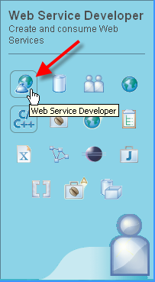

- Select the Web Service Developer
icon
- Note that the Web Service Developer, the Web Developer and the Java Developer are automatically added

Exercise 1.2: Add the business logic
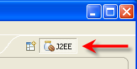
The Developer adds business logic to the skeleton implementation generated by the architect. To keep the lab simple, we created a code template, called dae (Determine Applicant Eligibility) that initializes the parameters and determines whether the credit report is needed or not simply based on for the company name and
- The Developer adds the implementation
- If you are not in a J2EE Perspective, open a J2EE Perspective.

The Tasks view appears at the bottom of the workspace. When it generates codes, RSA will put tasks into the Task list as reminders that we may have to modify the generated code. The first task (TODO Auto-generated method stub) was created when RSA generated the initial J2EE implemented. In the Task list, double-click on the “TODO Auto-generated method stub task” to open and position the editor.
(If you don’t see the Tasks view, select: Window  Show View  Tasks).

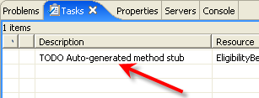

- Double-click on the task TODO Auto-generated method stub

- Right-click anywhere inside the Java code editor and select Show in Package Explorer
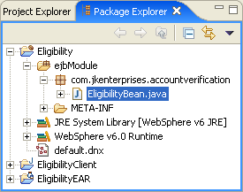

- The Package Explorer view shows the location of the EJB Bean class

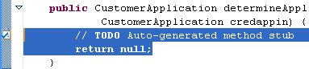
- Select these two lines (the comment line and the return line)

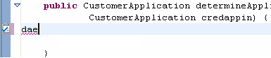
- Type dae,
then press Ctrl+SpaceBar to access the code template

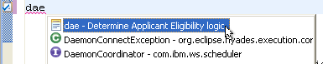
- Select the code template

At this point you will have to resolve the import for the DateFormat Java type:

- Resolve the imports automatically
- Right-click anywhere in the Java code editor and select Source  Organize Imports
- Select java.util.Date and click
- Type Ctrl+S to save the EligibilityBean.java file

- Deploy the Application

In this exercise we will create, deploy and run our Eligibility web service.
The Eligibility web service is one little piece of our bigger application – the Account Verification – that the Integration Developer is putting together.
After adding the required business logic, the J2EE Developer will convert the session bean into a web service, test it, and will make it available to the Integration Developer.
Exercise 2.1: Start the Application Server
We will first start the server and then deploy the project (inverting the order of these two steps will start the server in debug mode).
- Start the WebSphere Application Server v6.0 server
  - In the Servers view, start the WAS Server using the icon

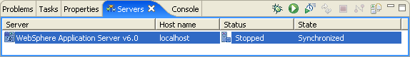
  - Wait a couple of minutes until the server has started

  - Check that the server started correctly, looking at the Console view:
Server server1 open for e-business
Workspace configuration consistency check is enabled.
[transfer]: Initialization successful.
Workspace configuration consistency check is enabled.
Workspace configuration consistency check is enabled.

Exercise 2.2: Deploy the Project
- Add the Eligibility project to the WAS server
  - in the Servers view, right-click the WebSphere Application Server v6.0  Add and remove projects …
  - select EligibilityEAR, click
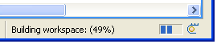
  - wait until the workspace is built and the EAR is published

- Generate the Web Service

In this part we will create and run a web service based on our Eligibility session bean.

Exercise 3.1: Generate the Web Service
The Developer creates a web service from the Eligibility session bean
- Select the Eligibility session bean
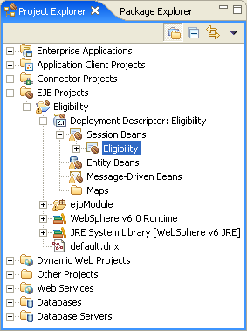

- In the “Project Explorer” view, select
EJB Projects  Eligibility  Deployment Descriptor: Eligibility  Session Beans  Eligibility

- Execute the Web service wizard
- Right-click and select Web Services  Create Web service
[if you don’t see this menu, then your Web Services role is not enabled. Go back to Exercise 1.1 setp 2]
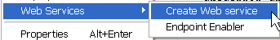
- On the Web Services panel, ensure EJB Web Service is selected as the Web service type.
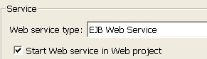
Select Test the Web service and Monitor the Web service.
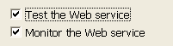
Click the Next button.
- On the “Object Selection Page” panel, note that we will be generating a Web service with:
EAR projects EligibilityEAR
EJB beans Eligilibility
Click the Next button.
- On the “Service Deployment Configuration” panel, ensure that:
Web service runtime: IBM WebSphere
Server: WebSphere Application Server v6.0
J2EE version: 1.4
Service project: Eligibility
EAR project: EligibilityEAR
Click the Next button.
- On the “Web Service EJB Configuration" panel, note that RSA will create a Web application called routerProject for us. This is the project where the Web service will be generated.
Select Router Project: routerProject
Select transports: SOAP over HTTP
Click the Next button.
- Wait for the Web Service to be created.
- On the “Web Service Java Bean Identity” panel, note that if our bean had more methods, we could pick which method to expose as an operation on our service. The only method we have is automatically selected. Check the defaults:
WSDL file: Eligibility.wsdl
Style and Use: Document/Literal
Security Configuration: No Security
Click the Next button.
- On the “Web Service Test Page”, click the Next button.
- Wait for the Web project to start.
- In the “Web Service Publication” panel, leave all options unselected. We will not publish the web service in a UDDI registry now.
Click the Finish button.
- Wait for the Web project to be deployed and executed.
When the Web Services Explorer windows appear, our service is ready to be tested.
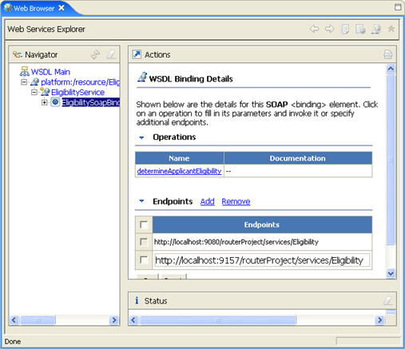

Exercise 3.2: Inspect the Generated Artifacts
Before testing our service, let us look at what was generated by Rational Application developer.
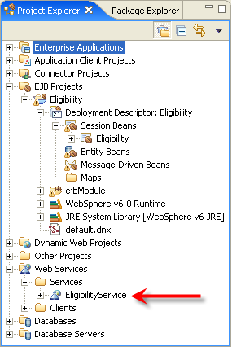
In the Web Services folder, you can see the EligibilityService web service.
- Unit Test the Web Service

Exercise 4.1: Enter Parameters and Execute the Web Service
- Switch back to the Web Services Explorer window
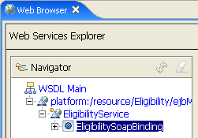

- In the Navigator view, select the determine_Applicant_Eligibility operation
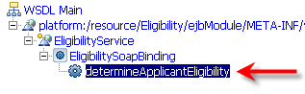
Now we can invoke the Web service operation. The Actions pane should show the parameter names for the Web service

- Add values to the parameters in the Actions window, paying attention to their types (string and integers)
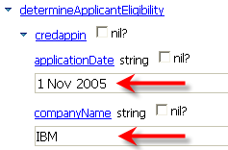
- Add values to all the remaining parameters (if some parameters values are missing, the Web Services Explorer will generate a validation error when you call the service)

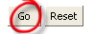
- Select Go at the bottom of the Actions window
This will execute the Web Service.
- Check that the Console windows shows the following message (we used the SystemErr message type, as the red text is easily distinguished):
ServletWrappe A SRVE0242I: [Eligibility]: Initialization successful.
SystemErr R Determine Applicant Eligibility - begins...
SystemErr R Credit report is not needed
SystemErr R Determine Applicant Eligibility - ...ends
- In the Actions pane, change the companyName parameter to ACME and again press the Go button at the bottom of the “Actions” pane.

- The Console window will show that the ACME company requires a credit score.
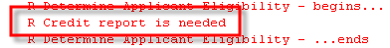

- If you do not want to do the next optional part (examine SOAP messages), remember to stop the WAS server, using the icon
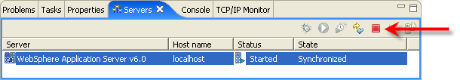

OPTIONAL Exercise 4.2: Examine SOAP messages
When we generated the Web service, we selected Monitor the Web service. This will bring up the TCP/IP Monitor when there is activity to monitor. The TCP/IP Monitor is a simple server that monitors all the requests and the responses between a Web browser and server. In our case, we want to look at the SOAP messages being sent and received.
- Browse the request and response messages in the TCP/IP Monitor window
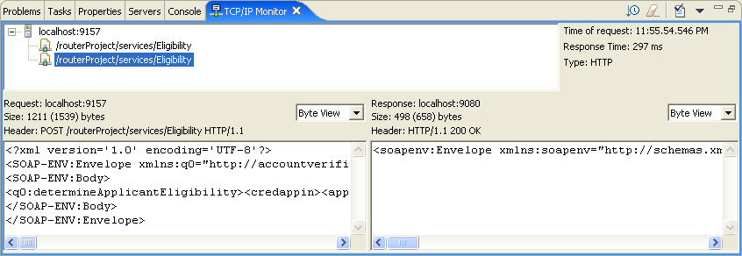
- To make it easier to work with the TCP/IP Monitor view, double-click the title bar (TCP/IP Monitor) to fully expand the view.
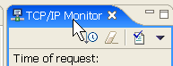
- From the top pane, the list of requests, click the second request.
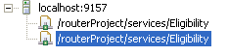
- In both the Request and Response view, use the drop-down arrow to select the XML View. This will make it easier to look at the SOAP messages.
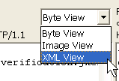
- Examine the Request. Note that the companyName is set to ACME.
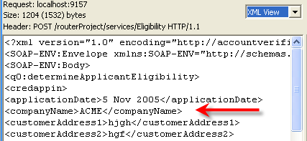
- Examine the Response. Note the creditReportNeeded is set to 1 (needed).
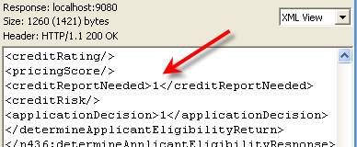
- Close the Web Browser view and the TCP/IP Monitor view.

- Stop the WAS server, using the icon

