Building a SOA Solution with WebSphere Process Integration
Model: Rational Software Architect

Lab Introduction
In this lab the student plays the role of a Software Architect (Architect).
Using a Model Driven Development approach, the Architect uses the business model developed using WebSphere Business Modeler (WBM) as a business contract to implement selected tasks as services.
Using IBM Rational Software Architect (RSA), the Architect creates a relationship between the existing business requirements and the model, and specifies new system requirements.
Once the candidate task(s) for automation have been identified, the Architect uses patterns and transformations to automatically create the skeleton implementation for the service.
Once the service is implemented, the Integration Developer will be able to use it in WebSphere Integration Developer (WID).

Lab Overview
The lab is divided into four parts. These parts correspond to a set of activities that the Architect and the Integration Developer perform in a typical Model Driven Development approach. Fig. 1 shows what roles are involved and what tools are used in each part of the lab.
- Part 1: Review Process Model
- Part 2: Manage Requirements
- Part 3: Identify Architectural Elements
- Part 4: Generate Initial Implementation

Important: If you encounter problems during the course of this exercise, please contact the class instructor or any of the lab assistants.

Note: This lab is intended to be completed in 1 hour.

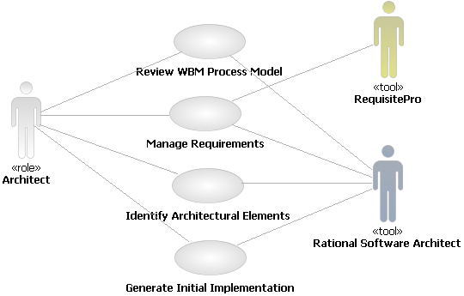

Fig.1 - Roles and Tools used in each part of the lab, represented as a Use Case diagram.

- Review the WBM Process Model

You can open WebSphere Business Modeler projects from within RSA. WBM elements are automatically translated into UML elements when the model is opened. You can browse WBM elements and use them to create UML business use case and analysis diagrams. RSA treats the WBM model as a read-only “business contract”. Any change in the business model should be done by a Business Analyst using WebSphere Business Modeler. You can see the changes in RSA by re-opening the model.
Exercise 1.1 Open the WBM Process Model in RSA

- Start Rational Software Architect as the Architect
  - Double-click the Rational Software Architect shortcut on your desktop

The RSA project Account Opening is already pointing to the WBM Model Workspace “C:\Workspaces\AccountOpeningModel\Account Opening”. We did this in order to pre-populate some diagrams, and make the lab simpler. The Account Opening project was created with the following steps:
- Select File  Import  Existing WBI Modeler 5.1 or 5.1.1 Project into Workspace
- Click Next
- Browse to “C:\Workspaces\AccountOpeningModel\Account Opening
- Click Finish
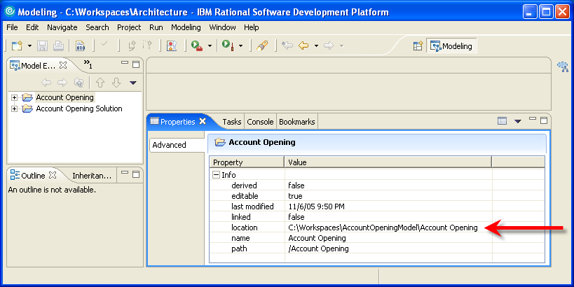

  - expand the Account Opening folder
The Model Explorer view shows the contents of the WBM workspace. Remember that this is NOT an import of the WBM project in RSA. The Account Opening project in RSA is only a reference to the WBM project.
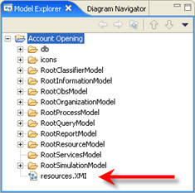
If you delete the Account Opening project in RSA, leave the “Do not delete contents” default selection, otherwise you will delete your WBM project.

- Double-click the resources.XMI file (shown above)
Wait until the translation is finished.

When you open the resources.XMI file, a transformation automatically converts the WBM elements into UML elements.

Exercise 1.2 Browse the WBM Elements
- Expand the model hierarchy
  - Navigate to:
resources.XMI  Account Opening  RootProcessModel  Processes  To-Be Processes

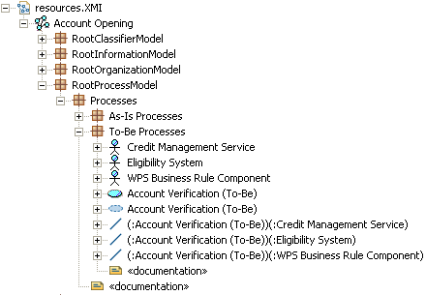

You can see that all the elements in WBM were translated into UML elements: folders into packages,
roles into business actors, processes into business use cases, etc.

- Get familiar with the UML element types
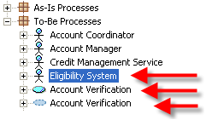
  - Select the Eligibility System (Actor)
  - Select the Account Verification (Use Case)
  - Select the Account Verification (Collaboration)

Each time you select one element in the “Model Explorer” view, the Properties view will show you the type of the element selected (in our example, respectively: Actor, Use Case, Collaboration). This is a very easy way to get familiar will all the UML elements types that are in our Account Opening project.

In case you don’t see the Properties view, go to: Window  Show View  Other… Basic  Properties
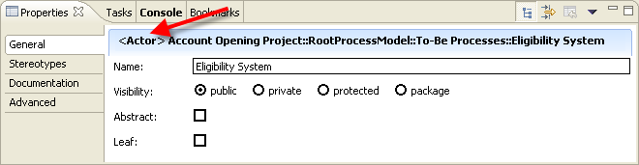

- Browse the “Business Items”
  - Expand the “RootInformationModel” package and the “Business items” package.
Note how all the attributes of the business items have been correctly translated.
The “Account Opening Project” is read-only. If you want to make changes to the business model, you will have to open it with WebSphere Business Modeler, make the changes, and re-open the .xmi file in RSA.
Exercise 1.3 Create a new UML Project
At this point, the Architect creates architectural elements that will fulfill the “contract” represented by the business model.
The Architect creates a new RSA project to separate the business model (the .xmi file) and the system models (where use cases, analysis and design elements will be created), and establishes “external references” between the models.
To make this exercise simpler, we created the UML project and the following UML models and diagrams:
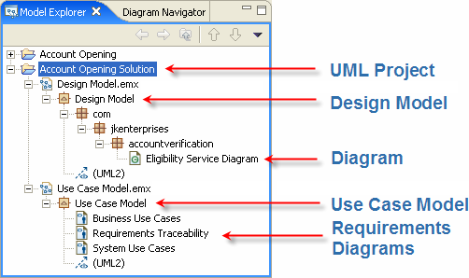

As you can see, the Architect already created the following elements in the Design Model…
com.jkenterprises.accountverification | packages that will contain our design elements (this way the Java code we will generate will have the proper namespace)
Eligibility Service Diagram | the diagram in which we will derive design elements from the business specification

… and the following diagrams in the Use Case Model:
Business Use Cases | to visualize how WBM elements are related
Requirements Traceability | to trace WBM elements to existing and new requirements.  We will populate this diagram in the next exercise (Manage Requirements)

Note that in this example we use a single UML Model for Business and System Use Cases. You could create a separate model for the business requirements.
Exercise 1.4 Browse the UML Diagrams
The Architect has already populated several diagrams. Let us start with the “Business Use Cases” diagram
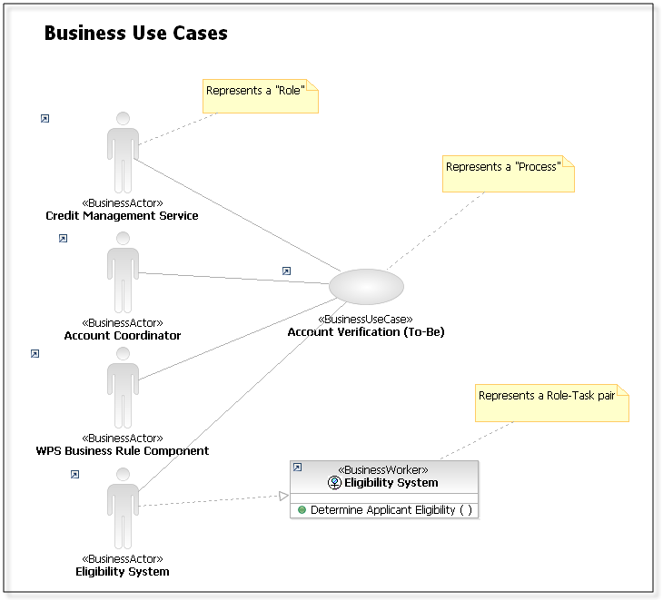

Here’s how your “Business Use Cases” diagram should appear:

Every UML element in the diagram has a little “arrow” symbol to show that the element is an external reference to a different model (our diagram is inside the “Use Case Model”, its elements were taken from the “Account Opening” model).
If you right-click any element in the diagram and select Navigate  Show in  Model Explorer, the Model Explorer will highlight the location of the selected element.
This is how the WBM  RSA transformation maps the elements:
WBM Element | UML Element
“Account Verification” Process | “Account Verification” Business Use Case
“Eligibility System” role | “Eligibility System” Business Actor
“Eligibility System” role associated to the “Determine Applicant Eligibility” task | “Eligibility System” Business Worker (interface) with a “Determine Applicant Eligibility” operation

- Manage Requirements

In this part of the lab the Architect maps UML elements to existing requirements, creating full traceability between the UML models in RSA and the requirements in RequisitePro.
The Architect will also create system requirements (System Use Cases) and trace them to the business use cases.
Exercise 2.1 Trace Requirements
Some business goals (high-level requirements that explain “why” we are interested in modeling and automating certain business processes) have been previously saved by the Business Analyst in RequisitePro.
The Architect populates a UML diagram to visually trace business goals to the business use cases.
- Open the RequisitePro project
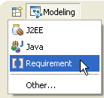
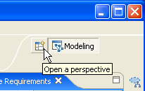

  - open the Requirement perspective in RSA

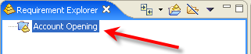
  - in the “Requirement Explorer” view, double-click the Account Opening folder to open the project

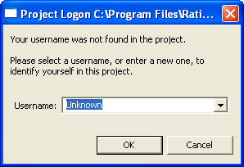

  - Confirm the “Unknown” username (we did not setup security for this project)

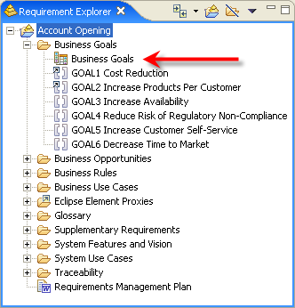
RequisitePro can organize several types of requirements (you can create any type of requirement and add any number of attributes to each). In this project the Business Analyst decided to keep track of the following types of requirements:
- Business Goals
- Business Opportunities
- Business Rules
- Business Use Cases
- Glossary Entries
- Supplementary Requirements
- System Use Cases

- View the Properties of the Business Goals (ROI, Cost, Benefit, Priority, etc.)
  - Double-click on the “Business Goals” query (shown above)

- Populate the Requirements Traceability diagram
  - In the model Explorer, navigate to: Account Opening Solution  Use Case Model.emx  Use Case Model  Requirements Traceability
  - Double-click the “Requirements Traceability” diagram
  - Drag the “Account Verification (To-Be)” business use case into the diagram
(look in: resources.XMI  Account Opening  RootProcessModel  Processes  To-Be Processes  Account Verification (To-Be))
  - From the “Requirements Explorer” view, drag the “GOAL1 Cost Reduction” and the “GOAL2 Increase Products Per Customer” into the diagram
RSA creates two “placeholders” (classes) to represent the two requirements in RequisitePro.

- Change visual attributes of classes
  - Select both classes, right-click and select Filters  Show/Hide Compartment  Name Compartment only
  - Select both classes, right-click and select Filters  Stereotype and Visibility Style  Stereotype: Text
  - Select both classes and use the icon in the RSA toolbox to change the fill color (we used yellow).
  - Select both classes, select the “Stereotypes” tab in the “Properties” view
Keywords: Business Goals

- Trace-up the “Account Verification” business use case to both business goals
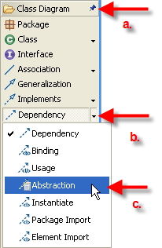
  - Select the “Class Diagram” Palette
  - Select the “Dependency” relationship
  - Select the “Abstraction” relationship
  - drag a line from “Account Verification” to “Cost Reduction”, selecting “Create New Trace”
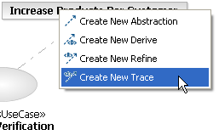

  - Select the “Abstraction” relationship again and drag a new trace line from “Account Verification” to “Increase Products Per Customer”

Here’s how your “Requirements Traceability” diagram should appear:
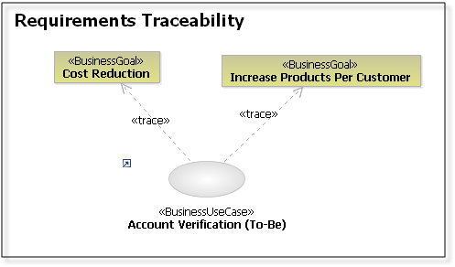

Exercise 2.2 Create System Requirements
Depending on how many requirement types you want to manage in your project, your requirements traceability diagram may look like the following:
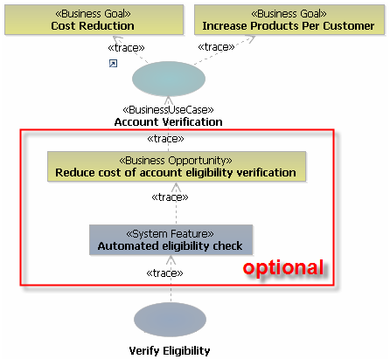
In this diagram we depict a rather complete set of requirements, traced from business goals, to business use cases, to business opportunities, to system features, to system use cases.
Obviously, not every project will require all these requirement types, or full traceability between all of them.
In this lab, we will simplify our requirements and trace business use cases directly to system use cases.
We will create a “Verify Eligibility” system use case, which will describe what the system does in one or more scenarios related to the “Account Verification” business use case.

- Create a System Use Case
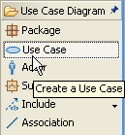

  - From the “Use Case Diagram” Palette, select a Use Case, and click on the diagram window
  - Name: Verify Eligibility

- Trace “Verify Eligibility” to “Account Verification”
  - From the “Class Diagram” palette, select “Abstraction” and drag a trace relationship between the “Verify Eligibility” use case and the “Account Verification” business use case
- Identify Architectural Elements
The Architect uses WBM elements not only to trace and organize requirements, but also as a starting point to model the design and the data of the application.
In the “Account Eligibility” process, the Architect identifies the “Determine Applicant Eligibility” task as a candidate for implementation as a service.
Exercise 3.1 Identify Services
The Architect has already organized the Design Model into packages. We will define the design of the service using the “Eligibility Service” class diagram.
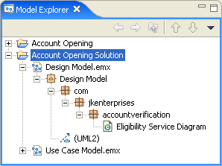
- Open the Design Model
  - in the “Model Explorer” view, double-click the Account Opening Solution project
  - Browse down to the Eligibility Service Diagram
  - double-click the diagram to open it.

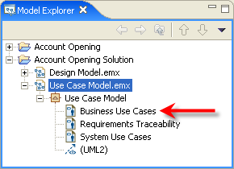
- Identify the interface that will be the starting point for our implementation.

  - Double-click on the “Business Use Cases” diagram you browsed before

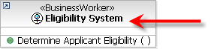
  - Right-click on the “Eligibility System” business worker and select Navigate  Show in  Model Explorer

This will be the starting point for the design of our service.

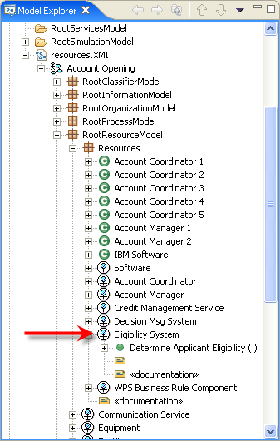
Note that the “Eligibility System” belongs to the WBM model.
The “Eligibility System” is a UML interface stereotyped as a <<Business Worker>> (look in the “Properties” view when the interface is selected).
The interface was automatically created during the WBMUML translation because our business model has an association between the “Eligibility System” role and the “Determine Applicant Eligibility” task.
That association is interpreted in UML as an interface (the role) that has a responsibility (the task). If the role were associated to more tasks, you would see more operations inside the interface.

  - Drag and drop the “Eligibility System” interface from the Model Explorer view into the “Eligibility Service Diagram” diagram

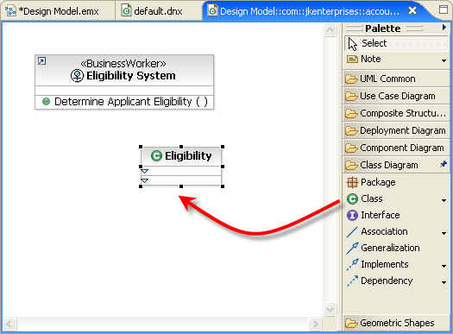
- Create a new class that will implement the interface
  - In the “Palette” view (usually on the right of your diagram), select Class
  - Click the cursor inside the diagram to create the class
  - Name the class Eligibility

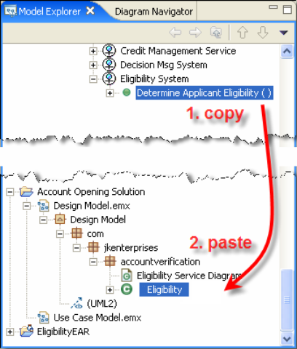
- Add an operation to the new class that matches the business contract.

We will Copy&Paste the existing operation from the interface into the new class.

  - Using the Model Explorer view, copy the Determine Applicant Eligibility() operation from the WBM interface and paste it on top of the new Eligibility class

- Create a “trace” relationship between the service and the business worker
  - In the “Palette” view, select the “Class Diagram” tab and select the “Abstaction” relationship (in the drop-down from the “Dependency” association)
  - Drag a line from the service to the interface, select create new Trace

- Apply the «service» stereotype to the Eligibility class
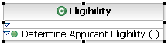
  - select the Eligibility class

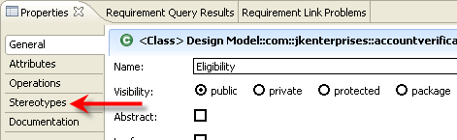
  - in the “Properties” view, select the “Stereotypes” tab

  - click

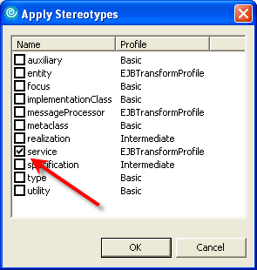

  - Select the service stereotype, click

A stereotype is an UML concept. A stereotype can be added to any UML element (in this lab we added the «service» stereotype to the class Eligibility), and gives “extra” properties to the element. A stereotype is also used by UML transformations: the transformation looks for specific stereotypes in a model, converting them into a new UML object or into implementation code, depending on the selected transformation (in our example, we will apply a transformation that recognizes a «service» and converts it into an EJB, generating all the required Java code automatically).
In RSA you can define your own stereotypes and your own transformations.

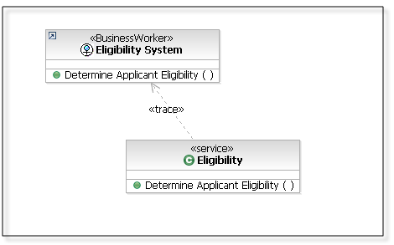

Here’s how your diagram should appear:
Exercise 3.2 Model Data
The Architect looks at the parameters of the “Determine Applicant Eligibility” operations and drags the “Customer Application” business entity in the diagram.
- Visualize the operation signature of the interface
  - Right-click on the “Eligibility” service, select Filters  Show Signature
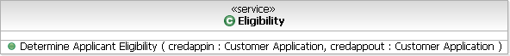

- Add the parameter to the diagram
  - Find the “Customer Application” business entity and drop it in the diagram (look in: resources.XMI  Account Opening Project  RootInformationModel  Business Items)

- Add the “Message” business entity to the diagram
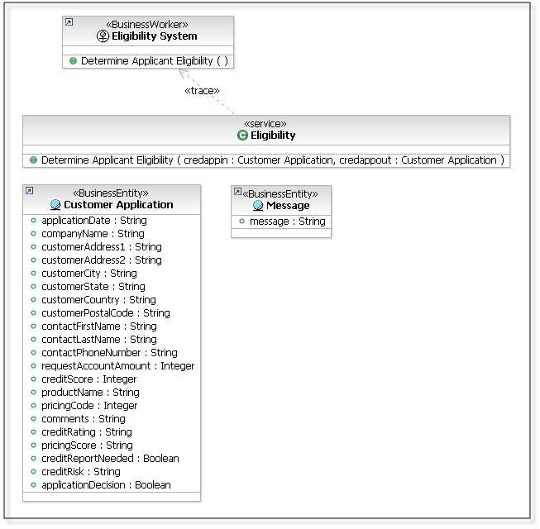

Here’s how your diagram should appear:

- Generate Initial Implementation
Exercise 4.1 Apply Transformations
At this point the Architect wants to use an RSA transformation that automatically generates the skeleton J2EE implementation from our UML design model.
The transformation recognizes several UML model elements and generates appropriate J2EE code based on their stereotype. We will load a UML profile that contains an optional <<Service>> stereotype that the transformation will convert into a Session EJB.

- Generate the skeleton code for the service and the parameter
  - Select the Eligibility service, the Customer Application and the Message business entites
  - Right-click, select Transform  Run Transformation  UML to EJB
  - In the “Run Transformation” dialog, click on
  - Name: Eligibility
  - Select the new “Eligibility” EJB Project

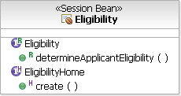
- Browse the generated code for the service
  - Right-click on the Eligibility session bean and select Navigate  Open with  EJB Bean Java Editor

  - Right-click on the white background of the java editor and select
Show in Package Explorer
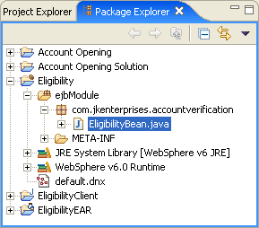

- Browse the generated code for the parameter
  - In the “Package Explorer”, browse to
Eligibility Client  ejbModule  RootInformationModel.BusinessItems
  - Double-click on the CustomerApplication.java file

