Building a SOA Solution with WebSphere Process Integration
Model: WebSphere Business Modeler

About WebSphere Business Modeler
IBM WebSphere® Business Modeler Version 6.0 provides business professionals with easy-to-use tools to design, improve and communicate complex business processes. Tailored for individual user requirements, IBM WebSphere Business Modeler Basic offers entry-level modeling capabilities that allow companies to capture processes at a lower cost per user. IBM WebSphere Business Modeler Advanced provides advanced modeling capabilities for advanced users and delivers sophisticated simulation and optimization capabilities that enable you to analyze the operational efficiency of business processes and potential business results—all before committing resources to development and deployment. Through WebSphere Business Modeler Advanced and WebSphere Business Modeler Basic, you can model the processes that can help you reap the full benefits of on demand business—and the flexibility you need to support and enable the world of integrated business processes.
IBM® WebSphere® Business Modeler Publishing Server Version 6.0 enhances WebSphere Business Modeler by providing a way to publish business processes and related business information, such as organization diagrams, to a secure Web site. This capability supports the development, documentation, and dissemination of business process models on an enterprise and worldwide scale.

Lab Introduction
Business Process Optimization (BPO) efforts analyze critical business processes in an end-end fashion, decomposing them to a series of steps, or activities. Activities are used step-by-step to compose process models, with metrics documented for each activity. As-Is models represent the current state. To-Be Models represent a target state, and are derived by enhancing the As-Is model with changes arrived at through simulation and analysis.
Simulation allows the user to define scenarios where work items (e.g. customer requests) arrive at the beginning of the process model, and flow through all the appropriate tasks in the model. As work items are processed, measurements such as time, cost, throughput are calculated and provide a complete picture of process behavior under “simulated” real conditions. The simulation of the As-Is model can help identify areas for possible improvement. Simulation of To-Be models predicts the performance and financial impact of proposed changes.
For the purposes of this training module, you will be a Business Analyst at JK Enterprises and part of a BPO effort called Project Enterprise with the overarching goals of reducing cost and cycle times. In the course of early BPO analysis, it became patently clear that Account Verification was a strategic reusable process whose improvement would greatly benefit the business. To this end, you are being asked to determine the impact of the process changes.
Once you have completed design, simulation and analysis of the To-Be model, you will define Key Performance Indicators, business measures and technical specifications. Finally, you will generate and export the following artifacts from the business model into the technology domain, for use by Integration Specialists or other IT professionals in automation, deployment and monitoring of the process
Note: Technical specifications are typically handled by advanced users of WebSphere Business Modeler, or by a member of the IT staff, for example, an Integration Specialist. For this lab, these steps are included for completeness.

The following steps have already been completed in your project:
- Model the As-Is process
- Simulate the As-Is process
- Analyze the As-Is process (using both Static and Dynamic Analysis)
- Design the To-Be process (based on Business Goals and Requirements, and results of As-Is simulation and analysis)
In this lab, you will perform the following steps:
- Review the As-Is process model
- Complete the To-Be process model
- Simulate the To-Be process model
- Perform a comparison dynamic analysis using the As-Is and To-Be simulation results
- Generate the Business Measures Model & Define and Review Key Performance Indicators (KPI’s)
- Add Technical Specifications to the To-Be model
- Export artifacts:
  - Business measures (including KPI’s) for WebSphere Business Monitor
  - BPEL and other artifacts to be used by IT in development of the runtime components

Lab Diagram

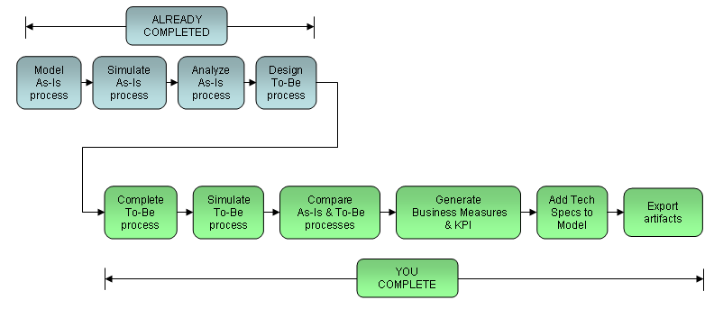

Lab Overview
- Part 1: Review the As-Is Model
- Part 2: Review & Complete the To-Be Model
- Part 3: Simulate, Analyze & Compare
- Part 4: Generate the Business Measures Model & Define and Review Key Performance Indicators
- Part 5: Add Technical Specifications to the To-Be Model
- Part 6: Export the Business Measures Model & BPEL

Important: If you encounter problems during the course of this exercise, please contact the class instructor or any of the lab assistants.

Note: At the time of this writing, WebSphere Business Modeler Version 6.0 is not yet Generally Available*. In this training module, you will be using and “Early Evaluation Program” version of WebSphere Business Modeler Advanced Version 6.0.
*WebSphere Business Modeler Version 6.0 is Announced to be Generally Available on November 30, 2005.

Note: This lab is intended to be completed in approximately 1 hour and 30 minutes.


- Review the As-Is Model
- Start WebSphere Business Modeler Advanced Edition Version 6 Early Evaluation Program
- Double-click on the WebSphere Business Modeler icon on the desktop.
- Click OK at the WebSphere Business Integration window to accept the default workspace location (C:\Workspaces\AccountOpening).
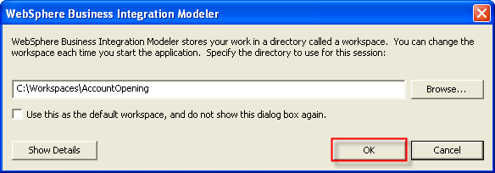

Note: WebSphere Business Modeler is an eclipse-based tool (for more information on eclipse, please visit www.eclipse.org). You will be using WebSphere Business Modeler stand-alone, as you would any standard Windows-based application; however, because it is based on the eclipse framework, we could also optionally plug-in WebSphere Business Modeler with other eclipse-based tools, such as WebSphere Integration Developer, Rational Software Architect or Rational Application Developer, etc. This provides many benefits, including a common workspace for artifacts, sharing the same eclipse ‘shell’ to reduce the use of system resources and the flexibility of being able to quickly switch between each tool’s eclipse perspective, without having to launch separate tools.
We will use the Business Modeling perspective. When WebSphere Business Modeler starts, the Account Verification (As-Is) model should be open in a single pane.

- Review the Account Verification (As-Is) Process Model
- Review the Account Verification (As-Is) process model in the Process Editor pane.
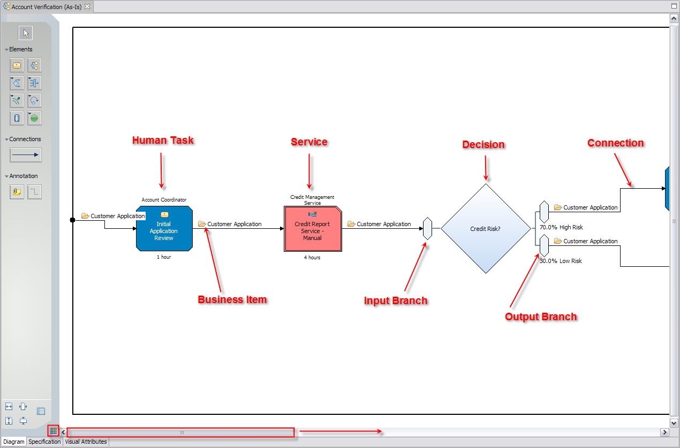
Hint: You can scroll left and right using the scroll bars and toggle the grid on and off (see previous diagram).
Hint: You can select different Zoom levels from the toolbar at the top of the screen.

Note: In the Account Verification (As-Is) process, an Account Coordinator reviews the customer application and researches information on several different systems and then calls or faxes the Credit Agency to request a credit report. Since we call or fax the Credit Agency (and require faxed credit reports) the current agency does not provide us favorable pricing. We do not differentiate between high and medium risk customers; this results in a large number of declined requests – far above the typical percentage for our industry. In our current process, most applications are considered “High Risk” and must go through additional steps, including Request More Information, which requires that the customer provide additional financial documentation and adds an average of 3 days to the process. Finally, the Account Coordinator manually generates an approval or decline. The pricing for the approval is determined by referencing complicated paper manuals.
Based on the As-Is model, analysis and simulation, we have identified several areas for improvement:
- Lack of single customer view and business rules for credit process result in our ordering more credit reports than we need.
- Manual process for retrieving credit reports is highly inconsistent, expensive and time consuming.
- Credit Report requests are manually faxed to the bureau cost $25 and take 4 hours to arrive.
- We decline too many customer requests, resulting in loss of potential revenue and dissatisfied Sales representatives.
- Too many customers are falling under the “High Risk” category and are asked to provide additional credit worthiness information - this increases the time to open the account by an average of 3 days and results in dissatisfied customers.
- The Initial Application Review task requires that the Account Coordinator log on to several systems to gather critical decision-making information resulting in increased errors and lower throughput.
- Average Elapsed Duration: 2 days 9 hours 27 minutes – exceeds industry averages and results in dissatisfied customers.
- Weighted Average Profit: $184.43 –below industry averages and could be improved.

- Select the Apply 4-pane layout button from the toolbar.
- Review the WebSphere Business Modeler in 4-pane Layout.
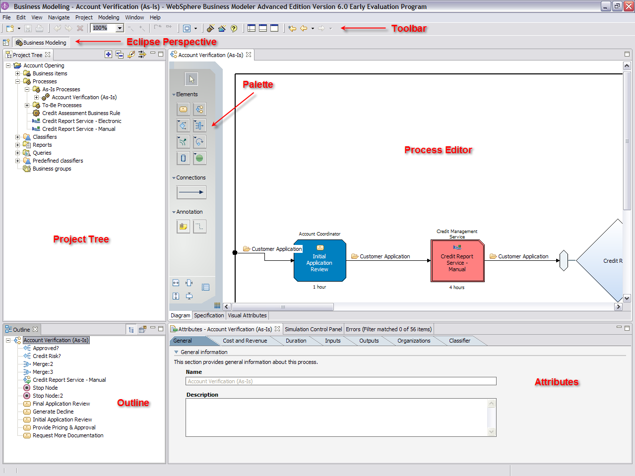
Hint: You can click on a task to review its attributes in the Attributes pane below the diagram.

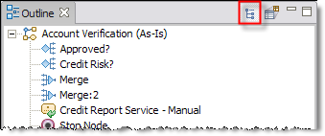
Hint: In the Outline pane, you can select the Structure view to navigate through the model. Click on any of the elements (i.e. Approved?, Credit Risk?, Merge, Merge: 2, etc.) to “jump” to that element in the process editor - note that the diagram repositions to display the element you selected.

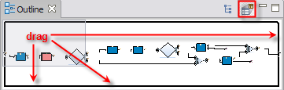
Hint: In the Outline Pane, you can select the Contents view to navigate through the model. Drag the gray box to move to a different part of the model - note that the diagram repositions accordingly.

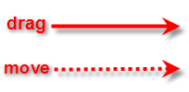
Note: Click & Drag vs. Click & Move in this Lab
A solid arrow means: after you left-click, you should drag your pointer to the specified location prior to releasing the left mouse button.
A dotted arrow means: after you left-click, you should release your left mouse button prior to moving your pointer to a specified location.

- Close the diagram by clicking on the X next to the diagram name in the Process Editor.
- Review & Complete the To-Be Model
- Open the Account Verification (To-Be) Model and Review
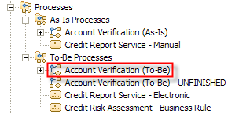
- Locate the Account Verification (To-Be) process model in the To-Be Processes process catalog.
Note: A process catalog is a useful way to organize process models. Think of it as a folder for processes in your project. Process catalogs can contain processes, global tasks, services and other catalogs. For example, the To-Be Processes catalog is a sub-catalog of the Processes catalog.

- Double-click on Account Verification (To-Be) to open the process model.
- Select the Apply 1-pane layout button from the toolbar.
- Review the Account Verification (To-Be) model.
Note: This process has the following improvements:
- Automated gathering of critical data, via a new Determine Applicant Eligibility service, will reduce process duration and the number of required credit reports requests.
- Addition of Credit Report Needed? decision, will provide automated approval of customers with credit reports on file, with existing relationships or pre-qualified applications. This will result in cost-savings, reduced cycle times, more applications approved and higher customer satisfaction.
- Automated (electronic) credit report service will be significantly less expensive, flexible and faster – it will allow us to “shop around” for the least expensive service provider.
- Dynamic, rules-based risk assessment that can be changed as necessary based on business need, via a new Credit Assessment Business Rule, that will add the ability to respond to market pressures and opportunities more quickly.
- New Medium Risk path. Risk will be mitigated by a Final Application Review by an Account Manager and will allow us to avoid the 3-day average Request More Documentation step and will result in reduced process duration and increased percentage of applications approved.
- Automated Provide Pricing & Approval and Generate Decline services will reduce average process duration and cost.

- Select the Apply 4-pane layout button from the toolbar.
- Close the diagram by clicking on the X next to the diagram name in the Process Editor.

- Open the Account Verification (To-Be) – Unfinished Process Model
We will now open an unfinished version of the To-Be model so that we can complete it.
- Double-click on the Account Verification (To-Be) – UNFINISHED process model to open it. 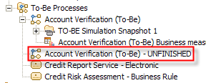

- Change Visual Attributes
Hint: You can undo work at any time by pressing Ctrl + Z on your key board or by selecting Edit → Undo… from the menu. You can undo multiple steps, back to your last Save.

  - Right-click on any white space in the Process Editor and select Color by → Role. 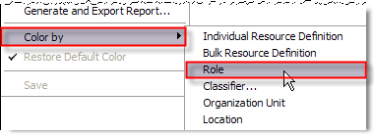
Note: The task colors in the Process Editor and the Outline are now colored according to their previously-assigned Role requirement.
  - Click on the Visual Attributes tab at the bottom of the diagram.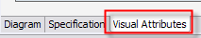
  - Click on the word Labels in the column on the top left corner of the pane.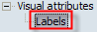
  - Click on the Do not display labels on the diagram checkbox located near the top - this will un-check it and un-hide labels in the diagram according to defaults we specified in our preferences.
Note: We can override global preferences (i.e. defaults) here – we can also restore defaults at any time using the Restore Defaults button.

  - Click on the Diagram tab to return to the diagram.

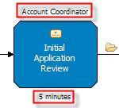
Note: The labels were explicitly hidden previously. You should now see the task Role above the task and the task Processing Time below the task. You can choose what to display in the top and bottom labels, for example: Description, Processing Cost, Startup Cost, Wait-Time Cost, Revenue, Processing Time, Resource Wait Time, etc.

  - Press Ctrl + S on your keyboard to save your changes.
Hint: You can also select File → Save from the Menu.

- Add a New Task and Set its Attributes
Tasks are the basic building blocks representing activities in a process model. Each task performs some function. Visually, a task represents the lowest level of work you can portray in a process.

Note: This new task will represent a new automated step to quickly gather eligibility information before the Account Coordinator performs the Initial Application Review. Since this information is currently being collected manually as a part of the old Initial Application Review task, the time required for the new Initial Application Review will be dramatically reduced from 1 hour in the As-Is model, to 5 minutes in the To-Be model.

- Click on the Create local task button on the palette and move your pointer to the process diagram. Click anywhere in the white space to add a new task.
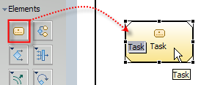

Hint: You do not need to “drag” the elements from the palette to the diagram. Click the appropriate button on the palette, release your left mouse button, move your pointer to the desired location in the Process Editor and click to add.
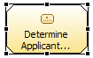
- Type the name Determine Applicant Eligibility as the new task name and press the Enter button on your keyboard.
Hint: If the task name is not highlighted and editable, click the task once and then type the task name. If you de-selected the task by clicking anywhere outside the task, you will need to click twice: once to select the task, and a second time to edit the name.

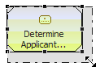
- Resize the task so the entire name is viewable by clicking on the task once (if it’s not already selected) and then clicking and dragging any of the black dots along the border of the task.
- Select the Apply 2-pane layout button from the toolbar.
- Click on the Duration tab in the Attributes pane.
Hint: Be sure that the Determine Applicant Eligibility task is already selected by clicking on it once. A selected task has a dark border, with dots, around it. The following diagram shows the visual difference between a selected task and an unselected task.
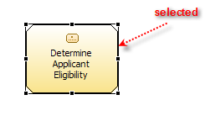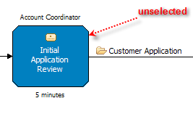
- Click the up arrow next to Seconds until it reads 10 seconds. 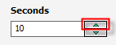
Hint: You can also place your cursor in the field; delete the 0 and type 10.

- In the Attributes – Determine Applicant Eligibility pane, click on the Resources tab.
Hint: Be sure that the Determine Applicant Eligibility task is still selected, if it is not, click on it once to select it.

- Click the Add button to the right of the Role requirements table.
- Click once in the cell under the Role column heading and click on the button.
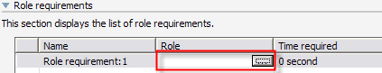
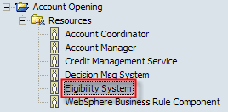
- Select Eligibility System from the Select Role Requirement dialog and click the OK button.

Note: In the diagram, the task color and upper label will change accordingly.

- Click inside the Time Required cell that says 0 second and click on the button.
Note: Since we would like to run simulations using either required resource time or task (elapsed) duration, we should specify the Time Required metric, which in this case, happens to be the same as the task duration (10 seconds). Resource Time Required can also be thought of as working duration.
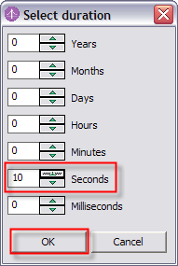
- In the Select Duration dialog box, click the up arrow next to Seconds until it reads 10 seconds

Hint: You can also place your cursor in the field; delete the 0 and type 10.

- Click the OK button.
- In the Attributes – Determine Applicant Eligibility pane, click on the Classifier tab.
- Click the Add button to the right of the Classifiers and classifier values table.
- Select Automated and click the OK button. 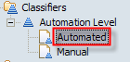
- Click the OK button.
Note: Classifiers enable you to categorize tasks and other process elements for decision-making or process optimization. Predefined classifiers are provided for quality control, value added, and workflow. You can also define your own classifiers. You can associate colors with each classifier value, enabling you to see these values at a glance in the Process or Simulation editor. You can also display each classifier value in a different row using swimlanes.
A custom classifier called Automation Level was defined for you. Automation Level contains two values: Automated and Manual.
We have just added the classifier value Automated to this task.

- Optional: Right-click on any white space in the Process Editor and select Color by → Classifier. Select Automation Level and click the OK button. Note how each task is colored according to its Automation Level classifier value. For your convenience, be sure to right-click on any white space in the Process Editor and select Color by → Role before continuing.
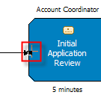
- Click the connection that leads into the Initial Application Review task, once.
- Move your pointer over the connector arrow that connects into the Initial Application Review task, until your pointer becomes cross-hairs.
- Click and drag the connection arrow to the Determine Applicant Eligibility task until your pointer becomes cross-hairs again.
- Click anywhere inside the Determine Applicant Eligibility task to re-connect the connection.
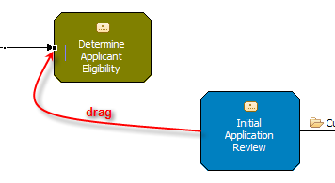
- Press Ctrl + S on your keyboard to save your changes.

- Add a Connection
A connection is a link between two elements and can be used to specify the sequence of activities in a process. Each task, subprocess, decision, or other element passes control to the next task or element along a connection. You can also associate business items with connections to pass data from element to element.
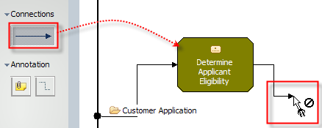
- Click the Connections button on the palette.
- Move your pointer to and click on the Determine Applicant Eligibility task.
Note: You should now have a connector attached to the Determine Applicant Eligibility task and to your pointer.

- Click anywhere inside the Initial Application Review task to finish the connection.
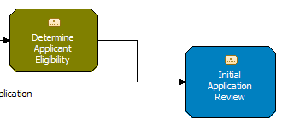
- Press the Esc key on your keyboard to return to the default pointer.
Hint: You can also click on the button on the palette to return to the default pointer.

- Add a Business Item
Business items represent the data in our process and contain attributes that can be basic types, like String and Integer, or Complex types, like other business items. Business items can also inherit attributes from a parent template. Attributes can have rules (expressions) associated with them.

Note: In our model, the Customer Application business item has already been defined, representing the application for credit that has prompted our Account Verification process. We will now assign the business item to the connection between the new task we have just added, and the existing task, to depict the flow of the Customer Application data between these two process steps.

- Select the Apply 4-pane layout button from the toolbar
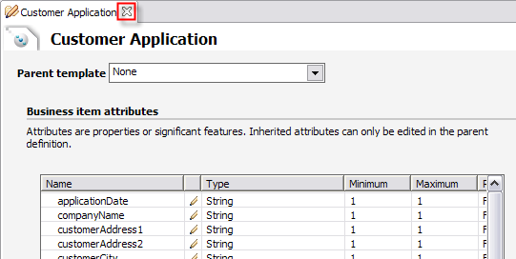
- Expand the Business Items catalog so that you can see the Customer Application and Message business items.
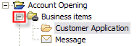
- Optional: Double-click on the Customer Application business item in the project tree to view its attributes and then close it by clicking the X in the Customer Application tab. Do not save changes if prompted to do so.
- Click and drag the Customer Application business item to the connection between Determine Applicant Eligibility and Initial Application Review.
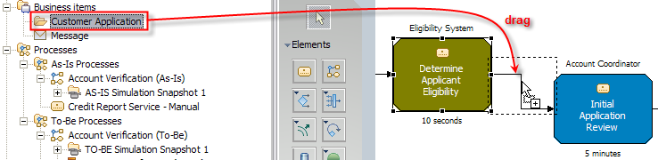

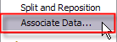
Hint: You can also right-click on a connection, and select a business item from a dialog, to associate data with it.

- Press Ctrl + S on your keyboard to save your changes.

- Add Global Tasks
Tasks, processes, and repositories in WebSphere Business Modeler can be either global or local. Global elements are found in the Project Tree and are reusable by other processes. Local elements are found within a process and used only within that process.

Note: We will now add two elements to the model to represent further automation. A global task has been defined in the project tree to represent electronic interaction with the Credit Bureau. This interaction will replace the manual version in our As-Is model. It has a significantly shorter duration and much lower cost. A global task has also been defined to represent a Business Rule that will be invoked to assist in credit assessment based on the credit score. Since these elements have already been defined in the project tree, we can simply drag them into our model and connect them as needed.

- Click and drag the Credit Report Service – Electronic global task from the Project Tree to the canvas and release the mouse button to place.
- Click and drag the Credit Assessment Business Rule global task from the Project Tree to the canvas and release the mouse button to place.
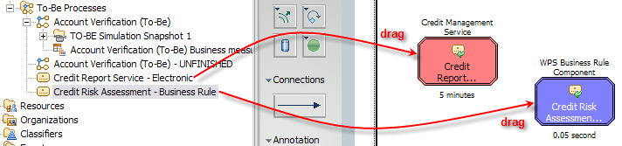
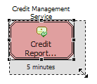
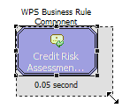
- Resize both new tasks, so their names are entirely viewable, by clicking on each task once and then clicking and dragging any of the black dots along the border of the task.

Hint: You can move or resize multiple tasks at the same time by holding the Shift key on your keyboard while selecting the desired tasks, releasing the shift key and moving or resizing one of the tasks. Note that all selected tasks will be moved or resized accordingly.

- Select the Apply 1-pane layout button from the toolbar.
- Click the Connections button on the palette and then click on the Yes branch of the Request Credit Report? decision to begin a connection. You should now have a connection attached to the Yes branch and to your pointer.
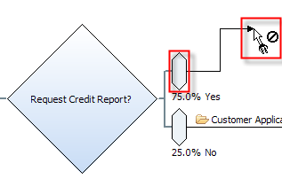
- Click anywhere inside the Credit Report Service - Electronic global task to finish the connection.
- You will be prompted to select the existing input and output or create new ones. By default, the existing input and output should be selected. Click the OK button to accept the defaults in the Data Connection dialog.
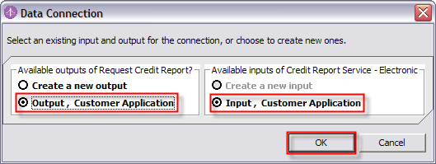
- Click anywhere inside the Credit Report Service - Electronic global task to begin a connection.
Hint: Your pointer should still look as follows. If not, click the Connections button in the toolbar again, before adding more connections.

- Click anywhere inside the Credit Assessment Business Rule global task to finish the connection.
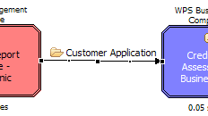
- Click the OK button to accept the defaults in the Data Connection dialog.
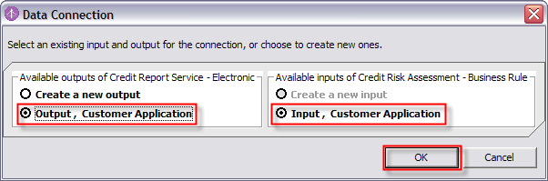
- Scroll to the right until you see the Credit Risk? decision and the Credit Assessment Business Rule task.
- Click on the Credit Assessment Business Rule task to begin a connection.
- Click the input branch of the Credit Risk? decision to finish the connection.
- Click the OK button to accept the defaults in the Data Connection dialog.
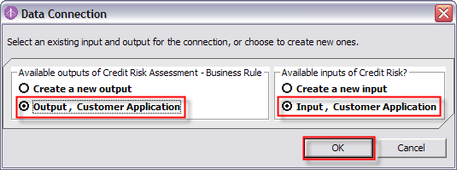
- Press the Esc key on your keyboard to return to the default pointer.
- Right-click on any white space in the diagram and select Auto-Layout Left to Right.
- Press Ctrl + S on your keyboard to save your changes.
- Explore your completed process by scrolling (or using other techniques as described earlier).
- Select the Apply 4-pane layout button from the toolbar
- Close the diagram by clicking on the X next to the diagram name in the Process Editor.

- Optional: Explore the Swimlane Editor
The Swimlane Editor provides an additional way to visualize and/or model a business process. Tasks and other elements of the process are arranged according to swimlanes, as per the Line of Visibility (LOV) methodology. Tasks can be added or moved to a swimlane (i.e. according to Role) and are automatically updated with the characteristics of that swimlane. You can switch back and forth between the free-form Process Editor you have been using up to now and the Swimlane Editor as desired.
- Double-click on the Account Verification (To-Be) – UNFINISHED process in the Process Tree to open it.
- Right-click on any white space in the Process Editor pane and select Switch to Swimlane Layout by → Role.
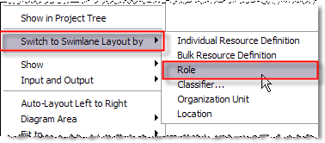

Hint: Your can also use the Switch to Swimlane Layout button in the palette.
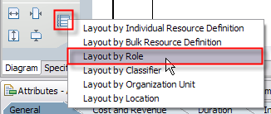

- Select the Apply 1-pane layout button from the toolbar.
- Right-click on any white space in the diagram and select Auto-Layout Left to Right.
- Select the Apply 4-pane layout button from the toolbar
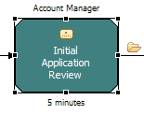
- Drag any task from its swimlane into any other swimlane.
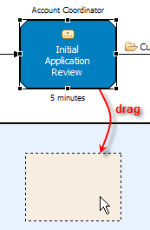
Note: The task’s Role, color and label change accordingly.

- Explore the task’s Role attributes in the Attributes pane to see how they have been updated. 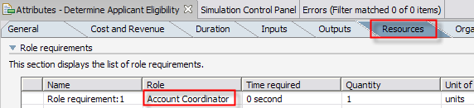
- Optional: Drag the task back to its original swimlane.
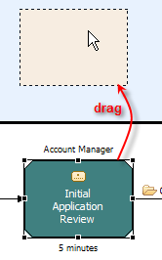
- Click on the Create local task button on the palette and move your pointer to the process diagram. Click in the white space of any swimlane to add a new task. Again, note how its Role, color and label have been updated accordingly.
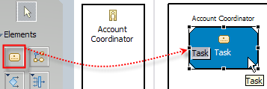
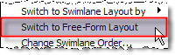
- Right-click on any white space in the Process Editor pane and select Switch to Freeform Layout.

- Click on the No button, since we don’t want to keep the changes we made. 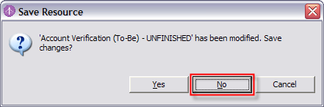

- Close the diagram by clicking on the X next to the diagram name in the Process Editor.

- Simulate, Analyze & Compare
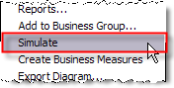
- Create a Simulation Snapshot
- Right-click on the Account Verification (To-Be)-UNFINISHED model in the Project Tree and select Simulate.
- Select the Apply 2-pane layout button from the toolbar.
- In the Attributes pane, click on the Inputs tab and then click on the first row of data in the table. 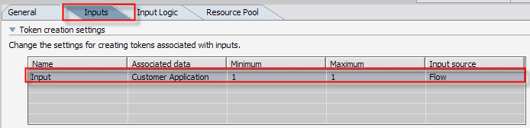
- Scroll down in the Attributes pane to see the settings.
- Click on the Edit button next to the Total number of tokens field.
Note: Tokens are the inputs to our process model, in our case, they are Customer Applications.
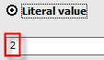
- Highlight or delete the existing number 1 and then type the number 2 in the Literal value field of the Edit simulation attribute dialog box.
- Click the OK button in the dialog box.
- Click on the Resource Pool button.
Note: This is where we will tell the Simulation engine if and how to use resources during simulation. In this case, instead of manually creating individual resources (such as Account Coordinator “Bob Jones”, etc.), we will let the Simulation engine generate a number of resources per role for us. By default, the Simulation engine will run with resource requirements and will generate an unlimited number of resources, as required during the simulation, but we will specify that we want a much smaller number of human resources.

- Click on the Account Coordinator role and then uncheck the Unlimited checkbox.
- Delete the 0 and type the number 5, or use the up arrow.
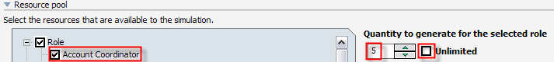
- Repeat the previous two steps for the Account Manager role, but type the number 2 for the number of Account Managers to generate.
- Press Ctrl + S on your keyboard to save your changes to the simulation profile.
Note: We can create multiple simulation snapshots a single process and we can create multiple profiles from the same snapshot. We can change default global settings, default snapshot settings, or individual profile settings as we did here. This affords us significant flexibility to perform “what if” analysis, by comparing simulation results from 1) changing the process itself and creating a new snapshot, 2) changing simulation settings without changing the process. As an example of the latter, we could hire more Account Coordinators to improve process throughput, if we identify a bottleneck due to Account Coordinator resource contention. We could also re-allocate (and retrain) resources from one role to another, if we determine that the resources are under-utilized in a specific role, etc. Process redesign improvements such as these can be achieved without, prior to or in addition to process automation.

- Run a Simulation
- Click on the Simulation Control Panel tab.
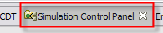
- Click on the black down-arrow in the top-right corner of the Simulation Control Panel tab.
- Select the Setting menu option.
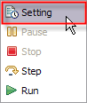
- Click the Display animation during simulation checkbox to turn animation on. 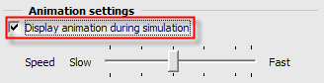
- Press the Run Simulation button in the top-right corner of the Simulation Control Panel.
- Observe the simulation animation in the diagram (you will need to scroll down and to the right as the simulation is running to “follow” the animation through the process) and the statistics that are being collected in the Attributes pane.
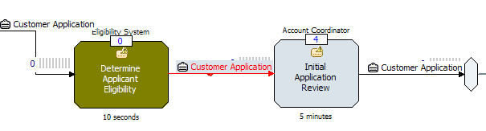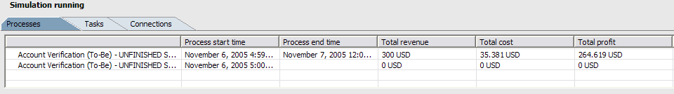
- When the simulation completes, double-click on the Simulation Control Panel tab to maximize.
- Review the simulation statistics by clicking on each of the tabs: Processes, Tasks and Connections. Resize columns as needed.
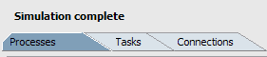
- Click on the Collect and display statistics across process instances checkbox on the bottom left in the Processes tab.
Note: This displays averages across all process instances in the simulation results.

- Double-click on the Simulation Control Panel tab to return it to its previous size.
- Select the Apply 4-pane layout button from the toolbar
- Close the diagram by clicking on the X next to the diagram name in the Process Editor.

- Visually Compare the Account Verification (To-Be) and (As-Is) Models
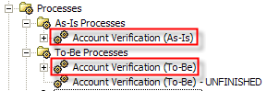
  - Expand the To-Be Processes catalog in the Project Tree and double-click on the Account Verification (To-Be) process to open it.
  - Expand the As-Is Processes catalog in the Project Tree and double-click on the Account Verification (As-Is) process to open it.
  - Select the Apply 1-pane layout button from the toolbar.
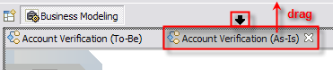
  - Slowly drag the tab for the Account Verification (As-Is) process, until your pointer becomes an up or down black arrow.
  - Drag the vertical scroll bars on the right-hand side of the models to bring them into view and drag the horizontal scroll bars beneath the models to visually compare the models.
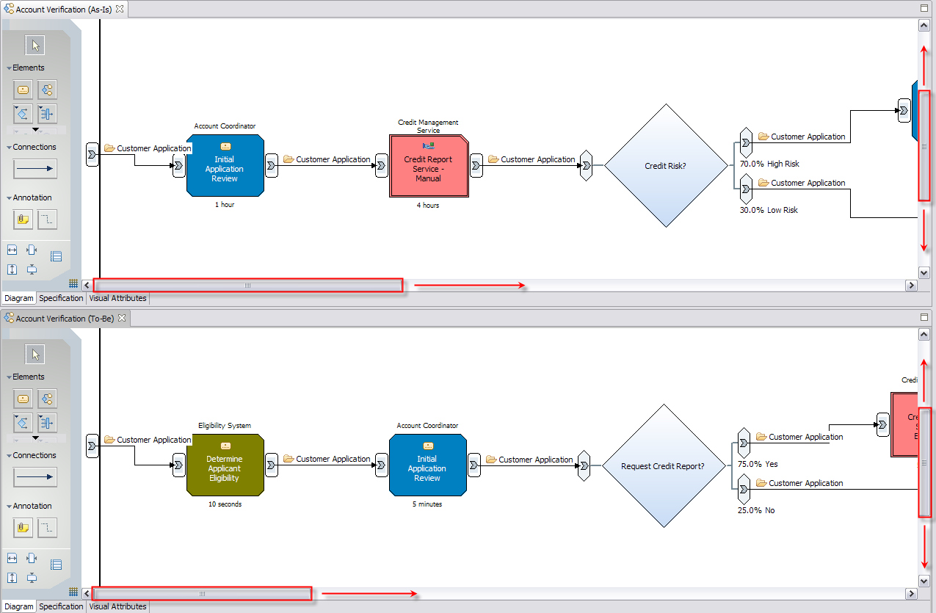

- Dynamic Analysis
  - Select the Apply 4-pane layout button from the toolbar.
  - Click on the Collapse all projects button in the Project Tree.
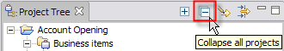
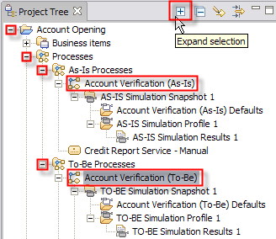
  - Expand the Account Opening project.
  - Expand the Processes catalog.
  - Expand the As-Is Processes catalog.
  - Expand the To-Be Processes catalog.
  - Click the Account Verification (To-Be) process once and click on the Expand selection button in the Project Tree.
  - Click the Account Verification (As-Is) process once and click on the Expand selection button in the Project Tree.
Note: The Account Verification (To-Be) and (As-Is) processes were completed in advance and contain simulation results (using 50 tokens) that we will use for our analysis. They are AS-IS Simulation Results 1 and TO-BE Simulation Results 1, respectively.

  - Right-click on AS-IS Simulation Results 1and select Dynamic Analysis→Process Comparison Analysis→Process Duration Comparison. 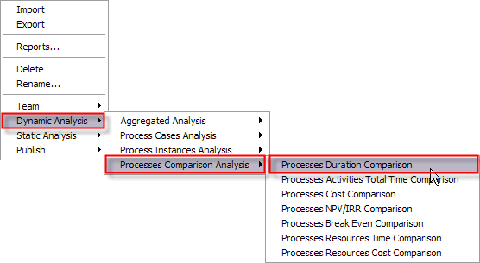
  - Select TO-BE Simulation Results 1 in the Select Simulation Result dialog and click the OK button.
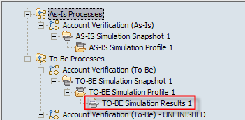
  - Accept the default selection (All process instances) and click the Finish button in the Process Duration Comparison Analysis dialog box.
  - Review the results. Resize columns as necessary.
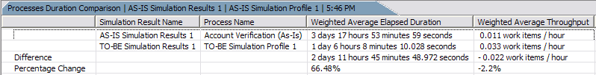
  - Right-click on AS-IS Simulation Results 1and select Dynamic Analysis→Process Comparison Analysis→Process Cost Comparison. 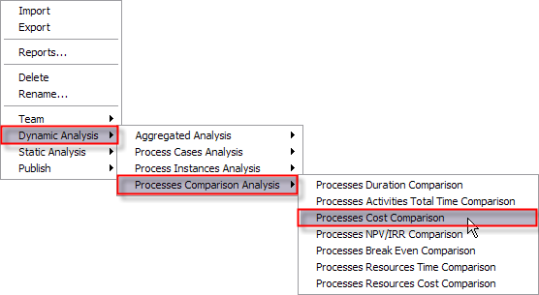
  - Select TO-BE Simulation Results 1 in the Select Simulation Result dialog and click the OK button.
  - Accept the default selection (All process instances) and click the Finish button in the Process Cost Comparison Analysis dialog box.
  - Double-click the Dynamic Analysis View tab to maximize it.
  - Review the results. Resize columns as necessary.
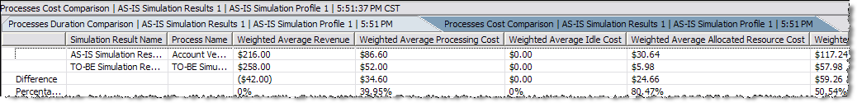

Note: Dynamic Comparative Analysis Summary (To-Be vs. As-Is):
- Average Elapsed Duration Percentage Change: 66.48% faster.
- Weighted Average Total Cost: 50.54% decrease.
- Weighted Average Profit: 102.53% increase.
  - Double-click the Dynamic Analysis View tab to return it to its previous size.
  - Close the diagrams by clicking on the X next to the diagram names in the Process Editor.

- Generate the Business Measures Model & Define and Review Key Performance Indicators
Business measures, as they relate to our process model, are defined using the metrics and data in our process. A business measures model describes business metrics, their dependencies on incoming events, conditions warranting business action (business situations), and outbound events that represent notifications of such conditions and may trigger business actions. The business measures model defines these steps in enough detail to allow their execution in a business monitor.
Key to having a successful set of business measures is deciding upon the vital measures that are linked to the success of the business. Determining which business measures will be needed from the executing process is achieved by studying the process itself and understanding business requirements and goals. Once business measures have been defined and deployed to the business monitor, you can evaluate them in real time and historically.
The Business Measures Editor in WebSphere Business Modeler provides IT professionals and Business Analysts the ability to create a Business Measures Model for a process.

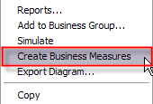
- Create the Default Business Measures Model
- Right-click on the Account-Verification (To-Be) – UNFINISHED process model and select Create Business Measures.
- Click the OK button in the Select Process Elements dialog box to accept the default values.
Note: We have just generated a default Business Measures Model. We can deploy it as it is or we can first add custom business measures such as Key Performance Indicators and Metrics that will measure and reflect the performance of our business.

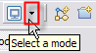
- Select the Apply 2-pane layout button from the toolbar.
- Click on the down-arrow selection button of the Select a mode button.
- Select Advanced mode from the menu. 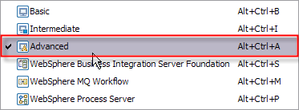

Note: WebSphere Business Modeler provides several business modeling modes that filter or reveal information on the model elements or provide validation to support exporting models in a specific format. The mode you choose determines the level of detail you see in diagrams, dialogs, and wizards.
In general you will use a single mode for all or most of the work you do. If you occasionally want to specify a different level of detail for a model or some aspect within it, you can switch to another business modeling mode.

- Click on the Diagram tab.
- Click on a task and explore the tabs in the Attributes pane. These are attributes corresponding to this specific task.
Note: In the Properties tab, there are pre-defined properties for the task (activity): Activity IsDelayed Metric, Activity Working Duration Timer, etc. We can use these properties to define custom business measures.

- Click on white space in the diagram and explore the tabs in the Attributes pane. These are attributes corresponding to the entire process.
Note: In the Properties tab, there are pre-defined properties for the process: Process Start Time, Process Elapsed Duration Timer, etc. We can use these properties to define custom business measures.

- Click the Duration button on the far right of the General tab.
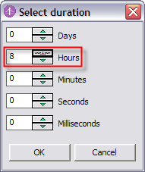

- Set the Maximum duration to 8 hours and click the OK button.
Note: By setting the Maximum duration for the process, we can later use the raise alerts or trigger calculations or metrics if the process exceeds this duration.

- Define KPI: Average Account Verification Duration
Key Performance Indicators (KPIs) are special business measures that are considered to most closely reflect business performance. Typically, KPIs have a benchmark (sometimes derived from or validated by the As-Is model), a target, an upper margin and a lower margin. If a KPI is not at its target or exceeds its upper or lower margin, alerts can be triggered so that corrective action can be taken as soon as possible. In fact, trending analysis in the business monitor can be used to prompt corrective action proactively, before a KPI approaches its margins.
- Click on the KPIs and Aggregate Metrics tab.
- Click on KPIs in the left column.
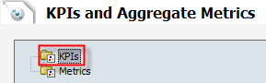
- Click on the Add button under to the KPIs table on the right.
- Click on the word Function1 in the Name column and type Average Account Opening Duration (expand the column width as necessary).
- Click on the word Total in the Aggregation Function column (3rd column). A drop-down box will appear.
- Click the down-arrow and select Average as the Aggregation Function.
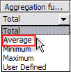
- Click in the cell under the Aggregation Source column, which contains a (4th column) and click on the button.
- Select the Process Elapsed Duration stopwatch.
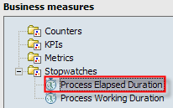
- Press Ctrl + S on your keyboard to save your changes.
Note: We have just created a KPI called Average Account Opening Duration, which is based on the aggregation of the pre-defined stopwatch called Processed Elapsed. This means that when deployed to the WebSphere Business Monitor, this KPI will track the average elapsed duration of all process instances, given any selected period of time. We would normally also specify either: 1) target value with upper and lower margin % or 2) upper and lower limits. In the interest of time, we will proceed to explore the completed Business Measures Model of the Account Verification (To-Be) process model.

- Explore Completed Business Measures Model
- Select the Apply 4-pane layout button from the toolbar.
- Expand the Account Verification (To-Be) process model as necessary and double-click on Account Verification (To-Be) Business measures model. 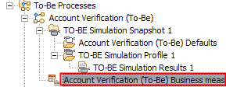
- Select the Apply 2-pane layout button from the toolbar.
- Explore the user-defined business measures.
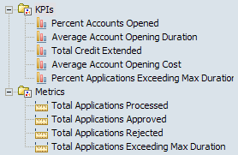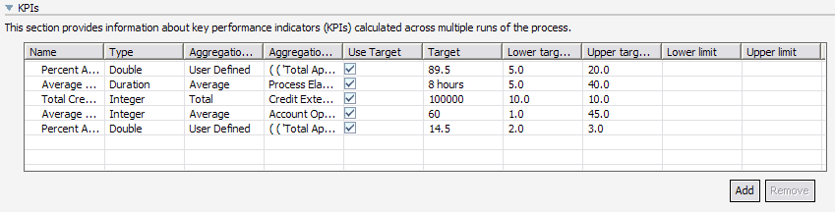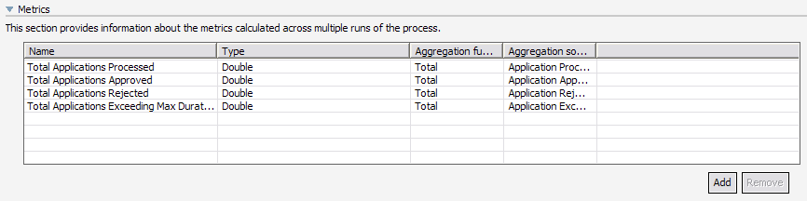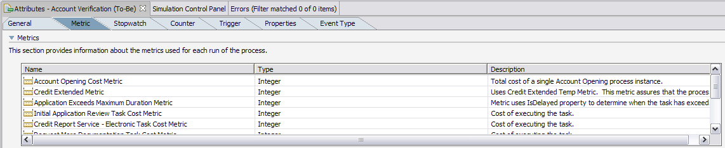
- Add Technical Specification to the To-Be Model
The WebSphere Process Server editing mode provides IT professionals and technically-oriented Business Analysts, the ability to view and override BPEL and implementation specifics prior to exporting the model as BPEL. While these steps are not required in order to generate BPEL, they are available to provide more detail for the IT implementation.
- Optional: Apply Default Values
- Select the Apply 4-pane layout button from the toolbar.
- Expand the To-Be Processes catalog and double-click on the Account Verification (To-Be) – UNFINISHED process to open it.
- Click on the down-arrow selection button of the Select a mode button.
- Select the WebSphere Process Server technology mode from the menu.
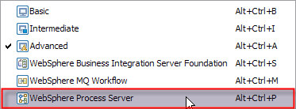
- Click on the Technical Specification tab.
- Click on the Apply Default Values… button.
Note: We just generated default values for the (BPEL) technical specification of our model. This is an optional step which allows us to view and override any of the defaults. If we choose not to Apply Default Values here, the default values still be generated when export our process as BPEL. We can still also add our own specifications prior to exporting.

- Specify Implementation Types
- Click on the Diagram tab.
- Click on the Initial Application Review task, click on the Technical Attributes View tab and then the Implementation tab.
- Scroll down to Implementation Type and select Human Task from the drop-down menu.
- Scroll right and click on the Request More Documentation task and set its Implementation Type to Human Task.
- Scroll right and click on the Final Application Review task and set its Implementation Type to Human Task.
- Scroll right and click on the Generate Decline task and set its Implementation Type to Java.
- Scroll right and click on the Provide Pricing & Approval task and set its Implementation Type to Java.
- Press Ctrl + S on your keyboard to save your changes.
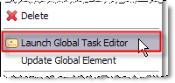
- Right-click on the Credit Assessment Business Rule in the process model and select Launch Global Task Editor from the menu.
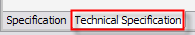
- Click on the Technical Specification tab of the Credit Assessment Business Rule global task.
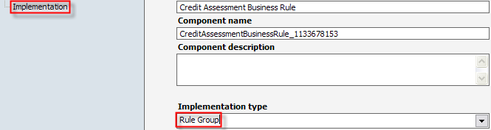
- Review on the Implementation and note that it is Rule Group.

- Close the Credit Assessment Business Rule by clicking on the X in the Credit Assessment Business Rule tab at the top. Do not save changes if prompted.
Note: .The implementation types that we just specified will be used by WebSphere Business Modeler to generate the corresponding WebSphere Process Server (Service Component Architecture) components. They will “jump start” the automation and assembly of this process. Human Task implementations be become Human Task Components. Java implementations will become Java components. Rule Group implementations will become Business Rule components. The Determine Applicant Eligibility task and Credit Report Service – Electronic global task will be Web Service so we do not need to generate an implementation. We will leave its Implementation type set to [none]; as a result no component will be created when the process is exported to WebSphere Process server.
- Export the Business Measures Model & BPEL
- Export Business Measures Model and BPEL
- Right-click on any white space in the Project Tree and select Export.
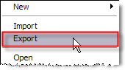
- Select WebSphere Business Monitor and development tool in the WebSphere Business Modeler Export dialog.
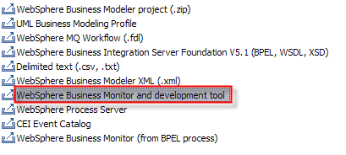
- Click the Browse button next to the Target directory field and click on the Desktop.
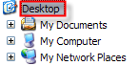
- Note that since the Account Opening project is the only one in our workspace, it is already selected under Project.
- Click the Finish button.
- Click the OK button in the Export finished dialog.
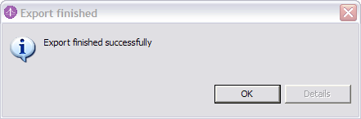
Note: In one export step, we have exported the Business Measures Model that will be used in WebSphere Business Monitor to monitor our process and the corresponding BPEL, WSDL’s, XSD and Service Component Architecture components to jump start the Assemble steps in WebSphere Integration Developer. The process will then be deployed to WebSphere Process Server.

- Explore the Exported Files
- Navigate to the Desktop using Windows Explorer.
- Double-click on the WebSphere Process Server folder and explore its contents.
Note: The WebSphere Process Server folder contains a BPEL file for each one of our processes (As-Is, To-Be and To-Be-UNFINISHED), as well as corresponding WSDL files (one for each process and one for each task within the processes) and a Businessitems.xsd file with our business items.
- Double-click on the Monitor.zip file folder and explore its contents.
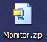
Note: The Monitor.zip file contains a model.xmi file that will be used as input to the WebSphere Business Monitor.

Congratulations! You have successfully completed the WebSphere Business Modeler lab!

