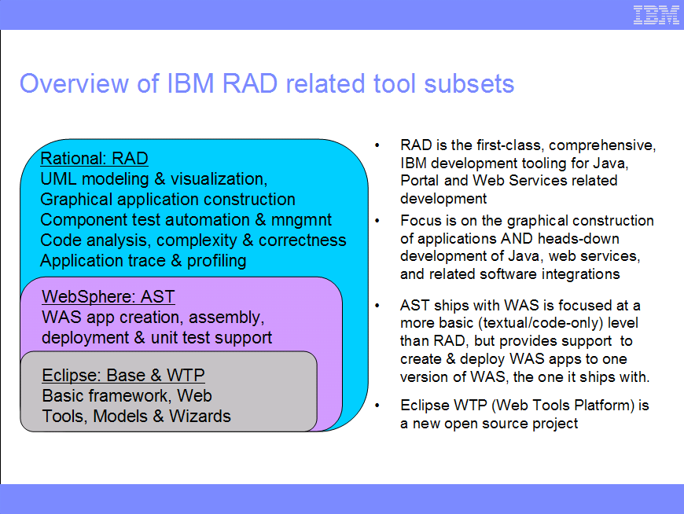

Document History

What is the difference between AST and RAD?
The Application Server Toolkit (AST) provides basic support for the creation of new applications targeting WebSphere Application Server v6.1. This includes wizards and tools for creating new Web applications, Web services, portlets, and EJBs, as well as annotation based programming support, new administration tools for the creation and maintenance of wsadmin Jython files, and tools to edit WebSphere-specific bindings and extensions. The AST also provides the tools necessary to develop and export JSR 116 SIP Servlets, including wizards to create SIP Servlets, a rich Deployment Descriptor Editor, and import/export wizards to package and deploy SIP Servlets. Support is also included for the rapid deployment feature, providing an easy mechanism to deploy applications to a running V6.1 server. A comprehensive Unit Test Environment is included, providing all function necessary to deploy and debug applications on WebSphere Application Server V6.1. This support includes a Unit Test Client Web application for easy testing of EJBs and Web services. AST is built on eclipse 3.2.
RAD v6.x is built on Eclipse 3.0. One of the key differences between AST and RAD is tight integration with multiple versions of WAS. (AST only supports the version of WAS that it is shipped with). Support is currently provided in RAD for the 3 latest versions of WAS (5.0, 5.1 and 6.0). Support for multiple WAS versions will continue in RAD v7.

In addition, RAD provides support for customers in environments with application servers from multiple vendors, such as Weblogic, Tomcat, and IBM’s latest WAS Community Edition.

Another key difference is that RAD is a rapid application development tool, with visual editors, code generators, code visualizers, code review, etc. focused on increasing developer productivity. With the exception of WSDL editing, AST is a source-level tool.

If customers want to leverage functionality such as visual editing and diagram representations of code, comprehensive visual Web development with JavaServer Faces, Static and Runtime Analysis, Portal/Portlet Development etc. then they should use RAD.

