
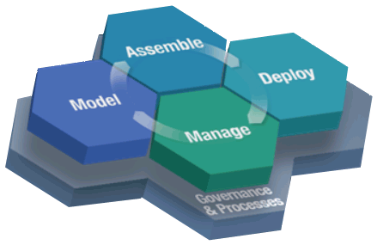
“Java In Action” Day

Come see the End-2-End capabilities of Java technologies. Java has flexibilities and powerful capabilities that range from your cell phone web browser, to Internet auction web sites like eBay, to the World’s largest Fortune 500 data centers, to executive dashboards. At this “Java-In-Action” Seminar you will see “A day in the life” perspectives of Java, across the Build ➔ Run ➔ Manage spectrum, for:
- Java Developers & Architects
- Java Web Portal End Users, Admins and Operations
- Java Web Services and SOA Integration
- Java Business Process Management for business and I/T stakeholders
- The Open Source movement and world-wide ecosystem
- And much more…

We will use live demonstrations and real-life examples to demystify and showcase the End-2-End capabilities of Java technologies and products.

Java In Action Agenda
I. Java End-2-End Overview
o Java Technologies Overview (Build ➔ Run ➔ Manage)
o Java Solution Space
- Lifecycle [ Model > Assemble > Deploy > Manage > Governance ]
- Roles [ Analyze > Architect > Develop > Integrate > Orchestrate ]
III. Java Tools In Action
o [Model]
- Analyze > Business Process Modeling and SOA
- Architect > Application Architecture Modeling
o [Assemble]
- Develop > Web Service Implementation and SOA
- Integrate > UI, Data, Service and Enterprise Integration
- Orchestrate > Service Orchestration and Business Process Management
III. Java Infrastructure Overview
o [Deploy]
- Java Servers, Middleware and Enterprise Service Bus (ESB)
- Java End User Experience with Portals
- Java Information Integration for relational data and beyond
o [Manage]
- Java Business Metrics and I/T Montoring
o [Governance]
- Business View: Java ROI Controls with Executive Dashboards
- IT View: Java SW Development Process, Quality and Change Mgmt

When: | ???, 10am-2pm
Where: | ???
More Information: | http://[TheURLforTheEvent]

