WebSphere V5 Update

When: XX:XXam – XX:XXam on Month, Day
Where: Street address, City, State, Zip (Room, Floor)
Confirm Your Seat today by: [Respond to email@ or call Phone-number or goto websiteURL]

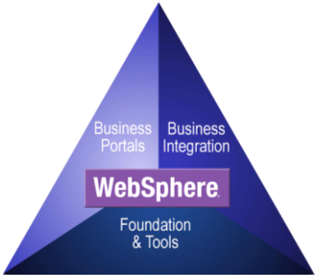
Agenda:

I. WebSphere Platform
- What's new and the latest announcements

II. Application Server V5
- What's new in V5.0
- Standards (J2EE 1.3, Web Services...)
- New Administration Model
- New Problem Determination features
- Performance Enhancements
- New JMS Messaging Support
- Security Enhancements
- and more…

III. WebSphere Studio V5 - What's new and beyond
- Eclipse 2.0 core IDE and Java enhancements
- Enhanced performance (Build, compile and Hot-redeploy)
- Enhanced Web Page Tooling - Usability and XML JSP pages
- Enhanced Web Services, XML/XSL, DB and Profile tooling
- New J2EE Tooling for EJB2.0 (MDB, Persistence, EJB QL, etc.)
- New Component Test tooling
- New Java Visual Editor (Java thick clients)
- New Struts Builder tools (web browser thin clients)
- Concurrent support of J2EE 1.2/1.3 projects and WAS V4/V5
- Futures…

Get your Quick Reference “Cheat Sheets” here:
- WebSphere Platform Quick Reference for everything WebSphere:
ftp://ibm4me:was35vaj@service2.boulder.ibm.com/QRef/WebSphereQuickReference.pdf
- WebSphere Studio Quick Reference:
ftp://ibm4me:was35vaj@service2.boulder.ibm.com/QRef/WSStudio-QuickReference.pdf

