(Click on demo link within PowerPoint to start demo. The demo should come up and remain in a paused state. If a security window pops up, select “OK.” Make sure the demo window is the active window or else the space bar will not control movement. Click on the top bar of the window if necessary. Also, you may need to maximize the window in order to see the player bar at the bottom. We recommend practicing on the same laptop that will be used at the customer site.)
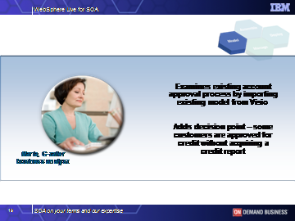
Maria, a G-tailer business analyst imports an existing account approval process from Visio for analysis. (We’ve used this as an example here…she could also be simply drafting the model within WebSphere Business Modeler itself.) G-tailer has decided that for low-risk customers (those with credit ratings above a certain thresh-hold), they can afford to forego requesting a credit report from a third party vendor in order to approve their credit applications. So Maria models this new process by adding a decision point to the flow – where some customers are approved for credit without acquiring a credit report.

(click the space bar)

- Maria sees the four-pane view with the process diagram in the upper right pane. She zooms in on the portion of the process she wishes to modify

- Maria selects a decision point from the elements toolbar in the left hand menu, and drags it over to the appropriate placement in the process diagram. She renames the decision point element. And can then simply drag connectors to connect the decision point within the current flow. She connects it so that it flows one way through the existing credit report request, and for another way, flows directly to a later point in the process, bypassing the credit report request steps.

(click the space bar)

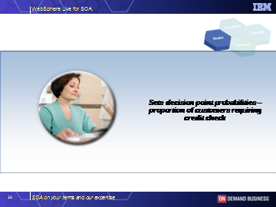
Maria then needs to set the probabilities for the decision point, corresponding to the proportion of customers anticipated to require a credit check.

(click the space bar)

- Maria selects the decision point and goes down to the selecting output branches view in the Attributes pane to modify the values in the output attributes table.

(click the space bar)

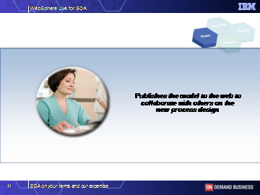
Now that Maria has modified the business process and entered the important metrics, she will share the proposed process with other stakeholders in the company. She publishes the work to the company’s internal website so that she can get the appropriate reviews, feedback, and agreement on the new process.

(click the space bar)

- She selects the new process in the Project Tree and then selects “Collaboration” and “Publish”.

- The people reviewing the new process do not need to have modeler on their desktop, since they use their web browsers to review and validate the model and add comments, attachments and web links. Maria can also respond to comments and ask for clarification when necessary.

(click the space bar)

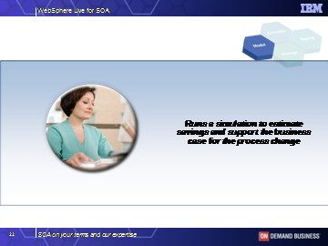
In addition to publishing the model, using WebSphere Business Modeler, Maria can run multiple simulations of the new process, performing “what if” analyses. Here, she is running different scenarios to evaluate the cost savings of the modified process. (She could also be simulating other metrics such as time customers wait for account approval, etc.) This helps Maria see how the process is likely to function once deployed, and it helps her make the business case for the process modification.

(click the space bar)

- Maria sets up the model for simulation by selecting the Account Verification process in the Project Tree pane and then selects “simulate”.

- This sets up a snap shot of the process using specific parameters for this simulation. The attributes in the lower right pane.

- She then selects the simulation control panel and now she’s ready to execute a simulation. She selects the green arrow on the right of the lower pane to start the simulation. In the simulation window in the lower right quadrant, it displays a bar with the progress of the simulation.

- The simulation complete window is displayed when the simulation is finished. It contains statistics based on the simulation settings and the business metrics defined in the model.

- Once Maria has completed her simulations, she runs several Dynamic Analysis reports, including a Process Comparison report, against the results from the currently operating process and newly modeled simulation. Process Comparison reports allow Maria to understand how the To Be process is expected to perform versus the As Is process.

- The Simulation result window pops up so she can select the correct version to compare. In the Attributes panel she can see both the As Is model and To Be model that will be compared. Then she selects the Analyst View tab to enlarge the window.

- She can see that the weighted average elapsed duration time of the To Be process has been significantly reduced by over 50% in this illustration. She could also simulate and analyze other attributes - for example, the weighted average throughput improvement.

(click the space bar)
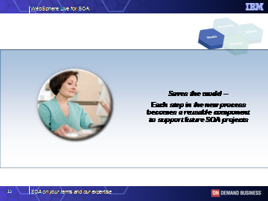
Happy with the new process flow, Maria is now done with the process. Each step in the new process is something that she can use again to support a future model. By saving and reusing components, each modeling project that she does becomes quicker to implement.

(click the space bar)

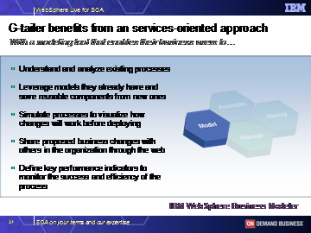
G-tailer benefits from employing an easy-to-use modeling tool for its business analysts. Modeling is critical in business process integration and management. The first step is understanding your processes. And streamlining how models are created, shared and refined will save your business analysts time. But, the real value is the ability to run ‘what-if’ scenarios and to accurately predict how the process will flow, where the bottlenecks will be, and projected cost savings BEFORE you begin any implementation work. As you work through the process changes, it is the ideal time to enter how you expect the process to work, - to define the key performance indicators. This allows you to do business monitoring for visibility into your processes at run-time. Simulations you run based on those metrics can also help you create a solid business case for making the proposed process changes.

(click the space bar)

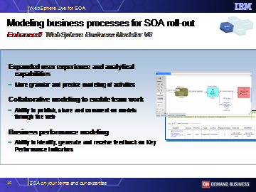
WebSphere Business Modeler v6 is enhanced with new functionality around the business analyst’s modeling experience, collaborative modeling, and capturing performance metrics. Within the new modeler, the business analyst can create and edit diagrams by roles (swimlane view) and the simulation engine has been enhanced to generate multiple resources based on roles and to use a table format for defining attributes to the various process elements. And attributes may be set up at a more granular level, to closely reflect the way your business operates today.

The new Collaborative modeling capabilities allow business analysts to share their work across a team. By publishing the model to the web, stakeholders can review, comment, and ask questions about the business processes. In other modeling tools, you must have a copy of the tool on your desktop to view and validate the models. This new piece of modeler allows users to work in a web-based team environment.

And, Business Performance Modeling is the set up for real-time business monitoring. Business users can create observation models that define and calculate the key performance indicators for monitoring the processes after their deployed. The observation models are auto-generated for the run-time environment.

(click the space bar)

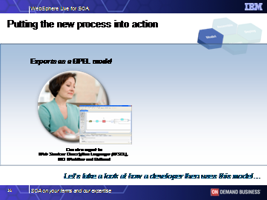
Now that Maria is done with her changes to the model, she hands the model off to I/T for rapid deployment. Here we’ve illustrated her exporting it as a BPEL model; she could also export as Web Services Description Language or to MQ Workflow or Rational tools.

(click the space bar)

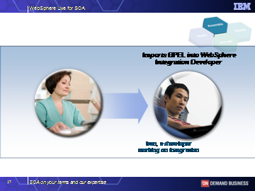
Ivan, a developer working on integration, imports the BPEL into WebSphere Integration Developer. He does not need to gather requirements – he can see exactly what Maria wants to do from the model that she created.

(click the space bar)

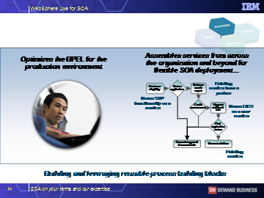
Ivan then optimizes the BPEL for the production environment and assembles the required services. He can access and use services from within and outside the enterprise for his flexible SOA deployment. He may be grabbing a service that reuses existing SAP functionality or using a CICS application that has been service-enabled. He may also be using an existing service provided by a business partner. Etc. Using WebSphere Integration Developer, he can assemble his application code without a detailed knowledge of Java or J2EE. He can simply drag and drop services. He does not need to know how each service is implemented or which protocol to use – the environment manages those details.

(click the space bar)

- Here is Ivan’s view of the BPEL model. He goes to the modular view, and right clicks a menu on the new decision point element to open the Rule Set window.

(click the space bar)

- The Rule Set window opens and Ivan enters the logic for the new rule. He uses a simple table tool to do this and adds the initial values for the logic. Here he sets up a table reflecting the variables ‘customer country’,

- The variables, such as ‘credit score’, can then be used by the Business Analyst to, for example, adjust the limits for credit approvals.

(click the space bar)

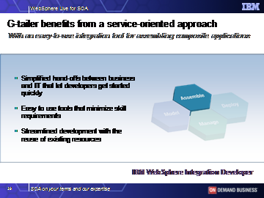
The tools that G-tailer leverages here are helping them streamline development to deploy the new process as quickly as possible.

To bridge the gap between business and IT, Maria’s modeling tool must be tightly integrated with the integration tool that Ivan is using. To rapidly deploy without traditional mistakes, the automated hand off is critical.

In addition, G-tailer needs ONE tool to describe and develop all their processes and one framework for all their integration needs. This needs to be the same whether they are talking about automated processes, manual processes, business rules…any type of integration. This allows them to streamline development and reuse everything that they develop.

(click the space bar)

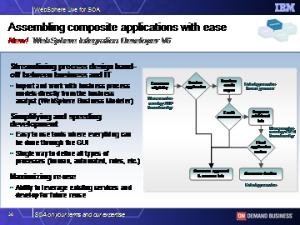
Building composite applications is about maximizing re-use – the ability to leverage all existing services in your environment. As you continue to build new components – whether they are automated tasks, human-to-human workflow tasks, or business rules – you need a tool that is designed for reuse.

WebSphere Integration Developer is a new product that has simplified process integration. All styles of integration can be done. . WebSphere Integration Developer Version 6 is a programming solution that allows users to develop code to compile composite applications using simple drag and drop technology without having a working knowledge of Java.

This facilitates the use of generic business logic, and the reuse of specific logic, by Business Process Developers without a programmer writing code.

WebSphere Integration Developer Background
WebSphere Integration Developer is used to finalize integration tasks and deploy the finished process to WebSphere run-time servers. It is an Eclipsed-based tool designed for developers and is easy to use. It has a BPEL Editor that’s used to assimilate the business process model provided by the Analyst and the EJBs and JSPs provided by the J2EE Developer. Beyond the specifics of each Interface, as an Integration Developer you don’t need to understand how the various Services were actually implemented. Just use the tooling to configure the Manual Tasks and Services to incorporate the services.

(click the space bar)

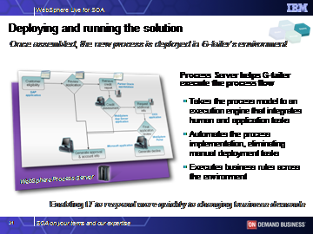
Once the process is assembled, G-tailer leverages WebSphere Process Server to take this process model into its deployment environment. By leveraging a process server, G-tailer automates the integration of tasks required to execute the process, irrespective of where their performed - human tasks or application tasks. It eliminates manual steps that would otherwise be required to deploy the process across a myriad of enabling applications and workflows. Developers need not go into each business application or to separate rules engines to connect various applications and human tasks and set up the appropriate business rules to run the new process. In the end, this enables G-tailer’s IT department to more quickly and flexibly respond to changing business process needs.

(click the space bar)

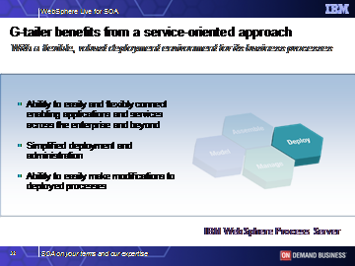
An approach leveraging an SOA allows businesses to keep pace with today’s business demands. Organizations are struggling to make the processes that are essential to their business run faster and respond quicker to market changes.

In this example, G-tailer is able to use an SOA to implement process changes quickly and easily. It can pull together the enabling services and applications together quickly to simplify deployment. A common process integration infrastructure simplified administration and makes it easier for G-tailer to make future modifications to deployed processes.

(click the space bar)
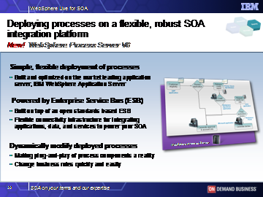
WebSphere Process Server Version 6 is built on a robust J2EE Runtime provided by WebSphere Application Server, offering qualities of service such as clustering, failover, scalability and security to support your business processes. The Process Server is powered by a robust Enterprise Service Bus for connectivity to any application, data, or service in your enterprise. I’ll talk more about the Enterprise Service Bus later.

The run-time is built to optimize the deployment of business processes. The flexible architecture allows replacing components real-time. For example, a human task (like an approval) can be replace with a business rule without changing anything else in the entire solution. This is an extremely powerful and valuable benefit – the reason you need process integration on a SOA – delivering greater flexibility and responsiveness to your business.

Additional information on WebSphere Process Server:
To do integration in an SOA properly it is necessary to have a single invocation model and a single data model. Service Component Architecture is this invocation model – every integration component is described through an interface. These services can then be assembled in a Component Assembly editor thus enabling a very flexible and encapsulated solution. Business Objects are the universal data description. They are being used as data going in and out of services – and are based on the Service Data Object (SDO) standard.

(click the space bar)

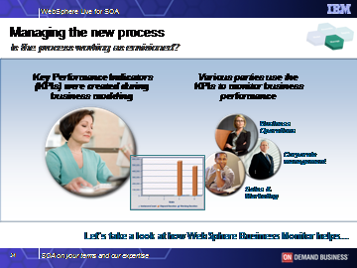
Once G-tailer has implemented their business processes, it’s essential to ensure that they are performing properly. There’s an old saying in business, “If you can’t measure it, you can’t manage it.”

So G-tailer leverages WebSphere Business Monitor to visualize process performance, so they can continuously make improvements to them. Various business users across the organization receive real-time information about their processes in graphical business dashboard views. Metrics are based upon the key performance indicators that Maria set up during business modeling. Business users can also establish performance thresholds so that when performance drops, they will receive alerts. With this information, users can make adjustments and improvements.

(click the space bar)
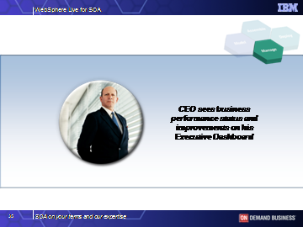
As an example, G-tailer’s CEO uses his dashboard keep track of the businesses’ performance. The CEO can see at a glance how specific areas of the business are performing against performance metrics that are aligned with business goals.

(click the space bar)

- Using his view of the Monitor, built on the market leading WebSphere Portal, the CEO can visualize alerts and data, including trending information, in a variety of formats

- He can also interact with these portlets to pull up different, more granular views of specific data.

(click the space bar)

- Here we illustrate him clicking on the U.S. portion of the map to pull up another graphical view representing performance in each of the states.

(At this point, hit ALT-TAB on your computer to switch back to the PowerPoint presentation. For the smoothest transition, all other files on your computer should be closed.)

