Re-Energize Your Call Center with IBM WebSphere HATS

Make customers happier and customer service representatives more productive and cost-effective with IBM WebSphere Host Access Transformation Services (HATS) applications.

By Elizabeth Pawelka

Have you ever wanted updated account information or status on an order you placed? All too often, you get frustrated navigating through the voice-response-unit, only to end up (finally) with a human on the line, and then have to tell the person everything you just entered via the phone and wait for him to find the answers to your question. Wouldn't it be nice if the customer service representative (CSR) had all the information at his fingertips? Or better yet, what if you could open a browser and update or retrieve the information on your own?

Your customers may have experienced similar frustrations. Your CSRs probably have to navigate several green-screen applications that have been with your company for years to try to answer customers' questions. All these factors can add up to irritated customers and frustrated CSRs, leading to reduced customer satisfaction, lost sales, lost customers, and a high CSR turnover rate.

IBM WebSphere Host Access Transformation Services (HATS) delivers tools to help you build integrated Web applications from existing terminal applications, thereby making the call center more productive and less error-prone. Because HATS creates a standard Web application, the only client software necessary for accessing the application is a standard Web browser. Access through a Web browser allows extension of all or selected functions of the green-screen applications to intranet, extranet, and Internet users. For example, you can create an integrated Internet self-service Web site where customers can enter information and queries to offload the call center and alleviate customer frustration. This article explains how HATS can help streamline your call center.

Call center challenges

Call centers typically have many different applications that track all the information the CSRs must access; for example, billing status, orders, account history, and previous calls. They may have to switch applications and screens several times to satisfy a single customer call. In addition, the user interface to those applications is usually non-intuitive and may require the CSRs to enter information, such as account numbers and cryptic entry codes multiple times. This redundancy introduces ample opportunity for errors and further frustration for customers and CSRs.

Companies typically have a big investment in their call center, customer support applications, and the systems that depend on them. These applications are generally tailored to the business and have been developed over many years. Companies value the functional capabilities that are built into those applications and have invested time, effort, and resources fine-tuning these applications and the infrastructure they execute in to achieve a high level of reliability and dependability. Re-writing or replacing these applications can be expensive and perhaps cost-prohibitive. Also, rewriting an existing application often increases risk in terms of stability, reliability, and dependability.

The key to improving the overall productivity of call center operations and, therefore, increasing customer satisfaction is to simplify the user interfaces to existing applications upon which the CSRs depend. User-interface improvement can also result in cost savings in terms of reduced average call times and CSR training time. Most companies don't have the funds or time to create that interface or re-write those applications. But, if they don't, they may lose customers and CSRs. Even if they can't easily measure customer satisfaction, they can measure the cost of customer service representative turnover, training, and call times.

HATS solution

IBM WebSphere Host Access Transformation Services (HATS) has helped many companies with these problems. With HATS, you can transform the CSR user experience without changing your applications. You can improve the appearance and usability, and streamline the navigation of the applications by creating screen customizations and macros.

Transform the CSR experience

You can quickly improve the user interface of your existing applications and achieve integration with other business information with minimal development cost. The result is an easy-to-use Web interface to the application, which can reduce training cost, simplify the application, or make the application accessible to new users.

For example, a typical call center application might require the screens in figure 1 to get to the customer account information.

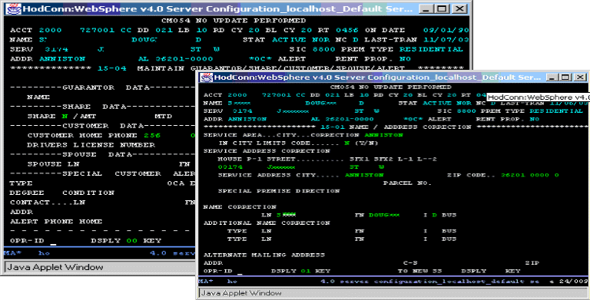

Figure 1: Typical call center application – User interface design has come a long way since these applications were developed, but it's typically too expensive for companies to develop new applications.

Using HATS, you can transform the screens from figure 1 into a Web page that's much easier to read and navigate (figure 2).
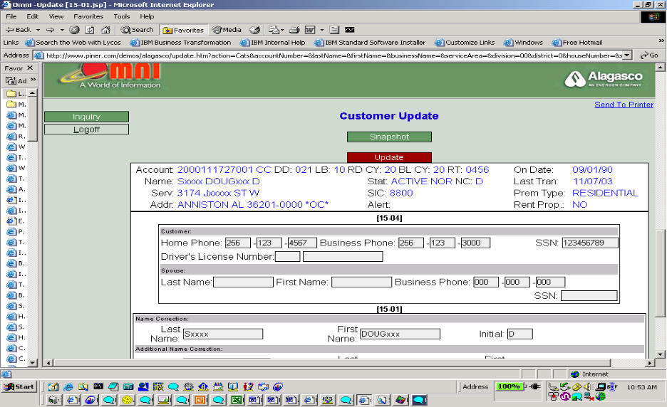

Figure 2: Much better – With WebSphere HATS, you can transform the screens from figure 1 into a much more user-friendly application.

Figure 2 shows:
- Selected information from the green screens rendered in a Web page that matches your corporate style.
- Use of HATS macros to combine multiple screens into one Web page. A macro is an XML script that defines a set of screens and the actions to take on those screens. You can use macros to skip over unnecessary screens or enter information for multiple host screens obtained from one Web page of user inputs.

You can enhance the usability of your application screens by adding widgets, such as drop-down lists, radio buttons, check buttons, macro buttons, and calendars. Using these widgets wisely can decrease the errors on such entries as order codes, countries, states, and date formats. Figure 3 shows a calendar widget and drop-down list added to an application.

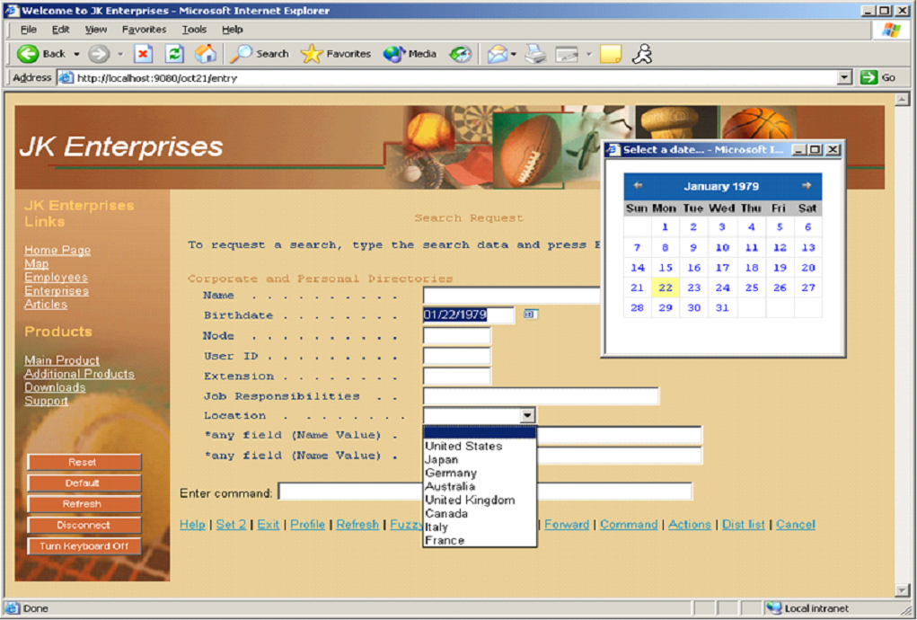

Figure 3: Application enhancements – A calendar widget and drop-down list can help reduce data entry errors.

Using global variables, you can store a value, such as the customer account number, that will exist throughout the lifetime of a browser session and can be entered automatically via a HATS screen customization or macro where necessary, further reducing entry errors. In addition, the Web Express Logon (WEL) feature of HATS enables single sign-on so CSRs don't have to re-logon when switching between multiple applications.

HATS overview

HATS consists of two components: the development toolkit and the runtime.

The HATS toolkit provides a set of wizards and editors that guide you through creating and modifying HATS applications. HATS toolkit is integrated with the Eclipse-based IBM Rational Software Development Platform (Rational SDP). This platform, which includes J2EE, Java, Team, Web (including Web page design), and Portal development capability and multiple integrated test servers, lets you develop and test a full-function application that matches your corporate look and feel in one development environment before deploying to the server. For deployment directly to IBM WebSphere Application Server, you'd package the HATS application as a J2EE Enterprise archive (.EAR) file. For deployment to IBM WebSphere Portal Server, you'd package the HATS application as a Web archive (.WAR) file.

The HATS runtime is a set of servlets and classes automatically packaged with the HATS application. The HATS runtime:
- Manages connections to the Telnet servers for the terminal applications you're transforming.
- Tracks users and their interactions with one or more HATS applications.
- Provides a transformation servlet (HATS entry servlet) that processes requests from users and dynamically transforms terminal data to HTML based on the request, the screen received from the terminal application, and the customizations the developer defines.
- Provides an Administrative Console servlet that enables connection management and problem determination for one or more HATS applications.

The runtime leverages IBM WebSphere Application Server (WAS) as its deployment platform (figure 4).

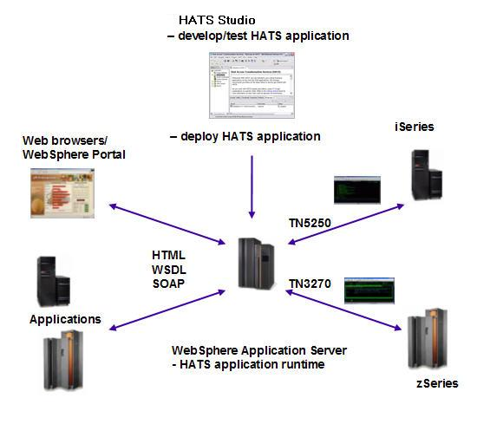

Figure 4: HATS environment -- A typical configuration to develop, test, and deploy a HATS application.

Benefits of a HATS solution

Using HATS, you can make your customer service representative job easier, streamlined, and more efficient without rewriting your current applications or the cost and disruption of buying a packaged solution. With the increased CSR productivity, reduced CSR training cost and turnover rate, and potential to off-load some customer calls to a self-service Web site, you could save nearly US$1,000,000 per year (see table 1 for details about this estimate).

Using the assumptions of a typical call center's employees, salary, and customer calls in table 1, you could save up to $345,000 a year by decreasing your customer call time by half a minute using HATS to reduce keystrokes and improve workflow steps. If you have 200 or more CSRs and a typical 20 percent turnover rate, you can save another $53,083 per year in CSR training cost and another $27,696 a year just on turnover and retraining. And the savings don't stop there. By employing a different rule-set for your CSRs and external customers, you can off-load some calls from your call center and let your customers get the answers to their questions themselves. Assuming eight percent of calls are handled via a self-service Web site, you could potentially save an additional $500,000 a year.

Table 1: The numbers -- Assumptions made for cost savings estimate.

Assumptions:

Customer Service call center handles billing inquiries, customer complaints, changes of service, and scheduling maintenance.
- 230 call center employees
- 20 percent employee turnover per year in call center = 46 new employees per year
- 10,000 call center calls per day
- 44 calls per employee per day = 5.4 calls per hour per employee
- Average call length is 11 minutes
- Average call center employee earns $25,000 + 25 percent for burden = $30,000
- 230 employees @ $30K per year = $6,900,000 call center employee cost
Streamlined Application Navigation using HATS:
- Reduce key stokes and workflow steps by 10 percent
- Save .5 minutes per call
- 230 employees @ $30K per year = $6,900,000 call center employee cost
- .5 minute savings (5 percent) saves $345,000 per year
- Plus reduce errors which will increase customer satisfaction
Reduce customer service representative training time:
- 4 week training course
- $30,000 yearly cost of employee x 4 weeks/52 weeks = $ 2,308 training cost/employee or $577 per week per new employee
- Reduce training time by two weeks
- 46 new employees x $577 x 2 = $53,083 per year
Reduce employee turnover and re-training:
- 230 employees at 20 percent turnover rate = 46 new employees per year
- Reduce turnover by 25 percent
- Don't have to train 12 new employees: 12 x $2308 = $27,696 saved per year and save hiring costs for 12 employees
Build Self-Service Transactions using HATS:
- Offload 8 percent of call center calls to Web self service
- 230 employees @ $30K per year = $6,900,000 call center employee cost
- 8 percent offload saves $552,000 per year

Total yearly savings: $345,000 – reduced call time
$ 53,083 – reduced training time
$ 27,696 – reduced turnover
$552,000 – offload calls to Web

$977,779 – nearly one million dollars savings per year

These savings are real. For example, Alabama Gas Company, with help from IBM Business Partner Mainline Information Systems, turned its customer service around using HATS to modernize its customer service call center application.

With an increasing customer base, price changes, and a seasonal spike in customer calls, Alabama Gas was finding it difficult to provide quality customer service. The existing solution served Alabama Gas well, but needed updating to be an effective customer service and call center tool. In addition, a steep learning curve with the existing customer service information application frustrated new employees. The application was comprised of more than 500 screens of data and required employees to constantly switch between screens due to the fact green screens could not organize information in an easily accessible manner. As a result, customer service reps needed three months of training before they were able to use the existing application.

When Mainline Information Systems showed Alabama Gas what HATS could do, Lynn Lovelady, Alabama Gas manager of enterprise applications, realized HATS "could meet our call center needs as well as, or better than, any other solution we had evaluated, and at a fraction of the cost of other options." HATS would solve the call center problems by taking critical information in legacy systems from green screens to browser-based viewing. Users could then easily navigate the database, quickly access and view the information, and the interface was user-friendly, reducing the three-month learning curve required for the current application.

Alabama Gas deployed WebSphere on its Windows 2000 system and used HATS to streamline its 3270 green-screen applications. Using macros, HATS gathers information from 12 to 15 different screens and presents it on one easy-to-navigate interface. After the CSR enters the customer's account number on the main screen, HATS accesses and combines all the pertinent data for that customer, such as the highest bill, account summary, service calls, and payment options.

Lynn Lovelady and the enterprise management team are pleased with the results. "The customer service representatives report an almost immediate understanding of the application," explained Lovelady. "The most frequently accessed information is viewable via tabs, making it simple for representatives to locate data and answer questions without bouncing between screens."

One major benefit Alabama Gas has realized is a reduction in the average duration of a customer call. The average call time with the HATS improved interface has been reduced by 30 seconds per call. That improvement relates to an 18 percent reduction in average call time. The customer gets results sooner and the fast-growing Alabama Gas can handle 18 percent more workload with its current staff.

So, start delighting your customers and your customer service representatives and reduce your current call center cost with HATS. There's no rewriting of applications required. You don't have to touch even a single line of code!

