6

IBM France Software Laboratory
Rational Enterprise Tools & Compilers
1, place Jean-Baptiste Clément
93891 Noisy-le-Grand Cedex

IBM Rational Software
Pacbase Convergence Plan
RDz 7.5. 1 and Pacbase Plug-ins installation

1. Introduction 3
2. Installation de Rational Developer for System z version 7.5 4
3. Installation des Plug-ins du plan de convergence Pacbase 9

Introduction
The objective of this document is to help you install the different artifacts needed to evaluate the Pacbase Convergence Plan product.
This evaluation should allow you to progressively discover the new integrated development environment that will be used for maintaining Pacbase applications, and facilitate the evaluation and organization of the applications transfer.
.

Installation of Rational Developer for System z version 7.5.1
The evaluation version of Rational Developer for System z v7.5 has been available on the Web since November 2008.
An important update 7.5.1 was delivered at the beginning of April 2009.
It is strongly recommended to install the 7.5.0 version and then to update with the 7.5.1 version.
You may have a trial version by contacting your IBM Sales Representative, and specify that you need it in the context of a Pacbase evaluation process.

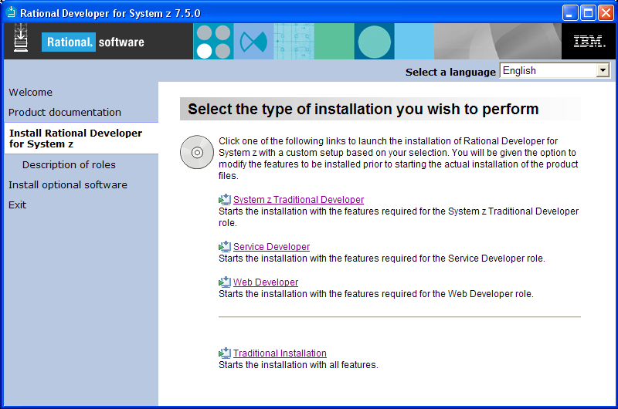
Select the installation option

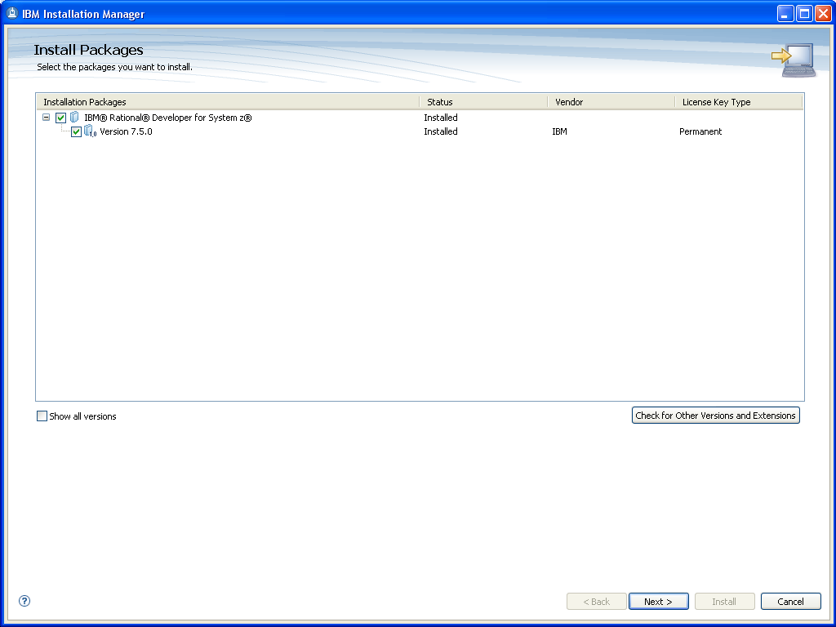

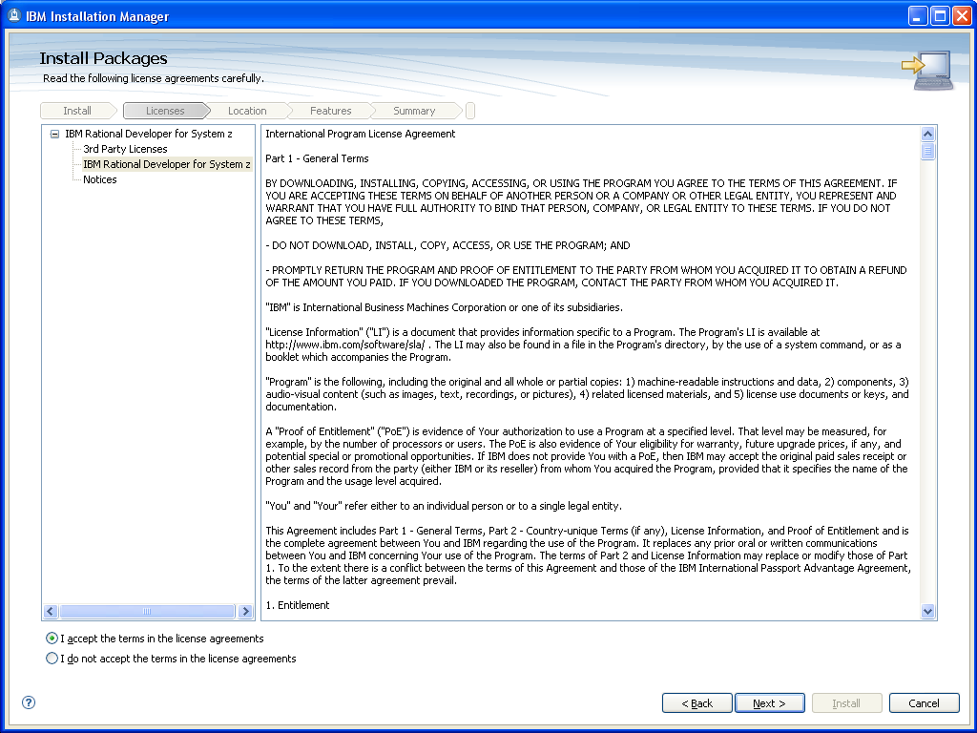

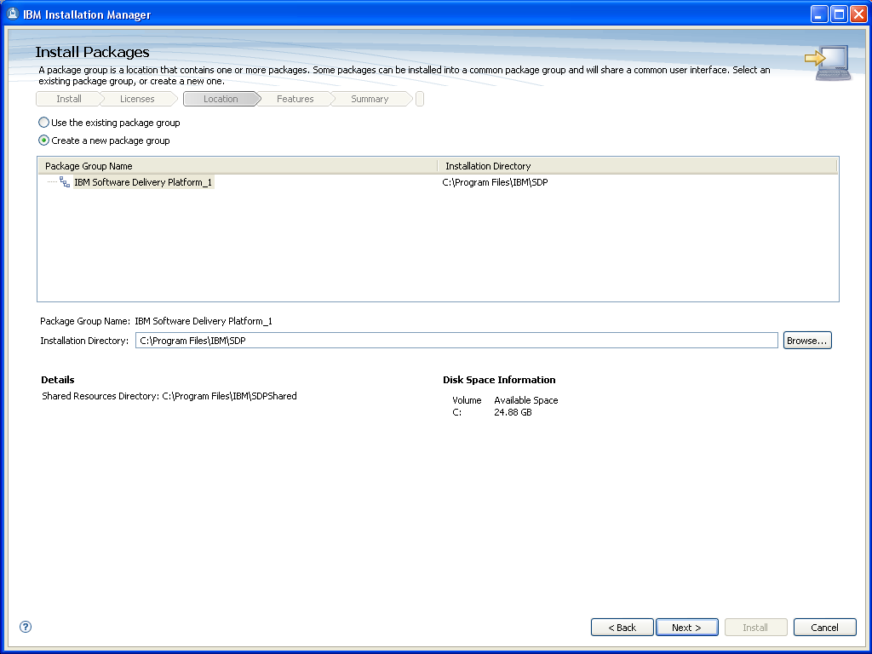

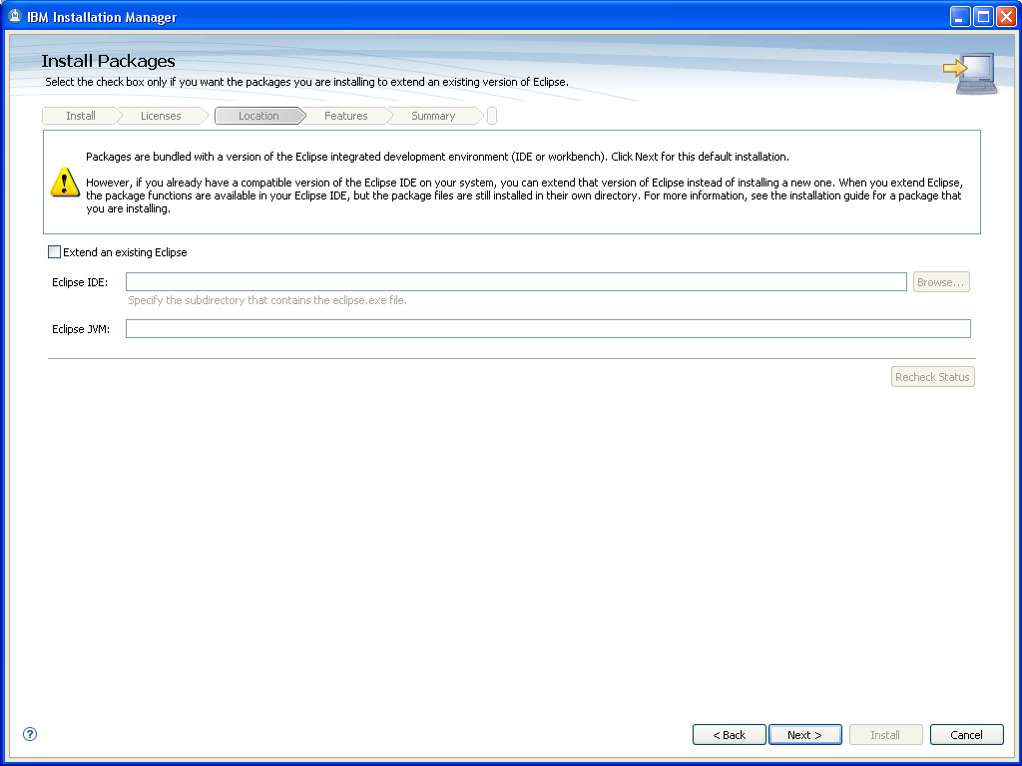
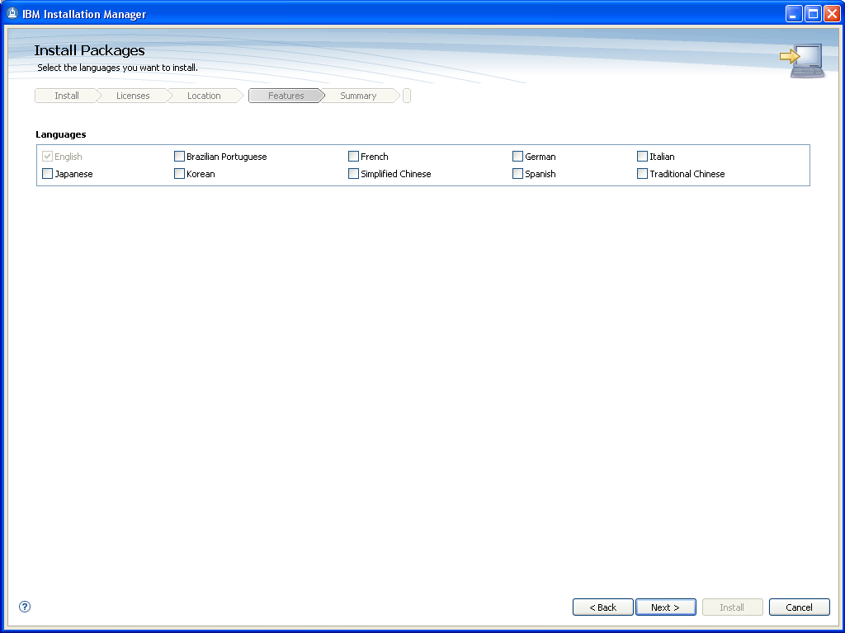

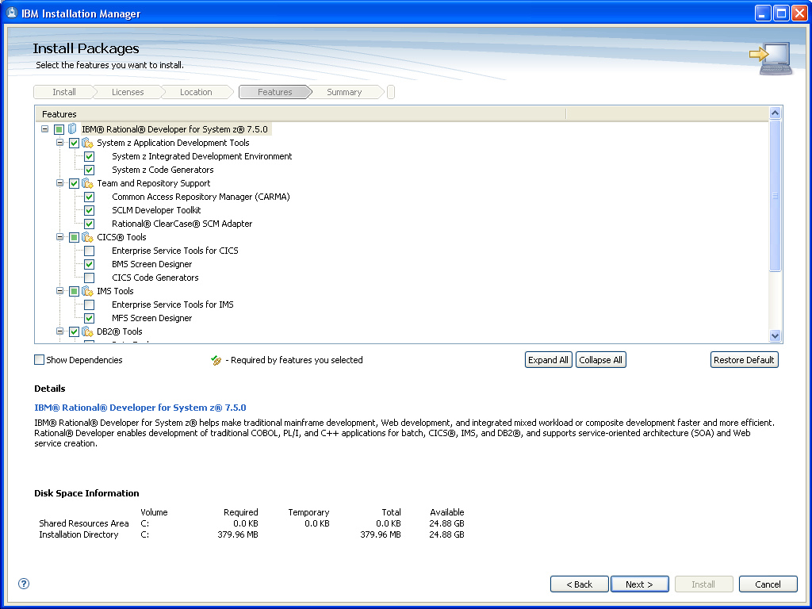

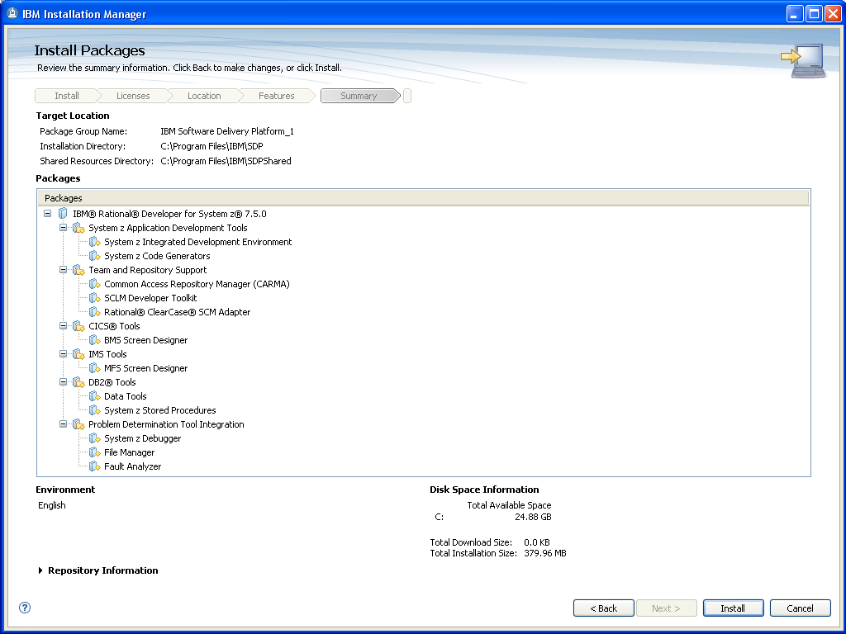
Install RDz

Once this installation finished, you've got the 7.5.0 version of Rational Developer for System z.
To update to the 7.5.1 version, you should start again « IBM Installation Manager » that was installed with Rational Developer for System z, then on the Welcome page, click on the "Update" icon.
At that time, if you have an Internet connection on your computer, the application will check for an update and will suggest it to you automatically.
With the same process as above, you will then be allowed to install the RDz update.

Installation of the Pacbase Convergence Plan Plug-ins on RDz
Once Rational Developer for System z installed, please download the Pacbase Convergence Plan artifacts from the download page of the Pacbase Support Web Site.
http://www-01.ibm.com/software/awdtools/vapacbase/support.html
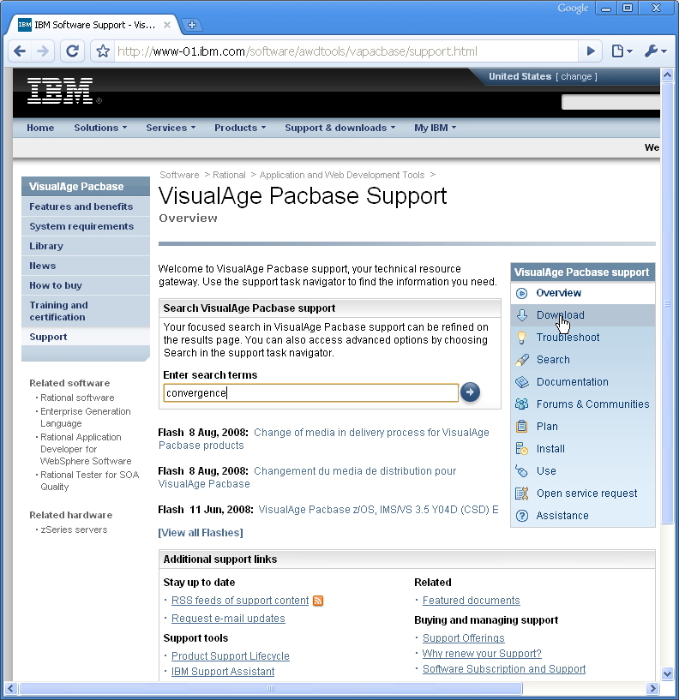
Type the keyword « convergence » or click « Download »

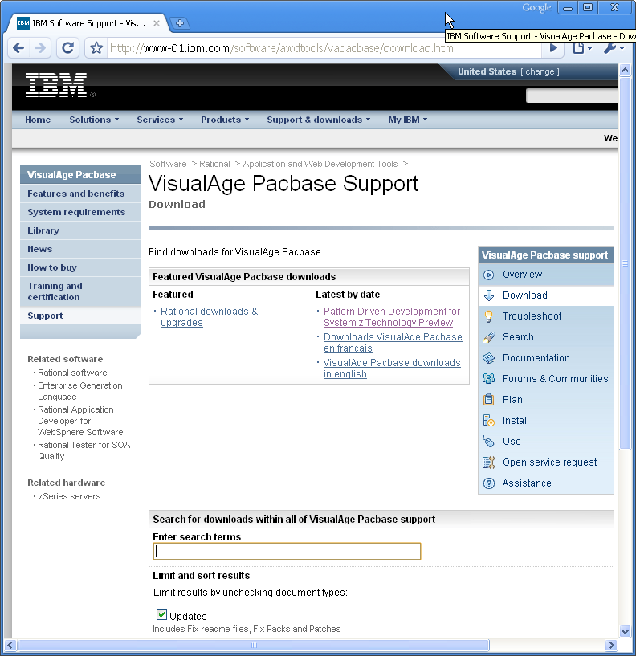
Select this link

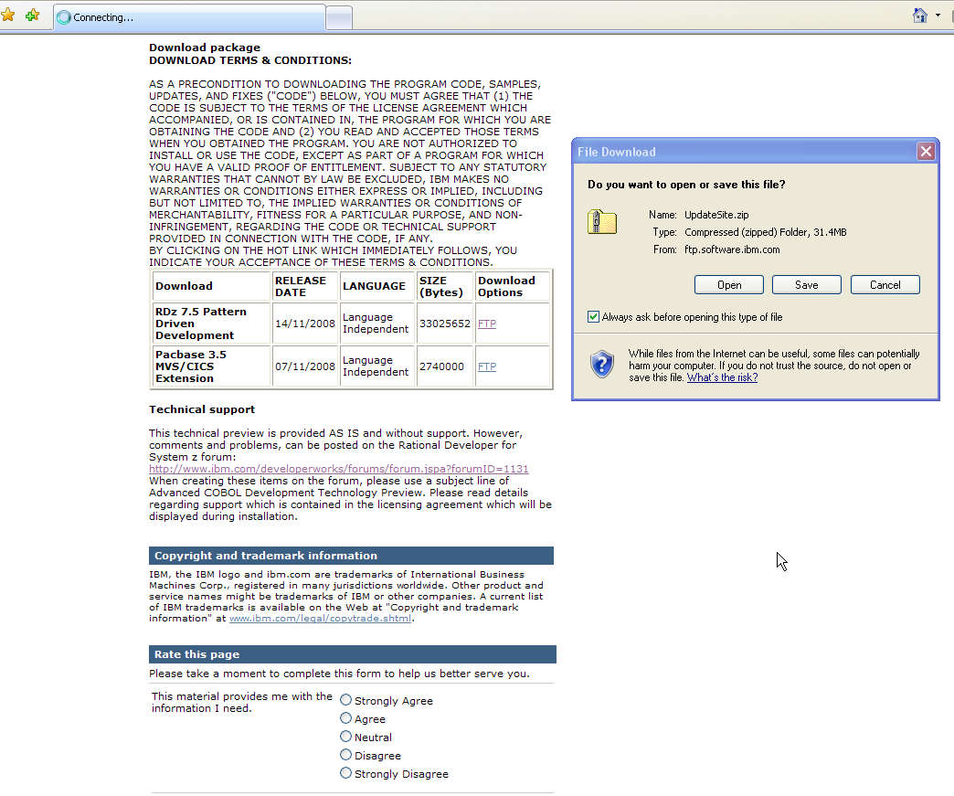
Select this link to download the server part

Select this link to download the client part

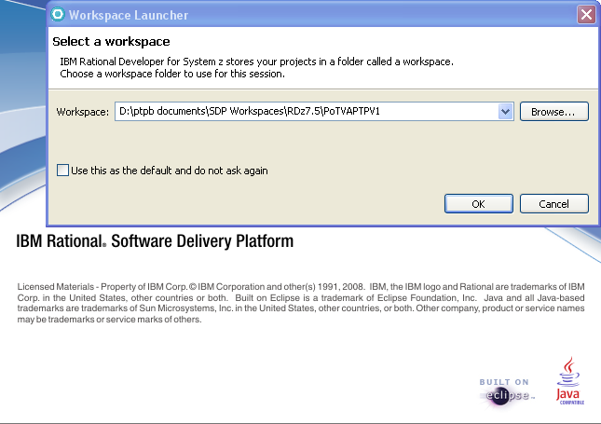
Start RDz 7.5 and select a new workspace

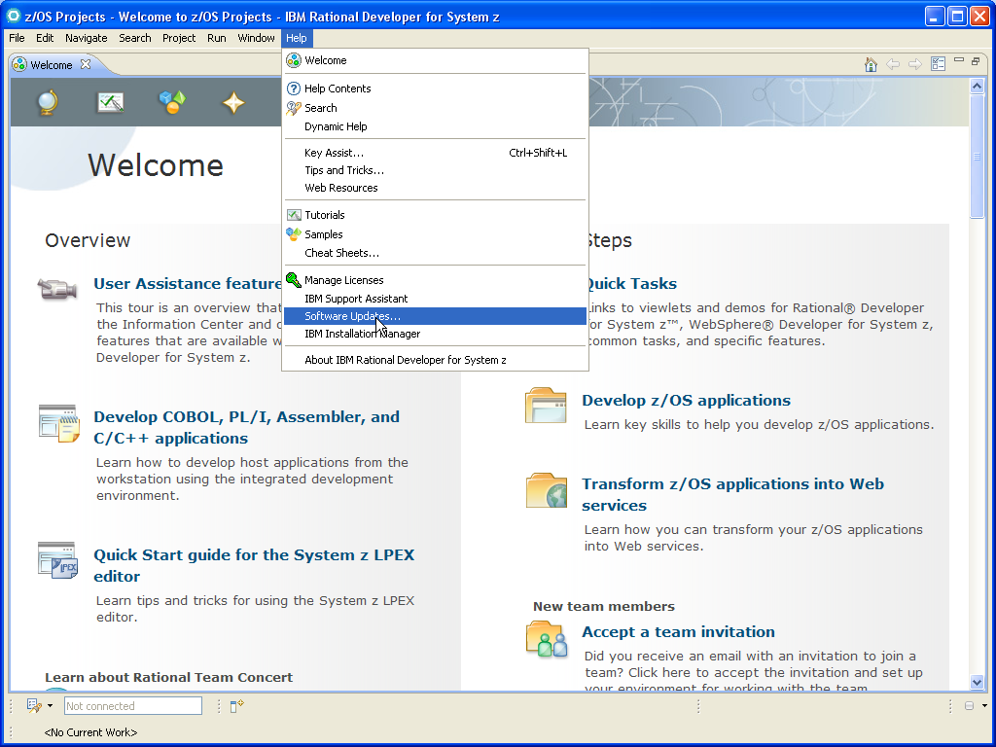
Install the client part

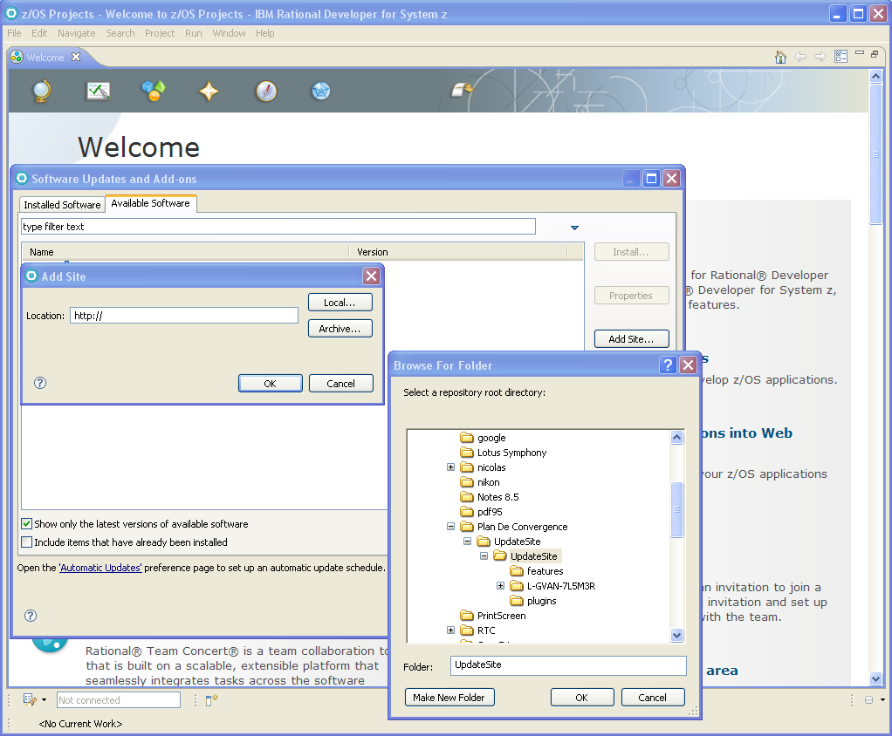
1) Select the « Available Software » tab
2) Click on « Add Site »
3) Click on « Local »
4) Select the directory where you have saved and unzipped the client part

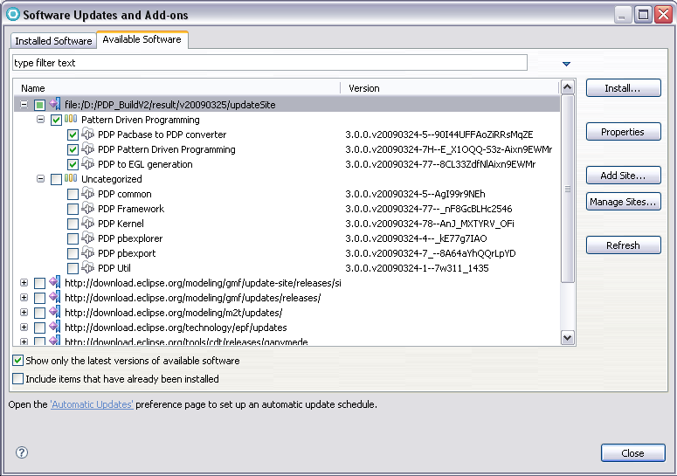
5) Select the check boxes corresponding to Pattern Driven Programming. The EGL plug-in cannot be selected if RDz 7.5 with RBD embedded wasnot installed.
6) Install the plug-ins

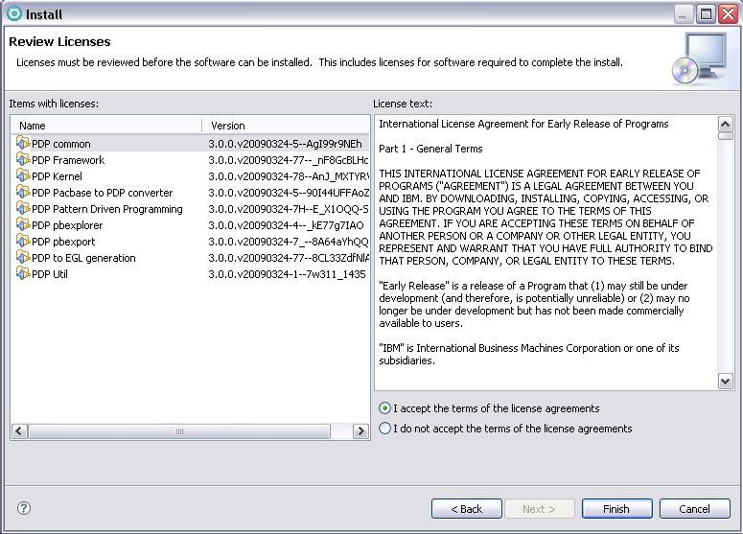
7) Accept the license and click "finish"

At this step, you must install the VisualAge Pacbase Middleware to be able to connect to a Pacbase repository through the "Pacbase explorer" perspective.
Please, refer to the VisualAge Pacbase installation documentation for this installation.

