Integrating IBM WebSphere Adapters with a migrated IBM WebSphere Process Server Runtime Environment

Table of Contents

1 Introduction 4
2 Overview 4
2.1 Server migration 4
2.2 Adapter integration 6
2.2.1 Obtaining the integration aids 7
2.2.2 Installing and configuring the adapter 7
2.2.3 Integrating the adapter 8
3 Adapter Configuration Assistant 8
3.1 Overview 8
3.2 Running the Adapter Configuration Assistant 9
3.3 Viewing the output 9
3.3.1 Typographical conventions 11
3.3.2 Output directory structure 11
3.4 Using the output 11
4 Using WebSphere adapters for applications with a migrated WebSphere Process Server runtime environment 12
4.1 Artifacts generated by the server migration wizard 12
4.2 Modifications to server migration wizard-generated artifacts 12
4.2.1 Common integration tasks 13
4.2.2 Tasks for outbound integration 16
4.2.3 Tasks for inbound integration 19
5 Tips for using WebSphere Adapters for technologies with a migrated WPS runtime Environment 22
6 Troubleshooting and Tips 24
6.1 Troubleshooting 24
6.2 Tips 25
Appendix A. IBM WebSphere Adapter for SAP Software 26
1 Configuration properties 26
1.1 Resource Adapter properties 26
1.2 Managed Connection Factory properties 26
1.3 ActivationSpec properties 27
2 Documentation 28
3 Known limitations 29
Appendix B. IBM WebSphere Adapter for JDBC 30
1 Configuration properties 30
1.1 Resource Adapter properties 30
1.2 Managed Connection Factory properties 31
1.3 ActivationSpec properties 32
2 Known limitations 35
Appendix C. IBM WebSphere Adapter for Siebel 37
1 Configuration properties 37
1.1 Resource Adapter properties 37
1.2 Managed Connection Factory properties 38
1.3 ActivationSpec properties 38
2 Known limitations 41
Appendix D. IBM WebSphere Adapter for JDE 42
1 Configuration properties 42
1.1 Resource Adapter properties 42
1.2 Managed Connection Factory properties 42
2 Known limitations 42
Appendix E. IBM WebSphere Adapter for Flat Files 43
1 Configuration properties 43
1.1 Resource Adapter properties 43
1.2 Managed Connection Factory properties 44
1.3 ActivationSpec properties 44
Appendix F. IBM WebSphere Adapter for FTP 50
2 Configuration properties 50
2.1 Resource Adapter properties 50
2.2 Managed Connection Factory properties 51
2.3 ActivationSpec properties 53
2.4 Wrapper BO properties 62
Appendix G. IBM WebSphere Adapter for Email 66
1 Configuration properties 66
1.1 Resource Adapter properties 66
1.2 Managed Connection Factory properties 67
1.3 ActivationSpec properties 67
2 Wrapper BO properties 72
2.1 EmailBO 72
2.1.1 Outbound 72
2.1.2 Inbound 75
2.2 Header BO 77
2.3 MailAttachment BO 77
2.4 ASI Mapping 78
Appendix H. IBM WebSphere Adapter for PeopleSoft 79
1 Configuration properties 79
1.1 Resource Adapter properties 79
1.2 Managed Connection Factory properties 80
1.3 ActivationSpec properties 80

Introduction
IBM WebSphere® Adapters provide a JCA 1.5 compliant implementation of a J2EE Resource Adapter. The deployment model, configuration, tooling, runtime environment and interaction pattern of this type of adapter are quite different from the previous IBM WebSphere Business Integration Adapter implementation. The purpose of this guide is to describe a method for integrating an IBM WebSphere Adapter with a migrated IBM WebSphere Process Server instance.

This document assumes that you have a working knowledge of the Business Integration capabilities of IBM WebSphere Integration Developer version 6.0.2 and that you are familiar with IBM WebSphere Adapters. The links below provide essential information regarding these products:

IBM WebSphere Process Server documentation
http://publib.boulder.ibm.com/infocenter/dmndhelp/v6rxmx/topic/com.ibm.wsps.602.doc/welcome_wps.html

IBM WebSphere Adapters Version: V6.0.2 Overview and new features
http://publib.boulder.ibm.com/infocenter/ieduasst/v1r1m0/index.jsp?topic=/com.ibm.iea.wa_v6/wa/6.0.2/Overview.html

Important Note: The method described in this guide is only for using IBM WebSphere Adapters with a migrated IBM WebSphere Process Server runtime. If you are not using a migrated runtime, use the instructions provided at the following site:
http://publib.boulder.ibm.com/infocenter/dmndhelp/v6rxmx/topic/com.ibm.wsadapters602.doc/welcome_wsa602.html

Overview
Migrating an existing WebSphere Business Integration solution to a WebSphere Process Server solution is a two-part process. The first part is migrating the business integration server and its related artifacts. The result of this migration is a migrated server runtime. The second part involves integrating the IBM WebSphere Adapters with the migrated server runtime artifacts.

The following sections provide a brief description of both parts of the process.

Server migration
Server migration is the first step in the overall migration process. The goal is to migrate to WebSphere Process Server, while preserving the existing business integration solution by leveraging the migration-support runtime supplied with WebSphere Process Server. Server migration does not modify the existing WebSphere Business Integration Adapters; instead it introduces a new connector enterprise application that sits between the existing JMS queue and the process enterprise application. The connector enterprise application acts as an intermediary. The existing adapters remain entirely unaware of the changes made to the server.

A series of Service Component Architecture artifacts mediate the differences between data models and between invocation models.
- Data model mediation—IBM WebSphere Process Server uses Service Data Objects as its runtime data format. IBM WebSphere InterChange Server uses the Business Objects as its runtime data format. When you migrate IBM WebSphere InterChange Server to IBM WebSphere Process Server, the runtime data format is a Service Data Object derived from the original Business Object (ASBO’ in figure 2 below). In many cases, the Service Data Object produced and consumed by the IBM WebSphere Adapters (ASBO” in figure 2 below) is different than the migrated Service Data Object (ASBO’). A conversion between the two formats needs to take place in order for the IBM WebSphere Adapter to be able to interoperate with a migrated IBM WebSphere Process Server runtime.
- Invocation model mediation—IBM WebSphere Business Integration Adapters rely on the verb attribute of the Business Object to determine how to handle incoming requests, whereas, IBM WebSphere Adapters use the operation specified on the interface. Additionally, IBM WebSphere Adapters support both synchronous and asynchronous event notification and service call request processing. IBM WebSphere Adapters support synchronous invocation and asynchronous event notification.

Figures 1 and 2 show how the server migration process insulates the existing WebSphere Business Integration Adapter from the server changes. The connector enterprise application consists of JMS bindings, data bindings (which invoke a business object converter), business object maps and interface maps. The business object converter performs in-flight business object conversions between WebSphere Business Integration business objects and WebSphere Process Server business graphs and vice versa. The Java component and interface maps provide compatibility between the invocation models.

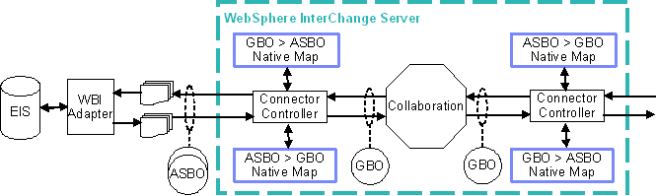
Figure 1: WebSphere InterChange Server configuration (before server migration)

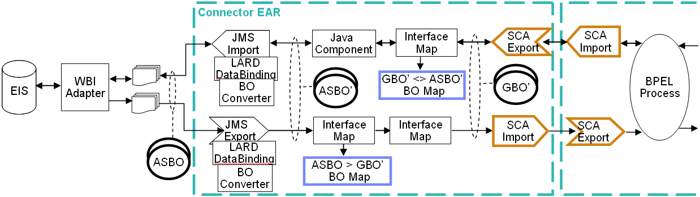
Figure 2: WebSphere Process Server configuration (after server migration)

The server migration wizard in WebSphere Integration Developer produces Business Integration modules and a library containing the migrated artifacts depicted in the Connector EAR and Process EAR boxes in Figure 2 above. For complete details on performing server migration and the artifacts generated, please see the following documents:

WebSphere Process Server V6 Migration Overview
http://publib.boulder.ibm.com/infocenter/ieduasst/v1r1m0/index.jsp?topic=/com.ibm.iea.wpi_v6/wpswid/6.0/Migration/WPSWIDv6_MigrationOverview/player.html
Migrating WebSphere InterChange Server solutions to WebSphere Process Server V6: A simple migration example -- Part 1
http://www3.software.ibm.com/ibmdl/pub/software/dw/wes/pdf/0511_mckinstry-WICS2WPS_migration.pdf
Migrating WebSphere InterChange Server solutions to WebSphere Process Server V6: A simple migration example -- Part 2: Artifacts generated by migration
http://www3.software.ibm.com/ibmdl/pub/software/dw/wes/pdf/0512_mckinstry-WICS2WPS_migration_p2.pdf

Adapter integration
You may choose to upgrade your IBM WebSphere Business Integration Adapters with analogous IBM WebSphere Adapters after your server migration is complete. You can upgrade any number of adapters at one time. There is no interdependency between the adapters you choose to upgrade. Upgrading requires you to integrate each new IBM WebSphere Adapter with the migrated server runtime.

To use an IBM WebSphere Adapter with a migrated server runtime, you must perform these steps:

- Obtain the integration aids
- Install and configure the adapter
- Integrate the adapter

Figure 3 shows how the solution looks after you complete the adapter integration.

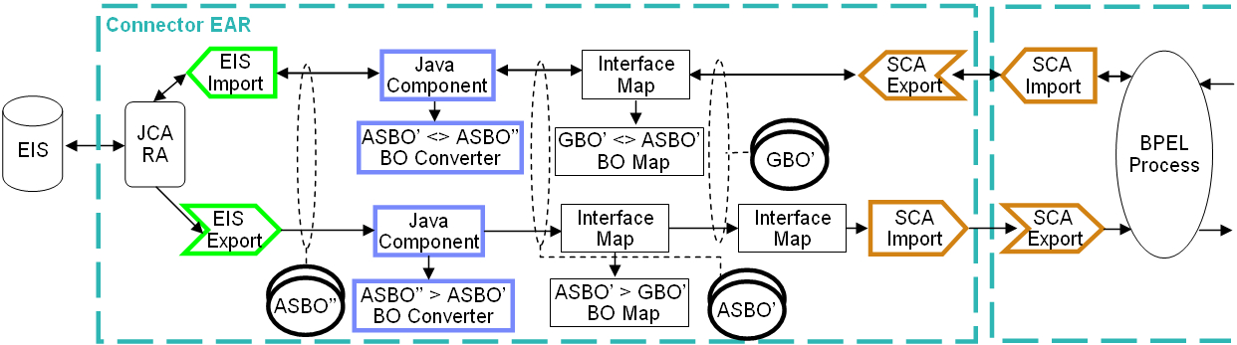
Figure 3: WebSphere Process Server configuration (after adapter upgrade)

Obtaining the integration aids
To help you integrate IBM WebSphere Adapters with a migrated server runtime, a set of tools specific to each adapter is available for download at the IBM WebSphere Adapters product support website. Simply search for the keyword: wbiaupgrade

To use the integration aids, download and extract the following files from the website above to a temporary location:

- extractConfig.jar – this is the Adapter Configuration Assistant tool
- Adapter-specific upgrade kit .zip file

- The content of the adapter-specific upgrade kit .zip file depends on the adapter. Although the actual file names vary, in general, the content includes these files:

- Adapter Configuration Assistant metadata file for the adapter (*.aef file)
- BO Converter .jar file (not applicable to the adapters for Flat Files, FTP, and Email adapters)
- one or more BOMapping .xml files (not applicable to the adapters for Flat Files, FTP, and Email adapters)

You’ll use these files later in the adapter integration process.

Installing and configuring the adapter
The installation instructions for WebSphere Adapters are provided in this document:

Installing IBM WebSphere Adapters
http://publib.boulder.ibm.com/infocenter/dmndhelp/v6rxmx/index.jsp?topic=/com.ibm.wsadapters602.ins.doc/doc/stins_welcome.html

When upgrading to an IBM WebSphere Adapter from an IBM WebSphere Business Integration Adapter, be sure to do the following:

Before running the Enterprise Service Discovery wizard, run the Adapter Configuration Assistant to extract and present relevant configuration information about the adapters contained in the ICS server repository. This information assists you with configuring your WebSphere Adapter using a method similar to the one you used to configure your WebSphere Business Integration Adapter.

On the Generating Artifact page of the Enterprise Discovery Wizard, do not specify a new module as instructed; instead, to facilitate the integration process, select the module that was created by the server migration that corresponds to the adapter you want to upgrade.

Integrating the adapter
As mentioned earlier in this document, migrating the server isolates the existing WebSphere Business Integration Adapter from the server by introducing a new connector enterprise application. This connector enterprise application uses JMS bindings to communicate with existing adapter queues.

To integrate an IBM WebSphere Adapter into this environment, you must 1)
replace the JMS bindings, which are generated by the server migration, with the EIS bindings, which are generated by the Enterprise Service Discovery wizard, 2) map the interfaces and business objects generated by the Enterprise Service Discovery wizard to those generated by the server migration.

This process is explained in the Using WebSphere Adapters with a migrated WPS runtime Environment section of this document.

Adapter Configuration Assistant
The Adapter Configuration Assistant is a utility that extracts relevant connector configuration information from your old server repository file and displays these values in an easy-to-read format. These values are useful when you are configuring your JCA Adapter.

Overview
The utility processes all available adapter-specific extraction files (*.aef) against the server repository. The adapter-specific extraction files provide information to the Adapter Configuration Assistant about how to parse specific WebSphere Business Integration Adapter connector configuration files. The Adapter Configuration Assistant produces one index.html file that references a set of adapter .html files.

Each adapter extraction file contains an adapter name value. Each .cfg file contains a name value. The utility matches adapter extraction files with .cfg files based on these two values. Specifically, the utility looks for the adapter name value in the adapter extraction file as a substring of the name value in the .cfg file. For example, if the name of the adapter in the .cfg file is “mySampleAdapter ”, the utility matches it with the extraction file whose adapter name is specified as “Sample”.

If the name in the .cfg file does not match any of the adapter names in the available adapter extraction files, an entry for that .cfg file is placed in the map.properties file. This feature allows you to manually specify the correct adapter extraction file for each particular adapter listed in this file. Delete the generated \config directory and re-run the tool. This time the previously unmatched files are processed appropriately.

For example:
If an IBM WebSphere Business Integration Adapter for JDBC has the Adapter Name property specified as “ABCConnector” in its connector configuration file, the Adapter Configuration Assistant is unable to determine which .aef file to use to parse it, so it generates the following entry in map.properties.

#Thu Feb 01 18:48:59 EST 2007
ABCConnector_4.3.0=

To identify this connector configuration file, you must edit the map.properties file and add the name identifier specified in the JDBC.aef file. See the snippet from the JDBC.aef file below:

<?xml version="1.0" encoding="UTF-8"?>
<adapter name="JDBC" version ="2.6.5">

The resulting map.properties file looks like this:

#Thu Feb 01 18:48:59 EST 2007
ABCConnector_4.3.0=JDBC

Now, you must delete the generated \config directory and rerun the Adapter Configuration Assistant as before. This time, the previously unidentifiable connector configuration file is correctly parsed.

Running the Adapter Configuration Assistant
The utility is invoked using a simple command-line interface. The command syntax is as follows:

java –jar extractConfig.jar -i<repository file> -o<mapping file dir>

Parameters:
-i: This parameter specifies the fully qualified name of the repository file.
-o: This parameter specifies the fully qualified output directory path. The utility creates a \configs subdirectory under this directory and places the output there.

Example:
java –jar extractConfig.jar –iC:\temp\MyICSRepository.jar –C:\temp

All .aef files needed to parse the connector configurations contained in the repository .jar file must reside in the same directory as the extractConfig.jar file. The utility will read all of the .aef files in this directory and use them to extract the relevant data from the repository .jar file.

Viewing the output
The Adapter Configuration Assistant generates a set of .html files for each adapter extraction file found in the mapping directory. All of the generated files are accessible though the index.html file.

To view the output generated by the utility, open a browser and direct it to the index.html file generated in <adapter extraction file directory>\configs\. A sample screen capture is shown in Figure 4.

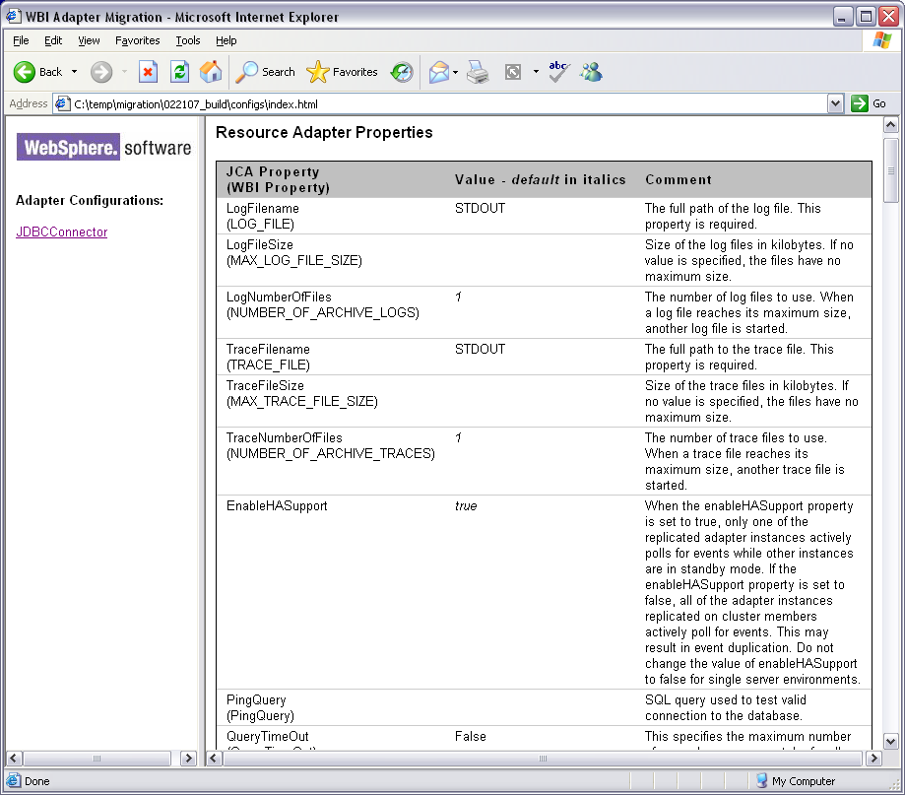

Figure 4: Adapter Configuration Assistant output

The output of the Adapter Configuration Assistant shows all of the processed WebSphere Business Integration Adapter configurations in the navigation (left) frame. Click on any one of the links in the navigation frame to display the processed information in the content (right) frame. The relevant configuration information is divided by these configuration property types:

- Resource Adapter properties
- Managed Connection Factory properties
- Activation Spec properties

Typographical conventions
There are several typographical conventions used in the output of the Adapter Configuration Assistant.

The JCA Property column displays the name of the JCA property, as well as the WebSphere Business Integration property name in parentheses. If no WebSphere Business Integration property is shown below the JCA Property, this is a new property and did not exist in the WebSphere Business Integration configuration.

If the WebSphere Business Integration property shown is preceded by a pound sign (#), this property’s value is specified in one or more meta objects. In this case, each meta object name is shown followed by a dash (-), followed by the corresponding value for this property in that particular meta object.

The Value column shows the value of the property. If the property value was extracted from an analogous WebSphere Business Integration property, the text is displayed normally. If the property value is blank in the WebSphere Business Integration configuration or did not exist in the WebSphere Business Integration configuration and a suitable default is appropriate, the text is displayed in an italic font.

Output directory structure
The following diagram shows the directory structure of the files output by the Adapter Configuration Assistant.

\<mapping file dir>
\configs
index.html
map.properties
nav.html
print.css
screen.css
websphere.gif
welcome.html
<adapter name>_<version>.html
\bos
<bo name>.html
print.css
screen.css

Using the output
The output generated by the Adapter Configuration Assistant helps you configure your IBM WebSphere Adapter. You can use the properties in the Managed Connection Factory section of the output when you run the Enterprise Service Discovery wizard for adapter outbound, and you can use the properties in the Activation Spec section when you run the Enterprise Service Discovery wizard for adapter inbound. The properties in the Resource Adapter section contain information for both adapter inbound and adapter outbound processing.

Using WebSphere adapters for applications with a migrated WebSphere Process Server runtime environment
This section describes the process of integrating an IBM WebSphere Adapter for applications with a migrated server runtime.

You must have successfully completed the following steps prior to attempting the integration described here:

- The server repository must be successfully migrated. All migration errors should be resolved.
- At least one IBM WebSphere Adapter must be installed and configured using the Enterprise Service Discovery wizard. Be sure that you generated the output artifacts into modules created by server migration.

Artifacts generated by the server migration wizard
The server migration process creates one business integration module for each WebSphere Business Integration connector in your server repository. This module represents the connection between the migrated business process and the WebSphere Business Integration Adapter. These modules are identified by the “Connector” suffix.

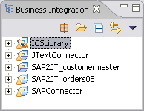

Each connector module contains a module assembly that shows how individual components are composed within the module. A description of each component generated by the server migration is beyond the scope of this document. For complete details of each component generated, please refer to the following document:
Migrating WebSphere InterChange Server solutions to WebSphere Process Server V6: A simple migration example -- Part 2: Artifacts generated by migration
http://www3.software.ibm.com/ibmdl/pub/software/dw/wes/pdf/0512_mckinstry-WICS2WPS_migration_p2.pdf

Modifications to server migration wizard-generated artifacts
To integrate an IBM WebSphere Adapter with a migrated WebSphere Process Server runtime, the module representing the IBM WebSphere Business Integration Adapter needs to be modified. The sections below provide detailed descriptions of these tasks:

- Common integration tasks
- Tasks for outbound integration
- Tasks for inbound integration

Common integration tasks

Add entries to a BO mapping file
A BO Converter uses a mapping file to map the source business object to the target business object. For each business object you want to convert, you need to add an entry into the BO mapping file provided. A map entry correlates a WBI business object definition to a WebSphere Adapter business object definition and vice versa. A map entry is an XML element with the following four sub elements:

- <wbiaTypeName> - WebSphere Business Integration BO Type name
- <wbiaTypeURL> - WebSphere Business Integration BO Type URL
- <wsaTypeName> - WebSphere Adapter BO Type name
- <wsaTypeURL> - WebSphere Adapter BO Type URL

A sample map entry is shown below:
<MapEntry>
<wbiaTypeUrl>http://www.ibm.com/websphere/crossworlds/2002/BOSchema/sap_orders05/sap_orders05BG</wbiaTypeUrl>
<wbiaTypeName>sap_orders05BG</wbiaTypeName>
<wsaTypeUrl>http://www.ibm.com/xmlns/prod/websphere/j2ca/sap/saporders05bg</wsaTypeUrl>
<wsaTypeName>SapOrders05BG</wsaTypeName>
</MapEntry>

Add a BO Converter and mapping files to the EAR file
You need to add the BO mapping file you created above and the BO Converter .jar file you downloaded to the EAR file to make those files available in the runtime environment.

- From the Business Integration Perspective, select the connector module created by the server migration process.

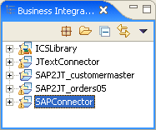

- Right-click the name of the connector module and select Import... Select File System. Then click Next.

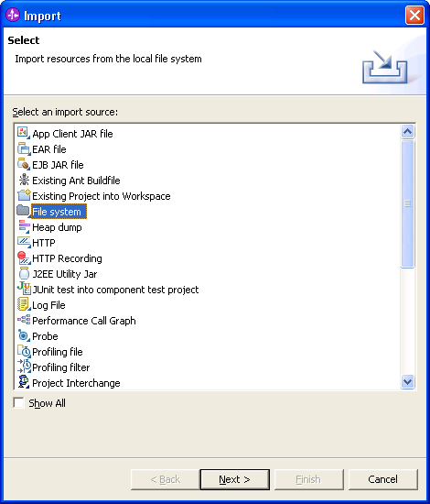

- Select the BO Mapping file you created following the instructions in section 4.2.1.1 and the BO Converter .jar file you downloaded following the instructions in section 2.2.1. Click Finish.
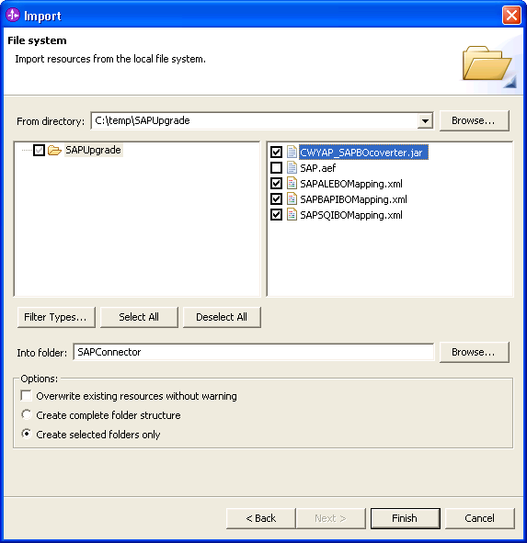

- The following window is displayed. Click Yes.
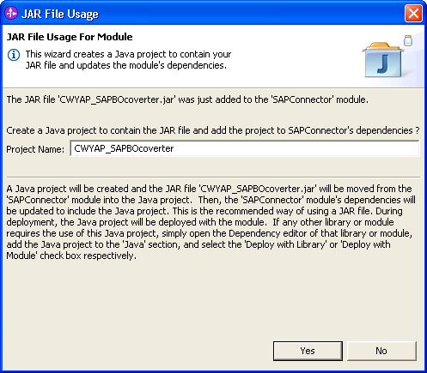

Tasks for outbound integration
Perform the following tasks on the module assembly that represents the adapter you want to integrate:

- Delete the JMS export binding named Output.
- Delete the Java component named Output_Processing.
- Create a new Java component called WBI2WSA.
- Wire the reference of the Generic_To_Native interface map component to the interface of the WBI2WSA Java component.
- Wire the reference of the WBI2WSA Java Component to the interface of the EIS export binding.
- The following prompt may be presented: check Remember my decision and do not ask me again. Click No.
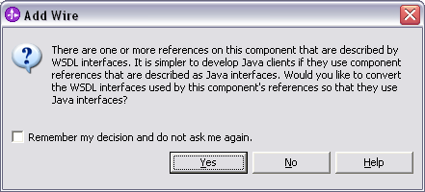

Here is an example of what the outbound assembly should look like before:

Here is an example of what the outbound assembly should look like after:

- Double click the WBI2WSA component. The following prompt appears. Click Yes.
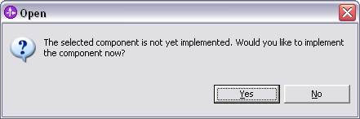

- The following window appears. Click OK.

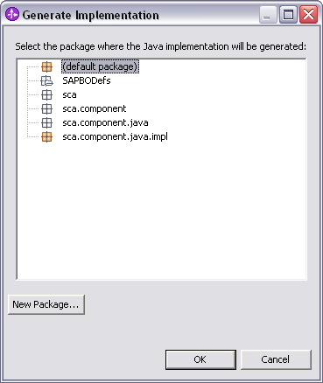

- The following prompt may appear. Click No.

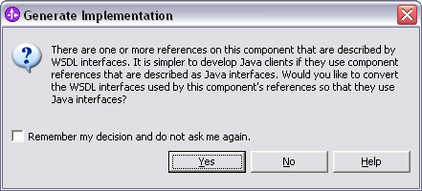

- The generated Java source code for WBI2WSA is displayed in the editor pane. Methods representing the operations defined on the interface are created for you. For outbound, you need to modify the method for synchronous operations. This method is identified by the “_Sync” suffix.
  - Insert the following code snippet:

ServiceInvoker invoker = new ServiceInvoker (this, “<name of mapping file>”);
return invoker.outbound_Sync(<input parameter>);

where <name of mapping file> is the name of the BO Mapping file you created and <input parameter> is the name of the input parameter passed to the original method.
For examples, if the original method looked like this:

public DataObject sap_orders05BG_Sync(DataObject aSap_orders05BG){
//TODO Needs to be implemented.
return null;
}

Then the method would look like this after the modification:
public DataObject sap_orders05BG_Sync(DataObject aSap_orders05BG){
ServiceInvoker invoker = new ServiceInvoker (this, “SAPALEBOMapping.xml”);
return invoker.outbound_Sync(aSap_orders05BG);
}

Additionally, you need to add an import statement to the generated Java Class. The easiest way to do this is to use the Quick Fix function on the Error displayed in WebSphere Integration Developer.

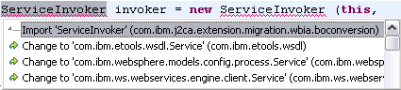

Tasks for inbound integration
Perform the following tasks on the module assembly that represents the adapter you want to integrate:

- Delete the JMS import binding named Input_Async.
- Create a new Java component called WSA2WBI.
- Wire the reference of the EIS import binding to the interface of the WSA2WBI Java Component.
- Wire the reference of the WSA2WBI Java component to the interface of the Native_To_Generic interface map.
- The following prompt may be presented: check Remember my decision and do not ask me again. Click No.

Here is an example of what the inbound assembly should look like before:

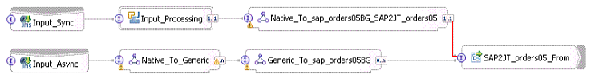

Note: IBM WebSphere Adapters version 6.0.2 do not support synchronous inbound event processing, so the wire highlighted in red above can be deleted.

Here is an example of what the outbound assembly should look like after:

- Double click the WSA2WBI component. The following prompt appears. Click Yes.

- The following window appears. Click OK.

- The following prompt may appear. Click No.

- The generated Java source code for WSA2WBI is displayed in the editor pane. Methods representing the operations defined on the interface are created for you. For inbound, you need to modify the method for asynchronous operations. This method is identified by the “_Async” suffix.
  - Insert the following code snippet:

ServiceInvoker invoker = new ServiceInvoker (this, “<name of mapping file>”);
invoker.inbound_async(<input parameter>);

where <name of mapping file> is the name of the BO Mapping file you created and <input parameter> is the name of the input parameter passed to the original method.

For example, if the original method looked like this:

public void emitCreateAfterImageSapOrders05(DataObject emitCreateAfterImageSapOrders05Input) {
//TODO Needs to be implemented.
}

Then, the method would look like this after the modification:

public void emitCreateAfterImageSapOrders05 (DataObject emitCreateAfterImageSapOrders05) {
ServiceInvoker invoker = new ServiceInvoker (this, "SAPALEBOMapping.xml");
invoker.inbound_Async(emitUpdatewithdeleteAfterImageSapOrders05Input);
}

Additionally, you need to add an import statement to the generated Java Class. The easiest way to do this is to use the Quick Fix function on the Error displayed in WebSphere Integration Developer.

Tips for using WebSphere Adapters for technologies with a migrated WPS runtime Environment
WebSphere Business Integration Adapters for JText and Email utilize datahandlers to provide data transformation capabilities from native data formats to WebSphere Business Integration business objects and vice versa. Please see their respective User Guides located at the link below:

http://publib.boulder.ibm.com/infocenter/wbihelp/v6rxmx/index.jsp?topic=/com.ibm.wbi_adapters.doc/welcome_adapters.htm

The WebSphere Adapters for Flat Files, FTP and Email utilize databindings to provide similar data transformation capabilities. Pleas see their respective User Guides located at the link below:

http://publib.boulder.ibm.com/infocenter/dmndhelp/v6rxmx/index.jsp?topic=/com.ibm.wsadapters602.doc/welcome_wsa602.html

IBM WebSphere Process Server ships a set of sample databindings which you can customize and use with your WebSphere Adapters. A documentation describing these samples can be found in:

<WPS install dir>\samples\doc\CustomEISDataBinding

Information on creating custom data bindings can be found at the link below:
http://www-128.ibm.com/developerworks/websphere/library/techarticles/0606_mishra/0606_mishra.html

Troubleshooting and Tips

Troubleshooting
The table below describes common problems encountered during the adapter upgrade process along with the cause and corrective action.

Problem | Cause | Action
Error message is displayed when attempting to use the Test Module function in WebSphere Integration Developer. | All components in the module are required to have a value for the Display Name property. | Ensure that all components in the module have a value specified for the Display Name property. Typically this is absent in the JMS import/export bindings created when a WICS repository is imported.
The following error message may be displayed during deployment.  “<Dump Handler is Processing OutOfMemory, JVM requesting Java core file. JVM Requesting Heap dump file. Insufficient space in Javaheap to satisfy allocation request.>” | The default Maximum Heap Size is insufficient. | Increase the Maximum Heap Size to 1024K using the WebSphere Process Server Administration Console.  This setting can be found under:  Application servers -> <your server name>-> Process Definition -> Java Virtual Machine.
When sending an inbound synchronous event, the following error is encountered:  “CNTR0020E: EJB threw an unexpected (non declared) exception during invocation of method "onMessage" on bean…” | Synchronous inbound requests are not supported. | Send the inbound request asynchronously.
Adapter may load the wrong version of a business object if there are two versions of the same business object type in the module. | The adapter inbound/outbound interface will load the first BO in its path if the BO name and namespace match the BO definition in the interface. | It is recommended to have only one copy of a BO type in the integration module.  If more than one copy of the same BO is desired, choose a different namespace for the second BO during ESD BO generation.
“Cannot resolve WSDL message…” | Artifacts in the workspace or in WebSphere Process Server Test Environment are out of sync. | Rebuild the workspace using the Project -> Clean… option.  If the problem persists, restart the WebSphere Process Server Test Environment instance.

Tips
Here are some general tips which may prove useful as you modify your migrated solution to use IBM WebSphere Adapters:
- If you encounter unexpected errors while developing your solution in WebSphere Integration Developer, try rebuilding the entire workspace using the Project -> Clean… function. This will help to ensure that all of your artifacts are synchronized and in many cases eliminates erroneous error messages.
- When generating Business Objects using the enterprise service discovery wizard, be sure to use the same or similar options you used when generating your WebSphere Business Integration business objects using the Object Discovery Wizard.
  - For example, if you chose to generate object attributes based on column description using the Object Discovery Agent, then be sure to choose the same option when running the enterprise service discovery wizard.
  - Also, if you generate business objects with the wrong option, be sure to delete all of the generated business objects before re-running the enterprise service discovery wizard again.

Appendix A. IBM WebSphere Adapter for SAP Software

Configuration properties
Configuration properties for WebSphere Adapters are collected when the enterprise service discovery wizard is run. The following sections show how configuration properties for the IBM WebSphere Business Integration Adapter for mySAP.com map to configuration properties for the WebSphere Adapter for SAP Software. Running the Adapter Configuration Assistant extracts and presents these values for easy reference when running the enterprise service discovery.

Resource Adapter properties
WebSphere Business Integration Adapter Property | WebSphere Adapter Property | Required | Default Value | Comments
 | Adapter ID | Yes | ResourceAdapter
MAX_LOG_FILE_SIZE | Log file size | No | 0 | Size of the log files in kilobytes. If no value is specified, the files have no maximum size.
LOG_FILE | Log file name | No |  | The full path of the log file.
NUMBER_OF_ARCHIVE_LOGS | Log files | No | 1 | The number of log files to use. When a log file reaches its maximum size, another log file is started.
MAX_TRACE_FILE_SIZE | Trace file size | No | 0 | Size of the trace files in kilobytes. If no value is specified, the files have no maximum size.
TRACE_FILE | Trace file name | No |  | The full path to the trace file.
NUMBER_OF_ARCHIVE_TRACES | Trace files | No | 1 | The number of trace files to use. When a trace file reaches its maximum size, another trace file is started.

Managed Connection Factory properties
WebSphere Business Integration Adapter Property | WebSphere Adapter Property | Required | Default Value | Comments
ApplicationUserName | User Name | No |  | Name of the adapter's user account on the SAP application
ApplicationPassword | Password | No |  | Password for the adapter's user account on the SAP application
Client | Client | Yes | 100 | Client number under which the adapter logs in
Language | Language | Yes | E | Language in which the adapter logs in
 | Codepage Number | Yes | 1100
PartnerCharset | Partner Charset | No
Sysnr | System Number | No | 0 | System number of the application server
Hostname | Application Server Host | No |  | The IP address or the host name of the application that the adapter logs in to (no load balancing)
 | Gateway Host | No
gwService | Gateway Service | No | sapgw00 | Gateway server identifier
Hostname | Message Server Host | No |  | The name of the message server (for load balancing)
Group | Name of the group of application servers(logon Group) | No |  | The logical name of the logon group that represents a group of application servers (for load balancing)
SAPSystemID | System ID (R3 Name) | No |  | The logical name of the SAP R/3 system, which is also known as R3name (for load balancing)
RfcTraceOn | RFC Trace On | No | FALSE | Specifies whether or not to generate a text file detailing the RFC activity for each listener thread
IgnoreBapiReturn | Ignore Bapi Return | No | FALSE
ABAPDebug | ABAP Debug | No | FALSE

ActivationSpec properties
WebSphere Business Integration Adapter Property | WebSphere Adapter Property | Required | Default Value | Comments
 | Gateway Host | Yes
gwService | Gateway Service | Yes | sapgw00 | Gateway server identifier
RfcProgramId | RFC Program ID | Yes |  | Identification that the adapter registers in the SAP Gateway so that the listener threads can process events from the RFC-enabled functions
Client | Client | Yes | 100 | Client number under which the adapter logs in
NumberOfListeners | Number of Listeners | Yes | 1
ApplicationUserName | User Name | No |  | Name of the adapter's user account on the SAP application
ApplicationPassword | Password | No |  | Password for the adapter's user account on the SAP application
Language | Language | Yes | E | Language in which the adapter logs in
 | Codepage Number | Yes | 1100
PartnerCharset | Partner Charset | No
Sysnr | System Number | Yes | 0 | System number of the application server
Hostname | Application Server Host | Yes |  | The IP address or the host name of the application that the adapter logs in to (no load balancing)
Hostname | Message Server Host | No |  | The name of the message server (for load balancing)
Group | Name of the group of application servers(logon Group) | No |  | The logical name of the logon group that represents a group of application servers (for load balancing)
SAPSystemID | System ID (R3 Name) | No |  | The logical name of the SAP R/3 system, which is also known as R3name (for load balancing)
RfcTraceOn | RFC Trace On | No | FALSE | Specifies whether or not to generate a text file detailing the RFC activity for each listener thread
ALEUpdateStatus | ALE Update Status | No | FALSE | Specifies whether an audit trail is required for all message types
ALEStatusMsgCode | ALE Status Message Code | No
ALESuccessCode | ALE Success Code | No
ALEFailureCode | ALE Failure Code | No
ALESuccessText | ALE Success Text | No
ALEFailureText | ALE Failure Text | No

Documentation
SAP BO converter supports the conversion of BOs for the following SAP interfaces:
- ALE
- BAPI
- HDR/SQI
Sample BO mapping files SAPALEBOMapping.xml, SAPBAPIBOMapping.xml and SAPSQIBOMapping.xml are provided for each of the supported interface. You specify the corresponding mapping file for each SAP interface. See section 4.2.1 and section 4.2.2 for more information on how to edit the BO mapping file and add the BO mapping file to the adapter migration project.

When working with ALE and BAPI interfaces BO mapping, only the top level business graph names need to be specified for the BOs that you are mapping. For example, if you are mapping ALE ORDERS05 business object then you specify sap_orders05BG and SapOrders05BG in the map entry.

When working with HDR/SQI interface BO mapping, a map entry need to be specified for each BO pair in the business object definition hierarchy. For example, if you are mapping HDR/SQI KNA1 business object and KNA1 has an ADRC and KNVV children business object. You need to create the following map entries:
- sap_kna1_hierBG to SapKna1BG
- sap_kna1_hier_ADRC with SapAdrc
- sap_kna1_hier_KNVV with SapKnvv
WebSphere Adapter for SAP Software’s ALE and BAPI outbound interfaces accepts a business graph as input type and returns the same business graph as the output type. WebSphere Adapter for SAP Software SQI outbound interface however takes a business graph as input and returns a container of business graphs. For this reason you must specify separate map entries for the outbound interface’s input and output. In the map entry you also need to specify the direction of the data flow.

For example, if you are mapping KNA1 business object, you must create a map entry for sap_kna1_hierBG to SapKna1BG and specify the direction attribute in the map entry element as direction="WBI2WSA". You must also create a second map entry for SapKna1Container to sap_kna1_hierBG with the direction attribute in the map entry element set to direction="WSA2WBI". The sample SAPSQIBOMapping.xml file shows an example of this directional specific mapping.

Known limitations
When running WebSphere Adapter for SAP Software’s SQI outbound interface, the return BO is a container. This container may contain 1 or more business graphs. Given that WebSphere Business Integration Adapter for mySAP.com’s HDR expects only a single business object/graph, the first business graph from SQI outbound is converted and returned.

Appendix B. IBM WebSphere Adapter for JDBC

Configuration properties
Configuration properties for WebSphere Adapters are collected when the enterprise service discovery wizard is run. The following sections show how configuration properties for the WBIA Adapter for JDBC map to configuration properties for the WebSphere Adapter for JDBC. Running the Adapter Configuration Assistant extracts and presents these values for easy reference when running the enterprise service discovery.

Resource Adapter properties
WebSphere Business Integration Adapter Property | WebSphere Adapter Property | Required | Default Value | Comments
LOG_FILE | LogFilename | Yes |  | The full path of the log file.
MAX_LOG_FILE_SIZE | LogFileSize | No |  | Size of the log files in kilobytes. If no value is specified, the files have no maximum size.
NUMBER_OF_ARCHIVE_LOGS | LogNumberOfFiles | No | 1 | The number of log files to use. When a log file reaches its maximum size, another log file is started.
TRACE_FILE | TraceFilename | Yes |  | The full path to the trace file.
MAX_TRACE_FILE_SIZE | TraceFileSize | No |  | Size of the trace files in kilobytes. If no value is specified, the files have no maximum size.
(NUMBER_OF_ARCHIVE_TRACES | TraceNumberOfFiles | No | 1 | The number of trace files to use. When a trace file reaches its maximum size, another trace file is started.
 | EnableHASupport | No | true | When the enableHASupport property is set to true, only one of the replicated adapter instances actively polls for events while other instances are in standby mode. If the enableHASupport property is set to false, all of the adapter instances replicated on cluster members actively poll for events. This may result in event duplication. Do not change the value of enableHASupport to false for single server environments.
PingQuery | PingQuery | No |  | SQL query used to test valid connection to the database.
QueryTimeOut | QueryTimeOut | No |  | This specifies the maximum number of seconds a query can take for all SQL statements. If a value is not specified, no timeout is set on the query. If the query takes longer than the number of seconds specified, the database produces an SQL exception that is captured. The associated message is logged in the log file.
RDBMSVendor | DatabaseVendor | Yes |  | Specifies which RDBMS the adapter uses for special processing. Set the value to DB2, Oracle, or MSSQLServer if using an IBM DB2, Oracle, or Microsoft SQL Server database. If using a different database, set the value to the name of that database. If using a non-default database, ensure that the proper driver is loaded. If this property is set to Others, the adapter determines which database to use by locating the driver. A value is required for the adapter to process successfully.
ReturnDummyBOForSP | ReturnDummyBOForSP | No | false | Used to return output parameters even when the result set is empty. In the case of RetrieveSP, a result set is returned. If the result set is empty, no business objects are created, and the output parameters returned by the procedure call cannot be retrieved. If this property value is true, a dummy business object with values from output and input/output parameters populated in the corresponding attributes is returned.

Managed Connection Factory properties
WebSphere Business Integration Adapter Property | WebSphere Adapter Property | Required | Default Value | Comments
AutoCommit | AutoCommit | No |  | Value for AutoCommit to be set on the connection.
DatabaseURL | DatabaseURL | No |  | Database URL used to connect to the database.
 | DataSourceJNDIName | No |  | The JNDI data source name used to establish connection to the database. If the UserName and Password properties are also set, they will also be used when establishing the connection. If not, only this property will be used.
JDBCDriverClass | JDBCDriverClass | No |  | JDBC driver class for the driver that is used to connect to the database.
ApplicationPassword | Password | No |  | Password for the corresponding user name.
ApplicationUserName | UserName | No |  | User name to log in to the enterprise information system.
 | XADataSourceName | No |  | XA datasource name to establish an XA connection to the database.
 | XADatabaseName | No |  | Database name used for the XA connection. This property must be set if you are using an IBM DB2 database.

ActivationSpec properties
WebSphere Business Integration Adapter Property | WebSphere Adapter Property | Required | Default Value | Comments
 | AssuredOnceDelivery | No | true | If this property is set to true, an xid value is set for each event in the event store. Each event is then delivered to its corresponding endpoint and subsequently deleted from the event table.
 | CustomDeleteQuery | No |  | The custom delete query that is run after each event is processed. This is enabled for use with bidirectional languages.
 | CustomEventQuery | No |  | The SQL query, stored procedure, or stored function for custom event processing. This query is run during each poll cycle when the EventQueryType is set to Dynamic. This is enabled for use with bidirectional languages.
 | CustomUpdateQuery | No |  | The custom update query that is run after each event is processed so that the same event does not get picked up for processing in the subsequent event cycle. This is enabled for use with bidirectional languages.
DatabaseURL | DatabaseURL | No |  | The driver-specific URL for creating a connection to the enterprise information system (EIS). This is enabled for use with bidirectional languages.
 | DataSourceJNDIName | No |  | Name used by the adapter to establish the connection to the database. If UserName and Password are also set, they are also used when establishing the connection. If not, just the DataSourceJNDIName property is used.
 | DeliveryType | No | ORDERED | This property determines the order in which the events are published. The value is either ORDERED or UNORDERED. Ordered means events are published one at a time, while unordered means events are published all at once.
 | EventTypeFilter | No | null | The adapter can filter the events to be processed by business object type. EventFilterType has a comma delimited list of business object types, and only the types specified in the property are picked up for processing. If no value is specified for the property, no filter is applied, and all the events are picked up for processing.
EventOrderBy | EventOrderBy | No |  | The order in which events are retrieved and processed. Expected values are comma-separated column names of the event table. This property is enabled for use with bidirectional languages.
EventQueryType | EventQueryType | No |  | Determines whether to use the standard event store or custom query. The valid values are Standard, for standard event store, and Dynamic, for custom event processing.
EventTableName | EventTableName | No |  | Table in the EIS that contains events generated by the EIS for inbound processing. This is enabled for use with bidirectional languages.
 | FilterFutureEvents | No |  | If this property is set to true, the adapter filters events based on timestamp. The adapter compares the system time in each poll cycle to the timestamp on each event. If an event is set to occur in the future, it is not picked up for processing until that time.
JDBCDriverClass | JDBCDriverClass | No |  | JDBC driver class used to connect to the EIS.
ApplicationUserName | UserName | No |  | User name for logging into the EIS for inbound events. This is enabled for use with bidirectional languages.
ApplicationPassword | Password | No |  | Password for authorizing the user to retrieve events from the EIS. This property is enabled for use with bidirectional languages.
PollFrequency | PollPeriod | Yes | 500 | The rate in milliseconds at which to poll the EIS event store for new inbound events. If 0, the adapter will not wait between cycles. The poll cycle is established at a fixed rate, meaning that if an execution of the poll cycle is delayed (for example, the prior poll cycle takes longer than expected to complete) the next cycle will occur immediately to catch up. This is a required property.
PollQuantity | PollQuantity | Yes |  | This property is used to determine the number of events to deliver to each endpoint per poll cycle. It is a required property.
 | RetryLimit | No | 0 | The number of times the adapter attempts to retry the connection to the EIS. A value of 0 (zero) causes the adapter to use an unlimited number of attempts.
 | RetryInterval | No | 60000 (1 minute) | If this value is non-negative and the adapter encounters an error related to the inbound connection to the EIS, the adapter continues to re-attempt a connection after the specified interval until a connection is re-established. Values are in milliseconds.
 | SPAfterPoll | No |  | Any stored procedure that you want to be run after each poll cycle. It takes one input parameter for PollQuantity. This is enabled for use with bidirectional languages.
SPBeforePollCall | SPBeforePoll | No |  | Any stored procedure that you want to be run before the actual poll query is called. It takes one input parameter for PollQuantity. This is enabled for use with bidirectional languages.
 | StopPollingOnError | No |  | If true, the adapter stops polling when it encounters an error during polling. If false, the adapter logs an exception when it encounters an error, and continues polling.
 | BONameSpace | Yes |  | Namespace for the business object definitions to be used by this adapter. This value should be taken from the value you provided during the metadata discovery process. This property is required.

Known limitations
The JDBC migration BO converter uses the attribute name as the key for the container attribute converting between migrated BO and WA BO. The equivalent attributes between migrated BO and WA BO should have the same attribute name. The attribute name is case sensitive.

The following figures show that the equivalent container attributes in yellow should have the same attribute name.
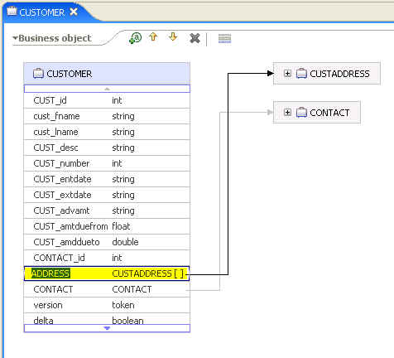
Figure 10: The container attribute in the migrated BO
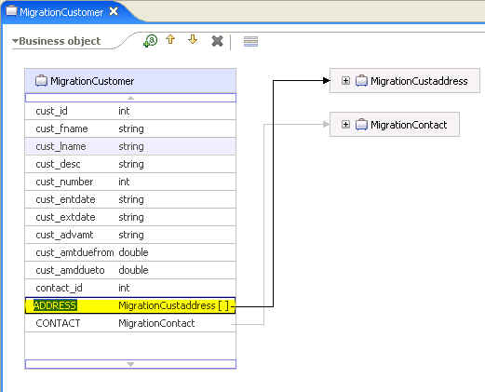
Figure 11: The container attribute in the WA BO

Appendix C. IBM WebSphere Adapter for Siebel

Configuration properties
Configuration properties for WebSphere Adapters are collected when the enterprise service discovery wizard is run. The following sections show how configuration properties for the WBIA Adapter for Siebel map to configuration properties for the WebSphere Adapter for Siebel. Running the Adapter Configuration Assistant extracts and presents these values for easy reference when running the enterprise service discovery.

Resource Adapter properties
WebSphere Business Integration Adapter Property | WebSphere Adapter Property | Required | Default Value | Comments
LOG_FILE | logFileName | Yes |  | The full path to the log file [please provide example]
MAX_LOG_FILE_SIZE | logFileSize | No |  | The size of the log files in bytes.  If no value is specified, the  files have no maximum size. [please include min value, max value, recommended value]
NUMBER_OF_ARCHIVE_LOGS | logNumberOfFiles | No | 1 | The number of log files to be  used. When a log file  reaches its maximum size,  another log file is created. [please include min value, max value, recommended value]
TRACE_FILE | traceFileName | Yes |  | The full path to the trace file [please include example]
MAX_TRACE_FILE_SIZE | traceFileSize | No |  | The size of the trace files in  bytes. If no value is  specified, the files have no  maximum size. [please include min value, max value, recommended value]
ViewMode | ViewMode | Yes | 3 | The view mode to be  set before executing  a query on the Siebel  end. [please include all possible values]
ResonateSupport | ResonateSupport | No | False | True indicates that Siebel provides resonate support.  False indicates that Siebel does not provide resonate support.
SupportNameValuePair | SupportNameValuePair | No | False | True indicates that an object key and object name combination  is set on the event table.  False indicates that an object key and object name combination is not set on the event table.

Managed Connection Factory properties
WebSphere Business Integration Adapter Property | WebSphere Adapter Property | Required | Default Value | Comments
ApplicationUserName | UserName | Yes |  | User name to log on to the Siebel enterprise information system.
ApplicationPassword | Password | Yes |  | Password for the corresponding user name.
SiebelLanguageCode | LanguageCode | Yes |  | The language code used when establishing connection to the Siebel enterprise information  System. [Is there a default value? What are the possible values?]
ConnectString | ConnectString | Yes |  | The Siebel connection string used to connect to the Siebel enterprise information system. [please provide an example]

ActivationSpec properties
WebSphere Business Integration Adapter Property | WebSphere Adapter Property | Required | Default Value | Comments
 | assuredOnceDelivery | No | True | True indicates that an xid value is set for each event in the event store. Each event is then delivered to its corresponding endpoint and subsequently deleted from the event table.  False indicates that an xid value is not set for events in the event store.
EventComponentName | eventComponentName | Yes | IBM2 | The name of the table in the enterprise information system that contains events generated by the enterprise information system for inbound processing. This is enabled for use with bidirectional languages.
 | deliveryType | No | ORDERED | This property determines the order in which the events are published.  ORDERED indicates that events are published one at a time.  UNORDERED indicates that events are published all at once.
 | eventTypeFilter | No | null | The adapter can filter the events to be processed by business object type. EventFilterType has a comma-delimited list of business object types, and only the types specified in this property are picked up for processing. If no value is specified for the property, no filter is applied, and all the events are picked up for processing. [please provide an example]
 | filterFutureEvents | No | False | True indicates that the adapter filters events based on timestamp. The adapter compares the system time in each poll cycle to the timestamp on each event. If an event is set to occur in the future, it is not picked up for processing until that time.  False indicates that [what?]
ConnectString | ConnectString | Yes |  | The Siebel connection string used to connect to the Siebel enterprise information system.
SiebelLanguageCode | LanguageCode | Yes |  | The language code used when establishing a connection to the Siebel enterprise information system. [possible values?]
ApplicationUserName | Username | Yes |  | User name for logging into the EIS for inbound events. This is enabled for use with bidirectional languages.
ApplicationPassword | Password | Yes |  | Password for authorizing the user to retrieve events from the EIS. This property is enabled for use with bidirectional languages.
PollFrequency | pollPeriod | No | 500 | The rate in milliseconds at which to poll the EIS event store for new inbound events. If 0, the adapter does not wait between cycles. The  poll cycle is established at a fixed rate, meaning that if an execution of the poll cycle is delayed (for example, the prior poll cycle takes longer than expected to complete) the next cycle occurs immediately to catch up. This is a required property.
PollQuantity | pollQuantity | No | 1 | This property is used to determine the number of events to deliver to each endpoint per poll cycle. It is a required property. [please include min value, max value, recommended value]
 | retryLimit | No | 0 | The number of times the adapter  attempts to retry the connection to the EIS. A value of 0 (zero) causes the adapter to use an unlimited number of attempts.  [please include max value, recommended value]
 | retryInterval |  | 60000 | If this value is non-negative and the adapter encounters an error related to the inbound connection to the EIS, the adapter continues to re-attempt a connection  after the specified interval until the connection is re-established. Values are in milliseconds. [please include min/max values]
 | stopPollingOnError |  |  | True indicates that the adapter stops polling when it encounters an error during polling.  False indicates that the adapter logs an exception when it  encounters an error and continues polling.  [What is the default?]
 | BONamespace | Yes |  | Namespace for the business object definitions to be used by this adapter. This value should be taken from the value you provided during the metadata discovery  process. [please provide example]

Known limitations

The Siebel migration BO converter uses the attribute name as the key for the container attribute converting between migrated BO and WA BO. The equivalent attributes between migrated BO and WA BO should have the same attribute name. The attribute name is case sensitive

.

Appendix D. IBM WebSphere Adapter for JDE

Configuration properties
Configuration properties for WebSphere Adapters are collected when the enterprise service discovery wizard is run. The following sections will show how configuration properties for the WBIA Adapter for JDE map to configuration properties for the WebSphere Adapter for JDE. Running the Adapter Configuration Assistant, will extract and present these values for easy reference when running the enterprise service discovery.

Resource Adapter properties
WebSphere Business Integration Adapter Property | WebSphere Adapter Property | Required | Default Value | Comments
 | Timeout | No | 30 sec | Global timeout value to be set on XML List request execute call.

Managed Connection Factory properties
WebSphere Business Integration Adapter Property | WebSphere Adapter Property | Required | Default Value | Comments
UserName | UserName | Yes |  | User name to log into the JD Edwards EnterpriseOne server
Password | Password | Yes |  | Password for the corresponding user name
Environment | Environment | Yes |  | JD Edwards EnterpriseOne environment name
 | Role | Yes |  | Role name to use to connect

Known limitations

WebSphere Adapter for JD Edwards EnterpriseOne's business function outbound interface accepts a business graph as input type and returns the same business graph as the output type. WebSphere Adapter for JD Edwards EnterpriseOne XML List outbound interface however takes a business graph as input and returns a different business graph. For this reason you must specify separate map entries for the outbound interface’s input and output. In the map entry you also need to specify the direction of the data flow.

For example, if you are mapping F0116 business object. You must create a map entry for wbiaF0116BG to F0116Query1BG and specify the direction attribute in the map entry element as direction="WBI2WSA". You must also create a second map entry for F0116BG to wbiaF0116BG with the direction attribute in the map entry element set to direction="WSA2WBI". The sample JDEXMLListBOMapping.xml file shows an example of this directional specific mapping

Appendix E. IBM WebSphere Adapter for Flat Files

Configuration properties
Configuration properties for WebSphere Adapters are collected when the enterprise service discovery wizard is run. The following sections will show how configuration properties for the WBIA Adapter for JText map to configuration properties for the WebSphere Adapter for Flat Files. Running the Adapter Configuration Assistant will extract and present these values for easy reference when running the enterprise service discovery.

Resource Adapter properties
WebSphere Business Integration Adapter Property | WebSphere Adapter Property | Required | Default Value | Comments
LOG_FILE | Log file name | No |  | The full path of the log file.
MAX_LOG_FILE_SIZE | Log file max size | No | 0 | Size of the log files in kilobytes. If no value is specified, the files have no maximum size.
NUMBER_OF_ARCHIVE_LOGS | Log files | No | 1 | The number of log files to use. When a log file reaches its maximum size, another log file is started.
TRACE_FILE | Trace file name | No |  | The full path to the trace file.
MAX_TRACE_FILE_SIZE | Trace file max size | No | 0 | Size of the trace files in kilobytes. If no value is specified, the files have no maximum size.
(NUMBER_OF_ARCHIVE_TRACES | Trace files | No | 1 | The number of trace files to use. When a trace file reaches its maximum size, another trace file is started.
 | Adapter ID | Yes |  | Identifies a deployment instance of the adapter. If you are using more than one instance of an adapter, the value of this property must be unique.
 | enableHASupport | No | true | When the enableHASupport property is set to true, only one of the replicated adapter instances actively polls for events while other instances are in standby mode. If the enableHASupport property is set to false, all of the adapter instances replicated on cluster members actively poll for events. This may result in event duplication. Do not change the value of enableHASupport to false for single server environments

Managed Connection Factory properties
WebSphere Business Integration Adapter Property | WebSphere Adapter Property | Required | Default Value | Comments
OutputDir | Output Directory | No |  | The absolute path of the directory on the local file system where the outbound operation needs to be performed.
OutputFileName | Output File Name | No |  | If this property is specified, the file created in the output directory will have this name. (This value will be overridden if a value for Output File Name is specified in the record object.)
StagingDir | Staging Directory | No |  | If this property is specified, a file is written first to the staging directory before it is written to the output directory.

ActivationSpec properties
WebSphere Business Integration Adapter Property | WebSphere Adapter Property | Required | Default Value | Comments
 | Namespace | Yes |  | Namespace for the business object definitions to be used by this adapter. This value should be taken from the value you provided during the metadata discovery process.
EventDir | Event Directory | Yes |  | Directory where the event files get stored by the backend enterprise Information System (EIS).
 | Event File Mask | Yes | *.* | Specifies the filter for the event files. The file filter is a well-qualified valid regular expression consisting of alphanumeric characters and only the wildcard.
ArchivingEnabled | Archiving Processed | No | True | Determines if the adapter should archive processed events.
ArchiveDir | Archive Directory | Yes, if archivingProcessed=true |  | Directory where the adapter archives processed event files.
SortFilesOnTimestamp | Sort Event Files | No | <blank> | Determines the sorting order of polled event files. The values supported are:  Filename – sort in ascending order on filename  Timestamp – sort in ascending order on last modified timestamp  <Blank> - not sorted  To support globalization, the sorting of filenames is provided according to the system locale. The ICU4J package is used to track the locales and the rules corresponding to the locales
EndBODelimiter | Split Criteria | No | 0 | This attribute takes different values based on the value set the SplittingFunctionClassName property.  If SplittingFunctionClassName property is set to a value that does split based on delimiter, the SplitCriteria property must contain the delimiter that separates the business objects (BOs) in the event file.  If SplittingFunctionClassName property is set to a value that does split based on size, the SplitCriteria property must contain a valid number that represents the size in bytes. If the event file size is greater than this value, number chunks are posted. If event file size is less than this value the entire event file is posted when SplitCriteria property is set to zero, chunking is disabled.  During an inbound pass through scenario, if file splitting is based on size and FilePassByReference property is enabled the event files are no split into chunks.
 | Splitting Function Class Name | No | com.ibm.j2ca.utils.filesplit.SplitBySize | This value takes a fully qualified class name of the class to be used in order to split the event file. It takes two values as of now, a class which splits the event file based on delimiter -(used to separate BO’s in event file) and another which splits based on event file size - .com.ibm.j2ca.utils.filesplit.SplitByDelimiter  The delimiter or file size is given in SplitCriteria. .com.ibm.j2ca.utils.filesplit.SplitBySize  If the EventContentType property is null, this property is automatically set to the class name that splits files based on size.
 | File Pass By Reference | Yes | False | This property determines if the adapter needs to load the contents of the file or just provide information on the directoryName and filename.
IncludeEndBODelimiter | Include End BO Delimiter | No | False | When this property is set to true, the delimiter value specified in the SplitCriteria property is also sent with the business object content for further processing. Note: This property is valid only if event file splitting is based on a delimiter.
 | Default Object Name | No |  | Name of the business graph that is used by the Data Transformation Framework before delivering an event to an endpoint. For example, the generic wrapper business graph used by the adapter is FlatFileBG.
 | Event Content Type | No |  | This property represents the mime type of the event file.
DataEncoding | File Content Encoding | No |  | Determines how files are read and written by the adapter.
 | DataSource JNDI Name | Yes |  | The JNDI name of the Data Source used by Event Persistence to obtain the JDBC database connection. The data source must be created in the WebSphere Process Server.
 | Event Table Name | Yes |  | Name of the table used by the adapter for event persistence. This value must be unique for each activation specification instance when multiple activation specification instances are used.
 | Database Schema Name | No |  | The schema name of the database used by Event Persistence.
 | Database User Name | No |  | The username used by Event Persistence for getting the JDBC database connection from the data source.
 | Database Password | No |  | The password used by Event Persistence for getting the JDBC database connection from the data source.
 | Create Table | No | True | Determines if the event persistence table gets created automatically or manually. If the value is true and the event persistence table does not exist, then the adapter creates the table. If the value is false, then the adapter does not create the table and the user must manually create the table.
FailArchiveExt | Failed Archive Extension | No | fail | Specifies the file extension used to archive business objects in the input event file that were not successfully processed.
OriginalArchiveExt | Original Archive Extension | Yes | original | Specifies the file extension used to archive the original event file, which preserves the entire event file for reference in case any of its business objects fail processing.
SuccessArchiveExt | Success Archive Extension | Yes | success | Specifies the file extension used to archive all the business objects that are successfully processed.
PollFrequency | Poll period | Yes | 500 | The rate in milliseconds at which to poll the EIS event store for new inbound events. If the value of this property is set to 0, the adapter will not wait between cycles. The poll cycle is established at a fixed rate, meaning that if an execution of the poll cycle is delayed (for example, the prior poll cycle takes longer than expected to complete) the next cycle will occur immediately to catch up. This is a required property.
PollQuantity | Poll quantity | Yes | 1 | This property is used to determine the number of events to deliver to each endpoint per poll cycle. It is a required property.
 | Event Type filter | No | null | List of event types that the adapter can deliver. The adapter will not deliver events that are not in the list. If the list is empty (null), no filter is applied, and all events are delivered.
 | Assured once  delivery | Yes | True | Provides assured once only event delivery. If the value is true, the adapter attempts to store XID information in the event store. If the value is false, the adapter will not attempt to store XID information in the Event Store. Note: Setting the value of this property to false improves adapter performance.
 | Delivery Type | No | ORDERED | This property determines the order in which the events are published. The value is either ORDERED or UNORDERED. Ordered means events are published one at a time, while unordered means events are published all at once
 | Filter future events | Yes | False | If true, the adapter will inspect the timestamp on each event and compare it to the system time. If the event time is ahead of the system time, the event will not be delivered.
RestartRetryInterval | Retry interval | No | 60000 | Determines the interval of time, in milliseconds, that an adapter uses to reconnect to the enterprise information system after the adapter encounters an inbound connection error.
RestartRetryCount | Retry limit | No | 0 | Specifies the number of times the adapter attempts to reconnect to the enterprise information system before the adapter stops trying. A value of 0 means that the adapter attempts re-connection an unlimited number of times.
 | Stop polling on error | No |  | If true, the adapter stops polling when it encounters an error during polling. If false, the adapter logs an exception when it encounters an error, and continues polling

Documentation

Link to Adapter User Guide, Tutorials, etc

Appendix F. IBM WebSphere Adapter for FTP

Configuration properties
Configuration properties for WebSphere Adapters are collected when the Enterprise Service Discovery wizard is run. The following sections will show how configuration properties for the WBIA Adapter for JText map to configuration properties for the WebSphere Adapter for FTP. Running the Adapter Configuration Assistant, will extract and present these values for easy reference when running the enterprise service discovery.

Resource Adapter properties
WebSphere Business Integration Adapter Property | WebSphere Adapter Property | Required | Default Value | Comments
LOG_FILE | Log file name [String] | No |  | The full path of the log file.
MAX_LOG_FILE_SIZE | Log file size [Integer] | No | 0 | Size of the log files in kilobytes. If no value is specified, the files have no maximum size.
NUMBER_OF_ARCHIVE_LOGS | Log files [Integer] | No | 1 | The number of log files to use. When a log file reaches its maximum size, another log file is started.
TRACE_FILE | Trace file name [String] | No |  | The full path to the trace file.
MAX_TRACE_FILE_SIZE | Trace file size [Integer] | No | 0 | Size of the trace files in kilobytes. If no value is specified, the files have no maximum size.
(NUMBER_OF_ARCHIVE_TRACES | Trace files [Integer] | No | 1 | The number of trace files to use. When a trace file reaches its maximum size, another trace file is started.
 | Adapter ID [String] | Yes | ResourceAdapter
 | enableHASupport | No | true | When the enableHASupport property is set to true, only one of the replicated adapter instances actively polls for events while other instances are in standby mode. If the enableHASupport property is set to false, all of the adapter instances replicated on cluster members actively poll for events. This may result in event duplication. Do not change the value of enableHASupport to false for single server environments.
 | EIS Encoding | No |  | This encoding is set on the control connection during the communication with the FTP Server. Control connection is sued to send ftp commands and receive the replies.

Managed Connection Factory properties
WebSphere Business Integration Adapter Property | WebSphere Adapter Property | Required | Default Value | Comments
OutputDir | Ftp Url | Yes |  | The URL of the FTP Server to which the connection is established during outbound operation.  Syntax for specifying URL in the Ftp Url attribute is:  ftp://[UserId:password@]FTPserver[:port]
FTPUserId | User Name | No |  | Specifies the name of the user who has privileges to connect to the FTP server and perform FTP operations. You need NOT specify a value for this attribute if the Username is included in the URL specified in the Ftp Url attribute.
FTPPassword | Password | No |  | Specifies the password of the user who has privileges to connect to the FTP server and perform FTP operations. You need NOT specify a value for this attribute if the Password is included in the URL specified in the Ftp Url attribute.
 | Staging Directory | No |  | During outbound create operation, the file will be first created into this directory (if specified) and once the creation is over we will move the file to the directory given in Directory Path of interaction Spec. This Staging Directory is also used for Append and Overwrite operations where the specified file is copied to Staging Directory (if present) first, then appended/overwritten with content and moved back to the original specified directory.  If Staging Directory is not present the operation is executed in the actual required directory. If both Staging Directory in MCF and Interaction Spec is specified, the staging directory value in Interaction Spec is used.
 | Custom Parser Class Name | No |  | The fully qualified class name of the custom parser which is used to parse the ls –l output. Custom parser is used only when the ls –l output deviates from standard output. The class implements the interface given in Section Error: Reference source not found. A default implementation is given by com.ibm.j2ca.ftp.util.FTPLongListEntryParser which is part of the adapter installer.
 | EIS Encoding | No |  | It’s a String value. It specifies the encoding of the FTP Server. We use this value to set the encoding for the control connection while communicating with the FTP Server. If this value is not set, EIS Encoding attribute value at the RA level is set to this. If both RA level attribute and MCF attribute have values, the MCF EIS Encoding is only considered. You can specify any Java-supported encoding set for this attribute  This should be set when the FTP Server’s directories or filenames have globalized characters.
 | Second Server Directory | No |  | The URL of the second FTP Server to which the ServerToServerFileTransfer outbound operation is performed.  Syntax for specifying FTP URL in the Second Server Directory attribute is:  ftp://[UserId:password@]FTPserver[:port]DirectoryForSecondServer
 | Second Server User Name | No |  | The user name of the Second FTP Server to which the file is transferred during a ServerToServerFileTransfer outbound operation. This property is used when the Second Server Directory is used.
 | Second Server Password | No |  | The password of the Second FTP Server to which the file is transferred during a ServerToServerFileTransfer outbound operation. This property is used when the Second Server Directory is used.
 | Socks Proxy Host | No |  | The host name of the machine which is used as a proxy server through which the adapter requests are routed to the FTP server This property should be configured when there is a ftp proxy configured between adapter and the FTP server. It takes the hostname or IP address of the proxy server.
 | Socks Proxy Port | No | 1080 | The port number of the proxy server through which the adapter requests are routed to the FTP server. This property is used by the adapter when Sock Proxy Host is set.
 | Socks Proxy User Name | No |  | The user name used to authenticate the proxy server. The adapter uses this property in proxy authentication if it has a value.
 | Socks Proxy Password | No |  | The password used to authenticate the proxy server. This property is used by the adapter when Socks Proxy User Name is set.

ActivationSpec properties
WebSphere Business Integration Adapter Property | WebSphere Adapter Property | Required | Default Value | Comments
 | Delivery Type | No | ORDERED | ORDERED or UNORDERED. This determines the order in which the events will be published. One at a time (ORDERED) or all at once (UNORDERED)
PollFrequency | Poll period [Int] | Yes | 2000 | This property is checked by the WBIResourceAdapter base implementation and is considered the rate (in milliseconds) at which to poll the EIS event store for new inbound events.  If set to “0”, the adapter will not wait between cycles.  The poll cycle is established at a fixed-rate meaning that if an execution of the poll cycle is delayed for any reason (e.g. prior poll cycle takes longer than expected to complete), the next cycle will occur immediately to “catch up”.
PollQuantity | Poll quantity [Int] | Yes | 10 | This property is checked by the WBIResourceAdapter base implementation and is used to determine the number of events to deliver to each endpoint per poll cycle.
RestartRetryInterval | Retry interval [Integer] | No | 60000 | If non-negative and the adapter encounters an error related to the inbound connection to the EIS, the adapter will continue to re-attempt a connection after the specified interval until a connection is re-established. Values are assumed to be in milliseconds.  Note: this requires support from the underlying adapter implementation to work. Specifically, the adapter-provided EventStore implementation must throw javax.resource.spi.CommException instances methods if it encounters any communication-related errors.
RestartRetryCount | Retry limit [Integer] | No | 0 | Specifies the number of times the foundation classes should attempt to retry the connection to the underlying EIS until giving up. A value of 0 (zero) will cause the adapter to attempt an unlimited number of times.
 | Stop polling on error [Boolean] | No | false | If True, the adapter will stop polling when it encounters an error during polling. If false, adapter will log the exception when it encounters an error and continue polling.
 | Assured once delivery [Boolean] | Yes | true | If true, the adapter will attempt to store XID information in the EventStore. If false, the adapter will not. “true” provides “assured once event delivery”, “false” does not, but provides better performance. This property is only used if the MDB is transactional. If it is not, no transaction can be used, regardless of the configuration
 | Filter future events [Boolean] | Yes | false | If true, the adapter will inspect the timestamp on each event and compare it to the system time. If the event time is ahead of the system time, the event will not be delivered.
 | DataSource JNDI Name | Yes |  | The JNDI name of the Data Source used by Event Persistence to get the JDBC database connection. The DataSource must be created in the WPS. The database name specified while creating the DataSource should already be existing.
 | Event Table Name | Yes |  | Name of the table that will be used by the adapter for Event Persistence (storing of event ids). This value must be unique for each Activation Spec when using multiple Activation Spec. The same table name also should not be used by other instances of same adapter or different adapter.  If the table does not exist in the database the Resource Adapter will create the table and use it.
 | Database Schema Name | No |  | The schema name of the database used by Event Persistence
 | Database User Name | No |  | The username used by Event Persistence for getting the JDBC database connection from the data source
 | Database Password | No |  | The password used by Event Persistence for getting the JDBC database connection from the data source
 | Create Table | No | true | This Boolean value tells if the adapter need to create the Event Persistence table or not. If the value is true and table does not exist then the adapter creates the table. If the value is false the adapter does not create the table.
EventDir | Event Directory | Yes |  | The FTP URL along with event directory of the FTP Server from where the event files are picked for inbound operation. The following additional information can also be specified.  Syntax for specifying FTP URL in the Event Directory attribute is:  ftp://[UserId:password@]FTPserver[:port][RemoteEventDirectory]
FTPEventFileMask | Event File Mask | Yes |  | Specifies the filter for the event files.  The file filter is a well-qualified valid regular expression consisting of alphanumeric characters and the wildcard * and ?.
SortFilesOnTimestamp | Sort Event Files | No |  | Would determine the sorting order of event files being polled. The values supported would be –  Filename – sort ascending on filename  Timestamp – sort ascending on last modified timestamp  <Blank> - not sorted  This ordering of the event files from which events need to be delivered is valid only if FC Activation Spec property Delivery Type is “ORDERED”  The sorting of filenames is provided based on the locale of the FTP server. The ICU4J package will be used to track the locales and the rules corresponding to the locales.
FTPArchiveDir | FTP Archive Directory | No |  | Specifies the relative path of the archive directory on the FTP server. The directory must already exist.
FTPRenameExt | FTP Rename Extension | No |  | Specifies the file extension or suffix that the RA uses to rename the remote FTP file after the connector has polled for it. Renaming the file prevents the connector from polling the same file in the next poll cycle. You can configure the RA to rename the processed event file and move it to an archive directory.
FTPUserId | User Name | No |  | Specifies the name of the user who has privileges to connect to the FTP server and perform FTP operations. You need not specify a value for this attribute if the Username is included in the URL specified in the Event Directory attribute.
FTPPassword | Password | No |  | Specifies the password of the user who has privileges to connect to the FTP server and perform FTP operations. You need not specify a value for this attribute if the password is included in the URL specified in the Event Directory attribute
FTPGetQuantity | FTP Get Quantity | Yes | 10 | Determines the number of files retrieved from the remote FTP URL with each remote poll.
FTPPollFrequency | FTP Poll Frequency | Yes | 5 | Determines how frequently the RA polls the FTP server measured in the number of standard poll cycles.  For example, if FTP Poll Frequency is set to 6, then the Resource Adapter will poll the event directory of the FTP server once for every 6 standard polls (polls Local Event Directory). If this property is set to 0, the RA does not perform FTP polling.
 | EIS Encoding | No |  | It’s a String value. It specifies the encoding of the FTP Server. We use this value to set the encoding for the control connection while communicating with the FTP Server. This should be set when the FTP Server’s directories or filenames have globalized characters.  If this value is not set, EIS Encoding attribute value at the RA level is set to this. If both RA level attribute and Activation Spec attribute have values, the Activation Spec EIS Encoding is only considered. You can specify any Java-supported encoding set for this attribute
FTPLocalEventDir | Local Event Directory | Yes |  | Specifies the local system directory into which the RA downloads event files from the FTP site. You must specify a value for this attribute to enable the RA to process events.
ArchiveDir | Local Archive Directory | No |  | Specifies the absolute path of the local Archive directory. The directory if given must be valid and already exist. If Local Archiving Directory is not set, the event file is deleted after processing of all the BO’s is completed.
FailArchiveExt | Failed Archive Extension | No |  | Specifies the file extension used to archive business objects in the input event file that were not successfully processed.  This property is used only when Local Archive Directory is valid and exists.
OriginalArchiveExt | Original Archive Extension | No |  | Specifies the file extension used to archive the original event file, which preserves the entire event file for reference in case any of its business objects fail processing. The file with this extension is created only if there is at least one failed BO in the event file.  This property is used only when Local Archive Directory is valid and exists.
SuccessArchiveExt | Success Archive Extension | No |  | Specifies the file extension used to archive all the business objects that are successfully processed.  This property is used only when Local Archive Directory is valid and exists.
DataConnectionMode | Data Connection Mode | No |  | The data connection mode used by the FTP server only during file transfers. It takes either active or passive. This value need to be set to passive when firewall is configured between the adapter and FTP Server.
FTPTransferType | File Transfer Type | No |  | The file transfer type used during inbound operations. It takes either ASCII or binary.
 | Custom Parser Class Name | No |  | The fully qualified class name of the custom parser which is used to parse the ls –l output. Custom parser is used only when the ls –l output deviates from standard output. The class implements the interface given in Section Error: Reference source not found.  A default implementation is given by com.ibm.j2ca.ftp.util.FTPLongListEntryParser which is part of the adapter installer.
 | File Pass By Reference | No |  | This property is used when the file content of the event file need not be sent to the endpoint. Only the file name (appended with timestamp) is sent to the endpoint. In this case the file is saved to the Local Archive Directory.  This property takes true only when Local Archive Directory is valid and exists. This property is valid only when you are doing a Pass Through inbound operation.  During inbound pass through (splitting based on size), when File Pass By Reference is enabled splitting of event file into chunks does not take place.
IncludeEndBODelimiter | Include End BO Delimiter | No |  | When this property is set to true the delimiter (given in Split Criteria) is also sent along with the BO content for further processing. This property is valid only if we are splitting the event files based on a delimiter.
 | Splitting Function Class Name | No |  | This value takes a fully qualified class name of the class to be used in order to split the event file. It takes two values as of now, a class which splits the event file based on delimiter, com.ibm.j2ca.utils.filesplit.SplitByDelimiter (used to separate BO’s in event file) and another which splits based on event file size, com.ibm.j2ca.utils.filesplit.SplitBySize.  The delimiter or file size is given in Split Criteria.  If Event Content Type is null, then this is automatically set to class name which does splitting based on size.
 | Split Criteria | No |  | This attribute takes different values based on value set in Splitting Function Class Name.  If Splitting Function Class Name is set to a value which does splitting based on delimiter then Split Criteria must contain the delimiter which separates the BO’s in the event file.  If Splitting Function Class Name is set to a value which does splitting based on size then Split Criteria must contain a valid number which represents the size in bytes. If event file size is greater than this value, it is split into chunks of this value and so many chunks are posted. If event file size is less than this value the entire event file is posted in one shot. When Split Criteria=0, chunking is disabled.  During inbound pass through (splitting based on size), when File Pass By Reference is enabled splitting of event file into chunks does not take place.
DataEncoding | File Content Encoding | No |  | This encoding is used to read the event files based on End BO Delimiter and also during string to byte[] conversions. If this property is not specified, the RA tries to read without using any specific encoding. You can specify any Java supported encoding set for this attribute
 | Socks Proxy Host | No |  | The host name of the machine which is used as a proxy server through which the adapter requests are routed to the FTP server. This property should be configured when there is a ftp proxy configured between adapter and the FTP server. It takes the hostname or IP address of the proxy server.
 | Socks Proxy Port | No |  | The port number of the proxy server through which the adapter requests are routed to the FTP server. This property is used by the adapter when Socks Proxy Host is set.
 | Socks Proxy User Name | No |  | The user name used to authenticate the proxy server. The adapter uses this property in proxy authentication if it has a value.
 | Socks Proxy Password | No |  | The password used to authenticate the proxy server. The adapter uses this property in proxy authentication if Socks Proxy User Name is set.
 | FTP Script File Executed Before Inbound | No |  | The absolute path of the ftp script file from the local adapter machine. All the ftp commands present in the file will get executed before every inbound poll cycle.
 | FTP Script File Executed After Inbound | No |  | The absolute path of the ftp script file from the local adapter machine. All the ftp commands present in the file will get executed after every inbound poll cycle
 | Default Object Name | No |  | The name of the wrapper data object bg which is used by the Data Transformation Framework before delivering the event to the endpoint. For example, the generic wrapper bg used by the adapter is FTPFileBG. The adapter gets the DataBinding class name corresponding to the Event Content Type value from the annotation of the wrapper data object
 | Event Content Type | No |  | The content/MIME type of the input event file which is sent to the Data Transformation Framework to invoke the right data handler while converting the BO string (in the form of byte[]) to a data object. During PassThrough this value is NULL.  Examples: text/xml, text/delimited, text/namevalue

Wrapper BO properties
WebSphere Business Integration Adapter Property | WebSphere Adapter Property | Required | Default Value | Comments
OutputDir | DirectoryPath | Yes |  | The absolute path of the directory on the FTP server where the outbound operation needs to be performed for all operations except ExecuteFTPScript. The directory path on the local adapter machine for ExecuteFTPScript operation only. The directory must already existing. This value is required for all outbound operations.
OutputFilename | Filename | No |  | The name of the file in the directory given by DirectoryPath on which the outbound operations are performed. This value is required for all outbound operations except LIST.
DataConnectionMode | DataConnectionMode | No |  | The data connection mode used by the FTP server only during file transfers. It takes either active or passive. This value is used only when a file transfer is taking place but this property is not used when we are performing ServerToServerFileTransfer outbound operation. This value need to be set to passive when firewall is configured between the adapter and FTP Server.
FileTransferType | FileTransferType | No |  | The file transfer type used during outbound operations. It takes either ASCII or binary.
 | SecondServerDirectory | No |  | The URL of the second FTP Server to which the ServerToServerFileTransfer outbound operation is performed.  Syntax for specifying FTP URL in the SecondServerDirectory attribute is:  ftp://[UserId:password@]FTPserver[:port]DirectoryForSecondServer
 | SecondServerUserName | No |  | The user name of the Second FTP Server to which the file is transferred during a ServerToServerFileTransfer outbound operation. This property is used when the SecondServerDirectory is used.
 | SecondServerPassword | No |  | The password of the Second FTP Server to which the file is transferred during a ServerToServerFileTransfer outbound operation. This property is used when the SecondServerDirectory is used.
DataEncoding | FileContentEncoding | No |  | This encoding is used while writing to the file. If this property is not specified, the RA tries to read without using any specific encoding. You can specify any Java supported encoding set for this attribute
IncludeEndBODelimiter | IncludeEndBODelimiter | No |  | This is used during the outbound create/append/overwrite operations. The File content is appended with the value of IncludeEndBODelimiter
 | FileInLocalDirectory | No | false | During an outbound create operation, when this property is set to true, the file content is not available as part of the request instead the file is picked from local directory (LocalDirectoryPath) of the adapter machine.  During an outbound retrieve operation, when this property is set to true, the file content is not sent to the J2EE application as part of the response object instead the file is saved to local directory (LocalDirectoryPath) of the adapter machine.
 | LocalDirectoryPath | No |  | During an outbound create operation, when FileInLocalDirectory property is set to true, the file content is not available in the request object instead the file is picked from this directory.  During an outbound retrieve operation, when FileInLocalDirectory property is set to true, the file content is not sent to the J2EE application as part of response object instead the file is saved to this directory.
 | LocalArchivingEnabledForCreate | No | false | During an outbound create operation, when the file content is coming as part of request object from a J2EE application and this property is set to true then the file is saved to the local machine in LocalArchiveDirForCreate directory before performing the outbound operation.
 | LocalArchiveDirForCreate | No |  | During an outbound create operation, when the file content is coming as part of request object from a J2EE application and LocalArchivingEnabledForCreate is set to true then the file is saved to the local machine in this directory.
StagingDir | StagingDirectory | No |  | During outbound create operation, the file will be first created into this directory(if specified) and once the creation is over we will copy the file to the directory given in DirectoryPath. This Staging Directory is also used for Append and Overwrite operations where the specified file is copied to StagingDirectory(if present) first, then appended/overwritten with content and moved back to the original specified directory. If StagingDirectory is not present the operation is executed in the actual required directory.

Appendix G. IBM WebSphere Adapter for Email

Configuration properties
Configuration properties for WebSphere Adapters are collected when the enterprise service discovery wizard is run. The following sections will show how configuration properties for the WBIA Adapter for e-Mail map to configuration properties for the WebSphere Adapter for Email. The adapter configuration assistant is run to extract the following properties and supply them to the enterprise service discovery wizard.

Resource Adapter properties
WebSphere Business Integration Adapter Property | WebSphere Adapter Property | Required | Default Value | Comments
LOG_FILE | Log file name [String] | No | No default | The full path of the log file.
MAX_LOG_FILE_SIZE | Log file size [Integer] | No | 0 | Size of the log files in kilobytes. If no value is specified, the files have no maximum size.
NUMBER_OF_ARCHIVE_LOGS | Log files [Integer] | No | 1 | The number of log files to use. When a log file reaches its maximum size, another log file is started.
TRACE_FILE | Trace file name [String] | No | No default | The full path to the trace file.
MAX_TRACE_FILE_SIZE | Trace file size [Integer] | No | 0 | Size of the trace files in kilobytes. If no value is specified, the files have no maximum size.
(NUMBER_OF_ARCHIVE_TRACES | Trace files [Integer] | No | 1 | The number of trace files to use. When a trace file reaches its maximum size, another trace file is started.
 | Adapter ID [String] | Yes | ResourceAdapter | The id of this deployment of the adapter.
 | enableHASupport | No | true | When the enableHASupport property is set to true, only one of the replicated adapter instances actively polls for events while other instances are in standby mode. If the enableHASupport property is set to false, all of the adapter instances replicated on cluster members actively poll for events. This may result in event duplication. Do not change the value of enableHASupport to false for single server environments.

Managed Connection Factory properties
WebSphere Business Integration Adapter Property | WebSphere Adapter Property | Required | Default Value | Comments
SMTP_MailHost | Host Name | Yes | localhost | The IP address or host name of the host where the mail server is running.
ApplicationUserName | User Name | No | No default | The mail user id to be used for the SMTP session. The mail account should be created in the same mail server running on above mentioned host
ApplicationPassword | Password | No | No default | The password, for the user id, to authenticate the SMTP session.
 | Protocol | Yes | Smtp | The protocol to be used for outbound communication with the mail server.  Presently only the SMTP protocol is supported for outbound.
SMTP_MailPort | Port | Yes | 25 | The SMTP port on which the mail server is listening.

ActivationSpec properties
WebSphere Business Integration Adapter Property | WebSphere Adapter Property | Required | Default Value | Comments
 | Delivery Type | No | ORDERED | ORDERED or UNORDERED. This determines the order in which the events will be published. When this value is set to ORDERED, events are published one at a time. When set to UNORDERED, events are published all at once.
PollFrequency | Poll period [Int] | Yes | 2000 | This property is checked by the WBIResourceAdapter base implementation and is considered the rate (in milliseconds) at which to poll the EIS event store for new inbound events.  If set to “0”, the adapter will not wait between cycles.  The poll cycle is established at a fixed-rate meaning that if an execution of the poll cycle is delayed for any reason (e.g. prior poll cycle takes longer than expected to complete), the next cycle will occur immediately to “catch up”.
PollQuantity | Poll quantity [Int] | Yes | 10 | This property is checked by the WBIResourceAdapter base implementation and is used to determine the number of events to deliver to each endpoint per poll cycle.
RestartRetryInterval | Retry interval [Integer] | No | 60000 | If set to a positive value and the adapter encounters an error related to the inbound connection to the mail server, the adapter will continue to re-attempt a connection after the specified interval until a connection is re-established. Values are specified in milliseconds.  Note: This requires support from the underlying adapter implementation to work. Specifically, the adapter-provided EventStore implementation must throw javax.resource.spi.CommException instances methods if it encounters any communication-related errors.
RestartRetryCount | Retry limit [Integer] | No | 0 | Specifies the number of times the adapter should attempt to retry the connection to the underlying mail server until giving up. A value of 0 (zero) will cause the adapter to attempt an unlimited number of times.
 | Stop polling on error [Boolean] | No | false | If set to true, the adapter will stop polling when it encounters an error during polling. If set to false, adapter will log the exception when it encounters an error and continue polling.
 | Assured once delivery [Boolean] | Yes | true | If set to true, the adapter will attempt to store XID information in the EventStore. If set to false, the adapter will not. Specifying a “true” value provides assured once event delivery. Specifying a “false” value does not, but it provides better performance. This property is only used if the MDB is transactional. If it is not, no transaction can be used, regardless of the configuration
 | Filter future events [Boolean] | Yes | false | If set to true, the adapter will inspect the timestamp on each event and compare it to the system time. If the event time is ahead of the system time, the event will not be delivered.
 | DataSource JNDI Name | Yes | No default | The JNDI name of the Data Source used by Event Persistence to get the JDBC database connection. The DataSource must be created in the WPS. The database name specified while creating the DataSource should exist prior to running the enterprise discovery wizard.
 | Event Table Name | Yes | No default | Name of the table that will be used by the adapter for event persistence (storing of event ids). This value must be unique for each Activation Spec when using multiple Activation Specs. The same table name also cannot be used by other instances of same adapter or a different adapter.  If the table does not exist in the database the resource adapter will create the table and use it.
 | Database Schema Name | No | No default | The schema name of the database used by event persistence
 | Database User Name | No | No default | The username used by event persistence for getting the JDBC database connection from the data source
 | Database Password | No | No default | The password used by event persistence for getting the JDBC database connection from the data source
 | Create Table | No | True | This boolean value tells if the adapter need to create the event persistence table or not. If the value is set to true and the table does not exist then the adapter creates the table. If the value is set to false the adapter does not create the table.
PollHostName | Host | Yes | localhost | The ip address of host where the mail server is running.
 | Port | Yes | 110 | The POP3/ IMAP port on which the mail server is listening
 | Protocol | Yes | POP3 | The protocol to be used for inbound communication with the mail server. Valid values are IMAP and POP3.
UserName | User Name | Yes | No default | The mail user id to be used for the IMAP/POP3 session. The account created in the mail server running on the host for either IMAP or POP3 protocols.
Password | Password | Yes | No default | The password, for the user id, to authenticate the IMAP/POP3 session.
PollFolder | Poll Folders(s) | No, if protocol is POP3. | For POP3 protocol, this value is ignored and defaulted to Inbox. Multiple poll folders can be mentioned, each value delimited by a comma. | Name of the mail folder on which the adapter should polls for mail events
 | Match All Search Criteria | No | No default | This field contains search criteria used for filtering which events are polled by the poll folder. All criteria defined in this field will be ANDed for the search.  Options for NOTing are also provided.
 | Match Some Search Criteria | No | No default | This field contains search criteria used for filtering which events are polled by the poll folder. The conditions specified under this property will be ORed for the search.  Options for NOTing will also be provided.
 | InProgress Folder | Yes | No default | The folder, on the file system, where the polled mails are first written to, in RFC822 format.  The name of the RFC822 format file will correspond to the Message-ID of the mail. These details are retrieved from the Email header
ArchiveFolder | Archive Folder | No | No default | The file-folder (on the local system where RA is running ) into which the successfully processed mails will be archived, in RFC822 format.  If no Archive Folder is mentioned the Email RA will not archive the successfully processed emails. The events are deleted from the InProgressFolder.  For WBIA email Adapter this folder is on mailbox.
FailFolder | Failed Events Folder | No | No default | The file-folder (on the local system where RA is running ) into which the un-successfully processed mails, or failed events, will be archived, in RFC822 format.  If no Failed Events Folder is mentioned, the Email RA will not archive the un-successfully processed emails.  For WBIA email Adapter this folder is on mail box
 | Archive File Name Pattern | No | The default file name will be the Message-ID of the mail. These details are retrieved from the Email header. | The user can specify the pattern for the name of the Archive file. The pattern can be a list of Header names that are comma delimited. Refer “Table 13. Standard headers supported by the Email adapter” from WebSphere Adapter for Email 6.0.2 user guide.  Example configuration is From, Date. The Email RA will pick the From address and the Date from the email headers and forms the file name from a combination of the same. – From name + Date + MessageID.
 | Default Object Name | No | Default object that the adapter emits on inbound  http://www.ibm.com/xmlns/prod/websphere/j2ca/email/emailbg/EmailBG | The name of the wrapper data object businesss graph, which is used by the Data Transformation Framework before delivering the event to the endpoint. For example, the generic wrapper business graph used by the adapter is EmailBG. The adapter gets the DataBinding class name corresponding to the Event Content Type value from the annotation of the wrapper data object
 | Event Content Type | No | No default | Nor applicable for Email RA.  For Email adapter the Event Content Type value is fetched from the mime-type of the email/attachment.

Wrapper BO properties

EmailBO
The WebSphere Adapter for Email uses the Email BO object for both inbound and outbound processing, however the attributes are different in both cases.

Outbound
The below table maps the WebSphere Adapter EmailBO attributes with WBIA eMail Adapter top level request business object (outbound / Request Processing).
WebSphere Business Integration Adapter Property | WebSphere Adapter Property | Required | Default Value | Comments
RecipientName  MessageSubject  FromAddress  ReplyTo | HeaderList  [HeaderBO] | Yes | No default | Contains details for all of the headers (which describe the routing information for e-mail message).  HeaderBO contains HeaderName and HeaderValue attributes. For each WBIA eMail Adapter top level attributes mentioned in first column a HeaderBO is added to the HeaderList.
MessageContentMimeCharset/  MessageHeaderMimeCharset | Encoding | No | No default | During outbound operation , the Encoding value is used for pass through data encoding.  For encoding headers the Email adapter uses Charset value provided by the annotation of specific mailContent business object .  In cases when both the Encoding value is set in the business object and Charset at annotation of mailContent specific business object, then the Charset at annotation level of mailContent specific business object takes precedence over the top level Encoding value at EmailBO.  Headers are always encoded in same way as mailContent.  The Email adapter also uses the Encoding value to encode headers in absence of a Charset(specific BO) or Encoding(pass through) value for the mailContent business object value.  In the absence of Charset or Encoding value at any level Email RA uses Encoding at top level to encode that specific level content.
MessageContent | mailContent | Yes |  | In the outbound context, this contains the data that has to become the content of the mail and not the attachment of the mail.  In a pass-through scenario, this will have the UnstructuredContent business object.  For WBIA e-Mail adapter this attribute is not applicable.
 | AttachmentBO [ ]  [MailAttachmentBO] | No | No default | Contains content details for all the attachments of an e-mail.  MailAttachmentBO explained below. For WBIA email adapter this attribute corresponds to all child Business Objects mentioned in top level business object.
Any non standard String type attribute in Top Level BO | fileReferences  String[] | No | No default | Contains a list of files that needs to be attached to the email.  During outbound, the J2EE client specifies absolute paths of the files in this field. The adapter reads those files from local file system (where the adapter runs), and attaches them as attachments to the email that is created during outbound.  The property is not used during inbound.  Here, please note that we support attaching only the local files in this release.

Outbound Header BO
HeaderBO Mapping for each header defined in WBIA email Adapter Top level business object (Outbound). Remember the WebSphere Adapter uses standard header names defined RFC 822. So all headers mentioned in HeaderList attribute should be mapped as below.
WebSphere Business Integration Adapter Property | WebSphere Adapter Property | Required | Default Value | Comments
RecipientName | HeaderName=To  HeaderValue=… | Yes | No default | Recipients correspond to To, CC and BCC fields in WebSphere Adapter for Email.
MessageSubject | HeaderName=Subject  HeaderValue=… | No | No default | E-mail subject
FromAddress | HeaderName=From  HeaderValue=…. | Yes | No default | Specifies From whom the mail is sent
ReplyTo | HeaderName=  ReplyTo  HeaderValue=….. | No | No default | Specify the e-mail address if the recipients wants to reply to e-mail.

Inbound
The below table maps WebSphereAdapter for Email EmailBO attributes to the WBIA eMail Adapter Inbound Wrapper BO (inbound / Polling)
WebSphere Business Integration Adapter Property | WebSphere Adapter Property | Required | Default Value | Comments
FromAddress  ToAddress  CC  BCC  Subject  ReplyTo  SendDate  RecievedDate | HeaderList  [HeaderBO] | Yes | No default | Contains details of all the headers on the polled email.
 | Encoding | No | No default | Not used during inbound.
<actual_bo> | MailContent | Yes | No default | In the outbound context, this contains the data that has to become the content of the mail and not the attachment of the mail.  In a pass-through scenario, this will have the UnstructuredContent BO.  For WBIA eMail adapter this attribute is not applicable.
<actual_bo> | AttachmentBO [ ]  [MailAttachmentBO] | No | No default | Contains content details for all the attachments of the email.  MailAttachmentBO explained below. For WBIA email adapter this attribute corresponds to all child Business Objects mentioned in top level BO.
 | fileReferences  String[] | No | No default | The property is not used during inbound.

Inbound Header BO
Header business object mapping for each header defined in WBIA eMail Adapter Inbound Wrapper business object (Inbound). Remember the WebSphere Adapter uses standard header names defined RFC 822. All headers mentioned in HeaderList attribute should be mapped as below.
WebSphere Business Integration Adapter Property | WebSphere Adapter Property | Required | Default Value | Comments
FromAddress | HeaderName=  From  HeaderValue=… | Yes | No default | Specifies From whom the mail is sent.
ToAddress | HeaderName=To  HeaderValue=… | Yes | No default | Recipient addresses
CC | HeaderName=CC  HeaderValue=…. | Yes | No default | Recipient to whom Carbon Copy of the mail should be sent
BCC | HeaderName=  BCC  HeaderValue=….. | No | No default | Recipient to whom Blind Carbon Copy of the mail should be sent
Subject | HeaderName=  Subject  HeaderValue=….. | No | No default | E-mail subject
ReplyTo | HeaderName=  ReplyTo  HeaderValue=….. | No | No default | Identifies the intended receiver for replies to a message.
SendDate | HeaderName=  SentDate  HeaderValue=….. | No | No default | Date and time when mail sent by the sender
RecievedDate | HeaderName=  RecievedDate  HeaderValue=….. | No | No default | Date and time when mail received by the recipient,

Header BO

The Header business object type is used to store all standard(RFC 822) e-mail headers along with customized user headers(header starting with ‘X-‘). Set and get methods are used to set and get headers value dynamically.

Each Header business object comprises of a name-value pair. The name would store the name of the header, and the value contains the value of the header.

HeaderBO example.
Email
-Header -headerName = to
-headerValue = emailjca@in.ibm.com
-Header -headerName = subject
-headerValue = header example
Header -headerName = cc
-headerValue = emaillegacy@in.ibm.com
.

MailAttachment BO

The MailAttachment business object stores the business objects corresponding to the attachments in the e-mail. The attachments can be of any user-defined type, such as Customer, or PurchaseOrder. The content of the same will be stored in this BO structure.
In the WBIA e-Mail Adapter each child business object(<actual_bo>) inside Inbound Wrapper business object corresponds to an attachments and the business object Level ASI specifies the attribute, which corresponds to a child business object. This child business object stores attachment related information. BO Level ASI – cw_mo_conn=<chile_bo_attribute_name>

The structure of the MailAttachmentBO is as follows –
WebSphere Business Integration Adapter Property | WebSphere Adapter Property | Required | Default Value | Comments
AttachmentName | AttachmentName | Yes | No default | Specify the name of the attachment.
 | AppBOData  [anyType] | Yes | No default | The data comprises of the mail attachment content.  anyType datatype can hold hexBinary or any SDO type of data.  For WBIA email adapter this attribute corresponds to all child Business Objects mentioned in top level BO.

ASI Mapping
The WebSphere Adapter for Email uses following ASI information at Business Object level.
Table shows corresponding mapping values in WBIA eMail adapter.
WebSphere Business Integration Adapter Property | WebSphere Adapter Property | Required | Default Value | Comments
 | Content Type | No | No default | Content Type to be used for all imported BOs.
ClassName | Data Binding Class | No | No default | Name of the Data Binding corresponding to selected content type.  List of Values (Display values will be based on the entries in EmailASI.xsd file as explained below. )

Appendix H. IBM WebSphere Adapter for PeopleSoft

Configuration properties
Configuration properties for WebSphere Adapters are collected when the enterprise service discovery wizard is run. The following sections show how configuration properties for the WBIA Adapter for PeopleSoft map to configuration properties for the WebSphere Adapter for PeopleSoft. Running the Adapter Configuration Assistant extracts and presents these values for easy reference when running the enterprise service discovery wizard.

Resource Adapter properties
WebSphere Business Integration Adapter Property | WebSphere Adapter Property | Required | Default Value | Comments
LOG_FILE | LogFileName | Yes |  | The full path to the log file.
MAX_LOG_FILE_SIZE | LogFileSize | No |  | Size of the log files in kilobytes. If no value is specified the file will have no maximum size.
NUMBER_OF_ARCHIVE_LOGS | LogNumberOfFiles | No | 1 | this property represents the number of log files to use. When a log file reaches its maximum size it will start using another log file. If no values is specified it will be set to 1.
TRACE_FILE | TraceFileName | Yes |  | The full path to the trace file.
MAX_TRACE_FILE_SIZE | TraceFileSize | No |  | Size of the trace files in kilobytes. If no values is specified the file will have no maximum size.
NUMBER_OF_ARCHIVE_TRACES | TraceNumberOfFiles | No | 1 | The number of trace files to use. When a trace file reaches its maximum size it will start using another trace file. If no values is specified it will be set to 1.
PingCompInterface | PingCompInterface | No |  | The name of an existing component interface to use to verify that a connection can be made. If the component interface does not exist or if the operation times out, the adapter returns an error. This property does not support globalized values.
EventKeyDelimiter | EventKeyDelimiter | No | =: | The delimiter for the Object key name-value pair in the event table. This property does not support globalized values.
PollFutureEvents | PollFutureEvents | No |  | Enables polling of events that are future effective-dated only on or after the set date. This property does not support globalized values

Managed Connection Factory properties
WebSphere Business Integration Adapter Property | WebSphere Adapter Property | Required | Default Value | Comments
ApplicationUserName | UserName | Yes |  | The user name for logging into the PeopleSoft enterprise information system (EIS). This property does not support globalized values. This property is enabled for bidirectional script languages.
ApplicationPassword | Password | Yes |  | The password for the user. This property does not support globalized values. This property is enabled for bidirectional script languages.
AppServerMachineNameOrIP | HostName | Yes |  | Name or IP Address of the machine hosting the PeopleSoft EIS. This property does not support globalized values.
PortNumber | Port | Yes |  | Jolt port number. This property does not support globalized values.
SetLangCode | Language | Yes |  | Language to be used. This property does not support globalized values.

ActivationSpec properties
WebSphere Business Integration Adapter Property | WebSphere Adapter Property | Required | Default Value | Comments
ApplicationUserName | UserName | Yes |  | The user name for logging into the PeopleSoft EIS. This property does not support globalized values.
ApplicationPassword | Password | Yes |  | The password for the user. This property does not support globalized values.
AppServerMachineNameOrIP | HostName | Yes |  | Name or IP Address of the machine hosting the PeopleSoft EIS. This property does not support globalized values.
PortNumber | Port | Yes |  | Jolt port number. This property does not support globalized values.
SetLangCode | Language | Yes |  | Language to be used. This property does not support globalized values
 | EventCIName | Yes | IBM_EVENT_CI | The name of the component interface that the adapter will interact with during inbound operations. This is a required value.
PollFrequency | PollPeriod | Yes | 500 | This is the rate (in milliseconds) at which the event store is polled for new inbound events. This property is required, and valid values are any integer equal to or greater than 0. If set to "0", the adapter will not wait between cycles. The poll cycle is established at a fixed-rate, meaning that if an execution of the poll cycle is delayed for any reason, such as a prior poll cycle taking longer than expected to complete, the next cycle will occur immediately to catch up.
PollQuantity | PollQuantity | Yes | 1 | This property is required and must be set to any positive integer greater than 0. It determines the number of events to deliver to each endpoint per poll cycle.
 | DeliveryType | No | ORDERED | This property determines the order in which the events will be published: one at a time (ORDERED), or all at once (UNORDERED).

