OSA Direct Express
The OSA Direct MIBs supported on the OSA Express features (Gigabit Ethernet, 1000BASE-T Ethernet, Fast Ethernet, Token Ring, ATM Ethernet LAN Emulation) when configured in QDIO mode. The Direct SNMP support does the following:
- Introduces the OSA Express Enterprise specific MIB.
- Removes a supporting operating system's dependency for shipping a specific level of OSA Express MIB.
- Allows for independent updates of device information by the OSA Express ifeature itself.
- Eliminates the need for the Open Systems Adapter Support Facility (OSA/SF) program to access OSA Express MIB data.
Software Requirements:
- IBM Communications Server for z/OS Version 1 Release 4 or
- Linux ucd-snmp 4.2x or net-snmp 5.0x package IBM OSA-Express device driver QETH June 2003 Stream IBM osasnmpd subagent June 2003 stream
See IBM Resource Link for the requirements that match the OSA LIC supported https://www.ibm.com/servers/resourcelink.

Hardware Requirements:
OSA-Express running in QDIO mode.
The LIC level needed varies depending on the processor type.
For IBM z990, z900, or z800 at the following LIC levels:
z900 and z800 at minimum Driver 3G with OSA-Express LIC level 3.33
z990 with OSA-Express
There are three OSA Direct type variables
- OSADirectExpress
- OSADirectV2Performance
- OSADirectEthernet

For IBM z900 and z800 at the prior LIC levels:
z900 and z800 Driver 3G with OSA LIC level 3.0A at MCLs
- J11204.007
- J11204.008
There are three OSA Direct type variables
- OSADirectExpress
- OSADirectPerformance
- OSADirectEthernet

OSADirectExpress
OSA Direct Express has one entry per OSA Device Interface
and is indexed by the ifIndex.
The OSA Direct Express Table has one subtable:
- PCI Bus / Processor Load
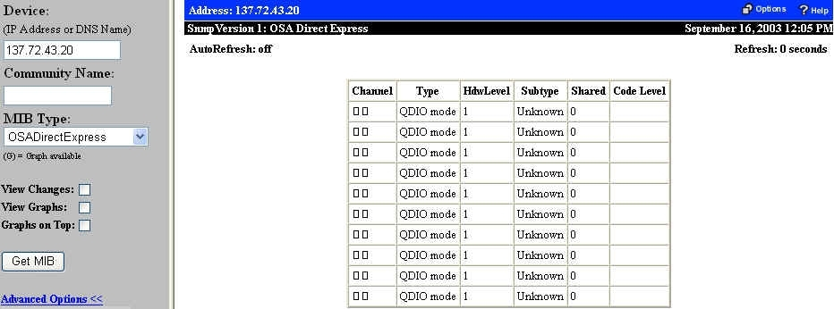
Figure 1. OSA Direct Express Table
The fields for OSADirectExpress are:
Channel | The CHPID corresponding to this ifIndex.
Type | The type of channel for this interface. OSA Direct Express has a value of 17.
HdwLevel | Hardware model of the channel.  - 1: unknown  - 2: osaExp150  - 3: osaExp175
Subtype | Indicates the type of OSA feature present. The values possible are:  - 1: unknown  - 65: gigabitEthernet  - 81: fastEthernet  - 82: tokenRing  - 2304: atmEmulatedEthernet
Shared | OSA-Express feature can be shared across multiple LPs. This object indicates if this feature is currently being shared between LPs.  - 0: notShared  - 1: shared
Code Level | This is the firmware (or micro code level) of the OSA feature. For example, OSA code level 05.6A would be represented as 0x056A.

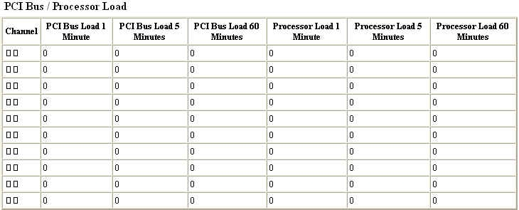Figure 2. OSA Direct Express PCI Bus/Processor Load Subtable
PCI Bus/Processor Load subtable:
Channel | The CHPID corresponding to this ifIndex.
PCI Bus Load 1 Minute | The average, over a 1 minute interval, of the percentage of time that the PCI bus was utilized to transfer data. It does not include idle time or time used by routine maintenance tasks. The range for this value is from 0 to 100%.
PCI Bus Load 5 Minutes | The average, over a 5 minute interval, of the percentage of time that the PCI bus was utilized to transfer data. It does not include idle time or time used by routine maintenance tasks. The range for this value is from 0 to 100%.
PCI Bus Load 60 Minutes | The average, over an hour interval, of the percentage of time that the PCI bus was utilized to transfer data. It does not include idle time or time used by routine maintenance tasks.
Processor Load 1 Minute | The average, over a 1 minute interval, of the percentage of time that the CHPID Processor was utilized to transfer data. It does not include idle time or time used by routine maintenance tasks. The range for this value is from 0 to 100%.
Processor Load 5 Minutes | The average, over a 5 minute interval, of the percentage of time that the CHPID Processor was utilized to transfer data. It does not include idle time or time used by routine maintenance tasks. The range for this value is from 0 to 100%.
Processor Load 60 Minutes | The average, over an hour interval, of the percentage of time that the CHPID Processor was utilized to transfer . It does not include idle time or time used by routine maintenance tasks. The range for this value is from 0 to 100%.

OSA Direct Performance
The OSA Direct Performance Table provides performance information for each Logical Partition (LP) the OSA can connect to.
The OSA Direct Performance Table has one subtable

Figure 3. OSA Direct Performance Table
The fields on OSA Direct Performance are:
DataLP0 through DataLP15 | The performance data on the OSA for partition 0 through15. The 40 bytes of hex data that are returned are decoded as follows, where each field is displayed as one column of each DataLP table:
 | Offset | Bytes | Field Meaning
 | 0  4  8  12  16  20  24  28  32  36 | 4  4  4  4  4  4  4  4  4  4 | LP Number  Processor Util 1 Minute  In Kbytes Rate 1 Minute  Out Kbytes Rate 1 Minute  Processor Util 5 Minutes  In Kbytes Rate 5 Minutes  Out Kbytes Rate 5 Minutes  Processor Util 60 Minutes  In Kbytes Rate 60 Minutes  Out Kbytes Rate 60 Minutes
The Processor Util 1 Minute is defined as follows:
- The average, over a 1 minute interval, of the percentage of time that the CHPID Processor was utilized to transfer data for a specific LP.
- It does not include idle time or time used by routine maintenance tasks.
- The range for this value is from 0 to 100%.
The In Kbytes Rate 1 Minute is defined as follows:
- The average, over a 1 minute interval, of the number of inbound kilobytes processed for a specific LP.
- The 5 and 60 minute fields are defined similar to the 1 minute fields, but pertain to intervals of 5 and 60 minutes.
The Out Kbytes Rate 1 Minute is defined as follows:
- The average, over a 1 minute interval, of the number of outbound kilobytes processed for a specific LP.
- The 5 and 60 minute fields are defined similar to the 1 minute fields, but pertain to intervals of 5 and 60 minutes.

OSA Direct V2 Performance
The OSA Direct V2 Performance table provides performance utilization information for each image the OSA can connect to.
The OSA Direct V2 Performance table has one subtable, where all fields after the first 3 column are equivalent to that of each of the 16 OSA Direct Performance subtables described above. The LP Number field is replaced by the following 3 new fields:
- Device Interface - ifIndex of the corresponding DEVICE interface.
- CSS ID - The Logical Channel Subsystem ID the performance data refers to. For a z900 or z800 system, there is only 1 Logical Channel Subsystem and is indicated by a CSS ID of 0. For z990 there can be ‘n’ Logical Channel Subsystems, numbered 0 to (n-1).
- Image ID - The image the performance data refers to. When running in basic mode, the image number is always 0.

OSA Direct Ethernet
The OSA Direct Ethernet Table represents the data associated with a port on an OSA-Express Gigabit or Fast Ethernet OSA.
The OSA Direct Ethernet Table has three subtables:
- Configuration
- Traffic/Errors
- MAC Addresses
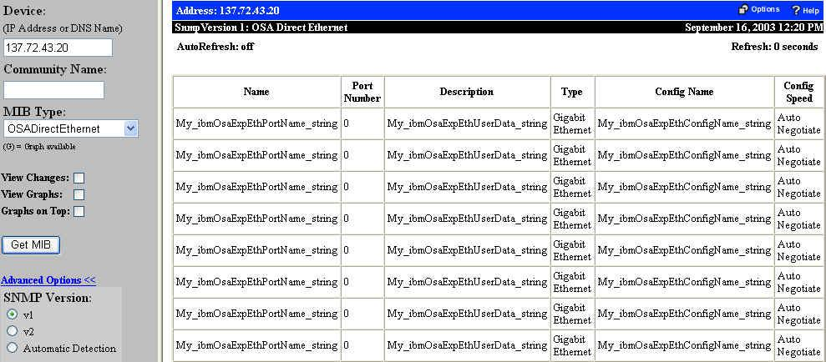
Figure 4. OSA Direct Ethernet Table
The fields on OSA Direct Ethernet are:
Name | This is the name of the configuration that in on the OSA. It is set using OSA/SF. It is not used by OSA
Port Number | The physical port number for this port. For Gigabit and Fast ethernet this can only be 0.
Description | Data set by the user. It is ignored by the OSA.
Type | The physical port type.
Config Name | This is the name of the configuration that in on the OSA. It is set using OSA/SF. It is not used by OSA.
Config Speed | The configured port speed. This field shows the speed that was configured by the user for the OSA-Express Fast Ethernet feature, which are:  - 0: autoNegotiate  - 1: tenMbHalfDuplex  - 2: tenMbFullDuplex  - 3: oneHundredMbHalfDuplex  - 4: oneHundredMbFullDuplex  - 6: oneThousandMbFullDuplex  It is not used by OSA-Express Gigabit features.

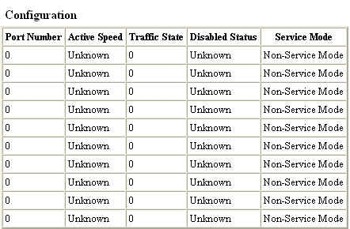
Figure 5. OSA Direct Ethernet Configuration Subtable

The fields on OSA Direct Ethernet are:
Port Number | The physical port number for this port. For Gigabit and Fast ethernet this can only be 0.
Active Speed | The actual speed and mode the OSA is running in:  - 0: unknown  - 1: tenMbHalfDuplex  - 2: tenMbFullDuplex  - 3: oneHundredMbHalfDuplex  - 4: oneHundredMbFullDuplex  - 6: oneThousandMbFullDuplex
Traffic State | The LAN state value ranges from 0 to 8. A value of 5, disabled is further explained in object ibmOsaExpEthDisabledStatus.  - 0: undefined  - 1: unavailable  - 2: enabling  - 3: disabling  - 4: enabled  - 5: disabled  - 6: linkMonitor  - 7: definitionError  - 8: configuredOffline
Disabled Status | When the value of ibmOsaExpEthLanTrafficState is NOT disabled, the value of this object will be zero. When the value of ibmOsaExpEthLanTrafficState is disabled(5), this object explains the reason for the disabled state. The value for this object may be a combination of the bits shown.  - 0: reserved0  - 1: internalPortFailure  - 2: reserved2  - 3: reserved3  - 4: reserved4  - 5: reserved5  - 6: portTemporarilyDisabled  - 7: reserved7  - 8: reserved8  - 9: serviceProcessorRequest  - 10: networkRequest  - 11: osasfReques  - 12: configurationChange  - 13: linkFailureThresholdExceeded  - 14: reserved14  - 15: reserved15
Service Mode | This object indicates if the processor is in service mode or not.  - 0: notInServiceMode  - 1: inServiceMode

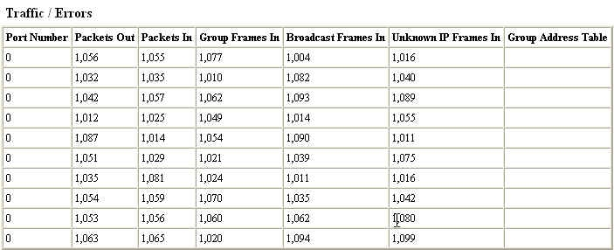
Figure 6. OSA Direct Ethernet Traffic/Errors Subtable
Traffic/Errors subtable fields:
Port Number | The physical port number for this port. For Gigabit and Fast ethernet this can only be 0.
Packets Out | This is the number of packets that have been transmitted by the OSA since the last time the OSA port was reset.
Packets In | This is the number of packets that have been received by the OSA since the last time the OSA port was reset.
Group Frames In | This is the number of multicast frames that have been received by the OSA.
Broadcast Frames In | This is the number of broadcast frames that have been received by the OSA.
Unknown IP Frames In | This is the number of non-IP received frames.
Group Address Table | This is the field of active Group Addresses. An individual Group Address is 6 bytes long, with an additional 2 bytes of padding. There are 32 group addresses.

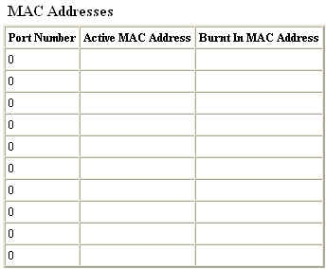
Figure 7. OSA Direct Ethernet MAC Addresses Subtable

Port Number | The physical port number for this port. For Gigabit and Fast ethernet this can only be 0.
Active MAC Address | A 6 byte OCTET STRING, which contains the current MAC address in use on the adapter. The values are in canonical format.
Burnt In MAC Address | A 6 byte OCTET STRING, which contains the burned in MAC address on the OSA. The values are in canonical format.

