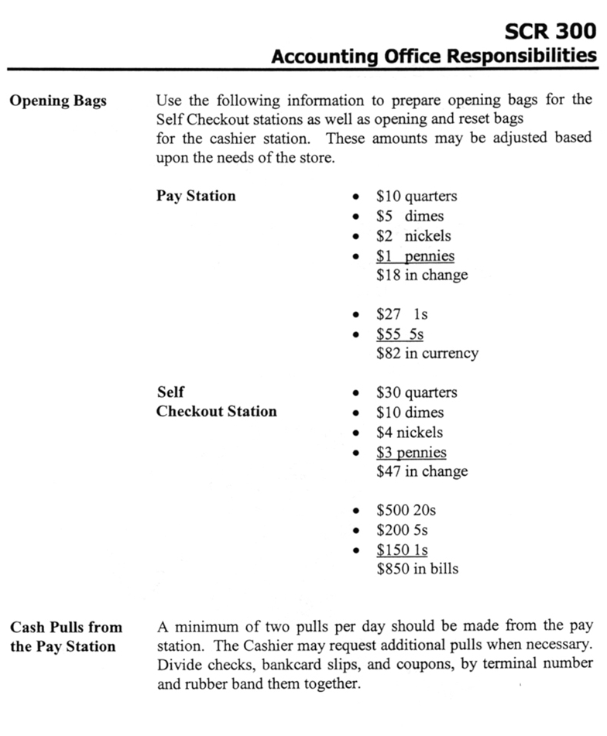

Sample #1

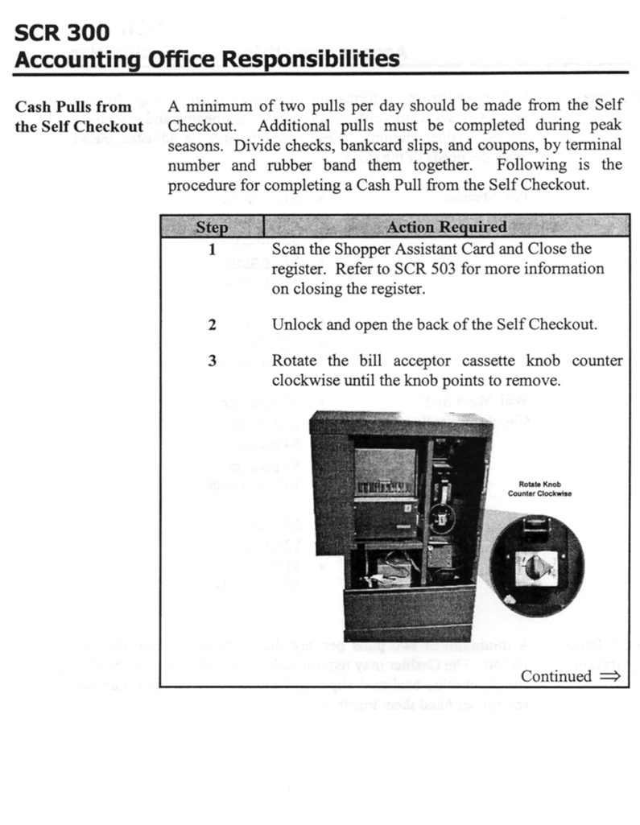

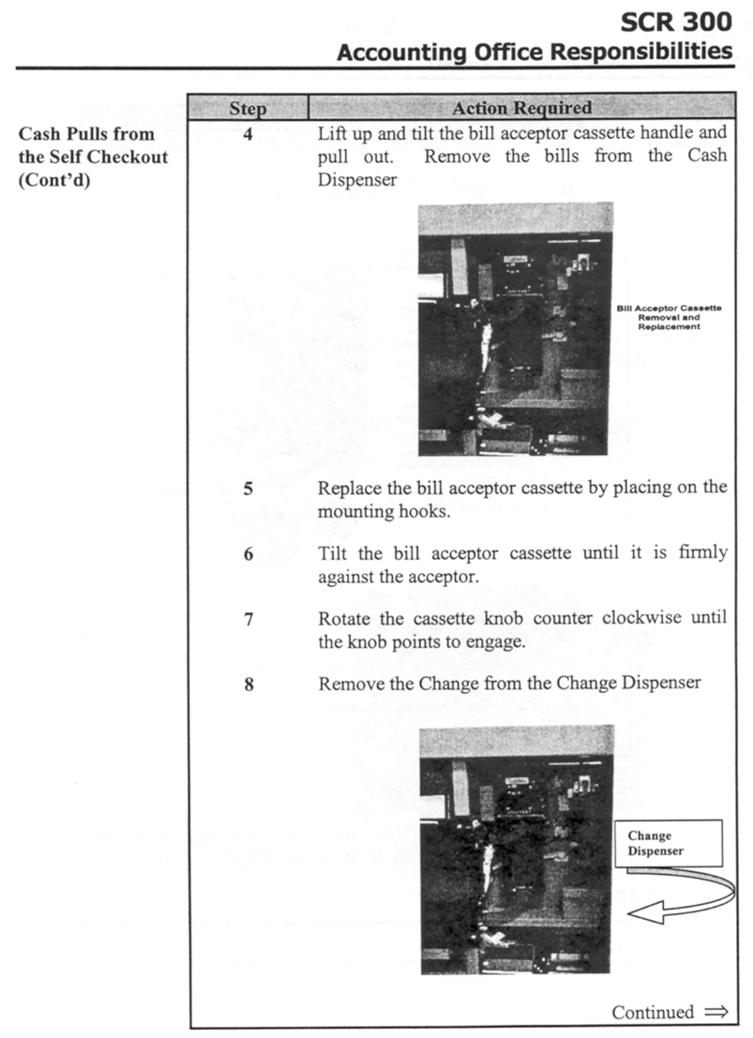

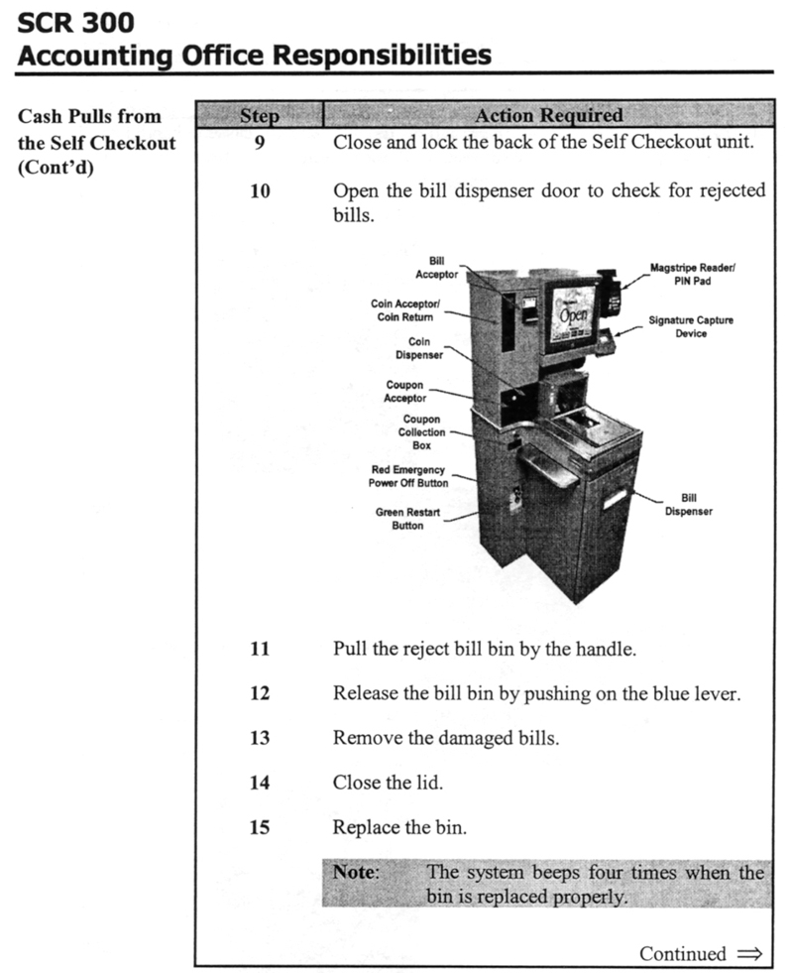

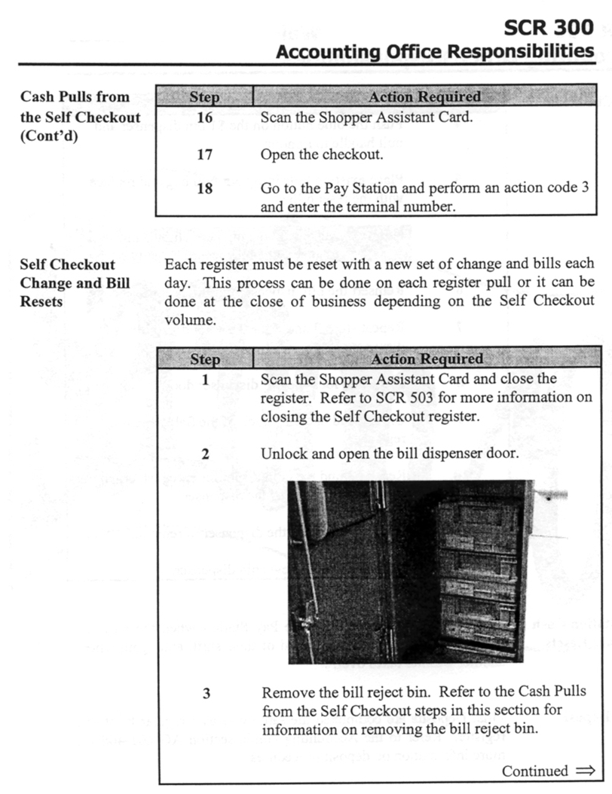

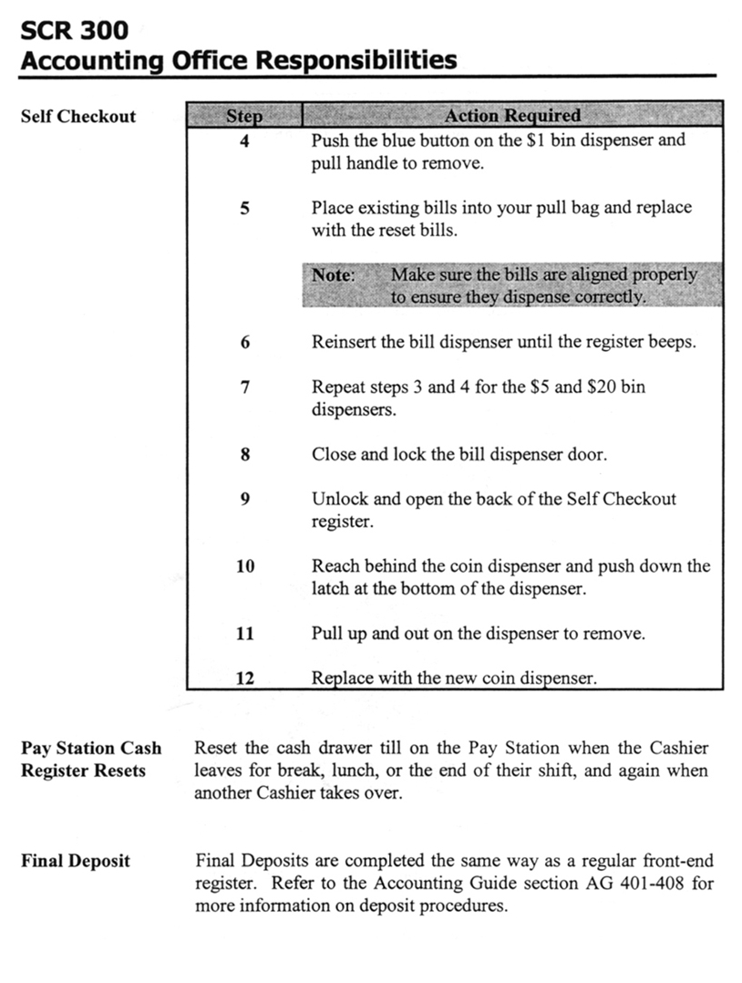

Sample #2

Accountability Procedures

Opening Procedures

- During the Morning Close, Self Checkout counts should be included in Safe Reconciliation. (Coin holders can be left locked up in the Self Checkouts)
- After accepting the Carry Forward, verify the money in the Self Checkout bags. Take the Self Checkout moneybags containing $1’s, $5’s, and $20’s and load into the Self Checkout registers. Replenish ones, fives, twenties and coins prior to opening the Self Checkout. List the loaned amounts on your Self Checkout count sheets and add to previous nights counts to determine each lane’s loan.
- To open and loan the Self Checkout, do the following:
- Scan Shopper Assistant Card
- Touch POS Emulator
- Key Operator Number and Password
- Terminal *21 – 217/223
- Terminal *22 – 218/224
- Terminal *23 – 219/225
- Terminal *24 – 220/226
- Press [Signon/off]
- Press [3] [Signon/off]
- Loan dollars and coins by denomination
- Press [Total]
- Press [Exit]
- After loaning the register, you should run Cash Maintenance to ensure the acceptor and dispenser are functioning properly:
- Take a penny, nickel, dime, quarter, $1 bill, $5 bill, $10 bill and $20 bill from the safe till
- Scan Shopper Assistant Card
- Press [Shopper Assistant Menu]
- Press [Next]
- Press [Cash Maintenance]
- Press [Cash Maintenance]
- Insert the coins into the coin acceptor one at a time. The system should dispense the coins as they are deposited.
- Deposit bills into the bill acceptor one at a time. The system will dispense the same amount as they are deposited.
- Press [Exit], then [Cancel]
- Return the money to the safe till.
- Self Checkout Lane is ready to operate.

Set-up Amounts
- The recommended set-up amount of currency and coins is as follows:
- One’s $200.00
- Five’s $300.00
- Twenties $600.00
- Quarters $60.00
- Dimes $25.00
- Nickels $4.00
- Pennies $3.00
- Total $1192.00
- This is just your initial set-up. You will not have to set the lane up to these exact amounts daily. However, please be very careful not to overload the Self Checkout with money. This will be especially true on Saturday night since Self Checkout lanes will count towards your approved Carryover Cash Total.

Pickup Procedures

- Self Checkout Lanes will not prompt you for pickups, however, you should perform cash and coin pickups as needed throughout the day and always prior to deposits.
- Cash pickups should be entered into ISSA as terminal *21, *22, or *23 depending on the lane you are performing the pickup on.
- Close lane to pickup Cash. Only close one Self Checkout lane at a time to pickup cash and coins.

Replenishing Self Checkouts

- In the event the Self Checkout runs out of money, the machine will issue the customer a Cash Voucher for the money owed.
- The customer will need to redeem the vouchers through the Paystation cashier.
- Cash vouchers should be defaced when redeemed.
- Replenish the Self Checkout as soon as possible. Lane must be closed to replenish and loan money.
- At the end of the night, take the cash vouchers from the paystation till and replace with money from the Self Checkout lane.
- Make every attempt to keep Self Checkout lanes at the recommended currency levels.

Closing Procedures

- Scan Shopper Assistant Card
- Press Shopper Assistant Menu
- To Perform Credit Card Closeout
- Press Reg Z
- Print Reg Z (Prints all Credit Card Transactions)
- Purge Reg Z
- To Perform Coupon Pickup (Closeout)
- Remove Coupons from Coupon Box
- Press Close Lane
- Remove cash and coin from the Cash and Coin Acceptors as well as the Reject box.
- Perform a pickup on money taken from Reject Box and Cash and Coin acceptors.

Reconciling Self Checkout Lanes

- Count one Self Checkout Lane at a time. One Self Checkout lane should remain open until 10:00pm. Do not close and count any Self Checkout lanes until 9:30pm.
- Count Coin holder and log on Self Checkout Count Sheet
- Remove money from $1, $5 and $20 cassette boxes.
- Count all cash ($1, $5 and $20) from cassette boxes and record on Self Checkout Count Sheet.
- Add cash and coins on Self Checkout Count Sheet and reconcile lanes.
- Under ISSA:
- Choose [1] – Accounting Support
- Choose [3] – Tender Count and Single Reconciliation
- Choose [1] – Current Period
- At Operator/Terminal Key in * and 21,22, or 23.
- Enter money picked up from Self Checkout.
- Pull over in other amounts in the over/short column
- Press [F5] to reconcile.

Note: Prior to leaving for the night, check the Automated Reconciliation screen to ensure all Self Checkout Lanes have been counted and reconciled.

