Self Checkout Shopper Assistant Responsibilities
Training Workbook
Version 1.0

ACM® Self Checkout Shopper Assistant Responsibilities Training Workbook
© 1996-2003 Productivity Solutions Incorporated. All Rights Reserved.
Trademarks
ACM® is a registered trademark of Productivity Solutions Incorporated.
MS Word and Windows NT are registered trademarks of Microsoft.
All other trademarks or registered trademarks are the property of their respective owners.
PRODUCTIVITY SOLUTIONS INCORPORATED (PSI) has made every effort to ensure that the information in this guide is complete, precise, and current. PSI assumes no liability to any person or entity with respect to alleged loss or damage caused by this workbook. The examples, sample screens, and reports used throughout this guide are intended for illustrative purposes only and may not conform to your system requirements. Implied warrantees are hereby specifically disclaimed. PSI may make improvements and/or changes in the product(s) and/or program(s) described in this publication at any time.
Warning
All computers supplied with the ACM® 700 are fully assembled in manufacturing. Additional cards or modifications are not to be inserted by the user.
Composed in AvantGarde and Garamond using Microsoft Word 97.
Written and designed at Productivity Solutions Incorporated, Suite 509, 10550 Deerwood Park Blvd., Jacksonville, FL 32256.
Printed in the USA.

Contents
Self Checkout Shopper Assistant Responsibilities Training Workbook ii
Contents 4
How This Workbook Is Organized 5
Conventions Used in This Workbook 5
Section One: The Role of the Self-Checkout Shopper Assistant 6
Shopper Assistant Responsibilities 7
Roles of a Shopper Assistant 7
Shopper Assistant Cards 7
Monitoring Transaction Awareness Lights 7
Transaction Awareness (Security) Light Conditions 7
How to Handle Not-On-File Items: 8
Shopper Assistant Menu Functions 10
Assisting Shoppers 14
Lane Security Modes 18
Closing and Opening the Lane 19
Tips for Shopper Assistants 20
Practice Session 21
Role of the Self-Checkout Shopper Assistant 21
Hands-On Section 22
Glossary of Self Checkout Terms 23
Index 24
Preface
This workbook is intended for store front-end personnel assigned to the positions that operate the ACM® Self Checkout Lanes and Paystations. Others within the store are encouraged to use this product as a tool to learn more information on the system’s operations.

How This Workbook Is Organized
Section One: The Role of the Self-Checkout Shopper Assistant

Conventions Used in This Workbook
Note: | Notes – important information concerning the subject being discussed.
 | Buttons – pictures representing the buttons that appear on the Self Checkout monitor’s touch-sensitive screen. The screen’s buttons, when pressed, activate a system function.
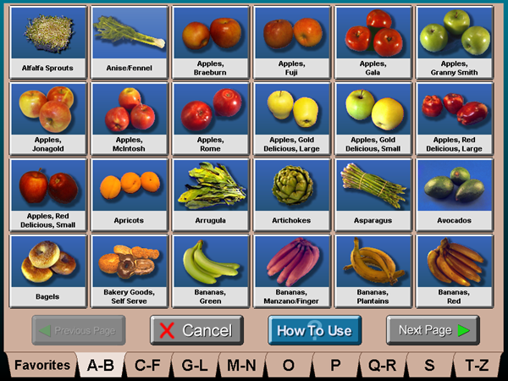 | Screen Captures – pictures representing the screens that appear on the Self Checkout monitor’s touch-sensitive screen as seen by the user.
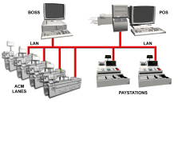 | Figures – graphics or diagrams used to illustrate components of the Self Checkout System.
Captions are located next to or under graphics | Captions – details or explanations about screen captures or figures.

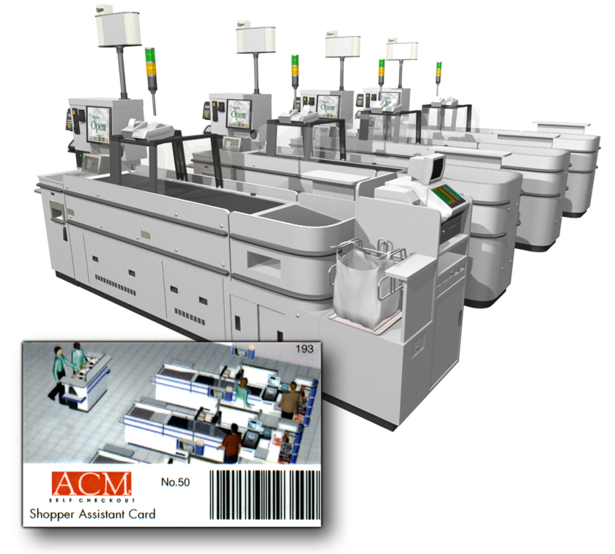
Section One: The Role of the Self-Checkout Shopper Assistant
This section discusses the roles and responsibilities of the Self Checkout Shopper Assistant. To fully understand how to fulfill the role, it is important to know how to assist shoppers when issues arise at the lanes.

Shopper Assistant Responsibilities
The Shopper Assistant provides fast and friendly service when a shopper encounters difficulty with his or her order. Though the Self Checkout lanes are automated, note that the system requires human interaction to function effectively.

Roles of a Shopper Assistant
- Assist customers in a quick and friendly manner.
- Educate customers to use the system and embrace the new technology. As customers learn and become more familiar with Self Checkout, they will rely less on the Shopper Assistant each time they use it.
- Clearly answer customer questions.
- Stay at the lanes to assist and interact with customers. The Shopper Assistant should stay behind the Paystation only when tendering a transaction.
- Always be available for customers who need assistance. Never leave the Self Checkout area unsupervised.

Shopper Assistant Cards
After successful completion of Self Checkout training, store associates receive a Shopper Assistant card to assist shoppers. Managers activate and, if lost or stolen, deactivate each card at the BOSS. The BOSS logs every action shopper assistants perform with the card to a report. These records include the lane, action, card number, cardholder’s name, and the time of the action. The card is a powerful tool. Use it properly to ensure system integrity. All employees and key management personnel should turn in cards at the end of each shift to ensure accountability. | 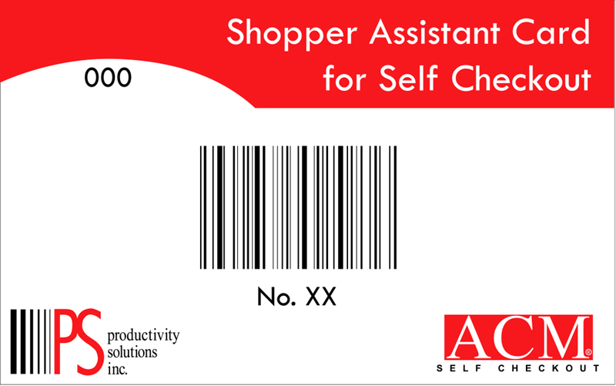  It’s important to note that anyone given a card must be trained in its use and understand the responsibility associated with the card.  (Picture)

Monitoring Transaction Awareness Lights
The transaction awareness light pole alerts the Shopper Assistant of transaction type and lane security conditions.

Transaction Awareness (Security) Light Conditions
Illuminated green light signals that the shopper will pay at the self-checkout lane. Amber light signals that the shopper will pay at the self-checkout lane’s Paystation. Flashing amber & green lights signal that the order has at least one pass-around item. The red light signals the Shopper Assistant to deactivate or remove Electronic Attached Security (EAS).


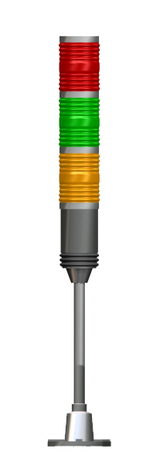
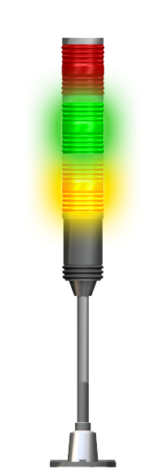

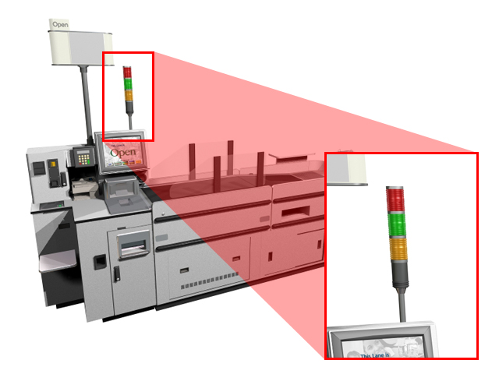
Green light Indicates Self Service Tender at the Self Checkout Lane
Amber light Indicates Tender at the Self Checkout Lanes Paystation
Flashing Amber & Green lights Indicate Pass-Around Items Present in the Order
Red light Indicates Electronic Attached Security (EAS) Needs to be Deactivated or Removed
Transaction Awareness (Security) Light

How to Handle Not-On-File Items:
When a shopper scans an item that is not-on-file in the store’s POS, the following corrective action occurs if the store has Learn Not-on-file (NOF) capability:
Procedure:
- Scan your Shopper Assistant Card. This places the system in security override mode. Scan the item’s barcode and follow the onscreen prompts.
Note: Some stores may not utilize this ACM® function. If this function is utilized, remember to “scan card then scan the item” and place it on the belt.
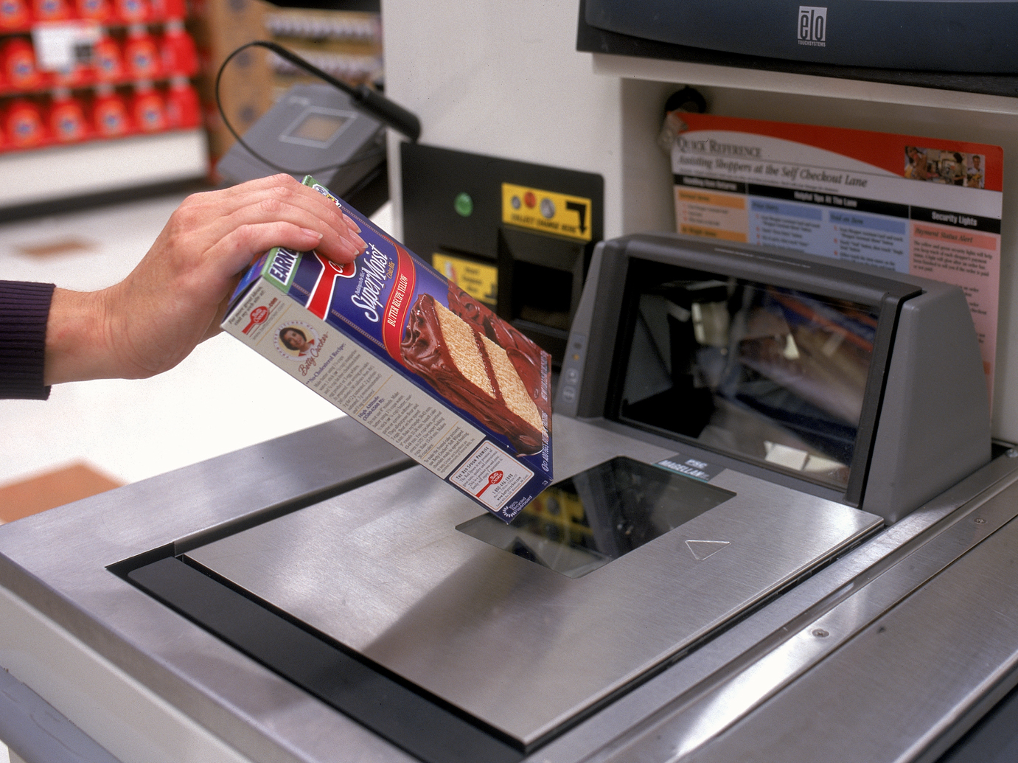
Item not in stores POS file
(Picture)
- A dialog box displays stating that the item is not on file.  - Press NO to exit the box. Ask the shopper to continue processing items and perform a price check.  - After obtaining the price and department, scan the Shopper Assistant card then scan the item.  - Press YES to learn the NOF item.  - Key in the price and press ENTER.  - Touch the appropriate department key and press ENTER.  - Place the item on the belt.  - Note: Once the item passes through the security zone, the lane will automatically return to full security mode. | 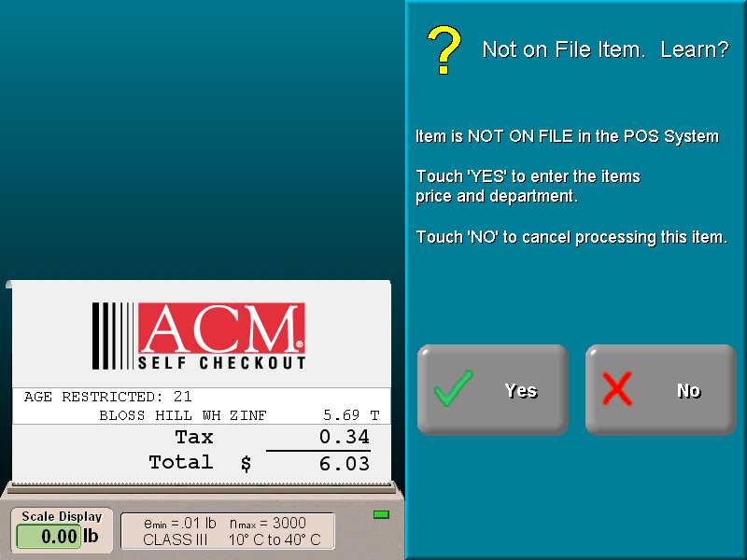  Not-on-file dialog display  (Screen Capture)
The ACM® lanes learn not-on-file items so self checkout customers will not be inconvenienced in the future. Remember that the item only processes on ACM® lanes and remains not-on- file at conventional lanes until the item is given to the scanning and pricing associates to enter it into the POS system.
The scanning and pricing associate resolves the following issues for random weight item returns:
- NOF – an item that is not on file in the store’s point of sale system.
- Altered or processed – an item that changed after it was weighed and labeled (i.e., cooked, steamed, de-boned, packed in ice, etc.)
- Scale Weight Difference – an item in which the weight on the label does not match the scale-measured weight.
The scanning and pricing associate resolves the following issues for all other item returns:
- NOF – an item that is not on file in the store’s point of sale system.
- Invalid Price – an item with an invalid price in the store’s point of sale system.
- Incorrect Audio – an item that voices the incorrect name when processed.
- Inappropriate Transport Method – an item that, when processed, causes the lane’s belt to function inappropriately (i.e., the lane requires the shopper to place a large bag of dog food on the belt).
- Inaccurate Tare Value – a weight-required item that reflected an inaccurate or non-existent tare value (reflected on receipt).
- No Quantity Prompt – a quantity-required item that did not prompt for quantity.

Shopper Assistant Menu Functions
Shopper Assistants perform specific procedures at the Self Checkout lane by accessing the Shopper Assistant Menu Screen.
To Access the Shopper Assistant Menu  - Scan Shopper Assistant card.  - Touch the SHOPPER ASSISTANT MENU button. | 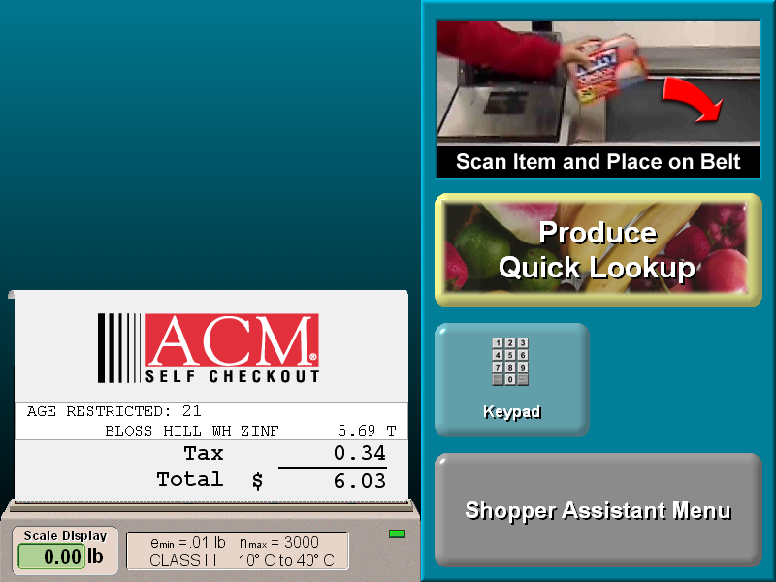  Shopper Assistant Menu button  (Screen Capture)
- The Shopper Assistant Menu appears. | 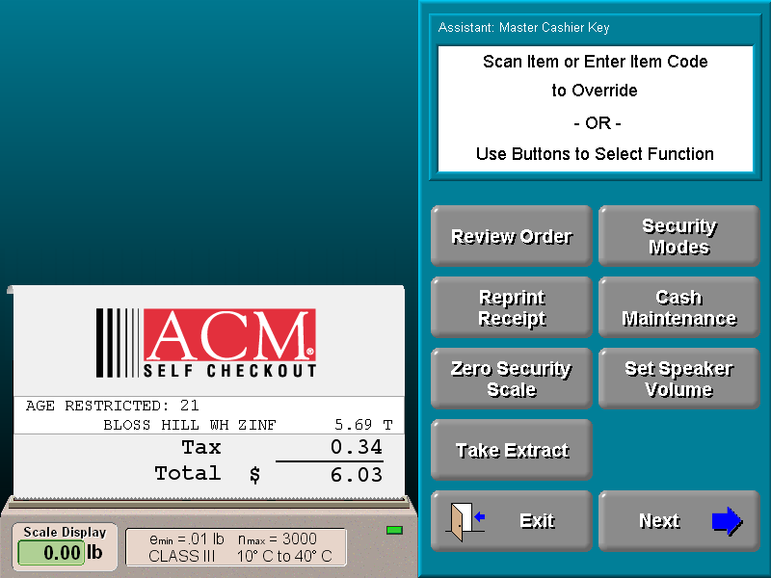  Shopper Assistant Menu  (Screen Capture)
Note: Each ACM® series lane has unique Shopper Assistant Menu functions. These unique functions are not covered in this section. Refer to the appropriate ACM® series tabs in the Implementation Kit to learn about unique ACM® series functions.

Processing Quantity Purchases  From the Shopper Assistant Menu:  - Touch the QUANTITY button.  - Key in the quantity and press ENTER.  - Scan one of the items. Then, place all of the items on the belt.  - Touch EXIT to return to the order. |   Quantity Button
Voiding Items  From the Shopper Assistant Menu:  - Touch the VOID button.  - Touch the SINGLE ITEM button.  - Next, either scan the item, or touch the item from the menu (the item will be highlighted) and touch the VOID ITEM button.  - Touch EXIT to return to the order. | 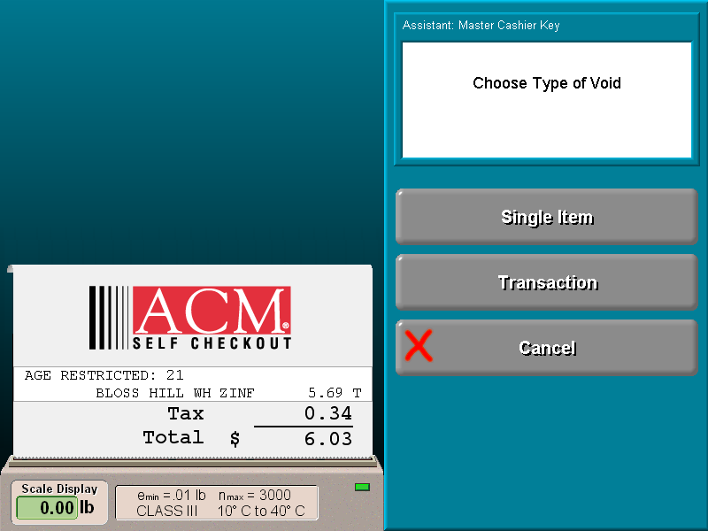  Void Menu  (Screen Capture)  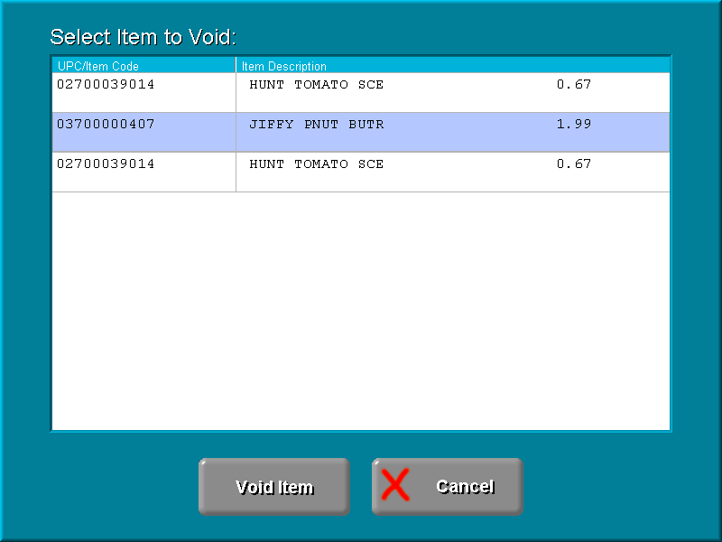  Single Item Void Menu  (Screen Capture)
Voiding Transactions  From the Shopper Assistant Menu:  - Touch the VOID button.  - Touch the TRANSACTION button. |   Void Transaction Button
Performing a Price Entry  From the Shopper Assistant Menu:  - Touch the PRICE ENTRY button.  - Key in the price and touch ENTER.  - Touch the appropriate department button.  - Place the item on the belt.  - Touch the EXIT button. |   Price Entry Button
Reprinting a Lost or Damaged Receipt at the Lane  From the Shopper Assistant Menu:  - Touch the REPRINT RECEIPT button.    Reprint Receipt Button  - Select the transaction from which you need the receipt.  - Touch the EXIT button. | 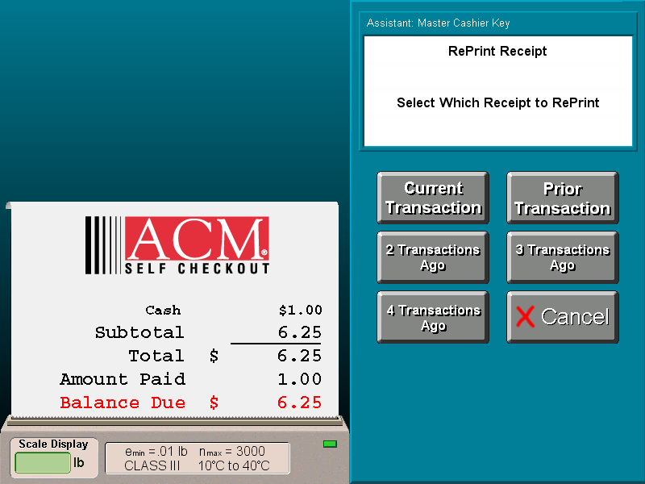  Reprint Receipt Menu Screen  (Screen Capture)
Reviewing an Order  From the Shopper Assistant Menu:  - Touch the REVIEW ORDER button.    Review Entry Button  - Use the up and down arrows to scroll through the order. | 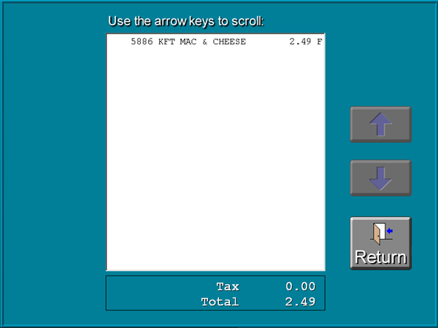  Review Order Screen  (Screen Capture)

Assisting Shoppers
Processing an Age-Restricted Item  If the Age Verification prompt is not displayed, scan Shopper Assistant card, then perform the following:  - Enter the shopper’s birth date (mm/dd/yyyy) as prompted, or select the OVER 21 or OVER 18 button if the shopper is of age.  - Upon verification, all other valid age restricted items will scan without assistance. | 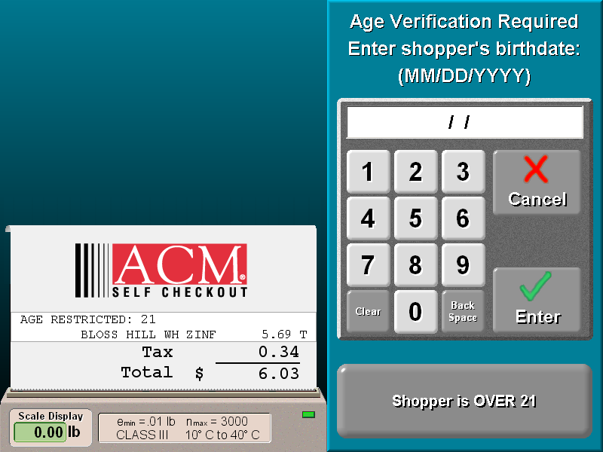  Age Verification Screen  (Screen Capture)
Manually Processing a Manufacturer or Store Coupon  With the Coupon Screen prompt displayed, scan Shopper Assistant card, then perform the following:  - Press the COUPON button.  - Select and press MANUFACTURER or STORE COUPON button.  - Enter the price of the coupon.  - Enter the department of the coupon.  - Touch the EXIT button. | 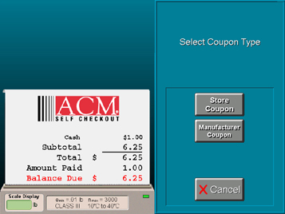  Select Coupon Screen  (Screen Capture)
Adjusting Lane Audio Volume  From the Shopper Assistant Menu:  - Touch SET SPEAKER VOLUME button.    SET SPEAKER VOLUME button.  - Touch the volume level slider or arrows up and down to reach your desired sound level.  - Touch the TEST VOLUME button.  - Readjust volume if necessary.  - Touch the EXIT button. | 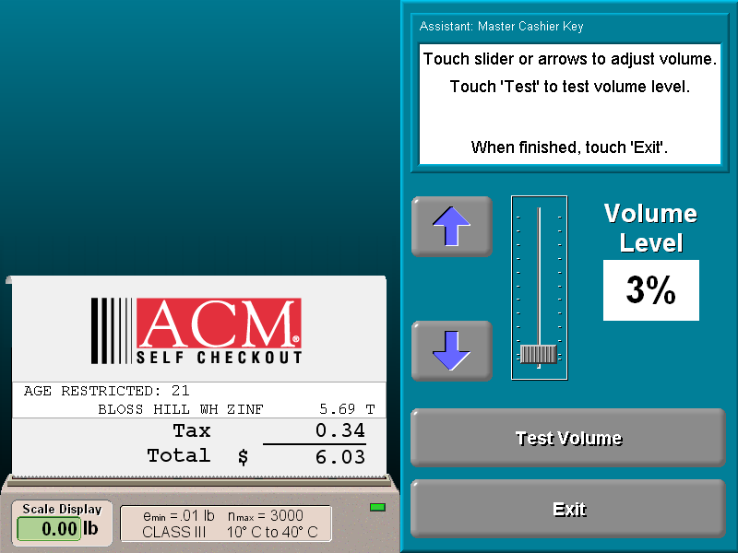  Open Lane Menu  (Screen Capture)
Changing Order Language at the Lane  From the Shopper Assistant Menu:  - Touch CHANGE LANGUAGE button.    CHANGE LANGUAGE button.  - Select the desired language button.  - The lane automatically changes language.  - Touch the EXIT button. | 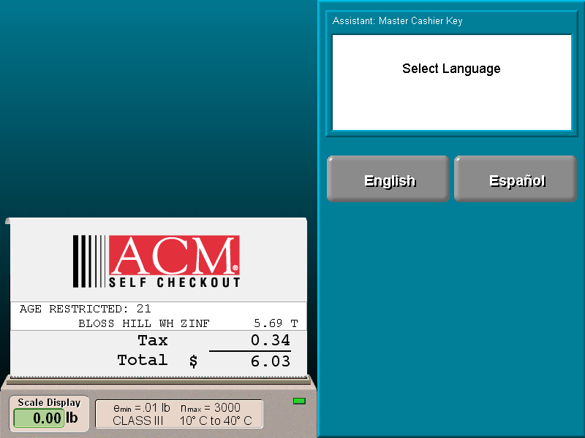  Language Menu  (Screen Capture)

Lane Security Modes
Shopper Assistants with permission to change lane security modes using their Shopper Assistant card may configure lanes as follows:
Full Security Mode – Enables all lane dimensional security features and audio reminders.
Shopper Speed Security Mode – Disables selected lane audios and opens security parameters so orders process faster at the lane.
Cashier Speed Security Mode – Disables dimensional security features and selected lane audios so orders process faster at the lane. This configuration requires store associates to scan shopper’s items for them at the lane.
Note: “Cashier Speed Security Mode” turns off lane security and keeps the SHOPPER ASSISTANT MENU button on the monitor. Never leave the lane unattended in “Cashier Speed Security Mode”.
Changing Lane Security Mode  From the Shopper Assistant Menu:  - Touch SECURITY MODES button.    SECURITY MODES button.  - Touch the desired security mode.  - Touch the EXIT button. | 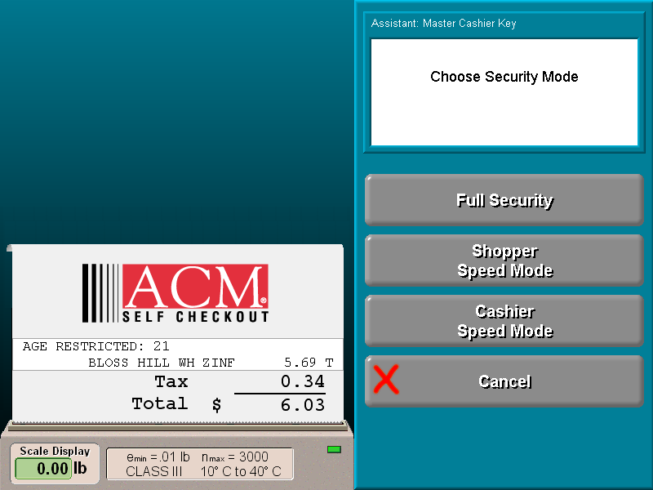  Open Lane Menu  (Screen Capture)

Closing and Opening the Lane
Closing the Lane  From the Shopper Assistant Menu:  - Complete all orders before closing the lane.    CLOSE LANE button  - Touch the CLOSE LANE button.  - The screen reads “Sorry, this lane is Closed”. | 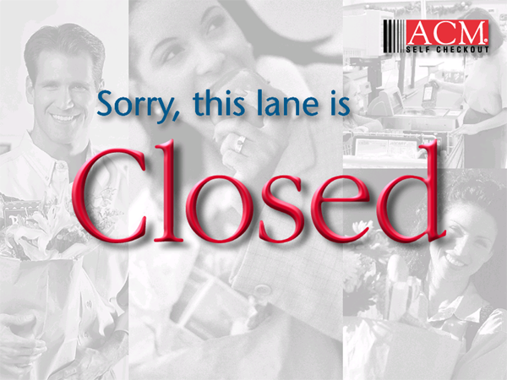  Lane Closed Screen  (Screen Capture)
Opening the Lane  - Make sure nothing is on the scanner/scale or conveyors.  - Scan Shopper Assistant card.  - The ACM® Lane Menu box appears.  - Touch the OPEN LANE button. | 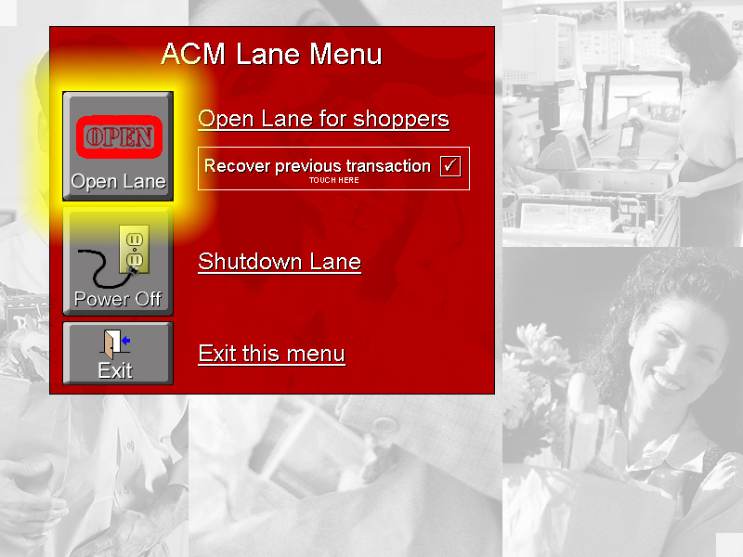  Open Lane Menu  (Screen Capture)

Tips for Shopper Assistants
Shopper assistants should follow these instructions when assisting shoppers.
- Read all system messages before performing any actions at the lanes.
- For best ACM performance avoid manual price entries. When items return, perform an override and use the LEARN NOF feature for not-on-file items. Key in the barcode numbers for items with damaged barcodes.
- When learning not-on-file items, retrieve an identical item during the price check and keep it in an easily accessible location for the store’s scanning and pricing associate.
- If a random weight (Type 2 barcode) item returns, check the label for possible mishandling, such as label switching, improper weighing, or invalid pricing. If a specific Type 2 item returns frequently (one that is typically processed, such as steamed crab legs or de-boned roasts), contact the scanning and pricing associate.
- During peak times (such as the day before a holiday), assign additional shopper assistants to operate Self Checkout lanes to quickly help shoppers.
- If store brings in additional staff, identify as bagger vs. shopper assistants or cashiers.
- If baggers are scheduled, routinely redirect them to the Self Checkout area when shoppers need assistance.

Practice Session

Role of the Self-Checkout Shopper Assistant
___________ | Which transaction awareness light illuminates when items that have been flagged for pass-around in the lane’s security system are processed?
- The green and amber lights flash.
- The green light illuminates
- The amber light illuminates
- The red light illuminates
___________ | Which transaction awareness light illuminates when successful payment is tendered at the lane?
- The green and amber lights flash.
- The green light illuminates
- The amber light illuminates
- The red light illuminates
 | Matching:
___________ | - Shopper Assistant Card | - Used when an item has voiced a price but has returned to the shopper.  - Assigned cards that access the Security Override Mode.  - The ability to learn a temporary price and department record in the ACM® security database for an item that does not yet have a record in the POS.  - Barcoded items that are sold by weight. If they return, check for mishandling, invalid pricing, or improper weighing.
___________ | - Override Security function
___________ | - Learn Not-on-File
___________ | - Type 2 (Random Weight) Items
___________ | A customer asks for help scanning 50 packages of Kool-Aid (in assorted flavors). Which of the following best describes your actions in assisting with this quantity purchase?
 | - Quantity purchases at the lanes are not possible, The Shopper Assistant or customer must scan all 50 packages individually.
 | - Sort packages by flavors noting the quantities of each. Enter the quantity on the keypad and press ENTER. Scan the item and place all packages on the belt.
 | - Sort packages by flavors noting the quantities of each. Scan Shopper Assistant card. Touch the SHOPPER ASSISTANT MENU button. Touch the QUANTITY button. Enter the quantity of one of the flavors. At the prompt, scan the appropriate flavor package. Place packages of that flavor on the belt. Repeat the process for additional flavors. Press EXIT when done.
___________ | Which of the following best describes the “Open Lane” procedure.
- Press the green re-start switch. Wait two minutes and scan Shopper Assistant card.
- Ensure no items are on the scanner/scale or conveyors, scan Shopper Assistant card. Touch the OPEN LANE button.

 | Hands-On Section  While standing at an ACM® Self Checkout Lane, perform the following Shopper Assistant actions.  ☑ Check off procedures, once performed, in the line provided.
___________ | - Process an item using the Security Override Mode.
___________ | - Process a NOF item using the Learn Not On File Feature.
___________ | - Process items using the QUANTITY button.
___________ | - Practice voiding items and transactions at the lane.
___________ | - Practice placing the lane in different security modes.
___________ | - Practice a price entry.
___________ | - Perform a “Close Lane” procedure.
___________ | - Perform an “Open Lane” procedure.

Glossary of Self Checkout Terms
age-restricted items — Items, such as alcohol and tobacco, require the purchaser to be a minimum age.
check cart item — Large items, such as a 50 pound bag of dog food are typically placed under the shopping cart. Upon system entry, this type of item will generate a “Check Cart” message on the lane receipt.
extract — File containing diagnostic information gathered while processing each item in an order. The extract file is stored at the BOSS until an ACM® engineer retrieves it for analysis and resolution.
not-for-sale items — Grocery items, such as seasonal items or federally recalled items, that have been pulled from the shelves and are not for sale at the current time.
not-on-file (NOF) items — Grocery items that have not been added to the point-of-sale (POS) system.
plu (price lookup) code — Code used for items that do not have barcodes.
quantity-required items — Grocery items sold by the number of items purchased (i.e., cucumbers, lemons, peaches, etc.).
random weight (type 2) items — Prepackaged items sold by price per kilogram or pound. These items are marked by a type 2 barcode and include most meat products.
retrieving orders — Process of bringing up suspended ACM® orders. The system suspends orders so customers can pay at the Paystation. Retrieving orders allows Shopper Assistants to process the customer’s order like any regular order.
shopper Assistant — Person designated to assist shoppers on the lanes whenever a difficulty is encountered. This assistance may require the use of the Shopper Assistant card.
shopper Assistant card — Programmable scan card that allows the card holder a range of functions in assisting the shopper and/or troubleshooting the lane.
time restricted items — Grocery items that are not sold during certain times or on certain days (for example, alcohol on Sunday).
transport methods — Method for transporting items from the ACM® lanes to the bagging areas. Some items must pass through the security arches, some items may optionally pass through the security arches, and other items must not pass through the security arches.
upc (universal product code) — Barcode printed on grocery items.
value or bonus packaged items — Grocery items that are specially packaged to promote a particular item or to serve as an enticement to shoppers (i.e., 10% more free, buy two for the price of one, etc.).
weight required items — Grocery items that are sold by weight, such as produce (i.e., bananas, beans, etc.) and bulk foods (i.e., trail mix).

Index

Assisting Shoppers, 10
Cards
Shopper Assistant, 7
Closing the Lane, 18
Glossary of Self Checkout Terms, 22
Lane
Closing, 18
Opening, 15, 16, 17, 18
Lost or Damaged Receipts, 13
Not-on-File Items, 9
Opening the Lane, 15, 16, 17, 18
Performing a Price Entry, 13
Price Entry
Performing, 13
Quantity Purchases, 11
Receipts
Reprinting, 13
Reprinting
Receipts, 13
Responsibilities
Shopper Assistant, 7
Role of the Self Checkout Shopper Assistant, 6
Self Checkout
Shopper Assistant, 6
Shopper Assistant, 6
Cards, 7
Menu, 10
Role, 6
Shopper Assistant Cards, 7
Shopper Assistant Responsibilities, 7
Shopper Assistants
Tips, 19
Shoppers
Assisting, 10
Tips for Shopper Assistants, 19
Void
Items, 12
Transactions, 12

