Review the following steps to learn the basic Rational XDE tasks you use when modeling and designing a Web application. This example adds server page and client page classes and connects these web artifacts using relationships. To read more about designing Web applications, see Web Applications in the Rational XDE help
- Create a XDE Web project
An XDE Java project creates a project folder in the Navigator and three empty models that you use when modeling JSP-based Web applications, a virtual directory model, a JSP tag library model, and a Java code model. You can open one or all models in the project to begin modeling a Web application.
Rational XDE uses the project name to automatically name the models contained in the XDE Web project. Rename the models to help you easily identify the Java code model from the virtual directory and tag library models.
In the Navigator, right-click the virtual directory model and click Open.
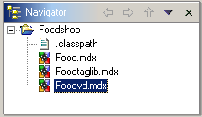
- Add a server page and client page
When you add a «ServerPage», XDE adds a «ClientPage» and creates a «Build» relationship from the server page to the client page.
The graphic shows the Foodvd virtual directory with a server page and client page. In this example the server page class name is Welcome and the file name for the server page is Welcome.jsp. For details on specifying a file name for the server page, see Changing Round-Trip Engineering Options in Rational XDE help.
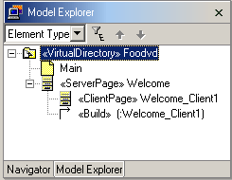
When you generate code from the Foodvd model, XDE captures the client page and HTML form between HTML tags in the Welcome.jsp file.
- Add a standalone client page
Use a standalone client page for HTML documents not built by a JSP. In your Web application, you can connect the standalone client page to another client page or a server page by defining a relationship. For details on relationships allowed between Web artifacts, see Relationship Rules for Web Artifacts in the Rational XDE help.
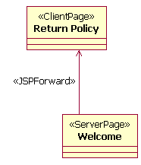
The graphic shows the client page class and the server page class with a «JSPForward» relationship linking the two Web artifacts. Use Web tools in the Toolbox to create relationships or classes. For details on defining a <jsp:forward> action in the .jsp file, see Creating JSP Forward Relationships in the Rational XDE help.
- Add an HTML Form
When modeling a Web application, add functionality to server side objects. Model interaction with the user by adding an «HTMLForm» to a client page. Create a server page which automatically builds a client page. Use a client page built by a server page to invoke server-side processing. You must use add an HTML Input element of the Type, Submit, to send input to the server for processing.
- Add an HTML input element
Since you probably want to collect and validate the user input, add the HTML form to a client page built by a JSP. The Web server processes the input collected by the JSP in the HTML Form. After adding the HTML form, add HTML input elements.
When you create an HTML Form, the must submit to a server page for processing. You can use the HTMLSubmit Relation tool to create the relationship from the HTML Form to the server page.
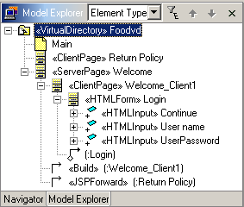
The graphic shows the HTML Form with three input elements to accept the user name, user password, and a submit button called Continue.
- Create a «JSPInclude» relationship between two server pages
To model a <jsp:include> action in a «ServerPage», you select the JSP Include relationship tool in the Web toolbox and draw the relationship from the destination JSP to the source JSP.
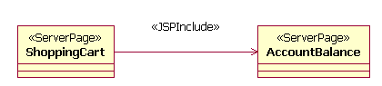
The example shows the ShoppingCart server page with a «JSPInclude» relationship drawn to the AccountBalance server page. When the client requests account balance information, the shoppingcart.jsp dynamically includes the user's account balance from the accountbal.jsp in its contents.
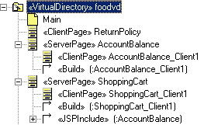
Rational XDE adds the «JSPInclude» relationship under the ShoppingCart Server page in the Model Explorer. When you generate code for a server page with a JSP include relationship, the <jsp:include> action appears similar to the following in the .jsp file:
<jsp:include flush="true" page="accountbal.jsp"/>
- Create a useBean relationship
This example adds a JavaBean, called calculator, to the AccountBalance server page. A <jsp:useBean> tag declares and instantiates a JavaBean in a JSP.
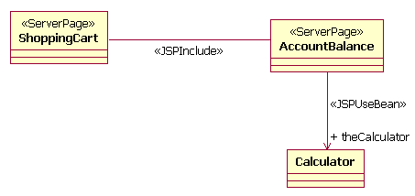
Rational XDE generates a class representing the Bean and adds it to the existing Java code model in the Java project. In this example, the class is added to the Food model.
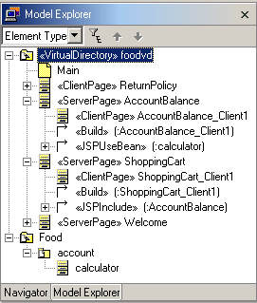
- Generate .jsp and .html files
In Rational XDE, you can generate .jsp, .htm, and .html files from the virtual directory model. For details on the results of generating code, see Synchronization in Web Applications in the Rational XDE help.
The Foodshop example shows adding server pages, client pages, and HTML Forms, and creating relationships in the virtual directory model called Foodvd.mdx. It also shows adding a Java class representing a JavaBean into the Java code model called, Food.mdx. You can open the Java code model in the Java project to add attributes and methods to the Java class and generate code to use in your Web application. You can also open the JSP tag library model to reverse engineer JSP tags for use with the JSP pages you created in the virtual directory model. To learn more about using JSP tag libraries, see Modeling JSP Pages with Tag Libraries in the Rational XDE help.

