Dear support,

We experience some problems with the graphical merge-tool on windows:

---------------------------------- Clearcase Version information ------------------------

ClearCase version 2002.05.00 (Tue Oct 30 08:27:59 2001)
clearcase patch p2002.05.00.NT-8 (Mon Jun 10 14:44:04 2002)
clearcase patch p2002.05.00.NT-9 (Tue Jul 23 15:16:07 2002)
clearcase patch p2002.05.00.NT-11 (Thu Aug 15 16:14:46 2002)
clearcase patch p2002.05.00.NT-12 (Thu Sep 12 11:15:10 2002)
clearcase patch p2002.05.00.NT-13 (Wed Oct 23 08:18:42 2002)
clearcase patch p2002.05.00.NT-14 (Fri Oct 18 14:10:54 2002)
clearcase patch p2002.05.00.NT-15 (Fri Oct 18 14:25:37 2002)
MVFS is not installed.
cleartool 2002.05.00 (Fri Oct 26 20:24:09 2001)
db_server 2002.05.00+ (Sun Sep 22 12:39:38 2002)
VOB database schema version: 53

----------------------------------- winver ----------------------------------------------

Microsoft (R) Windows
Version 5.0 (Build 2195: Service Pack 3)

When merging a larger file we experience the following problem.

Please find all files that are used for the examples attached in mergefiles.zip. (for security reasons the files have been modified)

C:\> cleartool merge -gra -base base_fail2.txt -out out.txt from_fail2.txt to_fail2.txt

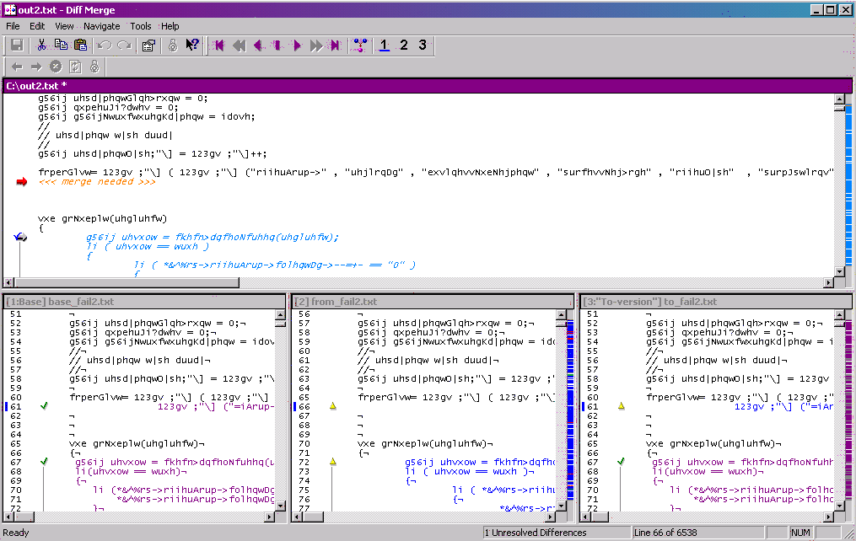

When selecting any of the contributors (1, 2 or 3) the code is not inserted in the line below:

frperGlvw= 123gv ;"\] ( 123gv ;"\] ("riihuArup->" , "uhjlrqDg" , …

as expected, but further down in the code:

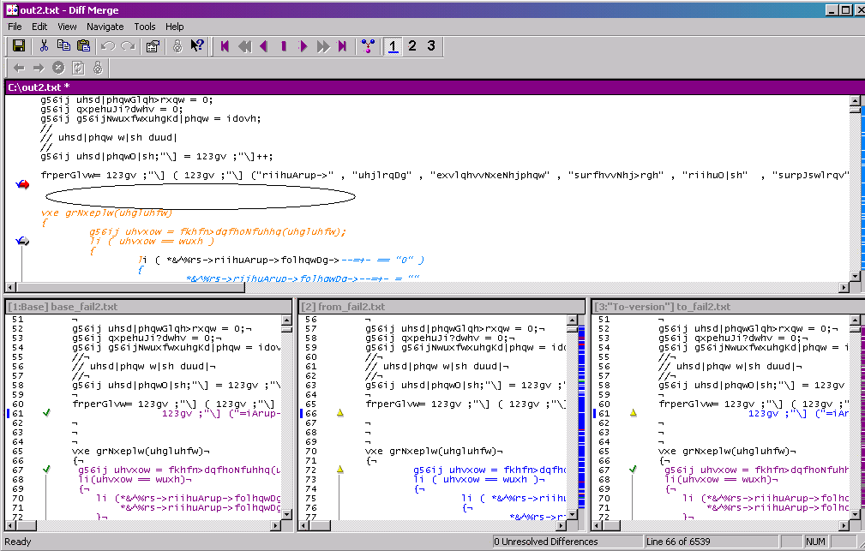

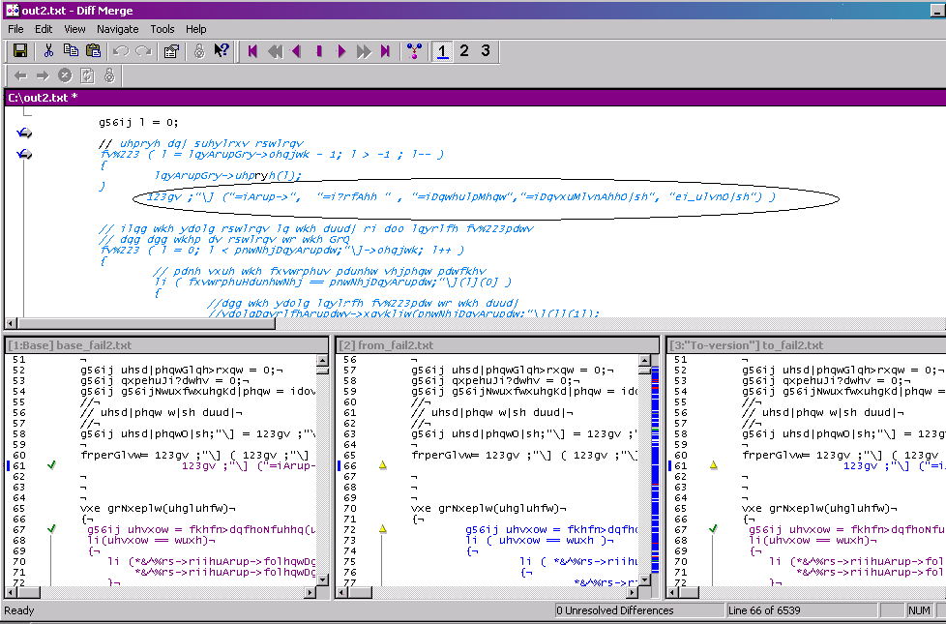

Unfortunately the incorrect merge was detected by the merging developer and the problematic merge was checked in. The usual compile after mergeing and some basic testing did not detect the problem and the problem made it undetected into the release code base.

Furtherm analysis of the problem shows that there is some connection with the filesize or the number of conflicts in the file. When all three files are shorten by a few thousend lines, the problem disappears and the merge behaves just as expected. The problem does not appear on UNIX.

C:\>cleartool merge -gra -base base2.txt -out out.txt from2.txt to2.txt

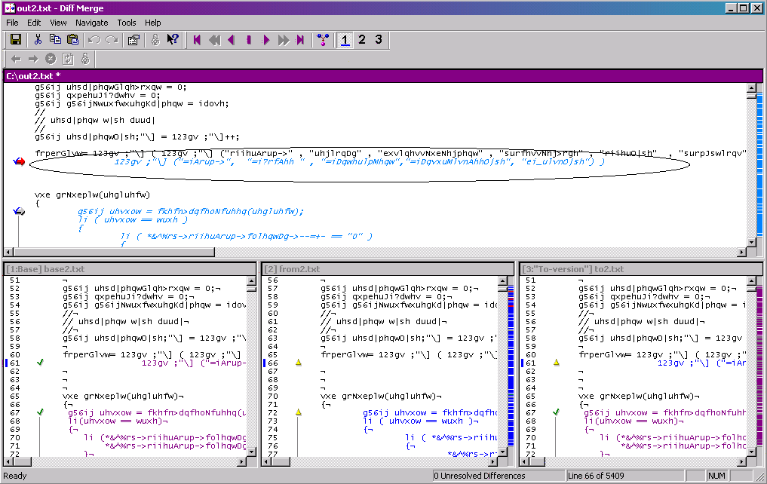

This project only recently moved from VSS to ClearCase and we went to a lot of effort to pitch CC. This problem unfortunately compromises all the work we spent in the past and discredits the tool.

Please let me know if you need some more information.

Tel: 00353 1 615-8033

Kind regards
Ralph

