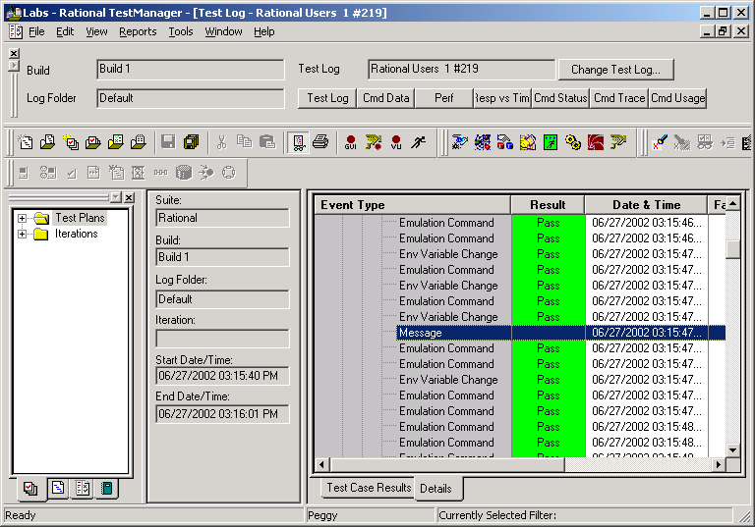

Right click on Message and select Properties:

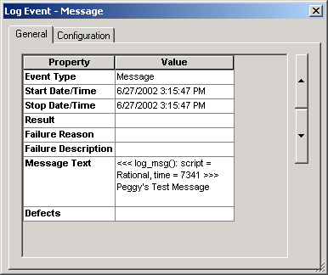

On the row that says Message Text, is the message written during playback. The command looked like this:

log_msg("Peggy's Test Message");

