Document ID: N/A

TITLE: Redundant instances of same model file listed in VS.NET Solution Explorer.
PRODUCT: Rational XDE
IDE/SHELL: VS.NET
OS: Windows XP and 2000
DEFECT #: RATLC 26595
PATCH #: N/A
REFERENCES: N/A
CREATED: 29-Jan-2002
REVISED: N/A

SYMPTOM:

Observed behaviors:
- Redundant Miscellaneous Files folders are displayed in the SE.
- Any newly created model is shown twice in the Miscellaneous Files folder(s) of the Solution Explorer (SE).
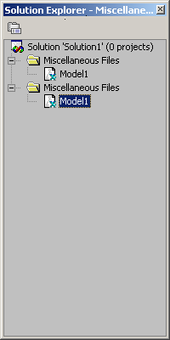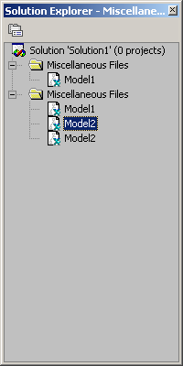

Expected behavior: There is only one Miscellaneous Files folder displayed in the SE. Also, for each model loaded in VS.NET, only one corresponding model file should be listed in the SE.

To reproduce:
- Open VS.Net.
- Navigate to Tools > Options...
- In the left pane of the Options dialog, select the Documents item in the Environment folder, and ensure that the Show Miscellaneous files in Solution Explorer setting is not enabled in the right pane.
If it is, disable it, and then click the dialog’s OK button.
- Create a new model and then check to see that the new model is shown in the SE under miscellaneous files.
- Navigate to Tools > Options...
- Select Documents item in Environment folder in the left pane of the dialog, and the enable Show Miscellaneous files in Solution Explorer. Click the OK button.
- Go to SE. Note that there are now 2 views of the Model file in the SE, each under an instance of the Miscellaneous Files folder.
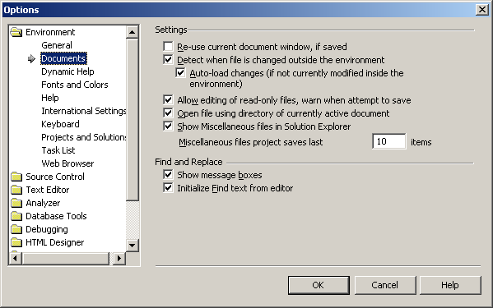

A related observation:
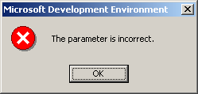
The error, "The parameter is incorrect", is displayed in an MS Dev Env message window after performing the following steps:
1. Go to the Model Explorer (ME), right-click on the model and then click Close.
(The ME window closes.) or in the SE, remove one of the instances of the model.
2. In the SE note that there is now only instance of the model file listed.
3. Attempt an operation. (For example, right-click on the remaining instance of the model entry, open the model, close the solution, or change the options.)
Note: The error above must be dismissed, and VS.NET closed, before the user is able to perform any further model operations, such as create or open.

CAUSE:

The user has done two things:
- created a model that is not associated with a project; and
- changed the ‘Show Miscellaneous file in Solution Explorer’ setting since starting this VS.NET session.

Background
When the user adds a model file to the solution without associating it with a project, XDE attempts to place the model directly under the current solution. If the Miscellaneous Files folder is not enabled/displayed in the SE, this activity causes a VS.NET crash. To get around this, the VS.NET Adaptor now intercepts and creates an instance of the Miscellaneous Files folder to hold the model in the current solution.

This means that there are now actually two instances of the Miscellaneous Files folder. One is the default VS.NET version, which is displayed only if the ‘Show Miscellaneous file in Solution Explorer’ setting is enabled. The other is the new VS.NET Adaptor version. At some level, these are managed as the same folder, but when the ‘Show Miscellaneous file in Solution Explorer’ setting is altered, the display behavior becomes unpredictable.

Scenarios

If the user starts VS.NET while the ‘Show Miscellaneous file in Solution Explorer’ setting is enabled, then the Miscellaneous Files folder is automatically displayed (by VS.NET). Any model the user creates that is not associated with a project will be placed in this folder.

If the user starts VS.NET while the ‘Show Miscellaneous file in Solution Explorer’ setting is disabled, then a Miscellaneous Files folder is displayed (by VS.NET Adaptor) only after the user creates a model that is not associated with a project. The new model is placed in this MF folder.

Trouble begins, in either scenario, when the user then changes the ‘Show Miscellaneous file in Solution Explorer’ setting during the VS.NET session, and then continues model development. (Problems are generally worse and more immediately noticeable after the user enables the setting.) The display behavior of the Miscellaneous Files folder, and any added models, is unpredictable, as are further operations on either.

DIAGNOSIS:

Ask user:
- Is there currently more than one view of the same model listed in the SE?
- Is there now or has there been more than one Miscellaneous Files folder shown in the SE in this VS.NET session?
- Has he altered the ‘Show Miscellaneous file in Solution Explorer’ setting since running XDE in this VS.NET session?
(For further information, determine the current setting by having the user perform these steps:
- Navigate to Tools > Options... to open the Options dialog.
- In the left pane of the Options dialog, select the Documents item in the Environment folder. In the right pane, is the Show Miscellaneous files in Solution Explorer setting enabled (have a checkmark). )
If the answer is yes to questions 1 and/or 2 and 3, proceed with short-term resolution to see if problem is resolved.

RESOLUTION:

Short Term Solution:

Have the user save and close the model, and then re-open it. Upon re-opening, there is one version of the model correctly listed in the SE.

There do not seem to be any negative, long-term side effects resulting from this problem. When the user saves the model, it is saved properly, and when the model is re-opened, there is only one version of the model in the SE.

Advise the user to avoid changing the ‘Show Miscellaneous file in Solution Explorer’ setting during development. Ideally, the setting is enabled. Ask all users to enable this setting once, and then leave it enabled. (The VS.NET Adaptor is not required to interfere when this setting is kept enabled.)

Long Term Solution:

Under investigation.

