Document ID: N/A

TITLE: Image list size affects ME display and model loading performance.
PRODUCT: Rational XDE
IDE/SHELL: VS.NET
OS: Windows XP and 2000
DEFECT #: Rose 77158/RATLC 26944 (Performance)
Rose 75489, Rose 75491, RATLC 26254 (Missing/wrong icons)
PATCH #: N/A
REFERENCES: N/A
CREATED: 30-Jan-2002
REVISED: N/A

SYMPTOM:

This technical note addresses two distinct symptoms:
- User application icons are missing from the Model Explorer (ME) or are incorrectly displayed in the ME.
(Example: Included here are two bitmaps, one showing the ME with some icons missing and others displayed incorrectly, and the second showing the same model displayed properly in the ME.)
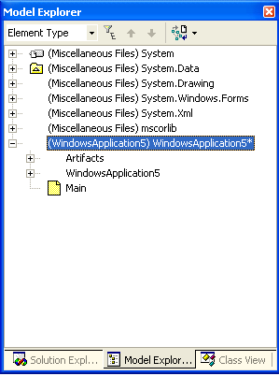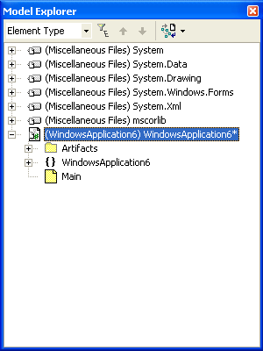

- Non-optimal performance observed when loading models in an application that requires few additional ME icons.

The user treats both symptoms by modifying the same registry entry.

CAUSE:

Symptom 1: Missing or incorrect icons - If the image list size is not adequate, such as might be true if the application adds more new icons than initially reserved for the image list. When the application attempts to use these additional images, access is unreliable and display results will be unpredictable.

Symptom 2: Poor performance in loading models in small applications - The IDE takes the time to load the entire image list. If the image list size is excessive for the application’s requirements, such as might be the case in a small application with few unique icons, model loading will be slower than necessary in that application.

Background
The icons used in the Model Explorer (ME) are added to the icon image list (a bitmap).
The number of unique ME icons managed by VS.NET correlates directly to the icon image list size, which is limited by the platform to 8K. Almost 150 entries in the list are reserved for use by VS.NET and the XDE, but the remaining portion can be allocated for user application icons.

At XDE start-up, the VS.NET Adaptor initializes the user portion of the icon image. By default, the number of entries that the VS.NET Adaptor reserves and initializes for the user application icons is 1500, but this number can be modified by the user through the registry.

Default VS.NET image list map:
Index | Number of Entries Reserved | Icon Owner
0-3 | 4 | VS.NET
4-133 | 130 | XDE
134-1634 | 1500 (default; can be changed to any value in range [200, 7500]*) | User (VS.NET Adaptor reserves space)
1635-7634 | 6000 | Reserved for user
7635 | 558 | Unallocated (reserve for buffer space)
* Internal note: technically, the VS.NET Adaptor allows values in the range [150, 8000], but display problems have been observed as the value approaches these limits. It is best to recommend that the user keep the value within the smaller recommended range.

DIAGNOSIS:

If the user reports either of the symptoms above, determine from the user:
- the current user icon image list size (see registry entry
HKEY_CURRENT_USER\SOFTWARE\Rational Software\RCSI\Adapters\VS.Net\IconlistSize)
- the approximate number of unique ME icons required by the models loaded in his application.

An application that requires many unique ME icons but is running with a small, insufficient image list size might suffer symptom #1. An application with few unique model elements that is running with an excessively large image list size might suffer symptom #2.

RESOLUTION:

User will update the following registry entry:
HKEY_CURRENT_USER\SOFTWARE\Rational Software\RCSI\Adapters\VS.Net\IconlistSize

The value of this registry entry is the number of entries in the icon image list reserved for user application icons. It can be set to any value in the range [200, 7500]. The default value is 1500. User interface and model loading performance improves as the image size is decreased, where optimal performance is achieved at values below 1000.

If the application is displaying incorrect icons in its GUI, or its GUI is missing icons, the user should increase the image list size using the above-named registry entry, and then restart the XDE. The degree of upgrade to the image size value should depend on the severity of the symptom: the more icons that are missing or incorrect, the greater the required increase. The user can continue to increase this size until the problem disappears or the maximum is reached.
NOTE: If the user has increased the size to the maximum value of 7500 and the symptoms persist, the user should report the problem again to technical support because there may be another problem.

To improve model loading performance in an application with minimal ME icon requirements, the user can make incremental reductions to the image list size as long as the appearance of the ME icons is not affected.

