This document describe the component model setup when including the Business Modelling Plug-In (RUP_Busmod) with RUP and MyPlugin

The goals is to produce a process/plug-in (MyPlugin) including content from RUP and BM

The used Models are:
RUP_2002_05_00
RUP_Busmod_2002_05_00
MyPlugin Model (Your model in RPW)

Scenario:
The goal is to provide a new version of the system_analyst Role
In the process model you derive from bm_system_analyst. (Picture a)
The business_process_analyst from BM should be included as is and the original requirement_specifier from RUP should be included.
All these are in the analyst role set.

When the modelling in the Process Model is done follow these instructions to setup the Component Model:

- Setup The component models as the diagram (picture b)
- Define a component in the MyPlugin component model: cust_analysts. This will replace RUP's analysts component
- Draw a dependency from cust_analysts to RUP::analysts. (Picture c)
- In this component, realize: (Picture d)
- MyPlugin_system_analyst,
- requirements_specifier from RUP
- business_process_analyst from BM
- Plus any other analyst roles you want.
- The thing to keep in mind is to make sure that the MyPlugin components realize all the wanted elements from BM & RUP, and that they replace the RUP components where necessary.

The end result should look like the diagrams/screen-dumps below.

a
The modelling in <<process model>> MyPlugin will look like this
Here all Roles Modified/Used are presented.
The Roles are presented without Activities for readability (Operations)

b
The Setup in the Component view should look like this

The name “MyPlugin (incl. Business Modeling)” is used so that when used with RUP-Builder the user will know that it includes the Business Modelling Plug-In, which makes sure that the BM Plug-In isn’t selected in RUP-Builder because it will cause conflicts.

MyPlugin can of course also be published directly from RPW, including the content from RUP, BM and MyPlugin

c
This is how the replacement of RUP’s component: analysts will look.

The above is true for all BM components that are referenced to RUP components.

Two Bm components (Displayed above) has no RUP reference and need to be referenced direct from the MyPlugin components if artifacts or disciplines in these components are replaced.

d
When realizing the different roles in the cust_Analysts component the end result will be:

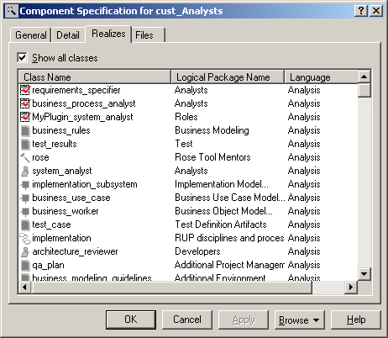

If there are questions regarding this example please contact Rational Customer Services.

