- For this example lets use one of your existing vobs- from here on out I will call it C-VOB. This is a base ClearCase vob
- Create new label in the C-VOB called IMPORT_BASE. NOTE: This label must be created as an ordinary type label in the C-VOB only. You can not use a Global label type from an Admin vob.
- Use the Apply Label Wizard to label the vob recursively with the IMPORT_BASE label. Make sure you are using a default config spec when you use the Apply Label Wizard.
- Confirm that the labels were placed correctly within the vob by navigating the directory structure and examining the version trees.
- Now go to the Project Explorer- Select Tools ➔Import Vob. Select the C-VOB as the vob to import.
- Now in Project Explorer select Tools➔Import Label. Select the IMPORT_BASE label.

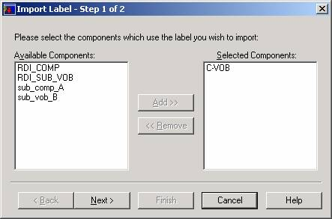

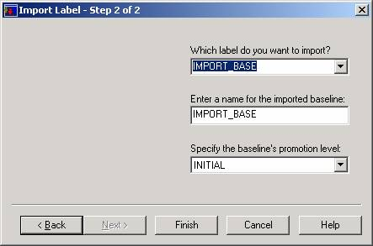

- Click Finish
- Now modify the configuration of the New projects integration stream to use the IMPORT_BASE label as the foundation.
- Right click on the projects integration stream and select properties

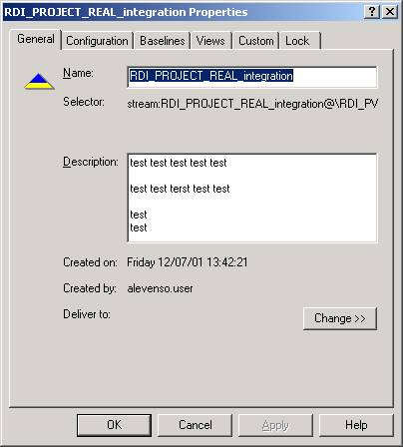

- Select the configuration tab

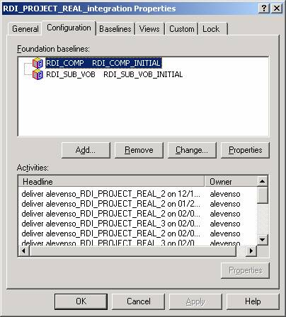

- Select the "Add" button

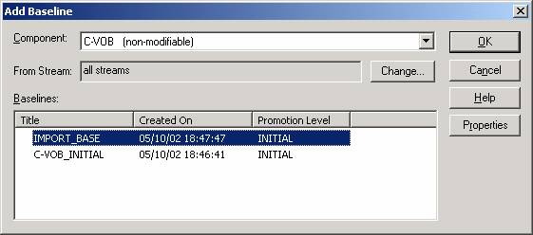

- Make sure you are selecting the C-VOB and then select the IMPORT_BASE label as the baseline. Click OK
- Now the C-VOB appears in the configuration list. Select OK
- You should then get prompted with a Rebase Stream Preview window

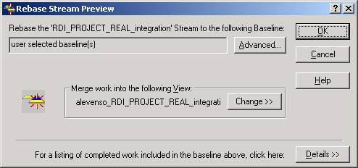

- Select OK
- A Rebase occurs

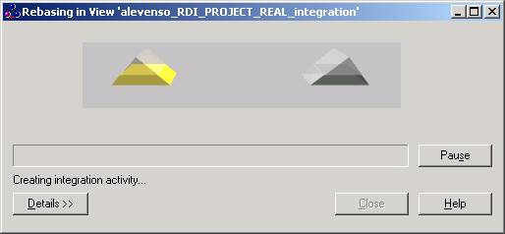

- Complete the rebase by selecting Complete. And then Select Close.
- Now right click on the Project and select Policies- Check the C-VOB to be modifiable.

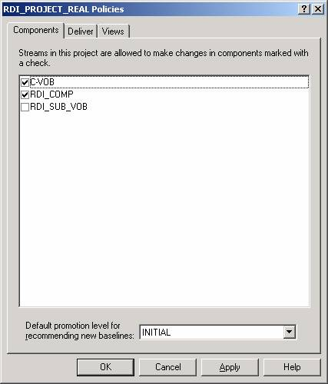

- Select OK
- Now right click on the Integration stream and select Recommend Baselines

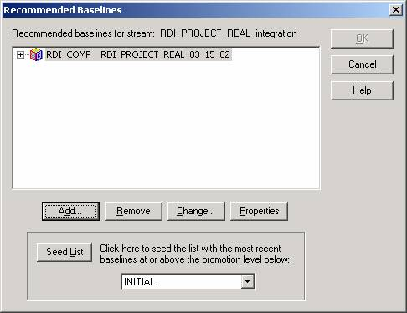

- Select "Add"

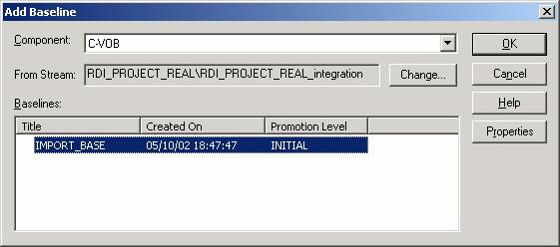

- Make sure the C-VOB is selected and the IMPORT_BASE label is selected and click OK.

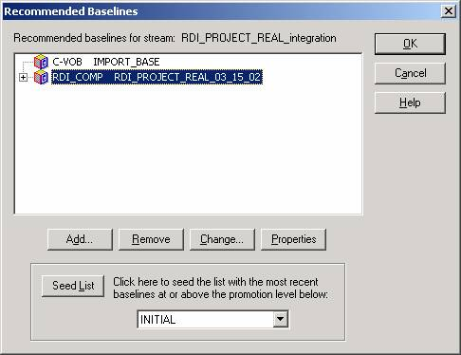

- Click Ok
- Now Join the Project and you should see your data!

