SQL Server 2000 Pricing and Licensing

Executive SUMMARY
Based on extensive input from customers, partners and analysts, Microsoft introduced a processor-based licensing model for Microsoft® SQL Server™ 2000 and other Microsoft .NET Enterprise Server products. This new licensing model was designed for customers building business-to-business, business-to-consumer and business-to-employee web-based applications. This hardware-based model has become standard in a web-based world where traditional measures of users or connecting devices are impossible or undesirable to track.
SQL Server 2000 also provides per-seat licensing as an option for customers using SQL Server in non-Web based scenarios.
This document explains key licensing considerations for SQL Server customers.

SQL SERVER 2000 Processor LicensING
Microsoft offers a processor-based licensing model to help alleviate complexity. Processor licenses can be used for any type of application (not limited to web-based scenarios).
Processor License – A processor license is required for each processor installed on each server running SQL Server or any of its components (e.g. Analysis Services). It includes access for an unlimited number of users/devices to connect from either inside or outside the firewall. Customers do not need to purchase additional Server Licenses or Client Access Licenses (CALs).
Processor Licenses are available in both Enterprise and Standard Editions and offer tremendous simplicity.

SQL Server 2000 Per-Seat Licensing
In addition to Processor Licenses, SQL Server 2000 continues to offer separate Server Licenses (in both Standard and Enterprise Editions) and per-seat CALs to customers using SQL Server in non-Web-based scenarios, as it did with SQL Server 7.0 and previous versions.
Server License - A server license (for either Standard or Enterprise edition) is required for every server on which that edition of SQL Server software or any of its components (e.g. Analysis Services) is installed.
Client Access License - A SQL Server Client Access License (CAL) is required in order for a device (e.g. a PC, workstation, terminal, PDA, mobile phone, etc.) to access or utilize the services or functionality of either edition of Microsoft SQL Server. A CAL is a device license and not a user license, so users with multiple devices need multiple CALs. Please see multiplexing section to ensure every device is licensed properly. The only exception is communication exclusively between SQL Servers.
A CAL is not software; it is a legal document granting a device access to server software. A single CAL grants access to multiple servers for one device (CAL must be same version as latest version of any of the servers). The following illustrates a scenario requiring two SQL Server licenses and three CALs deployed in the Per Seat mode:
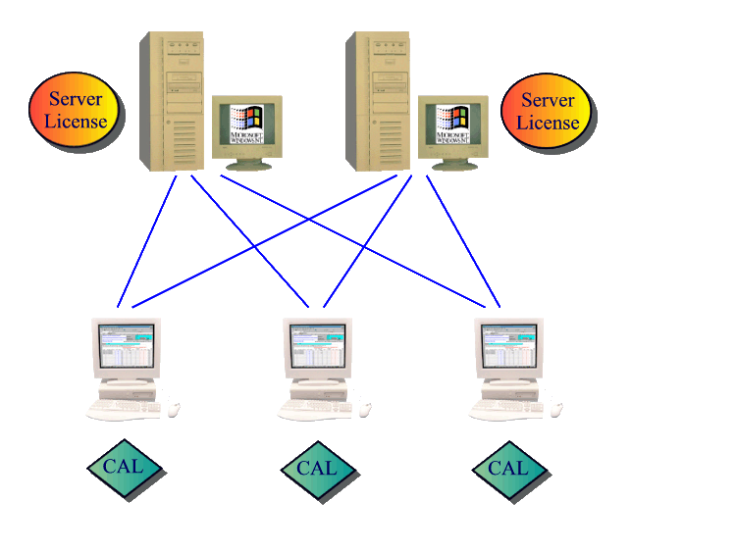

Multiplexing: Use of Middleware, Transaction Servers, and Multi-tiered architectures
Sometimes organizations develop network scenarios that use various forms of hardware and/or software that reduce the number of devices that directly access or utilize the software on a particular server, often called multiplexing or pooling hardware or software. For example, say a client PC is using a server application that calls the Microsoft Transaction Server (MTS) component of Microsoft Windows® 2000 Server on one server, which in turn pulls data from a Microsoft SQL Server database on another server. In this case, the only direct connection to Microsoft SQL Server is coming from the server running MTS. The client PC has a direct connection to the server running MTS, but also has an indirect connection to SQL Server because it is ultimately retrieving and using the SQL Server data through MTS. Use of such multiplexing or pooling hardware and/or software does not reduce the number of CALs required in order to access or utilize SQL Server software. A CAL is required for each distinct input to the multiplexing or pooling software or hardware front end. If, in the above example, 50 PCs were connected to the MTS server, 50 SQL Server CALs would be required. This is true no matter how many tiers of hardware or software exist between the SQL Server and the client devices that ultimately use its data, services or functionality.

clustering
One of the features offered by SQL Server Enterprise Edition is fail-over support when servers are used in a clustered environment. Two or more servers, each running SQL Server 2000 Enterprise Edition, can be configured such that if one server fails, its processing will be picked-up, recovered and continued by the other. This can be accomplished utilizing one of two configurations, known as Active-Active or Active-Passive.
Active-Active failover – In Active-Active fail-over clustering, two servers (sharing a common disc array) are each running one or more distinct SQL Server databases or SQL Server-based applications. In addition, they are configured such that if one fails, the database(s) or application(s) it is running will be continued seamlessly by the other. In active-active failover, both machines need to be fully licensed, and can be licensed using per-seat or per-processor licensing.
Active-Passive failover – In Active-Passive fail-over clustering, only one server is actively running one or more SQL Server databases or SQL Server-based applications at any one time. The other acts as a backup server, and is configured such that if the first server fails, the database(s) or application(s) it is running will be continued seamlessly by the other. In this scenario, only the active machine must be licensed. Disaster recovery servers are not covered by this exception.

MULTIPLE INSTANCES
SQL Server 2000 includes a multi-instancing feature which allows customers to install SQL Server more than once on a server. This is used in hosting and multi-application environments, for example. Customers using SQL Server Standard Edition must fully license each instance server (whether in per-seat or per-processor mode). Customers using SQL Server Enterprise Edition can install an unlimited number of instances on each machine without requiring any additional licensing.

Personal Edition
SQL Server Personal Edition is not a separate product, but instead a component of Microsoft SQL Server that is designed to bring SQL Server functionality to desktop applications. It can be installed and used on any Windows® device within an organization provided it is properly licensed with a CAL or connects to a server(s) that is properly licensed in Per-Processor mode.
If SQL Server Personal Edition interfaces with a SQL Server, and then distributes that data to other devices, it is acting as a mutliplexer and SQL Server CALs are required for all devices accessing it. Customers who have licensed their SQL Server in Per-Processor mode can have an unlimited number of connections to that server, whether it be through SQL Server Personal Edition or through direct connections.

developer Edition
SQL Server Developer Edition is a separate product and is used for development and testing purposes only. It is licensed per developer (person).

windows ce Edition
SQL Server Windows CE Edition is available for download by each person/developer who has purchased SQL Server Developer Edition. When Windows CE Edition is deployed, each device that connects directly or indirectly to a SQL Server must have a SQL Server CAL license (unless the SQL Server is licensed in Per Processor mode).

Microsoft data engine (MSDE)
MSDE is a data engine available through various Microsoft products including SQL Server Developer Edition, MSDN Universal, and Visual Studio .NET, and is 100% compatible with Microsoft SQL Server. MSDE can be used in conjunction with any these products, or on a stand-alone basis without requiring any Client, Server or Processor Licenses.
However, when a customer is licensed in per-seat (vs. per-processor) mode, and the client device uses MSDE to access or use the services of SQL Server, a CAL must be acquired for that device.

evaluation Edition
SQL Server Enterprise Evaluation Edition is for evaluation purposes only and for up to 120 days of use. It is downloadable for free or orderable via CD from the Microsoft.com website.

downgrade rights for previous versions
Customers can acquire SQL Server 2000 licenses and run prior versions of SQL Server per downgrade rights outlined in the EULAs (license agreements). Licenses can be added to existing prior version installations with this same method.

upgrades and Software assurance
Customers can choose to upgrade their SQL Server licenses by purchasing the new product outright, by purchasing Software Assurance for current version licenses to guarantee future version upgrades, or by purchasing Upgrade Advantage by July 2002 to upgrade to SQL Server 2000 from a previous version.

PRICING AND DISCOUNTING
SQL Server offers highly competitive Estimated Retail Pricing (ERP). Further, Microsoft has several options for customers making volume purchases to realize significant discounts off ERP. Many ISVs, ASPs, and OEMs also have an arrangement with Microsoft to offer attractive discounts on SQL Server to their customers.

For More Information
For more information, go to www.microsoft.com/sql/howtobuy for Answers to Frequently Asked Questions (FAQ), Estimated Retail Pricing, Sample End User License Agreements (EULAs), and much more Additional Information and Details.

This document is for informational purposes only. MICROSOFT MAKES NO WARRANTIES, EXPRESS OR IMPLIED, IN THIS DOCUMENT. Microsoft and Windows are either registered trademarks or trademarks of Microsoft Corporation in the United States and/or other countries.

