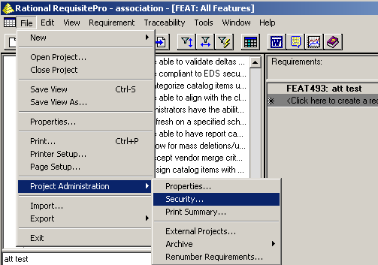

- Place the email address information for the users in RequisitePro\Project\Security.

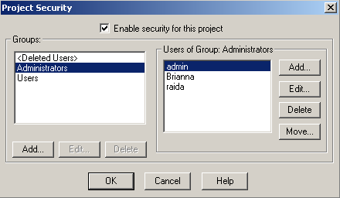

- Select the appropriate user from his\her user Group.

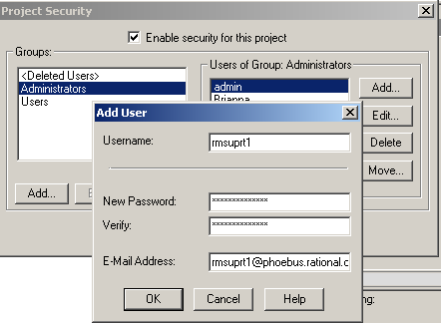

- Ensure the user's proper email address is included. (The email address includes the server name and the rational domain, as displayed in the screen shot above.)
- Follow this step for each "rmsuprt" user added to the project.
- Now, the mailreader.exe must be configured. Please review the subsequent screen shots for the mailreader.exe. The mailreader.exe is found in the common directory under Rational in Windows Explorer.

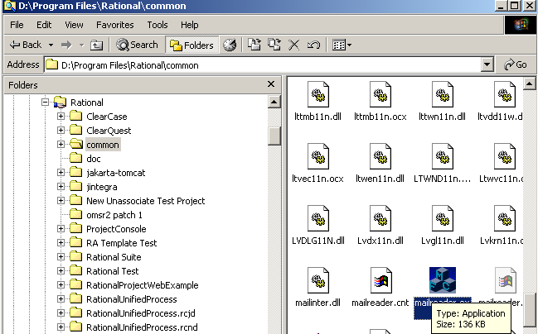

- Select the mailbox in the mailreader.exe

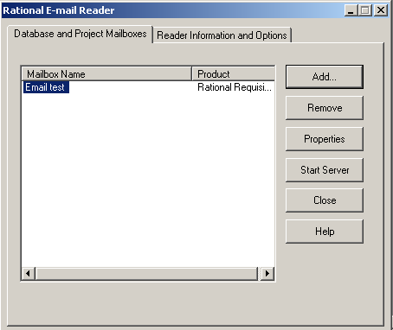

- Select the Properties option.
- Ensure SMTP is the protocol which is selected.
- Provide the SMTP Server and POP server as seen below.

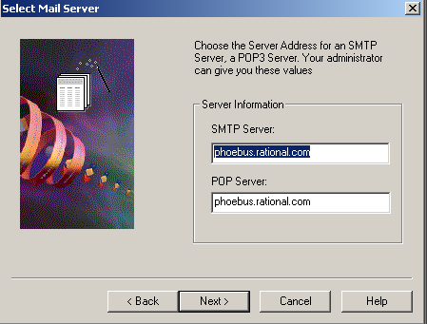

- Now provide the POP email address. As seen below, the email address is the fully qualified email address (i.e. rmsuprt1@phoebus.rational.com). The password is 1rmsuprt. This login is the NT Login.

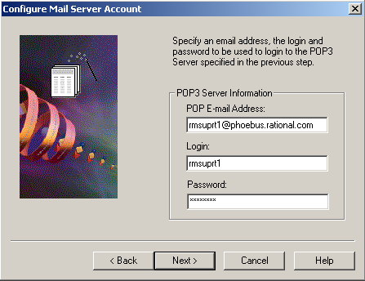

- Choose RequisitePro as the Email Handler, and navigate to the .rqs file for the RequisitePro project by selecting the Configure option.

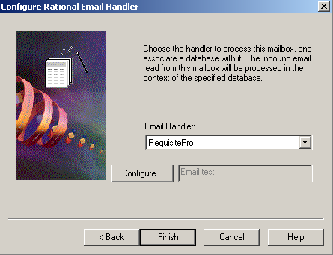

- Provide the login for the account that was created as a dummy account in the RequisitePro project.

