Here’s a history browser with the window sections resized so that the main history information is not visible.
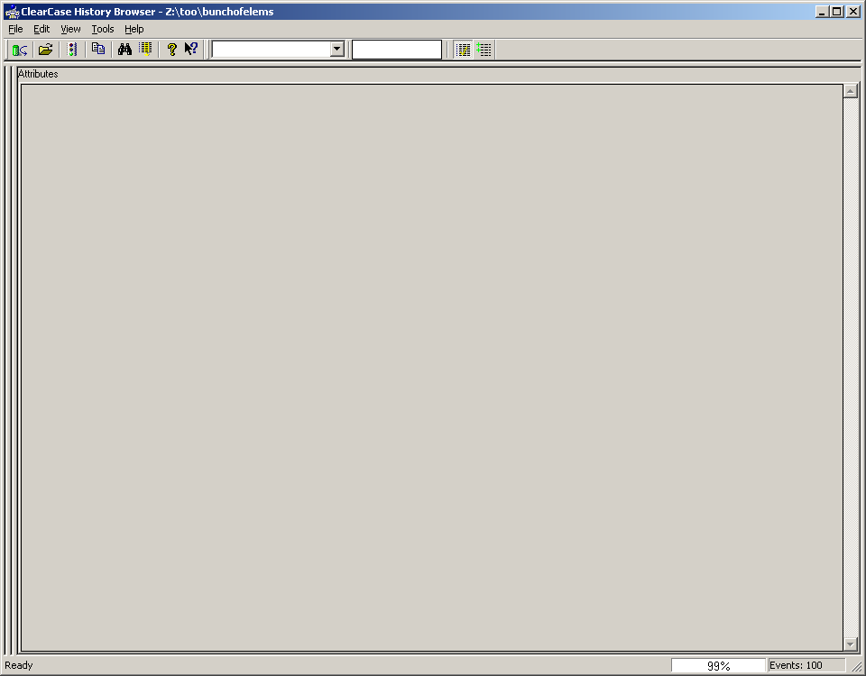
And here’s the same window after resizing the sections again so the history section is visible.
