There are two areas of the test datastore that need to be modified.
1. The .RTXML files associated with the Test Case.
2. The Case_Inputs table in the database.

1. Modifying the Test Case .RTXML files:
These steps must be repeated for each incorrectly marked Test Case.

a. Find the directory associated with the Test Case Folder that contains the Test Case. This directory will have a path similar to:

<project dir>\TestDatastore\TMS_TestPlans\<Test Plan Name>.TestPlan\<Folder Name>.CaseF\...

More than one level of Test Case Folder may have to be traversed to get to the desired Test Case.

An example:
To find Test Case “a” in “Test Plan 1” below.

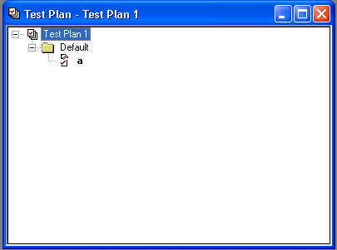

Look in:

C:\Datastores\project1\TestDatastore\TMS_TestPlans\Test Plan 1.TestPlan\Default.CaseF

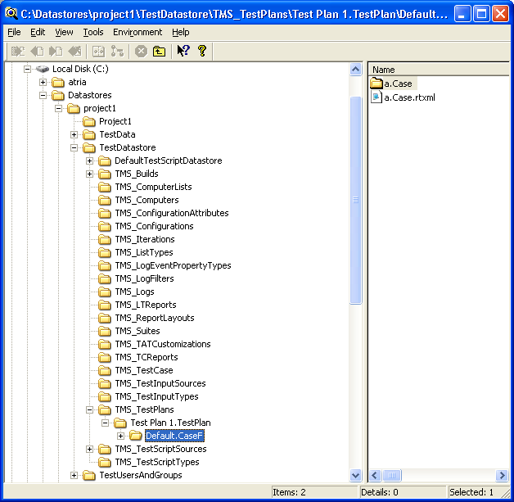

b. Locate the Test Case .RTXML file. In the Test Case Folder’s directory there will be a file named <Test Case Name>.Case.rtxml

In the example above, the file is named “a.Case.rtxml”

c. Edit the .RTXML file. This can be done using a text editor such as Notepad. Find the following line in the file:
<Suspect><![CDATA[1]]></Suspect>

Replace the 1 with a 0 so the line reads:
<Suspect><![CDATA[0]]></Suspect>

The <Inputs> section of the file must also be updated.
If this problem was caused by a TestInput having been deleted, then delete the entire <Inputs> section. This includes everything between and including <Inputs> and </Inputs>.

The following is an example – it is referencing “Feature x” in ReqPro:

<Inputs><![CDATA[86cdedaf-2512-4a7d-99f6e2dc34a356a7]]>
<Source Name="{468E7831-CD31-45FB-BC91-ECDC2A27D3F5}" Operator=""><![CDATA[]]></Source>
<External Name="1" Operator=""><![CDATA[FEAT2 Feature x]]></External>
</Inputs>

If the TestInput was not deleted, then the <Inputs> section should be preserved. To only remove the suspicion marking change the External Name="1" string to External Name="0" in the <Inputs> section.
**Note, this needs to be done for all TestInputs listed in the Test Case.

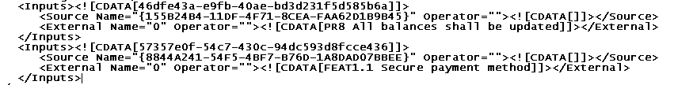

2. Cleaning the CaseInputs table:
Use the datastore utility’s dbpopulate command to reload the database with the cleaned-up TestCases.

