FOR INTERNAL USE ONLY

Symptom: After upgrading to a new release of XDE, diagram references to unnamed model items supplied by the reference models are broken. Only customer diagrams that contain associations (generalizations and realizations for example) from the reference models will be effected. In the example below the generalization from Class1 to Object will not be broken since that generalization is contained within the user's model. The relationship between ArrayList and Object will be broken since this relationship is in mscorlib, one of the supplied reference models.

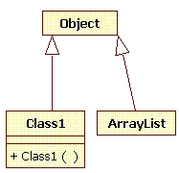

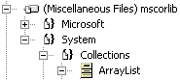

Cause: Reference models were released with new model ids (GUIDs) which causes references to unnamed model elements to be broken. Classes are named but relationships are not named.

Resolution:

To get around the problem follow these steps.

1) Open the solution for the existing model (created in a previous release of XDE) in the new version of XDE.
2) Open the model and follow the directions in any upgrade dialogs.
3) Save all
4) Find the broken references in the models by selecting the model node, right click, choose "Validate"
5) On the diagram for the model, select the model elements that have broken references.
6) Right-click and select "Add/Remove Connectors" from the context menu.
7) In the Add/Remove connectors dialog select "Add All"
8) Click OK

This should add valid connectors back into the diagram. However, the broken references will still be on the diagram.
The user should then remove the broken references.

If the model is validated at this point it should be successful.

NOTE: The "Add/Remove Connectors" action will add *all* of the connectors for the selected model elements. The user will then have to remove
any connectors which they may deem redundant.

FOR INTERNAL USE ONLY

