Clicking the “click here” hyperlink to view details of the failed operation generates the following runtime error:

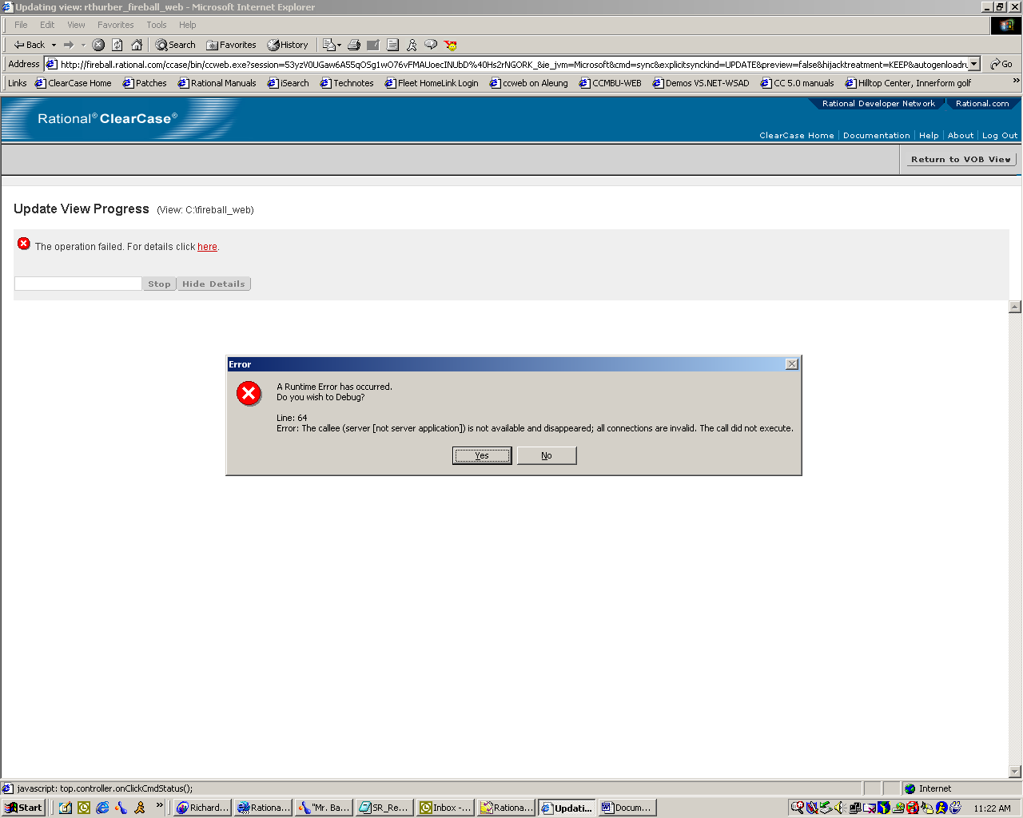

Check for a program called ‘NoAds’, or similar, installed on the workstation and disable it. Disabling the program will allow the correct details information window to be displayed as seen below:

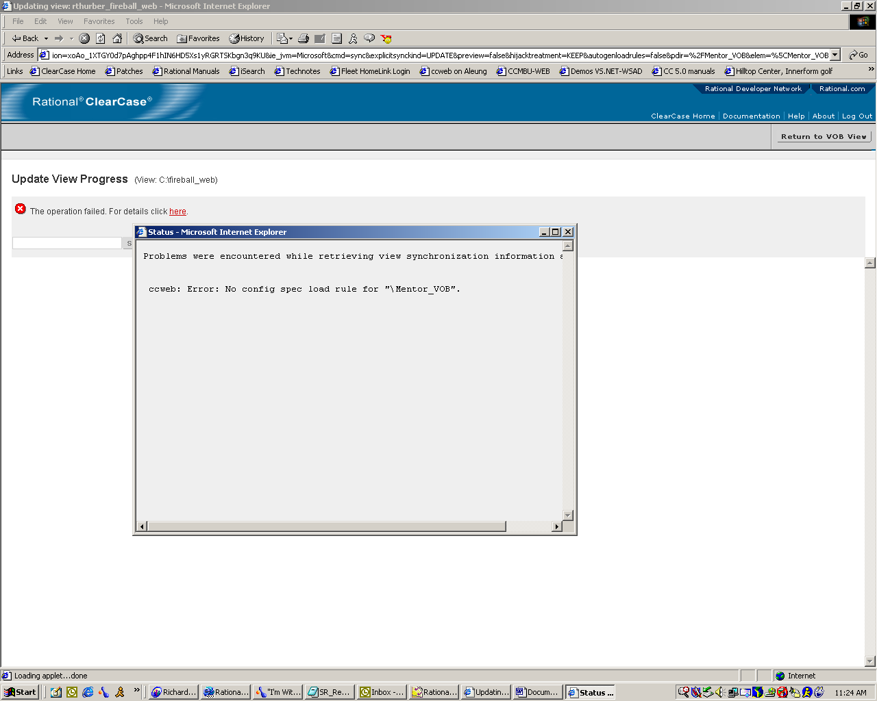

NoAds is a freeware program that stops Internet popup ads from appearing while using a web browser. As such, NoAds will sometimes stop necessary popup windows from appearing. These programs are not supported with the use of ClearCase Web and Rational Web Platform (RWP).

For more information on NoAds and other popup software programs, please refer to information as found by using an Internet search tool such as Google or Yahoo.

