Clicking ‘Browse’ to view the available View Profiles generates following error:

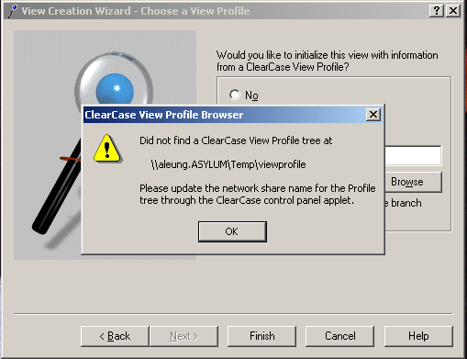

Check ClearCase Control Panel (Start > Settings > Control Panel > ClearCase) setting for the View Profile Tree location path:
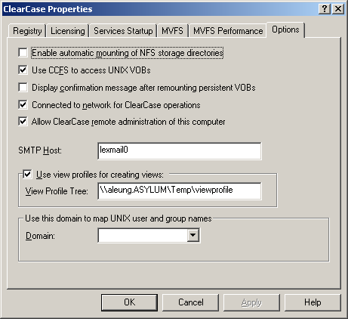
Including the domain name of the machine is not necessary - removing the domain name from the path will clear the error and allow the user to browse for the view profiles in the correct location.

