Solution: 142189567
How to verify that the latest patches for SoDA/Word 2002.05.20 have been correctly installed.

__________________________________________________________________
To verify that the latest patches have been applied to the system the following files need to be checked. Verify that the correct Module Version and Modified date is listed.

In the %Rational Home%\Common\ directory the following updated files should be verified:

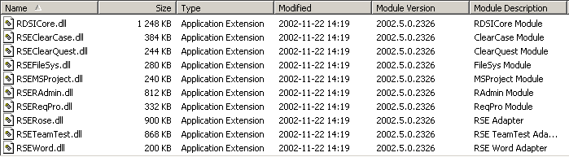

In the %Rational Home%\SoDA Word\ directory the following updated files should be verified:

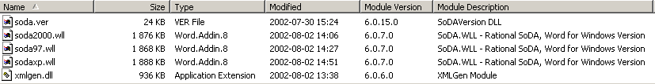

The directory %Rational Home%\soda word\domains\RDSI\ should have one updated file:

TeamTest.als, which should have the creation date: 19 June 2002, 16:43:52

