QUESTION: How to model instantiated classes with the Rational Rose Visual C++ add-in.

ANSWER:
Case A.
If one desires to model the following source files with the VC++ add-in:
//----------------------------------------------------
//MyTemplate.h
template <class T> class MyTemplate{};
//----------------------------------------------------
//----------------------------------------------------------
//MyInstantiated.h
#include "MyTemplate.h"
class MyType;
typedef MyTemplate<MyType> MyInstantiated;
//------------------------------------------------------------
//------------------------------------------------------------
//MyClients.h
#include "MyInstantiated.h"
class MyClient1: public MyInstantiated{//this client needs to inherit
};
class MyClient2{
private:
MyInstantiated the_MyInstantiated;
//this client uses the instantiated class as a class attribute
};
//-------------------------------------------------------
one should proceed as follows:
1. Create a parametrized class "MyTemplate" with the formal parameter "T" of type "class"
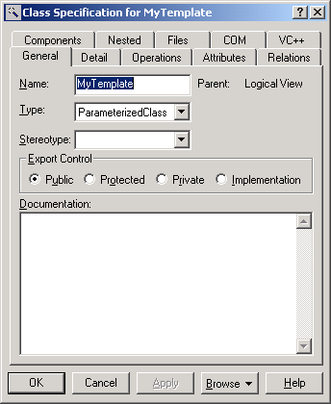
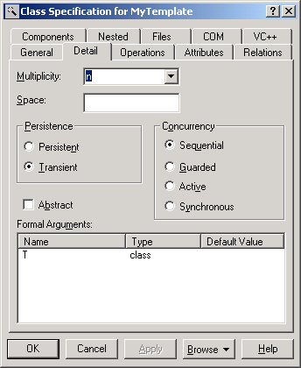
2. Create a normal class called "MyInstantiated", with stereotype <<typedef>>. Make sure that is NOT an InstantiatedClass (or the ModelAssistant will not open) and that it has no Instantiates relationships towards the ParametrizedClass. Right click on the class “MyInstantiated” and browse to the Model Assistant, you'll see in the typedef tab that the ImplementationType is set to:
typedef <TYPE> MyInstantiated;
replace <TYPE> as to get the following text:
typedef MyTemplate<MyType> MyInstantiated;
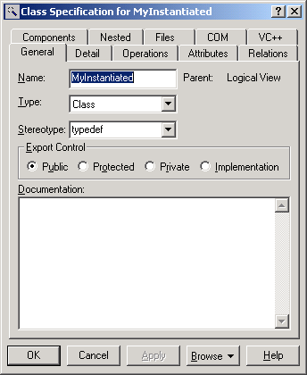
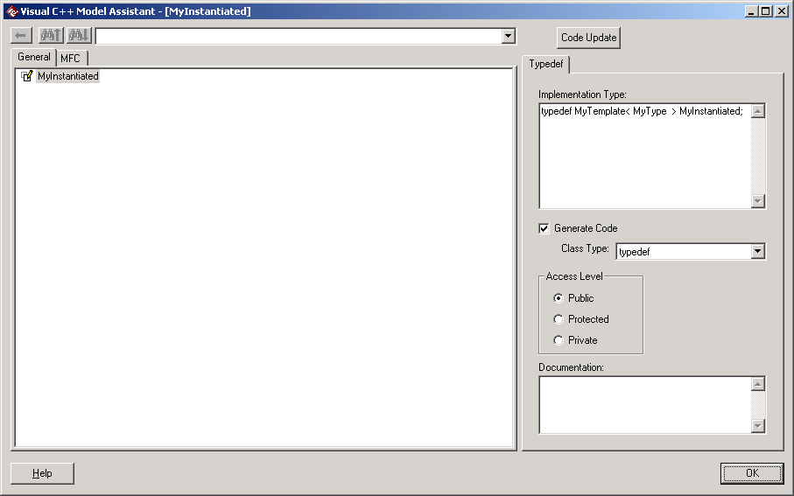
3. Draw a dependency from MyInstantiated to MyType and Mytemplate to generate the needed include statements in MyInstantiated.h. Note that the dependencies alone would generate forward declarations in MyInstantied.h. It turns out that for the template a forward declaration is not enough: the inclusion header file is required by the compiler.
To force the generation of the include of the MyTemplate.h, open the Properties menu of the component that realizes MyTemplate. If MyInstantiated is also realized by the same component, then go to the Internal Map tab. Otherwise go to the Extarnal Map tab.
Add the following:
Class: MyTemplate
FileName: AUTO
Location: Header
In the properties menu of the component that realizes MyType (Internal or External Map tab as needed) add the following:
Class: MyType
Filename: AUTO
Location: AUTO
In the following screenshot, all files were mapped to the same component “a”, so all properties were set in the Internal Map tab of said component:
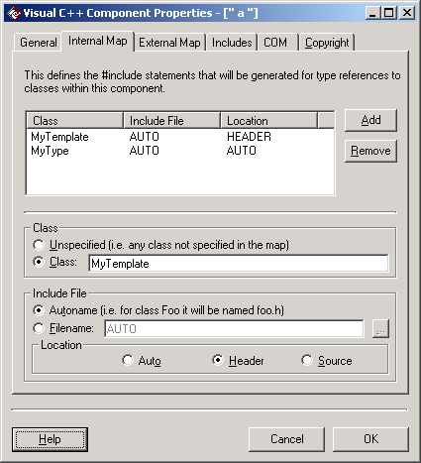
4. Use MyInstantiated as any other class: as inheritance supplier, as attribute type, as operation parameter or return type etc.
Case B.
If the desired code is like this (without using any typedef) :
//----------------------------------------------------
//Mytemplate.h
template <class T> class MyTemplate{};
//----------------------------------------------------
//----------------------------------------------------
//MyClients.h
#include "MyTemplate.h"
#include "MyType.h"
class MyClient1: public MyTemplate<MyType>{
//this client needs to inherit from the instantiated class
};
class MyClient2{
private:
Mytemplate<MyType> the_MyInstantiated;
//this client uses the instantiated class as an attribute type
};
//----------------------------------------------------
then the model should be created like this:
- Create a ParametrizedClass "MyTemplate" with the formal parameter "T" of type "class"
- Create an InstantiatedClass with name: “MyTemplate<MyType>”
- Actual parameters in the Detail Tab are ignored for code generation
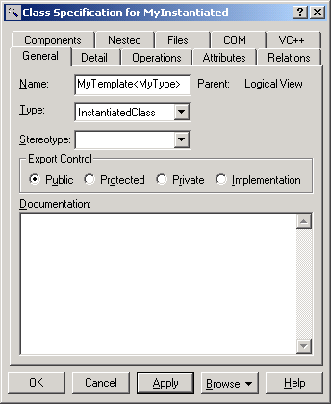

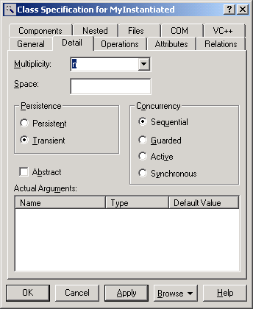
- Draw an Instantiates relationship from “MyTemplate<MyType>” to “MyTemplate”
- Draw any needed relationships from client classes to “MyTemplate<MyType>”. The correct #include statements are generated, for both the ParametrizedClass and the actual arguments.
Rational Customer Service Policies and Information: http://www.rational.com/support/info.jsp

