Rational Rose 2003.06.12 Hot Fix 1 Release Notes
March 2004

© Copyright IBM Corporation. 1992, 2004. All Rights Reserved.
Any reproduction or distribution of this work is expressly prohibited without the prior written consent of IBM Corporation.
Legal Notices Information

Scope
This Hot Fix updates the Rose release as described below.

Hardware/Software Information
Hardware / Software requirements for this Hot Fix are the same as those described in the installation Guide for Suites v2003.06.00.

Getting Started
In addition to the instructions provided in the "Getting Started" section of the Rose 2003.06.00 Release Notes, please review the following information new in this Hot Fix for Rose 2003.06.12:

Installation Information
Prerequisite

Licensing
No licensing changes are required when installing this Hot Fix.

Installation Instructions
Note: [Release_Location] is the Rational Products installation directory. This is typically "C:\Program Files\Rational".
- Rose 2003.06.12 must be installed prior to installing this Hot Fix.
- Backup (rename) the files “Files Updated in this Hot Fix” (if they exist).
- Place the following files in a temporary directory:
  - Rose_2003r2_HotFix_1_02.29.2004.exe
  - install_Rose_2003r2_HotFix_1_02.29.2004.bat
- Run install_Rose_2003r2_HotFix_1_02.29.2004.bat
The following preliminary information will display – press Enter to continue:
========================================
Rose 2003.06.12 Hot Fix (1)

Product: Rose Enterprise
Installs and Registers
Rose 2003.06.12 Hot Fix 1
%TEMP%\Rose_2003r2HF1_HOTFIX_ERRORLOG.log
will include a listing
of any errors encountered while
installing this Hot Fix.
Contact Rational Technical Support if
you encounter any Installation Errors.
========================================

Installing Rose 2003.06.12 Rose Hotfix(1)…
- The “WinZip Self_Extractor” dialog will display. Select “Unzip”.
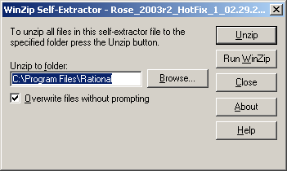
You will see the following message box, Select “OK” and then Select “Close” in the original “WinZip Self_Extractor” dialog (see, above).
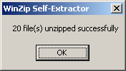
In the Command Prompt Window you will see a messages and message boxes (see below) as each Add-In included in this Hot Fix is registered. Select “OK” to each message box.
Registering Rose Visual C++ Add-In
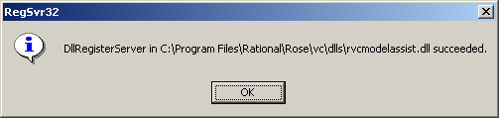
Registering Rose J Add-In
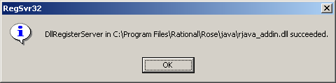
Registering Rose Version Control Add-In
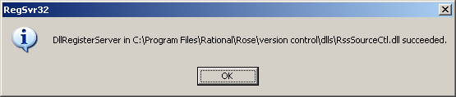
Registering Rose ANSI C++ Add-In
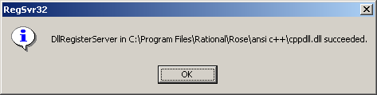
Registering Rose ClearCase Add-In
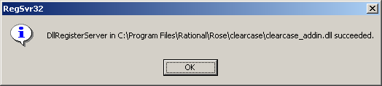
Registering Rose Data Modeler Add-In
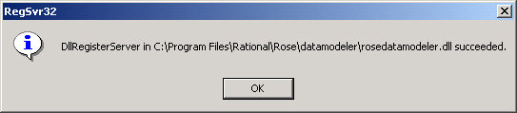
Select “OK” to each message box, above.
- You will then see a message in the Command Prompt Window indicating that the Hot Fix was successfully installed:
Removing %TEMP%\ Rose_2003r2HF1_HOTFIX_ERRORLOG.log
=========================================
Rose 2003.06.12 Rose (Hot Fix 1)
Successfully Installed
=========================================
Press any key to continue . . .
If you encounter any errors during the installation of this Hot Fix, refer to the error log:
%TEMP%\Rose_2003r2HF1_HOTFIX_ERRORLOG.log which will include a listing of the errors. If no errors were encountered, this file will not exist.

Product Documentation
Documentation for Rational Rose is available on-line at http://www.rational.com/support/products/rose.jsp

Compatibility Issues
This section describes any compatibility issues that could arise from use of this Hot Fix.

With Rational Products
This Hot Fix does not introduce any compatibility issues with other Rational products.

With Third-Party Products
This Hot Fix does not introduce any known compatibility issues with third-party products.

Defects and Changes

Core Rose Defects Fixed in this Hot Fix
Defect | Description
RATLC00053047 | The use of Rose Data Modeler can cause the manual loading of the controlled unit to crash Rose.
RATLC00213154  RATLC00245211 | Rose 2003 fix for defect RBU 66331 has created side effect.  Classes with the “Automatic resize” option, become too wide.
RATLC00244424 | A Statemachine cannot be moved back to its original location.
RATLC00244435 | Incorrect object flows are being created even when object flow cannot be pasted in the context.
RATLC00244458 | Undo deletion of unresolved transition to self and nested activity may cause Rose to crash.
RATLC00244591 | Move Creation Message over an object message will loose focus of control and cause the numbering is wrong.
RATLC00244602 | Move Message to the top of the Object's focus of control results in double lined focus of control.
RATLC00244630 | Transitions cannot be dragged from browser back to Statechart diagram.  Workaround: Use Menu Item Query / Filter relationship to add those views of the transitions back onto the diagram.
RATLC00244634 | The Ambiguous Name Dialog should not display again after the user applies changes and clicks “OK” in the Specification dialog. When the dialog displays again the second time, whatever the user chooses this time will overwrite what was chosen previously.
RATLC00244640 | The Ambiguous name dialog box should display when user cancels the changes via the "X" button.
RATLC00244646 | Renaming a self-transition on an activity and then performing a copy / paste may cause Rose to crash.
RATLC00244649 | Creation Object not shifted down after copy and paste.
RATLC00244659 | Decision should not allow self-transition.
RATLC00244678 | Deleting the upper Object Message may cause the lower return message focus of control to be missing.
RATLC00244754 | Creation Message to Object will generate incorrect sequence number.
RATLC00244769 | Pasting Activity with Transition to Self may crash Rose.
RATLC00244703 | Pasting after undoing delete from model may cause Rose to crash.  Side effect of fix: When you place the mouse cursor on a nested vertex whose parent is unnamed, you will see a tooltip like “#9A234BD1” instead of “#1”.
RATLC00244772 | Rose may crash when deep-deleting Objects connected by Link Message with Data Token.
RATLC00244774 | Link Message numbers on Collaboration Diagram are not refreshed correctly after performing a copy and paste. In this case, the Link Message numbers may have other characters overlapping on top of them.
RATLC00244868 | Pasting nested state on Statechart diagram may cause errors to occur and Rose to crash.
RATLC00245010 | Stereotype icon does not display correctly, when the class reference is missing. In this case, the object becomes very small and the actor icon doesn’t get displayed as the class referenced is missing.
RATLC00245112 | Duplicate transition is created after renaming and pasting activities.
RATLC00453391 | Edited Model Properties do not persist upon closing and opening model.
RATLC00245493 | Unnamed nested decision view may not be resolved after performing copy and paste.
RATLC00245373 | New operation on link message will create a new link message instead.
RATLC00245394 | Cannot delete entries in the specifications files tab
RATLC00245549 | Rose may crash when deleting EJB operations.
RATLC00245611 | Unable to drag and drop nested transition from browser to diagram.
RATLC00452390 | When loading a model created by Rose 2001A-I, classes and relationships may overlap and not display correctly.
RATLC00452912 | Upon loading a Rose 2001A model, the Sequence Diagram message name may not display completely.

Rose ANSI C++ Defect Fixed in this Hot Fix
Defect | Description
RATLC00049551 | Incorrect source code generated in body file if operation’s return type is a nested class.
RATLC00245182 | No #include generated for dependency if BodyReferenceOnly=True and the body file has already been generated once.

Rose C++ Defect Fixed in this Hot Fix
Defect | Description
RATLC00245208 | Rose C++ Namespace fix to allow the method signature for the body to be generated without the fully qualified name.

Rose ClearCase Add-In Defect Fixed in this Hot Fix
Defect | Description
RATLC00245441 | After performing an undo checkout (from Rose, utilizing Rose / ClearCase integration), Rose is unable to determine the object has been unchecked-out in version control (ClearCase)

Rose J Defects Fixed in this Hot Fix
Defect | Description
RATLC00244126 | Changing local interface to remote interface doesn't detect invalid *CMR. No warning message is written into the Rose log.
RATLC00244670 | Multiple Getter / Setter operations could be created when undeleting CMR association.
RATLC00244709 | Multiple CMR's on bean are not imported when reverse engineering.
RATLC00244865 | Getter / Setter methods are not created in Remote Interface.
RATLC00244866 | Removing Navigable on a CMR does not remove Getter / Setter methods correctly.
RATLC00244867 | No warning displays when changing visibility of an invalid CMR.
RATLC00245097 | Unable to reverse engineer XML file that does not have rolename specified. The rolenames in Rose should follow the CMR-field name in the XML file.
RATLC00245234 | Messages in relation to “Invalid CMR’s” are now written to the Rose log, rather than displaying a pop-up dialog.
RATLC00245457 | The EJB naming convention setting gets lost when reloading the model.
RATLC00245549 | Rose crashes when deleting EJB operations.
RATLC00438022 | Japanese comments may become corrupt.
RATLC00453151 | Setting "boolean" as the return type of a method does not persist. As shown in the Specification dialog, the return type is changed to "Boolean".

*CMR = Container Managed Relationship

Rose Data Modeler Defects Fixed in this Hot Fix
Defect | Description
RATLC00245131 | Rose Data Modeler may generate the wrong column name when forward engineering.
RATLC00245447 | Deleting the Primary Key on the specification does not delete Foreign Key in dependent tables, and may cause Rose to crash.
RATLC00245631 | Addition of context menu option to allow user to enable or disable Rose Data Modeler Name Shortening feature for each Schema (see “To Disable Rose Data Modeler Name Shortening Enhancement” below). In some cases, the view could become corrupt after forward engineering when using the Rose Data Modeler Name Shortening feature.

To Disable Rose Data Modeler Shortening Name Enhancement

A new menu option “Shorten Name Engine” is available on the Schema Data Modeler context menu, in the browser. By default, you will notice that the “Shorten Name Engine” is enabled (the “√” appears directly before “Shorten Name Engine”) on the context menu. The “Shorten Name Engine” option can be enabled or disabled per Schema.

All users working on the same model should use the same “Shorten Name Engine” option applied to the Schema, in order to avoid potential code generation differences.

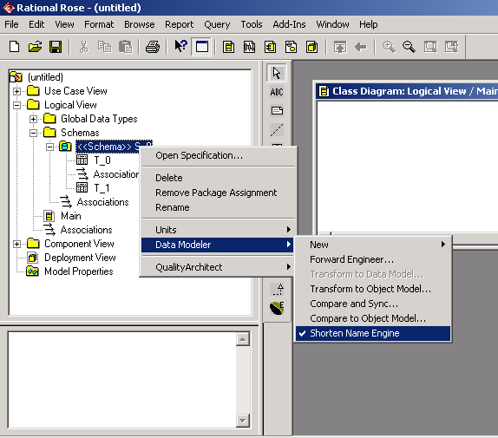

Select Data Modeler > Shorten Name Engine (from the browser context menu for a specific Schema). The √ will no longer appear in this context menu and the “Shorten Name Engine” will be disabled.

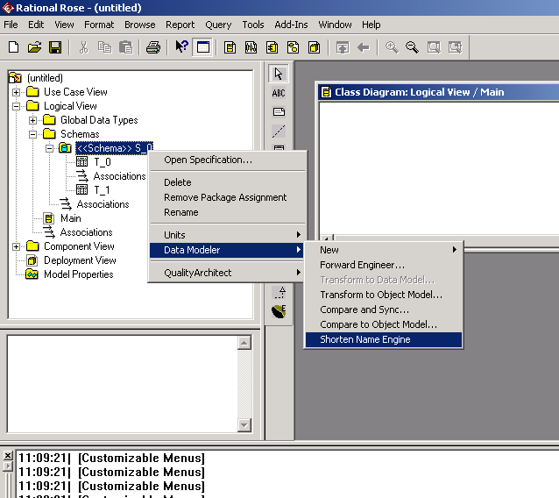

To again Enable the Shorten Name Engine, right click on the appropriate Schema and select Data Modeler > Shorten Name Engine.

Once “√” precedes “Shorten Name Engine” in this context menu, this feature is enabled.

Rose Version Control Add-In Defect Fixed in this Hot Fix
Defect | Description
RATLC00239120 | LpAuxProjPath is not passed back to the Source Code Control Provider, which does not allow correct communication between Rose and source code control provider.

Rose VC++ Defect Fixed in this Hot Fix
Defect | Description
RATLC00244131 | Model assistant may crash after creating attribute "m_First" after then adding attribute with format of “:m_<string>First” for the same class.

Files Updated by this Hot Fix
[Release_Location]\rose\rose.exe
[Release_Location]\rose\roseres.dll
[Release_Location]\rose\ansi c++\cppdll.dll
[Release_Location]\rose\c++\rosecpp.cx
[Release_Location]\rose\clearcase\clearcase_addin.dll
[Release_Location]\rose\clearcase\clearcase_addinres.dll
[Release_Location]\rose\datamodeler\RoseDataModeler.Dll
[Release_Location]\rose\datamodeler\RoseDataModelerResources.Dll
[Release_Location]\rose\java\rjava_addin.dll
[Release_Location]\rose\java\rjava_addinres.dll
[Release_Location]\rose\vc\dlls\rvcmodelassist.dll
[Release_Location]\rose\version contol\dlls\RssSourceCtl.dll
[Release_Location]\doc\ROSE_2003r2_HotFix_1_02.29.2004_README.doc
[trustlib Location]\RoseDataModeler.Zip
Note:
[Release_Location] is the Rational Products installation directory. This is typically "C:\Program Files\Rational".
[trustlib Location] either \winnt\java\trustlib or \windows\java\trustlib directory (based on Operating System)

Additional Information

Contacting Rational Customer Support
Contacting Rational Customer Support The IBM software support Internet site provides you with self-help resources and electronic problem submission. The IBM Software Support homepage can be found at www.ibm.com/software/support.
Voice Support is available to all current contract holders via a telephone number in your country (where available). For specific country phone numbers, please refer to the IBM Software Support Handbook, Appendix B: Contact Information, found at www.ibm.com/software/support.

