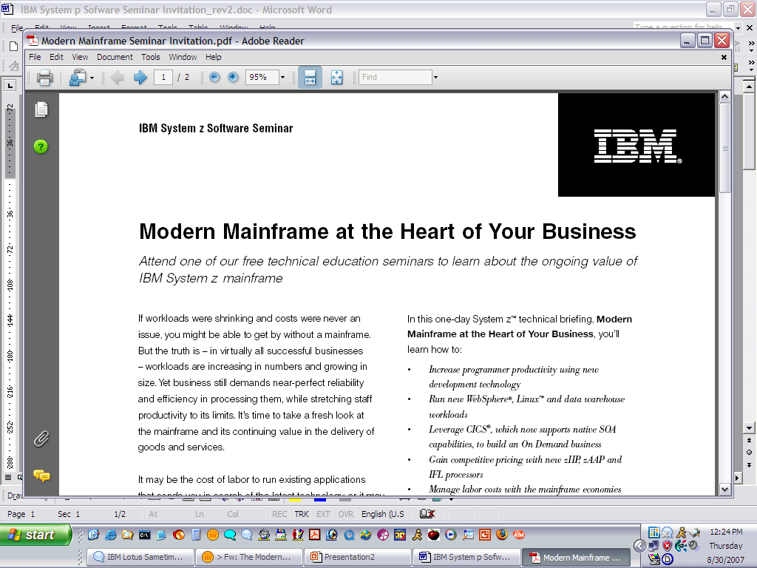
IBM Software and System p Seminar

X86 Server Sprawl got you down?
Take back control of your IT Infrastructure

Attend our November 12 free seminar to learn how to reduce system costs with a virtualized infrastructure and how to effectively manage performance and achieve energy efficiency

IBM Middleware is the industry’s best platform for integrating the systems, processes, people and data in your business. IBM System p hardware featuring the new POWER6 processor technology is the industry’s hottest server platform. The combination of the industry’s best middleware on the fastest, most flexible hardware is unbeatable.
Agenda
- IBM Middleware on System p - An Unbeatable Combination for TCO
- POWER Hardware Improves Utilization and Reduces Data Center Costs
- Reduce Database Complexity and Improve Performance with IBM DB2
- Simplify Collaboration Services with Lotus Domino
- Consolidation Through Virtualization Saves Space, Energy and Costs
- Simplify Sprawling Web Tiers To Scalable WebSphere Servers
- Manage Datacenter Services With Best Practices
- Scale Up and Consolidate to Reduce Costs, Restore Flexibility
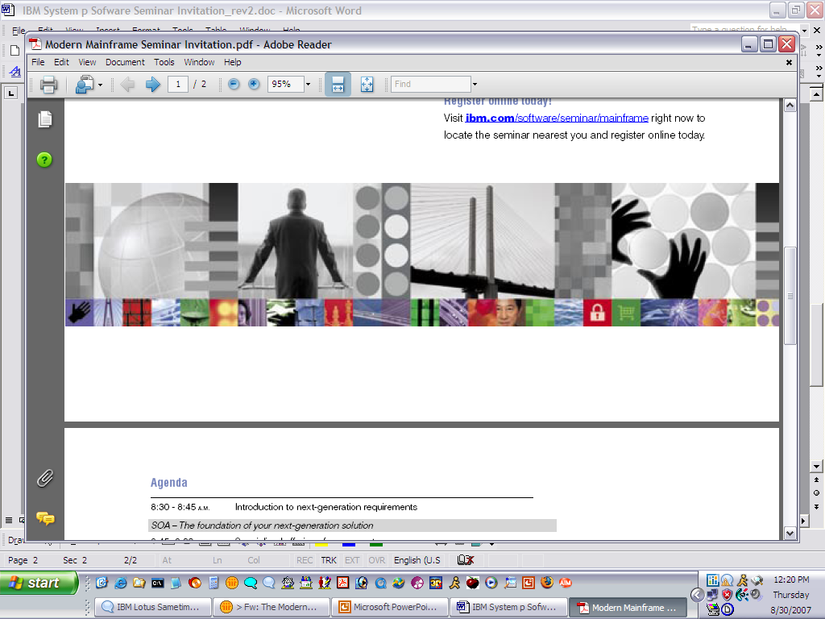

In this one day briefing, you will understand why IBM’s unique value is unmatched by the competition such as HP, Sun, BEA and Oracle:
- Simplify datacenters by migrating complex database and email systems to simple, scalable environments.
- Improving resource utilization using to reduce floor space, energy and administration requirements.
- Manage IT services more efficiently with best practices and automated provisioning.
- Lower total cost of ownership, including cost recovery and ongoing savings, for implementing each of the approaches used
Event Location:
IBM
4601 Touchton Road, East Building 400, Suite 4120
Jacksonville, FL 32246
Register online today! http://www.ibm.com/developerworks/offers/techbriefings/details/pseries.html Questions? Contact smitran@us.ibm.com

