SOA Solution Design Workshop (SSDW)

JK Enterprises Business and IT Context


© Copyright IBM Corporation 2008. All rights reserved

Revision History
Date of this revision: 01/11/2008 | Date of next revision Final

Revision Number | Revision Date | Summary of Changes | Who
v1r0 | 01/11/2008 | Final Version | Robert Spory, Lisa Noon, Mamoun Hirzalla

Approvals

Name | Title | Date
Lisa Noon | Director, WW SOA Tech Sales

Table of Contents
1 Introduction 4
2 JKE Business Context and Initiatives 4
2.1 JKE AS-IS Business Context 6
2.2 JKE AS-IS Account Open Process 7
2.3 JKE Critical Success Factors 10
2.4 JKE Business and IT Pain Points 11
3 JKE AS-IS IT Context 13
3.1 Business Domain 14
3.2 Organization 15
3.3 Methods 17
3.4 Applications 17
3.5 Architecture 18
3.6 Information 19
3.7 Infrastructure 20
3.8 JKE Existing Major IT Assets 21
4 CBM and SIMM Mapping 23
5 JKE Requirements 23
5.1 Functional Requirements 23
5.1.1 Integration Requirements 23
5.1.2 Information Requirements 24
5.1.3 Optimization Requirements 24
5.1.4 Interaction Requirements 25
5.2 Non-Functional Requirements 26
5.2.1 Availability, Scalability, and Performance Requirements 26
5.2.2 Security Requirements 26
5.2.3 Monitoring and Management Requirements 27
5.2.4 Disaster Recovery Requirements 27
5.2.5 Interoperability Requirements 27
5.2.6 Audit and Compliance Requirements 27
5.3 Governance Requirements 28
5.4 Other Requirements 28
6 Appendix A: CBM Engagement Report 29
7 Appendix B: Sample SOW for a CBM Engagement 29

Introduction
This document is the primary input for the practical work of the SOA Solution Design Workshop, i.e. case studies and SOA Roadmap Exercise.
This document provides the business information necessary for students to understand the business and IT challenges at JK Enterprises (JKE). It outlines their pain points and details both functional and non-functional requirements.
In addition, the document provides the detailed results of the CBM engagement that IBM finished at JKE along with a high level overview of the SIMM work that was completed to date.

JKE Business Context and Initiatives
JKE has continued to grow their business over the past 50 years by providing high-touch, personal attention to their customers. In recent years, JKE added call center and self-service facilities. JKE also added a remote sales force and outbound telemarketing, so that they can grow their business while satisfying a variety of customer types with different needs. However, the CEO of JKE recognizes additional changes must be made in order to compete in today’s global marketplace. After reviewing the results of the past improvement projects, he came to the conclusion that key executives at JKE did not fully understand the details of their business.
Executives at JKE are unable to manage or affect cost, and report challenges in implementing new strategies. They are routinely unable to accurately predict the impact of significant strategic decisions nor report on results of business and IT investments to the satisfaction of the CEO. The CEO feels that he needs to take immediate action to increase the business flexibility of his company. He plans to do this via an aggressive transformation effort driven via a Center of Business Optimization (CBO).
The CBO launched a business-driven initiative named “Project Enterprise.” The CEO is supporting the initial recommendations coming from the “Project Enterprise team:”
- Deliver a similar customer experience regardless of the service channel
- Improve speed and customer service during on-boarding
- Gain a 360 customer view and cross-sell to retain customers
- Identify Key Performance Indicators and use them to manage the Business
- Support BTO Initiatives across the organization
1. Deliver a similar customer experience regardless of the service channel
JKE competes in a number of market segments and therefore offers a variety of service delivery channels. Both existing and prospective customers are demanding highly personalized -- yet automated services -- regardless of how they submit their request. While some of their customers prefer a single way of interacting, their most sophisticated customers use more than one channel, and expect consistency of process and treatment among them. For example, customers might submit a request over the Web, and then phone the call center, Salesperson, or Account Manager to inquire on the status.

2. Improve speed and customer service during on-boarding
JKE wants to make it as easy as possible to add new customers. It is desirable to accept applications for new customer accounts from any appropriate channel, ie : web, call center, sales laptop, mobile devices and back office workstations. Today’s Account Open process includes manual steps. This degrades success rate of on-boarding while increasing costs. The Operations departments would like the process to appear seamless to the customer, even in the cases where manual steps remain necessary.
Manual steps in JKE’s as-is Account Open process causing the process to be two times slower than the competition. Although speed is critical, the JKE CEO does not want the introduction of automation to result in less personal customer service -- every effort should be made to treat customers as VIPs in all interactions, especially the profitable ones. The customers’ initial experiences in a customer center or in any of the call centers should be optimized for superlative experience with the excellent customer service JKE has traditionally been known for.
3. Gain a 360 customer view and cross-sell to retain customers
JKE’s early CRM initiatives have delivered interesting metrics that it now wishes to leverage to improve performance. Based on direct experience, JKE knows that the first 180 days of a customer’s relationship is critical to winning their long term loyalty. If the business can create a positive impression in that timeframe, the odds of a long-term mutually beneficial relationship is high. JKE wishes to improve the monitoring and management of a customer through this critical time. Reflective of their high-touch service mentality, JKE has managed to keep the attrition rate for JKE’s established customers to 10% -14% which is considered low compared to their peers and competitors. However, CRM statistics document that attrition rates for customers who have been with JKE for less than six months can reach 45%-50%. JKE clearly needs to lower their attrition rate of newly acquired customers by offering them differentiated and enhanced services that match their profiles.
Cross-selling a customer on new products and services is also a proven way to maintain the relationship. JKE has invested significantly in cross selling mechanisms – they have a superior lead management system and an expert sales force. Up to now however they have not tied their sales process to customer on-boarding. A business consultant recently reported that upwards of 65% of all of JKE cross-selling opportunities arise within 90 days after an account is opened.
4. Identify Key Performance Indicators and use them to manage the Business
Managers have a difficult time understanding how processes and the participants in the processes are performing. Currently, no reporting structure is in place to notify the managers when customers in process have exceeded the internal benchmark for duration. Some manual customer tracking exists, but the quality and accuracy varies by Customer Service Representative. These inconsistencies often result in customers ‘falling through the cracks,’ becoming frustrated, and going to a competitor. The management team does receive a monthly spreadsheet provided by Finance. However, the reports do not provide all the data necessary to effectively run the business. For example, overall processing time for a new account is calculated, but the specific steps can not be broken-out.
The management team is expecting to monitor the duration and cost of the on-boarding process. The team wants to be notified when a customer is delayed at any point in the account open process. Additionally, they wish to track the following Key Performance Indicators (KPIs): attrition, retention, cross selling, and number of products per customer.

5. Support BTO initiatives across the organization
JKE has traditionally grown through mergers and acquisitions which resulted in a heterogeneous mix of policies, business practices, glossaries, infrastructure and applications. This complicates how JKE designs and manages their systems. The differences in the way different parts of the business operate makes reuse of assets difficult and the complexity introduces challenges that hinders their time–to-market to offer new business services to our customers.
The transformation initiative will identify opportunities and solutions for optimizing business structures, applications, and supporting IT infrastructure. Strategic outsourcing of selectively identified functions will empower JKE to provide better business services to our customers, while freeing business and IT staff to focus on delivering strategic and differentiating new services rather than maintaining redundancy.

JKE AS-IS Business Context
The following diagram shows the JKE AS-IS business context.
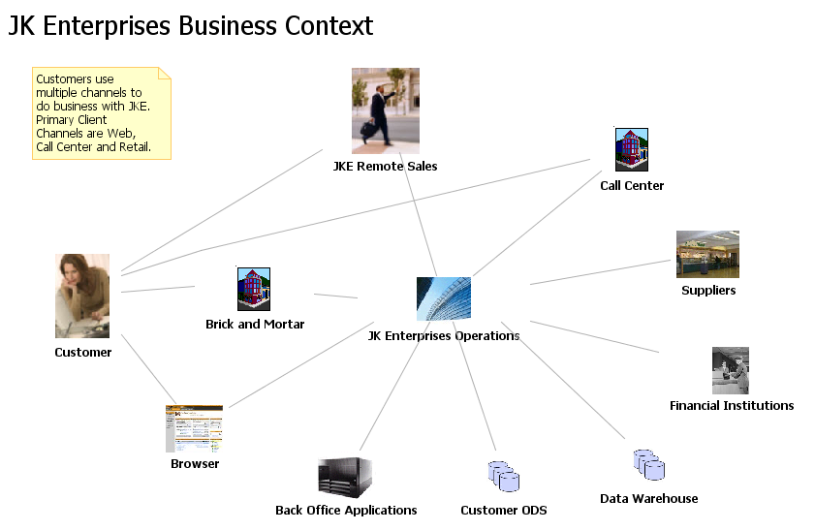
Figure 1: JKE AS-IS Business Context

JKE AS-IS Account Open Process
This following diagrams shows the AS-IS JKE Account Open Process and its associated AS-IS sub-processes Account Verification and Account Activation.
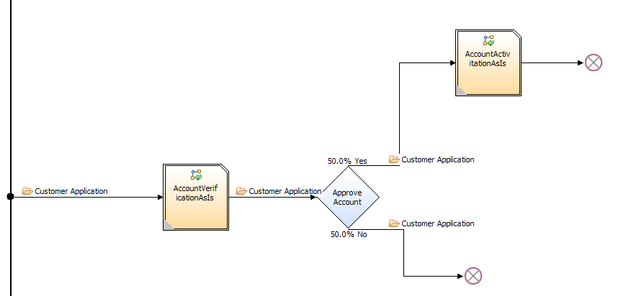
Figure 2: JKE AS-IS Account Process
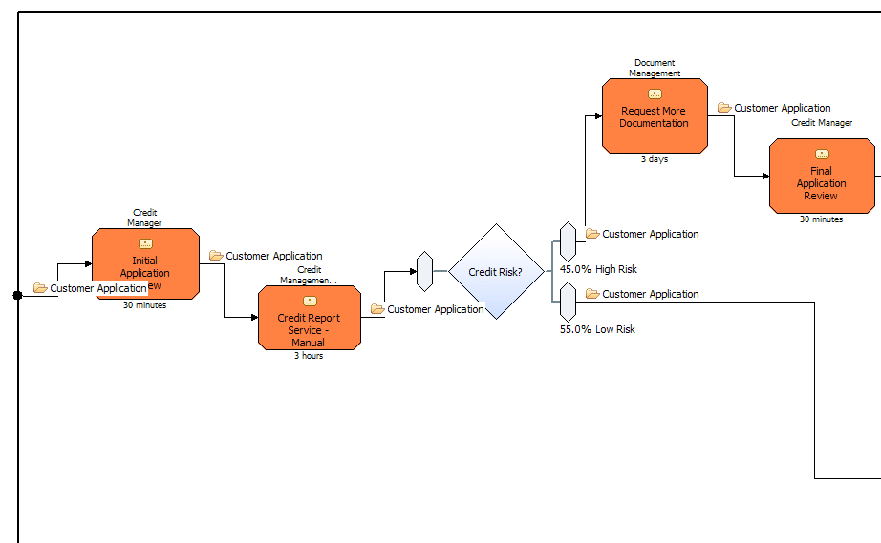
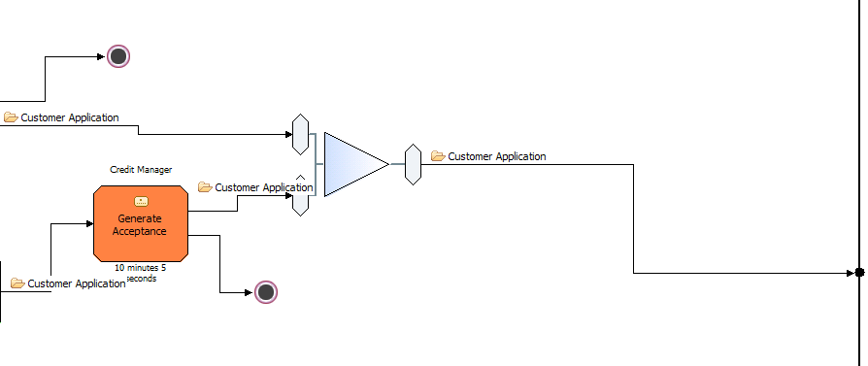
Figure 3: JKE AS-IS Account Verification

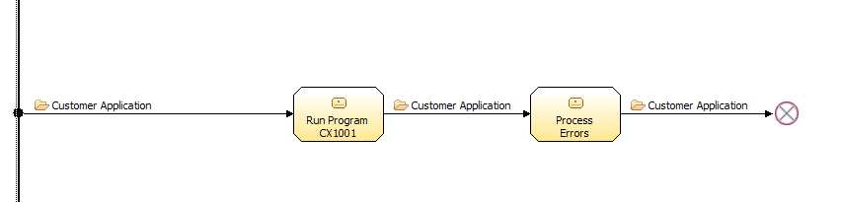
Figure 4: JKE AS-IS Account Activation Sub-Process

JKE Critical Success Factors
- JKE needs to provide optimized multi-channel account application process that provides the business with the relevant KPIs – as an initial target, JKE should increase Cross Sell Ratio to 2.0
- JKE must automate the manual tasks for creating and administering accounts and decrease cost of account activation by 50%
- JKE needs to improve profitability by shifting customers from using high cost channels e.g. call centers and brick and mortar to the web – as a tactical goal, JKE should reduce the number of call center calls by sales force and offices by 30% (this could be done easily for account inquiry)
- Credit reporting is a high cost business function today – JKE needs to negotiate better prices taking advantage of our combined size. JKE wishes to reduce negotiated prices using vendor volume discount. For credit report retrievals, JKE wishes to reduce retrievals by 20% and automate 75% of them. Another way to cut the cost of credit reporting is to implement consistent business rules to manage risk and to decrease number of credit report retrievals by 10%
- JKE must decrease the amount of time required to open a new account from nearly a month to less than a day which will require significant work – the intent is to improve the straight through processing of account applications by 35%
- Document Management is a high cost function at JKE. JKE needs to decrease the number of paper documents processed by task automation – as a tactical objective, JKE should Increase electronic applications by 25%
- Due to a tightening of internal and external compliance requirements, JKE needs to introduce access control and auditing of access to services. In order to keep in line with other initiatives this needs to be done with minimal or no impact on the service/application implementations.
- JKE needs to reduce the costs and audit/compliance risks associated with the access to their systems from its network of agents who sell JKE products and services.

JKE Business and IT Pain Points

# | Pain Point | Priority | Type
1- | JKE’s cost for operating their business is high compared to their competitors due to many inefficiencies in their business processes | High | Business
2- | Lack of complete acquisition integration has left JKE with significant redundancy and heterogeneity in their organization. Several departments exist in more than one LOB, although this is not always obvious due to different business glossaries | High | Business
3- | Since JKE is consumed with managing redundancies, in spite of their new size they fail to negotiate with their vendors better terms for conducting business | High | Business
4- | Customer experience is different across channels and JKE cannot seem to provide a well-thought out delivery model that is consistent across divisions | High | Business
5- | Enrolling new customers to do business with JKE is riddled with too many manual steps that are causing the account open process to take in excess of 3 weeks | Medium | Business
6- | Executives at JKE are unable to manage or affect cost, and report challenges in implementing new strategies. They are routinely unable to neither accurately predict the impact of significant strategic decisions nor report on results of business and IT investments to the satisfaction of the CEO. | High | Business
7- | Some LOBs at JKE have good working relationships with their IT counterparts and some do not. There are very few formal processes that help align business requirements with IT projects and plans. | High | Business
8- | JKE attempts to achieve reuse in their IT deliverables and artifacts were hampered by funding issues, inconsistent business glossaries, and lack of standards. | High | Business
9- | Inadequate standards and processes are employed or exchanged across the business units. | High | Business
10- | The IT group works in silos with redundant efforts that are repeated across different LOBs that cause JKE to spend more on operations with limited returns. | High | Business
11- | The enhancements to existing applications is high due to the significant point-to-point connections in place that mandate significant changes to multiple applications | Very High | IT
12- | The cost of enrolling new customers is high due in part to poor integration of applications | Very High | IT
13- | JKE does not have proper processes to inventory and manage existing or new IT assets | High | IT
14- | There is no standard development methodology. The software development process does not enforce any traceability links across various components of the solution architecture. This often leads to under developed features, miss-communicated requirements, and solutions that do not meet the original requirements to address a business problem. | Medium | IT
15- | The IT staff is reactive vs. proactive when it comes to the health of deployed applications and identifying issues. While JKE has some monitoring tools in place, it’s very clear that enhancements are required in the future. | High | IT
16- | There is no Enterprise Content Management strategy in place to address the automation of paper based applications and associated documentation | Medium | IT
17- | There is a form of IT Governance, but it’s deficient on multiple fronts, especially when it comes to being proactive about the health status of applications. | High | Mixed
18- | Lack of a common business glossary poses challenges for an enterprise data model that can be used for creating a common view of the customer and their accounts (billing, receivable etc.) across the channels | Medium | IT
19- | JKE suffers from data inconsistency issues in customer information while updating customer account information across different channels. While JKE has one ODS that houses Customer data, there are some implementation issues that prohibit JKE from providing a single customer view across all channels | Medium | IT
20- | Applications tend to fail without any previous warning therefore leading JKE to miss their promised service level agreements. | Medium | IT
21- | Earlier attempts at synchronizing key attributes about users across domains has proven costly, fragile and in many cases inaccurate. | Medium | IT
22- | JKE suffers from high user and password management costs associated with external users from different agencies that possess high staff turnover. | Medium | IT
23- | Supervisors are unable to track what applications are being processed by which agents through the web | Low | IT
24- | Management is unable to have an overall online view into applications that is available on demand to reflect the latest statistics. Instead, management must wait for a manual report to be generated to view such information which takes on average seven days to complete. | Low | MIXED
Table 1: JKE AS-IS Business and IT Pain Points

JKE AS-IS IT Context
The JKE current state represents a combination of in-house components, point to point integration, and a rudimentary messaging framework (used largely to support mainframe CICS/IMS and iSeries integration). JKE provides basic routing and message transformation (e.g. COBOL to XML) to application teams and currently meets performance and throughput requirements. Some limitations of the current framework are as follows:
- Proprietary messaging components need to be maintained by JKE resources.
- Proprietary frameworks support a limited set of integration capabilities.
- Support processes are not streamlined.
The JKE IT organization consists of the following:
- 8 Data Centers
- 2000 IT Staff
- 40+ different development tools
- No end-end methodology
- Lacking governance model
LOBs tend to maintain dedicated IT resources to service their applications. Each IT department receives funding directly from the LOB with which it is aligned. The LOB funds hardware, software, and the applications built on them.
JKE realizes it should centralize its Data Centers, standardize the infrastructure and consolidate operations. The CIO knows that standardization of platform, infrastructure, and setting corporate standards for operations, security, and management are important, but he wishes to do this carefully as part of a larger plan to consolidate the systems into shared services. IBM GTS (Global Technology Services) is discussing a Data Center Consolidation project and is preparing a Statement of Work for a SOA Healthcheck.
JKE leverages a collection of IT systems that are composed of the following:
- Mix of build vs buy – SAP, Siebel, CICS, Batch
- Legacy Applications – core accounting, order entry
- Multiple Platforms - Windows, AIX, iSeries, zSeries
- Heterogeneous topology
- Some .Net applications as well as some J2EE components, i.e. EJBs
Because of this heterogeneity JKE achieves very little reuse of components, techniques, methods, and skills within their IT organization.
JKE uses a variety of tools to build and manage their application portfolio. A recent survey returned a list of over 50 different application development products – some purchased, some shareware, some freeware. There is little standardization, in fact new developers are sometimes permitted to choose based on personal preferences. It is unclear whether JKE would pass an IT audit. For example, the software development process does not enforce any traceability links across various components of the solution architecture. This often leads to under developed features, miss-communicated requirements, and solutions that do not meet the original requirements to address a business problem. To make things worse, the development leaders are not certain what development tools are even supported.

JKE current messaging framework uses MQ as the underlying technology. The framework uses the proprietary messaging interfaces of MQ and lacks naming conventions, standards or a common/shared message schema. Use of XML is inconsistent. Message mapping often requires custom Java or other code. Problem determination often requires a manual effort to analyze logs for troubleshooting and problem determination. Mechanisms and guidelines for processing/retrying failed asynchronous messages differ among teams and sometimes vary by developer.

Business Domain
Within JKE today, all lines of business tend to have their own applications with some project-driven integration between them. LOBs fund and create their own applications rather than reusing similar capabilities from other LOBs. There are exceptions to this scenario, but the predominant thinking at JKE is to build new function in house according to the needs of the LOB funding the project.
JKE has grown through acquisition, and in several cases a new acquisition has been integrated as a separate LOB. This has resulted in a company that does not always share the same business terms and policies regarding key business entities, for example “Account” and “Customer” and “Product.”
Each LOB in JKE is accustomed to having their own dedicated set of services. This is true not only of IT but of business services as well. Many have their own sales, customer service and accounting departments, etc. Because they use different business glossaries it is often difficult to determine whether or not there are valid business reasons for the redundancies. In addition, using different business glossaries introduces many challenges to creating, managing, and using a common set of business terms and categories. Moreover, it hinders the collaboration of IT and business since business terms are not labeled properly and are open to interpretations which masks many redundancies that permeate across the organization.
Given the cost and efficiency pressures the company is under there is a lot of competition across LOBs for corporate funding. The CEO has reacted to the lack of collaborative sharing by cutting everyone’s budget and that has led to a difficult climate for gaining approval of strategic initiatives.
The CIO has been asking the CEO for clear business requirements and an overall business strategy that will support better IT decision making. The CIO plans to align the Enterprise Architecture team with the LOBs giving it the power to enforce standards and IT strategy. In addition, the CEO has hired Global Business Services to conduct a strategy review of the business and make recommendations on the Business Architecture. A Component Business Model engagement was completed and was very successful.

Organization
JKE’s organization largely reflects its acquisition of Jensen, Inc in 2000, and it’s eBusiness initiative in 1998. It has evolved into silos that reflect this. Here is a copy of their organization chart today:

Figure 5: JKE Organization Chart
Commercial
Retail
eBusiness
CEO
Sales
Service
Credit
Service
Service
Sales
Sales
Credit
Credit

Lack of complete acquisition integration has left JKE with significant redundancy and heterogeneity in their organization. Several departments exist in more than one LOB, although this is not always obvious due to different business glossaries.
In general, LOBs tend to maintain their IT staff to service their own applications. However, recent sponsored projects by the CEO have led to a set of ”common services” where resources are shared between application teams within different LOBs, mostly around “Customer.” Inadequate standards and processes are employed or exchanged across the business units. There is a form of IT Governance, but it’s deficient on multiple fronts, especially when it comes to being proactive about the health status of applications.
Below is the organizational chart for JKE’s IT department. Except for the recent organization added to support the implementation of “shared services,” you will notice how closely it reflects their business architecture.
Their architecture team resides in the Shared Services group.

Figure 6: JKE IT Department Organization Chart
Commercial
Retail
eBusiness
CIO
Order
Processing
Relationship
Management
Billing
Retail Ops
Customer

Service
Call Center
Web
Distribu-tion
Shipping
Shared
Services
SAP Accting
CRM
HR

Some LOBs have good working relationships with their IT counterparts and some do not. There are very few formal processes that help align business requirements with IT projects and plans.
In part because of the mix of business practices, applications, methods, etc JKE has done little to set organizational standards for roles and responsibilities in all functions.
JKE has a group of IT help desks to address minor IT issues. In addition, JKE has a team of level 1 support to address initial problem requests as they come in. Once problems are identified, the IT staff gets involved to resolve major IT issues. Level 1 support is responsible for both distributed and mainframe problem determination and resolution.
On the bright side, JKE has an emerging Enterprise Architecture and IT standards that are established within the organization. JK Enterprise has taken a shot at establishing some form of SOA vision and realizes the importance of SOA for the enterprise. SOA Governance is emerging and requires some refining in order to make it a standard across all LOBs. JKE realizes the potential for business services and their ability to transform the way it approaches certain applications.

Methods
CBM is becoming the corporate standard for Business Modeling. The CEO has funded a small group of Business Architects to help drive CBM and he is very happy with the results. Business Users are starting to ask for business models of their own – the Business Architects are in high demand.
IBM consultants have recently introduced Service Integration Maturity Model (SIMM) as a framework for increasing JKE’s maturity and Service Oriented Modeling and Architecture (SOMA) as a method to help JKE deconstruct their business into processes and services suitable for intelligent forward engineering. IBM has recommended a Proof of Architecture for SOMA that will deliver a service model for a set of core reusable services in the area of Account Management.
JKE has standardized on UML for all development that requires Object Oriented (OO) artifacts. JKE realizes that it needs to incorporate service design best practices in order to meet its objectives of making services more prevalent within the organization. Developers, designers, architects and project managers have minimal awareness of the differences between service oriented development and non service oriented development projects.

Applications
JKE has grown aggressively through acquisition. They acquired a company called Jensen in 2000 in order to expand their very profitable corporate business. Because of concern for attrition of these important and profitable customers they avoided consolidation of the core business systems. Aside from the CRM initiative and a consolidation of HR and accounting systems on SAP as part of Jenson integration, JKE has done little to consolidate business applications.
Their applications therefore tend to be siloed within LOBs. Several LOBs have offered to start looking into service orientation to address some of the integration issues that plague some of our applications.
JKE sometimes uses EJBs as a form of capturing common functionality and some departments tend to share those EJBs with other departments. Most of our connections today are point to point, with the exception of one department where they have successfully deployed MQ to aid with their integration issues.
A portion of the JKE applications have been componentized; that is, the application is structured around components. Service orientation is beginning to be applied to the application portfolio with the entry point largely around integration of certain components. However, JKE has a long way to go due to the brittleness of some of the application interfaces which keep JKE IT staff engaged in maintenance mode.
JKE has built out a small set of “common services,” that has shown some value (albeit limited) and wishes to do more. Their attempts to achieve reuse were hampered by funding issues, inconsistent business glossaries and policies, and they realize they need to address those issues in order to better succeed in future attempts.
The IBM CBM engagement has provided a mapping of applications to the CBM, with gaps and redundancies called out. Results of the CBM engagement are included in Appendix A.

Architecture
As stated earlier, JKE has a limited EA group that is tasked with defining the architectural standards that LOBs must follow. Among the advocated best practices, EA emphasizes the importance of separation of concerns. Services are packaged in EJBs and some form of integration is present. Architectural artifacts are created using Visio and Power Point. JKE is in the process of evaluating architectural tools available in the market place.
JKE has a multi-channel architecture in place to address any business services from any channel. The capabilities that are in place provide a different set of methods to handle the same operation depending on the channel type. This creates a lot of maintenance issues and causes lost productivity to our IT staff whenever an issue is uncovered. Ideally, JKE would like to have the same consistent handling of all channels and provide the same treatment of customers based on their tiers rather than on which channels they are coming from.
The majority of integration methods incorporated at JKE is considered point to point, with some applications utilizing an MQI approach for applications integration. There exist a lot of dependencies between our backend office applications and other applications within JKE. Any minor change in our backend office systems cause many ripple effects in the organization due to the tight coupling of applications
While JKE leverages Java EE for encapsulating common business logic in EJBs, there are a few instances, however, where reusability of business functionality is largely accomplished through cut and paste of required business logic in multiple applications across LOBs. This also creates inconsistency in handling similar processes and causes maintenance issues and improper handling of various customer data across different channels even though JKE has one standard ODS for housing customer data.
At JKE, there are two schools of thought regarding building applications. The old school of thought required the creation of custom applications for every new functionality. On the other hand, the new school of thought is trying to enforce the procurement of Customer Of The Shelf (COTS) packages to expedite the delivery cycle. A good example of the second approach is our CRM application where we picked Siebel due to its major market share and its ability to meet our requirements.
JKE has done a fair amount of work to meet quality of service attributes mandated by business uses. While there certain aspects of applications monitoring, JKE still lacks the complete vision regarding the overall health status of all deployed applications. In certain instances, our IT department is notified of major issues without any warning issued from the monitoring applications. From security perspective, JKE seems to be doing a good job in this domain since no security breaches have been reported over the past 5 years. However, there are security nuisances that JKE would like to address as part of any new IT initiatives. A good example of such issues is the proliferation of many passwords that JKE employees need to maintain to operate the various number of applications to get their job done.
One of the major IT risks that we face at JKE is our IT department’s ability to meet business demands on time. Our IT department is trying to do their best to meet our expedited delivery of new business services to our customers, however, existing IT systems do not provide out IT department with the proper agility and flexibility to meet our business requirements.

Information

JKE succeeded with an aggressive CRM project that took several years. With sponsorship from the CEO himself they consolidated several of the acquired and poorly integrated Customer Operational Datastores into one. The implementation of this single datastore across the multiple lines of business has been quite challenging however, given JKE’s different LOBs that have different definitions and policies for customers. For example Sales believes that prospects should be customers, while Accounting does not. LOBs feel that they “own” specific customers and continue to disagree about policies that permit other LOBs to view and maintain them. This experience has taught the CEO and CIO that in order to succeed at an Enterprise Data Strategy JKE must change the way it does business. So while the databases are now consolidated, JKE continues to struggle with the “build out” of services that support the “Customer” entity. This is slowing down the expected reuse of these services across the various LOBs.
The architecture team realizes the need for structured and canonical data forms across the Enterprise Data Model, however, they have not been able to achieve that goal. During the past 3 months, the architecture team along with our Data Architects started a project to create some conceptual data models in order to incrementally apply them for the new initiatives within our organization. Even though the CRM system supports it, because of the business issues above JKE continues to struggle with having a consistent view of our customer. At this point it is up to the LOBs to come together and agree on a standardized master data and policy model for our customer data across all LOBs. This data model will support the shared services that will finally achieve the reuse JKE’s CIO has promised the CEO.
Ideally, the CIO would like to have a consistent definition of our primary entities through use of an enterprise glossary, and have standard XML representation for them, and to enable applications to leverage such standards. In addition, JKE wishes to ensure that data is represented in a consistent manner across all LOBs and service channels through separation of the information assets from the applications and exposing them as services that can reused across the LOB applications.
JKE has started to achieve some of the promised business benefits of its CRM project with Business Intelligence. Reports are flowing to the executives based on the consolidated datastore. These reports are helping the CEO discover business patterns that are driving strategy decisions, and give him reason to expect more. For example, he can now compare his cross-sell ratio to his competitors, understand the behavior of specific customer segments, and track profitability and risk. This enables the executives to understand the implications of a fragmented and uncoordinated Cross-LOB business strategy.
JKE has implemented a data warehouse to store all historical data from various applications across the enterprise. The data warehouse receives weekly batch feeds from the operational data stores of the following enterprise applications: Risk Management, Collections, Ordering/Billing, SAP, Marketing, CRM, Accounts Receivable, and Customer ODS. The data warehouse is leveraged across JKE to enable reporting and some form of business intelligence that requires a lot of enhancement in the future to meet our strategic objectives. With the latest update of the technology of the data warehouse, JKE is counting on achieving great business intelligence benefits to mine the existing data regarding their important KPIs to streamline their business. In addition, JKE has plans to introduce sophisticated mining techniques to analyze different parameters from various systems to enhance their business decision capabilities and marketing campaigns that will feed into the Siebel CRM to provide to customers as soon as they are identified across any channel.

The CIO also lacks an implementable Enterprise Content Management (ECM) strategy. JKE has a number of content management solutions today, inherited from multiple acquisitions and hopes to consolidate them as part of the Data Center Consolidation project. ECM will support the automation of the paper-based manual steps the LoBs perform today while opening new accounts. The content generated today and use for daily activities is either housed in different warehouses or scattered across employee desktops and hence cannot be searched, reused (in terms of templates) and traced back and archived for audit tracking related compliance needs.

Infrastructure
The infrastructure that exists across JKE’s 8 data centers is tailored to meet the needs of the existing applications in their own silos. The administration of existing machines and applications is done through one central IT department with specific focus on LOBs.
As stated earlier, consolidation is overdue, and along with that the setting and implementation of modern infrastructure standards and techniques.
Minor work has been done to investigate the impact of using services on exiting IT infrastructure. To be specific, we know that we need to pay significant attention to our security and IT monitoring capabilities. At JKE, we tend to operate in a reactive mode after certain failures happen for most of the time. In certain instances, JKE has some monitoring tools that will provide some clues to potential upcoming issues before they become real ones. Given that our IT systems are not proactively monitored as we would like to, this is an important area for us to explore in the future.

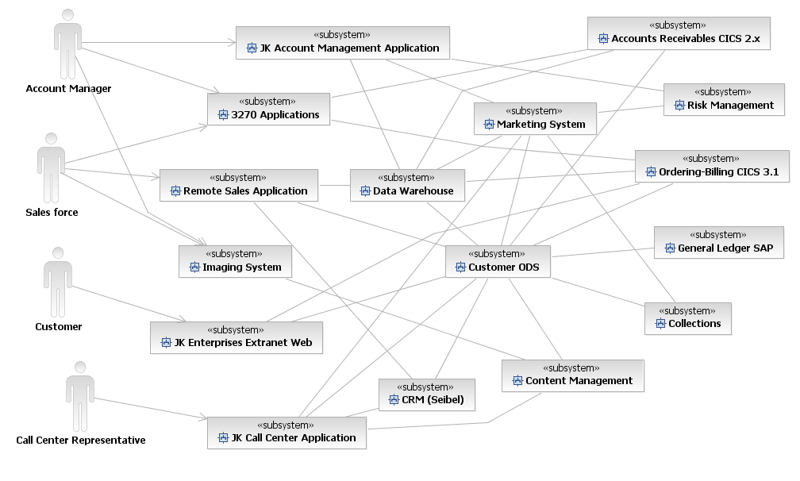
Figure 7: AS-IS JKE IT Context

JKE Existing Major IT Assets
The following table shows the major IT assets that exist at JKE. It also lists all major systems that were acquired through the Jensen acquisition.
Name | Source | Developer | Installed | Technical Architecture | Primary Users | Notes
SAP | Developed | External | 2002 | - R/3 | - Enterprise Wide
Seibel | Purchased | External | 2005 | - Java | - CRM
Customer ODS | Developed | IT | 2005 | - Informix SQL/ PL/SQL | - Sales/Marketing
Data Warehouse | Developed | IT | 1992 | - DB2 | - Enterprise Wide  Recently upgraded to DB2-DWE
Collections | Developed | IT | 1995 | - IDMS | - Finance
Ordering/ Billing | Developed | IT | 1990 | - CICS 3.1  - COBOL  - DB2 | - Sales  Recently upgraded to CICS 3.1
AR | Developed | IT | 1989 | - CICS 2.2 | - Finance  Evaluating migration to CICS 3.1
Marketing | Developed | IT | 2005 | - Sharepot | - Marketing | In house
Risk Mgmt | Developed | IT | 2002 | - DB2 | - Credit
Credit | Developed | IT | 2000 | - DB2 | - Risk Mgmt
Remote Sales | Purchased/ Extended | IT | 2005 | - Seibel  - JME | - Sales
Intranet (HR and other) | Developed | IT | 2005 | - JEE | - IT
JKE Extranet (Account Open) | Developed | IT | 2002 | - JEE | - Various
Content Management | Purchased/ Developed | IT | 2001 | - JEE | - Various
Imaging System | Purchased | IT | 2003 | - JEE | - Various
Table 3: JKE Existing Major IT Assets

The following architecture overview diagram shows the existing major systems at JKE
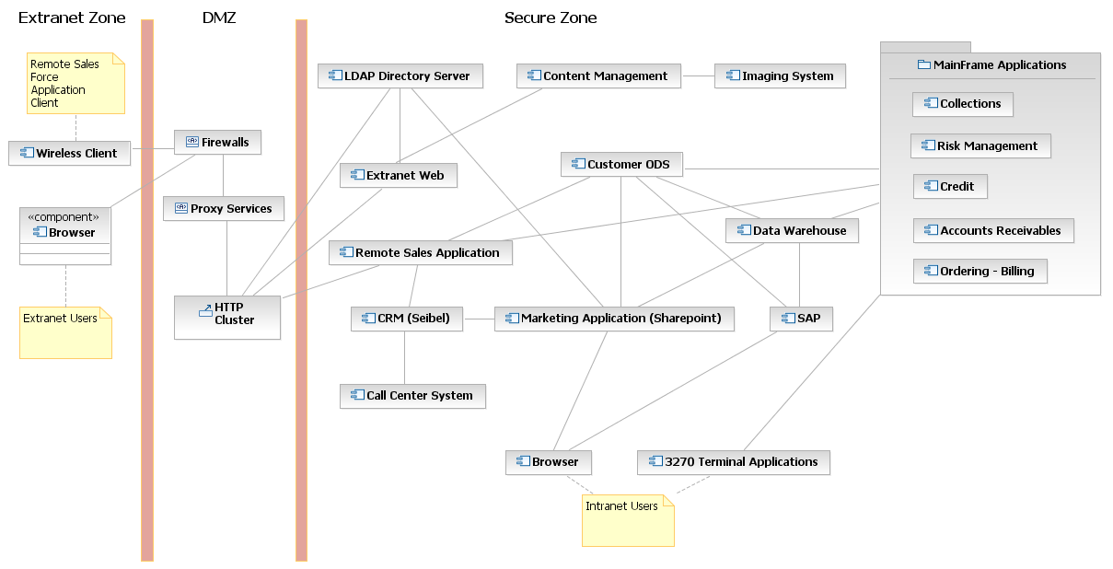
Figure 8: AS-IS JKE Architecture Overview Diagram

CBM and SIMM Mapping
Based on the CBM engagement that IBM performed, JKE received a list of business components that were considered hot.
For a complete view of the CBM engagement results, please see Appendix A.
In addition, JKE completed a SIMM assessment with the help of IBM using the Heat Map produced during the CBM engagement. This resulted in a recommendation that required the initiation of multiple incremental projects to address the pain points taking into consideration JKE’s critical success factors and business initiatives. The list of recommended projects and SIMM mappings will be shared with students during the first day of the class.

JKE Requirements
The following list of requirements reflects JKE business priorities, and their thinking on how SOA can help them in achieving the business objectives that are tied to the following requirements.
The requirements will be mapped to business initiatives and KPIs as specified in the CBM engagement output. Requirements will be also mapped to additional development components such as architectural decisions.

Functional Requirements

Integration Requirements

The integration platform shall reflect data changes from any channel to another within 5 minutes of any update

The integration platform shall provide customer information in a consistent manner across all channels. For example, all addresses will need to have CITY and STATE attributes displayed in all-caps format.

The integration platform shall allow JKE to interoperate with external outsourced services that provide critical functionality to the enrollment of new customers. For example, we would like to connect to credit check bureaus to determine the best available services to use and leverage those in our own processes.

The integration platform shall enable users to receive targeted offers based on their profile, history, and navigation of the web site

The integration platform shall support the transmission of both XML and binary data.. In addition, JKE requires direct support and transformation of EDI and SAP IDOCS into internal formats based on partner and application requirements

The integration platform shall support interaction with consumers / providers using both synchronous / asynchronous transport modes.

The integration platform shall support the exchange of messages across all geographic locations where JKE conduct business. Initially headquarters location will be responsible for all communications coming into JKE. However, in the future and as the business grows, we would like our strategic branches located in different geographies to handle their own business traffic.

The integration platform shall support caching of responses interactions for transactions that use request/response style. The caching of responses is intended to reduce the load on service provides, and reduce WAN utilization when services are only located in a single geography but accessed in other geographies.

Information Requirements

The system shall provide a single customer view that is consistent across all channels and built using an enterprise business glossary

The system shall enable the retrieval of customer information in standardized fashion

The system shall eliminate data redundancy issues that exist for customer data across different databases by ensuring that all applications that need current customer data are leveraging the Customer ODS.

The system shall provide means as part of the same query to dynamically retrieve most current data in the operational datastore(s), e.g. Customer, Account Receivable, Credit, Risk Management, etc., in conjunction with their historic data in the data warehouse.

The system shall provide data validation and standardization prior to inserting the data into data repositories.

The system shall provide a native XML store for credit reports and Account-related application’s forms transmitted from the UI in order to be in compliance with new auditing requirements.

The system shall provide capability to profile the customers as high, medium and low credit risk using data mining based analysis of historic customer order and payment patterns

The system shall provide capabilities to support enterprise search to deliver content from the various existing document management systems.

The system shall provide capabilities for enterprise content management to handle new account and credit request applications and associated documentations and images (fax, scanned images).

Optimization Requirements

The system shall minimize the number of manual steps during the on-boarding process. The credit check process is a prime candidate for automation due to the availability of online services that meet the requirements for JKE.

The system shall enable the monitoring of the duration and cost of the on-boarding process to ensure KPIs are met and report any deviations. E.g. attrition, retention, cross selling, and number of products per customer.

The system shall allow the dynamic change of service method depending on the status of serviced client. Platinum level customers are offered better access to services and offers as soon as they are identified through the system.

Interaction Requirements

The system shall enable users to create an account using JKE’s web site

The system shall enable user to receive account creation status at the end of the account creation step

The system shall provide users with rejection reason if the rejection is related to their credit status. Otherwise, the system shall start the process of sending a rejection email/letter with detailed information regarding the rejection reasons.

The system shall enable users to view their account information on the web

The system shall enable user to update their account information on the web

The system shall enable users to contact an agent during the application process to chat should they need any help.

The system shall enable users to retrieve their account information thru the voice response unit

The system shall enable users to update their account information through the call center.

The system shall enable employees to login to view applications information

The system shall provide employees with their own view that is tailored to their specific job. For example, a supervisor should have the ability to approve an application manually after reviewing account information.

The system shall enable supervisors to re-assign tasks after they are assigned

The system shall enable users to accept or reject task assignments with notifications being sent to their assigning supervisor

They system shall enable management to see a graphical display of all the applications in process and the process duration and completed steps

The system shall enable management to see a graphical display of the number of applications applied and the percentage of those rejected and approved applications

The system shall allow managers to drill down on the graphical display to find out more information regarding the rejection reasons

The system shall provide management with graphical rendering KPIs both at the business and operational levels, as defined by the line of business

The system will provide account profitability and complete customer profile information.

The system shall provide a list of rejected applicants for further monitoring of their credit status for future contact when their credit situation becomes appropriate for JKE requirements

The system shall provide a forms interface for the Account Open web interface to support an enhanced method for entering customer data.

Non-Functional Requirements

Availability, Scalability, and Performance Requirements

The system shall be available 99.95% with minimal downtime for periodical maintenance windows. JKE is also expected to have some short maintenance windows that happen over Sundays between 12 and 2 PM CST.

The system shall be able to handle a max of 10 million customers, 11000 employees, and 500,000 orders per year. It’s expected that customers will double over the next few years, and order will increase by 30% over the coming 3 years.

The system shall be able to handle a transaction load of 576,000 transactions per day during non-peak time, and be able to handle 4.32 million transactions per day during peak time.

The system shall provide responses to any transaction over the Internet with no more than 7 seconds from the moment a user submits a request to the moment a response is provided.

The system shall minimize full-page refreshes on the web channel in order to improve response time.

Security Requirements

The system shall be able to authenticate employers and business partners after they register through the company’s web registration process. The userid/password pair shall enable registered users to navigate across different applications wherever they are authorized to do so

The system shall guard against XML threats to exposed services that are used from external business partners.

The system shall provide seamless authentication across independent IT Silos through seamless mapping of different authentication concepts. The seamless authentication should also extend to authenticating against mainframe applications

The system shall always provide security to newly created services by mandating that all users accessing the new services are authenticated and have the proper credentials and rights to use the service

The system shall terminate access of any employee who may no longer require access to services due to separation or moving to another role.

Each user must be able to edit his/her own security profile, in a manner consistent with corporate identity management policy.

Monitoring and Management Requirements

The system shall detect any service level agreement thresholds deviations as soon as they happen and notify administrators

The system’s overall performance shall be monitored at all times through a graphical console, and any exceptions (failure, critical events, and SLA breaches) shall be communicated to designated IT support staff immediately through a pager alert

All IT assets shall be accounted for both during build time and runtime. In addition, runtime changes to service metadata shall be governed and reported.

The system shall enable administrators to track and manage multiple versions of service assets that are in use by other systems. In addition, the system shall provide necessary checks and balances to ensure that service versions are configured properly with governed approach on how to use them in production systems.

The system shall measure and monitor the business KPIs that were identified in the critical success factors section, and enable reporting against those KPIs.

The system shall provide management with service’s utilization reports, along with compliance percentages to promised service level agreements by service providers

Disaster Recovery Requirements

The resulting architecture shall enable the recovery of all applications within 2 hours should a major disaster (e.g. earthquake, fire, etc.) occur and take out any of our data centers. The procedures of recovering from any major disaster shall be documented and tested prior to any final approvals.

The system shall provide proper backup measures in case of any disaster-related conditions, e.g. earthquakes

Interoperability Requirements

Any new applications or services provided shall integrate with existing JKE systems and applications that span the following technologies: JEE, .Net, SAP, and Siebel

Audit and Compliance Requirements

The system shall provide a complete audit for all employees/administrators accessing all authorized on non-authorized applications/services.

The system shall maintain audit trails for at least 24 months at a minimum. Certain LOBs may have different requirements that may warrant additional time periods.

The system shall store all XML-received data in its native format to be in compliance with new auditing requirements that will be used in non-repudiation scenarios..

Governance Requirements

JKE shall enforce standards and best practices, so that the service lifecycle compliance, audit and approval checkpoints are traced back to requirements

JKE has to define ownership and funding models for the development, changes in functionality and maintenance or services that is sustainable in the long term and supports service reuse.

JKE shall define and implement processes and policies in order to regulate the creation of a new service, effectively managing the portfolio of services and ensuring that the enterprise is driving the greatest value through service orientation.

JKE shall govern an enterprise-wide use of consistent business terms, in order to maximize service reuse

JKE shall govern service entitlement, controlling who can use a service, how often, and what quality of service is expected.

JKE shall minimize the number of rogue services allowed in the system

JKE shall regulate the runtime selection of Services through policies. Services endpoints should be automatically selected at runtime based on policies and runtime properties of the service.

JKE shall create security policies that are configurable and automatically enforced, and there should be no security violations from external accesses

Other Requirements

Services should be designed and implemented using a requirements-driven approach that aligns business and IT and has documented and repeatable end-end methodology

JKE Business Analysts need the ability to model current business processes and enable creation of To-Be processes.

Appendix A: CBM Engagement Report

Available in the PPIG Team Room in the Master Document for SSDW

Appendix B: Sample SOW for a CBM Engagement

Available in the PPIG Team Room in the Master Document for SSDW

Please note that the provided zip file contains copies of the CBM Engagement Report and a Sample SOW for a CBM Engagement.

