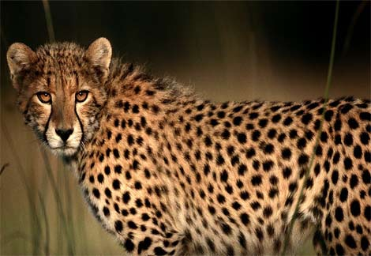

Cheetah 2 Three Day Boot Camp Agenda

Safari Day One – 8 hours

1.0 Welcome! (15 mins)
1.1 Informix Dynamic Server (IDS) Techie Survival Guide (30 mins)
1.2 IDS Fundamentals (30 mins)
1.3 IDS version 11.50 a.k.a Cheetah 2 Features Spotlight (60 mins)
1.4 Getting Started with IDS 11.50 - Installing and Configuring IDS 11.50 on Linux (45 mins)
Lunch Break (60 mins)
1.5 Getting Started with IDS 11.50 - Installing and Configuring IDS 11.50 on Linux (Hands On) (60 mins)
1.6 Administering IDS in free time (45 mins)
1.7 Administering IDS in free time (Hands On) (45 mins)
1.8 IDS Open Admin Tool (45 mins)
1.9 IDS Open Admin Tool (Hands On) (45 mins)

Safari Day Two – 8 hours

2.1 IDS Application Development Overview (45 mins)
2.2 Introduction to IDS SPL (45 mins)
2.3 Introduction to Data Studio (45 mins)
2.4 Introduction to Data Studio (Hands On) (45 mins)
Lunch Break (60 mins)
2.5 IDS 11.50 Unmatched Continuous High Availability - Replication in IDS (90 mins)
2.6 IDS 11.50 Unmatched Continuous High Availability - Replication in IDS (Hands On) (2 hrs 30 mins)

Safari Day Three - 8 hours

3.1 IDS Performance Tuning & Troubleshooting Tools and Techniques (60 mins)
3.2 IDS Performance Tuning & Troubleshooting Tools and Techniques (Hands On) (60 mins)
3.3 IDS Security (45 mins)
3.4 IDS Security (Hands On) (45 mins)
Lunch Break (60 mins)
3.5 Upgrading your IDS databases to Cheetah 2 (45 mins)
3.6 Upgrading your IDS databases to Cheetah 2 (Hands On) (60 mins)
3.7 Solid DB and IDS - Killer Combination (60 mins)
3.8 Solid DB and IDS – Killer Combination (Hands On) (45 mins)

