J.K. Direct Demo Script

This demo shows what is possible using the WebSphere V6.1 Business Process Management software from IBM BPM Suite. It is based on a fictional company called “J.K. Direct” that is a consumer electronics retailer.

The CEO of J.K. Direct, Craig, starts with the center of his daily life – the desktop. We can see that he has just received an alert from WebSphere Business Monitor version 6.1, IBM’s Business Activity Monitoring software. The alert appears in a Google Gadgets widget that sits on his desktop. Craig uses Google Gadgets to stay on top of what’s going on inside and outside of J.K. Direct.

Alert in Google Gadget (00:00)
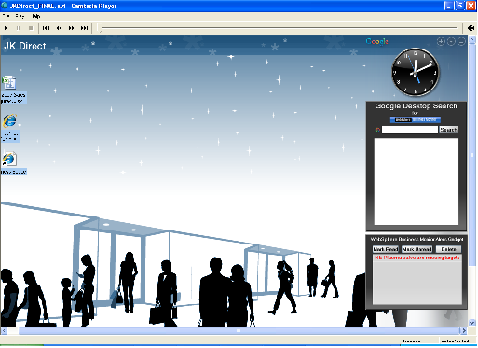

This is the first example of how business users can get access to information from WebSphere Business Monitor wherever they need it, an approach with which IBM is leading the BPM market. Business alerts and data about J.K. Direct’s business – supplied directly by WebSphere Business Monitor are available to Craig within Google Gadgets. We’ll see many more examples of the “business users can access information wherever they are” concept during this demo.

The alert tells Craig that there’s a problem with HD Plasma TV sales in the North East region, so he wants to learn more. Staying within Google Gadgets, he uses Google Desktop Search, which IBM has extended to include searching within WebSphere Business Monitor. He searches “plasma sales” and finds a sales report spreadsheet from December. He sees Key Performance Indicators, or KPIs, on plasma sales measured in WebSphere Business Monitor. There’s no issue in the other three regions – so there is at least some good news today!

View KPIs in Gadget (00:13)
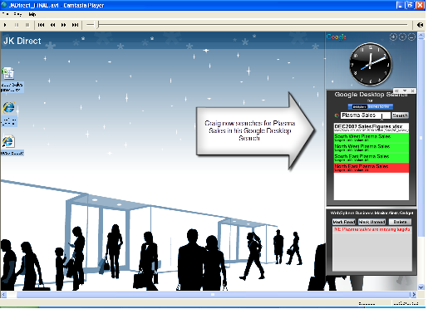
Next, Craig examines the December report, which shows KPIs that are green and that sales are on track. Only one problem – it’s from last month! So, Craig decides it’s time to get his VP of Sales, Angel, to look into this for him.
Gadget to spreadsheet (00:27)
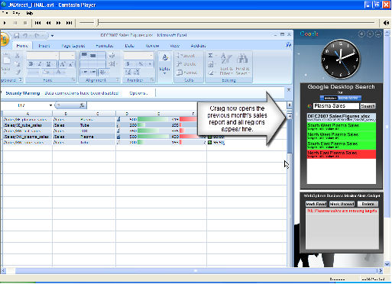

Craig opens up his Lotus Sametime contact list. Here we see yet more of the “business users access information wherever they are” theme. There is integration of WebSphere Business Monitor data into Lotus Sametime, and the same can be done for Lotus Notes. In fact, with the Web 2.0 REST services interface that WebSphere Business Monitor has, anyone can create simple applications that include the WebSphere Business Monitor data. Best of all, this plug-in is available for download from IBM now on alphaWorks.

Forward alert from Sametime (00:52)
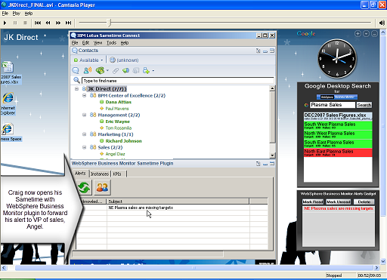

Craig opens the alert to take a look at the details of the situation. He then clicks on the alert and forwards it to Angel through Lotus Sametime. Collaboration is a core capability of IBM’s BPM Suite as you can see here. Craig also sends Angel the December report spreadsheet and asks him to update it.

So now let’s turn to Angel, the VP of Sales for J.K. Direct. He receives the Lotus Sametime from Craig, including the forwarded alerts and the spreadsheet.

At this point, the demo switches to Angel, the VP of Sales for J.K.Direct. He receives the Sametime from Craig, including the forwarded alerts and the spreadsheet. The first thing he Angel does is open up the spreadsheet. Angel knows a trick here that will help him impress Craig. WebSphere Business Monitor data is everywhere again accessible right where Angel needs it—in Excel! Angel goes to the data tab of the spreadsheet and clicks Refresh All. By doing this, Angel refreshes the old report data with real-time data from WebSphere business Monitor.
Refreshes spreadsheet from database (02:41)
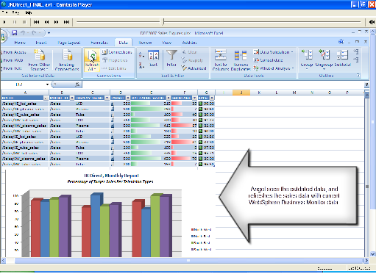

The KPIs have changed from green to red for North East Plasma sales, and the graph underlines the fact that things are not great right now. This decline in sales really concerns Angel because the Super Bowl is coming up on February 3rd, less than a week away, and HD plasma sales should be at their peak. Especially in the North East, where both teams playing in the 2008 Super Bowl are from!

Angel then goes back to Lotus Sametime with Craig and looks at the alert. The alert has a helpful link in it, enabling him to drill down into the problem. He clicks on the link and logs into his personalized process workspace. Here, Angel has access to all of the process and productivity tools he needs in one place. He accesses the page with the sales data, and here he begins to dive deeper into the problem. Looking at the KPIs for North East stores, he notices that New York is actually doing great, but Boston and Philadelphia are in the red – meaning they are performing poorly.

KPIs for regions (03:37)
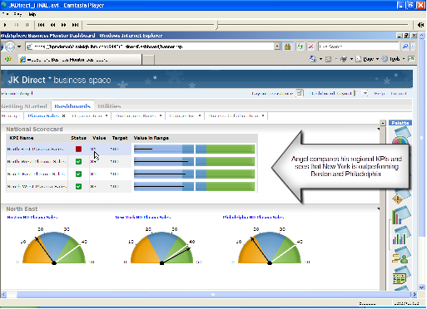
Angel didn’t become VP without understanding sales, and he knows the impact of floor layouts on the figures. That’s why he had his graphics team build a dedicated floor layout application in Flash and integrated that with WebSphere Business Monitor, using the simplicity of Web 2.0 REST services.

He goes to the palette on the right of his workspace, and drags the floor layout analysis application from the palette and adds it to his page—self-service, dynamic business dashboards reacting to real-time information. The custom Flash application opens and lets him click down to the North East stores, and then look at their floor layouts one by one. Because the data can be integrated with WebSphere Business Monitor, he sees live annotations on the layouts, showing him the sales figures in real-time.

Sure enough, in New York HD plasmas are doing great, and no surprise – they’re positioned right by all the old CRT style TVs. That’s a trick Angel learned years back – make your best products look even better by putting them by your worst.

NY sales on floor layout (04:13)
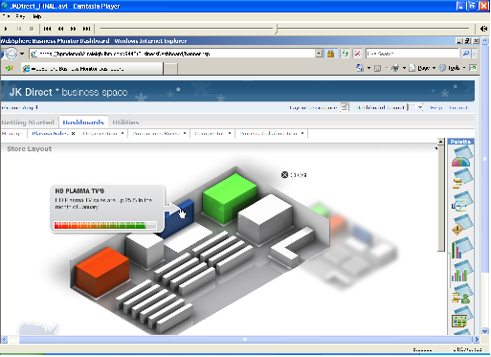
Looking at Philadelphia and Boston shows that they haven’t adopted this approach. Instead they have the DVD-Recorders positioned by the plasmas. They need to switch in order to emulate the success of New York stores.

Angel knows that there is a business process analyst in charge of the store layout process at J.K. Direct, but he can’t remember who it is, so he switches over to the Organization view, still within his own process workspace.

The Organization view shows further integration with everyday productivity tools—such as Microsoft PowerPoint, inside his own process workspace. IBM also provides dedicated organizational views that can be integrated with corporate directories.

Organization chart (05:10)
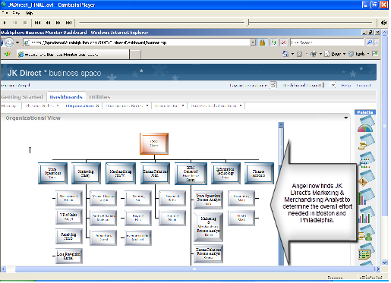
In this case, Angel looks down the organizational chart in the BPM Center of Excellence that J.K. Direct put in place with the help of IBM Global Business Services. Within that the BPM Center of Excellence organization, he finds Dana – she’s the person who can use process analysis to tell him what it will take to fix Boston and Philadelphia. Angel calls Dana and asks her to run some simulations, what-if scenarios, and create a report to let him know what it would take to make those changes.

Dana uses WebSphere Business Modeler Advanced Version 6.1 to run simulations against her store layout process. Her model covers all the aspects, such as additional inventory ordering, sales re-training, store floor logistics, and much more.

Dana’s report shows that changing the stores will take a few days, which is not bad, but not good enough for Angel. He asks Dana to go ahead and implement the changes anyway – they’ll be good to have in place next week. Angel will come back to this issue later to improve J.K. Direct’s store layout process, but right now Angel has a more immediate concern – Super Bowl weekend. He needs to do something NOW to get those sales moving. Time for a tactical solution!

Angel noticed earlier that although the Philadelphia and Boston stores did not have the old TVs by the plasmas, they did have DVD-Recorders next to them. The best thing he can do to sell more plasmas is to offer a promotion – buy a plasma and get a free DVD-Recorder. So Angel switches to his Promotions page in his workspace, where he can change the promotions business rules.

He creates a new one for the Plasma with DVD-R promotion, and then looks at the Promotions business process. J.K. Direct is very process oriented, so Angel uses IBM’s BPM Suite to gain visibility into the processes whenever he needs it. Here he can see in WebSphere Business Modeler that the promotions rules will be followed by a Promotions human workflow to set up the promotion, signified by the person icon on the blue task.

Angel creates a new promotions rule (05:37)
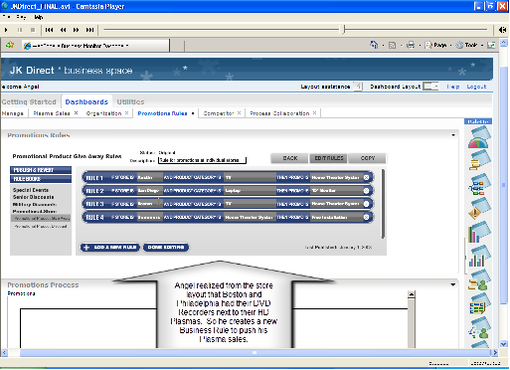
This human workflow of creating a new business rule is automatically created in WebSphere Process Server Version 6.1, and manages all of the human steps required to set up promotions. Such as creating flyers to hand out to customers, writing the deal of the day on the white board, putting ribbons around the plasmas and DVD-Recorders, and so on. It also can create work items to ensure that all sales staff in the store get up to speed on the promotion.

Let’s take a quick look at the human workflow experience switching roles to Richard – the store Promotions Manager. He logs into his Business User Client and sees the promotions to-do list that was created as a result of Angel’s new business rule promotion. Richard clicks on it, then claims it. The form displayed is what he will use to instruct his colleagues on what they need to do. This is a Lotus Form, a very popular product from IBM that is completely embedded into IBM’s BPM solution. It allows Richard to digitally sign the form, providing an audit trail, and ensuring others do not alter the promotion by preventing changes to the values. Richard completes the form and his To-do is complete.
Promotions human task (07:04)
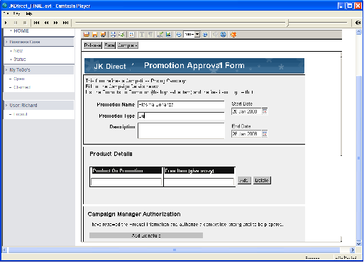

Now, let’s go back to Angel, who wants to focus on process improvement. He moves to the Process Collaboration page that allows various stakeholders within J.K. Direct to participate in continuous process improvement by using WebSphere Business Modeler Publishing Server Version 6.1. This tools offers a Web-based browser where subject matter experts and process stakeholders can view and comment on process models. Although Dana owns the process model, others can contribute requirements and suggestions through the interactive blog-like interface for better business and IT collaboration to ensure there’s no repeat of the Boston and Philadelphia problems next time.

Process collaboration (08:03)
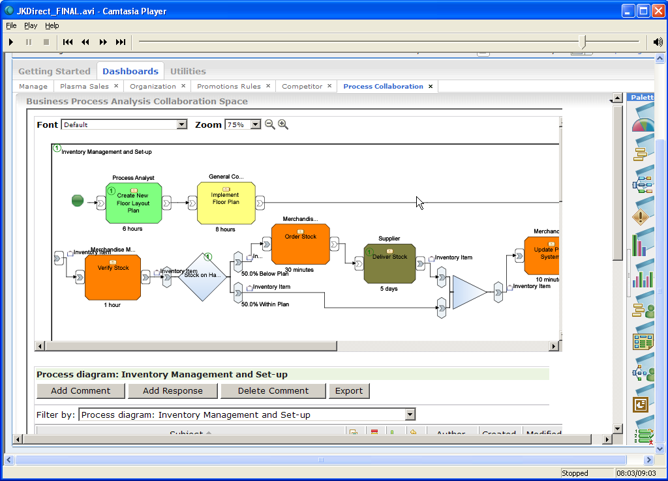

IBM’s Business Process Management Suite has enabled J.K. Direct to perform everything you’ve seen today and gives them the competitive edge to succeed – an edge that your business needs, and can receive by harnessing the power of IBM BPM Suite. To learn more, contact your local IBM representative, or visit ibm.com/software/innovate.

