Better Buy Demonstration Script and Notes, 9:03 seconds

This demo shows what is possible using the V6.1 WebSphere BPM products from IBM, with some previews of direction. It is based on a fictional company called ‘Better Buy’ that is a consumer electrical and electronics retailer.

NOTE TO SELLERS: Summary of features highlighted:

- Lotus Sametime Integration - Available Now
- Google Gadgets - Available Now, talk to development if of interest to a customer
- Microsoft Excel integration - Available Now using Excel 2007, with further simplified capability coming
- Business Space -- You can extend WebSphere Business Monitor today to achieve this with IT customization. This concept focuses on incorporating more WebSphere BPM tooling along with day to day productivity tools (e.g. Excel, Sametime, etc. into one user interface)
- Embedding Flash applications that connect to Monitor (the store layouts) - Can be done now, requires customer developing a Flash application and connecting it to Monitor's REST services – this piece demonstrates custom dashboard Flash apps.
- Collaboration Space/WebSphere Business Modeler Publishing Server - Available Now

---------------------------------------------------------------------------------------------------------------------------------

The demo begins with the CEO of Better Buy, Craig, starting with his daily life – the desktop. He has just received an alert from WebSphere Business Monitor V6.1, IBM’s BAM product. The alert appears in a “Google Gadgets” that sits on his desktop. Google Gadgets allows people to download and add applications/widgets that are useful to them, for example stock prices, news feeds, clocks, etc. Craig uses them to keep on top of developments in Better Buy’s world, inside and outside of the company.

This is the first example of the ‘BAM Everywhere’ approach that IBM is leading the BPM market with. Business alerts and data about Better Buy’s business – supplied directly by WebSphere Business Monitor V6.1 – is available to Craig within Google Gadgets. We’ll see many more examples of where that data can be seen to show more of this ‘BAM Everywhere’ concept during this demo.

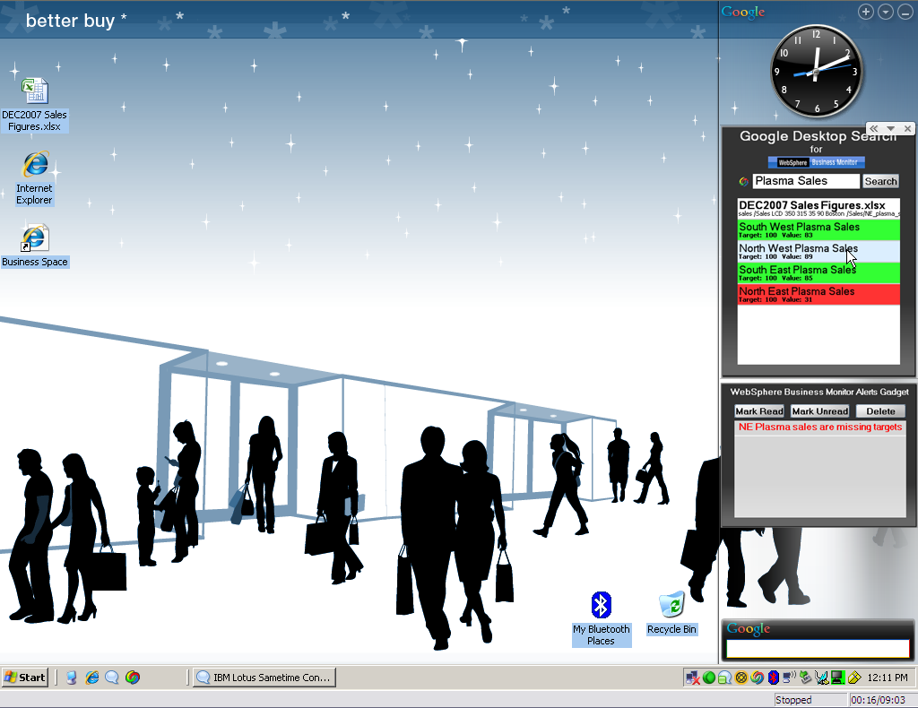

Craig sees that the alert tells him there’s a problem with HD Plasma sales in the North East region, so wants to learn more. Staying within Google Gadgets he uses Google Desktop Search which IBM has extended to include searching of WebSphere Business Monitor. He searches on plasma sales and finds a sales report spreadsheet from December which might tell him something. But better still, the search has also found him the Key Performance Indicators (KPIs) that WebSphere Business Monitor is measuring for him concerning plasma sales. He can see that there’s no issue in the other three regions – at least that’s some good news today!

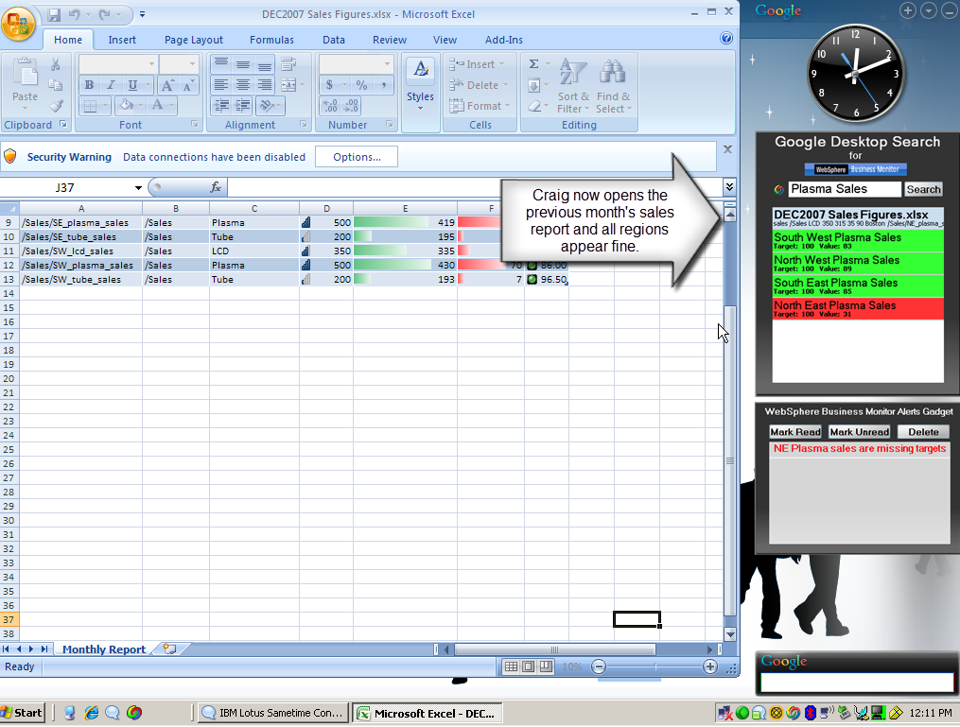

Next Craig double clicks on the spreadsheet to open it up and check out that December report. It all looks good – the report shows KPIs that are green, and a nice chart to show sales on track. Only one problem – it’s from last month! “That’s the problem with spreadsheets isn’t it?” Craig decides it’s time to get his VP of Sales, Angel, to look into this for him.

Craig opens up his Lotus Sametime contact list. Here we see yet more of the ‘BAM Everywhere’ theme. There is integration of WebSphere Business Monitor V6.1 data into Sametime, and the same can be done for Lotus Notes. In fact, with the Web 2.0 RESTful services interface that Monitor has, anyone can create simple applications that include the Monitor data. Best of all, this Sametime plug-in is available from IBM now.

Craig opens the alert to take a look at the details of when it occurred and look at the rest of the information. He then clicks on it and forwards it to Angel. Collaboration is a core capability of IBM’s BPM as you can see here. Craig also sends Angel the December report spreadsheet and asks him to update it.

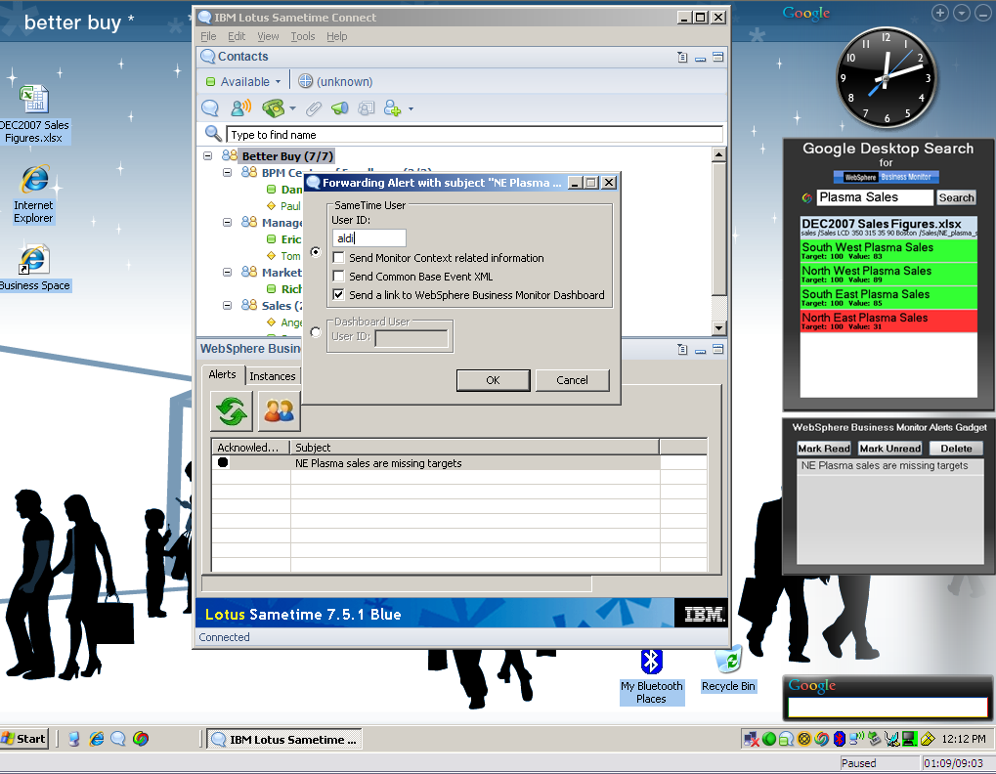

At this point the demo switches to Angel, the VP of Sales for Better Buy. He receives the Lotus Sametime from Craig, including the forwarded alerts and the spreadsheet.

The first thing Angel does is open up the spreadsheet. Angel knows a trick here that will help him impress Craig. WebSphere Business Monitor is everywhere again! This time the data is available inside Excel. Angel goes to the data tab of the spreadsheet and clicks Refresh All. After confirming he wants to do this, he selects the WebSphere Business Monitor and clicks OK. All of the data in the spreadsheet is updated with the real-time information from Monitor. This is no longer a December report, this is a right now report, and it doesn’t look good!

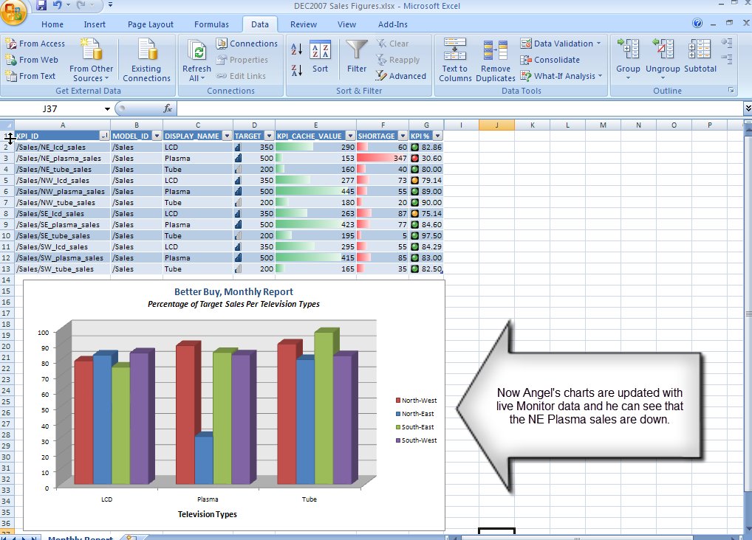

The KPIs have changed from green to red for NE Plasmas, and the graph shows things are not doing well at the moment. This really concerns Angel because the Super Bowl is coming this weekend (Feb 3, 2008), and HD plasma sales should be at their peak. Especially in the North East where both of the teams in the 2008 Super Bowl are from!

Angel goes back to the Lotus Sametime with Craig and looks at the alert. The alert has a helpful link in it for him to drill down into the problem. He clicks on the link to the Business Space. This is a key theme for IBM’s BPM so let’s take a good look at what can be done.

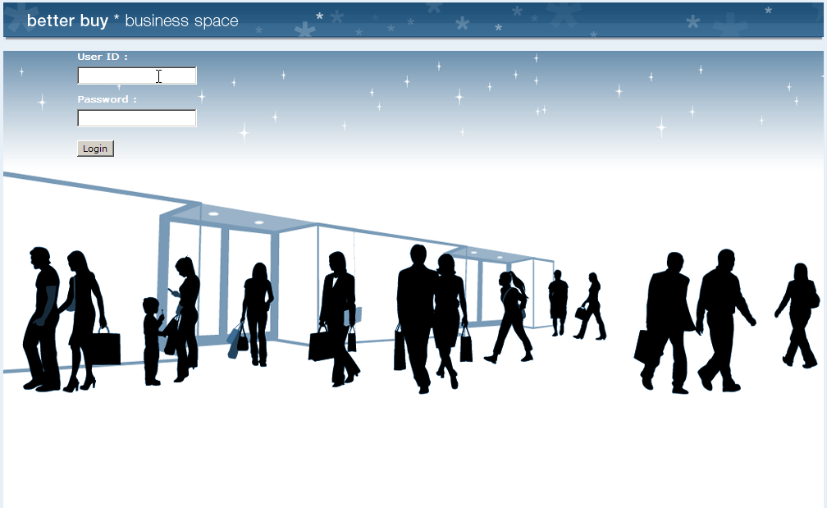

The Business Space opens and Angel logs in. He gets his own personal business space (WebSphere Business Monitor V6.1 dashboards that incorporate other WebSphere BPM tools inside one user interface) and he has full self-service control of what’s in it. He comes in to the page with sales data and here he begins to peal back the onion on the problem. Looking at the key performance indicators for North East stores, he notices that New York is actually doing great, but Boston and Philadelphia are in the red (poor) range.

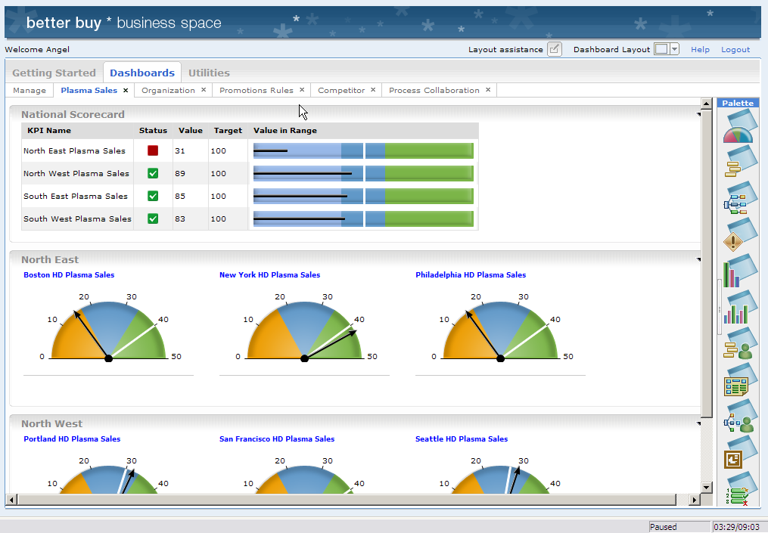

Angel is a seasoned sales pro, and he knows what helps sales. He didn’t get to be VP without understanding the impact of floor layouts on the figures. That’s why he had a dedicated floor layout application built in Flash by his graphics team and integrated with WebSphere Business Monitor V6.1 using the Web 2.0 RESTful services simplicity.

He goes to the palette on the right of his business space and drags the floor layout analysis application from the view and adds it to his page. This is self-service dynamic dashboards to react to whatever happens in real-time. The Flash application opens and lets him click down to the North East stores, and then look at their floor layouts one by one. Because the data can be integrated with WebSphere Business Monitor V6.1, he sees live annotations on the layouts to show the sales figures.

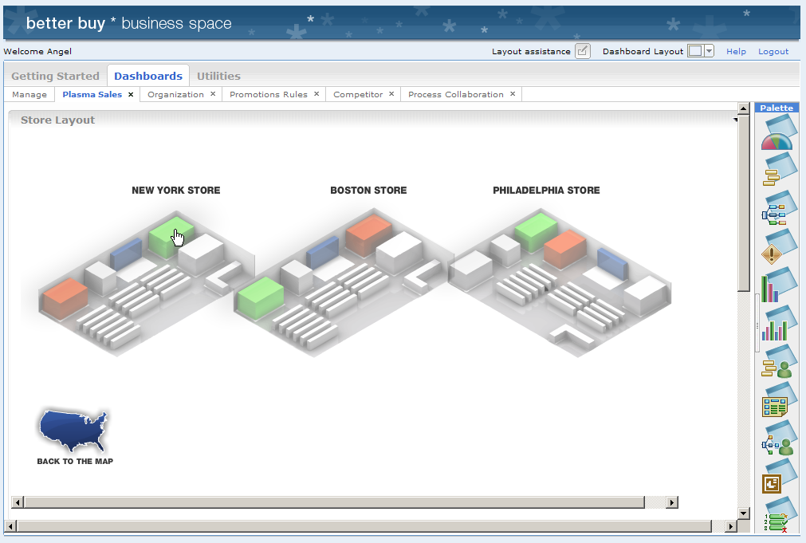

Sure enough, in New York HD plasmas are doing great, and no surprise – they’re positioned right by all the old CRT style TVs. That’s a trick Angel learned years back – make your best products look even better by putting them by your worst. No wonder New York is doing so well!

Looking at Philadelphia and Boston shows that they haven’t adopted this approach. Instead they have the DVD-Recorders positioned by the plasmas. They need to switch in order to emulate the success of New York.

Angel knows that there is a business process analyst in charge of the store layout process at Better Buy, but he can’t remember who it is. No matter – he switches over to the Organization view, still within the Business Space. The Business Space concept should be becoming more obvious now – empowering the business user with all the tools they need within one application.

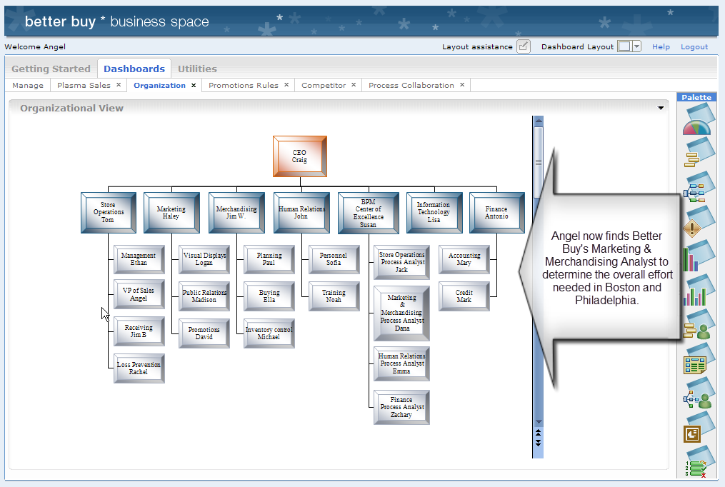

The organization view shows further integration, this time running Microsoft PowerPoint inside the business space. IBM also provides dedicated organization views that can be integrated with corporate directories. In this case he looks down the org chart in the BPM Center of Excellence that Better Buy put in place with the help of IBM Software Services. Within that organization he finds Dana – she’s the person who can tell him what it will take to fix Boston and Philadelphia with some process analysis. Angel calls up Dana at this stage (not shown) and asks her to run some simulations, what if scenarios, and create a report for him to let him know what it would take to make those changes.

Dana (not shown) uses WebSphere Business Modeler Advanced V6.1 to run simulations against her store layout process. Her model covers all the aspects such as additional inventory ordering, sales re-training, store floor logistics, and much more. WebSphere Business Modeler Advanced V6.1 allows her to run simulations of what will happen if she changes Boston and Philadelphia, and then generate reports on the resources, time, money needed. She has the report back to Angel in minutes (NOTE TO SELLERS: This report is available to show to your customers and is entitled: Better Buy Inventory Management Report).

The report shows that changing the stores will take a few days, which is not bad, but not good enough for Angel. He asks Dana to go ahead and implement the changes anyway – they’ll be good to have in place next week. Angel will come back to this issue later to improve Better Buy’s process and strategy, but right now Angel has a more immediate concern – Super Bowl weekend. He needs to do something NOW to get those sales moving. Time for a tactical solution….

Angel noticed earlier that although the Philadelphia and Boston stores did not have the old TVs by the plasmas, they did have DVD-Recorders next to them. The best thing he can do here to sell more plasmas is to offer a promotion – buy a plasma and get a free DVD-Recorder. So Angel switches to his Promotions page in the business space where he can change the promotions business rules.

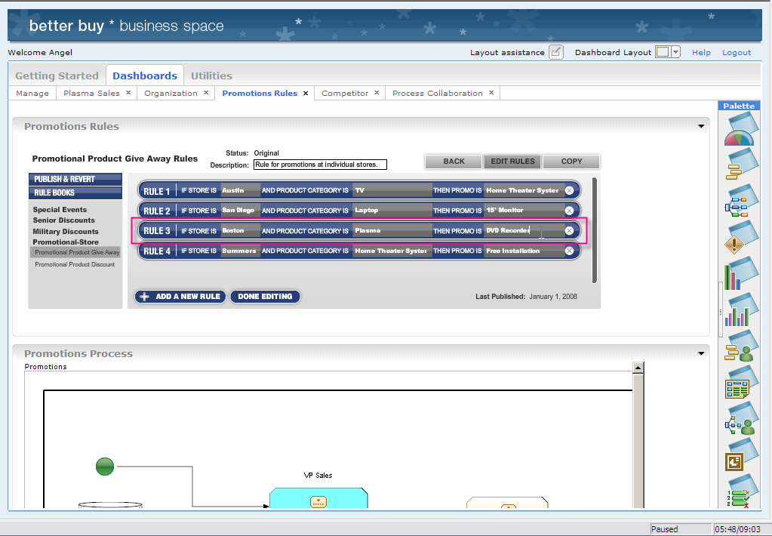

NOTE TO SELLERS: The Business Rules Client (Promotions Rules) shown above is a mock-up and the image below (Business Rules Group) is what is available in V6.1 – Business Rules embedded inside a view in the Monitor dashboard.

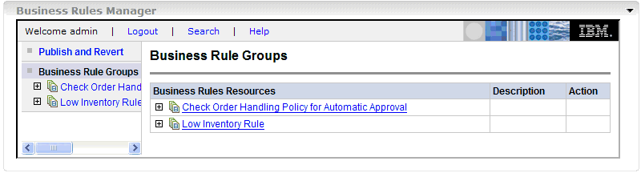
He creates a new one for the plasma/DVD-R promotion, and then looks at the promotions business process. Better Buy is very process oriented – Angel therefore has visibility into the processes whenever he needs them. Here he can see in WebSphere Business Modeler V6.1 that’s embedded into the Monitor interface that the promotions rules will be followed by a promotions human workflow to set up the promotion, signified by the person icon on the blue task.

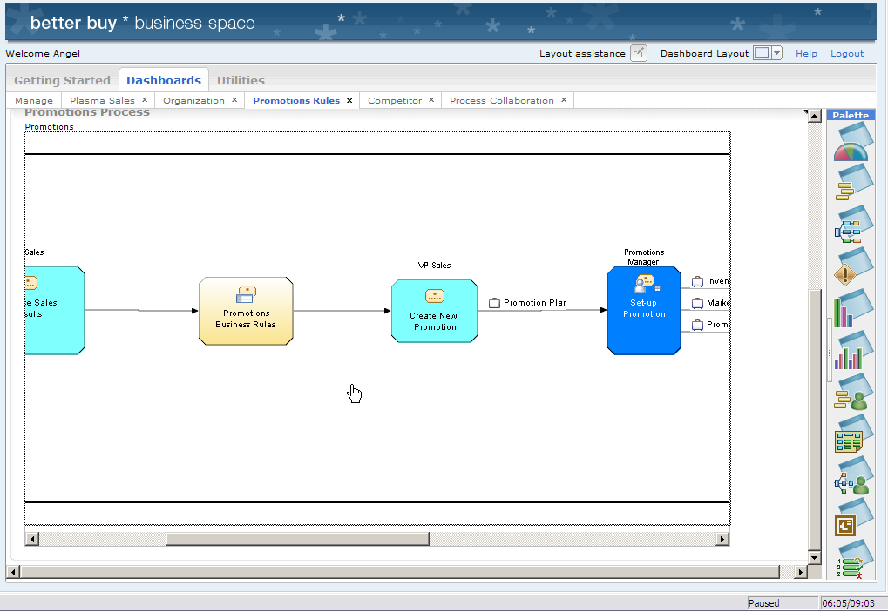

This human workflow of creating new business rule is automatically created in WebSphere Process Server V6.1, and manages all of the people steps required to set up promotions such as, creating flyers to hand out to customers, writing the deal of the day on the white board, putting ribbons etc. around the plasmas and DVD-Recorders. It also can work items to ensure that all sales staff in the store are knowledgeable about the promotion.

Let’s take a quick look at the human workflow experience by showing one of the steps. We’ll log out of the “Business Space” screen and switch roles to ‘Richard’ – the store Promotions Manager. He logs into his Business User Client, just like the Business Space, and here he sees the promotions “to do” that was created as a result of Angel’s new promotional business rule. He clicks on it, then claims it. The form displayed is what he will use to tell his colleagues about what they need to do. This is a Lotus Form, a very popular product from IBM that is completely embedded into IBM’s BPM solution. It allows Richard to digitally sign the form, providing an audit trail, and ensuring others do not alter the promotion by preventing changes to the values. Richard completes the form and his to do is complete. Let’s switch back to Angel.

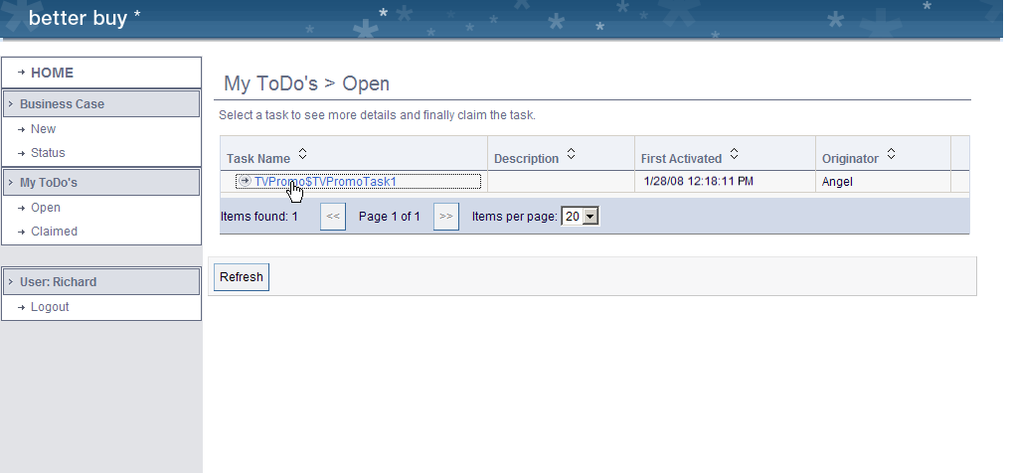

Lotus e-Forms embedded in Monitor V6.1

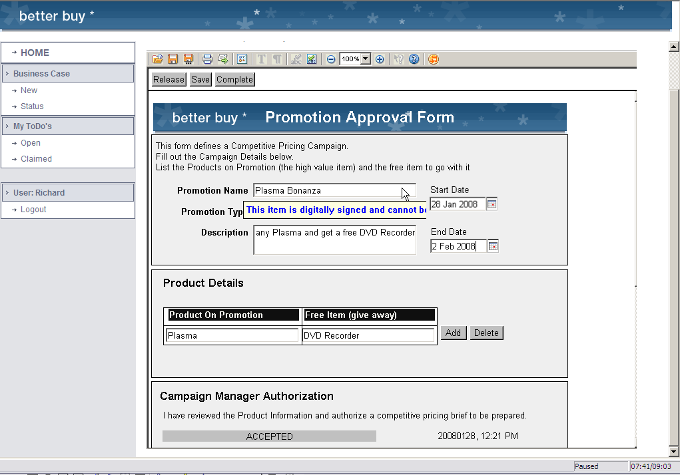

It’s time to think about process improvement. Angel moves to the Process Collaboration page. This is where Better Buy allows all stakeholders to participate in the process improvement by using WebSphere Business Modeler Publishing Server V6.1. Although Dana owns the process model, others can contribute requirements and suggestions through the interactive blog-like interface. They can better understand the process and can even see the IT implementation process too, especially useful for business and IT collaboration. Angel could use this to suggest adding an approval step to the business process so that any new floor layouts must be approved by him. It’s all about process improvement at Better Buy, and this will ensure there’s no repeat of the Boston/Philadelphia problems next time.

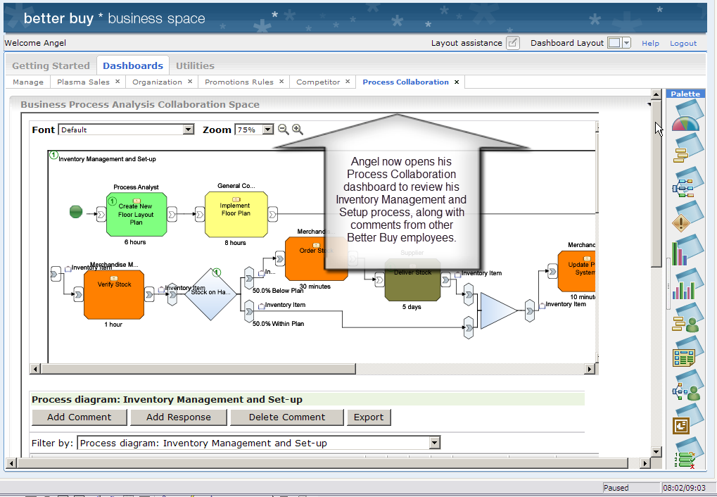

IBM’s Business Process Management has enabled Better Buy to perform everything you’ve seen today and gives them the competitive edge that your business needs.

