How to play in the sandbox

All the IMS tutorials are now consolidated into a Web page under the IMS Trials and Demos page, so you can easily find all the IMS demos and trials and download the PDF files for the tutorial instructions.
To play in the sandbox:
1. Go to the IMS Trials and Demos page at http://www.ibm.com/software/data/ims/demos.html.
2. Download and print a copy of the trial and demo that you are interested in.
3. On the IMS Trials and Demos page, click the Try Now link for the tutorial that you are interested in. You are now in the Enterprise Modernization Sandbox for System z Applications entry point.
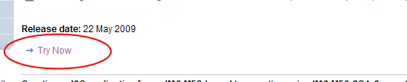
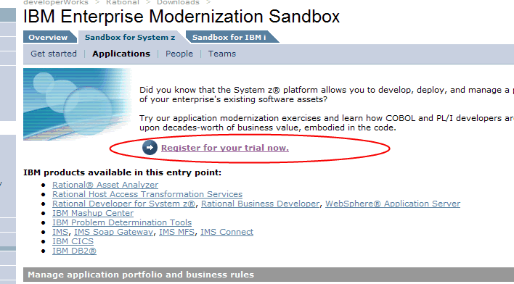
4. If you do not have the required Citrix XenApp client installed, install it:
a. In the section “Extend IMS applications for SOA and Web 2.0,” click read more on how to use the Sandbox.
b. Go to the “Online trial prerequisites” section, and follow the link to download the Citrix XenApp client.
The online trial program uses the Citrix XenApp client to provide a connection from your workstation to a remote IBM server that is running the IBM product you are evaluating. This is a one-time installation. Select the version based on your operating system.
c. Install the Citrix XenApp client.
d. After the installation process is complete, restart your browser.
You can now go back to the IBM Enterprise Modernization Sandbox for System z Applications entry point and register for the trial. After you register, you can access Rational Developer for System z, IMS SOAP Gateway, IMS TM Resource Adapter, IMS MFS SOA support, and IBM Mashup Center, all installed in an online environment. You also have access to a test mainframe environment that lets you quickly deploy and test the scenarios.

