

International Business Machines Corporation

1300 East Ninth Street – Suite 700

Cleveland, OH 44114

January 07, 2003
Miss XYZ
XXX Incorporated
street
city, state, zip
Mail code:
Dear Miss:
Thank you for the opportunity to propose IBM Access Manager for e-business (AMEB) as a solution for XXX’s Extranet Access Management (EAM) Project.
We have carefully assessed your business and technical requirements and IBM feels that we are uniquely qualified as a solution provider for this project. IBM has chosen to partner with Deloitte and Touche on this opportunity. D&T will be responsible for the deployment services as it relates to this project. IBM and D&T have built a strong business practice around IBM’s Security solutions, specifically AMEB. D&T has a tremendous amount of experience and expertise in assisting organization like XXX in deploying Extranet Access Management solutions.
In the following RFP proposal response, IBM’s solution is outlined in detail and we welcome the opportunity to clarify and answer any additional questions about our software solution and implementation approach. IBM believes through this collaborative effort we can help XXX achieve the business goals stated in your RFP.
IBM hopes you find our proposal informative and thorough. After XXX’s review please feel free to contact Ron Kruse, IBM’s solution leader, at, with any questions.
Best Regards,

Ron Kruse Mary Wagner Karen Bacheder
Security Sales Specialist Software Account Manager XXX Client Executive
IBM Corporation IBM Corporation IBM Corporation
1300 East Ninth Street 18000 West 9 Mile Road 18000 West 9 Mile Road
Suite 700 Southfield, MI 48075 Southfield, MI 48075
Cleveland, OH 44114
XXX

Customer Access Management

2002 Request for Proposal

January 15, 2003

IBM Corporation
1300 East Ninth Street – Suite 700
Cleveland, OH 44114
Contents

Executive Summary 3
4 Supplier Information 9
4.1 Supplier Contact Information 9
4.2 References 10
4.3 Subsidiary/Commonly Controlled Affiliate/Parent Information 12
4.4 Organization Overview and Financial Information 13
4.5 Supplier’s Customer Base 16
4.6 Supplier’s Account Team 16
4.7 Billing Requirements 18
4.8 Supplier Diversity 20
4.9 Insurance 22
4.10 Lawsuits and Legal Action 23
4.11 Privacy 23
5 Customer Access Management 25
5.1 Requirements 25
5.2 Quality of Service 99
5.3 Services – 124
5.4 Vision 167
5.5 Pricing 171
Attachment 1: Announcement of Intent to Respond 176
Attachment 2: Non-Disclosure Agreement 177
Attachment 3: Questions for Bidders 179
Attachment 4: Authorization Letter 180
Appendix A: IBM Software Support Guide 181

Preface

The information in this proposal shall not be disclosed outside the XXX organization and shall not be duplicated, used or disclosed in whole or in part for any purpose other than to evaluate the proposal, provided that if a contract is awarded to IBM as a result of or in connection with the submission of this proposal, XXX shall have the right to duplicate, use or disclose the information to the extent provided in the contract. This restriction does not limit the right of XXX to use information contained in the proposal if it is obtained from another source without restriction.
IBM's products and services are proposed under the terms of the IBM Customer Agreement.

Executive Summary

Why IBM:
An integral part of the comprehensive IBM e-business infrastructure solution, Access Manager for e-business software helps traditional enterprises, emerging e-businesses, and Internet businesses worldwide maximize their existing and future technology investments. Backed by world-class IBM services, support and research, Access Manager for e-business software provides a seamlessly integrated and flexible e-business infrastructure management solution that uses robust security to connect employees, business partners and customers.

Why Deloitte And Touche:
Deloitte & Touche is one of the nation’s leading professional services firms providing management consulting, assurance and advisory, tax, and actuarial services. Our firm is one of the largest and most highly regarded professional services organizations in the world, with worldwide revenues of more than $12 billion in 2002.
We are pleased at this opportunity to provide Implementation Services in partnership with IBM and are very qualified to serve you. Deloitte & Touche has a long and experienced history addressing trust, security, and control activities for our clients. Our Enterprise Risk Services (ERS) group consists of approximately 5,000 full-time professionals on six continents who offer a full spectrum of risk-related services. In the United States alone, we have approximately 2,000 dedicated professionals in 35 offices.
During this engagement we will partner with XXX in a collaborative fashion and leverage to the fullest extent possible our knowledge of your industry and business. We appreciate the opportunity to propose on this important project for XXX. Our services are provided with a level of dedication and excellence that reflects our commitment to your success.

Why Access Manager For E-Business:
Enterprises are discovering that security not only can protect their business, but it can also help deliver real bottom-line results. As an industry analyst from Gartner states, “For e-business to be successful, security solutions must be seen as business enablers rather than a limitation or an inhibitor and must be addressed early.” Obviously, today’s security measures continue to protect networks, but there has been a significant shift in the focus of security technologies, resulting in solutions that can actually move your business forward faster.
Today’s business-oriented solutions can secure the enterprise in a way that proactively helps companies achieve their goals, such as improving customer acquisition and retention and corporate expansion. Specifically, they allow organizations to deploy secure e-business applications and portals quickly and cost-effectively and securely manage e-business relationships, by automating and centralizing security administration. In addition, with these solutions, organizations can now leverage plug-and-play security for e-business applications and put in place a consistent security policy across the entire e-business infrastructure. Increased efficiency and productivity, reduced costs and faster time-to-market for new initiatives are just a few of the business benefits you can expect from Access Manager for e-business.

Robust Security For E-Business And Legacy Applications:
IBM Access Manager for e-business can help enable you to manage growth and complexity, control escalating management costs and address the difficulties of implementing security policies across a wide range of Web and application resources. You can use it to control wired and wireless access to applications and data and keep unauthorized users out. And for authorized users, IBM Access Manager for e-business integrates with e-business applications to deliver a secure, unified and personalized e-business experience. It helps you secure access to business critical applications and data spread across the extended enterprise, allowing highly available and scalable transactions with partners, customers, suppliers and employees.

IBM Access Manager For E-Business Benefits:
- Centrally define and manage security policy for a broad range of e-business applications and other managed resources.
- Provide flexible SSO to Web-based applications that can span multiple sites or domains with a range of SSO options, including a highly secure Web SSO lockbox.
- Address Federated Identity needs, through an interface that can accommodate SAML or other token implementations.
- Leverage a common security policy model with the IBM Access Manager family of products to extend support to other resources such as WebSphere MQ applications and UNIX® system resources.
- Secure your e-business environments that have demanding scalability requirements across a broad range of platforms, including Linux for zSeries.

Policy-Driven Security:
IBM Access Manager for e-business allows you to define a comprehensive policy and administer security based on that policy, giving your employees, partners, suppliers and customer’s specific access based on each user’s responsibilities. You can group users and assign permissions to groups, simplifying administration of access control across multiple applications and resources. There is support for dynamic roles, dynamic business entitlements and authorization decisions based on external data for applications that require it.
With a Web-based tool called Web Portal Manager, you can manage users, groups, roles, permissions, policies, junctions and application access provisioning. Web Portal Manager extends beyond delegated user management to also deliver delegated security administration. Multiple levels of delegated administration are possible, with great flexibility in capabilities assigned to lower-level administrators. The SSL enabled management application program interfaces (APIs) used by Web Portal Manager are available if you need to integrate or build your own customer-care management applications. These include full support for Java, C and C++.
Web Portal Manager enables administration over a broad range of target resources, including resources protected by a scalable proxy (WebSEAL or the Edge Server Caching Proxy), resources protected by IBM Access Manager Web Server Plug-Ins and J2EE, WebSphere MQ and UNIX resources that have been factored into the secure environment.
These resources are represented in a single protected object space that a single administrator or a coordinated team of delegated administrators can manage. IBM Access Manager for e-business writes audit records in a standard XML format that allows easy parsing for extracting required information. An information-gathering tool allows secure, centralized collection and reporting of audit, log, statistics and other information across the extended enterprise.

Integated Identity Management:
IBM Access Manager for e-business is an integrated component of the IBM identity management solution that can help you get users, systems and applications online and productive fast, reduce costs and maximize return on investment. IBM identity management provides identity lifecycle management (user self-care, enrollment and provisioning), identity control (access and privacy control, single sign-on and auditing), identity federation (sharing user authentication and attribute information between trusted Web services applications) and identity foundation (directory and workflow) to effectively manage internal users as well as an increasing number of customers and partners through the Internet.

Secure, Unified User Experience:
IBM Access Manager for e-business includes support to help large numbers of users participate in convenient, available and personalized transactions. With authentication and access-control services for e-business and enterprise applications and resources, you can secure customer, supplier, employee and partner connectivity across:
- Web servers.
- J2EE-based application servers.
- Industry-leading Web applications including Siebel 7, Siebel 2000, WebSphere Portal Family, WebSphere Edge Server, WebSphere Everyplace Server Service Provider Offering for Multiplatforms, Lotus Domino, Lotus iNotes™, Lotus QuickPlace™, Lotus Sametime®, mySAP.com, SAP Portal Server, BEA WebLogic Server, Epicentric Foundation Server, PeopleSoft 8, BroadVision One-to-One Enterprise, Vignette V5 and Vignette V6 Content Suite, Plumtree Corporate Portal, Oracle 9iAS Portal, KANA Platform, i2 TradeMatrix, Ariba Dynamic Trade, ATG Dynamo, Interwoven TeamSite, iPlanet Calendar, iPlanet Messenger Express, MatrixOne eMatrix and Web Intelligence (business objects).

IBM Access Manager for e-business accommodates a broad range of possible user-authentication mechanisms, including user IDs and passwords, client-side certificates, RSA SecurID tokens and mobile and wireless identities. It supports e-business configurations common to many of today’s enterprises, involving subsets of users requiring their transactions to be conducted in different languages. It also supports both the Wireless Application Protocol and the i-mode protocol. Customers with unique authentication requirements can use the plug-in authentication mechanism that comes with IBM Access Manager for e-business.
IBM Access Manager for e-business helps you deliver a consistent and secure user experience by having end users use a single identity to log in once to the Enterprise Portal or Microsoft IIS Server and gain access to resources according to authorization rules. With support for Web SSO and secure session management across e-communities, it helps securely extend your business processes to partners and business affiliates.
IBM Access Manager for e-business performs intelligent load balancing over replicated servers and can scale your server deployment. It supports implementations in excess of 1 million users, takes advantage of SSL accelerator card technology and secure hardware keystore and provides a fail-over capability that allows automatic switchover to a backup Web server.

Supports Autonomic Computing:
IBM Access Manager for e-business helps provide a self-protecting environment through:
- Prevention of unauthorized access by using a single security policy server to enforce security across multiple file types, application providers, devices and protocols.
- Web SSO for maintaining password and user integrity
- Robust auditing and information-gathering tools for discovering problems or potential problems.

It also helps provide a self-optimizing environment through:
- Load balancing and automated reflection of Web object spaces.
- Highly available and scalable architecture, based on open standards.

Modular Design For Easier Use:
The modular architecture of IBM Access Manager for e-business separates security code from application code. This can translate to an improved time to market for your e-business initiatives, because typically you can change the security code without affecting application code and vice versa. This separation also accommodates “defense in depth” designs that involve enforcing security in a layer, such as a demilitarized zone.
IBM Access Manager for e-business can help lower your cost of building security into new applications by reducing the need to write complex security code. It integrates with Web application servers that support Java 2 or JAAS without requiring nonstandard tasks such as extra pre-compiles. It also has focused J2EE-based support for securing WebSphere Application Server.
The centralized authentication and authorization services of IBM Access Manager for e-business can be provided to servlets, JSPs and Enterprise JavaBeans™ to keep the programming model simple. This support for programmatic security (with security calls right in the application) and declarative security (with security handled by containers) can greatly enhance portability and time to market.
In addition to the Java 2 services and The Open Group authorization API, IBM Access Manager for e-business supports many open industry standards and integration, including:
- LDAP for storing user and group information. IBM Directory Server, Sun ONE Directory Server, Novell eDirectory, Microsoft Active Directory and Lotus Domino Server are among the supported user registries.
- X.509 V3 client certificates for strong authentication to Web-based resources. Many certificate providers, including VeriSign, Entrust and Baltimore, are supported.
- Mutually authenticated and confidential component interactions through SSL. IBM Access Manager for e-business is an open-standards based implementation.
- Integration with IBM Identity Manager lets you share user information in a common directory and create and manage IBM Access Manager for e-business users, groups and security policies through IBM Identity Manager offering a single point of security management for the enterprise.
- IBM/ is in a leadership position with regard to security for Web Services. IBM, along with Microsoft and VeriSign, has helped ensure a workable, industry-wide approach to Web Services security by promoting the WS-Security standards, via the Organization for the Advancement of Structure Information Standards (OASIS). In line with WS-Security, IBM/ has already achieved a number of milestones regarding advancing the state of secure Web Services including:
- Completing thorough testing to ensure compatibility of SOAP message transactions, through its WebSEAL proxy. This testing included SOAP transactions in J2EE and.Net implementations.
- Defining a “Federated Identity Interface” in Access Manager for e-business V4.1 that enables customized accommodation of multiple token types, enabling business –to-business (cross-domain) single sign-on.,
- Successful in 2 key Burton Group Security Assertion Markup Language (SAML) “bake-offs” held in 2002, where Web Services compatibility and communication was shown through the exchange of SAML tokens with other vendors SAML-capable solutions.
- IBM plans to release enhancements and new products in 2003 that will focus on key areas that include Federated Identity, Web Services and Desktop Integration, and will begin with “out-of-the-box” support for SAML tokens, culminating with trust services, authentication services and both course- and fine- grained access control for Web Services, all available as part of a unified, policy-based, Access Manager authorization solution.

4 Supplier Information
XXX may request additional data, discussion, or presentation in support of any submitted RFP. Additionally, XXX may conduct a survey of any supplier under consideration to confirm or clarify any information provided, or to collect more evidence of managerial, financial and technical abilities, including, but not limited to, meetings and visits to current customers serviced by the supplier.

4.1 Supplier Contact Information
Supplier Name IBM - Ron Kruse
Address 1300 East Ninth Street
City, State, Zip Cleveland, OH 44114
Phone No. 440-582-6740 Fax No. 440-582-6741

Please specify the name and telephone number of the following individuals in the chart below.
Title | Name | Phone
President or Product Executive | Arvind Krishna | 512-286-1228
Lead Architect | Greg Cornett | 614-659-7064
Technical Sales Eng. | Michael Core | 614-755-2445
XXX’s Contact | Ron Kruse | 44-582-6740

4.2 References
Please provide us with references for your company’s three largest accounts, three accounts within the financial services industry, and three accounts lost within the last eighteen months in the charts below.
Overall Accounts
Company Name & Address | Principal Contact & Phone | 2001 Annual Billing | Scope of Work
1. Ford Motor Co. | Karen Bachelder (248) 552-5980 |  | Information Technology and Service
2. General Motors | Karen Bachelder (248)552-5980 |  | Information Technology and Service
3. JP Morgan Chase & Co. | Karen Bachelder (248) 552-5980 |  | Information Technology and Service

Financial Services Accounts
The Financial service sector is the largest vertical market that IBM serves. We are fortunate enough to have relationships with every major financial services firm around the globe.
Principal contacts are coordinated through your financial services representative. Due to confidentially agreements in place with our clients, we do not disclose “Annual Billing” figures. However, the following are a sample of a few financial services providers that IBM has in the US. Please note that they are not ranked in any order.
Company Name & Address | Principal Contact & Phone | 2001 Annual Billing | Scope of Work
1. Wells Fargo and Co. | Karen Bachelder (248) 552-5980 |  | Information Technology and Service
2. ABN Amro | Karen Bachelder (248)552-5980 |  | Information Technology and Service
3. National City Corp. | Karen Bachelder (248) 552-5980 |  | Information Technology and Service

Accounts lost within the last 18 months
Company Name & Address | Principal Contact & Phone | 2001 Annual Billing | Scope of Work
1
2
3

It is IBM’s policy not to comment regarding IBM internal decisions or our client company’s internal decisions.

4.3 Subsidiary/Commonly Controlled Affiliate/Parent Information
Please list all of your company’s subsidiaries, commonly controlled affiliates and/or parent companies in the following chart. If additional space is required, please include it as an attachment.
Subsidiary/Commonly Controlled Affiliate/Parent Company (Please specify which one with an S,A, Or P) | Location (City, State)
1
2
3
4
5

A complete listing of all IBM subsidiaries is posted in the IBM 10-K Annual Report on pages 134 through 137. The 10-K Annual Report can be obtained at the following website: http://www.ibm.com/annualreport/2001/downloads/dl_index.html.

4.4 Organization Overview and Financial Information
Provide information on your company’s organizational structure and financial condition by including the following attachments:
1. A copy of your company’s 2001 financial statements including cash flow statement.
A complete copy of IBM's 2001 financial statements can be obtained at the following web address: http://www.ibm.com/annualreport/2001/financial_reports/fr_index.html. We have included a copy of the 2001 cash flow statement as per your request.
Consolidated Statement of Cash Flows

INTERNATIONAL BUSINESS MACHINES CORPORATION
and Subsidiary Companies (Audited)
(dollars in millions)
FOR THE YEAR ENDED DECEMBER 31: |  | 2001 |  | 2000* |  | 1999*
CASH FLOW FROM OPERATING ACTIVITIES:
Net income | $ | 7,723 | $ | 8,093 | $ | 7,712
Adjustments to reconcile net income to net cash provided
from operating activities:
Depreciation |  | 4,195 |  | 4,513 |  | 6,159
Amortization of software |  | 625 |  | 482 |  | 426
Deferred income taxes |  | 658 |  | 29 |  | (713)
Gain on asset sales |  | (317) |  | (792) |  | (4,791)
Write-down of impaired investment assets |  | 405 |  | -- |  | --
Other changes that provided/(used) cash:
Receivables |  | 3,284 |  | (4,720) |  | (1,677)
Inventories |  | 337 |  | (55) |  | 301
Other assets |  | (545) |  | (643) |  | (130)
Accounts payable |  | (969) |  | 2,245 |  | (3)
Other liabilities |  | (1,131) |  | 122 |  | 2,827
NET CASH PROVIDED FROM OPERATING ACTIVITIES |  | 14,265 |  | 9,274 |  | 10,111
CASH FLOW FROM INVESTING ACTIVITIES:
Payments for plant, rental machines and other property |  | (5,660) |  | (5,616) |  | (5,959)
Proceeds from disposition of plant, rental machines
and other property |  | 1,165 |  | 1,619 |  | 1,207
Investment in software |  | (655) |  | (565) |  | (464)
Purchases of marketable securities and other investments |  | (778) |  | (750) |  | (2,628)
Proceeds from marketable securities and other investments |  | 738 |  | 1,393 |  | 2,616
Proceeds from sale of the Global Network |  | -- |  | -- |  | 4,880
Acquisitions |  | (916) |  | (329) |  | (1,321)
NET CASH USED IN INVESTING ACTIVITIES |  | (6,106) |  | (4,248) |  | (1,669)
CASH FLOW FROM FINANCING ACTIVITIES:
Proceeds from new debt |  | 4,535 |  | 9,604 |  | 6,133
Short-term borrowings/(repayments) less than 90 days-net |  | 2,926 |  | (1,400) |  | 276
Payments to settle debt |  | (7,898) |  | (7,561) |  | (7,510)
Preferred stock transactions--net |  | (254) |  | -- |  | --
Common stock transactions--net |  | (3,652) |  | (6,073) |  | (6,645)
Cash dividends paid |  | (966) |  | (929) |  | (879)
NET CASH USED IN FINANCING ACTIVITIES |  | (5,309) |  | (6,359) |  | (8,625)
Effect of exchange rate changes on cash and cash equivalents |  | (83) |  | (147) |  | (149)
Net change in cash and cash equivalents |  | 2,767 |  | (1,480) |  | (332)
Cash and cash equivalents at January 1 |  | 3,563 |  | 5,043 |  | 5,375
CASH AND CASH EQUIVALENTS AT DECEMBER 31 | $ | 6,330 | $ | 3,563 | $ | 5,043
SUPPLEMENTAL DATA:
Cash paid during the year for:
Income taxes | $ | 2,279 | $ | 2,697 | $ | 1,904
Interest | $ | 1,247 | $ | 1,447 | $ | 1,574
* Reclassified to conform with 2001 presentation.
The accompanying notes in the 2001 IBM Annual Report are an integral part of the financial statements.

2. A corporate organizational chart.
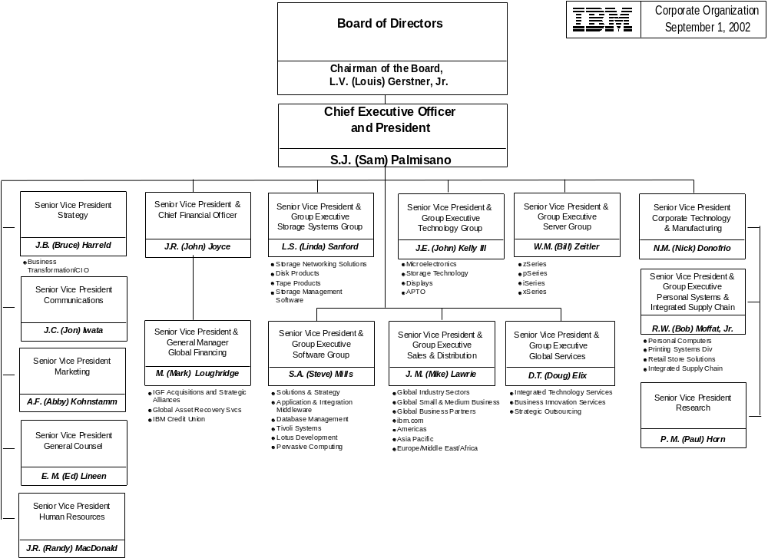

4.5 Supplier’s Customer Base
Assuming that XXX is a ____ million account, where would we fall within your customer base? Please select:
Top 10% Yes
Top 30% Yes
Top 50% X Yes
Top 70% Yes

4.6 Supplier’s Account Team
Provide Single-Point-of-Contact information and describe how your company would organize an enterprise wide account team to support XXX’s requirements. Identify how many full-time employees would be dedicated to the XXX account.
XXX has a local client team dedicated to meeting all needs of XXX. The Client Executive, Karen Bachelder, leads representatives from all IBM products lines and business units to deliver all of IBM’s capabilities to XXX. The account team leaders that will be assigned to support your requirements are listed below.
Single point of contact:
Ron Kruse
IBM Security Sales
1300 East Ninth Street
Cleveland OH 44114
614-582-6740.
Provide a brief biography/background on key Account Team employees.
Ron Kruse -IBM Security Sales Specialist:
A professional Sales Executive for 25 years. Ron has been with IBM's Software Group for 5 plus years. Ron has sold Systems Management solutions and Security solutions during his 5 years at IBM. Previously, Ron has had experience in selling or managing a sales force. His expertise ranges from Manufacturing ERP solutions, Databases, and UNIX Systems.
Michael Core - IBM Certified IT Security Specialist :
Professional Software Engineer for 24 years. Mike has been with IBM's Software Group for 6 plus years. Mike has seventeen years of UNIX experience on multiple platforms such as SUN, HP, IBM AIX, and Windows NT servers and desktops. Mike previously worked for AT&T Bell Labs in diverse development and UNIX systems management areas.
Greg Cornett - IBM Certified IT Consulting Specialist:
Professional Systems Engineer for 15 years. Greg has been with IBM's Software Group during that time, working in various solution areas including Computer Integrated Manaufacturing, Client/Server Technologies, Storage Management, Enterprise Systems Management, and most recently Enterprise Security Management, all focusing on heterogenous, distributed computing environments. Prior to this, Greg was a Chemical Engineer responsible for Chemical Vapor Deposition and other Hot Process Equipment Engineering Systems in IBM's Burlington, VT Semiconductor Manufacturing Facility.
Provide information if you have different customer status levels that XXX can attain. What are the general criteria for achieving that status (e.g. spend, etc.) and what are the advantages gained by that status?
XXX and IBM have established a strong, long-standing relationship that has resulted in significant benefits to XXX. Some of the benefits include a dedicated Client Team and Customer Engineer, assigned specialists from IBM's hardware, software and services organizations, aggressive pricing on IBM product and solution offerings, and frequent access to IBM's support resources such as product engineering, software development labs and Executive Briefing centers.
XXX currently enjoys various discounts on hardware, software and services; based on spend and product set. In addition, revenue based partnership agreements between IBM and XXX may be structured. These agreements are based on future acquisitions and use previous purchase history, total spend and forecast data. Partnership Agreement credits must be applied to net, new additional IBM business.

4.7 Billing Requirements
Methods of Billing and Payments
Processing numerous invoices drives up administrative costs. Our preference is to receive monthly invoices in a Louts file via email or diskette. Please comment on your ability to invoice in this format, with the data shown below.
Field Name | Format | Characters | Default/Description
Supplier # | Text | 9 | XXX will provide
Invoice # | Text | 16
ID # | Text |  | Used to differentiate line items
Corp # | Text | 3 | XXX company number
Account | Text | 5 | GL account number
Center | Text | 5 | Cost Center
Sub ID | Text | 1 | Will always be a capital “P”
Sub Account | Text | 16 | Invoice approver
Amount | Currency | 2 | decimal places

In addition to the electronic format shown above, XXX requires hard copy invoice detail, which includes a description of the products or services, for audit purposes.
IBM will provide a hard copy invoice but is unable to send billing in a Lotus File. IBM does offer IBM Invoices OnLine which would enable XXX to create a print file or down load an invoice from an Internet Website. Please review attached Word Pro Document.

Please describe the methods you currently use to bill and receive payments from your current customers, noting the advantages to both yourself and the customer.
IBM currently sends XXX Invoices via hardcopy and receives payment via check. We also provide IBM Invoices OnLine which enables XXX to download invoices from a website.
Payment Terms
XXX normally requires suppliers to provide payment terms of Net 30. We look favorably upon suppliers, however, who offer discounts if we accelerate payment. If XXX were to accelerate payment, what discount would your company offer on the entire bill?
Payment Terms | Percent Discount
5 Net 30
10 Net 30
15 Net 30
20 Net 30
25 Net 30

No, IBM does not offer discounts to accelerate payment, however, we do have late payment fees of 2.5% when invoices are not paid in accordance with our payment terms and conditions.
Does your company accept payment via major credit card? Yes No
Yes
Invoice Submission
No invoice will be due unless it is fully accurate in all respects. Furthermore, if any invoice is received later than 60 days after the date the work was completed, such invoice will be null and void, and XXX will not be liable for any charges associated with the work represented by that invoice.
********IBM cannot agree to this clause in any contract.

4.8 Supplier Diversity
XXX is committed to providing business opportunities to minority and women-owned businesses. In conjunction with this commitment we require our strategic suppliers to subcontract work and/or partner with minority and women-owned firms in each geographic market where applicable. The current supplier diversity corporate objectives for XXX are as follows:
State | Objective
Michigan | 32% of all expenditures in Detroit Metro Area must be with ethnic minority or women owned suppliers (23% with African American owned firms and 9% “all other”.)
Texas | 25% of all expenditures with ethnic minority or women owned firms, which are preferably located in Texas.
California | 25% of all expenditures with ethnic minority owned firms, which are preferably located in California.

Bidders are required to submit a plan designed to achieve the objectives outlined above. Also, provide examples of how this data has been tracked and reported for your other financial clients.
IBM as a corporation has long recognized the benefit of diversity and the sound business practice of utilizing and partnering with Minor, Women and Small Business in buying products and services. IBM currently provides XXX a quarterly report detailing IBM’s results.
IBM’s supplier diversity initiatives are designed to increase purchasing opportunities and contracts for businesses owned and operated by minorities, women, and veterans. These same initiatives increase purchasing opportunities for non-profit organizations that employ people with disabilities, and for small businesses located in historically underutilized business zones. IBM’s diverse supplier base is a strategic necessity for its success and for the success of IBM's customers. IBM's commitment to Supplier Diversity is a long-standing corporate policy, actively followed, and will remain so as we enter the new Millennium.
Also, it is notable that IBM's first written statement of equal opportunity was published in 1953, more than a decade before the landmark Civil Rights Act of 1964. This statement reinforced IBM's commitment to nondiscriminatory hiring practices. Since then, our policy has maintained a non-discriminating and harassment-free environment, where no IBM employee feels at a disadvantage because of his or her differences, but where all employees are confident they will be evaluated solely by their qualifications.
Since 1974 IBM has actively participated in the National Minority Supplier Development Council (NMSDC), and its regional councils. Participation with the NMSDC and many other organizations, such as the Women's Business Enterprise National Council (WBENC) and the National Association of Women Business Owners (NAWBO), has facilitated IBM's support and development of diverse businesses. As an example, the following chart illustrates IBM’s purchases from minorities, women-owned businesses and handicap-owned businesses, reflecting a year-to-date reporting period of the 4th quarter 2001:
Minority |  | $1,486.9M  (11.6%)
- African American | $210.3M  (1.6%)
- Asian American | $1,013.6M  (7.94%)
- Hispanic American | $178.9M  (1.4%)
- Native American | $84.1M  (0.66%)
Female |  | $141.7M  (1.1%)
Persons with Disabilities (and/or Veterans) |  | $2.4M  (0.02%)
Total |  | $1,631M  (12.72%)

Figure – IBM Supplier Diversity
IBM's history of supporting and developing diverse businesses has formed a strong connection with suppliers and leadership groups. Together, we make commitment to diversity a reality. IBM is proud of our accomplishments in this area and IBM has had the privilege of being recognized for its commitment to diversity by nearly every diverse group.
IBM reports to Brinda Bradley, Vice President of Supplier Diversity at XXX, MBE/WBE information on a quarterly basis.

4.9 Insurance
At, prior to, or within 30 days of the execution of the contract, or agreement, XXX must be provided with properly executed valid Certificates of Insurance. Depending on the services offered, there might be instances where other insurance should be required.
During the period of the contract, the supplier agrees to maintain the following insurance coverage:
Coverage | Amount
Property/Casualty/Fire Insurance – To cover Lease Requirements & Inventory  (If applicable) | Replacement Basis
Commercial General Liability  (Occurrence Basis Including Contractual, Product, Liability if products are involved) | $1 Million
Workers Compensation | Statutory
Employers Liability | $1 Million
Automobile Liability  (If applicable) | $1 Million
Professional Liability – Errors & Omissions  (If applicable) | $1 Million
Employee Fidelity Bond  (If applicable, with 3rd Party Liability Endorsement) | $1 Million
Umbrella/Excess Liability | Dependant upon contract value

A.M. Best’s Rating Service or equivalent must rate the insurance companies used at least A+. XXX must be named as “additional insured” on appropriate Commercial General Liability policies and the policies should provide primary non-contributory coverage to XXX for claims arising out of the contractual relationship. XXX should be added as “Loss Payee” on the Fidelity Bond Coverage. Insurance carriers will provide at least 30 days notice before limits and scope of coverage are materially altered or insurance protection is cancelled.

Prior to finalizing any agreement, XXX may review each supplier’s insurance coverage to ensure that it meets set requirements.
IBM Corporation holds insurance coverage through American Home Assurance and Liberty Mutual Insurance, Certificate of Insurance number NYC-001131113-00. A copy of the insurance certificate will be provided in the timeframe required.

4.10 Lawsuits and Legal Action
XXX requires information about any significant lawsuits, liens, restraining orders, consent decrees, foreclosures or other legal/financial actions either now pending, in progress or which have been brought against the company or any of its officers/principals in the past three years. For lawsuits, please include date initiated, plaintiff, description, name of court location, docket number, resolution and current status.
IBM Corporation is not involved in any legal actions that would impair our ability to perform the requirements of the contract award resulting from this RFP.

4.11 Privacy
Both XXX and Vendor have duties under state and federal law, including the privacy provisions of the federal Financial Modernization Act of 1999, to maintain the confidentiality of XXX customer needs. To assure the protection of customer records shared by XXX with Vendor during the existence of this Agreement and indefinitely thereafter, the parties agree as follows:
4.11.1 All information about XXX’s customers, whether obtained from XXX or obtained to perform services under this Agreement, including, without limitation, names, addresses, telephone numbers, account numbers, customer lists, account relationships, and demographic, financial and transaction information “Customer Information”, is confidential. Vendor shall not use the Customer Information or add the Customer Information to its own records unless required to perform under this Agreement. Further, Vendor shall not disclose any of the Customer Information to its shareholders, directors, officers and employees other than for the sole purpose of the performance of Vendor’s obligations hereunder;
4.11.2 Vendor shall not disclose Customer Information to any third party without XXX’s prior written consent. Vendor shall promptly notify XXX upon becoming aware of any loss, or breach of confidentiality of such Customer Information. Unless otherwise prohibited by law, Vendor shall (A) immediately notify XXX of its receipt of any legal process for Customer Information and (B) permit XXX adequate time to seek to prohibit or limit such disclosure;
4.11.3 Vendor shall have policies and procedures to insure the confidentiality of the Customer Information. Such policies and procedures shall be designed to meet the objectives of the Federal Reserve Board’s Interagency Guidelines Establishing Standards for Safeguarding Customer Information, as may be amended from time to time “the Guidelines”, being Appendix D-2 to Part 208 of the FRB’s Regulation H. In the event Vendor is permitted to use one or more subservicers to fulfill its obligations under the terms of this Agreement, Vendor shall require such subservicer(s) to maintain adequate controls to ensure that such subservicer(s) will protect the Customer Information in the same manner Vendor is required to maintain Customer Information hereunder;
4.11.4 Vendor shall permit XXX to audit Vendor’s compliance with these confidentiality provisions at any time during Vendor’s regular business hours;
4.11.5 within thirty (30) days after this Agreement terminates Vendor shall, at XXX’s discretion, either (A) return the Customer Information or (B) destroy the Customer Information and provide written certification signed by a senior officer of Vendor that such Customer Information has been destroyed;
4.11.6 since unauthorized disclosure of the Customer Information may cause immediate irreparable harm to XXX for which monetary damages may be inadequate, XXX shall be entitled to equitable relief, including a temporary and permanent injunction and specific performance if Vendor threatens or actually breaches its duty of confidentiality; and
4.11.7 this paragraph shall survive the termination of this Agreement.
The provisions of the recently negotiated IBM/XXX Agreement for Exchange of Confidential Information will govern activity regarding privacy.

5 Customer Access Management

5.1 Requirements

5.1.1 Authentication

5.1.1.1 Authentication Types
5.1.1.1.1 Which of the following authentication methods does your software support:
- Basic authentication (user ID/password) Yes
- Basic authentication over secure sockets layer (SSL) Yes
- Forms based authentication (user ID/password) Yes
- X.509v3 digital certificates with revocation list (CRL) checking Yes
- Smart Cards Yes
- Two-factor tokens Yes, with customization
- RSA SecurID Tokens (OTP token) with PIN Yes
- RADIUS Authentication Yes, with customization
- Biometrics Yes, with customization
- Custom methods Yes, with customization

5.1.1.1.2 What other authentication methods are supported by your software?
IBM Access Manager employs an extensible authentication model which can take advantage of practically any authentication mechanism you wish to employ. Essentially any external method that returns a user identity can be integrated with IBM Access Manager through the use of a custom CDAS (cross domain authentication service) that maps the returned user ID to an IBM Access Manager identity.
5.1.1.1.3 Does your software support the pluggable authentication module (PAM) standard for adding new authentication methods?
Yes.
5.1.1.1.4 Can your product force the user to reauthenticate when he accesses a specified resource?
Yes.
5.1.1.1.5 When a person attempts to access a specified resource, e.g., a transaction that is more than one million dollars, can your product require more than one type of authentication? In this case XXX would require the transaction to use both basic authentication (encrypted) and a X.509v3 digital certificate.
Yes, this is referred to as “step-up” authentication, and is fully supported by IBM Access Manager for most authentication mechanisms “out of the box” Stepping up to an X.509v3 digital certificate can be handled either through a redirection to a WebSEAL server protecting those resources that is configured only for digital certificates. Other options would require customization.
5.1.1.1.6 For high value transactions does your product have the capability of requiring the authorization of two or more individuals before the transaction can be processed?
IBM Access Manager is designed to authorize specific resource requests (user, object, action). Depending upon the architecture of the application itself, IBM Access Manager’s authorization engine can be used in this manner to engineer multi-principal authorization requirements, but the underlying workflow logic and multiple authentications would need to be contained in the application itself.
5.1.1.1.7 Describe the products ability to support priority levels for authentication.
Within the IBM Access Manager Master policy server configuration file is a section where a numerical identifier can be assigned to each authentication mechanism you define. This essentially designates a priority level to each method. IBM Access Manager allows you to specify for each protected object a “minimum required level of authentication” parameter. If a user requesting access to the resource has authenticated with a method that is lower on the priority list than the security policy specifies, he will be challenged to authenticate again using a method that satisfies the policy requirement.
5.1.1.1.8 Does your product support mobile computing identifiers such as a phone number with PIN?
Yes.
5.1.1.1.9 Does your product support wireless transport layer security (WRLS) certificates?
Yes.

5.1.1.2 Single signon
5.1.1.2.1 List all authentication methods that do not support single sign-on across multiple servers in one domain.
None. Once a user has authenticated to WebSEAL (the reverse-proxy resource manager component of IBM Access Manager), a credential is built for that user that persists for the duration of the user’s session. This credential will be used for SSO to all resources in the secured domain.
5.1.1.2.2 List all authentication methods that do not support single sign-on across homogenous domains.
Same as above. WebSEAL is capable of existing in a “trusted” relationship with other IBM Access Manager secure domains such that an authentication token from one domain can be trusted by resources in another, and vice versa if so desired.
5.1.1.2.3 List all authentication methods that do not support single sign-on across heterogeneous cross domains.
Same again. IBM Access Manager is capable of heterogeneous Cross-Domain SSO as well. Once a user is authenticated to IBM Access Manager, their identity has either been confirmed as one from the IBM Access Manager User Registry or has been mapped to one via a CDAS. In either case, that IBM Access Manager identity is the one used to build the user’s credential and CDSSO token, so the original method of authentication is unimportant.
5.1.1.2.4 If your product supports single sign-on across heterogeneous domains, what other products has it been tested with?
As part of Burton Group SAML interoperability, we have demonstrated interoperability with most major vendors including Oblix, Sun, Netegrity, Novell, RSA, and Crosslogic. Please see Burton Group Catalyst Conference/SAML releases for more information and list of participating vendors.
- Any product in any environment that supports standard http and SSl would be supported. Not all possible products have been tested.
- When a protected resource is located on the plug-in enhanced Web application server, a client requesting that resource can be required to perform multiple logons when accessing different secure applications. Each log on is likely to require different logon identities.
- The problem of administering and maintaining multiple logon identities can often be solved with a single sign on (SSO) mechanism. SSO allows the user to access a resource using only one initial log on. Any further log on requirements for resources on the Web server are handled transparent to the user.
- There are a number of different single sign on architectures supported by Access Manager Plug-in for Web Servers. For example there are:
- One plug-in instance providing single sign on to more than one secure application on a server.
- Single sign on to the plug-in from WebSEAL or other proxy agent such as a WAP gateway.
- Use of failover cookies to provide single sign on between different domains.
- Use of the Global Single Sign on (GSO) Lockbox module to provide access to applications using stored user credential information.
- Use of Security Provider NEGOtiation (SPNEGO) for permitting access to resources on IIS based Web servers.
- e-Community single sign on, where a user authenticates once and is issued a token that allows them to access other domains within a virtual community of domains without the need to re-authenticate.
- The first five SSO scenarios are discussed in this chapter. The sixth scenario is the topic of the next chapter.
- Websphere Application Server multi-application, multi-platform
- Websphere Portal Server multi-application multi-platform environment
- Custom CDAS

5.1.1.2.5 When a logoff occurs for a single sign-on across domains (homogenous or heterogeneous) how has the product been designed so that resources in each domain will not be able to be accessed unless the user is re-authenticated?
Logoff from a domain destroys the user’s credentials and session information, without which the user is unable to access resources.
WebSEAL can maintain session state with clients over HTTP and HTTPS.
Additionally, you can configure WebSEAL to provide user session information to back-end junctioned application servers. With this user session information, back-end applications can maintain session state with clients.
5.1.1.2.6 Does the product support lightweight third party authentication (LTPA) single sign-on support for IBM’s WebSphere and Lotus Domino?
Yes, this is supported, although the preferred integration method with WebSphere or Domino V6 is the use of a Trust Association Interceptor instead of an LTPA cookie.
5.1.1.2.7 How does your product support anonymous / unauthenticated users?
As just that: unauthenticated. There is a special group in the policy database that allows you to define permissions for unauthenticated users. Using this group, you are able to define content that is publicly accessible.
5.1.1.2.8 During self registration can your software use an external vendor authentication service to prove who the user is by the information they know? One example of this type of service is Equifax elDverifier. Explain if this is accomplished out of the box, via an exit, or by modification to the base product.
This service is not provided out of the box. It requires customization.
5.1.1.2.9 Explain how authentication for administrative functions is handled differently from application authentication.
The process is the same. All administrators log into either the GUI or the CLI using their IBM Access Manager userID and password. All management objects within the secure domain are protected by ACLs, and only users (or groups) designated in the ACLs with management operation permissions are authorized to perform these operations.
Direct web based administration access is via userid/password authentication to LDAP directory. If the administration application is placed behind the WebSEAL reverse proxy server then those additional authentication methods are available for a higher level of protection
For CLI or API administrative functions a separate administrator identification can be used in the call.
5.1.1.2.10 Does authentication for administrative functions support multiple factor authentication?
Yes via “step-up” authentication using the Protected Object Policy as you would for any other resource in the secure domain by placing the browser base administration application behind WebSEAL.
The solution does not provide multifactor authentication such as multiple biometrics, but it is compatible with it.
5.1.1.2.11 Can authentication for a person or agent be restricted to a domain, IP address or time period?
Yes. Again using a POP you may define an IP address (or netmask) to limit access as well as define days of the week and times of the day to restrict user access.
5.1.1.2.12 In what way does the product support SSO and the use of multiple user registries at the same time?
A pluggable authentication mechanism can be written that would check one or more user registries until it finds the appropriate user record to authenticate to, and then map this user to an Access Manager user. At this point, all the SSO capabilities of WebSEAL are available for use as described elsewhere in this response.

5.1.1.3 User ID
5.1.1.3.1 To what extent can the length and contents of a user ID be controlled?
While other password strength policies can be defined and enforced using an extensible module, the native Access Manager CLI allows control over 5 password characteristics by default:

- Minimum length
- Minimum alphabetic characters
- Minimum non-alphabetic characters
- Maximum repeated characters
- Spaces allowed/disallowed

The optional Identity Manager module provides additional capabilities to restrict password policy when the user utilizes that password change/reset interface for password management.

5.1.1.3.2 How does your product support the assignment of unique universal identifiers to user or agents?
Each IBM Access Manager user account exists in an LDAP user registry, and must therefore possess a unique Distinguished Name. The nature of the LDAP standard itself does not allow multiple instances of a single DN, so every userID must therefore be unique. Access Manager also generates an internal UUID (Universally Unique Identifier) for all users and groups, which is also stored in the LDAP user registry.

5.1.1.4. Password Policies
5.1.1.4.1 To what extent can each of the following password characteristics be controlled:
- Number of letters (minimum required; non-alpha)
- Number of digits (minimum required; non-alpha)
- Number of total letters and digits (custom policy)
- Number of non-alphanumeric characters (minimum required)
- Number of punctuation characters (minimum required; non-alpha)
- Number of spaces (spaced allowed or not; if so, considered non-alpha)
- Number of non-printable characters (minimum required; non-alpha)
- Length of the password (minimum length)
- Repeating characters (maximum repetitions)
- Percentage of characters that must differ (custom policy)
- The amount of difference from previous passwords (custom policy)
- How often the same password can be used (custom policy)
- Password is not the same as the user ID (custom policy)

5.1.1.4.2 To what degree can password policies be customized?
Through the use of a Pluggable Authentication Module, any custom password strength policy module can be created and implemented. A pre-built module is included as part of the ADK and fully documented, and custom modules can be constructed using it as a template or entirely from scratch. This module is designed to serve as a complement to the 5 natively managed password strength rules, not a replacement. Common policies can involve checking against a database of previous passwords to enforce historical usage criteria, or performing a dictionary lookup to disallow simple passwords, or userID comparison to prevent its usage in the password.
5.1.1.4.3 To what degree can password policies as delivered be customized?
Yes, see 5.1.1.4.2 above.
5.1.1.4.4 Are passwords checked against a supplied dictionary?
Not by default, but they can be. See 5.1.1.4.2 above.
        - Can the supplied dictionary be customized?
Yes, see 5.1.1.4.2 above.
5.1.1.4.6 Does the product have a mechanism that forces a user to change her password on the first authentication attempt after her password was reset by a security administrator?
Yes.
5.1.1.4.7 Describe the product’s ability to expire passwords after a set time period
Using the Access Manager pdadmin CLI, the command policy set max-password-age is used to set the period of time for which passwords are valid, relative to the previous password change.
5.1.1.4.8 Describe how the password expiration period can be controlled.
The command above can set a policy for the entire user registry, or can be executed against any specific user or set of users. The relative age of the password is expressed in days, hours, minutes and seconds.
5.1.1.4.9 What controls exist for password history retention? Is history controlled by the number of old passwords or the number of days since a password was last changed?
There is no native facility for maintaining password history, although one can be customized. See 5.1.1.4.2 above.
5.1.1.4.10 Describe how password change grace periods work in your product.
The management of password policy is provided by IBM Identity Manager, which provides the ability to send grace period messages through password policy.
5.1.1.4.11 For a user ID that has failed a set number of sign on attempts can it be:
- Disabled for a period of time Yes
- Disabled until reset by the user (to be reset by the user, she must present a set of information that is only know by her)

Custom unless using the Identity Manager module which provides a challenge/response based password reset utility via a browser
- Disabled until addressed by a security administrator Yes

5.1.1.4.12 How can the number of failed sign on attempts that cause a user ID to be disabled be controlled?
Again, the Access Manager pdadmin CLI has a command that sets the parameters of this policy. The maximum number of failed attempts allowed as well as the time interval in seconds for which the account is locked out are set using this utility.
If the time interval is set to disabled instead of a time value, then the user’s LDAP account-valid flag is set to no, effectively deactivating the user’s account until it is manually reactivated.
5.1.1.4.13 Is an audit event created when a password is disabled?
Yes, auditable events occur for every authentication attempt, pass or fail. To capture the events, auditing must be activated for the server.
5.1.1.4.14 What messages are returned after a successful logon? Do any of the messages include the date and time of last successful logon?
No. The only indication to the user that login was successful is the presentation of the requested resource. Unless one is customized, no messages are displayed regarding last login date and time. A failed login will result in an error page being displayed, but otherwise the user interaction with the requested resource appears seamless.
5.1.1.4.15 What messages are returned after a unsuccessful logon attempt? Is the message customizable?
The resource manager (WebSEAL) redirects the user to an HTML error page which can be customized as required.
5.1.1.4.16 Can the user be notified of unsuccessful logon attempts since his last successful sign on?
By default, WebSEAL operates as seamlessly as possible. Users are not challenged to authenticate until they request access to a protected resource. Upon successful authentication, they are presented with the requested resource, not a welcome screen, and are not advised of their past login activity, pass or fail. This information is available to be passed to the user if you choose, but it will require some customization.
5.1.1.4.17 Can a user be prohibited from logging in with the same security credentials from multiple computers?
Requires customization.
5.1.1.4.18 What date and time restrictions can be placed on a user ID?
Any that you choose. Using the Access Manager pdadmin CLI, a policy can be attached to any or all users, that restricts their userID’s validity to specific days of the week and/or hours of the day. All date and time restrictions are interpreted in the local server’s time zone. Time of Day restrictions can also be placed at the protected object level.
5.1.1.4.19 Can a password be changed by a user before it has expired? Does a password change reset the expiration period?
Yes, and yes.
5.1.1.4.20 Where is security credential information stored? How is this information encrypted before it is stored?
All user-specific information is maintained in IBM Access Manager’s LDAP User Registry. With the exception of Access Manager passwords, all data is stored in plaintext, so each customer must evaluate the need to enable SSL connections between IBM Access Manager server components and the LDAP server, and set appropriate LDAP ACLS and encryption levels.
5.1.1.4.21 Can an account be disabled or deleted after a period of non-use?
Can be accomplished by taking advantage of available APIs.
        - Can passwords expire with different policies based on the user’s role or group?
No. The account expiry date policy can be applied to single user account, sets of accounts, or the entire User Registry population as you see fit.
The optional Identity Manager module provides this capability.

5.1.1.5 Maintaining Session
5.1.1.5.1 Which of the following methods do you use to maintain session state:
- Cookie Yes, although this is not the default method
- Hidden form fields No
- URL rewrite No

5.1.1.5.2 List all other methods your product uses to maintain session state.
IBM Access Manager’s primary means of maintaining session state is through the SSL Session ID value, as this is inherently more secure than a cookie of any sort.

Other methods of maintaining session state include server-specific session cookies, BA header data, HTTP header data, and client IP address.

In a multiple-WebSEAL replica environment, an independent failover cookie system can be enabled that will allow a WebSEAL server other than the original session server to pick up the user’s session in the event the original WebSEAL becomes unavailable, regardless of the mechanism used for maintaining session state.

5.1.1.5.3 What is the content of your session token?
The only data contained in the cookie is a random number identifier that indexes the session cache on the specific WebSEAL server that issued the cookie, and it is only viable for a short time period (typically 10 minutes) before it expires. There is no user or policy information contained in the cookie.
It also contains domain and path parameters that prohibit any other server (even another WebSEAL) from accessing the cookie. Finally, this cookie is retained in the client browser’s memory only – it is NOT written to the client’s disk drive.
5.1.1.5.4 List the standards used in the product's session token implementation.
WebSEAL maintains an internally cached table of user session data. This table has a proprietary architecture and resides in memory only.
5.1.1.5.5 How is your session information encrypted?
Session data is only maintained within the memory of the WebSEAL itself…no additional protective measures are necessary, as this data is never transferred to any other system.
5.1.1.5.6 What encryption mechanism do you use to encrypt the session data?
Please See above.
5.1.1.5.7 What additional software is required to maintain state, other than a browser?
None.
5.1.1.5.8 Is a unique session key generated for each session?
Yes. Since the session is typically maintained by the user’s SSL Session ID, this value will always be unique. If this parameter isn’t used for maintaining state, then a randomly generated session ID is used to maintain state with a cookie.
5.1.1.5.9 Are session identifiers randomized between each communication?
Yes.

5.1.1.6 Session Timeout
5.1.1.6.1 Describe how a session times out?
Two of the values maintained within WebSEAL’s session cache are the expiry timestamps of the user session. These values are controlled by customizable parameters in each WebSEAL’s local configuration file, and are the session-timeout and inactivity-timeout parameters. If either of these timestamps is exceeded, the user will be challenged to re-authenticate.
5.1.1.6.2 Is a user notified of a session timeout notification at the time that the timeout occurs?
No. The user will receive an authentication challenge, indicating that his session has expired.
5.1.1.6.3 Is a user notified of a time out only at the point she attempts to use the resource next?
Yes.
5.1.1.6.4 After a timeout, how does the system insure that a user can not use a resource until the user signs on again?
The user will receive an authentication challenge, indicating that his session has expired, because the user’s Access Manager credential has been destroyed.

5.1.1.7 Logout
5.1.1.7.1 Does your product have the ability to globally logoff an account so that none of its authorized resources can be accessed without another log on?
Each resource manager (WebSEAL) is responsible for maintaining its’ own user session information. If a user had existing sessions with more than one WebSEAL, each would exist independent of the others and each would have to be terminated separately by either logging off or closing the browser windows. These sessions can also be cancelled via the Access Manager CLI or APIs.
5.1.1.7.2 Does your product have the ability to remove or suspend all access for an account?
Yes, this can be accomplished in several fashions. The first step should be to implement a root-level ACL on the master policy server that specifically denies the user account in question the traverse permission. In so doing, the user is immediately denied access to the entire protected objectspace, even if they have open sessions.
The second step would be to remove the active flag from their account in the LDAP User Registry using the management console to prevent future logins at all.

5.1.1.8 External Authentication Sources
5.1.1.8.1 Which of the following external authentication source bindings does your product fully support:
- CSIv2
- DCE
- Kerberos
- RACF compatible (RACF, Top Secret)
- RSA
- SAML
- Windows NTLM
- Windows Kerberos
- X509
- XrML

X.509 certificate authentication is supported out of the box. A more appropriate statement is that a CDAS library for X.509 authentication is provided as part of the IBM Access Manager distribution.
A custom CDAS library can be constructed to support any of the listed authentication mechanisms. Some have already been constructed by our services group and made available, including the ability to host the User Registry on a mainframe platform using RACF for authentication.
The latest version, 4.1 extends support for the federated identity model to provide open e-Community interfaces to allow customization and interoperability for multi-domain Web single sign-on. To facilitate integration with other environments (such as applications using SAML or WS-Security), this version has the interfaces to support (produce and consume) new federation tokens. With this framework in place, libraries can be written to allow WebSEAL to CDSSO to non-WebSEAL servers, and for WebSEAL to accept single sign-on requests from non-WebSEAL servers. Therefore, customers can override the default CDSSO token creation and customize it to their environment by inserting their choice of third-party defined token formats, token mapping, and token encryption/decryption techniques (e.g. SAML). This open interface allows Access Manager to support cross-enterprise, cross-platform, and cross-vendor integration.
5.1.1.8.2 Which of the following external authentication source bindings does your product partially support (describe what is not supported):
- CSIv2
- DCE
- Kerberos
- RACF compatible (RACF, Top Secret)
- RSA
- SAML
- Windows NTLM
- Windows Kerberos
- X509
- XrML

See 5.1.1.8.1 above.

5.1.1.8.3 Which of the following external authentication bindings does your product plan to support by the end of year 2003:
- CSIv2
- DCE
- Kerberos
- RACF compatible (RACF, Top Secret)
- RSA
- SAML
- Windows NTLM
- Windows Kerberos
- X509
- XrML

See 5.1.1.8.1 above.
5.1.1.8.4 Which of the following is the native security implementation for this product:
- CSIv2
- DCE
- Kerberos
- RACF compatible (RACF, Top Secret)
- RSA
- SAML
- Windows NTLM
- Windows Kerberos
- X509
- XrML

See 5.1.1.8.1 above.

5.1.1.8.5 When integrating with the above products are there limitations that are placed on the use of your product?
None as long as the CDAS authentication module returns an authenticated identity that can be mapped to an identity in Access Manager’s LDAP User Registry.
5.1.1.8.6 Is your product able to store security policies in a RACF compatible security server?
No. All policy data is maintained in a proprietary format on the IBM Access Manager master policy server. RACF authorization policy can be incorporated in the access decision by using the External Authorization Service exit provide in the ACL object. This exit can be used to interface to RACF (or other sources) to obtain an authorization decision.

5.1.2 Authorization
5.1.2.1 List each non-Java resource that can be authorized. List the permissions that can be granted for each resource. Some possible resources are web page, URL, CGI script, application server page, web server directory.
Any object that can be accessed using a URL can be secured, which covers the vast majority of resources. This includes all files, regardless of type. Also, specific URLs can be secured as well.
The permissions that can be addressed by ACLs in the WebSEAL objectspace include read, execute (script), list, delete, modify, and delegate. Most of those are management permissions, however, and only list, read, and execute apply to users accessing junctioned resources on backend servers.
5.1.2.2 List each Java resource that can be authorized. List the permissions that can be granted for each resource. Some possible resources are JSP, Servlet, EJB, methods, network connections.
Any accessible resource can be secured, including JSPs, EJBs, servlets and methods. IBM Access Manager supports authorization for both J2EE and non-J2EE resources.
5.1.2.3 Can your product be customized to add additional resource and permission types that are not supported out of the box.
Yes.
5.1.2.4 Can authorization be based on identity?
Yes.
5.1.2.5 Can authorization be based on an identity’s role?
Yes.
5.1.2.6 Can authorization be based on the group the identity belongs to?
Yes.
5.1.2.7 Can authorization be based on one or more attributes of an identity?
Yes, via the External Authorization Service exit. A future release of Access Manager will provide additional out of the box functionality based on boolean rules.
      - Can authorization be based on data contained in the information resource to which access is requested?
Yes, via the External Authorization Service exit.
5.1.2.9 What are the possible results from an authorization request? E.g., permit, deny, etc.
Permit or deny. In addition, there is an entitlements API that provides a list of objects that the user has an explicit requested permission on i.e. user ‘a’ has ‘access’ permission on these five objects.
5.1.2.10 When an identity has been assigned multiple roles, groups and access control lists what is the rule for combining these items to determine if authorization should be granted? E.g., deny overrides, permit overrides, first applicable, etc.
Most are permissive of authorization actions, with denials always taking precedence.
5.1.2.11 Can an authorization request have multiple subjects? A high value transaction may require two or more subjects for the request to be authorized.
Yes, secondary information may be passed to IBM Access Manager with the authorization requests, and the decision based on that information. In addition, Access Manager provides a 'switch user' capability that may meet this requirement
5.1.2.12 Can roles be nested inside one another? What is the limit on the number of levels that roles can be nested?
Not supported at this time.
5.1.2.13 Describe your products support for fine-grained security?
Security policy is applied and evaluated at the individual resource level, and can be as general as so to apply to everyone, or as specific as to only apply to a single user. The granularity exists to be as specific as you choose.
5.1.2.14 Are any pre-compiler or post-compiles necessary when using a Java application with your product?
No, IBM Access Manager is designed to provide authorization services without the need to modify your application code.
5.1.2.15 Describe your Java support for programmatic security.
When an application developer has added security code directly into the application (programmatic security), the application server container uses IBM Access Manager to perform the necessary role membership checks. Access Manager supports the user or caller in role along with JAAS support.
      - Describe your Java support for declarative security.
When security is specified in the deployment descriptor for an application (declarative security), the application server container determines which roles are required to access the resource, and uses IBM Access Manager J2EE support to determine if the current principal has been granted any of the required roles (user to role mapping is externalized to Access Manager allowing dynamic, centralized management. This support will be extended to support the JSR115 specification when completed.
5.1.2.17 Does you Java support require any proprietary calls?
No, security for Java resources is provided through standard native JAAS and J2EE calls.
5.1.2.18 Does your product fully support JAAS and J2EE 1.3?
Yes.
5.1.2.19 Can authorization of a resource, not an user ID, be restricted to a domain, IP address or time period?
Yes, security authorization policy (such as domain or IP restrictions) are attached to the protected resources
5.1.2.20 Describe the components of a policy or policy set in your product.
An ACL consists of a list of users and groups that are each defined a set of permissions. The ACL is then attached to a resource or container object in the IBM Access Manager object namespace hierarchy.
A Protected Object Policy (POP) is similar to an ACL, except it allows definition of further authorization parameters, including quality of protection, level of authentication, day of week and time of day restrictions, and client IP address restrictions.
5.1.2.21 Describe the components of a rule in your product.
IBM Access Manager authorization is not rule based today in the sense of “if this, then that”. This is a future direction of the product. Third party rule based tools can be integrated with Access Manager via the External Authorization Service exit.
5.1.2.22 Describe any wild card capabilities for specifying a resource.
Any resource can be defined within the objectspace, including filenames, URLs, even pattern matching through wildcard characters, including dynamic URLs.
5.1.2.23 Describe regular expression capabilities for specifying a resource.
Please See above.
5.1.2.24 Do policy changes take place immediately or at the time the user or agent is re-authenticated?
Policy changes are effective immediately. There may be a slight delay in propagation of the change from the master policy server down to the resource managers’ local cache copies, but this update interval is customizable through a parameter in a configuration file. Only group membership changes require re-authentication to take affect.
5.1.2.25 Can permissions be assigned to groups and roles? Do both have the same set of functionality?
Yes, and the permissions are functionally identical.
5.1.2.26 Describe how the same rule can able to different resources.
Again, IBM Access Manager authorization is not rules based, but ACL based.
5.1.2.27 Can permissions be assigned to groups and roles? Are there are limitations to a permission in either case?
See 5.1.2.25 above.
5.1.2.28 Describe how the same rule can be used for different resources.
See 5.1.2.26 above.
5.1.2.29 Describe how your product can ensure that portal users will start at the same point (a forced redirect).
All un-authenticated users come to the public home page and other portal users are authenticated to their private page.
IBM Access Manager’s ideal architecture involves a single point of user access to the company resource through a firewall. All inbound HTTP requests go through an outside firewall into a WebSEAL sitting in a DMZ. All client communication passes through WebSEAL as a reverse-proxy. This access flow requirement is enforced architecturally, not programmatically.

5.1.3 Architecture

5.1.3.1 Overall Architecture
5.1.3.1.1 Describe the major components for each product in the proposed solution.
- User Registry – Master LDAP server maintaining user data, plus LDAP replica servers
- Policy Server – Master database of all protected resources and access policy
- WebSEAL – Reverse proxy web server that performs authentication and authorizations.
5.1.3.1.2 Provide a diagram showing how your product can be implemented for external (Internet) facing applications hosted at XXX and at application service providers (ASP). Show high level flows showing how the components work together.
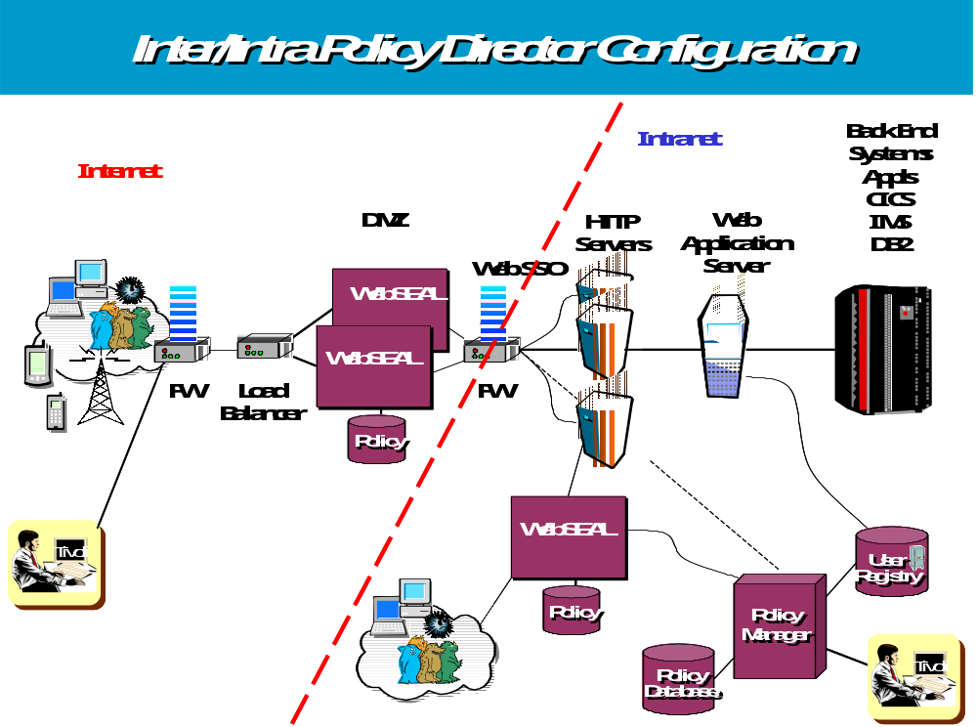
5.1.3.1.3 Provide a diagram showing how your product can be implemented for web based applications that are used internally by XXX. Show high level flows showing how the components work together.

5.1.3.1.4. Provide a diagram showing how your product can be implemented for web based applications that are used by the branches in XXX. Please note that some of the web applications at the branches must be able to run in off line mode when the network has an outage. Show high level flows showing how the components work together.
We will be happy to discuss the possible architecture suggested. Some possible questions are if the application is either an Intranet, Internet, or a web kiosk application.
One way would be to put an ldap replica on a WebSEAL or web server plugin in the branch (or set the credential lifetime very long). The issue here is how many branches - too many will kill the LDAP and PD DB replication. Otherwise each branch would have to have its own AM domain which could mean way too many to manage.
5.1.3.1.5 Does the product support the WS-Security web services standard? How is your product configured to support web services?
To facilitate integration with other environments (such as applications using SAML or WS-Security), this version has the interfaces to support (produce and consume) new federation tokens. With this framework in place, libraries can be written to allow WebSEAL to CDSSO to non-WebSEAL servers, and for WebSEAL to accept single sign-on requests from non-WebSEAL servers. Therefore, customers can override the default CDSSO token creation and customize it to their environment by inserting their choice of third-party defined token formats, token mapping, and token encryption/decryption techniques (e.g. SAML). This open interface allows Access Manager to support cross-enterprise, cross-platform, and cross-vendor integration.
- IBM/ is in a leadership position with regard to security for Web Services. IBM, along with Microsoft and VeriSign, has helped ensure a workable, industry-wide approach to Web Services security by promoting the WS-Security standards, via the Organization for the Advancement of Structure Information Standards (OASIS). In line with WS-Security, IBM has already achieved a number of milestones regarding advancing the state of secure Web Services including:
- Completing thorough testing to ensure compatibility of SOAP message transactions, through its WebSEAL proxy. This testing included SOAP transactions in J2EE and.Net implementations.
- Defining a “Federated Identity Interface” in Access Manager for e-business V4.1 that enables customized accommodation of multiple token types, enabling business –to-business (cross-domain) single sign-on.,
- Successful in 2 key Burton Group Security Assertion Markup Language (SAML) “bake-offs” held in 2002, where Web Services compatibility and communication was shown through the exchange of SAML tokens with other vendors SAML-capable solutions.

IBM plans to release enhancements in 2003 that will begin with “out-of-the-box” support for SAML tokens , and will culminate with trust services, authentication services and both course- and fine- grained access control for Web Services, all available as part of a unified, policy-based, Access Manager authorization solution.
5.1.3.1.6 Provide all architectural limits for your software.
Aside from operating platform compatibility and minimum hardware requirements, there are none.
5.1.3.1.7 Describe the major components for each product in the proposed solution
Please see 5.1.3.1.1
5.1.3.1.8 Describe how your product uses caching?
Each WebSEAL can be tuned independently to operate as a caching reverse-proxy, although this is disabled by default for performance reasons. The product documentation covers all of the cache tuning parameters in detail.
Also, once users have authenticated, their credential data is maintained in WebSEAL’s session cache for the duration of the session. Parameters of this session cache can be tuned for each WebSEAL as well.
Other caches include local policy caches by WebSEAL and local authorization servers, LDAP caches, and DB2 caches if using the IBM LDAP Directory Server as the user registry.
5.1.3.1.9 Does your product support HTTP 1.0?
Yes.
5.1.3.1.10 Does your product support HTTP 1.1?
Yes.
5.1.3.1.11 Does your product support WAP?
Yes.
5.1.3.1.12 Does your product support i-mode?
Yes.
5.1.3.1.13 What is needed in another domain for homogeneous cross domain single sign-on?
CDSSO is achieved through either an e-community trust relationship or through the use of CDSSO tokens.
5.1.3.1.14 What is needed in another domain for heterogeneous cross domain single sign-on?
Please See above.
5.1.3.1.15 How is authentication accomplished to the LDAP directory server?
By default, the authentication resource manager (typically WebSEAL) binds to the LDAP server, requests the DN matching the user’s input ID, and compares the input password to the password on file for that DN.
5.1.3.1.16 Explain how to setup your product so that it is fault tolerant.
IBM Access Manager achieves fault tolerance and availability though replication of its server components. Multiple replicas of a WebSEAL server can reside behind a network dispatcher or load balancer. Multiple LDAP replicas can exist to service authentications more efficiently. Backend web and application servers can also be replicated to provide content availability and load balancing.
Furthermore, the local cache architecture of the resource manager means that even if the IBM Access Manager master policy server goes down, authorizations will continue to occur based on your security policy. Updates to the policy will not become effective, however, until the master policy server is restored to operation, as it is the one server component which cannot be replicated within a secure domain.
In addition, both the Master LDAP and Master Policy servers can be protected via IBM AIX HACMP solution or ‘replica’ promotion. A best practices white paper is available on this subject.
5.1.3.1.17 Explain how to setup your product so that it is scalable.
Please See above.
5.1.3.1.18 How should the servers be hardened that run your product?
Administrators should keep up with application of the latest service packs and patches to the operating systems. Standard web server best practices should be used on the WebSEAL server including disabling un-necessary services and locking down key directories and files.
5.1.3.1.19 Does your product support SSL hardware based acceleration?
Yes, using the IBM 4960 PCI card, nCipher nForce 300 PCI card, or Rainbow CryptoSwift PCI card.
5.1.3.1.20 Describe the ability of your product to store digital keys in tamper-resistant hardware.
Support exists for the IBM 4758 PCI Cryptographic Coprocessor as well as the nCipher nForce 300 PCI card.
5.1.3.1.21 Can authentication and authorization occur on separate servers?
Yes.
5.1.3.1.22 When a policy is changed how does the product ensure that all the security enforcement points are updated with this information?
Each resource manager operating in local cache mode has a parameter in its configuration file that specifies the time interval between update requests to the master policy server. If the resource manager is in remote cache mode, all of its requests are authorized against the master policy server itself.
5.1.3.1.23 Is the administrative interface implemented with a Java application, an applet, browser plugins or a thick client?
The Access Manager administrative GUI is a thin web client. It is not Java based at all, but purely HTML. There is also a CLI along with C and Java based APIs available.
        - When a policy is changed how does the product ensure that all the security enforcement points are updated about the change?
See 5.1.3.1.22 above.
5.1.3.1.25 Describe the products ability to pass personalization information in the HTTP header? Is this supported for regular browsers, custom HTTP headers such as the Entrust proxy header and the WAP protocol?
WebSEAL has the ability to pass on all information contained in the original client HTTP headers. It can also insert other information into the header from the user’s LDAP record or other external source upon authentication. WebSEAL can also selectively strip and replace header information as you see fit for your implementation.
Yes, it is compatible with Entrust proxy headers and WAP information.
5.1.3.1.26 If a browser interface is used for administration does it have full administrative capabilities?
Yes, and it does.
5.1.3.1.27 How does the product support the delegation of credentials from one part of an application to another?
We have the ability to pass back credential to back end applications through several methods.
Credentials are attached to registered user identities, not to applications. If an application attaches to another in the context of a given user, then it operates with that user’s credentials.
Through IBM Access Manager’s delegated administration model, sub-domains of the secure objectspace can be defined and administrators created with authority only within the sub-domain.
5.1.3.1.28 How does the product support the mapping of credentials from one set to another?
Authenticated user identities are obtained from whatever authentication mechanism you have in place. These identities are then mapped to an IBM Access Manager registered user identity by a CDAS library.
5.1.3.1.29 Does the product have a super user ID or a root ID?
Yes.
5.1.3.1.30 Describe your products support for the life cycle of a digital certificate.
IBM Access Manager uses the IBM GSKit to maintain certificates for each of the server components, but this requires no manual intervention. End user client certificates are not managed by IBM Access Manager.
5.1.3.1.31 Describe your products ability to test policies before placing them into use?
In test environments a security administrator can assume the role of users and exercise the functions to exercise the roles.
Testing is accomplished using a special POP attribute called warning. When you set the warning attribute to yes, any action is possible by any user on the object where the POP is attached. Any access to an object is permitted even if the ACL policy attached to the object is set to deny this access. Audit records are generated that capture the results of all ACL policies with warning mode set throughout the object space. The audit log shows the outcome of an authorization decision as it would have been made if the warning attribute has been set to no. Therefore, the administrator can determine if policy is set and enforced correctly.

5.1.3.2 Sequence Diagrams
Please provide us with UML sequence diagrams showing:
- Self registration with automatic setup
- Self registration requiring approval
- Single domain authentication
- Homogenous cross domain authentication
- Heterogeneous cross domain authentication
- Single domain log off
- Homogenous cross domain log off
- Heterogeneous cross domain log off
- Request to resource involving authorization
- Identity administration
- Policy administration
- Authentication and access to a Java application (assume JSP, servlet, EJB and method level security)
- Self service password reset
- Web Services Authentication and authorization

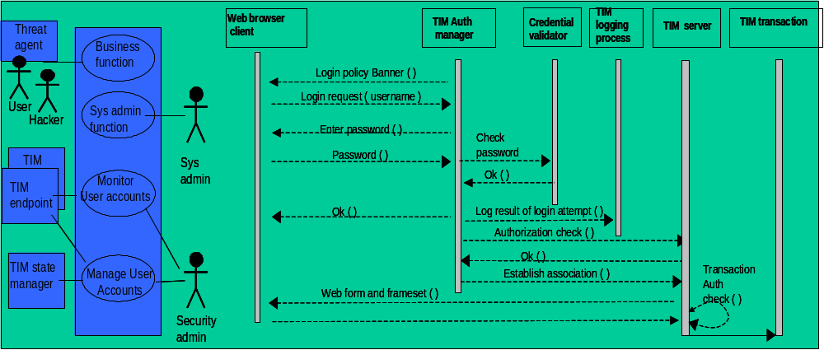

FYI, the left-hand side represents a Use Case Diagram, where the "business function" would be "enroll" and/or "manage account". The Security administrator (and the server components) monitors user accounts, for change in status or expiration.
The Right hand side is a generic sequence diagram for validated login. The key points shown are that login activity is recorded and appropriate authorization for transactions is enforced.

Integrated Security Demo Scenario
In this demonstration we visit an on-line prescription company called “webmeds.” Webmeds depends on several IBM software security products:
IBM Identity Manager (Note: you will still see the Access360 enRole product name in the demonstration)
IBM Privacy Manager for e-business
IBM Access Manager for e-business

These security products are part of the integrated IBM identity management solution that can help you get users, systems and applications online and productive fast, reduce costs and maximize return on investment. IBM provides the industry’s only totally integrated Identity, Access, and Privacy solution. Laura Gashlin from Prudential indicates that IBM Identity Manager (enRole) allows their same staff to manage 3x the user population.
IBM identity management provides:
- Identity lifecycle management (user self-care, enrollment and provisioning)
- Identity control (access and privacy control, single sign-on and auditing),
- Identity federation (sharing user authentication and attribute information between trusted web services applications)
- Identity foundation (directory and workflow) to effectively manage internal users as well as an increasing number of customers and partners through the Internet.

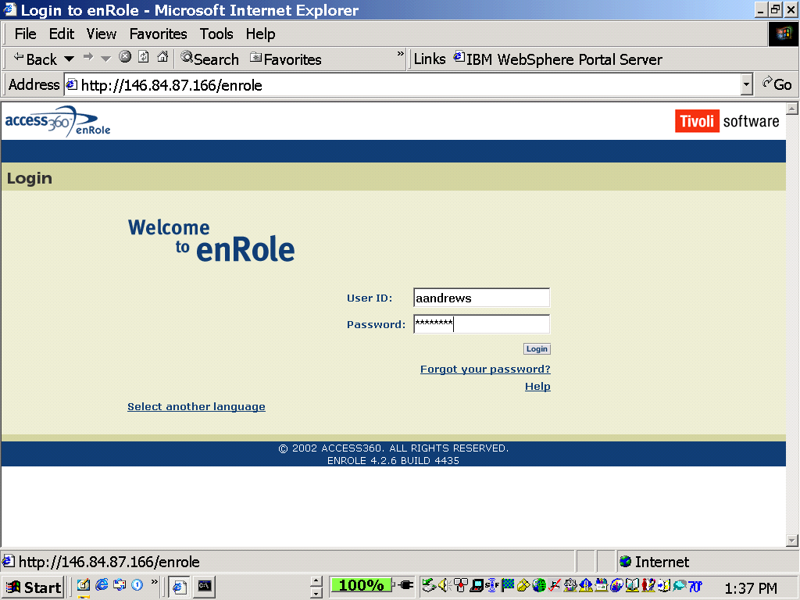
Paul Dorey from British Petroleum says that with IBM Identity Manager (enRole) their provisioning of user accounts went from 5 days to 10 minutes, and the project was cost justified after just one merger.

Andy Andrews is our Security Administrator. He logs in to the Identity Manager Application (enRole). Once logged in, Andy Andrews is presented with the Administrator GUI. A broad range of identity management actions is available to Andy from this screen, like creating and managing user account information. A single console enables Andy to perform centralized user administration activities.
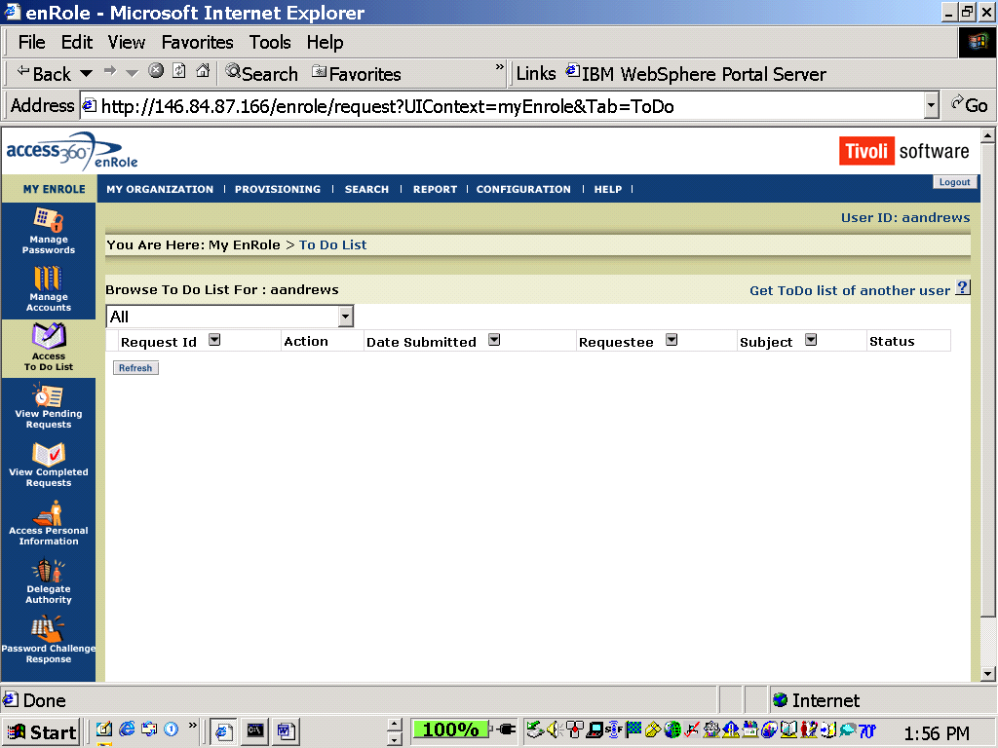
Additionally, notice that Andy has a TODO list, which currently shows no action items. Later in the demonstration this will change.
Action - Start another IE window and you are ready to run the demo. webMEDs home page is the browser default home page on xtreme6. Register as a new user to the webMEDs online prescription store. Click on “Register” and fill out the user registration form.
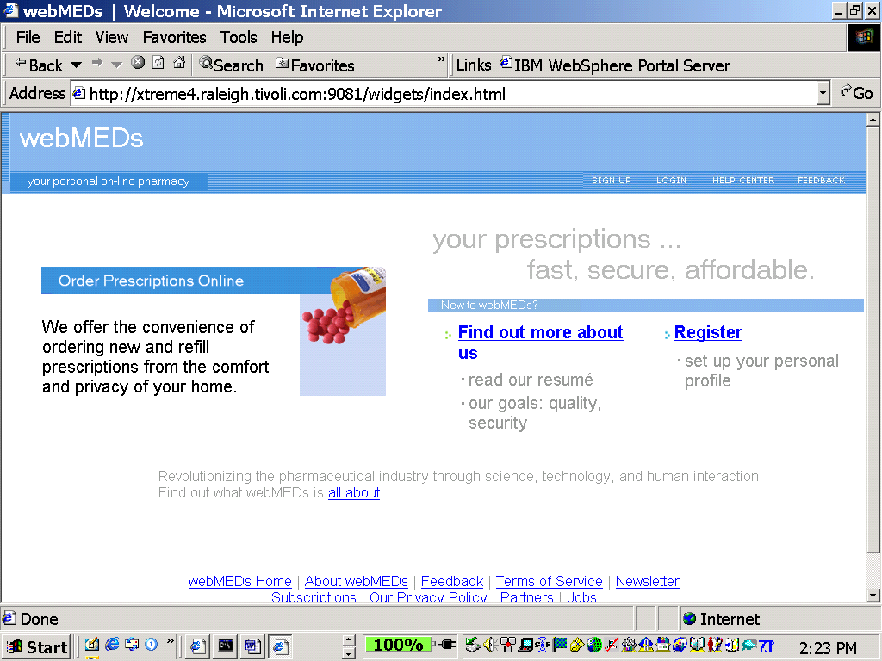
In our example, a user has been motivated in some way to visit the webMEDs site, which offers convenient online ordering of pharmaceuticals.
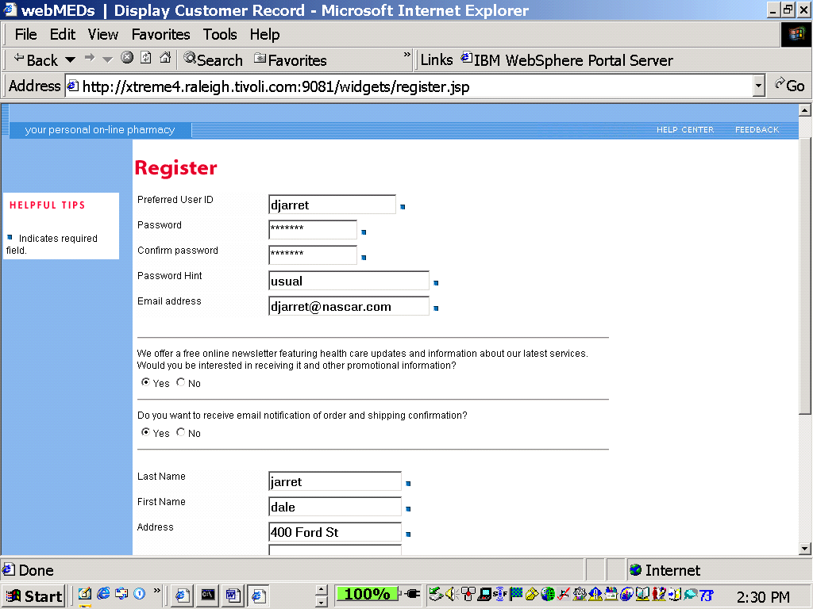
The user is presented with an easy self-care registration. There are tremendous IT productivity gains when new users enter their own profile information. This registration also helps prevent future help-desk workload through required items like “Password Hint.”
At the same time user privacy preferences are collected using opt-in or opt-out choices that reflect webMEDs privacy policies. Using IBM Privacy Manager for ebusiness, these preferences can be respected by other applications to help maintain customer trust and confidence.
Automated workflow and approval decisions can also be made based on the specific user profile. In this example, webMEDs has a policy where all registrations from Canada require manual approval to adhere to regulatory requirements. Since this user is from Canada, a manual approval action will automatically be initiated.
Also note that this user opted in for shipping notification, and for Marketing Newsletters.
Action - After completing the form click on “Submit registration.”
The completed registration information is then forwarded from WebMeds to the IBM Identity Management solution. Because of company policy, a manual approval process is needed for this customer, the user account record will be automatically routed for approval prior to provisioning the appropriate resources.
The webMEDs administrator is automatically notified that a new user registration is waiting to be approved. Note the action requested in the “To Do List.”
The administrator can use a single console to view the request, ensure compliance with company policy, and then easily approve the request. Once approved, IBM Identity Manager automatically provisions all of the appropriate systems, applications and resources for this user. The IBM security solution has the capability to provision over 70 different types of endpoints. Automated provisioning can help get new users online and productive fast.
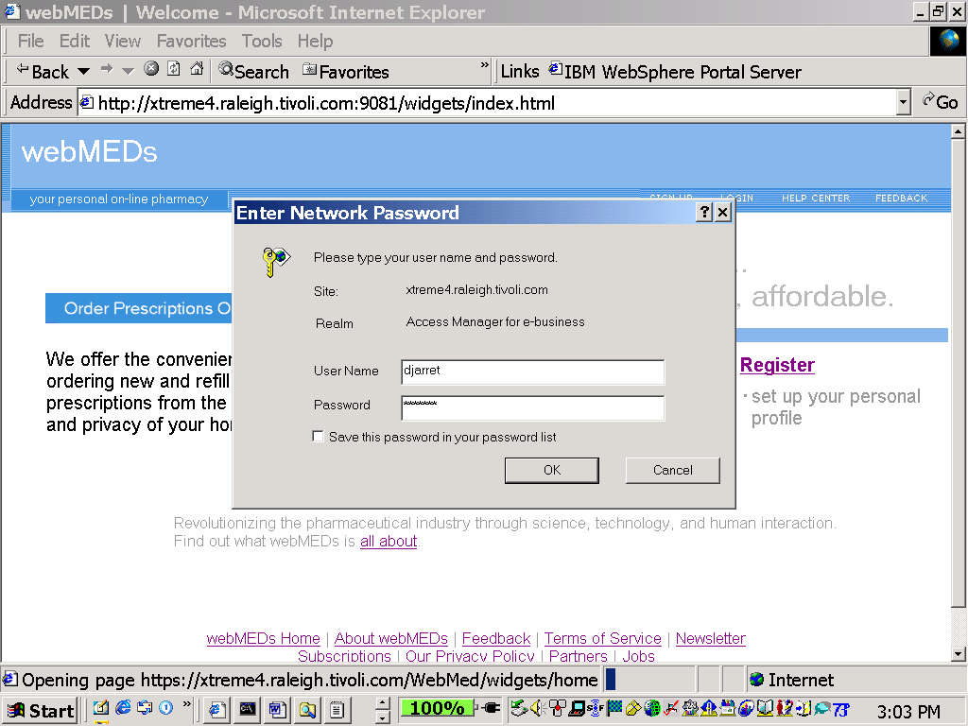
The user received an email confirmation that his account had been created, and he could use the userid and password specified during the registration process to access the webMEDs site. To access online ordering, the user enters a single sign-on userid and password. IBM Access Manager for e-business authenticates the user and authorizes access to all appropriate resources. This provides consistent security policy enforcement across the entire organization creating a truly Autonomic self-protecting environment.
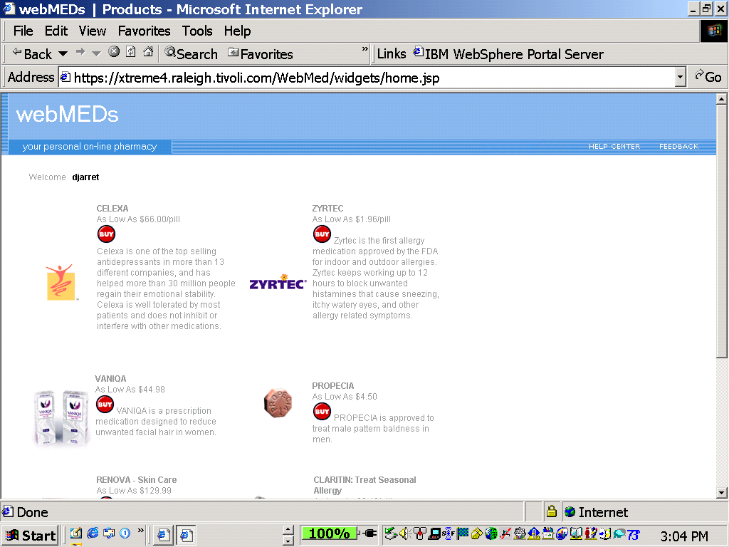
This user has had some stress lately so he decides to purchase some celexa – an anti depressant.
Action - select buy and fill in Credit Card info. Notice preferences are remembered. Select continue to place order.
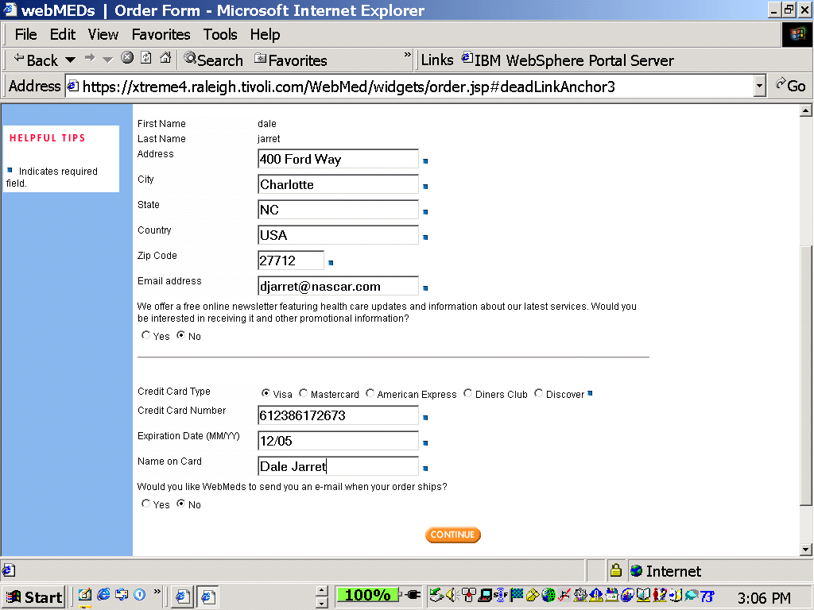

The user is notified that the order has been received.
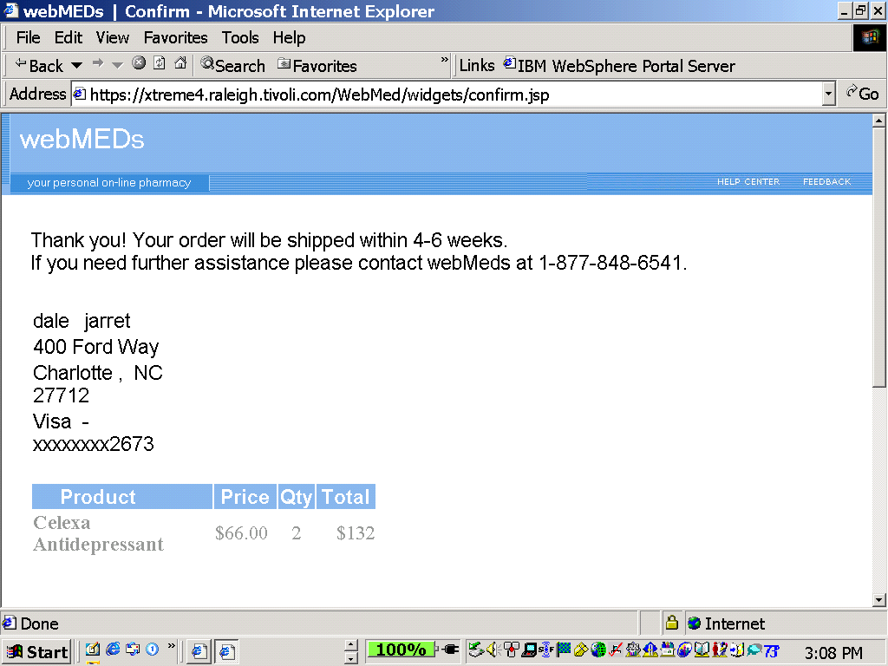

Action - Open another explorer window… because the user credentials are remembered throughout the session and logon as Sally in shipping. Userid Sally, Password Smartway
An employee of WebMeds, Sally from Shipping accesses the application in the same way as a customer, she logs in. Her default page is the shipping section of the site, because of her job function. On sally’s shipping page you see the requested order.
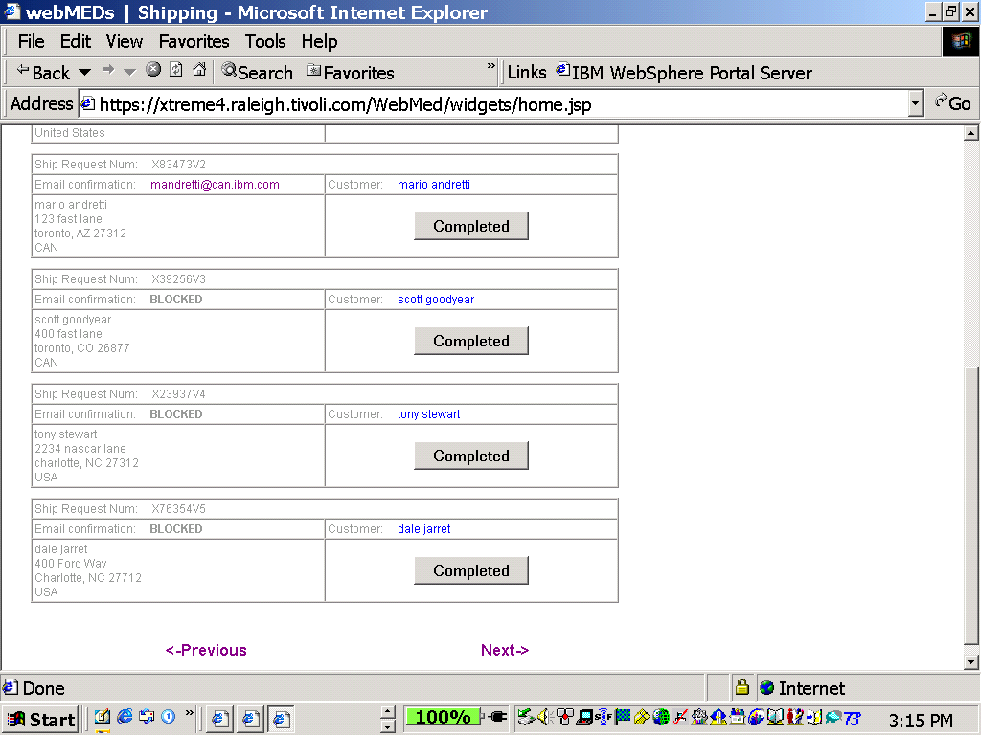
Action - logon with a new browser using Mark (marketing mgr) to view marketing info.
Mark is from Marketing and he accesses the site in order to generate an email distribution list of everyone that has opted in for marketing information.
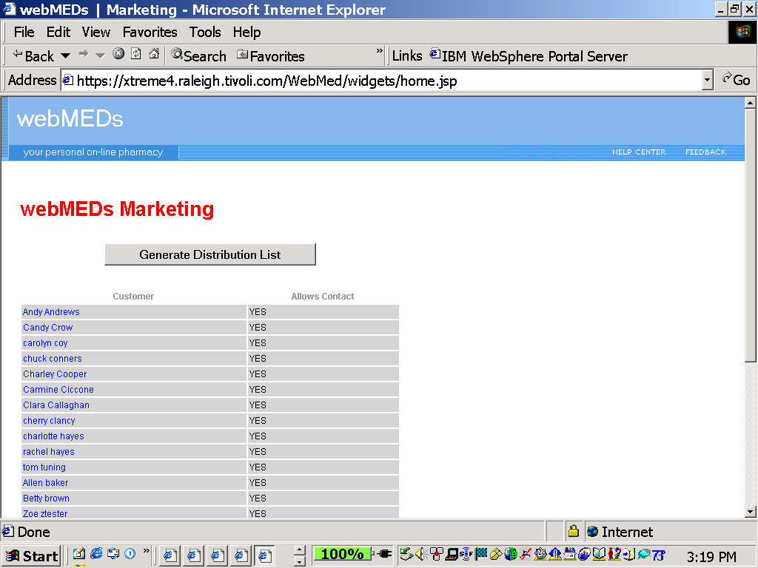
Notice the new user is on this page because they opted in for Marketing Newsletter information.
Action – Click on the customer name to view their customer record
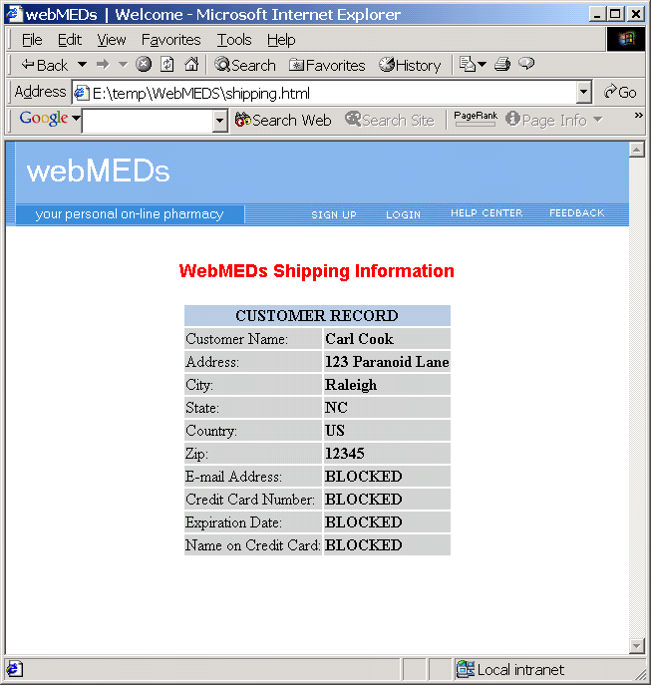
Notice that the Mark from Marketing doesn’t have access to the Credit Card information. This is the Power of IBM Privacy Manager… Building Trust by managing consent.
Privacy Manager is the first application that monitors access to personal information and evaluates permission based on who is requesting the data, for what purpose, and which fields based on the translated categories in the privacy policy.
As a final step, let’s quickly show an audit report generated by Privacy Manager that details who has accessed a particular record, and for what purpose. Enterprises face a challenge in ensuring that they are respecting end-user privacy preferences consistently and effectively across their environment. Not doing so exposes them to the risk of mis-using personal and sensitive information, which is translated into lower customer retention, bad user experience and low levels of loyalty and trust.
This is the industry’s first fully integrated identity, access, and privacy management solution.
A final thought from Mark Ford of Deloitte and Touche … $75K / Month cost reduction for clients based on under 5 minutes to provision systems accounts (from days).

5.1.3.3 Platforms Supported
5.1.3.3.1 Consider these operating systems when answering the questions in this section:
- AIX Yes: 4.3.3 and 5L
- HP/UX Yes: 11.0 and 11i
- Linux on zSeries Yes: SuSE Linux Enterprise Server 7
- Linux on pSeries No
- Linux on Intel (Red Hat, Suse) Yes: Red Hat 7.1 and 7.2 (select components)
- Novell No
- OS/390 No
- Solaris Yes: Solaris 2.7 and 8, both 32- and 64-bit
- Windows NT 3.5, 4.0, 2000 Yes: WinNT 4.0 Server and Win2K Adv. Server
- z/OS No

5.1.3.3.2 Which of the following web servers do you fully support with agents? For each response specify the version of the server as well as the operating system version that it runs on:
- Apache
- IBM HTTP
- Lotus Domino Server
- Microsoft IIS 4.0, 5.0
- Red Hat Stronghold Web Server
- Sun One Web Server
- Zeus Web Server
- List others that are supported

- Apache
- IBM HTTP AIX 4.3.3 and 5L
- Lotus Domino Server
- Microsoft IIS 4.0, 5.0 IIS 5.0 on Win2K Advanced Server
- Red Hat Stronghold Web Server
- Sun One Web Server Solaris 2.7 and 8
- Zeus Web Server
- List others that are supported

The WebSEAL reverse proxy server can protect and typically SSO to any HTTP server.
5.1.3.3.3 Which of the following application servers do you fully support with agents? For each response specify the version of the server as well as the operating system version that it runs on:
- Java Application Servers
- IBM WebSphere
- BEA WebLogic
- Oracle 9i Application Server
- Sun One Application Server
- SilverStream
- Jakarta Tomcat
- Microsoft Technology Based
- BEA Tuxedo
- Lotus Domino
- List others that are supported

- Java Application Servers
- IBM WebSphere AIX 4.3.3 and 5L, Solaris 2.7 and 8, HP-UX 11.0 and 11i, Win2K Adv. Server, Red Hat for Intel 7.1 and 7.2
- BEA WebLogic AIX 4.3.3 and 5L (WLS 6.1), Solaris 2.7 and 8, HP-UX 11.0 and 11i, Win2K Adv. Server, Red Hat for Intel 7.1
- Oracle 9i Application Server
- Sun One Application Server
- SilverStream
- Jakarta Tomcat
- Microsoft Technology Based
- BEA Tuxedo
- Lotus Domino
- List others that are supported

Other Java environments can utilize PDPermissions support via the Java runtime
5.1.3.3.4 Which of the following portal servers do you fully support with agents? For each response specify the version of the server as well as the operating system version that it runs on:
- Ascential DataStage XE Portal Edition
- BEA WebLogic Portal
- Brio Portal
- Citrix Metaframe and Nfuse Portal
- IBM WebSphere Portal Server
- Microsoft SharePoint Portal Server
- Oracle 9iAS Portal
- Plumtree Portal Server
- Sun One Portal Server
- Vignette Application Portal (a.k.a. Epicentric)
- List others that are supported

IBM Access Manager does not use agents for portal server integration. Full portal integration goes beyond the scope of an out-of-the-box IBM Access Manager deployment, so it is highly recommended that a professional services group be consulted for this operation.
Some of the products that we have provided integration with are:
- Adesso
- Aediles
- Aelita
- Akamai
- Alteon
- Ariba
- ATG
- BEA
- Bowstreet
- Brience
- Broadvision
- Business Layers
- BusinessObjects
- Cacheflow
- Cisco
- Citrix
- Daon
- DWL
- Elsinore
- Entrust
- Epicentric
- Eversystems
- GraphOn
- i2
- IBM
- iCognito
- Inso
- Interwoven
- iPlanet
- Kana
- Lawson
- MatrixOne
- Microsoft
- Microstrategy
- Oracle
- O'Reilly
- Peoplesoft
- Plumtree
- Reactivity
- SAP
- Sena
- Siebel
- TalkingBlocks
- Tarantella
- Tradenable
- Verity
- Vignette
- Vordel
- WebEx
- webMethods

5.1.3.3.5 Do you fully support agents for Vignette Content Management? Which version of Vignette content management do you support as well as the operating system version that it runs on.
Content management has no bearing on IBM Access Manager.
5.1.3.3.6 Which of the following applications do you fully support with agents? For each response specify the version of the application as well as the operating system version that it runs on:
- Oracle
- PeopleSoft
- SAP
- Siebel
- WebTone
- List others that are supported

Again, IBM Access Manager does not use agents for this type of integration. Full documentation is available for integration with Peoplesoft, SAP, and Siebel. Other integrations will require the consultation of a services team.
5.1.3.3.7 What web browsers are supported by your product for authentication and self-service? For each web browser supported state the version and the version of the operating system it runs on. What requirements must the browser meet so it can be supported?
Any web browser that conforms to the minimum HTTP 1.0 standards can be used to authenticate to IBM Access Manager.
5.1.3.3.8 What requirements must be met for a web browser to be used with your product for administration? For each web browser supported state the version and the version of the operating system it runs on. What requirements must the browser meet so that it can be supported?
Netscape Navigator 4.78 and 6.2
MS Internet Explorer 5.5 and 6.0
5.1.3.3.9 What reverse proxy servers does your product support? For each reverse proxy server state the version and version of the operating system it runs on.
IBM Access Manager includes the WebSEAL reverse-proxy as the default resource manager for web environments.
No known restrictions with other reverse proxies
5.1.3.3.10 What forward proxy servers does your product support? For each forward proxy server state the version and version of the operating system it runs on.
IBM edge server is supported and tested. There are no known limitations with any other proxy servers.
5.1.3.3.11 What are the hardware and software requirements for the authentication server?
LDAP Master server and replica hardware requirements are driven mainly based on number of users and groups in the domain Supported user registries, if not using the supplied IBM LDAP Directory Server, are listed in the release notes. The minimum LDAP hardware requirements are 100MB disk, 256MB RAM but typically entail 450 MHz, 1-2 GB RAM servers , subject to authentication and replication transaction workloads.
5.1.3.3.12 What are the hardware and software requirements for the authorization server?
The minimum Access Manager Master policy server hardware requirements are 100MB disk space, 128MB RAM, but are driven by the size of the object database and administration transaction workload.
5.1.3.3.13 What are the hardware and software requirements for the proxy server?
The minimum WebSEAL hardware requirements are 100MB disk, 256MB RAM but typically entail 450 MHz, 1-2 GB RAM servers , subject to authentication and authorization transaction workloads.
5.1.3.3.14 What are the hardware and software requirements for any other server component your solution requires?
See below.
5.1.3.3.15 What are the hardware and software requirements for the directory servers that can be used for this product?
All hardware requirements are laid out in the product release notes for these and additional components, such as web server plug-ins, runtime environments, and ADKs. Aside from the supported operating systems, IBM Access Manager has no additional software requirements.

5.1.3.4 Confidentiality and Integrity of Communication
5.1.3.4.1 Which of the following methods does your product use to encrypt transmitted data:
- SSL for Browser and I-mode Yes
- WTLS for WAP Yes
- SSL with mutual authentication for inter-component communication Yes

5.1.3.4.2 List any other method use to encrypt data that is encrypted.
None. SSL is used exclusively in communications.
5.1.3.4.3 How does your product insure that data has not been modified during transmission?
It relies on SSL session integrity.

5.1.4 AUDITING
Are audit records created for each of the following:
- < Successful logons
- < Unsuccessful logons
- < Accounts when they become locked
- < Violation messages
- < All access attempts
- < Authorization failures
- < Anonymous users
- < Identify creation, modification or deletion
- < Policy creation, modification or deletion
- < Suspicious events
- < Anonymous user tracking

Yes, for all of the above.
5.1.4.2 For what other events are audit records created?
When enabled, IBM Access Manager will produce audit events for all authentication, authorization, and management events, as well as server component warnings and serviceability messages.
5.1.4.3 Does each audit record the following information?
- Event type
- Timestamp of event
- Principle or identity initiating the event
- Identification of the target resource
- Permission requested on the target system
- Location from which resource request is made

Yes, all of this information is contained within the audit records.

5.1.4.5 Are audit log records created at the policy level?
Yes. Auditing is enabled for each server component by a parameter in its configuration file. This parameter controls whether auditing is on or off, and if on, which type of activity is audited: authentication, authorization, management, HTTP, or ALL.
Once auditing is enabled at the server level, a POP specifies which resources actually generate authorization audit records, and which level of auditing occurs: success, failure, or all.
5.1.4.6 How are the audit logs protected from unauthorized use or access?
By default, all server components write their audit records in XML formatted ASCII flat files on the server they reside at, and so are protected by the native operating system. Again, through configuration options for each server, log records can be forwarded to other locations or even piped into running daemon processes.
5.1.4.7 What tools can be used to report against reporting data?
Any standard reporting tool can be used.
5.1.4.8 How does the product support changing audit levels?
Each server’s configuration file allows specification of the type of activity to be audited, as well as the level of detail to audit.
5.1.4.9 How is audit log roll over accomplished?
Configuration file parameters allow customization of log size and rollover thresholds. There is also a setting to produce a new file for each day’s logs.
5.1.4.10 How are audit logs archived?
See 5.1.4.6 above.
5.1.4.11 Based upon realtime events can an alert be created to notify system management consoles or administrators immediately? If so, how?
Audit records from any or all servers can be piped into a 3rd party monitoring process to generate alerts. One example of this technology is IBM’s Risk Manager, built upon the logfile adapters of The Enterprise Console.
5.1.4.12 Is auditing down to the individual object level?
Yes, authorization auditing occurs at the object level, as specified by the audit policy in the POP for that object (or the POP for its container object).

5.1.5 Reporting
The optional Identity Manager module provides additional reporting capabilities via LDAP and RDBMS tools.
5.1.5.1 What reports are included out of the box?
None. The Access Manager Audit records are written in XML format to facilitate importation into any standard reporting tool. Standard LDAP reporting tools can be utilized with the user registry. Custom reporting can be done utilizing Access Manager’s C and Java APIs.
5.1.5.2 What information can be reported on such as identity, policy and audit information?
See 5.1.5.1 above
5.1.5.3 What reporting capabilities does your product provide?
See 5.1.5.1 above
5.1.5.4 Is reporting real-time? Are there reports that cannot be done real-time?
See 5.1.5.1 above

5.1.6 Administration

5.1.6.1 Policy Management
The optional Identity Manager module provides additional management capabilities of the Access Manager environment based on roles and approval workflow.
5.1.6.1.1 Can the administration of identities be separated from that of policies?
Yes. Although the GUI manages both user and policy information, it is possible to delegate administration such that one group is authorized to manage user and group information only while another set of administrators manages policies.
5.1.6.1.2 Describe how the administration of identities can be delegated?
From the standpoint of policy management, identities can be delegated in an organizational model.
5.1.6.1.3 Describe how the administration of identities can be delegated across homogeneous domains?
From the standpoint of policy management in a homogeneous domain, identities can be delegated in an organizational model.
5.1.6.1.4 Describe how the administration of identities can be delegated across heterogeneous domains?
Access Manager and Identity Manager provide for delegation of administration as required by your policies and your organization.
5.1.6.1.5 What identity administration tasks can not be delegated?
None. Once a domain administrator has been created and delegated authority, they have the permissions to create other administrators with any subset of their permissions.
5.1.6.1.6 How does the product support dual approval of an identity before it is placed into use?
This is accomplished by defining an approval workflow process for identities.

5.1.6.2 Identity Management
The optional Identity Manager module provides additional management capabilities of the Access Manager environment based on roles and approval workflow
5.1.6.2.1 Describe how the administration of policies can be delegated?
From the standpoint of identity management, identities can be delegated in an organizational model.
5.1.6.2.2 Describe how the administration of policies can be delegated across homogeneous domains?
From the standpoint of identity management in a homogeneous domain identities can be delegated in an organizational model.
5.1.6.2.3 Describe how the administration of policies can be delegated across heterogeneous domains?
CDAS provides the ability to imbed detailed user authorizations in HTTP headers that can be acted upon by applications cross-domain.
5.1.6.2.4 What policy administration tasks can not be delegated?
None. Once a domain administrator has been created and delegated authority, they have the permissions to create other administrators with any subset of their permissions.
5.1.6.2.5 Explain how the administrative tool can show a view of the URL resources that can be protected on a particular web server.
Within the master policy server, IBM Access Manager maintains a hierarchical representation of all resources in your secure domain, referred to as the protected object space. The GUI shows all of these resources in a collapsible-level “tree” view, ala Windows Explorer. From the root level, the /WebSEAL branch contains all of your web resources. Each WebSEAL server in your domain has a separate branch below this container, and each junction from a WebSEAL server to a backend web or application server is represented by a branch below that. For supported web servers, Access Manager provides a customizable ‘query_contents’ tool that discovers the web server resources. Additional resources can be defined programmatically via the Access Manager CLI and API (C and Java) interfaces.
5.1.6.2.6 How does the product support dual approval of a policy before it is placed into use?
This is accomplished by defining an approval workflow process for policies utilizing the optional Identity Manager module.

5.1.6.3 Provisioning
5.1.6.3.1 Describe your products support for provisioning?
Access Manager provisioning is based on group or roll membership. The optional IBM Identity Manager solution provides the ability to provision user resources within its LDAP server as well as backend servers as needed using an automated, workflow-driven engine, based on static and dynamic roles and provisioning policy.
5.1.6.3.2 Describe your products ability to de-provision an account or identifier.
The same provisioning capabilities described in 5.1.6.3.2 can be used for deleting and deactivating user accounts as necessary.
5.1.6.3.3 When a user ID is de-provisioned what happens to any of the user ID’s pending application transactions?
If the user has one or more active sessions, then their authenticated identity is valid in the WebSEAL session cache for the duration of their session. Once they log off or close their browser, or exceed the session lifetime setting, they would be forced to re-authenticate. This would fail, since their ID no longer existed.
If the Identity Manager provisioning workflow were scripted to also implement a root-level ACL denying them permissions to all resources, the policy change would take effect almost immediately. There would be a brief delay until the change was propagated from the master policy database to the resource manager, but once it had done so, no further transactions would be authorized.

5.1.6.4 Workflow
5.1.6.4.1 Does the provisioning in your product use workflow? If it does describe the products workflow capabilities.
Yes, see 5.1.6.4.2 below
5.1.6.4.2 Does your workflow adhere to any workflow industry standards?
Not at this time. The workflow for Identity Manager is user defined through a graphical tool.
5.1.6.4.3 Does your product use another product to implement its workflow? If so what is the product?
The Identity Manager workflow is built into the product.

5.1.6.5 Self Registration
5.1.6.5.1 Describe your products self registration capabilities.
Access Manager supplies a sample self-registration JSP based application. Most customers utilize the CLI or APIs and/or services to create their own custom self-registration pages, which can front end the optional Identity Manager module to complete the provisioning process.
5.1.6.5.2 Can a security administrator approval be part of the self registration process?
Approval workflow can be provided via the optional Identity Manager module.
5.1.6.5.3 Does your product provide workflow for the approval of self-registration?
Approval workflow can be provided via the optional Identity Manager module.

5.1.6.6 Self Service
5.1.6.6.1 What security functions can the customer handle through self service?
Access Manager provides self service password change. The optional Identity Manager module provides password reset self service via challenge/response questions.
5.1.6.6.2 What non-security functions can the customer handle through self-service?
Access Manager CLI and APIs can be used to provide custom self-service. The optional Identity Manager module can provide access to any of the user’s LDAP record information that you choose to permit self-servicing by the users.

5.1.7 Application Programming Interfaces
5.1.7.1 Describe your application programming interfaces by category. Possible categories are:
- Authentication authAPI, documented
- Authorization Open Group’s aznAPI, documented
- Identity Management adminAPI, documented
- Access Management adminAPI, documented
- Presentation
- API’s for non-web applications
- Customization
- New authentication method
- New auditing capabilities

5.1.7.2 For each API show what language or technology it supports. Possible languages and technologies are:
- ASP
- C/C++
- C#
- CGI
- COM/DCOM
- Java, JAAS, JSP, EJB
- PERL
- Web Services
- WebSphere MQ
- Visual Basic.Net

The standard APIs exposed by IBM Access Manager are native C and Java APIs. In addition, the CLIs are accessible via most scripting tools such as PERL.

5.1.8 XXX Security Standards

5.1.8.1 Security Questions For Purchased Products

5.1.8.1.1 System Description
5.1.8.1.1.1List and describe the hardware and its associated operating system, version of the OS including service pack and patch level. This should include all computer hardware (mainframes, servers, and network) components that would be added to our environment.
The IBM solution is multiplatform capable. Hardware requirements and OS version and patch level requirements vary across platforms and are fully documented in the product release notes.
5.1.8.1.1.2 List and describe any data base management systems that would be running on the above hardware, including version of the DBMS, service pack and patch level.
None, unless you use the included IBM Directory Server software for your LDAP User Registry. If you do, then IBM DB2 Universal Database is installed as the backing store for the Directory Server. This instance of DB2 carries a limited-use license for the Directory Server only, and requires no manual administration.
5.1.8.1.1.3 List and describe the application(s) that will be running on the above hardware, including version, service pack and patch level.
Access Manager 4.1 and optionally the Identity Manager 4.4 module. Sub systems include Websphere Application Server, optional IBM LDAP Directory Server and DB2 backend.
5.1.8.1.1.4 List protocols and describe how each protocol is utilized by your application
All communication occurs over TCP/IP. HTTP and LDAP are the protocols used, including HTTPS and LDAPS (using SSL encryption).
5.1.8.1.1.5 Please include any utility programs (i.e. telnet, ftp, ssh, etc.) you anticipate using, including version, service pack and patch level.
None.
5.1.8.1.1.6 Provide any security related certifications your product has obtained (i.e. Bits, I.C.S.A.)
IBM is in the process of getting CC certification; also have various FIPS certifications for components (such as GSKit) the target for completion of CC evaluation is Q3, so target is for ISO 15409 by the end of 2003.

5.1.8.1.2 System/Application Diagrams, Charts & Overviews
5.1.8.1.2.1 Provide a technical overview that illustrates how the hardware components are physically wired. Describe what function each hardware component performs.

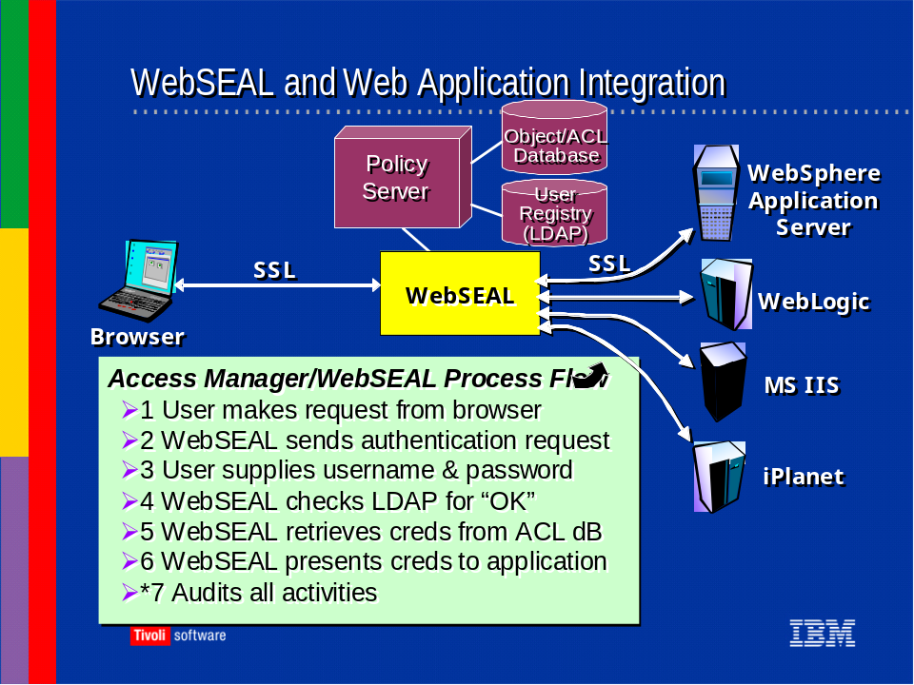

Further explanation:
This process flow assumes a request to a protected asset and all answers are “yes”. Item #2 (WebSEAL sends an authentication request), user is presented with a Basic Auth Form or whatever means on authentication you have implemented. Items #4 and #5, WebSEAL checks the Policy Manager where LDAP contains user information and the Object/ACL dB contains permissions.
5.1.8.1.2.2 Provide a “data flow” of the proposed system/application. Including encryption/decryption points, authentication points, transaction flow, administration processes. (Typically in bullet text format)
A typical flow might look like this:
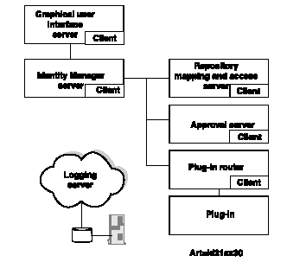
1. A new employee accesses the Graphical User Interface (GUI) of Identity Manager in a browser at her workstation to self-register. The new employee also indicates requirements to access an NT system (for a Human Resources application), a UNIX system (for a programming development application), and an Oracle database (to access customer relationship information).
2. The information entered via the GUI is routed through the Identity Manager Server to the Approval Server, where an approver (a manager, for example) approves the request to create a User data object representing the new employee.
3. The approved request to create the User data object (for the employee) and the Accounts data objects (for the NT, UNIX, and Oracle systems) is sent to the Repository Mapping and Access Server for processing. Before the accounts can be created, they must be routed for approval to the Approval Server, where an approval list distributes the request to the system administrators for approval.
4. The approved request to create Account data objects is sent to the Repository Mapping and Access Server for processing. To complete the Accounts creation, requests are sent to the endpoints (NT, UNIX, and Oracle) via the Plug-in Router Server. The Plug-in Router Server determines to which Plug-in to send the request. Once there, the plug-in sends the request to the actual NT, UNIX, and Oracle systems for processing. So, the NT and UNIX requests will be sent to the Plug-in Router Server, which will route them to the Enterprise Account and Security Group Plug-in. The Oracle request will be sent to the Plug-in Router Server, which will route it to the Proxy Plug-in.
5. Throughout this process, the logging server provides message or trace generation and storage. Message records inform the user of the progress of the request, and trace records provide audit and troubleshooting information. This is just one example. Identity Manager also simplifies other recurring and time-consuming tasks in managing identities, such as:
- changes to user profiles
- password changes and reset
- customer (as opposed to employee) self-registration
- complete deletion of a user from the corporate (or customer) directory
- delegation of user, group, and user-attribute management to one or more administrators
- default access to specified resources based upon group membership.

5.1.8.1.2.3List all external connectivity required by your application. This could include remote client access or administration.
Access Manager does not require any external connectivity. The administrative GUI called web portal manager (WPM) is browser based and can be used internally or externally.

5.1.8.1.3 Access Controls
5.1.8.1.3.1 Describe the method(s) used to provide for identification and authentication of users of the application.
All users, including IBM Access Manager administrators, are identified by accounts in the LDAP User Registry. The method of authentication is dependent upon your needs, but by default is verified through users inputting their IBM Access Manager userID and password.
5.1.8.1.3.2 Is a unique user ID and access code (i.e. passwords, pins) combination assigned to each user of the system?
Yes, in the LDAP registry, each user is identified by a unique DN. Password strength rules can also be implemented and enforced.
5.1.8.1.3.3 Do all accounts have an access code?
Yes. By default, each is password protected.
5.1.8.1.3.4 Are the access codes encrypted in storage? Where are access codes stored?
This depends on how your LDAP server is configured. Passwords are stored in the LDAP server, with encryption being a server configuration option.
5.1.8.1.3.5 Are the access codes encrypted in transmission?
Yes. All server component intercommunication takes place over SSL encrypted channels.
5.1.8.1.3.6 Does the system require the user to change their initial access code during their first logon?
Yes, this option can be set so that users must change their PW at first logon.
5.1.8.1.3.7 What is the minimum and maximum length of the access code? Is this length configurable?
Yes, see previous section covering password strength policies.
5.1.8.1.3.8 What is the minimum and maximum length of the user ID? Is this length configurable?
You may determine your own rules governing the composition and content of userIDs.
5.1.8.1.3.9Does the system allow the user to change their access code when desired?
Yes, passwords can be changed at the users’ discretion, if you choose to allow it.
5.1.8.1.3.10 Does the system automatically prompt users to change their access code periodically? Is this time interval configurable?
Yes and yes.
5.1.8.1.3.11 What restrictions are placed on the contents of the access code to ensure appropriate strength? For example, user ID not equal to access code, access code not equal to “password”, access code not set to multiple repetitive characters.
Access manager provides a password policy to ensure that access codes are not trivial and not equal to the password. See also previous section covering password strength policies.
The optional Identity Manager module provides additional policy restriction capabilities
5.1.8.1.3.12 Does the system disable, or suspend, user IDs after a fixed number of unsuccessful logon attempts? Is this number configurable?
Yes, see previous section on password lockout policies.
5.1.8.1.3.13 Does the system prevent the reuse of old access codes for a determined length of time? Is this length of time or number of different access code configurable?
Yes, with customization. See previous section covering password strength policies.
5.1.8.1.3.14 Describe the message back to the user indicating that they have not been authenticated? Is this message configurable?
The user is redirected to an HTML error page indicating an HTTP 403 (Not Authorized) error. The contents of this page can be anything you choose to include.
5.1.8.1.3.15 Does your application provide a message during logon that notifies the user of their last date and time of logon?
No, aside from authentication and authorization failures, the solution operates transparent to the user.
5.1.8.1.3.15 Does your application automatically terminate, or require re-authentication, after a period of inactivity? Is that period of time configurable?
Yes and yes. See previous section on session expiry.
5.1.8.1.3.16 Does your application prohibit a user from being logging in from more than one workstation at a time?
Not at this time.
5.1.8.1.3.17 Are any user IDs and access codes imbedded into the software, scripts or batch files?
No user Ids and access codes are imbedded into software scripts or batch files.

5.1.8.1.4 Administration of User IDs and Access Codes
5.1.8.1.4.1 Does the system provide for the suspension and deletion of user IDs after a period of inactivity? Is this time period configurable?
Can be accomplished by taking advantage of available APIs.
5.1.8.1.4.2 Describe your access code reset process when an access code is suspended or forgotten.
Access Manager only solution requires administrator action via the browser based GUI or available CLI (or custom application via C or Java APIs). The optional Identity Manager module provides a browser based password reset capability via a set of challenge/response questions. Identity Manager administrators can also change the user’s password.

5.1.8.1.5 Logging and Audit Trails
5.1.8.1.5.1 Does the system provide an audit trail/log of successful logons?
Yes, if authentication success auditing is enabled.
5.1.8.1.5.2 Does the system provide an audit trail/log of unsuccessful and suspended access attempts, notification of ID suspensions and violation messages?
Yes, if authentication failure auditing is enabled.
5.1.8.1.5.3 Describe your application’s ability to provide any notification capabilities for such things as unsuccessful logon attempts that result in suspending a user ID.
These activities are audited in the log file, if enabled Using a 3rd party adapter like the IBM Enterprise Console or Risk Manager modules to scan the logs for events of this nature can provide alerts to such activity. The audit events could also be piped to a monitoring daemon process to raise the alerts.
5.1.8.1.5.4 Does the system provide the ability to list the users and their associated rights?
IBM Access Manager provides a web based or command line way of querying users and displaying associated group memberships.
5.1.8.1.5.5 Describe how the audit trail/logs are protected from unauthorized access?
Audit logs are protected by the operating system mechanism on the server where they reside.
5.1.8.1.5.6 Does the system provide an audit trail/log for system and application configuration changes?
Yes, server serviceability messages can be audited and logged as well.

5.1.9 Security Standards Supported
5.1.9.1 For each of the standards listed in this section specify:
If the standard is fully supported
Which part of the standard has not been implemented in your product?
Which components use the standard?
If the standard is planned to be fully supported by the product by the end of the year 2003.

Standard | Is the Standard fully supported? | What is not supported? | Which components Use the Standard? | Will the Standard Be fully supported by 2003? | Standard’s Body
.Net Passport | .Net Passport is not a standard, but MS proprietary technology |  | Will be supported with Access Manager web services security (target GA Q3 2003) | Will be supported with Access Manager web services security (target GA Q3 2003) | Microsoft
ADSI | ADSI is not a standard, but a MS proprietary technology | Access Manager is able to use Active Directory as the user registry. This allows TAM to manage users that are maintained in AD – use of ADSI is not required for external management | Web Portal Manager |  | Microsoft
AES (Advanced Encryption Standard) |  |  |  | Depends on when support for AES is integrated into GSKit | Federal Information Standard (FIPS)
aznAPI (authorization API) | Yes |  | Access Manager for eBusiness – WebSEAL, Policy Server, authorization APIs, custom components coded to TAM’s aznAPI |  | Open Group’s Technical Authorization Standard
Common Secure Interoperability (CSI) v2 | No |  | Will be supported by WebSEAL, Access Manager web services security | Yes | Object Management Group
CRL (Certificate Revocation List) | Yes |  | WebSEAL |  | Internet Engineering Task Force
DSML (Directory Services Markup Language) 1.0, 1.1 | No |  |  |  | OASIS
GSS (Genetic Security Services) API | Yes |  | LDAP, WebSEAL, WPM |  | Internet Engineering Task Force
HTTP (Hypertext Transfer Protocol) 1.0, 1.1 | Yes |  | WebSEAL, Policy Server, aznAPI, WPM |  | Internet Engineering Task Force
Standard | Is the Standard fully supported? | What is not supported? | Which components Use the Standard? | Will the Standard Be fully supported by 2003? | Standard’s Body
i-mode (a wireless protocol) | Yes |  | WebSEAL provides support for iMode and iMode gateways |  | NTT DoCoMO
IPSEC (IP Security Protocol) |  |  |  |  | Internet Engineering Task Force
ISO 15408 (aka Common Criteria) |  |  |  | ALL IBM Software Group products are undergoing Common Criteria evaluation. IT is not known when this will be completed | ISO
J2EE (Java 2 Enterprise Edition) | Yes |  | TAMeB |  | Sun Microsystems
JAAS (Java Authentication and Authorization Service) | Yes |  | TAMeB Java authorization API |  | Sun Micorsystems
JCA (Java Connector Architecture) | No |  |  | No – not relevant to TAMeB | Sun Microsystems
JCE (Java Cryptography Extension) | No |  |  |  | Sun Microsystems
JSSL (Java Secured Socket Layer) | No |  |  |  | Sum Microsystems
Kerberos Version 5 release 1.2 | Yes |  | LDAP | Support for Kerberos token will also be available through Access Manager web services security | Internet Engineering Task Force
LDAP (Lightweight Directory Access Protocol) v3 | Yes |  | WebSEAL, WPM |  | Internet Engineering Task Force
Liberty 1.0, 1.1 | THIS IS NOT A STANDARD |  |  | If the Liberty specifications are taken to a standards body then IBM will work with the standards body and will support any resulting standards | Liberty Alliance
OCSP - Online Certificate Status Protocol | Yes |  | TAMeB – CDAS | We have written custom CDAS implementations to support OCSP | Internet Engineering Task Force
PAM (Pluggable Authentication Module) | Yes |  | TAMeB |  | The Open Group
S-HTTP (Secure Hypertext Transfer Protocol) | No |  |  |  | Internet Engineering Task Force
SAML (Security Assertion Markup Language) 1.0 | No | Browser POST profile is not supported | WebSEAL |  | OASIS
SOAP (communication protocol for Web Services) | Yes |  | TAMeB |  | World Wide Web Consortium
SSL (part of theTLS standard) | Yes |  | All Components |  | Internet Engineering Task Force
TLS (Transport Layer Security) protocol 1.0 | Yes |  | WebSEAL |  | Internet Engineering Task Force
Triple DES (Data Encryption Standard) encryption | Yes |  | WebSEAL |  | Federal Information Standard (FIPS)
WAP (Wireless Application Protocol) 1.2.1 | Yes |  | WebSEAL supports WAP access via a WAP Gateway |  | WAP Forum
WS- Security | THIS IS NOT A STANDARD |  | This will be supported with Access Manager web services security support | Yes | OASIS – Standard activities not yet complete
WS- I Basic Profile 1.0 | No |  |  | No – handled by other IBM products such as WebSphere Application Server (and the Web Services Gateway) | Web Services Interoperability Organization
WS-Security (Web Services Security) | THIS IS NOT A STANDARD |  | This will be supported with Access Manager web services security support | Yes | OASIS – Standard activities not yet complete
X.509v3 | Yes |  | WebSEAL |  | ISO, ITU and Internet Engineering Task Force
XACL (eXtensible Access Control Markup Language) | THIS IS NOT A STANDARD |  |  | No – handled by other IBM products such as WebSphere Application Server (and the Web Services Gateway) | OASIS – Standard activities not yet complete
XKMS (XML Key Management Specification) | No |  | This will be supported by next with Access Manager web services security support | Yes | World Wide Web Consortium
XML | No |  |  | Support for XML is provided through other IBM products, such as IBM WebSphere | World Wide Web Consortium
WS-Trust | THIS IS NOT A STANDARD |  | This will be supported with Access Manager web services security support | Yes | Joint specification by IBM, Microsoft, RSA and Verisign – NOT YET AT A STANDARDS ORGANIZATION

ISO 15408, Common Criteria is a very broad and comprehensive set of functional and assurance requirements for security, some of which apply directly to hardware and software components, and some of which apply to the design, integration and operation of IT products and solutions.
Trained IBM security personnel reference Common Criteria as a baseline for security in the design of IT solutions, to ensure that all Common Criteria requirements are considered during the solution design process. This patented method is an IBM exclusive. An overview was published in the IBM Systems Journal http://www.research.ibm.com/journal/sj/403/whitmore.html A formal view of the security of the entire solution architecture is available as part of a services engagement.
While most of the components in the IBM proposal have not yet been submitted for a formal Common Criteria certification, Access Manager generally fits the form of the Role-based / Rights-based Access Control Protection Profile (RBAC-PP) as defined by http://www.commoncriteria.org/ccc/protection_profiles/ppdetail.jsp?id=PP-009
Operationally, Access Manager incorporates many CC specifications beyond the RBAC PP. has functional elements in eleven the Common Criteria Functional Requirements classes: Security Audit, Data Protection, Communication, Cryptographic support, Identification and Authentication, Component Access, Privacy, Trusted Path/Channel, Security Management, Component Protection, Resource Utilization.
In addition, many of the Technology Oriented standards in the table, such as IPSec, Kerberos, X.509, CRL, OCSP, etc., represent design options and choices within the broader scope of ISO 15408, Common Criteria.

5.1.10 Integration
5.1.10.1 Describe the various ways that an existing application can be integrated to your software.
Access Manager provides several levels of potential application integration including:
- web SSO via basic auth or forms based credential posting (typically can be done via WebSEAL configuration)
- web SSO by passing user identity and group info to the back end application (configuration in WebSEAL and modification of back end application to pull information out of HTTP headers)
- web SSO via IBM Websphere TAI or LTPA (WebSEAL and Websphere configuration)
- passing LDAP tag/value pairs in HTTP headers (WebSEAL configuration and modification of back end application to pull information out of HTTP headers)
- passing entitlement information in HTTP headers (WebSEAL configuration and modification of back end application to pull information out of HTTP headers)
- passing Access Manager credential to back end application (WebSEAL configuration and modification of back end application to utilize credential via APIs)
- C or Java based authorization and administration API access (via APIs)
- Sharing a common LDAP user registry which may also be centrally managed by either Access Manager or the optional Identity Manager module (application specific LDAP user registry integration i.e. WebSphere is configurable).
5.1.10.2 For each integration method, describe the type of application changes that would be necessary.
See Above.
5.1.10.3 What UNIX security based products is your product able to integrate with out of the box?
IBM Access Manager for Operating Systems
5.1.10.4 What IBM WebSphere security products is your product able to integrate with out of the box?
Access Manager provides WebSEAL junction support for WebSphere Application Server and WebSphere Portal Server solutions.
Access Manager provides enhanced authorization support for WebSphere Application Server and WebSphere Portal Server solutions, to include precise Actions, Protected Object Policies, Access Control Lists and Global Sign On. The Authorization service supports decision by individual, group and role, and Action within any of those. For Websphere Portal Server, Access Manager can control access and actions for Portlets.
Access Manager packages its Web Administration facility (called Web Portal Manager) in a WebSphere Enterprise Application.
5.1.10.5 Does your product integrate with any Enterprise User Management products such as Access 360 and BMC INCONTROL.
Access Manager can be a provisioned endpoint of the optional Identity Manager module which was acquired with the purchase of Access360 (enRole solution) by IBM on 10/06/2002
5.1.10.6 For each of the following product categories list the vendors with which your product is certified to work.
- PKI RSA, Verisign, Entrust, others
- Firewalls No vendor constraints
- Provisioning Solution includes provisioning, based on Access360 EnRole
- Risk Management IBM Risk Manager

5.1.10.7 Describe your support for Microsoft Passport.
IBM is actively working with Microsoft in this arena. As these specifications are taken to a standards body, IBM will participate in the standards effort and will support any resulting (applicable) standards in the appropriate products.
5.1.10.8 Describe your support for the Liberty Alliance standard.
When the Liberty Alliance takes these specifications to a standards body, IBM will participate in the standards effort and will support any resulting (applicable) standards in the appropriate products.
5.1.10.9 Describe your support for Identrus’ project Eleanor.
IBM has participated with Identrus since its inception, on many levels. It currently has many pilots with project Eleanor around the world.

5.1.11 Miscellaneous Questions
5.1.11.1 Provide us with a three year history of new versions, release and patches.
Access Manager has had two version/releases typically per year during the time frame. Access Manager 4.1 came out in October, 2002. Its’ predecessor, Policy Director had multiple releases including 3.7, 3.8 and 3.9
5.1.11.2 Provide us with a history of security vulnerabilities for the product.
To date there has only been one security vulnerability discovered (and corrected) and placed on bugtrak
      - How do you notify customers of security vulnerabilities?
The IBM support site provides vulnerabilities information and provides notification to registered users along with bugtrak notification.
5.1.11.4 Include in your response electronic copies of your documentation.
Electronic documentation is being provided in the CD provided to XXX.
5.1.11.5 What is your companies commitment on supporting new versions or releases of:
- Web Servers
- Application Servers
- Portal Servers
- Proxy Servers
- Directory Servers
- Operating Systems
- External Authentication Services

IBM Access Manager is for the most part “server agnostic”. That is, changes in web servers, application servers, portal and proxy servers does not affect Access Manager components. Changes in directory servers, where this includes changes in directory software, may or may not affect TAM. Changes in Operating Systems do affect our product in that IBM will not provide official support for a product on a new O/S until the product and O/S in question have been through a QA cycle.
5.1.11.6 What issues are you aware of that often must be overcome to convince an application server provider (ASP) to use the extranet access management product that a company has picked?
IBM access manager uses standard ports for access through the ASPs firewall. They include the standard HTTP 80, HTTPS 443. In general, these issues are political and not technological.
Some factors:
- integration with ASP platforms
- integration with ASP network infrastructure and firewalls
- integration with ASP systems management, security monitoring policies, tools, processes and services

5.1.11.7 What are the features that are planned to be added to your product by the end of year 2003?
IBM plans to release enhancements and new products in 2003 that will focus on key areas that include Federated Identity, Web Services and Desktop Integration, and will begin with “out-of-the-box” support for SAML tokens, culminating with trust services, authentication services and both course- and fine- grained access control for Web Services, all available as part of a unified, policy-based, Access Manager authorization solution.
Additional details on IBM’s future product plans can be discussed under a non-disclosure agreement.
All plans are subject to changing business conditions and thus may change appropriately.
5.1.11.8 What is the install base for the product?
Substantial number of Fortune 3000 companies have installed and deployed our product with several large scale production installations across several vertical industries
5.1.11.9 What is the financial institution install base for the product?
We have successful deployments of IBM Access Manager in financial institutions
5.1.11.10 What other vendor’s product is imbedded in your product? For instance Crystal Reports?
None. The solution is comprised entirely of IBM software.
5.1.11.11 Are there plans for your product to work with Microsoft’s TrustBridge by the end of year 2003?
IBM will be introducing a new web services security product (targeted GA of Q3 2003) that will interoperate with TrustBridge. This will be based on web services security and the web services security specifications released by IBM and Microsoft. Note that as part of these specification releases, IBM and Microsoft have demonstrated interoperability of tech preview/toolkit products.
5.1.11.12 What are your plans for supporting the .Net framework? What resources in .Net will you be able to protect?
All web resources can be secured by IBM Access Manager, regardless of their services framework.
5.1.11.13 For both availability and security reasons, we require critical systems to tolerate the presence of host-based agents:
- Does your product have any known issues coexisting with either HP OVO monitor agents or ISS Server Sensor? Any other similar products?

No known issues.
- Do you have an established track record of stabile performance with such software running alongside yours?

Yes/
- Do you have any actual "partnerships" or similar cooperative arrangements with any such vendors? (Does your product come ready-to-plug-in to HP OVO, for instance, is it easily configured to do so?)

Just with IBM systems management tools.
5.1.11.14Our VPN solution is likely to be either AT&T or FiberLink. Do you have any support considerations in light of this, good news or bad?
No known restrictions. IBM Access Manager is operationally unaware of the class of connection being used, be it HTTP/SLL over an open TCP socket or through a VPN.
5.1.11.15 For communications between machines in at-risk zones or across DMZs, we require both strong authentication and strong encryption. Typically, this is achieved by SSL/TLS connections and digital certificates on each machine involved. We also expect to support both employee and some client/customer connectivity by VPN.
- Does your product support or behave well under these conditions? (Was it designed with this sort of connectivity in mind?)

Access Manager was designed with this in mind – there are no known restrictions. Access Manager provides the capability to configure mutually authenticated SSL connections between WebSEAL and back end HTTP servers and is currently implemented in customer VPN environments.

5.1.11.16 We also require sensitive data to be flushed from caches when no longer needed, and secured in the store if required to be locally preserved. MD5 or SHA-1 hashes of passwords in a shadow file is one common example of this.
- Does your product's architecture require any such sensitive data to be stored locally? If so, does it provide for local security with strong encryption? If so, what algorithms, and what bit lengths? (For block ciphers, DES is unacceptable; 3DES is acceptable and currently preferred; current or near-future announced support for AES at least 128 bits is expected. For one-way hashes, both MD5 and SHA-1 are acceptable.) If your product is dependent on the host OS for this functionality, which OS(es) and at what patch levels do you recommend?

Sensitive data such as passwords are not stored “locally” on the WebSEAL component. Passwords protection in SecureWay LDAP is configurable to none, imask, crypt, or SHA. Crypt and SHA are one-way hashes; imask allows two-way masking.
WebSEAL provides secure hardware key store support to allow the private key and certificate of a server to be stored on a tamper-resistant hardware key store.
Sensitive data such as passwords are not stored “locally” on the WebSEAL component. Passwords protection in SecureWay LDAP is configurable to none, imask, crypt, or SHA. Crypt and SHA are one-way hashes; imask allows two-way masking.
WebSEAL provides secure hardware key store support to allow the private key and certificate of a server to be stored on a tamper-resistant hardware key store.
5.1.11.17 Please identify which of these products or organizations and what release/location with which you have integrated your product successfully
Applications:
Corillion Voyager
FundTech CashPlus
Checkfree
IBS Netaccess
Yodlee

Partners (ASP)
National Financial Services (Fidelity)
Clark American
MBNA

We are currently not aware of any integration with the products and organizations mentioned here. If the products conform to standard such as HTTP and SSL integration should be a simple matter.
5.1.11.18 Identify if your product can be set to a "learn mode" to record user id's and passwords as users login ...in order to build the directory information.
IBM Access Manager does not provide this out of the box. Requires customization
5.1.11.19 Identify if your product supports customization or branding of both the user login page as well as the administrative login page.
Completely customizable. User login page can be branded. The administrator login page can be changed by changing the JSP pages.
5.1.11.20 Identify which directory platform is utilized in your product development life cycle.
The product is developed and tested with standard LDAP directories, such as IBM directory, iPlanet, and Microsoft active directory.
5.1.11.21 What product features make your product unique in the marketplace?
Scalability and platform support are the best in the industry. The authorization infrastructure is common to web, operating systems and secure messaging systems.
Flexible Architecture (Proxy, Agents)
Scalability and Performance
Integrated Identity Management
Unified Access Control across multiple touchpoints (INTRANET, INTERNET, Wireless, iMode, WAP)
Deep Integration with J2EE App Servers
Integration with Portals (Plumtree, Epicentric, SAP), CRM (Siebel, KANA) and ERM (SAP, Lawson, PeopleSoft) solutions, Collaboration (Lotus Sametime, Lotus Quickplace)
Digital Authentication Services (integration with RSA, Daon Biometric)
5.1.11.22 Can your sales team provide a demo using a XXX Use Case?
Out of the box Access Manager and Identity Manager functionality can be demonstrated by the sales team. Typically, additional customization would be done via services as part of a billable POC

5.2 Quality of Service

5.2.1 Scale
5.2.1.1What scale, in terms of concurrent users and servers, has your application been designed AND tested for? Use figures from a current installation or from your largest stress-test.
The number of concurrent users that can be supported is dependant on the authentication, authorization, password reset rates and other workload on the servers. Access Manager has been publicly tested with up to 4 million users stored in the IBM LDAP directory. The test results are available at www.mindcraft.com. The test used 2 LDAP servers and 4 WebSEAL servers. We have a large customer in the telephone industry who has privately tested Access Manager with over 10 million users. We have a financial customer with over 1 million users in production.
5.2.1.2How has your application suite been designed for this scale?
Access Manager server components have been designed to handle for replication and high availability. WebSEAL, LDAP and Policy Servers can all be replicated to handle large volumes of users. In addition, WebSEAL servers cache security policy locally. This allows the WebSEAL servers to make authorization decisions locally without going across the network to contact the policy server. WebSEAL can also provide load balancing across backend replicated backend webservers.
The LDAP server can also be configured to cache user information for faster authentication times.
5.2.1.3What are the maximum, minimum and average end-to-end response time?
Varies based on customer environment.
5.2.1.4Time to authenticate new user
In an effort to accurately represent most customer environments, the Mindcraft testing was conducted using a combination of authentication and authorization operations. This combination is called an “extranet sequence” and consists of a single authentication and 10 authorization operations, totaling eleven operations. With 4 million users in the LDAP directory, IBM Access Manager has been proven to handle 16,447 operations per CPU, per minute.
5.2.1.5 Time to validate access to resource
Please See above.
5.2.1.5.1 Concurrent User Installations
5.2.1.7 What is your largest installation in terms of concurrent users? Please specify the number of concurrent users and include a brief description of the network architecture.
Access Manager has been publicly tested with up to 4 million users stored in the IBM LDAP directory. The test results are available at www.mindcraft.com. The test used 2 LDAP servers and 4 WebSEAL servers. We have a large customer in the telephone industry that has privately tested Access Manager with over 10 million users. We have a financial customer with over 1 million users in production.
5.2.1.8 What are the maximum, minimum and average end-to-end response times?
Varies based on customer environment.
5.2.1.9 What is your average installation in terms of concurrent users? Please specify the number of concurrent users and include a brief description of the network architecture.
The number of concurrent users is a configurable option. The practical limit for the system is dependent upon the system resources available and workload. Additionally, the throughput of the systems is dependent upon both the transaction load and the authentication load. SSL handshake protocol invokes cryptographic operations. This portion of the load will be dependent upon hardware or software cryptography.
5.2.1.10 What are the maximum, minimum and average end-to-end response times?
Varies based on customer environment.

5.2.2 Protected Web Servers
5.2.2.1 What is your largest installation in terms of protected web servers. Please specify the number of web servers and include a brief description of the network architecture.
There are Access Manager implementations protecting over 120 web servers using multiple WebSEAL servers behind an ipsprayer (load balencer), with multiple LDAP replicas.
5.2.2.2 Describe how web server resources are protected (Reverse Proxy, or Plugin).
Most customers choose to use the WebSEAL reverse proxy to protect webservers. However, some customers choose to use the Access Manager Web Plug-ins or a combination of both.
5.2.2.3 If a plugin is used to protect resources on a web server, describe impact of plugin on web server scalability and performance.
Plug-in overhead on webserver scalability is minimal because each plug-in has the ability to locally cache security policy for fast authorization decisions.
5.2.2.4 What is your average installation in terms of protected web servers? Please specify the number of application servers and include a brief description of the network architecture.
On average, Access Manager implementations protect 10's of web servers using the same architecture described in 5.2.2.1

5.2.3 Directory Servers
5.2.3.1.1 What is your largest installation in terms of Directory servers? Please specify the number of Directory servers and include a brief description of the network architecture.
Our largest installation is only using 3 LDAP servers. With 100 Mb fast Ethernet.
5.2.3.2 What is your average installation in terms of Directory servers? Please specify the number of Directory servers and include a brief description of the network architecture.
Most customers do not find it necessary to use more than 2 LDAP servers. Most use a 10/100 Mb Ethernet backbones in their network.
5.2.3.3. Describe any performance enhancements such as connection pooling or caching of directory data.
IBM LDAP Directory server has the ability to cache user information in memory for faster authentication of users and retrieval of user information. Connection pooling is utilized where appropriate along with caching at WebSEAL.

5.2.4 Database Servers
5.2.4.1 Is a database used to store user or policy information? Please describe how information is accessed from the database.
Authentication and authorization is provided by WebSEAL and or Web Plug-ins typically via the LDAP client to LDAP server. Please see above information.
5.2.4.2 Describe ways database information is replicated in your system.
Authentication and authorization is provided by WebSEAL and or Web Plug-ins typically via the LDAP client to LDAP server. Please see above information.
5.2.4.3 What is your largest installation in terms of database servers? Please specify the number of database servers and include a brief description of the network architecture.
WebSEAL supports hardware acceleration using the IBM 4960 PCI, Rainbow or nCipher hardware to accelerate SSL communication between WebSEAL and the end-user. Access Manager also has been used with network appliances such as the Alteon which supports SSL acceleration offload from WebSEAL.
5.2.4.4 What is your average installation in terms of database servers? Please specify the number of Database servers and include a brief description of the network architecture.
Access Manager does not require a database server.
5.2.4.5 Describe any performance enhancements such as connection pooling or caching of database data.
IBM LDAP Directory Server uses both.

5.2.5 Reverse Proxy Servers
5.2.5.1.What is your largest installation in terms of reverse proxy servers? Please specify the number of reverse proxy servers and include a brief description of the network architecture.
The largest installation of reverse proxy servers is seven. The customer chose to use seven uni-processor boxes to meet their individual needs. It should be noted that Access Manager’s reverse proxy has been tested and proven to provide near linear scalability on multi-processor machines.
5.2.5.2 What is your average installation in terms of reverse proxy servers? Please specify the number of reverse proxy servers and include a brief description of the network architecture.
Most customers install at least two WebSEAL servers for redundancy purposes. Many customers use 4 WebSEAL servers depending on performance requirements.
5.2.5.3 Describe load-balancing options used by your Reverse Proxy Server (round robin, weighted round robin, etc).
WebSEAL has the ability to provide load balancing across backend webservers using a least busy algorithm. That is, the decision to send a request to a specific backend webserver is based on how many requests are on the queues for all other back end webservers.
5.2.3.4 If a reverse proxy server quits processing, do users have to re-authenticate?
No, WebSEAL provides a failover option that transparently allows users to be shifted to another WebSEAL without reauthentication, assuming there is an ipsprayer load balancer in front of the WebSEAL servers.
5.2.3.5 Do users have to return to the same reverse proxy server to maintain authentication? Describe solutions commonly used in your installations.
No, users do not have to return to the same reverse proxy server to maintain authentication. Authentication state can be maintained across multiple WebSEAL servers via either failover cookie, or Access Manager e-community single sign-on (ECSSO). The failover cookie is an encrypted cookie which uses a large number to identify the user. ECSSO uses a combination of URL tokens and browser redirects to identify the user. Both mechanisms allow the user to be transparently authenticated to other WebSEAL servers. The choice of mechanism is dependent on customer requirements and customer environment.

5.2.4 Authentication Servers
5.2.4.1 What is your largest installation in terms of authentication servers? Please specify the number of authentication servers and include a brief description of the network architecture.
Authentication and authorization is provided by WebSEAL and or Web Plug-ins. Please see above information.
5.2.4.2What is your average installation in terms of authentication servers? Please specify the number of authentication servers and include a brief description of the network architecture.
Authentication and authorization is provided by WebSEAL and or Web Plug-ins. Please see above information.
5.2.4.3 Is SSL used to communication between servers. In what way does your product support hardware SSL acceleration?
All Access Manager server communication is secured via mutually authenticated SSL. WebSEAL supports hardware acceleration using the IBM 4960 PCI, Rainbow or nCipher hardware to accelerate SSL communication between WebSEAL and the end-user.

5.2.5 Benchmarks
5.2.5.1Provide all public benchmarks for your application which will show how the application scales in regard to:
Access Manager has been publicly tested with up to 4 million users stored in the IBM LDAP directory. The test results are available at www.mindcraft.com. The test used 2 LDAP servers and 4 WebSEAL servers. We have a large customer in the telephone industry that has privately tested Access Manager with over 10 million users.
5.2.5.2Number of users
Please see above.
5.2.5.3Size of database
Please see above.
5.2.5.4 Number of web users
Please see above.

5.2.6 Scalability
5.2.6.1 How is consistent response time maintained regardless of the current workload?
Consistent response time can be partially maintained via load balancing of WebSEAL servers. WebSEAL servers can provide load balancing across backend webservers. A third party load balancer can also be used to provide load balancing across webservers protected by the Access Manager web agent. WebSEAL configuration also supports load balancing across multiple LDAP replicas. “Intelligent” load balancers such as the IBM eNetwork Dispatcher may also help consistent response time.
Also see 5.2.6.4
5.2.6.2 Is the application designed to scale by adding processors, memory and disk to one server?
Yes.
5.2.6.3 Is the application designed to scale by adding additional servers?
Yes as described previously.
5.2.6.4Can the database/directory be scaled either by scaling shared nothing or shared disk database implementations?
The LDAP scaling is accomplished via standard LDAP replication techniques
Directory scaling has three objectives: greater availability, greater capacity and better response time.
The underlying data repository for the IBM Directory Server is DB2. This repository has great capacity and has been tested to millions of entries per node. DB2 databases can reside on a variety of hardware platforms and operating systems to meet your needs.
The IBM Directory solution has been tested for more than 10 million entries. The availability and response time of an IBM Directory solution can be enhanced through the deployment of replicas strategically replaced in the IT environment.

5.2.7 System Performance
5.2.7.1 State the recommended technology for load balancing across each server tier.
Please see 5.2.6.1
5.2.7.2Describe any restrictions for your application when using hardware or software load balancing solutions.
There are no known restrictions
5.2.7.3Provide which of your platform configurations support 32-bit memory.
Windows NT, Windows 2000, AIX, Solaris, HP-UX
5.2.7.4 Provide which of your platform configurations support 64-bit memory.
SuSE Linux Enterprise Server 7 for 64 bit IBM eServer zSeries
      - Describe your support for asynchronous processing.
The APIs provide this support.
5.2.7.6 Describe your support for parallel server processing.
Yes.
5.2.7.7 Where does your application utilize multiple server threads?
WebSEAL and other components utilize this capability along with configurable usage of threads
5.2.7.8 To what degree does your application take advantage of SMP?
IBM Directory serializes updates to the LDAP master server. This means that update performance does not benefit from having more than one processor on the LDAP master server. Searching performance benefits from multiple processors on the LDAP server.
SMP systems can experience performance degradation when multiple threads make concurrent heap requests. Compiler runtime libraries are designed for single-processor environments. They allow only one thread at a time to be active in a key resource that is constantly used by all threads: the heap. On single CPU systems this is not a problem since only one thread executes at any given time. But on multi-CPU systems where multiple threads make concurrent heap requests, all but one is blocked by the heap manager, effectively nullifying the benefit of the extra CPUs.
Additionally, each time a thread is blocked it loses its time slice and causes an immediate (and very expensive) operating system context switch that uses up otherwise useful cycles. Adding processors increases the number of concurrent threads, thus increasing the likelihood of heap blocking and the consequential context switches. Extra CPUs can actually cause a vicious cycle of operating system context switching overhead that can slow an application’s overall performance to below single processor levels.
IBM Access Manager WebSEAL ships with a library that replaces standard heap allocators with alternative allocators to improve performance. These alternative allocators more successfully eliminate heap contention and allow multiple threads to proceed with reduced blocking and true concurrency. By eliminating heap contention and associated operating system overhead, a near linear performance can be obtained with additional CPUs export instruction.
5.2.7.9 Is SMP support at the client level?
Yes.
5.2.7.10 Is SMP supported at the server level?
Yes.
5.2.7.11 Tightly Coupled System (Symmetric Multi-Processing)? SMPs have multiple processors on a single box that use common shared memory.
Yes.
5.2.7.12 Loosely Coupled System? Stand-alone computers that have access to a shared set of disks. Each computer has its own CPU and its own memory.
Yes.
5.2.7.13 Massively Parallel System? Instead of a high-speed bus used in the Loosely Coupled Architecture, Massively Parallel Systems use high-speed links between the nodes.
Yes.

5.2.8 System Monitoring
5.2.8.1.Describe the solution's ability to monitor:
- Overall response time
- Health of processes
- Client level
- Server level
- Database level
- Middleware level
- Systems of record

Access Manager provides basic statistics information on various server components and allows various tracing to be turned on for problem diagnostics – WebSEAL provides statistics as described below which provide the basis for response time determination from the reverse proxy in (not round trip to the user’s browser – IBM provides other solutions for that type of monitoring)
5.2.8.2 Does your application provide any tools for monitoring the performance of components within the application?
Yes. WebSEAL provides statistics information on events such as avg authentication time, max authentication time, total authentication time, total number of http requests, max time used by worker thread to process http request, max time used by WebSEAL to process http request, total number of configured threads, total number of active threads, sessions cache information such hits, misses, additions and deletions.
5.2.8.3If so, please provide a description of the tools and their functionalities. If not, do you have recommendation for performance monitoring your applications?
The following describes many of the statistics available from the WebSEAL reverse proxy:
pdweb.authn component
The pdweb.authn statistics component gathers information related to WebSEAL authentication. The following table describes the types of information available:
Type Description
pass The total number of successful authentications
fail The total number of failed authentications
pwd exp The total number of authentication attempts made with an expired
password
max The maximum time for a single authentication process
avg The average time for a single authentication process
total The total time for all authentication processing
Example:
pdadmin>server task WebSEALd-<instance >stats get pdweb.authn
pass :2
fail :1
pwd exp :0
max :0.178
avg :0.029
total :0.382
pdweb.authz component
The pdweb.authz statistics component gathers information related to WebSEAL
authorization. The following table describes the types of information available:
Type Description
pass The total number of successful authorization requests (how many
resources were successfully accessed)
fail The total number of failed authorization requests
Example:
pdadmin>server task WebSEALd-<instance >stats get pdweb.authz
pass :2
fail :1

pdweb.http component
The pdweb.http statistics component gathers information related to WebSEAL
HTTP communication. The following table describes the types of information
available:
Type Description
reqs The total number of HTTP requests received
max-worker The maximum time used by a single worker thread to process an HTTP
request
total-worker The total time used by all worker threads that process HTTP requests
max-WebSEAL The maximum time used to process a single HTTP request - measured
inside the worker thread, after the request headers have been read, and
eliminating connection setup overhead
total-WebSEAL The total time used to process all HTTP requests - measured inside the
worker threads, after the request headers have been read, and eliminating
connection setup overhead
Example:
pdadmin>server task WebSEALd-<instance >stats get pdweb.http
reqs :0
max-worker :0.000
total-worker :0.000
max-WebSEAL :0.000
total-WebSEAL :0.000

pdweb.https component
The pdweb.https statistics component gathers information related to WebSEAL
HTTPS communication. The following table describes the types of information
available:
Type Description
reqs The total number of HTTPS requests received
max-worker The maximum time used by a single worker thread to process an HTTPS
request
total-worker The total time used by all worker threads that process HTTPS requests
max-WebSEAL The maximum time used to process a single HTTPS request - measured
inside the worker thread, after the request headers have been read, and
eliminating connection setup overhead
Type Description
total-WebSEAL The total time used to process all HTTPS requests - measured inside the
worker threads, after the request headers have been read, and eliminating
connection setup overhead
Example:
pdadmin>server task WebSEALd-<instance >stats get pdweb.https
reqs :0
max-worker :0.000
total-worker :0.000
max-WebSEAL :0.000
total-WebSEAL :0.000

pdweb.threads component
The pdweb.threads statistics component gathers information related to WebSEAL
worker thread activity. This component is always enabled by default and cannot be
disabled. The following table describes the types of information available:
Type Description
active The total number active worker threads handling requests
total The total number of configured worker threads
Example:
pdadmin>server task WebSEALd-<instance >stats get pdweb.threads
active :0
total :50

pdweb.jmt component
The pdweb.jmt statistics component gathers information related to the WebSEAL
junction mapping table. This component is always enabled by default and cannot
be disabled. The following table describes the types of information available:
Type Description
hits The total number of requests that required URL mapping via the junction
mapping table
Example:
pdadmin>server task WebSEALd-<instance >stats get pdweb.jmt
hits :5

pdweb.sescache component
The pdweb.sescache statistics component gathers information related to the
WebSEAL session/credential cache activity. The following table describes the types
of information available:
Type Description
hit The number of requests that resulted in a session cache hit - that is, the
user had a session cache entry and it was successfully referenced
miss The number of requests that missed a session cache hit
add The number of entries that have been added to the session cache
del The number of entries that have been deleted from the cache
inactive The number of entries removed from the cache because the inactivity
timeout value had expired
lifetime The number of entries removed from the cache because the lifetime
timeout value had expired
LRU expired The number of times a Least Recently Used“´¬–”²ª›cache entry is expired or
removed to make room for a new entry.
Example:
pdadmin>server task WebSEALd-<instance >stats get pdweb.sescache
hit :0
miss :0
add :0
del :0
inactive :0
lifetime :0
LRU expired :0

pdweb.doccache component
The pdweb.doccache statistics component gathers information related to WebSEAL
document caching activity. This component reports statistics for all MIME types
enabled in the [content-cache] stanza of the WebSEALd.conf configuration file. This
component is always enabled by default and cannot be disabled.
The following table describes the types of global information available for all
MIME types:
Type Description
General Errors The number of errors reported by the pdweb.doccache
component when the there are memory allocation failures,
initialization failures, and invalid MIME type header values
Uncachable The number of instances when there is no cache defined for the
MIME type of the document to be cached
Pending Deletes The number of entries marked for deletion, but are still in use
Pending Size The number of bytes used by entries marked for deletion but are
still in use
Misses The number of times a URL is looked up in the document cache
and not found. A found cached document eliminates the need to
access the real document again.
Cache MIME type The MIME type of documents stored in this cache.

Max size The maximum combined byte size of all documents in the cache.
Max entry size The maximum byte size for any single cached document. If the
document size exceeds this internally calculated value, it is not
cached.
Size The total byte count for all documents currently residing in the
cache
Count The current number of entries in the cache.
Hits The number of successful lookups (documents successfully found
in the cache)
Stale hits The number of successful lookups that found an entry that was too
old and was purged instead
Create waits The number of times subsequent requests for a document are
blocked (made to wait) while the document content is initially
being cached
Cache no room The number of times a document that is valid for caching cannot
fit into the cache because there are too many entries being created
at the same time
Additions The number of successful new entries in the cache
Aborts The number of times the creation of a new cache entry is aborted
because of problems or a header that indicates the entry should
not be cached
Deletes The number of cache entries deleted because the entry is stale
(expired) or the creation was aborted
Updates The number of entries that have had expiry times updated
Too big errors The number of attempts to cache documents that exceed the
maximum entry size (and therefore are not cached)
MT errors The number of times more than one thread tries to create the same
entry in the cache (MT=Multi-Threading)
Example:
pdadmin>server task WebSEALd-<instance >stats get pdweb.doccache
General Errors :0
Uncachable :0
Pending Deletes:0
Pending Size :0
Misses :0
Cache MIME type :text/html
Max size :2048000
Max entry size :128000
Size :0
Count :0
Hits :0
Stale hits :0
Create waits :0
Cache no room :0
Additions :0
Aborts :0
Deletes :0
Updates :0
Too big errors :0
MT errors :0

pdweb.jct.# component
The pdweb.jct.# statistics component gathers information related to WebSEAL
junctions. The following table describes the types of information available:
Type Description
[/] The actual junction name (listed as a number in the command)
reqs The total number of requests routed across this junction
max The maximum time consumed in a single request across this junction
total The total time consumed by requests across this junction
Example:
pdadmin>server task WebSEALd-<instance >stats get pdweb.jct.1
[/]
reqs :0
max :0.000
total :0.000

5.2.8.4Describe how auditing of the status & performance of key server processes could be achieved in your solution.
Statistics and event information can be written out to a flat file. Event information can also be piped to a customer provided monitoring process. This t information can be used to generate customer specific reports or be monitored using IBM or other third party application/system monitoring tools along with monitoring key server processes
5.2.8.5 What Systems management and monitoring tool does your solution integrate with? e.g. HPOpenview, BMC Patrol, Omegamon, Landmark, etc.
The IBM solution generates numerous logs and auditing information. This data could be used by most systems management software, especially from IBM. These types of systems management tools are your best choice for monitoring applications such as Access Manager, and Identity Manager.
5.2.8.6Does the solution monitor SNMP and SNMPv2 Traps?
No. See section 5.2.8.5.
5.2.8.7List what performance metrics your software collects. Describe how alerts are created by your software when a performance metric threshold has been exceeded. Can end to end performance be monitored? If so, how is it?
Software metrics are listed above in section 5.2.8.3. Alerts are not generated by Access Manager, but many systems management software tools have the capability to monitor the events and statistics generated by Access Manager.

5.2.9 System Fault Tolerance
5.2.9.1Can ALL transactions that have been processed be recorded or re-created in the event of a hardware or software failure at any level (client, server, database, systems of record, network)
All Access Manager events (HTTP requests by end user as well as admin activity) can be written to an audit log.
5.2.9.2Describe fault tolerant solutions for your application. Which components require fail over?
See section 5.2.9.4
5.2.9.3 Describe your support for high availability and failover.
Access Manager server components have been designed to provide for high availability and failover. WebSEAL, LDAP and authorization services can all be replicated. WebSEAL and authorization services can be configured to failover to multiple LDAP replicas. In addition, WebSEAL servers cache security policy locally. This allows the WebSEAL servers to continue to make authorization decisions locally without the policy server. WebSEAL can also provide load balancing across backend replicated backend webservers. In addition, solutions such as LDAP replica promotion, HACMP, etc can be used as required for the master LDAP and master Policy Server.
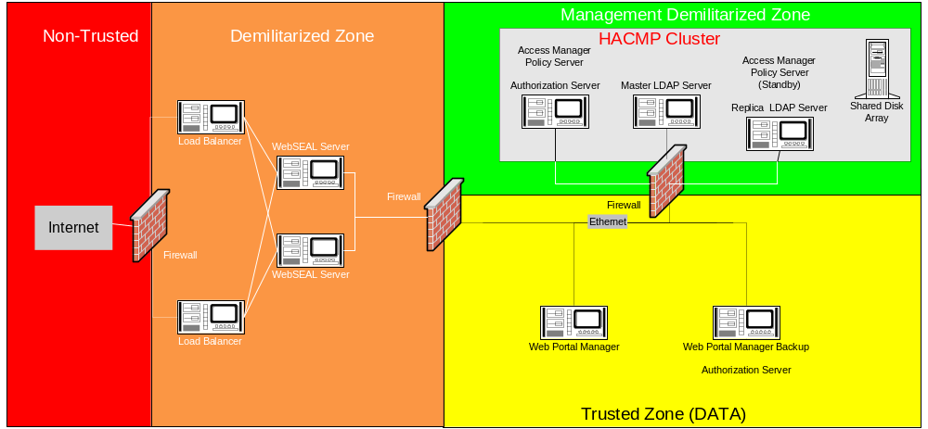
The system has been designed with the ability to recover from unexpected failures (please see question #1, section 3.1 and question #3, section 3.6 for more details). Turning to the chart below, you can see that there are two WebSEAL servers sitting behind two load balancers. The load balancers take the requests from the non-trusted internet and distribute the load amongst the two WebSEAL servers. Should either one of the WebSEAL servers go down, the system will continue to operate as all requests will pass to the other WebSEAL server. When the WebSEAL that was unavailable comes back online, the latest replica of the authorization database will be loaded into memory, and the WebSEAL server will once again begin receiving requests from the load balancers.
Should the systems on which the Policy Manager or the LDAP Master are running go down, then a HACMP configuration can take over in order to feed the WebSEAL servers. Note: it is not necessary for the policy manager or master LDAP servers to be up and running in order for the WebSEAL’s to continue to function. The addition of the HACMP cluster enables Kaiser to continue to set management policy.
Replication of WebSEAL (component of Access Manager 4.1) servers allows for increased availability, as there is no single WebSEAL acting as a single-point-of-failure; if one WebSEAL fails, or is brought down for maintenance, the other WebSEAL replicas will continue to provide service. WebSEAL is easily “replicated”. This implies that multiple instances (“replicas”) of WebSEAL are configured behind a single “load balancer” (for example, the IBM WebSphere Edge Server or Cisco Local Dispatcher). The load balanced distributes requests across the WebSEAL replicas; evenly distributing traffic across the multiple WebSEAL instances.
Because of WebSEAL’s built-in back-end load balancing, the failure of a back-end application server can be hidden from a user, as WebSEAL will re-direct their requests to a functioning application server. The same front-end load balancing that is provided by a distinct load balancer (as described in the previous paragraph) is provided internally by WebSEAL across duplicate instances of back-end application servers.
5.2.9.4 If your system has to failover, does the user have to re-authenticate?
Users do not have to return to the same reverse proxy server to maintain authentication. Authentication state can be maintained across multiple WebSEAL servers via either failover cookie, or Access Manager e-community single sign-on (ECSSO). The failover cookie is an encrypted cookie which uses a large number to identify the user. ECSSO uses a combination of URL tokens and browser redirects to identify the user. Both mechanisms allow the user to transparently authenticate to other WebSEAL servers. The choice of mechanism is dependent on customer requirements and customer environment.

5.2.10 System Availability
5.2.10.1 Describe how your solution can meet our availability requirements.
Availability and scalability features include the replication of WebSEAL servers, replication of target Web servers, replication of security policy and replication of LDAP directory servers. The solution provides the ability to address e-business scenarios involving multi-millions of users and 24x7 availability for e-business transactions and for e-business users.
WebSEAL servers cache security policy locally. This allows the WebSEAL servers to continue to make authorization decisions locally without the policy server. WebSEAL can also provide load balancing across backend replicated backend webservers.
Authorization service components can be replicated to increase availability in a heavy-demand environment. You can configure the master authorization policy database, containing policy rules and credential information, to automatically replicate. Applications that call the authorization service have two options for referencing this database information:
The application — when configured to work seamlessly with the authorization evaluator — uses a local cache of the database. The database is replicated for each application that uses the authorization service in local cache mode.
The application uses a shared replica cached by the remote authorization server component. The database is replicated for each instance of the authorization server. Many applications can access a single authorization server. Update notification from the policy server (whenever a change has been made to the master authorization policy database) triggers the caching process to update all replicas.
In addition, solutions such as LDAP replica promotion, HACMP, etc can be used as required for the master LDAP and master Policy Server.
5.2.10.2 Is your application effected by database backups and reorgs?
DB2, the underlying data repository used by the IBM Directory Server is highly reliable and flexible. Operations procedures can bed crafted to avoid production outage when database reorganization and migration is desired.
5.2.10.3 How is your solution impacted when any one server is backed up?
The solution is not impacted because of the replication of policy severs and local cached databases.
5.2.10.4 How is your solution impacted when any one server is restored?
The solution is not impacted because of the replication of policy severs and local cached databases.
5.2.10.5 How does loading of the database effect the availability of the application?
LDAP databases can be loaded via bulkload utilities or LDIF imports with little or no disruption to production work.
5.2.10.6How does the exporting of data from the database effect the availability of the application?
LDAP databases can be exported and DB2 databases can be backed up with little or no disruption to production work.
5.2.10.7 Describe any application maintenance that would result in an application outage.
If the policy server or master LDAP server went down, there would be no update capability
Shutdown of WebSphere App Server would prevent use of Access Manager Administration web GUI.
Business Applications running under WebSphere Application Server can be individually refreshed without disruption to other applications. Maintenance to WebSphere Application Servers that necessitate restart of the server can be scheduled to minimize disruption to production work.
5.2.10.8 What other factors may effect availability?
Availability can be affected by normal factors such as network, and other subsystem availability.

5.2.11 Recovery
5.2.11.1If any of the servers fail what effect does its recovery have on the remainder of the servers?
The continuity and recovery of the proposed solution is dependent upon many factors network outage, operating system outage, hardware platform outage, authentication infrastructure outage, application outage, database outage, etc. A complete failure analysis and recovery plan can be provided as part of a services engagement. This will identify critical components, single and multiple point of failure in the solution and in you IT environment, and provide plans and procedures for continuity and recovery.
Some of the recovery considerations for the components proposed include:
- loss of Access Manager policy server
- loss of LDAP master
- loss of random WebSEAL server
- loss of LDAP replica

5.2.11.2 How is the recovery of the application coordinated across all tiers?
Properly designed, deployed and configured the solution can meet rigid continuity and recovery requirements.
5.2.11.3 How is the application recovered to the point of failure?
A properly conceived recovery plan will address your requirements for continuity and recovery of critical components.

5.2.12 Disaster Recovery
5.2.12.1 Can the software be used at a backup site for alternate processing and disaster recovery testing?
Yes.
5.2.12.2 What notification, if any, is necessary to move the software to an alternate site?
None.
5.2.12.3 Are special authorization codes required to run the software at an alternate site or alternate server? If yes, what type of advance notification is necessary to obtain the codes for:
No special authorization codes are required to run the software at an alternate sites or alternate server
5.2.12.4 Offsite testing purposes?
No special authorization codes are required
5.2.12.5 For recovery purposes?
No special authorization codes are required
5.2.12.6 How long are the authorization codes valid?
Not applicable
5.2.12.7 How many days in advance may they be obtained?
Not applicable
5.2.12.8 In an emergency, how long would it take to obtain replacements for the software documentation?
Documentation is publicly available on the IBM website.
5.2.12.9 Can you provide knowledgeable personnel to assist in recovery efforts, if necessary?
Yes.
5.2.12.10 Will you identify a member(s) of your staff as an emergency contact person(s) in the event of a disaster?
This should be coordinated through your IBM Sales Representative.

5.2.13 Serviceability
5.2.13.1 Describe facilities for problem determination
Access Manager provides tracing facilities for all server components (i.e. WebSEAL, Policy Server, Authorization Server, etc). Traces can be set at 9 different levels, depending on the level of detail required.
5.2.13.2 Describe facilities for error logging.
IBM Access Manager provides a number of logging and auditing capabilities. Log files can capture any error and warning messages generated by IBM Access Manager servers. Audit trail files can capture authorization, authentication, management, and HTTP events occurring on the IBM Access Manager servers.
5.2.13.3 Describe facilities for error alerts.
IBM Access Manager provides a number of logging and auditing capabilities. All or selected Access Manager events can be forwarded to a customer provided central logging process that can then generate appropriate alerts

5.2.14 System Management
5.2.14.1 Are remote administration and support supported by your product? If yes, please describe it.
Web Portal Manager (WPM). A Web-based graphical application used to manage IBM Access Manager Base and WebSEAL security policy in a secure domain. An alternative to the Access Manager pdadmin command line interface, this GUI enables remote administrator access and enables administrators to create delegated user domains and assign delegate administrators to these domains.
5.2.14.2 Describe how configuration and application level parameter changes are deployed into production.
Configuration changes are made via .CONF files for each Access Manager Service or via CLI, API, or WPM
5.2.14.3 Describe all the areas for the application which need version management. Describe for each area how to accomplish version management.
No extra version management is required, besides the normal patch updating typically required for any application in your environment.
5.2.14.4 Does your solution have task, job or script scheduling facility?
Access Manager does not have a scheduling facility but other scheduling facilities can take advantage of the CLI and API interfaces
5.2.14.5 To what degree can a third party scheduling system be used with your software?
Third party scheduling facilities can take advantage of the Access Manager CLI and API interfaces

5.3 Services –
The Implementation and deployment services articulated in our proposal are all being provided by Deloitte &Touche under separate contract to XXX, Inc. IBM also has deployment services that could be utilized by XXX for this EAM project. It will be up to XXX to decide which implantation organization that XXX would like to partner with on this project.

5.3.1 Professional Consulting Services
5.3.1.1 Does your organization offer project management services?
Yes, Deloitte & Touche is a leader in the implementation of Managed Access System solutions, and has developed a field-tested, proven methodology known as iMAAP^{tm}. It provides a detailed, customizable framework for deploying a complete Managed Access System solution. Project Management services are an integral part of the methodology. Please refer to the table below for an overview of iMAAP^{tm}.
5.3.1.2 Does your organization provide project management services on a fixed time, fixed price basis?
Yes, we can facilitate fixed fee project management; however, project management services are embedded into the complete implementation services package as laid out in our iMAAPtm methodology. As such, pricing for the Project Management services typically follow the same pricing structure as negotiated for the implementation project as a whole. We can be very flexible in how we structure the pricing of the implementation services engagement itself, meaning, we can use fixed pricing, time & material based pricing.
5.3.1.3 Does your firm facilitate planning of EAM implementations and subsequent enhancements?
Yes. The Deloitte & Touche iMAAPtm methodology has proven successful at other organizations similar in size and complexity to XXX. Implementation planning is one of the main phases built into iMAAPtm (as outlined in the table below, which shows the project phases as columns and a sample of main activities per project phase). The methodology provides structure and guidance for project teams, while being flexible and modular enough to be uniquely deployed to meet the needs of each customer. This deployment methodology has proven to be successful for a wide range of customers across many industries, including the banking industry. The iMAAPtm methodology will be followed for initial implementations and future Access Management infrastructure enhancements. Keep in mind that our methodology is modular, so rarely does any one particular project require all of the activities outlined. The iMAAPtm methodology is updated over time and incorporates leading industry practices and the collective knowledge gained over the many engagements that Deloitte & Touche and our partners have successfully completed for our customers.
Table 1: iMAAP^{tm} methodology phases and sample activities
Project Phases | Planning & Resources | Analysis & Design | Installation & Configuration | Deployment
 | Project Management
Activities | - Develop Project Organization Chart  - Develop Resource Plan  - Develop Project Estimate & Scope  - Develop Detailed Project Workplan and Milestones  - Define Status Report Process  - Obtain Project Work Space  - Define Availability Calendar  - Create Kickoff Meeting Presentation  - Develop Personnel/Contact List  - Develop Communications Presentation  - Develop Project Standards  - Develop Time Tracking Process  - Develop Change Control Process  - Develop Issues Log / Resolution Process  - Develop Performance Measures  - Develop Initial Fit/Gap Assessment  - Identify Skills Gap / Training Requirements  - Conduct Risk Assessment  - Define Deliverables List and Approval Processes  - Document Deployment Strategy  - Obtain Project Scoping and Planning Phase Sign- Off | - Conduct Managed Access Analysis  - Conduct Business Requirements & Functional Specs Interviews  - Conduct Business Requirements & Functional Specs Workshop  - Develop Business Requirements & Functional Specifications Document  - Conduct Technical Requirements Interviews  - Conduct Technical Requirements Workshop  - Develop Technical Requirements Document  - Conduct Requirements Technical Review  - Revise Project Plan  - Execute and Manage the Project Plan  - Develop Managed Access System Design Document  - Implementation Planning  - Conduct Detailed Design Technical Review Session  - Revise Project Plan  - Execute and Manage the Project Plan | - Install and configure hardware  - Install and configure software  - Configure application interfaces  - Develop custom application interfaces  - Build/configure repository schema  - Populate user data repository  - Assign roles to users  - Configure authentication mechanisms  - Configure authorization policies  - Configure password policies  - Configure/Develop administration processes and user interfaces  - Configure/Develop self –service processes and user interfaces  - Configure logging and monitoring  - Configure/develop reports  - Develop Quality Assurance (QA) test plans and scripts  - Perform QA testing  - Develop deployment/rollout plan  - Develop acceptance test plan  - Develop support staff training materials | - Production installation and configuration  - Data migration  - Acceptance testing  - Develop processes for change control and configuration management  - Develop documentation:  - Operations guide  - Technical manual  - Training materials  - Conduct training

5.3.1.4 Does your firm negotiate timeframes and funding requirements?
Yes, As one of the outputs of our Planning & Resources and Analysis & Design project phases, we make recommendations to the client in our planning and design deliverables with regards to the timing of project phases and characteristics of technical resources, such as computer systems and network components. In doing so, we help our clients with building a business case for their initial and any additional investments. An additional advantage of working with both IBM and D&T is the availability of services project funding through IBM Global Finance.
5.3.1.5 Does your firm resolve priority conflicts?
Yes, a critical part of the project management support we provide during the course of an implementation would include issue resolution and risk management support to the designated XXX Project Manager.
5.3.1.6 Does your organization allow clients to build the names of key individuals from your firm into the implementation contract?
Yes. XXX will have every opportunity to approve implementation team members. The Deloitte & Touche has deep experience and dedicated resources, located locally and nationally. Deloitte & Touche has more than 400 security practitioners in the US, of which, over 75 focused on EAM implementation. We have an exceptional local team specializing in the services that XXX needs. This will benefit XXX in the form of reduced project expenses, as well as providing easy access to critical project resources. We are committed to dedicate our best resources to this important project.
5.3.1.7 If changes are made to the implementation team, does the client have approval rights for replacements?
Yes, Deloitte will work with XXX to establish a process for providing XXX opportunities to review resumes and conduct interviews of Deloitte resources, as appropriate, prior to commencement of work.
5.3.1.8 Does your organization provide deliverables to assist in Project Management, including:
- Project Plan for each Implementation
- Funding Requests
- Training or Education Plans
- Scope Document and Management
- Formal Status Reports
- Performance to key project metrics
- Implementation Review
- EAM Business Strategy Review

Yes, once again embedded as a continuous thread in the methodology we provide project management support, such as project planning, issue resolution, risk management and quality assurance reviews, to the XXX Project Manager. These activities include project status reporting, project plan updating, issue tracking, and project team coordination. As a result, most of the documents listed above are deliverables of our standard project output.
5.3.1.9 Does your organization provide quality assurance for all aspects of a project for your clients; does it encompass the following:
- Planning
- Tracking
- Organization
- Documentation
- Deliverables
- Performance
- Implementation Approach
- Implementation Strategy
- Testing
- Change Management

Yes, Deloitte & Touche prides itself on its reputation of providing high quality service to our clients. We dedicate significant effort to ensuring quality delivery of service with a robust quality assurance program. Deloitte & Touche will use proven techniques and methods to drive the delivery of our services. Deloitte & Touche has a strong track record of delivering high quality projects with a large number of clients. Our professional services personnel are experienced in managing project and implementation risk in large, complex organizations. Using our iMAAPtm methodology, our objective is to design a consistent managed access architecture that can be implemented in stages to assist XXX in achieving improved security and increased customer satisfaction now and in the future.
Achieving organizational alignment and user acceptance are critical to success, yet they are often the biggest stumbling blocks to achieving project objectives. Deloitte & Touche has extensive experience in preparing all facets of an organization to embrace change. We have developed a change management methodology that focuses on reducing the barriers to change, while successfully preparing stakeholders to realize the benefits of major systems integration projects. We can assist XXX with preparing individual employees, executives, management, and project teams for the significant changes that the managed access implementation will bring. These areas include:
- A well-defined and executed communication plan
- Strategies and tools to build awareness and understanding of the new environment
- Training in the capabilities of the Managed Access System and in its operation and maintenance

5.3.1.10 Does your organization employ independent third party organizations to perform quality control reviews?
Not typically. Deloitte & Touche is a global services provider, our reputation as such is key to our ability to provide on-going services. Therefore we have developed an extensive quality assurance process that is driven from with in the Firm. Quality control reviews are performed by experienced executives of our Firm at the Senior Manager and the Partner level at certain pre-defined milestones of the project. An overall project quality review will be performed by an independent Partner (not directly assigned to the project) throughout the project.
5.3.1.11 Please describe the range of services, methodologies and pricing offered for managing EAM implementations.
Deloitte & Touche, one of the nation’s leading professional services firms, provides assurance and advisory, tax, and management consulting services through nearly 30,000 people in more than 100 U.S. cities.
The Secure eBusiness Group focuses on four key areas of our Network Economy: Identity Management, Application Security, Infrastructure Security, and Security Management Services. Our Identity Management Practice utilizes the iMAAPTM methodology. iMAAPTM is a proven methodology used to design and implement identity-based corporate directory solutions focusing on authoritative sources, repositories, resource provisioning and access management. We help our clients to reduce cost through an integrated identity management approach, including authentication, directory services, single sign-on and resource provisioning software. The Identity Management Practice will be the primary support group for this services opportunity. We understand that XXX is seeking a professional services firm with a proven track record for implementing an Access Management solution that meets XXX’s needs. Deloitte & Touche is the firm with the qualifications and professional staff capabilities to not only implement this eBusiness solution, but bring value added experience that will prepare XXX to meet the operating needs of its external clients and internal users. Deloitte & Touche, as an official business partner of IBM. IBM has built a practice to support implementation and integration of IBM’s Security Management solutions as a part of our Identity Management integration service. We have (75+) security professionals focused in this area. Deloitte & Touche is fully committed to this market space and has invested strongly in our people, methodology and partner channels. This commitment provides our clients with unprecedented value for their Identity Management initiatives.
5.3.1.12 How is your project management team or organization structured?
We believe a focus on project management is critical to the success of the project. Activities include project planning, issue identification and resolution, risk management and quality assurance reviews are performed in communication with the XXX Project Team and management. Based on our experience, we believe that to ensure the success of this initiative and to meet the project timelines, Deloitte and XXX resources must be correctly aligned, and respective roles must be well established.
An example of how the project team may be organized follows. This is based on our experience with similar organizations; therefore, this example may or may not be employed during the service opportunity. XXX resources to be assigned to the overall project may include:
- XXX Project Sponsor – to provide leadership, support and oversight, and to guide overall project direction.
- Full Time XXX Project Coordinator – to act as the primary interface between Deloitte and XXX resources, and to facilitate the execution of the project tasks.
- Full and Part Time participants – Which may include owners of the in-scope components of the initiative (includes availability for interviews, attendance at workshops, and review of selected deliverables) as well as full time team members who will be responsible to understand how the product is implemented and manage the system after the project is complete.

An example of a typical Deloitte EAM implementation team may include the following:
- Project Sponsor/Partner – to oversee and advise on project direction and perform quality assurance and risk management functions.
- Senior Project Manager (one – three days per week to full time depending upon the scope of work) – will provide overall project management, continuity and coordination with the client.
- Senior Network Architect/Technical Team Lead/Integration Consultants (three days per week to full time depending upon the scope of work) – will provide deep technical expertise and lead the implementation team and provide hands-on consulting experience.

5.3.1.13 Please describe how your firm trains and certifies project managers.
Our Project Managers have a long track record in the field of Information Technology and are highly skilled as Project Managers for these types of complex projects. Deloitte & Touche provides our Managers with Project Management training (some are certified project managers) while many are certified security professionals (CISSP). Over the years our Managers have demonstrated and expanded their Project Management skills by managing large implementation projects very much like the one XXX is describing in this RFP. All of our practitioners across all levels in the Identity Management practice receive technical training on a regular basis, to keep their technical hands-on skills current and remain able to provide world class service to our clients. Training consists of a combination of product specific technical training, on-the-job training and continuous self-training.
5.3.1.14 Please identify your top five alliances that you have established to provide project management services to your clients.
Deloitte & Touche maintains a specialization in project management, therefore, D&T will serve as the primary service provider for this proposal response. D&T close alliance with IBM provides the opportunity to combine expert solutions from IBM with award winning implementation / project management skill from Deloitte & Touche.
5.3.1.15 What makes you or would make you a leader in providing project management services?
Recognized as one of the largest, truly global professional services firms, the financial service industry consulting practice is led by more than 150 partners and well over 500 senior practitioners worldwide. Our financial services industry practice is one of the largest industry groups in our Firm, providing next-generation thought leadership. We are engaged by many of the world’s largest financial services institutions to assist them with a range of business issues including strategy, reengineering, process improvement, financial management, people, and technology initiatives. We provide these services to banking, securities, and insurance clients within the financial services industry. Each of these projects is headed by a team of qualified and experienced project management professionals. It is through this experience that we have established ourselves as world class providers of project management services.
5.3.1.16 How many projects did your organization manage in the past year?
As one of the largest professional services organizations in the world, Deloitte & Touche executed many project across all of our service lines. Hundreds of Security Services related projects in the United States alone. In 2002 we completed 8 large pure Identity Management focused projects in the US for which we were responsible for both Project Management and implementation services.

5.3.2 Implementation
5.3.2.1 What is the average implementation in terms of scope and complexity that your project management team has directed?
Most Identity Management projects are not small projects. They range from 3 months to 1 year or more, depending on the complexity of the implementation. Looking at the implementations we did for our clients, in general a typical starting point for any implementation project is Access Manager integrated with 1 or 2 web based applications. Integration with more web based applications and legacy applications, and more complex ways to authenticate (e.g. Tokens or certs) is usually the next step. The projects we did evolved along those lines.
5.3.2.2 What steps or best practices have been adopted by your Project Managers to minimize implementation time and costs
Deloitte & Touche considers project management an integral part of any project and has developed and continued to refine our Project Management Methodology and Tools. Our methodology focuses on Project Initiation, Control, Execution, Planning, and Close-Out with consideration of the following:
Communications | Integration
Quality | Risk
Organization | Time
Costs/Financials | Issue/Change Management
Scope

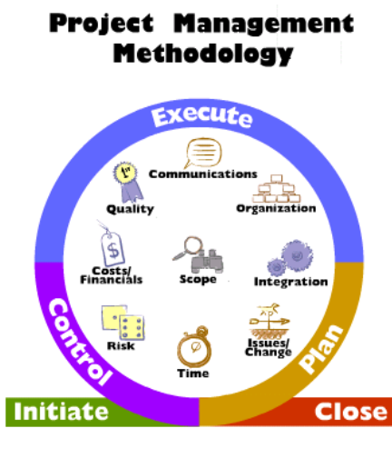
Deloitte’s project management approach achieves project goals through its focus on:
- Delivering economically viable solutions that meet client needs
- Accommodating changing client needs due to technical, economic, regulatory, and political factors
- Developing high quality deliverables
- Understanding the relationship between people, processes, and technology
- Operating within budget and time constraints

Deloitte practitioners will make use of several methods, tools, and techniques to maximize project staff efficiency. We use these project control tools, along with our proven project management methodology, to effectively monitor and control project activities.
The ability to manage the often-conflicting needs or expectations of multiple stakeholders while simultaneously controlling scope, cost, and project schedules is an art that our practitioners have been refining for many years. The repeated success of our project management strategy is a direct result of three basic, yet fundamental principles:
- Develop practical plans early in the project and implement the right “early warning” mechanisms to identify issues far in advance of their impact
- Deliver the right resources to meet deadlines on time and within budget
- Actively involve stakeholders in the process

We believe that our proven project management methodology will assist XXX in keeping the project on track. During the onset of the project we will revise and refine the proposed project schedule to incorporate any changes, and to create a baseline for our work.
When delivering our solution, we will maintain six related focus areas to ensure that our implemented solution will help XXX to meet its Managed Access System business and technology challenges:
- Organizational
- Confirm and document requirements
- Identify key stakeholders and establish a communication plan
- Understand and adapt standards (policies, procedures)
- Initiate marketing (buy-in) strategy and gain support of stakeholders
- Process Alignment
- Confirm process requirements and focus on adherence to them
- Engage key stakeholders and maintain participation
- Determine point of diminishing returns for automated and manual processes
- Identity Definition
- Confirm requirements – differentiate between wants and needs
- Identify key identity stakeholders and engage-focus on benefits
- Define identity populations, sources and characteristics and build identities based on how data will be structured
- Technology Integration
- Assist in selecting technology solutions
- Pilot the implementation to validate the solution
- Implement the solution; deliver in phases (highest value first)
- Test performance and functionality
- Rollout
- Develop rollout strategy
- Provide training to stakeholders
- Deploy the solution in phases
- Transition ownership to responsible Business Units or functions
- Maintenance
- Adhere to the business policies and procedures after initial deployment
- Perform periodic assessment to validate adherence to policies and rules
- Adapt solution as the business changes

5.3.2.3 Does your firm aid in the development of management processes for the implementation and operation of the application suite?
Our project management team will work with the XXX project manager(s) during the initial week(s) of the project to finalize the project work plan, staff assignments, and manage processes. We will work with you so that we have a common understanding of our plans and both agree that they are achievable.
The plan and on-going management procedures will be explained to both our professionals and XXX’s staff as part of the project kick-off meeting.
To maximize our effectiveness, the project management team will also collect and analyze existing documentation consisting of security policies and procedures, network diagrams, and system hardening guidelines.
During the project we will consistently follow our management processes to track progress, identify issues, and meet your expectations. Our traditional management processes during the project include:
- Communication - We are proud of our ability to collaborate and partner with our clients with communication as a cornerstone of our approach. We will communicate through both formal in informal channels at various organizational levels of XXX to foster teamwork and eliminate surprises. In addition to weekly status meetings, we will bring important findings and issues to your attention as soon as they are identified or during daily progress meetings. We will share draft deliverables with appropriate County staff during the development process for review and concurrence. We will also conduct walkthroughs of final deliverables to achieve consensus.
- Project Controls - As stated earlier, sound planning is the foundation of successful project management. The work plan and resulting milestone chart are key tools in gauging performance to the plan and making early adjustments, when necessary. We will update the work plan weekly, review any potential impacts and implement adjustments to our schedule, staffing or approach, as necessary.
- Human Resources - Although often overlooked, human issues can have significant impacts on project success. As we develop initial staffing assignments, we will consider personal situations and other work commitments in order to not be unrealistic in our planning.
- Quality Control - On projects, we also typically build in formal quality reviews by our Quality Assurance principle. These reviews focus on the quality of our deliverables (including reasonableness or our findings and feasibility of our recommendations) and our progress compared to established milestones and budget.
- Project Management Tools - We typically utilize the following tools to manage the project:
- Microsoft Project (Work plans and milestone reports)
- Microsoft Word or PowerPoint (Status reporting, project documentation)
- Microsoft Excel or Word (issues management)
- Microsoft Outlook (communication, scheduling)

5.3.2.4 Does your firm establish with the user organization a system of milestones for the implementation?
One of the initial tasks completed during the beginning of the project will be to establish and finalize a workplan. This workplan will contain the tasks needed to complete the project and the milestones and deliverables to be completed during the project. These milestones will be agreed upon by the project management team and will be used to evaluate and gauge the ongoing progress of the implementation.
A key to successful project management is the presence of timely, accurate, and understandable project status reports. Our approach to project status reporting incorporates information from every activity and team member so that detail and summary information is available to client management.
Our project manager will prepare weekly status reports identifying accomplishments for the previous reporting period, planned activities to be started during the next reporting period, expected milestones that will be completed during the next reporting period and identification of project risks and associated mitigation options/strategies.
Additionally, our project manager and project team will meet with key individuals from XXX at weekly status meetings to review the status reports and to discuss issues related to the project.
We will strive to attain an atmosphere that permits open communication and mutual respect among all parties. This type of project atmosphere allows for “hallway briefings,” during which team members can discuss project issues outside of the usual forum, and keep abreast of new issues.
5.3.2.5 Have you documented specific processes for the implementation of your EAM?
Our iMAAP™ Methodology is an outcome of the significant investment that we have made to build identity management solutions and related thoughtware. We have incorporated our firm’s experience assisting clients to successfully conduct large enterprise transformation efforts in the Management, Resource Provisioning, Authentication, Authorization, and Protection of identities using directory-enabled technologies. This methodology reflects a comprehensive scope, including project management, strategy, technology, business process, people alignment, project management, quality assurance and change management.
The advantage of our iMAAP™ Methodology is that it is specifically built for implementing identity management solutions – providing an ‘Identity Management Roadmap’ with associated examples and templates, which is adaptable to meet the needs of each particular activity in a project. The roadmap includes modules of work activities by project phase as described below.
In our iMAAP™ Methodology, we group identity solutions into identity management, authentication, authorization, and protection. Using our experience, methodology, and understanding of your requirements, we will use the following conceptual design as a foundation for creating the XXX’s Enterprise Access Management solution.

This conceptual design provides a logical grouping of components used to facilitate the design and implementation of authoritative source(s), the identity repositor(ies), resource provisioning, access management, role based access controls, and identity protection. Within each of these components, we consider not just the technology implications but also the people and process impacts.
Deloitte has been performing Access Manager implementations for almost 3 years.

As a derivative of our iMAAPtm approach, which is non-product specific, we developed specific and documented procedures to implement Access Manager and related products.
5.3.2.6 Has your organization documented specific processes for the ongoing use and maintenance of your EAM application?
A key focus in our iMAAPtm Methodology concentrates on the deliverables produced during the project. As part of our iMAAPtm Methodology, a standard set of deliverables are produced during each phase of the project. Included in the deployment phase of the project, documents detailing the policies and procedures for ongoing use and maintenance are created. Topics included in these documents are
- Installation procedures,
- Roles and responsibilities,
- Development life cycle,
- Change Control and migration path,
- General administration,
- Help desk and monitoring procedures, and
- Troubleshooting guide.

While these are the typical area included in this documentation, inclusion of other topics can be discussed and agreed upon during the initial planning phase.
5.3.2.7 Do you share your implementation and operations processes with your clients?
Deloitte & Touche standard operating procedures are to provide the methodologies and processes utilized and developed during the project with their clients.
5.3.2.8 Describe the recommended roles required to implement, support, customize, maintain, administrator, and operate the application.
Below is a sample of a minimal set of roles that we implement as part of our IBM Access Manager projects. In most cases these roles are assigned to individuals in the Security and Engineering and Operations departments respectively, but this might be different from organization to organization.
- Technical Security Administrator
- Requirements
- Assign and maintain role access
- Maintain Access Manager
- Delegate access rights to other administrators
- Manage implemented policies
- Function
- LDAP maintenance
- ACL maintenance
- Junction maintenance
- Create management accounts
- Delegate management permissions
- Create (implement) and maintain security policies

- Security User Administrator:
- Requirements
- Delegated administration - access to maintain user accounts
- Function
- Reset passwords
- Create user IDs
- Delete/Inactivate user

- Help Desk:
- Requirements
- Full functionality to all applications, user should not be able to read, modify, or delete confidential data.
- Function
- Reset password
- Log and escalate issues
- First level support, resolve end user issues

5.3.2.9 List the skill sets required for each role.
Each role as described above requires a certain level of product knowledge. The Technical Security Administrator should know the product’s technical and functional characteristics well. This is accomplished by thorough product training and day-to-day and hands-on experience with the product. For the Security Administrator and the Help Desk Access Manager has a tool available to perform their tasks (Web Portal Manager).
These roles do not cover implementation of the product, as this requires many specific skills and product knowledge. Implementation therefore is typically performed by a team of security professionals, network and IT operations specialists either with or without the help of external resources.
5.3.2.10 Describe the training available for each role. Provide who provides the training as well as training schedules.
Administrators Roadmap:
Access Manager Fundamentals Self Study 10 Hours
Access Manager System Administration Self Study 20 Hours
OR Class Room 5 Days

Infrastructure/Developers Roadmap:
Access Manager Fundamentals Self Study 10 Hours
Access Manager System Administration Self Study 20 Hours
OR Class Room 5 Days

Access Manager Arch & Solution Design Self Study 10 Hours
OR Class Room 4 Days

Course schedules and locations are available at the following URL
http://www-3.ibm.com/services/learning/us/
5.3.2.11 Provide the possible sites for in class training, e.g. client, vendor, or public.
Classes are taught at various IBM education centers around the world, examples closest to XXX would be Chicago, Atlanta, and Dallas.
Course schedules and locations are available at the following URL
http://www-3.ibm.com/services/learning/us/
5.3.2.12 Describe the background of your trainers. What certifications do your training personnel have?
IBM Learning Services is a division of IBM Global Services and employs a large number of employees that all have been selected and hired based on their skills in the specific subject area. Additionally, IBM Learning Services has the ability to staff classes with consultants from IBM Global Services and as a result can dig deep into the skill set of not only educators but implementers as well. Most instructors are certified in several areas of expertise. Once a curriculum is chosen by XXX and specific classes are selected, we would be happy to provide specific information on the instructor that will be conducting a class that XXX employees will attend.
5.3.2.13 Approximately how many certified trainers do you have dedicated to the products referenced in this RFP?
As mentioned above, IBM Learning Services is a division of IBM Global Services and employs a large number of employees that all have been selected and hired based on their skills in the specific subject area. Additionally, IBM Learning Services has the ability to staff classes with consultants from IBM Global Services and as a result can dig deep into the skill set of not only educators but implementers as well. As a result, IBM Learning Services has many trainers available to teach the curriculum.
5.3.2.14 Is there an industry certification(s) for technical staff on your product? If so, please provide curriculum information and any other related documentation.
No, there isn't an industry certification on our product. There are certifications available and curriculums available for our business partners to be certified in order to prove they are skilled in the product set but there isn't a customer level certification program.
5.3.2.15 Please provide information on user training available for this solution. Include class overview, format, duration, location, prerequisites, and intended audiences.
User training is typically not required. In most cases, if the user is familiar with using browser based applications, using this solution would be transparent to them. If required, IBM Learning Services can customize training classes and curriculum to meet the specific needs of XXX.
5.3.2.16 Can your training be customized to meet the specific needs of XXX?
Yes, IBM Learning Services can customize training classes and curriculum to meet the specific needs of XXX. These classes can be at your location or at an IBM facility, they can include labs or you may choose not to have lab exercises. We would have a curriculum coordinator and instructor work with you to customize an offering that meets your needs and then determine the price for that offering based on several factors - Development time, delivery time, lab equipment required and other related factors.
5.3.2.17 Do you provide a ‘train-the-trainer’ program? If yes, include class overview, format, duration, location, and prerequisites along with copyright details for the reproduction of necessary training materials.
Yes, IBM Learning Services can customize a train the trainer program to meet the specific needs of XXX. We would have a curriculum coordinator and instructor work with you to customize an offering that meets your needs and then determine the price for that offering based on several factors - Development time, delivery time, lab equipment required and other related factors.
5.3.2.18 Is computer-based training (CBT) available with your product? If yes, describe the training content.
Yes, CBT self studies are available as mentioned above.
Access Manager System Administration
The student will learn to install and configure IBM Access Manager for e-business components and supporting software in a multi-machine scenario Create and assign access rights to IBM Access Manager for e-business users and groups.
The student will learn to install and configure WebSEAL to support various types of configurations and authentication, including Multiplexing Proxy Agents (MPA) and Single Sign-On (SSO)
The student will be able to describe and configure delegated administration.
Access Manager for e-business Architecture and Solutions
This course begins with guidelines to initiate an Access Manager for e-business engagement. Business and technical requirements are assessed. After specifying integration requirements, a high-level solution architecture is presented. User Registry design methodology is discussed and PKI integration issues are explored. Authorization Policy implementation using Authorization Servers and Authorization API is presented. This course also covers IBM Access Manager for WebSphere, IBM Access Manager Plug-in for Edge Server, and IBM Access Manager for Weblogic Server. Included is a presentation on J2EE applications covering JAAS and J2EE security in WebSphere 4.02 and how Access Manager provides this support without requiring any coding or deployment changes to the application.
5.3.2.19 Provide information on conferences, and national and local user groups.
IBM’s user group conference is a respected annual national event for sharing of experiences and technical information and security. There is also a Midwest User Group, in which you can participate.
5.3.2.20 Please describe the training regimen that you would recommend for a beginner, advanced programmer, and end user.
Administrators Roadmap:
Access Manager Fundamentals Self Study 10 Hours
Access Manager System Administration Self Study 20 Hours
OR Class Room 5 Days

Infrastructure/Developers Roadmap:
Access Manager Fundamentals Self Study 10 Hours
Access Manager System Administration Self Study 20 Hours
OR Class Room 5 Days

Access Manager Arch & Solution Design Self Study 10 Hours
OR Class Room 4 Days

Course schedules and locations are available at the following URL
http://www-3.ibm.com/services/learning/us/
5.3.2.21 How is your training organization structured?
IBM Learning Services is a division of IBM Global Services and employs a large number of employees that all have been selected and hired based on their skills in the specific subject area. Additionally, IBM Learning Services has the ability to staff classes with consultants from IBM Global Services and as a result can dig deep into the skill set of not only educators but implementers as well.
5.3.2.22 Please describe how your firm trains and tests the training personnel.
Our instructors are certified using the same curriculum and test that we use for our business partner certification process. Most instructors are certified in several areas of expertise. Once a curriculum is chosen by XXX, and specific classes are selected, we would be happy to provide specific information on the instructor that will be conducting a class that XXX employees will attend.
5.3.2.23 What locations does the vendor organization support Systems Integration Services?
IBM has offices in all major cities in the United States and around the globe.
5.3.2.24 What locations does the vendor organization support Training Services?
IBM has offices in all major cities in the United States and around the globe.
5.3.2.25 What locations does the vendor organization provide Project Management Services?
IBM has offices in all major cities in the United States and around the globe.
5.3.2.26 What locations does the vendor organization support Applications Development Services?
IBM has offices in all major cities in the United States and around the globe.
5.3.2.27 What locations does the vendor organization support Consulting Services?
Deloitte & Touche has offices in al major cities in the United States and across the Globe.
5.3.2.28 Does your organization provide industry-specific templates or starter kits to assist clients?
No, while we have experience implementing our solutions across a broad range of industries, we have not found it to be of value to provide industry specific templates with this solution.
5.3.2.29 Does your organization provide industry-specific data models?
No, while we have experience implementing our solutions across a broad range of industries, we have not found it to be of value to provide industry specific data models with this solution.
5.3.2.30 Does your organization provide pre-defined infrastructure architectures?
We have extensive experience in architecting security infrastructure and have found that there are common elements but each customer's environment is unique based on their directory choice, firewall, routers, application servers, applications, etc. so we can bring to bear industry best practices and architectural experience but have not found any environment or customer where a pre-defined infrastructure architecture would fit.
5.3.2.31 Does your organization provide pre-defined application architectures?
No, pre-defined application architectures would not be available for this solution
5.3.2.32 Does the vendor provide “verticalized” versions or modules?
No, pre-defined verticalized versions or modules would not be available for this solution
5.3.2.33 Does your organization provide prospective clients with five references pertaining to their industry?
Yes, upon request we can provide references. We would discuss with you the specifics of what you would be looking for in a reference call. E.g. performance and scalability or application integration, etc and then determine which of our references would be most appropriate based on the specific issues or questions XXX would want to discuss.
5.3.2.34 Focus of overall projects within the following industry - Banking
Recognized as one of the largest, truly global professional services firms, the financial service industry consulting practice is led by more than 150 partners and well over 500 senior practitioners worldwide. Our financial services industry practice is one of the largest industry groups in our Firm, providing next-generation thought leadership. We are engaged by many of the world’s largest financial services institutions to assist them with a range of business issues including strategy, reengineering, process improvement, financial management, people, and technology initiatives. We provide these services to banking, securities, and insurance clients within the financial services industry. The financial services practice offers a variety of surveys and research studies that focus on current issues, and key trends, and innovations facing the financial services industry. Through this information, our practitioners are better poised to respond to the unique challenges of our clients. As the pace of change quickens, this base of knowledge becomes an even greater contributor to our ability to work with our clients to solve their business issues.
Examples of representive clients served:
Fireman’s Fund Insurance Company
Federal Reserve Bank – Richmond, Virginia
KeyBank
5.3.2.35 Overall Partnership Development: Consulting, Systems Integration and Training Alliances
Vendor partnerships are a key foundational piece of the Identity Management Practice. Multiple vendor software and hardware solutions exist that support the six key components of Identity Management. D&T maintains strong relationships with the key vendors needed to provide unparalleled teamwork on the project for XXX. Many of these business partnerships are based on formal contracts, providing official resource support and commitment. The specific Identity Management related business partners and vendor relationships include IBM, Microsoft, Sun Microsystems, RSA, Netegrity, Novell, Access360, and BMC. In addition to our Identity Management relationships, D&T maintains close ties with a variety of key “IT infrastructure” providers such as Cisco, Web Methods, Tibco, ISS, Axent Technologies/Symantec, Network Associates, and CheckPoint.
5.3.2.36 Strategic Alliances
The Business Partner channel is a major revenue contributor and is key to our future success. IBM is investing heavily in the Business Partner channel to increase the number of active Business Partners in all channel segments. In 2002, our strategy was to grow revenue by expanding our market reach through partners. We focused on four strategies to accomplish our goal:
Expand our “value net” of partnerships by recruiting a new set of partners to the IBM brand.
Increase the sales support and relationship resources we provide to our partners.
Leverage SWG offerings, programs and resources.
Significantly increase our investments for recruitment, training and campaigns for partners.
The results this year have been successful; we’ve exceeded our goal of driving 30% of our revenue through partners, and have significantly expanded our relationships with GSIs and ISVs.
For 2003, the goal will be to continue on our current strategy, further expanding our market reach through partners. We’ll continue the strategic paths outlined above, and particularly focus on the following areas:
Take our ISV relationships to the next step-establish go-to-market plans and capabilities with both first and second tier ISVs.
Drive more IBM SWG cross-brand solutions, and recruit SWG partners who have capability and reach.
Provide IBM specific support to our value add partners, i.e., value add resellers (VARs), system and web integrators, consultants, and service providers (xSPs).
Continue to provide incentives to our partners to sell into the middle and upper middle market; at the same time we will increase incentives to significant value add partners who expand our market reach in the enterprise space.
Bottom line, we’ll continue on the current strategy but get more focused on our individual partner relationships and go-to-market capabilities with partners.
Please see the white paper provided titled Channel Strategy, provided as an appendix.
5.3.2.37 Quality of provided services:
Please see the white paper provided titled Channel Strategy, provided as an appendix.
5.3.2.38 Rating based on perceptions of the quality of available professional resources associated with the following vendors:
Please see the white paper provided titled Channel Strategy, provided as an appendix.

5.3.3 Support

5.3.3.1 Help Desk
5.3.3.1.1 For each support offering provide:

5.3.3.1.2 Whether level 1 support can be contacted by an 800 toll-free number
Yes, level 1 support is accessed through 1-800-978-2246
5.3.3.1.3 Whether level 2 support can be contacted by an 800 toll-free number
Yes, Level 2 support is accessed through 1-800-978-2246
5.3.3.1.4 The hours of support for each day of the week. (EST)
Support Line is available for regular support during a country’s normal business hours. Support coverage for a customer’s mission critical problems is available 24 hours per day, 7 days of the week.
5.3.3.1.5 How support is handled on holidays.
Support Line is available for regular support during a country’s normal business hours. Support coverage for a customer’s mission critical problems is available 24 hours per day, 7 days of the week.
5.3.3.1.6 Whether priority response service is offered
Support coverage for a mission critical application is available 24 hours per day
5.3.3.1.7 What priority levels can be assigned to a problem
Levels are assigned by the customer in relation to how the problem impacts the business.
Severity | Impact | Response Goal
1 | Critical Business Impact | Within 2 business hours
2 | Significant Business Impact | Within 4 business hours
3 | Some Business Impact | By the end of the next business day
4 | Minimal Business Impact | By the end of the next
business day
During off shift hours, we will use commercially reasonable efforts to respond, by telephone, within 2 hours to a severity 1 call.
5.3.3.1.8 Whether support is on a call back basis
There is a self help tool which can be accessed via the Web plus call back is available.
5.3.3.1.9 The service level for a call back from support personnel.
See question 5.3.3.1.7
5.3.3.1.10 Whether your support personnel are on-site or need to be dispatched
All on site personnel will need to be dispatched
5.3.3.1.11 Whether response times for inquires are guaranteed
We use every reasonable effort to call back within the time specified for a given severity.
5.3.3.1.12 The process for escalating unanswered or critical problems; The number of escalation levels; Whether problems are automatically escalated after a set time
If you expectation are not met at any time, please escalate to an IBM Duty manager. Escalation to a duty manager will receive IBM’s prompt attention and focus.
5.3.3.1.13 What is the maximum time to respond and resolve a problem at each level
IBM takes many factors into consideration when resolving a customer problem. Some of these factors include: severity of the problem, the impact of the problem and whether additional diagnostic efforts could cause additional production impact. IBM support personnel are trained in not only resolving problems but managing the problem as well, based on unique customer circumstances.
5.3.3.1.14 The average time for resolving a critical problem
See 5.3.3.1.13
5.3.3.1.15 The average time for resolving a non-critical problem
See 5.3.3.1.13
5.3.3.1.16 Whether named technical support is offered
Named technical support is offered for a fee, please see IBM software support guide for further clarification.
5.3.3.1.17 If any part of the support is handled by a third party
No.
5.3.3.1.18 To receive support must XXX have applied the most recent fixes and releases?
Not in all cases
5.3.3.1.19 Does your organization offer alliance programs with designated support teams?
IBM maintains alliances through IBM Channel Developer programs. These programs are intended to support the development of applications and products by other vendors, to run on IBM O/S.
5.3.3.1.20 Does your organization have a laboratory or work center to replicate and diagnose, in a managed environment, issues encountered at client sites?
Yes we do.
5.3.3.1.21 Does your organization have a certification program for training help desk personnel?
Not at this time.
5.3.3.1.22 Does your organization support services based on the ability to meet user defined service levels?
Not at this time.
5.3.3.1.23 How many people are employed at your help desk? What is the average length of experience with your software?
IBM software support uses consistent processes, across or entire software portfolio, this single 800 number and point of contact is XXX’s entry into our helpdesk system. IBM's depth, breadth and reach in the services industry, with over 260,000 employees worldwide, makes available what it takes via a single convenient call to IBM Service to put the worlds most advanced support organization to work for XXX.
5.3.3.1.24 What is your software maintenance and support policy? Please provide a copy of the service description and associated terms/agreement
Support Line is available for regular support during a country’s normal business hours. Support coverage for a customer’s mission critical problems is available 24 hours per day, 7 days of the week.
Please see Appendix A
5.3.3.1.25 Are upgrades and /or new releases included in the software maintenance and support agreements?
All new releases and upgrades are included as long as a customer’s subscription and support are current with IBM.
5.3.3.1.26 Do you have a standard for the frequency of upgrades to your software? Please provide a schedule of the upgrades and new releases over the past three (3) years.
IBM Access Manager has had two version/releases typically per year during this time frame. Access Manager 4.1 came out in October, 2002. Its predecessor, Policy Director had multiple releases including 3.7, 3.8 and 3.9. IBM plans for two major releases in 2003 and will also release maintenance patches as required.
5.3.3.1.27 Do you have a user group for your EAM product? How often do they meet and where was their last meeting? What is your company’s involvement in the organization and administration of the user group?
IBM does not have a specific user group meeting for the Access Management Product. IBM does provide world wide user group meetings at the event. There is an active customer advisory board made up of many large key customers. They meet with our product executive team bi-annually to exchange information and ideas. Additionally, several WebSphere user groups in the USA are beginning to form Access Manager special interest groups.
Some of the Highlights include:
- Over 7600 total attendees World Wide
- Over 250 Technical Sessions Worldwide
- Over 250 Product Demonstrations Worldwide
- Certification
- 273 individuals took at least one certification exam (174 in Washington D.C. + 99 in Vienna)
- 444 certification exams were delivered (345 in Washington D.C. + 99 in Vienna)
- 185 exams were passed (128 in Washington D.C. + 57 in Vienna)
- 89 new certifications were awarded (60 in Washington D.C. + 29 in Vienna)
- Over 200 journalists attended the events Worldwide
- 65 IBM Customers presented Customer Case Studies
- 95% of customers Worldwide said their expectations were met at by the event.

5.3.3.1.28 Describe the procedures for requesting enhancements to your software’s functionality?
The best ways for requirements to be made to IBM are the following:
- – Attendance of a technical conference
- – Contacting the local IBM support team
- – Contacting the IBM support Center

5.3.3.1.29 Describe the process in which customers and user groups influence the release of new products or enhancements to existing products.
IBM consistently maintains the highest level of customer satisfaction and values the input of its customers and user groups. Every effort is made to evaluate and prioritize software requirements/enhancements by our development team for inclusion into future releases.
5.3.3.1.30 What is the general background of the individual responsible for the support on your application? Describe the process for certifying your trainers.
Support comes in the form of various levels of product specific expertise. This supports ranges from support center agents all the way to product development staff.
5.3.3.1.31 Please describe all documentation that is available for your product? What is included with the base purchase of our product? What documentation is optional and what are costs? Describe the media of the documentation. Also, please provide copyright details for the reproduction of documentation.
IBM provides the following Access Manager product manuals free of charge, downloadable from the internet: Release Notes, Base Installation Guide, WebSEAL Installation Guide, WebSphere Application Server User's Guide, WebLogic Server User's Guide, Plug-in for Edge Server User's Guide, Plug-in for Web Servers User's Guide, Secure Socket Layer Introduction and iKeyman User's Guide, Base Administrator's Guide, WebSEAL Administrator's Guide, Authorization C API Developer's Reference and Authorization Java Classes Developer's, Administration C API Developer's Reference, Administration Java Classes Developer's Reference, WebSEAL Developer's Reference, Command Reference, Error Message Reference, Javadoc Information, Performance Tuning Guide and Problem Determination Guide. Additional related Redbooks are downloadable also.
© Copyright International Business Machines Corporation 1999, 2002. All rights reserved.
US Government Users Restricted Rights – Use, duplication or disclosure restricted by GSA ADP Schedule Contract with IBM Corp.
5.3.3.1.32 What type of technical support do you offer via the Internet? Can problems be opened from the Internet? Do problems opened on the internet have the same priority as problems opened via the telephone?
Yes, technical support if offered on the internet and problems can be opened and managed via the Internet. Problems that are opened via the Internet and the phone are put in a priority sequence based on the level of severity.
5.3.3.1.33 Please list any other available technical support self-help tools? Examples of self-help tools are developer portals, news groups, magazines and certification programs.
IBM provides self help through a software support internet site. This assistance is available through the IBM software support home page.
www.IBM.com/softwre/support
Forums are also available through the local IBM support team.
5.3.3.1.34 How well does your firm train and test service and support staff?
IBM is the developer of this product and has a vested interest towards insuring the highest level of product satisfaction thorough the highest level of support.
5.3.3.1.35 What are the various levels of help desk support that you offer?
IBM Offerings:
IBM Select Support
For those customers who require more support than what Software Maintenance provides or the previous IBM Standard Support Offering they may choose to enhance their support with IBM Select.
This offering provides:
- All components offered in IBM Standard-24 Support
- In addition, IBM Select provides enhanced features including:
- Initial IBM Select support review
- Heightened responsiveness
- Severity 1 — 1 hour
- Severity 2 — 2 hours
- Severity 3 — 4 hours
- Severity 4 — 4 hours
- Fast path to IBM Select

Level-2 Engineers
- Heightened Resolution Priority
- Proactive IBM Management Notification
- Customer Initiated On-Site Support available up to twice per contract period
- IBM Select Support review and recommendations
- Support provided in English only IBM Professional Services — IBM Deployment Expertise Delivering on the promise of services starts at home. IBM has invested heavily in the IBM Professional Services (TPS) group to provide industry-leading skills for Enterprise Systems Management solutions.

Services Foundation
IBM Professional Services provides the foundation for IBM’s global services capability. From bases in key international locations, TPS delivers certified resources for network, systems, and applications management to maximize your investment in end-to-end Enterprise Systems Management.
You can further leverage this expertise by taking advantage of skills transfer, using on site TPS subject matter experts to better prepare our technical professionals. To engage TPS re-sources contact your IBM sales manager by calling the IBM sales office in your country
5.3.3.1.36 Please describe your approach to delivering 24X7 support to a organization employing your EAM application suite.
See 5.3.3.1.35
5.3.3.1.37 Please describe how your firm trains and certifies help desk personnel?
IBM is a leader in the software service and support arena. We employee hundreds of helpdesk personnel on a worldwide basis and have developed internal new hire training programs and certification programs for all of our personnel. Upon request we could get training documents and materials from our help desk human resources department.
5.3.3.1.38 How are your VARs certified? Please describe training available to VAR personnel.
VARs are not required to be certified to resell Security products. There are classes available for Certification via PartnerWorld for Software. There are sales classes available and are published on the PartnerWorld for software site and are communicated via various business partner communications.
5.3.3.1.39 Please describe any future VAR channel development plans.
We are constantly working to make the VAR channel work better by gaining insight to VAR requirements.
5.3.3.1.40 What makes you or would make you a leader in providing help desk services?
IBM software support uses consistent processes, across or entire software portfolio, this single 800 number and point of contact is XXX’s entry into our helpdesk system. IBM's depth, breadth and reach in the services industry, with over 260,000 employees worldwide, makes available what it takes via a single convenient call to IBM Service to put the worlds most advanced support organization to work for XXX.
5.3.3.1.41 How many individuals does your company employ or contract the are solely dedicated to customer support?
IBM has a significant product support team in place to handle our customer inquiries and support issues. The IBM software support organization is made up of thousands of individuals world wide that are dedicated to resolve customers issues while all insuring a high level of product satisfaction.
5.3.3.1.42 Does your company provide these service channels?

5.3.3.1.43 Telephone
Yes.
5.3.3.1.44 Online Free Access
Yes.
5.3.3.1.45 Web Based Automated Problem Resolution Systems Access
Yes.
5.3.3.1.46 Bulletin Board Service
IBM uses forums to post information.
5.3.3.1.47 Video Conference Support Free
No.
5.3.3.1.48 Remote Diagnostic Support
Yes.
5.3.3.1.49 Is remote diagnostic support available? If so, describe how it works?
As necessary under the direction of support center personnel, traces, dumps, error codes may be analyzed remotely by support center personnel. These outputs are “file transferred” between the client location and the IBM support center.
5.3.3.1.50 Do problems that are opened on the Internet have the same priority as problems opened by telephone?
Priority for both Internet and telephone support are established by the client response to the severity of the problem. Response to the established severity levels is consistent between the telephone and internet reported problems.

5.3.3.2 Documentation
5.3.3.2.1 Include with your response a set of product manuals.
No, our response does not include product documentation. This information can be found at www.IBM.com/public/applications/publications or by calling 800-879-2755
5.3.3.2.2 Does your firm provide paper-based documentation in Spanish?
Yes, we do
5.3.3.2.3 Does your firm provide on-line documentation in Spanish?
Yes, we do
5.3.3.2.4 Does your firm provide documentation via CD-ROM in Spanish?
Yes, we do
5.3.3.2.5 Does your organization support the following media for facilitating knowledge transfers:

5.3.3.2.6 Online Documentation
Yes.
5.3.3.2.7 CD Rom
Yes.
5.3.3.2.8 Demo Disks for Evaluation
Yes.
5.3.3.2.9 Hard Copy Documentation and how many sets free
No.
5.3.3.2.10 Computer Based Training Software with Multi-media Capabilities
No.
5.3.3.2.10 Does you organization provide the following technical information as deliverables:
Product Manuals and how frequently updates are published yes, as needed
Technical Manuals and Patch Documentation yes
Tutorials yes
FAQ yes
Certification and Problem Reports yes
Technical Newsletter and frequency yes
Product Availability Reports yes
White Papers yes
Release Bulletins yes
Migration Guides yes
Solved Cases on a limited basis

5.3.3.2.12 Does you organization support the following means for accessing documentation or product-related information:
Online Help Facility yes
Search Engine yes
Electronic Case Management
Email List Services
Expandable Table of Contents yes
Creating and publishing annotations and bookmarks yes

5.3.3.2.13 Does your organization conduct usability testing of all electronic media provided for self education?
Yes
5.3.3.2.14 What documentation would you recommend with the purchase of your application suite?
IBM provides documentation online for our customers in addition to the electronic documentation provided on the software CDs. All documentation is provided without costs for download. Customer can reproduce as many copies as needed.
5.3.3.2.15 How frequently is the documentation updated?
As needed

5.3.3.3Maintenance
Maintenance and Support entitles XXX to product upgrades and 24x7 technical support. All software purchases include maintenance and support to the first anniversary IBM Passport Advantage contract date. XXX may opt to purchase additional years of maintenance up front or renew the contract on a yearly basis.
IBM’S SUPPORT ORGANIZATION:
IBM has a sophisticated support organization that can offer a wide range of services that can be tailored to meet each client's individual requirements, from procurement through product disposition. IBM's depth, breadth and reach in the services industry, with over 260,000 employees worldwide, makes available what it takes via a single convenient call to IBM Service to put the worlds most advanced support organization to work for XXX
With Software Maintenance, XXX receives the following:
- Remote problem analysis and assistance during normal country business hours (e.g.: in North America, Monday through Friday, excluding national or statutory holidays).
- Support for mission critical emergencies (Severity 1) during off-shift hours (non-prime shift hours for the country).
- Response time objective of two hours during prime shift for voice and electronic problem submissions. Response objective for critical/emergency problems during off-shift hours is two hours.
- Access to registered Web site for enhanced electronic support features
- Ability to authorize any number of technical IS staff who can submit problems to the IBM Support specialists.
- Ability to assign a Site Technical Contact (STC) who maintains the list of technical IS staff from XXX authorized to submit/view problem records to IBM, for electronic access

KNOWLEDGE DATABASE ACCESS:
Access to a Knowledge Database is available under the maintenance contract.
1. Describe product problem severity levels and problem escalation to resolution. Can this be fast tracked? If yes, please describe.
SEVERITY LEVELS:
There are four Severity levels:
Severity 1
Critical business impact, this indicates you are unable to use the program resulting in a critical impact on operations. This condition requires an immediate solution.
Severity 2
Significant business impact, this indicates the program is usable but is severely limited.
Severity 3
Some business impact, this indicates the program is usable with less significant features (not critical to operations) unavailable.
Severity 4
Minimal business impact, this indicates the problem causes little impact on operations or that a reasonable circumvention to the problem has been implemented.
RESOLUTION PROCESS:
XXX may submit a request for assistance by using Web problem submission tool(s) or by contacting IBM directly by telephone. These requests are logged into the IBM problem management system.
Once logged, a unique problem management record (PMR) or Incident/Support Case is created. The PMR, Incident, or Support Case is routed to a resolution team for handling. You may be transferred directly to the resolution team or your issue will be placed in a queue for call back. In either case, the next person you speak with will be a specialist in the appropriate resolution team.
At the resolution team level the call is researched, resolved, or escalated as appropriate. Due to the level of specialization required to maintain superior technical expertise at the team level, it is sometimes necessary to involve more than one support team in resolving a particular software problem. This is easily handled, as our support teams are all networked together and work as one to resolve whatever problems or issues arise.
In order to investigate the issue, IBM may need to access information on your system relative to the failure, or may need to recreate the failure to get additional information. Should the problem be configuration related, it is possible you may need to recreate the problem to get that required information.
During this investigation process, the Resolution Team determines if the defect issue falls into one of three categories as described below:
1. A known defect-related issue: If the Resolution Team determines that the issue is the result of a software defect that has previously been reported, the following actions may be taken:
- A fix or workaround is provided to circumvent or correct the issue
- If no workaround is available and it is determined that one is required, the Resolution Team will work with the customer to find the best feasible workaround
- The Resolution Team advises the customer when the defect (APAR) is closed, assists in fix implementation and updates the customers problem record

2. A new defect: If the Resolution Team determines that the issue is the result of an IBM software defect that has not been reported before, IBM will work to create an Authorized Program Analysis Report (APAR) or Software Problem Report (SPR) to track the resolution of the defect. These APAR’s and SPRs are routed to the appropriate development teams.
The development teams analyze the APAR or SPR to determine how the defect will be addressed. One of a number of fix schedules may result.
- The defect is determined to be of high impact; a code fix is created and delivered to the customer.
- The defect is determined to be of lower impact that does not require an immediate, permanent fix, we may defer the fix for a future release. APARs will reflect deferred fixes with a closing code of "FIN "(Fixed If there is a Next release) to designate plans for inclusion in a future release.
- For impacting problems, once an APAR or SPR is created the appropriate development team(s) become engaged and will work to resolve the situation.

Because of the complexities of the environments supported and the development, verification and testing resources required, defect fixes might require an extended period of time for resolution. For high impact problems, the resolution teams will make every effort to develop a workaround that can use until the APAR or SPR has been resolved.
3. A problem that is not defect-related: If the Resolution Team determines that the issue is not a software defect in supported IBM code; IBM will continue to work the problem to resolution only at the request and agreement of the customer under a separate services agreement.
Once the program is fixed, IBM will follow up with XXX to confirm resolution of the problem. If XXX verifies the fix, please contact the support center so that the PMR/Incident/Support Case may be placed in a resolved status. If for some reason the problem is not resolved, or XXX is dissatisfied with the solution, the problem record will remain open while IBM support personnel continue to work on the problem. The PMR/Incident/Support Case will not be closed until the problem has been resolved to XXX’s satisfaction.
FAST TRACK OR OTHER REQUESTS:
If at any point in our service process, XXX’s expectations are not met by IBM, XXX may call IBM’s attention to this problem by asking to speak with a Duty Manager or by calling a customer service executive or branch office field manager. Escalations to an IBM manager will receive prompt attention and management focus. The Duty Manager or field manager will work with the technical staff to ensure XXX’s expectations are met and that requests are being handled appropriately.
24X7 SUPPORT COVERAGE IS DESCRIBED AS FOLLOWS:
Maintenance and support entitles all customers to 24x7 support. During Off shift hours IBM will use commercially reasonable efforts to respond, by telephone, within two hours to service calls, which XXX specifies to be Customer Critical problems (severity 1). Normal country business hours are defined by the prevailing business hours, e.g.: 8:00am to 5:00pm in North America, Monday through Friday, except national holidays. Off shift hours are defined as all other hours outside of normal country business hours. An appropriately skilled technical caller from your site must be available to work with IBM’s technical support staff during the entire time we are performing support services outside of normal country business hours.
IBM OPERATIONAL SUPPORT SERVICES – CONSULT LINE:
The Consult Line is an optional service that is available to XXX for an additional fee. Additional support services such as the Consult Line, via the IBM Support Family of Services offerings, gives XXX direct access to IBM specialists who are able to handle all types of software support issues that XXX may encounter.
IBM Consult Line provides the ability to schedule telephone consultation with IBM technical specialists on such topics as application design, software configuration, database recovery and repair, and performance tuning. Consult Line leverages the customer’s own technical skills and increases productivity by providing fast access to IBM’s technical specialists. IBM will assemble a group of specialists from various sources as required to meet the specific needs of your consultation. Examples of common Consult Line activities include:
- Database and catalog recovery
- Analyzing documentation for a non-IBM caused problem
- Performing steps of an installation
- Reviewing user code to isolate or fix the cause of a problem not suspected to be an IBM defect
- Diagnosing or reviewing user exit code
- Writing samples at the customer request
- Reviewing performance data or performing in-depth performance analysis or tuning
- Installing maintenance

Consult Line engagements can be customized and will be arranged by mutual agreement between the customer and IBM based on availability of resources to deliver on the agreement in the time frame required by XXX.
UPGRADE SCHEDULE:
The usual schedule calls for a major/enhancement release approximately every 18 months. Sub-releases/PTFs are released approximately nine months after a major/enhancement release. All releases are automatically shipped to clients who are on the maintenance program.
Purchasing a maintenance and support contract for IBM product entitles XXX to product upgrades at no additional charge during the term of the maintenance contract for all IBM products licensed and covered by maintenance.
MAINTENANCE:
All software purchases include maintenance and support to the first anniversary IBM Passport Advantage contract date. XXX may opt to purchase additional years of maintenance up front or renew the contract on a yearly basis.
PRODUCT WARRANTY
IBM warrants that when the Program is used in the specified operating environment it will conform to its specifications. IBM does not warrant uninterrupted or error-free operation of the Program or that IBM will correct all Program defects. The customer is responsible for the results obtained from the use of the Program. The warranty period for the program expires 12 months from purchase. If the Program does not function as warranted during the first year after you obtain your license and IBM is unable to resolve the problem by providing a correction, restriction or bypass, the customer may return the Program to the party (either IBM or its reseller) from whom you acquired it and receive a refund in the amount the customer paid for it.
IS WARRANTY THE SAME AS MAINTENANCE? - NO
Maintenance and Support entitles XXX to product upgrades and 24x7 technical support for the as long as XXX continues to remain current with maintenance yearly invoices.
IBM has a sophisticated support organization that can offer a wide range of services that can be tailored to meet each client's individual requirements, from procurement through product disposition. IBM's depth, breadth and reach in the services industry, with over 260,000 employees worldwide, makes available what it takes via a single convenient call to IBM Service to put the worlds most advanced support organization to work for XXX.
All IBM customers are entitled to take advantage of the Self-Help services available at
http://www.ibm.com/software/support.
We offer a vast range of on-line service offerings designed to augment and enhance the value of your IT operation. With these resources and tools, our self-help software support Internet site is likely to meet many of your support needs. Self-help services include:
- Support Downloads: Patches, fixes, corrective service diskettes, and other downloads
- Forums and newsGroups where members share their knowledge and experience with others
- Hints and tips
- Authorized program analysis records
- Product information: Books, manuals, and IBM -warranted product documentation
- Redbooks: Technical manuals with solution scenarios, step-by-step instructions, and product experiences
- Solutions: Specific problems with a known fix
- Support Flashes: Flashes are published to alert IBM customers and personnel of significant new technical developments and provide guidance on installation, use, and management of IBM products.
- White papers: Detailed investigations into how products work, including coding and tips

IBM software customers are entitled to report and seek a resolution to defects in IBM code and publications, known as Program Services. What is included in Program Services, if any, depends upon what IBM Software Product you acquire. Onsite software support, while available in many geographies, is not part of the service included when you purchase our software.
Enhanced support services are services that are available to you for an additional charge and include:
- IBM Software Maintenance
- IBM Support Line
- IBM Support Offerings

IBM Software Support Guide
http://techsupport.services.ibm.com/guides/handbook.html
5.3.3.3.1 Does your organization offer subscriptions to software update services, including:
- Bugfixes
- Patches
- Service Packs
- Enhancement Releases
- Version Upgrades
- Tailored Technical Alerts

5.3.3.3.2 What is the method for notifying a customer of critical and non-critical fixes and releases?
www.ibm.com/software/support
Please see the IBM Software Support Guide
http://techsupport.services.ibm.com/guides/handbook.html
5.3.3.3.3 What is the method for receiving fixes, both critical and non-critical?
www.ibm.com/software/support
Please see the IBM Software Support Guide
http://techsupport.services.ibm.com/guides/handbook.html
5.3.3.3.4 How long is the time period before a particular release of your software is no longer supported? How often are new versions or releases?
www.ibm.com/software/support
Please see the IBM Software Support Guide
http://techsupport.services.ibm.com/guides/handbook.html
5.3.3.3.5 Does your organization provide software stability and migration planning?
www.ibm.com/software/support
Please see the IBM Software Support Guide
http://techsupport.services.ibm.com/guides/handbook.html
5.3.3.3.6 Does your organization assist users with identifying any customizations that might be negatively impacted by a version upgrade process?
www.ibm.com/software/support
Please see the IBM Software Support Guide
http://techsupport.services.ibm.com/guides/handbook.html
5.3.3.3.7 Does your organization provide tools to identify and retain customizations during a version upgrade process?
www.ibm.com/software/support
Please see the IBM Software Support Guide
http://techsupport.services.ibm.com/guides/handbook.html
5.3.3.3.8 Does your organization provide quality assurance methodology when implementing version upgrades, and does it encompass the following:
- Planning
- Tracking
- Organization
- Documentation
- Deliverables
- Performance
- Implementation Approach
- Implementation Strategy
- Quality Assurance Testing

5.3.3.4 Change Management

5.3.3.4.1 Geography
5.3.3.4.1.1 Relative to the rest of the vendors in the market, the vendor geographical coverage for each of the following geographical areas is as follows:
IBM has worldwide vendor coverage.
5.3.3.4.1.2 Provide the geographic location of your Help Desk.
In North America, IBM has Help Desks located in Atlanta, GA., Dallas, TX, Toronto (CAN), as well as several call centers located in Latin America.
          - Does the vendor organization provide maintenance services in the following locations:
IBM provides maintenance services in all of the required geographical locations.
- Michigan
Yes
- Texas
Yes
- California
Yes

5.4 Vision

5.4.1 Product Vision
5.4.1.1 Is the vendor entering new markets within the next six months?
IBM Software group is constantly entering new markets. Since 1995, IBM has consistently pursued a strategy to grow and diversify its software portfolio organically, through innovation, and with targeted acquisitions. Each purchase has added to IBM's ability to achieve one overriding objective: to create the industry's only comprehensive environment for customers to build integrated e-businesses. While continuing our ongoing development effort in all of our SW Brands (Lotus, IBM, Database and WebSphere) we acquired 7 software companies in the last 12 months to help us achieve our strategy. Two of those 7 acquisitions were specifically related to this RFP in the Metadirectory, Provisioning and Security marketplace. We will continue this trend in the future.
5.4.1.2 Did the vendor introduce any new marketing products within the last six months?
Within the last six months, IBM has announced new versions of all of the mainline products in the Security Portfolio. Additionally, we introduced in the metadirectory market place a product called the IBM Directory Integrator. More relevant to this RFP would be the introduction of Privacy Manager within the last six months as a complimentary product to Access Manager for e-Business.
5.4.1.3 Is the vendor’s technology impacting the market, and if so how?
IBM has been providing industry leading solutions for the last 30 years and has significantly impacted the market. We will continue to invest in research and development of additional security solutions. One example of this research is in the area of Privacy Management. IBM has led the way in the development of a Privacy Management product.
5.4.1.4 Is the vendor making changes to its product line within 3-5 years, and are these developments in line with the changes in the market?
Yes, IBM Software Group continues to invest heavily in the Security portfolio. We will continue to enhance our Access Management, Identity Management and Privacy Management offerings over the next 3-5 years. These developments are very much in line with the direction that the industry and our customer solution requirements are taking us.
      - Is the vendor a technological leader or follower?
IBM is a technological leader in all of the markets it chooses to compete. One of the measures of technological leadership is the number of patents issued each year. While data is not yet available for 2002, for the ninth consecutive year, IBM was awarded the most U.S. patents in 2001, with a record 3,411 issued by the United States Patent and Trademark Office. This represents nearly a 20 per cent increase over its previous record of 2,886 set in 2000 and makes IBM the first patent holder in history to be granted more than 3,000 U.S. patents in a single year.
IBM topped the next closest company by 75 per cent, a margin of more than 1,450 patents. In fact, IBM's number surpassed the combined total of patents awarded to 12 of the largest U.S. companies in the IT industry -- Hewlett-Packard, Intel, Sun, Microsoft, Compaq, Dell, Apple, EMC, Oracle, EDS, Accenture and AOL.

5.4.2 Service Vision
5.4.2.1 Does the vendor have a separate professional services group?
Yes, IBM Global Services has quickly grown to be the largest business and information consulting provider in the world. IBM Global Services has extensive skills in implementing these solutions. Additionally, IGS can bring in additional resources from the IBM Professional Services organization that has a tighter connection to the product development team.
5.4.2.2 If VARs provide professional services, does the vendor have any programs in place to maintain quality control of these groups?
Yes, IBM Software Group has many types of business partners that can provide professional services specifically on the IBM Security solution set. Companies like Deloitte and Touche have full time IBM employees assigned to ensure their success and ensure the customer success in their engagements. For all types of partners, we have plans and programs in place to ensure quality. These include but are not limited to product training and certification. There are literally hundreds of full-time IBM professionals assigned in the US to recruit, enable and ensure quality across our business partner community.
5.4.2.3 Does the vendor provide phone/on-line/real time/just in time support?
Included in the acquisition of IBM’s Distributed Software is an enhanced level of support named Software Maintenance. The objective of this offering is to provide comprehensive, high quality remote technical support to your IS organization. Remote technical support allows you to obtain assistance from IBM for product-specific, task-oriented questions regarding the installation and operation of currently supported IBM software products. This is not intended as an end-user support offering.
With Software Maintenance you receive the following:
- Remote problem analysis and assistance during normal country business hours
- Assistance with identifying the failing product/component will be performed for products covered with a support contract
- Support for code-related problems
- Support for routine, short duration installation and usage questions
- Support for mission critical emergencies (Severity 1) during off-shift hours.
- Telephone (voice) and/or electronic access via the Web
- Response time objective of two hours during prime shift for voice and electronic problem submissions. Response objective for critical/emergency problems during off-shift hours is two hours.
- Access to registered Web site for enhanced electronic support features
- Ability to authorize any number of technical IS staff who can submit problems to the IBM Support specialists.
- Ability to assign a Site Technical Contact (STC) who maintains the list of technical IS staff whom you authorize to submit/view problem records to IBM, for electronic access.

The enhanced electronic support features allows IBM to provide customers with "around-the-clock self-service" capabilities.
5.4.2.4 Is the vendor a leader in support and professional services?
Yes, IBM has always been a leader in support. Our support processes are consistent across our entire SW line, the same phone number and procedures are used for SW support on Mainframe and distributed platforms. This consistent process simplifies what the customer needs to know and also allows our support team to provide a single point of entry and tracking for all your software support issues.
5.4.2.5 Is the vendor implementing a strategy to extend service and support capabilities through third parties?
Yes, it is our intent to maintain service and support in house consistently across the entire IBM SW portfolio. Through our partnerships with implementation partners such as Deloitte and Touche we extend our service and support capabilities and provide to our partners additional services to ensure that they are getting what is needed to provide high quality implementation skills on customer projects.

5.4.3Corporate Vision
5.4.3.1 New Sales Initiatives in last six months?
While IBM is constantly tuning its sales force and processes to be more customer and solution driven, we continue to implement corporate driven sales initiatives across team IBM. In the IBM Software Group we have been on the same deployment and coverage strategy with quarterly refinements for several years. We have a successful and proven team sales approach which includes the IBM Client team, the IBM Software Account Manager and the various product sales specialists across the four Software Group Brands (Lotus, IBM, Database and WebSphere). We continue to refine this initiative but have not made significant changes in the last six months.
5.4.3.2 Meet or exceed financial expectations two quarters in a row?
Yes, the IBM SWG and more specifically the IBM Brand exceeded its financial expectations two quarters in a row.
5.4.3.3 Form any major alliances or partnerships within the last six months?
IBM has entered into a new range of relationships that couple applications from leading software firms with IBM's hardware, software, services, and unmatched industry expertise to deliver the best e-business solutions available to customers worldwide. The strategic alliance initiative, announced in November 1999, represents IBM's highest level of commitment to software providers. Thus far, more than 70 strategic alliance deals have been signed and more than 54 "Alliance Lites," a new program launched to encourage joint marketing and sales activities in smaller or niche marketplaces.
Within the last six months, we made two acquisitions specifically relevant to this RFP, Metamerge and Access/360. These acquisitions compliment our portfolio by filling out our Directory and Provisioning solution areas. Additionally as an example of the program mentioned above, 12 months ago, we announced a major alliance with Verisign to provide many services and offerings in the Access, Authorization and PKI market place specifically with our Access Manager product.
5.4.3.4 Does the vendor target new customers or sell deeper into your installed base?
Both, our sales force works to develop new customers, The IBM Security team successfully developed many new customers worldwide in 2002 and we also work to ensure high customer satisfaction in our installed base with the hope to sell incremental products and/or additional licenses as the products are deployed.
5.4.3.5 Hiring more people?
Yes, IBM continues to grow its employee base. More specifically to Software in the US, we will be adding a significant number of sales and support professionals in 2003.
5.4.3.6 Developing external sales channels?
Yes, we have a dedicated team focused on developing external sales channels and partners.
5.4.3.7 Is the vendor targeting VARs, big 5 consultants, or boutiques for consultants?
The dedicated team developing external sales channels has individuals focused on developing relationships and Go-to- market strategies with all of the channels listed. (VARs, big 5 consultants and boutiques)

5.5 Pricing
Please provide information based upon the following assumptions of volume.
 | 2003 | 2004 | 2005
Total Users | 150,000 | 210,000 | 250,000
Concurrent Users | 30,000 | 42,000 | 50,000

We can offer XXX options in how to acquire Access Manager for e-business. Our standard pricing is based upon number of users. There are quantity breaks offered whenever you purchase licenses from IBM. Today, because of the relationship XXX has with IBM Software Group (Passport Advantage) you will be able to purchase Access Manager for e-business licenses at a discount. Today, XXX is at Discount Level J. Our pricing will reflect your discount.
The Anniversary Date of your contract is January 1. Therefore, the pricing I will share with you includes Maintenance to the first Anniversary (1/2004).
Option I – The following Investment Summary is for 250,000 Users of Access Manager for e-business only:
Access Manager for e-business to 1st Anniversary $650,000
Maintenance Renewal after1st Anniversary $120,000
The term for this fee would be 1/2004 – 12/2004
Option II – This Option would include the Identity Manager module for enhanced Provisioning, Workflow, and Self Registration capabilities:
It would be our recommendation for XXX to purchase 250,000 User licenses for your initial purchase. That quantity offers XXX a good quantity break discount. It would also be our recommendation to use IGF in order to match the deployment to the investment. We can make the term 3 years and spread out the cost over that period of time. I believe this is a valid option as XXX has in the past utilized IGF when you signed your last IBM ELA.
Here’s the price for 250,000 Users:
Access Manager for e-business to1st Anniversary $875,000
Maintenance Renewal after1st Anniversary $162,000
The term for this fee would be 1/2004 – 12/2004
The actual final pricing will be negotiated with XXX after you have successfully assessed the viability of our solution and deployment services. We believe that we offer XXX a Best-of-Breed Overall Solution in all of the key evaluation categories:
- Company Viability.
- Our Solution Meets and exceeds your RFP Requirements.
- Post Sales Support,
- Implementation Services.
- Investment Flexibility.

5.5.1 Is your pricing based strictly on number of users?
IBM has two acquisition options for Access Manager for e-business:
First, is strictly on number of Users. This is our recommended pricing strategy for XXX.
We also have an Unlimited User License option. This is more applicable when an organization requires millions of User Licenses.
If so, please identify break-points for discounts.

0-50,000
50,001 – 100,000
100,001 – 200,000
200,001 - 500,000
500,001 – 1,000,000
1,000,001 – 2,500,000
5.5.2 If it is server based please identify if your pricing is based on number of web servers, number of agents per server, or number of domains, locations, DMZ’s etc?
We are not server based
5.5.3 If a trading partner (ASP) participates in XXX’s single sign-on solution do we have to pay for additional licenses for their servers?
Our pricing is solely based upon the number of Users.
5.5.3 Is your pricing based upon annual license fees?
No, we offer a perpetual license.
5.5.4 What is included in annual maintenance support? Periodic Upgrades? Is a percentage of the maintenance required for upgrade?
While under Maintenance Support from IBM XXX would receive Technical Support as defined in section 5.3. IBM does not offer any “percentage offerings” in our Support Program. The product is either on Maintenance or not.
5.5.5 What software is optional - please price per component, and describe briefly the benefits of purchasing as a suite if available.
IBM offers a suite of Security Solutions that are tightly integrated. The additional value IBM brings to XXX is in our overall Security strategy. IBM has the most comprehensive and integrated suite of Security solution in the market today. XXX can invest further into our solutions when required and the future investments will build upon the acquisition of Access Manager for e-business. This strategy would permit IBM to become your Security solution provider, eliminating any future need to integrate other Security point products into your Infrastructure. No other vendor can supply the depth that IBM has in the Security Market place today.
Here’s a quick outline of our additional offerings:
Access Manager for Business Integration: A robust, multi-platform security solution for IBM WebSphere MQ. Communicate securely across platforms. IBM Access Manager for Business Integration is a centralized security management solution for IBM WebSphere MQ. It helps WebSphere MQ-based applications communicate securely across a variety of platforms. This scalable, high-performance solution provides access control to govern which applications can put messages to, or get messages from, specific queues. Using public key technology it helps protect messages, maintaining both message integrity and confidentiality. These services are supplied transparently to WebSphere MQ-based applications; many existing applications are already compatible and do not have to be changed.
Access Manager for Operating Systems: A comprehensive and centralized solution IBM Access Manager for Operating Systems provides a centrally administered solution to help prevent unauthorized access to your UNIX and Linux systems. With just a single solution, you can help increase the integrity of your systems and improve the efficiency of your access management. You can also avoid the costly need to implement different techniques for operating systems from different vendors. Easy integration with IBM Access Manager for e-business and IBM Access Manager for Business Integration also helps you provide a consistent policy management model based on a single user repository.
Privacy Manager: Privacy Manager for e-business is an enterprise privacy management solution designed to meet these challenges by building privacy policy management directly into IT systems. With this solution, private data is linked to policy at the point of collection, and subsequent requests to use the data are then filtered and permitted or denied according to policy and the data owner’s preferences. IBM Privacy Manager for e-business enables organizations to manage personal information in an automated manner that can help cut the costs of privacy management and mitigate the risks of unauthorized disclosure.
Integration with Websphere Portal – Access Manager for e-business is also tightly integrated into the IBM Websphere Portal. The integration provided by IBM will reduce the cost to integrate other 3rd Party solutions into the IBM Portal solution. XXX would use Access Manager for e-business as the Authentication, Authorization and Web Single Sign-on engine for your Portal project.
XXX would be able to leverage the experience and expertise gained from the deployment in your EAM project for any up and coming Portal deployment project at XXX. The need to further invest in Access Manager for e-business will be based upon the number of licenses acquired for the EAM project and the requirements in any future Portal project.
5.5.6 Please provide standard rates for each level of professional services.
Implementor: $1800/day
Project Manager: $2250
Architect: $2500
5.5.7 Please identify the various levels of support and maintenance and provide pricing for each level.
IBM under Passport Advantage offer 24/7 support as explained earlier in our proposal. The initial purchase of Access Manager for e-business includes Maintenance to the 1st Anniversary Date (1/2004 for XXX). Here’s the Renewal price:
Maintenance Renewal after 1st Anniversary $162,000
5.5.8 Please provide a summary of the pricing proposal for the base components and support that you would recommend for implementation.
Here’s the price for 250,000 Users:
Access Manager for e-business to 1st Anniversary $875,000
Maintenance Renewal after 1st Anniversary $162,000
The term for this fee would be 1/2004 – 12/2004
Implementation costs are highly dependent on factors like the number and size of the to-be-build environments, their locations and whether the environment in different locations need to build in parallel or sequential, the number of the application that need to be integrated and their characteristics, the failover and redundancy requirements etc. These specifics are not incorporated in the XXX RFP. In order to give XXX an idea of the implementation fees, we describe herewith a typical Access Management SSO solution, one which we built our for one of our clients and which might be comparable in size and complexity with what XXX’s has in mind for one of their locations. This soup-to-nuts implementation project took approximately 5000 man hours to complete and included these main Scope Components:
Access Manager Implementation and Application Integration
- Build out of multiple Access Manager environments (Sandbox, Development, Integration, Production) – an overall of 20 computers systems of various types
- Role Based Access Control (RBAC) design and implementation
- Access Manager integration with four web based applications (authentication only)
- Access Manager integration with one application with SecurID token based authentication
- Developed Access Manager Implementation Baseline Standards Document.
- LDAP Design to Support Web Self Service application (built by client)
- Developed Pdadmin API and LDAP JNDI package to support Application Integration
- Developed WebSEAL Audit Log Reporting Tool to support Security
- Knowledge Transfer

Portal Integration with Access Manager
- Build out of Integration Development Environment
- Access Manager integration with Web Self Service Application (built by client)
- Access Manager Delegated Administration design
- Delegated Administration Implementation based on Web Portal Manager
- Configuration of SSL secure communication in Access Manager Environment
- Knowledge Transfer

Attachment 1: Announcement of Intent to Respond
All RFP recipients must complete and return this form via email.
INTENT TO RESPOND TO RFP
Corporate Sourcing Initiative
Due Date: December 18, 2002
To: Miss XYZ
Email: Miss_A_XYZ@XXX.com

Contact Name(s) __________________________________________
Email address: ___________________________________________
Company Name ___________________________________________
Company Address ____________________________________________
____________________________________________
____________________________________________
Phone ____________________________________________
Fax _____________________________________________
Please indicate whether or not you intend to respond to the RFP by checking Yes or No.
We intend to respond to the RFP by 12/18/02 YES____________ NO______________
_______________________________________
Company Name
________________________________________
Contact Name
________________________________________
Date

Attachment 2: Non-Disclosure Agreement
The undersigned____________________________ (“Seller”), being the seller/supplier of ___________________________________________(“Product/Service”) and in consideration of XXX (“XXX”) agreeing to discuss with Seller the potential purchase of the Product/Service (“Service”), XXX’s requirements, RFP and proposals, the parties agree as follows:
- XXX had duties to maintain the confidentiality of its customer records and XXX needs to maintain other proprietary information in confidence. Seller shall keep all such information in confidence and not disclose the same to any other party.
- That in discussion of XXX’s requirements XXX may allow Seller access to customer records and other proprietary information and that any such information obtained by Seller from XXX shall be kept in strictest confidence and Seller shall not disclose the same to any other party.
- That for business reasons XXX has determined that all discussion with Seller regarding the Product/Service, the potential sale to XXX of the Product/Service and any negotiations between XXX and Seller regarding the Product/Service shall be deemed confidential and Seller shall hold in strictest confidence the nature of the discussions and all information which XXX provides to Seller. Seller shall use such information solely in connection with its proposals and negotiations, if any, with XXX and not disclose the same to any other person or entity.
- That access to and knowledge regarding the discussions and/or potential sale of the Product/Service to XXX shall be limited to those employees of Seller who have a need to know of such matters.
- Seller shall require all employees whom it gives access to the discussions or access to the confidential and or proprietary information contemplated under this Agreement to keep such information confidential.
- Seller will promptly notify XXX in the event that it becomes legally compelled in a judicial, administrative or governmental proceeding to disclose any of the information relating to the discussions, negotiations or information shared for the purposes described in this agreement and to promptly notify XXX upon becoming aware of any loss, unauthorized disclosure, or unauthorized duplication of the information described herein, or the breach of confidentiality or misappropriation of the information.
- Seller will indemnify and hold XXX harmless and defend XXX for and against any and all claims, losses or injuries made against or suffered by XXX as a direct or indirect result of unauthorized access, negligent use or dissemination or willful misuse or dissemination of XXX'’ confidential records, proprietary information, or the nature or contents of the discussions regarding the Product/Service with Seller.
- That a breach of any of the provisions of this agreement will cause XXX and/or its customers irreparable injury and damage and therefore the breaching party may be enjoined through injunctive proceedings in addition to any other rights or remedies available to non- breaching party at law or in equity.
- That this agreement shall be governed and construed and interpreted exclusively in accordance with the laws of the State of Michigan and without regard to choice of law provisions. Any proceeding, suit or action, whether at law or equity concerning, arising out of or in any way connected to this agreement shall be brought in the appropriate Courts that serve Detroit, Michigan and such jurisdiction and venue, shall be exclusive; as both XXX and Seller submit to the personal jurisdiction of such Court.
- Each party hereby waives all right to trial by jury in regard to any dispute arising from any claim under this Agreement. Each party acknowledges that a jury trial is a constitutional right but each party nevertheless agrees after consulting with or having an opportunity to consult with legal counsel of their choice, to waive the right to a jury trial.
- This Agreement shall inure to the benefit of XXX’s subsidiaries and affiliates.
- This Agreement shall survive the negotiations between the parties whether or not a final Agreement for the purchase/sale of Services is entered into by the parties. All confidential information shall be delivered by the Seller to XXX at XXX’s request without making or retaining copies or excerpts of the information.

Accepted for ____________________________
(‘Seller’)
BY : ___________________________________
ITS :____________________________________
Dated :__________________________________

Accepted for XXX

BY :_____________________________________
ITS : ____________________________________
Dated :___________________________________

Attachment 3: Questions for Bidders
Must receive via email by 12:00 p.m., December 20, 2002.
QUESTION FORM
Corporate Sourcing Initiative
To: Miss XYZ
Email: Miss_A_XYZ@XXX.com

From: ___________________________Email address: _______________________
Fax#: ___________________________
Date: ___________________________
Time: ___________________________

Reference to:
Section(s)____________ Subsection(s) _____________ Paragraph(s) ________________
Question: _____________________________________________________________________
______________________________________________________________________________
______________________________________________________________________________
______________________________________________________________________________
______________________________________________________________________________
______________________________________________________________________________
______________________________________________________________________________

Attachment 4: Authorization Letter
I, _________________________, an authorized representative of the firm, (Company name)__________________________________ agree to the terms of this RFP and to the prices quoted herein. I further acknowledge that the XXX is in no way obligated to purchase any goods/services until such time as contracts and agreements are negotiated in detail and purchase orders are issued, if indeed our firm is chosen for further consideration in the selection process.

_______________________________
(Name)

_______________________________
(Signature)

_______________________________
(Title)

_______________________________
(Date)

Appendix A: IBM Software Support Guide


