Take Control of Your MQ Applications with IBM WebSphere Service Registry and Repository!
Table of Contents

Take Control of Your MQ Applications with IBM WebSphere Service Registry and Repository! 1
Table of Contents 2
Value Proposition 3
Increase Productivity and Reduce Costs 4
MQ application versus MQ endpoint? 4
Typical pain points addressed 4
Manage undocumented MQ Applications 4
Challenge 4
Solution 4
Benefits 5
Promote Reuse of MQ Applications 5
Challenge 5
Solution 5
Benefits 5
Control changes to MQ Services 6
Challenge 6
Solution 6
Benefit 6
Apply policies to MQ Services 6
Challenge 7
Solution 7
Benefits 7
Govern Lifecycle of MQ Services 7
Challenge 7
Solution 7
Benefits 8
Financial Services Sector Case Study 8
Resources 9
Publication and Legal Information 10

Value Proposition

IT Managers and Enterprise Architects can provide visibility to MQ applications by cataloging them as services in WSRR. Once in WSRR, they are now visible to all the consumers of the SOA, thus promoting reuse. Also, in WSRR controlled changes can be made to MQ services by fully understanding the impact of changes on consumers and to notify the consumers when changes are made. You can ensure quality of the MQ services by governing them just like any other service in your SOA, making sure best practices are followed and relevant policies are consistently enforced.
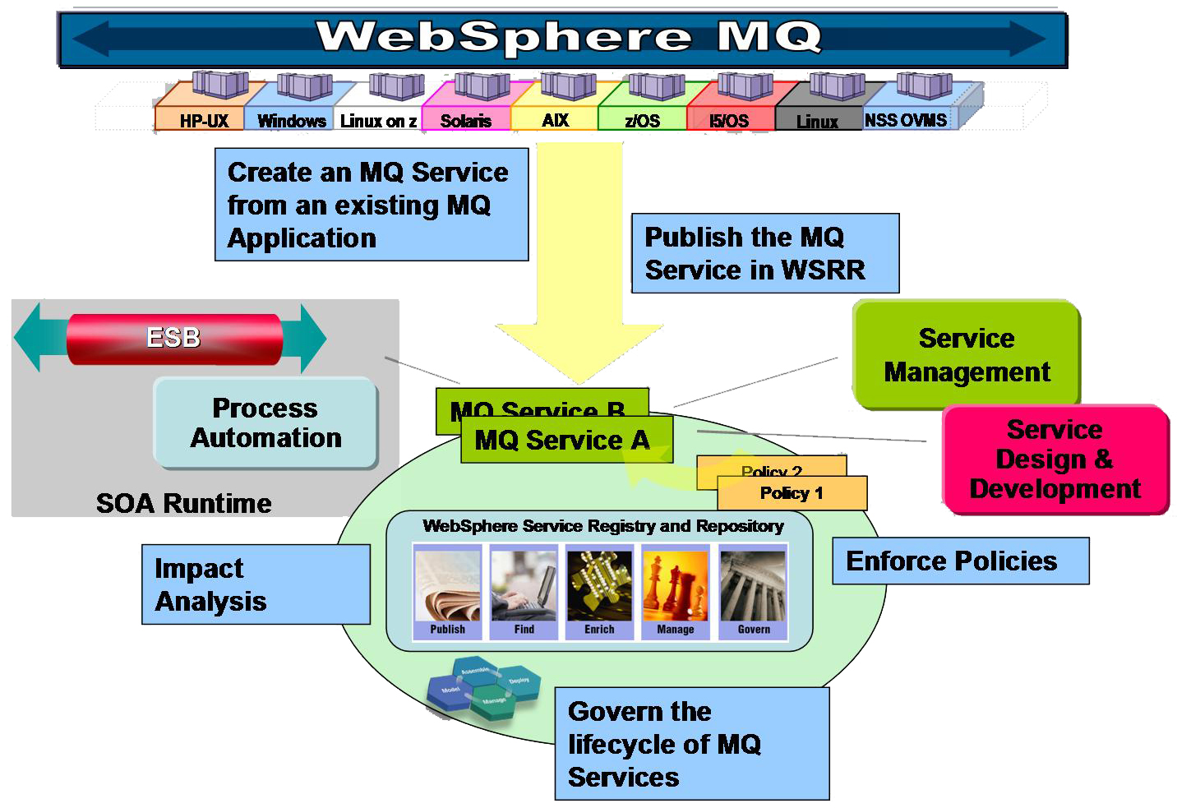

Diagram that shows how you can publish an MQ application to WSRR and its interactions within the SOA.

Users can select an MQ application and leverage the MQ explorer to create an MQ service based on an MQ Service Definition Specification. Once created, this MQ service can be registered in WSRR. The graphical view in WSRR allows users to explore the structure of WSRR with its queues, queue managers, operations and messages. MQ artifacts can be enriched by associating policies and other metadata. Based on this metadata, queries can be run to determine which applications are using which queues, and which are using persistent messages, etc. Users can then govern the lifecycle of MQ services and ensure full understanding of the impact of making changes and dependencies for reuse.

Increase Productivity and Reduce Costs
With WebSphere MQ and WebSphere Service Registry and Repository, IT Managers and Architects can:
- Leverage high value MQ applications across the enterprise by ensuring that MQ Services are visible to all SOA consumers
- Maximize utilization of limited IT budgets and resources by better understanding of MQ Applications and their usage promotes reuse
- Ensure consistency and interoperability of your SOA where MQ Services follow same best practices & policies, as all other services.

MQ application versus MQ endpoint?
An MQ Application (or Service) is code which gets and puts Messages (with specific formats) on to one or more Queues using a Message Exchange Pattern (MEP). An MQ endpoint is just the address of the Queue which the MQ Application (Service) uses. MQ Service Definition contains the MEP and message formats as well as the address of the Queues, i.e. it describes an MQ Application (or Service) not just an MQ endpoint.

Typical pain points addressed

Manage undocumented MQ Applications
By publishing standalone MQ Applications as services in WebSphere Service Registry and Repository (WSRR), Architects can leverage WSRR to better understand their previously undocumented MQ applications.

Challenge
Many organizations have unmanaged or undocumented MQ applications that are not well known or well understood, and are not widely available for use. These stand-alone Windows, UNIX, or batch mainframe applications have typically been developed over time with inconsistent (or non-existent) documentation and without a reliable inventory of the applications.

Solution
For any MQ application, for example an Insurance Service, leverage the MQ explorer to create an MQ service based on the MQ Service Definition Specification. You can enter all the relevant details which describe the service, including its queue, queue manager and message details, and generate the corresponding WSDL. The newly generated MQ Service can be easily published into WSRR. Once in WSRR, we can utilize the graphical view to explore the MQ service structure with its queue managers, queues, operations and messages.

Benefits
Cataloging MQ applications in WSRR is a key step in developing a better understanding of previously undocumented MQ applications. It helps IT managers and architects to:
- Understand what capabilities are available to support the business
- Reduce maintenance costs for MQ applications
- Increase the validity and awareness of their MQ applications
- Evaluate the compliance of these MQ applications (e.g. Naming standards, Best Practices and Security)

Promote Reuse of MQ Applications
IT Managers can leverage high-value MQ applications across SOA by increasing their enterprise visibility as services stored in WSRR that can be easily found and reused by the SOA infrastructure.

Challenge
IT Managers in many organizations worry about lack of awareness of services that exist in their organization. Typically, this leads to creation of redundant services with multiple services that may be just slightly different. The architect is worried about how to encourage reuse of services across multiple teams.

Solution
MQ Applications can be published as services in WSRR. MQ artifacts such as queues, queue managers and messages can be enriched by associating policies and other metadata. Based on this metadata, queries can be run to determine which applications are using which queues, and which are using persistent messages. This allows users to quickly find services based on metadata associated with MQ artifacts. WSRR also allows a flexible organization of services based on domain-specific taxonomy. In order to find services quickly, users can leverage powerful query and search mechanisms, and standards-based API.

Benefits
WSRR increases the visibility of MQ Applications as services in an SOA. The metadata associated with MQ services is readily available to all the potential consumers to help in determining how or when to use the service. This simplifies finding and reusing of high-value, time-tested MQ services across the enterprise. It helps IT managers and architects to:
- Share their high-value IT assets more widely in the organization
- Enable ESBs and other runtimes to find and invoke MQ services during runtime
- Maximize utilization of limited IT budgets and resources
- Minimize redundant services, which reduces costs and increases staff productivity

Control changes to MQ Services
IT Architects leverage WSRR to understand the impact on their applications & processes of reusing and/or changing an MQ service, which helps avoid service disruptions or critical system outages.

Challenge
A typical challenge that IT Architects deal with is to determine what Applications and Business Processes depend on or are using which MQ Applications and how they are being used. They also want to better understand the impact of changing an MQ Application on its various consumers.

Solution
A powerful feature of WSRR is the ability to generate graphical views to help determine the impact of changes or analyze service dependencies when considering reuse. This allows users to quickly discover what applications, processes, or services are related to MQ services. When changes are made to MQ services, all consumers are notified using one of several options, such as JMS notifications or email.

Benefit
IT Architects can minimize or eliminate the risk of making changes to MQ Services by leveraging WSRR. WSRR helps architects to:
- Make controlled changes to MQ services by fully understanding the service dependencies on its various consumers
- Notify consumers if a service or a version of a service is changed or deprecated
- Reduce customer dissatisfaction as a result of abrupt service withdrawal or failure.

Apply policies to MQ Services
By utilizing WSRR for managing policies, IT Managers and Enterprise Architects can consistently enforce their SOA policies for MQ services and apply governance best practices, just like any other service in their SOA environment.

Challenge
One of the key challenges that IT managers face is applying a small set of high-quality policies consistently across all their services, including MQ services. They also need to roll out changes to these policies quickly and efficiently with changing business and customer needs.

Solution
In WSRR, users can easily associate policies with MQ services as well as with MQ artifacts such as services, queues, queue managers and messages. Templates for over a dozen types of operational policies and over 70 policies that capture governance best practices are available out of the box. Since policies in WSRR are maintained as first class assets with a lifecycle of their own, changes to policies can be managed, validated and then easily propagated to all associated services.

Benefits
By managing their policies and applying them consistently to MQ services, IT Managers enable interoperability, consistency and governance of SOA. This greatly enhances the ability of IT organizations to quickly respond to changing business requirements. The governance best practices applied to any other service in SOA can now be applied equally to MQ services. Also, WSRR can help keep track of health and performance of MQ services by capturing alerts generated by service management and monitoring infrastructure.

Govern Lifecycle of MQ Services
IT Managers can create a trusted, high-quality and reliable source of MQ services by governing their lifecycle in WSRR, helping reduce business risk and realizing greater ROI on their SOA investment.

Challenge
IT Managers are often not able to realize the agility and benefits of reuse in SOA even after increasing the provisioning of their MQ applications as services. This is due to lack of governing the lifecycle of MQ services which will allow only the most reliable and trustworthy services to be available for reuse.

Solution
Once MQ Applications are registered in WSRR as services, users can start to govern the lifecycle of MQ services. A customizable lifecycle allows users to introduce, promote and retire MQ services while making sure that each transition is validated according to organizational policies. Out of the box WSRR profiles, templates, and editors allow users to quickly get started with their governance efforts.

Benefits
IT Managers can ensure quality and reliability of MQ services for consumption across the organization by governing their lifecycle using WSRR. Doing so really starts to drive some key benefits of SOA in reducing risk and increasing agility. IT Managers are now able to:
- Ensure that MQ services are properly funded, owned and resourced with increasing reuse
- Introduce, promote and retire MQ services with confidence leveraging fine-grained, role-based access control and customizable validations
- Reduce customer dissatisfaction by avoiding abrupt service withdrawal or failure by ensuring that consumers are notified if an MQ service is retired, or a version is deprecated

Financial Services Sector Case Study

JK Enterprises is one of the world’s largest financial institutions and processes transactions worth several billion dollars daily. Financial transactions require fast, secure and reliable data transfer and to meet those requirements, JK Enterprises have long used IBM WebSphere MQ. Currently, JK Enterprises has deployed over 2,000 Queue Managers, which facilitate several hundred applications. The applications use a variety of message formats –XML, COBOL copy book format, and C++ structures.

The applications are documented in a number of different formats and repositories. Some departments keep a spreadsheet of the queues used by applications, other departments use a visual tool to describe their architecture, and some applications are described in word processing documents.

JK Enterprises has realized that having a central catalogue of the WebSphere MQ applications, in a consistent format, would provide them with significant benefits and solve several problems:
- Identifying which lines of business and which applications, would be effected when a particular queue manager is refreshed for maintenance
- Providing up to date and accurate information pertaining to a particular application to all consumers

Based on these requirements, JK Enterprises is leveraging the MQ Service Definition Specification to create WSDLs for their WebSphere MQ applications, and then storing those in WSRRs. By using MQ Explorer, MQ Services can be created quickly without training their resources to understand the intricacies of WSDL.

- Using the impact analysis capability of WSRR, JK Enterprises can query which applications are using which Queue Manager and who owns those applications. Also, subscribers to the applications are automatically notified when a Queue Manager changes.
- Developers at JK Enterprises log on to the single web client provided by WSRR, to find the details for particular WebSphere MQ applications. Changes are reflected immediately, ensuring developers are always presented with accurate information.

Resources

For more information, please visit the following links –

- WebSphere Service Registry and Repository Website
http://www-306.ibm.com/software/integration/wsrr/index.html

- WebSphere MQ Website
http://www-01.ibm.com/software/integration/wmq/

- WebSphere MQ - Service Definition Specification Supportpac
http://www-01.ibm.com/support/docview.wss?rs=171&uid=swg24017518&loc=en_US&cs=utf-8&lang=en

- Analyst Whitepaper: Effective Governance of the Service Lifecycle, Jason Bloomberg, ZapThink, July 2008
ftp://ftp.software.ibm.com/software/integration/wsrr/EffectiveGovernanceServiceLifecycle-IBM-072008-WP-0172-1.pdf

- SOA Governance and Service Lifecycle Management Website
http://www 306.ibm.com/software/solutions/soa/gov/

- White Paper: IBM's Federated Metadata Management Strategy, Michael J. Blechar, Gartner Research, April 2007
ftp://ftp.software.ibm.com/software/rational/web/whitepapers/federated_metadata_mana_147616.pdf

Publication and Legal Information

© Copyright IBM Corporation 2008

IBM Corporation
Software Group
Route 100
Somers, NY 10589
U.S.A.

Produced in the United States of America
October 2008
All rights reserved

IBM, the IBM logo, ibm.com, WebSphere are trademarks or registered trademarks of International Business Machines Corporation in the United States, other countries, or both. If these and other IBM trademarked terms are marked on their first occurrence in this information with a trademark symbol (® or ™), these symbols indicate U.S. registered or common law trademarks owned by IBM at the time this information was published. Such trademarks may also be registered or common law trademarks in other countries. A current list of IBM trademarks is available on the Web at “Copyright and trademark information” at ibm.com/legal/copytrade.shtml

Other company, product, or service names may be trademarks or service marks of others.

References in this publication to IBM products or services do not imply that IBM intends to make them available in all countries in which IBM operates.

The information contained in this documentation is provided for informational purposes only. While efforts were made to verify the completeness and accuracy of the information contained in this documentation, it is provided “as is” without warranty of any kind, express or implied. In addition, this information is based on IBM’s current product plans and strategy, which are subject to change by IBM without notice. IBM shall not be responsible for any damages arising out of the use of, or otherwise related to, this documentation or any other documentation. Nothing contained in this documentation is intended to, nor shall have the effect of, creating any warranties or representations from IBM (or its suppliers or licensors), or altering the terms and conditions of the applicable license agreement governing the use of IBM software.

