CICS Transaction Server support for the WebSphere Service Registry and Repository (SupportPac CA1N)

The new tools provided in CICS SupportPac CA1N support the interoperation of CICS Transaction Server with WebSphere Service Registry and Repository (WSRR). The tools streamline the job of registering the service descriptions for CICS applications that are being deployed as Web services, and reading descriptions for services to be called by CICS applications.

The tools provide additional support in the move towards a Service-Oriented Architecture (SOA) for which WSRR is a key component. They also provide additional evidence of IBM’s ongoing commitment to SOA as the modern environment for conducting today’s business operations.

WSRR
WSRR allows service metadata assets to be catalogued and stored in a common repository. WSRR delivers strong governance capabilities for the publication, discovery, subscription, management and policy enforcement of SOA services and service metadata assets.

The service metadata assets stored in WSRR are used by other applications when selecting, invoking, governing or reusing Web services as part of a successful SOA. WSRR can contain service metadata assets that describe the Web services in an organization’s own business systems, or in different business systems.

When an application needs to request (invoke) a Web service, it discovers information about suitable Web services by looking in WSRR.

CICS resource information held in WSRR
Information about CICS applications is stored in WSRR as Web Services Description Language (WSDL) files and metadata.

WSDL is an extension of the XML data description standard that provides public interfaces for accessing applications over the Web. WSDL documents describe application protocol bindings and message formats in a way that allows other applications to access them. Put another way, WSDL files describe CICS applications in terms that can be easily understood by other applications on the Web.

WSRR user interface
To list the WSDL documents held in the WSRR, from the WSRR console click Service Documents > WSDL Documents:

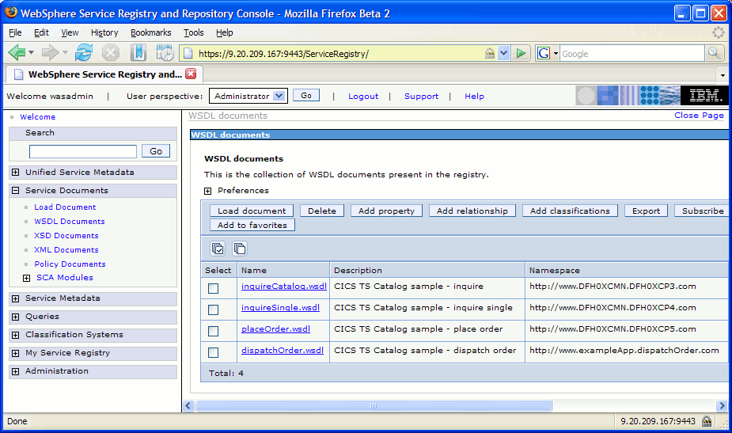

Figure 1 - List of WSDL documents held in the WSRR

To display the details of a selected WSDL document, click the WSDL document’s Name field:

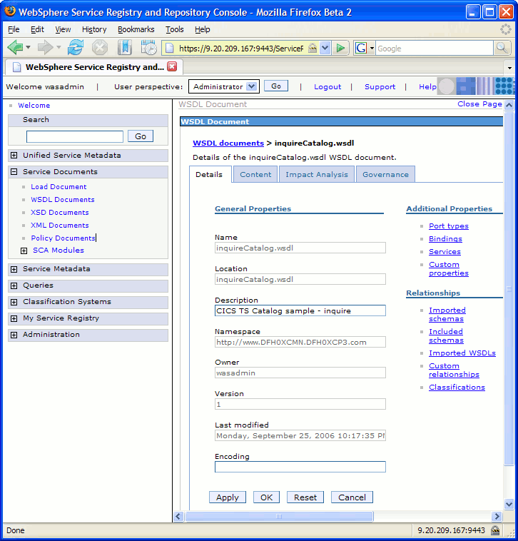

Figure 2 - Details of a WSDL document held in WSRR

How the SupportPac tools enable better governance
Better governance means carefully managing key business assets (for example the service metadata assets held in WSRR) in order to maximize their benefit. It also means the ability to formulate, control, and oversee the proper maintenance, regulation and growth of business IT assets.

The new SupportPac tools encourage better governance because they allow CICS Transaction Server to interoperate directly with a single, centralized service metadata asset management system (WSRR).

WSRR is a critically important component for ensuring effective governance within an SOA, not only because it provides a central storage location for service metadata assets, but also because it encourages a unified and consistent approach to asset management across the enterprise.

Initially, having a central location for storing and managing service metadata assets may not seem very important, but as the business grows and as more Web services are created and deployed, this becomes imperative. Registering these is easier if a central location is available. Discovering these is also easier if they are held in a single location.

How the SupportPac tools make it easier to register CICS resources
When enabling a CICS application as a Web services provider, it is necessary to generate a set of WSDL files from the application’s HLL structures and register them in WSRR. The SupportPac contains a tool for registering WSDL files that have been generated from CICS applications.

The CICS Web Services Assistant included with CICS Transaction Server provides facilities for generating WSDL files directly from CICS applications.
The SupportPac tool automates the registration process and allows for metadata to be published along with the WSDL files. For more sophisticated interface mapping requirements, WebSphere Developer for zSeries provides comprehensive visual tools to generate WSDL files.

How the SupportPac tools make it easier to discover CICS resources
When developing a CICS application that is going to request (invoke) a Web service, it is necessary to discover the application’s WSDL files in WSRR. HLL structures must then be generated for passing data back to CICS when the Web service is invoked. The CICS Web Services Assistant provides facilities for generating HLL structures from the discovered WSDL files. The SupportPac tool automates the discovery process.

Summary
The new tools provided in SupportPac CA1N allow CICS Transaction Server to register and discover information about CICS applications in WSRR. These CICS applications can be service providers or service requesters. WSRR provides a centralized service metadata asset base that supports good governance. The tools automate the processes of registration and discovery.

To download the SupportPac and user documentation, go to:

http://www.ibm.com/software/htp/cics/tserver/support

