

Essentials of On Demand Automation
Executive Summary
As computing has become more capable, computing systems have become more complex, demanding substantial skilled Human Capital to implement and manage them. While this complexity can enable more sophisticated and useful business applications and environments it also can prevent progress. So much IT resource is spent keeping existing systems smoothly running that not enough money or people are left to build the new systems a growing and changing business demands.
In an increasingly dynamic On Demand world, customers need not only to maintain and manage existing skills and resources, but must also become agile, optimize IT resources, and manage complexity while reducing costs. The essentials of automation help organizations to achieve these goals.
In this white paper, we'll discuss how investing in the three Automation Essentials to: (1) Manage Resources and Minimize Risk, (2) Optimize Human Capital, and (3) Manage Service Levels & Business Processes positions an organization to more efficiently use its existing IT investments and frees up resources -- in both dollars and human capital -- to implement valuable new systems. At the same time, Automation helps an organization reduce overall IT costs and more effectively align IT with business needs.
Introduction
On Demand Automation is all about allowing your company to use as much IT technology as you need - no matter how complex - while simplifying its management. Importantly, this approach to simplification does not require a revolution in the Data Center; it assumes you will want to continue using your current investments in hardware and software, adding to them or replacing them on your own schedule - not changing everything at great cost in money and disruption in the hope that this will somehow make things better. IT management knows, by experience, that it will always be in charge of heterogeneous collections of hardware and software, so any simplification scheme must address mixed collections - by brand and vintage - or fail the reality check.
Business Organizations are excited by the opportunity to take advantage of advances in technology - networking, open standards, web services - to allow them to provide dynamic and flexible changes in IT to support the continuous changes in their business environment. But that requires that all of their technology be able to work together, that it be possible to manage it efficiently, and that some of the IT manpower now required to maintain and manage existing systems be freed up to create new systems and tackle higher value added tasks.
That's what On Demand Automation is all about. It's for any business organization that would like to get more out of the IT systems and skilled employees it already has and to move forward toward building systems that are easier and less expensive to build and manage in the future. More important, Automation both facilitates the process of building new systems while it enable building a more flexible, responsive, and resilient IT organization that is able to respond faster to changes in business needs. . It is a key element to support an on demand business.
Many of these organizations will be classic "big" data centers in large enterprises, but even more will be in mid-sized organizations where capital and skilled employees are scarcer resources. It's happening now partly because IT systems have become so complex that in order to move forward we have to better manage what we already have - and partly because advances in technology are enabling better solutions.
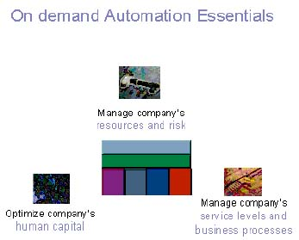
The Three Essentials of On Demand Automation
In order to successfully achieve On Demand Automation, you must address three essentials.
(1) Manage Resources & Risks
Simplifies the management of an IT environment's complexity, including multiple platforms, numerous sites and robust security. This is done via simplifying change, configuration and identity management, through an intelligent sense and respond system, centrally and securely managed, based on business policy.
A multi-national building firm uses many sub-contractors. Its computing systems must flexibly adapt to support a changing array of projects and volumes, including temporary employees, consultants, and contractors who access the systems from their on-site locations. A system with dynamic intelligent sense and respond can react to changes in need, assigning system resources according to changing needs and priorities. Thousands of systems can be automatically changed and redeployed, in any location, without the need to move skilled manpower to distant sites to physically reconfigure hardware or load software. Valid users can be created and users associated with completed projects immediately removed from the system, for complete security.
(2) Optimize Human Capital
Enables IT staff to increase their productivity and become more flexible, through automating complex, manual tasks which results in lowering support costs and increasing the ability to act, thereby lowering overall costs.
An insurance company headquarters requires hundreds of IT professionals to keep its systems properly deployed to current business needs. Departments appear and vanish (10% of the employees move each year) and new insurance product offerings require new systems and software throughout a highly distributed environment with hundreds of offices. Automation (entirely controlled by IT) takes over tedious tasks previously performed by humans, saving time, and money in salaries and travel expenses. IT Professionals are now focused on more interesting work and the turnover rate for IT falls, lowering recruitment and training costs.
(3) Manage Service Levels & Business Processes
Helps manage processes from a business's point of view; thereby, enabling service levels to be delivered at the business level, regardless of the deep underlying technology. This helps ensure business processes meet defined service level agreements.
In an international financial services firm, the product offerings must change frequently, to take advantage of changes in the world economy, interest rates, and the state of the financial markets - to say nothing of consumer confidence levels. IT must be able to respond to the firm's desire to provide new offerings by providing the IT infrastructure that supports these financial products. In the past, efforts to react quickly resulted in huge costs for maintaining excess capacity "just in case," and huge overtime bills to make changes to systems as new products were created, tested, and implemented. With On Demand Automation, the firm can make much more efficient use of its hardware, change the use of its resources from a central location with a much smaller staffing resource, and focus its skilled IT staff on the actual design and testing of the new product infrastructure. This results in faster responses to market opportunities and less overhead, leading to higher profits.
The Marketplace for Dynamic Computing
All around us the IT marketplace is changing. Business organizations are demanding that their IT departments be able to perform more efficiently yet be prepared to react dynamically, to support frequent business changes and take advantage of business opportunities. Last month's business information is no longer interesting - business management wants today's - or this minute's! This flexible, ever-changing, more efficient environment can't be created or implemented by humans alone. They need the assistance of computer automation for the tasks that computer can do best. Under human supervision and innovation, these tasks are growing in both volume and complexity, freeing up humans to work on new challenges, rather than maintaining previously solved solutions.
Many vendors will attempt to serve this market, including both systems (complete hardware, software and services solutions) and infrastructure software vendors. Each will have its own approach, depending on the company's strengths, its weaknesses, and its heritage in products and customers. Some will address the entire problem, supporting large and complex systems and products from every vendor. Others will focus mainly on supporting their own products or a few popular systems. Still others will focus on a particular problem or niche market. We suspect that many customers will prefer a vendor with a broad portfolio of offerings who can, if the customer desires, provide a complete solution.
Directions
Automation Essentials offer many different opportunities for IT organizations; nearly everyone will start in a different place, depending on where you are in your computing investment and development cycle and what you need to do to meet your organization's business goals. Since there are different levels of Automation, different customers will be starting from different levels. Where will you get to? The sky's the limit, but most successful projects start with small incremental steps that will, in themselves, have valuable results. Bigger steps and bigger results can then follow. There's no "right" pace. How fast you go will be determined by what you need to do, the resources early automation projects free up, and the confidence an incremental approach to new technology can offer. All of these projects lead in the directions of enhanced Business Agility, Optimized IT Resources, and increased ability to Manage Complexity while reducing costs.
Getting started is easy. Think of it as a five-step process (but you'll be taking it one step at a time).
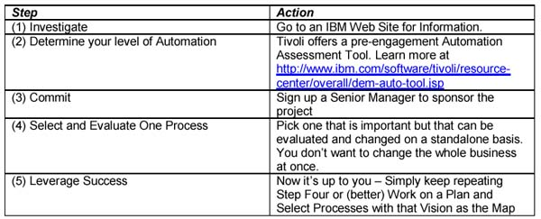
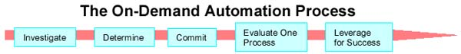
And now you're ready to start. Go to one of these web sites for more information.
IBM Automation external web site: http://www.ibm.com/software/info/openenvironment/automation.html
IBM Tivoli external web site: http://www.ibm.com/software/tivoli/
Prepared for IBM by A Amy Wohl
Wohl Associates
Wohl Associates is an analyst firm specializing in new and emerging technologies.
Wohl Associates
915 Montgomery Avenue
Narberth, PA 19072
www.wohl.com

