What is Storage Optimization in DB2 9?

DB2 9 Storage Optimization, or Deep compression, is a new feature of the latest release of DB2. Deep Compression reduces database storage requirements by eliminating data redundancy. DB2 9 provides industry-leading reductions in storage needs by compressing data at the table rather than the page level, which is typical of other databases. The DB2 9 approach leads to fewer pages per table, less data to store and therefore lower storage costs. Since storage represents nearly 48 percent of the total cost of a typical enterprise IT infrastructure, cutting storage costs can dramatically affect total costs.

What kind of storage savings have your customers reported?

DB2 can bring significant savings to production, test and development environments. Compressed databases translate into reduced backup storage as well as less mirrored and offsite storage. Additional storage-related costs are also reduced, including rack space, cables, floor space, and cooling and power systems, making an investment in DB2 9 deep compression very attractive.

A simple example shows the multiplier effect that DB2 9 deep compression can have on storage costs. An organization with a 5TB database warehouse may also incur storage costs for a 5TB development database, a 5TB test database, weekly logs and a backup copy of the 5TB database—up to 15TB total—and potentially even a 5TB offsite mirror. Thus, the 5TB database could consume as much as 25TB– 30TB of storage—more storage than most of us would initially think. As a result of DB2 9 deep compression, disk requirements are cut in half, power and cooling is lowered, less administrative resources are needed and smaller floor space is required.

How can the Deep Compression ROI tool help me?

The ROI Tool enables you to explore savings and perform breakeven analysis on your potential investment in Deep Compression. Without making a purchase or leaving your office, you can evaluate for yourself exactly how much you can save by deploying the feature. The report generated by the tool is a comprehensive analysis of the investment and benefits of the Deep Compression feature. Be a hero by proving to your management that you have numbers to back up your claim that DB2 9 is the right data server for your company.

What is ROI and how is it calculated?
Return on Investment (ROI) is one of the most elegant ways to calculate the efficacy of a business investment. It is expressed as a percentage and is calculated by dividing the present value of the accumulated net benefits over a time horizon, divided by your initial investment. In IT purchases, three years is the most common time span used and that is the horizon we’ve used in this tool.
The present value in the previous paragraph refers to the fact that money spent a year from today is not the same as money spent today. Therefore we use a discount rate to equate money spent in the future to today’s equivalent amount. The most common discount rate used in ROI calculations is 10%.
ROI is calculated as follows: {NB Year 1 / (1+DR) + NB Year 2 / (1+ DR) + NB Year 3 / (1+ DR)}
Initial Investment
where NB = Net Benefits (Gross Benefits – Annual Cost) and DR = Discount Rate
Let’s look at an example to make it clear. Let’s say your initial investment is $100, your annual benefits minus annual costs are constant at $50 for the next three years, and the discount rate is 10%, your 3-year ROI would be about 125%.
($50 / (1 + .1) + $50 / (1 + .1)^2 + $50 / (1 + .1)^3)
= 125%
$100
An ROI of over 100% implies that you will earn back your initial investment over three years and gain the excess over 100% as pure profit. We chose ROI to calculate the value of your investment in Deep Compression because it is the simplest metric that gives you a good idea of how valuable your investment is.
What is the difference between Aggressive and Conservative Estimates?

The aggressive estimate assumes that the number of disks for the whole system is reduced by the percent of compression. The conservative estimate assumes only data disks are saved at the same compression rate. In reality the true savings will likely be between these two values.
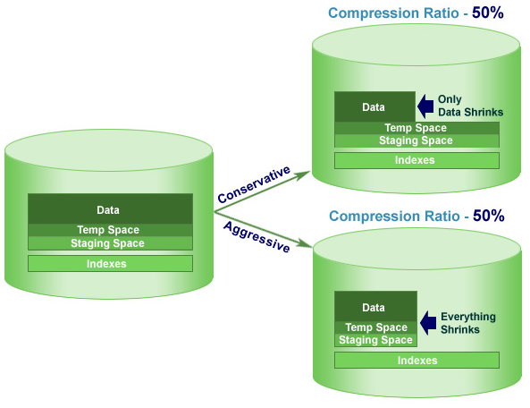
Figure 1: The difference between Conservative and Aggressive is not the compression ratio - it is the way you implement the feature and what sections of your database you will compress.

Do data compression rates differ for OLTP and Warehouse environments?

While the actual compression rate you might realize after deploying the Deep Compression feature will vary based on a number of factors, it is hard to say if the rates will significantly vary depending on the type of data environment. The biggest factor that determines the rate of compression is the type of data you have and the number of repetitive patterns you have within your data.

In this tool, we make a distinction between OLTP and data warehouse environments not for the sake of compression ratios. In fact, the compression estimator tool you might have used to estimate your compression rate is agnostic to the data environment in which it is run. The reason we make a distinction between OLTP and Data Warehouse environments is that in our experience, a good rule of thumb to estimate the total size of a database from the size of the data is to multiply the size of the “raw” data by a factor. We call this factor the Aggressive Savings Multiplier.

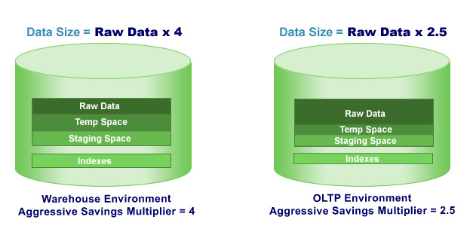
For instance, the Aggressive Savings Multiplier we use in this tool for a typical Data Warehouse is 4. That implies that if you only knew the size of the raw data and had to guesstimate the size of the database i.e. the total size of the raw data, temporary space, staging space (that might house MDCs, MQTs and such), and indexes - you would multiply the size of the raw data by 4. Similarly, in an OLTP environment, you would typically multiply the size of the raw data by 2 or 3. Therefore our default Aggressive Savings Multiplier for an OLTP environment is 2.5. You can adjust this value under the Defaults tab.
What is break-even analysis?
The Deep Compression Tool shows you exactly when you will recover all the costs you put into the software license purchase. The point at which that happens is the break even point. The graph in the report shows you when you will make up your investment using an aggressive and conservative approach.

Can you give me an example of an ROI calculation using the Deep Compression feature costs?

Most certainly! Let’s say your IT department charges you $2.50 a month per GB and you have 50 TB of storage. If you purchase twenty Storage Optimization licenses and your data storage needs drop by 30% here’s what your ROI would look like using these conservative assumptions:

One-Time Investment: $270,000
Savings over 3 Years : $1,870,000
ROI on disk savings alone = 125%

Assumptions:
- Feature is priced at full retail price without any IBM customer discounts
- Discount rate for ROI is 10%. (See what Discount Rate is above)
- Your data grows only 10% annually (most companies grow between 10%-25%)

Your savings would increase dramatically had we included IBM license discounts and a more realistic data growth rate. Remember this is only disk savings – we’ve not added savings due to reduction in personnel costs, IT infrastructure costs and downtime costs.

How much faith can I put into these numbers?

The ROI tool takes into account most of the costs and savings that need to be considered when making a decision on purchasing the Storage Optimization feature of DB2 9. However, this report should not be treated as a substitute for a thorough NPV analysis of the investment case that you would normally undertake in a similar situation.

This report is accurate to the extent that your input data about your data environment is accurate and the assumptions we’ve made in the way you plan to implement the feature hold good. In addition, the compression ratio you will obtain after installing the feature is dependent on a number of variables. The ratio you used in this analysis is a good start but your actual ratio may vary.

The best way to interpret this report is to treat this as a reasonably accurate estimate of the savings you will accrue after installing the feature and speak to a IBM sales representative about a more in-depth analysis of your specific data environment to reach a more accurate figure.

Where can I learn more?

Learn  Demo  ibm.com/software/data/db2/hero  Deep Compression Webcast  ibm.com/software/data/db2/9/labchats.html#16  DB2 9 Blog  blogs.ittoolbox.com/database/technology  developerWorks article  ibm.com/developerworks/db2/library/techarticle/dm-0605ahuja | Try  ibm.com/software/data/db2/9/download.html    Buy  DB2 Value Unit Pricing  ibm.com/developerworks/db2/library/techarticle/dm-0611zikopoulos2/  IBM Database Winback Pricing  ibm.com/software/data/info/winback

NOTE:

The Deep Compression tool for DB2 9 for Linux, UNIX and Windows ("Tool") was developed by IBM to assist IBM Customers and Business Partners to assess the potential savings and expenses in deploying the Storage Optimization feature of DB2 9 for Linux, UNIX and Windows, also known as "Deep Compression". The Tool is based on numerous industry-wide assumptions, financial projections and projected growth of data rates, not all of which may be accurate. These assumptions, projections and growth rates are not guaranteed, and may vary from historical rates based on a variety of factors, including business conditions, competitive factors, and execution factors. The accuracy of your input may also affect the quality of the projections that the Tool generates. IBM is not responsible for the quality of any projections rendered by the Tool or any reports generated by the Tool. IBM is not responsible for the accuracy of the data contained in the Tool or any report, or how results are generated. Any reliance by you on the Tool and any results from the Tool is at your sole risk and will not create any liability or obligation for IBM.

© Copyright IBM Corporation 2007
IBM Software Group
Route 100
Somers, NY 10589
U.S.A.
All Rights Reserved

DB2, IBM, the IBM logo, the On Demand
Business logo and z/OS are trademarks of
International Business Machines Corporation in the United States, other countries, or both.
Linux is a registered trademark of Linus Torvalds in the United States, other countries, or both.

Microsoft and Windows are trademarks of
Microsoft Corporation in the United States, other countries, or both.

UNIX is a registered trademark of The Open
Group in the United States and other countries.

Other company, product or service names may be trademarks or service marks of others.

